Component.setPreferredSize(new Dimension(width, height))

Component.SetBackGround(color.green)

New Color(255,255)

JOptionPane :

pop up a standard dialog box that prompts users for a value or informs them of something.

Create:

MessageDialogue = simple message

JOptionPane.showMessageDialogue(parentComponenent, message, title, messageType);

//messageType = JOptionPane.PLAIN_MESSAGE/WARNING_MESSAGE….

ConfirmDialogue = yes or no or cancel

JOptionPane.showConfirmDialogue(.,.,.)

System.out.println(JOptionPane.showConfirmDialogue(.,.,.))

= 0 if yes

= 1 if no

= 2 if cancel

=-1 if close

String name = JOptionPane.showInputDialogue(“message”)

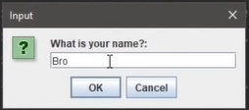

Name = “bro”

OptionDialogue = combine all of them

JOptionPane.showOptionDialogue(parentComponenent , message, title, OptionType, MessageType,Icon, Option, intialvalue) ;

parentComponenet= frame or panel or null, …

OptionType= JOptionPane.YES_NO_CANCEL_OPTION … LES BUTTONS

Option = String[] response = {“les bouttons,,, }

JTextField :

A GUI TEXTBOT COMPONENT THAT CAN BE USED TO ADD , SET , OR GET TEXT

JTextField textfield = new JTextField();

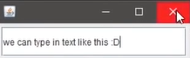

ActionListener .

JButton button = new JButton();

Button.addActionListener(frame);

Public void actionPerformed(ActionEvent e){

If(e.getSource()==button){

We do smthing

}

OR

Button.addActionListener(e -> we do smthing);

GridLayout:

Component.setLayout(new GridLayout(nbr de ligne, nbr de colonne,distance entre component horizontalement, verticalement))

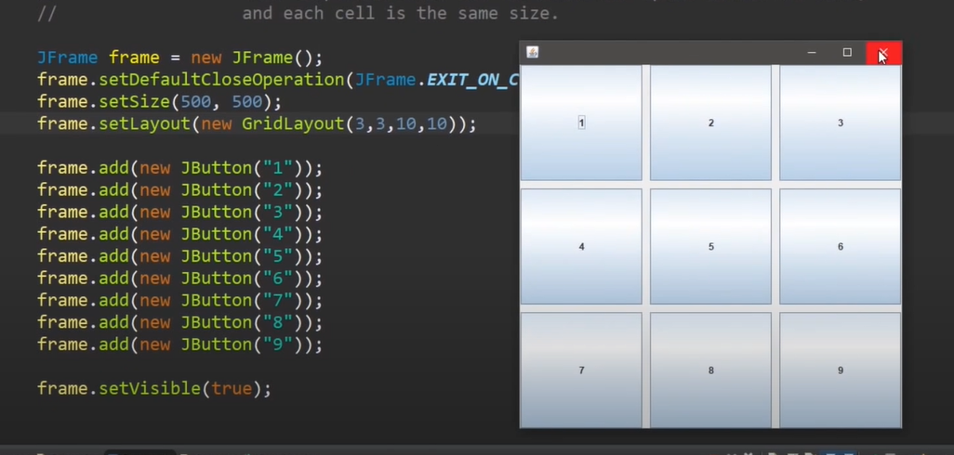

FlowLayout:

Component.SetLayout(new FlowLayout( FlowLayout.LEADING, horizontal spacing, vertical spacing)); .CENTER :the DEFAULT setting

BorderLayout :

Places component north or south or west or east of component

Component.setLayout(new BorderLayout())

Component.add(component1,BorderLayout.NORTH);

SetLayout(null);

Component.setBound(x,y, width,height)