Web pack/ web pack encore !

To install :

* composer require symfony/webpack-encore-bundle (this give us the package.json file that contains the npm dependencies)
* npm install (to install those dependencies)

Webpack allows us to compile all js/css files into one file.

Encore is a configuration generating, you tell it how you want the webpack to behave, it makes things easy.

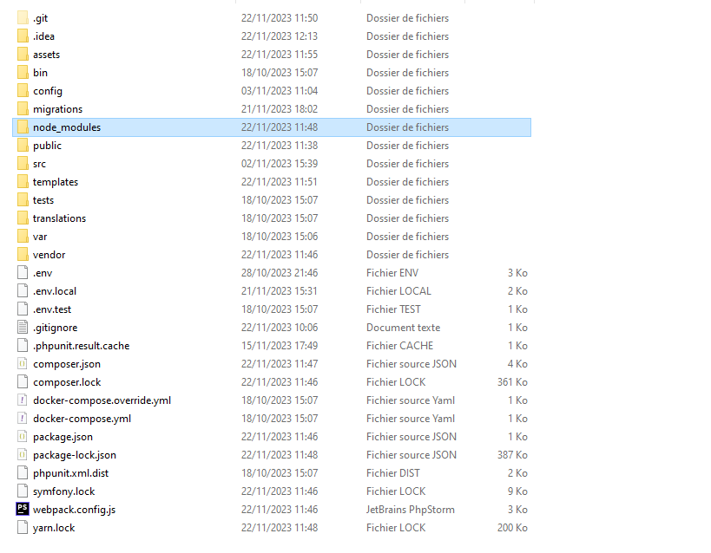

We get the webpack.config.js, it is where to configure how we want webpack to behave, where to look for the js/css files to compile and where to put the compiled file

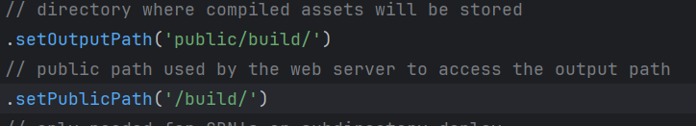

**Outputpath tells webpack where to put the final built file**.

publicPath, tells it the public path to this directory.

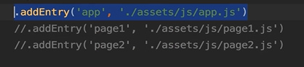.

**addEntry**, the concept of webpack is that we point the webpack to one js file (app.js), and it parses through all the import statement it finds in app.js, puts all the code into one file in public/build called app.js (the first argument ‘app’)

**the second argument is the javascript file that we points into :**

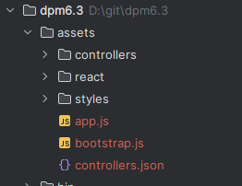

We can create a js file, where we declare a function that we want to use through out the project,

The function must starts with :

module.exports = function nameFunc() {}

because here we are exporting modules !

to fetch this, in our app.js we declare a const :

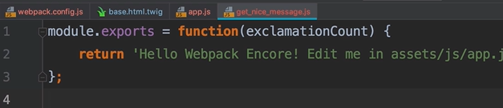

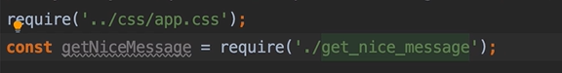

./js file

Is because the js file and app are in the same folder :

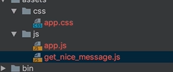



We can use another way to export function,

Export default function nameFun( variable ) {}

With this we can export more than on function

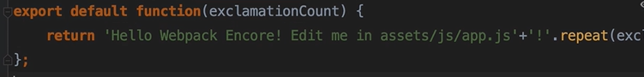

And to call it :

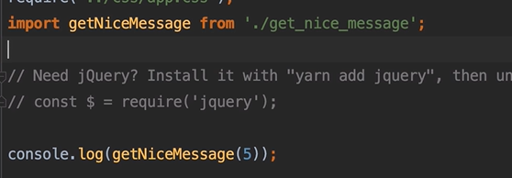



If there is no ./ npm looks for the dependency inside the node modules



To reference files in node modules. Or simply 