To build project :

From cmd :

* mvn clean install -Dmaven.wagon.http.ssl.insecure=true -Dmaven.wagon.http.ssl.allowall=true -Dmaven.wagon.http.ssl.ignore.validity.dates=true -X -DskipTests
* ServletContext app = getServletContext();  
   File tmpDir = (File)app.getAttribute("javax.servlet.context.tempdir");  
  // String path = tmpDir + "£" + logFileName;  
  // path = path.replaceAll("£","\\\\");  
   String tomcatBase = System.*getProperty*("catalina.base");  
   String webApp = String.*format*("%s/webapps/%s/", tomcatBase, "DFD-server");  
    
   String pathTemp = PersistenceManager.*getInstance*().getTempFolder();  
    
   System.*out*.println(tmpDir); // C:\Program Files (x86)\apache-tomcat-9.0.86\work\Catalina\localhost\DFD-server  
   System.*out*.println(webApp); // C:\Program Files (x86)\apache-tomcat-9.0.86\logs\  
    
   System.*out*.println(pathTemp); // C:\NFD\temp\

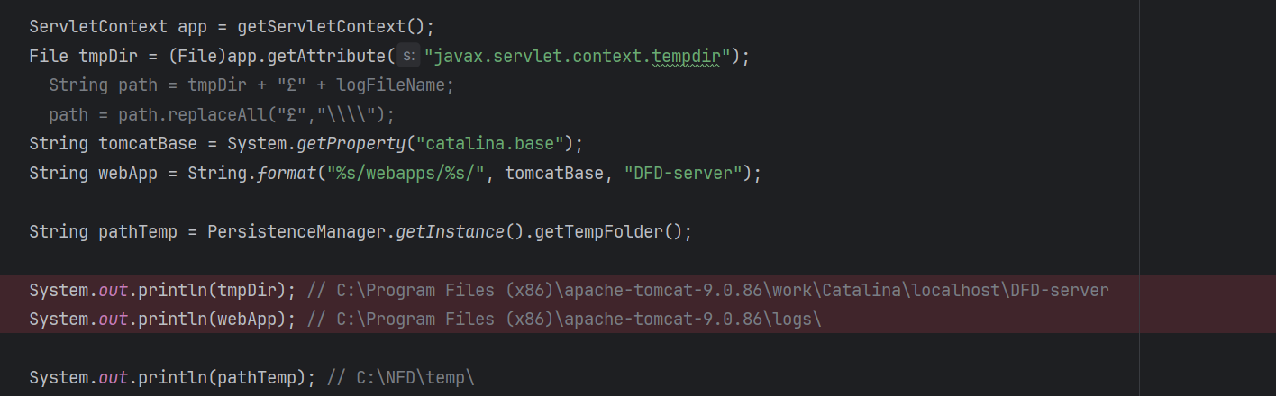

|  |
| --- |
| + **String** tomcatBase **=** **System.**getProperty**(**"catalina.base"**);** |
| + **String** logPath **=** **PersistenceManager.**getInstance**().**getTempFolder**();** *// C:\NFD\temp* |