Application of orchestration systems in LearnShell 2.0

Introduction

As we become ever more reliant on technology in our lives, be it personal, professional or educational, it stands to reason that there is a growing demand on the safety, accessibilility and perhaps most importantly, dependability of the software we use every day.

The days when outages and hiccups were tolerated and taken in stride are no longer, as we now have the tools to make sure that our systems can work at scale without a hitch, using containerization and orchestration to put together microservices to work in tandem. For these purposes, technologies such as Docker and Kubernetes, representing containerization and orchestration, are being used by companies small and large to make sure that the user base, however large its number, can use the software without worrying about overloading the servers to the point of system failure.

On the other hand, the developers, after getting through the learning curve of mastering these technologies, can sleep soundly at night, as their clusteres can work automatically to make sure that any problem regarding faulty services or system outage in a particular service can be mitigated by periodic healthy check on a 24/7 basis.

The main goal of this thesis is to explain containerization and orchestration to the reader as well as present a working, practical example, which will be used in LearnShell 2.0.

In summary, this thesis has several talking points:

- Introducing the concepts and the history of containerization and orchestration.
- Explaining the ins and outs of specific technologies used for these purposes.
- Comparing the use cases of Docker Swarm and Kubernetes, and making a choice between them for LearnShell 2.0.
- Presenting the configuration of a working cluster in the chosen technology.

Containerization and orchestration

Virtualization

In days of yore, the only viable way for most companies to work out an IT infrastructure and provision servers for a company was by spending considerable resources on buying physical servers, that is, by spending money on computers and computer parts and running the servers on them. Although it works at first glance, there is an issue which becomes apparent at scale; underutilization of the machine’s resources, be it its RAM, CPU, or physical memory. I

Ideas of creating some sort of abstraction appeared in the 60’s, when Jim Rymarczyk from IBM worked out a way to host multiple operating systems on the same piece of hardware, using a hypervisor, which is a software, firmware or hardware that creates virtual machines, emulations of computer systems running their own operating systems. This type of hypervisor would stand directly above the hardware in hierarchy, and host multiple virtual machines on top of it.

Later on, in the 90’s, a newer virtualization model to provide abstraction of virtualized resources was developed by the engineers at VMWare. It would employ a hosted hypervisor, which means that the hypervisor would be run on a host operating system, making it much easier to manage virtual machines, therefore making virtualization more viable than ever before.

However, VM-based virtualization still effectively “carves out” a part of the hardware resources of the physical server, as it creates a full-fledged operating system which treats its allocated hardware as if it was the only operating system running on it.

With the advent of Docker, container-based virtualization (henceworth referred to as containerization) turned into an extremely popular virtualization technique, which I will describe in the following chapter.

VM-based virtualization
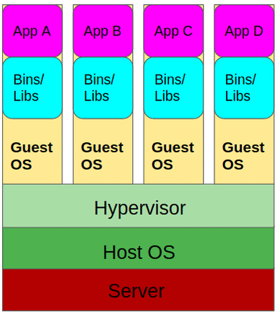

Containerization

Even though containerization has been around for decades before Docker, for example in the form of BSD “jails”, it’s only with the creation of Docker that it truly hit its stride. As seen on the diagrams, the difference between VM-based and container-based virtualization lies mainly in the fact that while VM-based virtualization creates (virtualizes) an entire operating system, with abstractions for hardware such as virtual CPUs and virtual disks, container-based virtualization uses techniques within the kernel to only virtualize the non-hardware aspects of the operating system, creating a separate root filesystem or network system, while not emulating hardware at all.

This opens up a whole new world of possibilities. Thanks to the efficiency and fast start-up caused by using far fewer resources than full-fledged virtual machines, as well as the opportunity to create truly specialized containers that only focus on providing one service, it’s now possible to manage these containers in such a way that it’s much easier to integrate these services together in a container-based architecture with the added benefit of greater security and easier scaling if each container only has one job.

These containers can then be efficiently managed, upgraded and be overseeen by tools built specifically for the configuration and management of containers, also known as container-orchestration systems, with the most commonly used at the moment being Kubernetes, or K8 for short.

Container-based virtualization
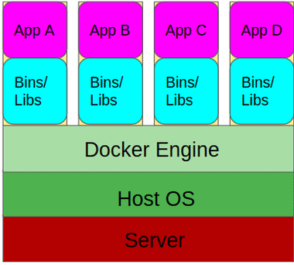

Orchestration

As we move into a container-based architecture, in which several microservices delegate tasks and communicate with each other, there arises a need for a need to manage the containers, their lifecycles and the relations between them. This is where the term container orchestration comes in.

There are several tasks which are managed by orchestration tools, such as the provisioning and deployment of containers, health checks of these containers, managing the allocation of resources between these containers and many more.

More broadly, orchestration is the automated configuration and coordination of systems and software in general. However, in this particular thesis, we shall focus on container orchestration in particular, that is, on the management of containers.

At this moment in time, the most popular container orchestration software by far is Kubernetes, as mentioned in the previous section, however, Docker Swarm is another such tool that posits itself as easier to use, and therefore preferable in certain cases. We shall describe these two platforms and the differences between them in more detail in some of the next chapters.

Docker, Kubernetes and Docker Swarm

Docker

Today, Docker is without any doubt the pre-eminent software for containerisation. It was originally meant to be merely a an internal PaaS (Platform as a Service) tool for dotCloud, an European company, however, it quickly gained traction as many truly big companies, for example Microsoft and Google, started noticing the numerous tangible benefits provided by switching to Docker in production. This led to a huge amount of resources being spent on the development and improvement of the Docker project, with several off-shoot tools created as a result, such as Docker Compose, or Docker Swarm.

Even though Docker is a complex piece of software, using it in practice is not as difficult as one may think. Generally, it boils down to writing a configuration file called a Dockerfile. Within the Dockerfile, the user specificies several parameters, such as commands that are to be executed upon deployment of the container, and most importantly, using the FROM keyword, the base image from which the container is to be derived. This image will be downloaded from Dockerhub, which is essentially a public repository of pre-configured images, with minimal overhead.

TBD do viaaaac detailov

Docker Compose

TBD

Docker Swarm

TBD

Kubernetes

TBD do viaaac detailov ako Docker Swarm, nakolko vyberam Kubernetes na 90%

Comparing Docker Swarm and Kubernetes

TBD – dlha kapitola, jedna cast bude vo vseobecnosti, jedna specificka pre LearnShell

Bibliography

books:

Linux Containers and Virtualization – Jain Shashank Mohan
Docker Orchestration – Randall Smith
DevOps Handbook – Gene Kim, Jez Humble, Patrick Debois, John Willis
Docker and Kubernetes for Java Developers – Jaroslaw Krochmalski

internet:
https://www.ibm.com/cloud/blog/the-benefits-of-containerization-and-what-it-means-for-you
https://www.ibm.com/cloud/blog/containers-vs-vms

