Target Journal: JESEE
- IF = 4.7
- Word limit = 7,000
- Ref limit = 75
- Table + figure limit in main text = 6 total
- Relevant aims/scope: Environmental justice and highly impacted communities, Understand the sources, pathways, and patterns of exposure to legacy and emerging environmental stressors

Title:
Volatile organic compound (VOC) concentrations and source apportionment in South Philadelphia fenceline communities: results from THRIVEair, a community-responsive air monitoring network

Authors:
Lisa Frueh,¹ Karlin Moore,² Grace Tiegs,³ KC Wahl,³ Leah Johnston,³ Jane Clougherty,¹ Nancy Johnston,³ Sheila Tripathy,¹

¹Drexel University Dornsife School of Public Health, Department of Environmental and Occupational Health; Philadelphia, PA
²Drexel University Dornsife School of Public Health, Department of Epidemiology and Bisotatistics; Philadelphia, PA
³Lewis Clark State College Department of Chemistry; Lewiston, ID

Corresponding Author:
Lisa Frueh
Department of Environmental and Occupational Health
Drexel University Dornsife School of Public Health
3215 Market Street
Philadelphia, PA, 19104
Lf649@drexel.edu
503-734-6123

Competing Financial Interests:
The authors declare they have no actual or potential competing financial interests.

Funding:
This work was supported by the National Institutes of Environmental Health Sciences (NIEHS grant # 5R21ES034494), the Drexel University Environmental Collaboratory, Drexel University Urban Health Collaborative pilot grant, a Build Up Peace Engineering Fellowship, and Institutional Development Award (IDeA) from the National Institute of General Medical Sciences of the National Institutes of Health under Grant #P20GM103408.

ABSTRACT

Background: Urban exposure to volatile organic compounds (VOCs) is associated with a wide range of adverse health outcomes. We previously partnered with Philly Thrive, a Philadelphia-based environmental justice organization, to co-design a one-year VOC monitoring campaign in South and Southwest Philadelphia to identify air quality impacts of traffic and local emissions from nearby redevelopment of a former oil refinery site. Our community-focused research dissemination focused on benzene, a primary pollutant of concern, though we were able to characterize many additional VOCs. Here, we present source identification and apportionment using diagnostic ratios, principal component analysis (PCA), and positive matrix factorization (PMF).

Methods: Using passive thermal desorption tubes, we took one-week integrated samples of 38 VOCs across 20 monitoring sites from July 2023 – June 2024. We summarized concentrations of VOCs across land use types and traffic density. To identify potential sources, we calculated the toluene:benzene (T/B) ratio and (m,p)-xylenes:ethylbenzene (X/E) ratios and compared them across sites. We employed PCA and PMF to identify potential VOC sources.

Results: Overall, VOC concentrations were low (e.g., mean benzene for site sampled weekly: 1.32 µg/m³; range: 0.30-9.04 µg/m³), but concentrations were generally higher in industrial, vs. non-industrial, and high-traffic, vs. low-traffic areas. We identified (m,p)-xylenes as a potential pollutant of concern, with high concentrations particularly among industrial sites. T/B and X/E ratios were higher among industrial and high-traffic sites, indicating fresh emissions of benzene derivatives. PCA and PMF revealed four common source groupings: (1) mixed industrial and urban combustion sources, (2) petroleum-based solvents, (3) chlorinated solvent use, and (4) background / legacy contamination.

Significance: Using a community-responsive study design, we characterized 38 VOCs in ambient air in a pollution-burdened area of South Philadelphia. Source apportionment analyses confirmed traffic and petroleum infrastructure as primary VOC sources in the area, echoing community concern, and further identified industrial solvent use and legacy air pollution as contributors to VOC pollution. **need one more sentence here**

IMPACT STATEMENT
THRIVEair was a community-based volatile organic compound (VOC) monitoring campaign in South and Southwest Philadelphia designed in response to residents’ concerns about benzene pollution during the redevelopment of a former refinery. Leveraging data on 37 additional VOC species measured across 20 sites from June 2023 – June 2024, this analysis focuses on characterizing spatial and temporal trends in VOC pollution and source apportionment. Source apportionment analyses identified four VOC source groups: (1) mixed industrial and urban combustion sources, (2) petroleum-based solvent usage (3) chlorinated solvent use and (4) background / legacy contamination identified as additional VOC sources. *need one more sentence here*

INTRODUCTION
Urban populations are exposed to a wide range of volatile organic compounds (VOCs) with a range of health impacts from sources including local fossil fuel combustion and industrial sources and long-range transport from other urban areas. VOCs can impact health as both carcinogens and noncarcinogens, contributing to several adverse health risks.^{1,2} Many VOCs that are common in the urban environment have detrimental health impacts, even at low ambient levels. For example, benzene is a known carcinogen, while its derivatives toluene, ethylbenzene, and (m,p)-xylenes (BTEX) have been linked to respiratory and immune-related diseases including asthma.³ In the United States (US), several VOCs are designated as Hazardous Air Pollutants, which allows for regulation of point source emissions by the Environmental Protection Agency (EPA) under the Clean Air Act.⁴ However, the National Ambient Air Quality Standards do not regulate any VOCs in ambient air.

In urban communities that border industrial areas (often called “fenceline” communities),⁵ air pollution as a whole is associated with asthma,⁶ certain cancers,⁷ and mental health and quality of life concerns.^{8,9} Like other air pollutants, ambient VOCs tend to be elevated in fenceline communities,¹⁰ contributing to elevated health risks.¹¹ Fenceline community members are also more likely to be economically burdened and less likely to be non-Hispanic white, highlighting the environmental justice implications.¹²

In Philadelphia, the largest city in Pennsylvania, a 1300-acre swath of land on the Schuylkill River was home to petroleum storage and refining operations as far back as 1866,¹³ eventually becoming the Sunoco Philadelphia Refinery, sold in 2012 to Philadelphia Energy Systems (PES). As operations on the refinery site grew in the mid-twentieth century, so too did Philadelphia’s population, leading to a growing fenceline population that was and is, due to racist housing policies, disproportionately Black and low-income.¹⁴ Despite decades of activism demanding environmental monitoring around the refinery, the impact of refinery emissions on local community air quality remained largely uncharacterized, save for a 2016 monitoring campaign which found elevated concentrations of BTEX.^{15,16} In June 2019, a catastrophic explosion at the refinery led PES to cease operations and declare bankruptcy. Successful pressure from local community members guaranteed that the refinery site would be decommissioned and the land sold for non-refinery redevelopment. Today, the site, which comprised 2% of Philadelphia’s land mass, is being redeveloped into a logistics and warehousing center. In accordance with the 2015 EPA Petroleum Refinery Sector Rule,¹⁷ an air toxics regulation that required, among other things, refineries continually monitor the concentration of benzene emissions along their property boundary, PES monitored benzene concentrations on the perimeter of the refinery beginning in 2018. The PES refinery was the highest benzene emitter of all US refineries in 2019 and 2020, and the second-highest in 2021, two years after the explosion.¹⁸ Benzene emissions from PES exceeded the EPA action level of 9 µg/m³ moving annual average from 2018 until perimeter monitoring ended in early 2022 (Figure S1).¹⁹

Philly Thrive, a local environmental justice organization, has been at the heart of community advocacy around closing the refinery and fighting for community involvement and environmental justice throughout the redevelopment process.²⁰ Responding to community member concerns about potential further air pollution exposure during the site redevelopment, we partnered with Philly Thrive to complete a one-year VOC monitoring campaign. Through a community-based participatory process, we identified and collected samples from 20 air monitoring sites in S/SW Philadelphia and co-created and disseminated interim findings (CITE CBPR paper).

In our co-design process, community members identified benzene, lead, and traffic-related air pollutants as primary pollutants of concern, and refinery redevelopment and traffic as major sources of concern. To that end, our community-based report-back process focused on benzene and BTEX. However, we were also able to quantify 34 additional VOCs, affording an opportunity to use these data to further characterize potential sources and source contributions in South/Southwest Philadelphia. Here, we describe the results of these additional analyses.

MATERIALS AND METHODS
Study Design
Partnered with Philly Thrive, we co-designed a VOC monitoring campaign in South/Southwest Philadelphia. A comprehensive description of our community-based participatory research process is published elsewhere (CITE CBPR paper). In short, through a series of design meetings with Philly Thrive members (“Thrivers”), we identified two primary sources of concern: a former oil refinery site in the process of redevelopment into a logistics center, and traffic-related emissions. Thrivers were primarily concerned about pollution from benzene and benzene-related compounds.

We selected 9 sites which were sampled weekly: 1 background site at Bartram’s Gardens where we expected generally low VOC concentrations; 7 sites surrounding the former refinery site; and 1 site co-located with a government Air Quality Services (AQS) monitor. We further selected 11 “community” sites which were sampled for two 2-week periods (one in summer, one in winter) rotating through 3 community sites per 2-week session during these two seasons. Community sites were selected by matching a pool of community-recommended locations (e.g., schools, parks) with Philadelphia Electricity Company (PECO)-owned streetside telephone poles. Community sites were narrowed down using a stratified approach to ensure we included community sites in high- and low-traffic areas, and across varying distances from the former refinery fenceline. Traffic density was calculated for 30m grid cells across the domain and categorized into 30th vs. 70th percentiles (low vs. high) of weighted traffic density.²¹ For each grid cell, distance to refinery was calculated as shortest distance between the grid cell centroid and the nearest refinery fenceline, and categorized into near, mid, and far from fenceline based on distance tertiles. In addition to traffic density classifications used to select community sites, all sites were further categorized based on nearby (100m buffer) land use at the time of analysis, using 2023 tax parcel data from Open Data Philly.²² Site locations are mapped in Figure 1.

VOC Sampling & Laboratory Analysis
Our field team mounted Markes passive thermal desorption tubes (TDTs) 8-10 feet off the ground on telephone poles in stainless steel shelters. TDTs were capped and replaced once per week and refrigerated until they were sent for laboratory analysis (biweekly). We collected one lab blank for each two-week session and one field blank per week and mounted co-located TDTs at one site per week to test reliability.

We used thermal desorption gas chromatography with paired mass spectrometry (TD-GC-MS) to analyze TDT samples. Quality control was ensured using method blanks and a 5-point calibration for all VOC compounds, including routine standard checks using gas and liquid standards. Complete laboratory methods are published elsewhere.^{23,24} For each VOC the limit of detection (LOD) was calculated using 3x the standard deviation of the peak intensity of lab blanks and the upper limit of detection (ULOD) was calculated as….??. GC-MS peaks below the LOD value but above zero were recorded as observations but flagged as LOD; a lack of peak was flagged as non-detect (ND) and the value was replaced with LOD/2; values at or above the ULOD were recorded as observations but flagged as ULOD. Measurements were subsequently blank-corrected by subtracting the average of the field blanks. Peak intensities were converted to concentrations using the VOC-specific diffusion rate and the total time the tube was exposed to air. We excluded compounds with < 40% regular (LOD < sample < ULOD) samples and/or > 25% non-detects from further analysis.

Statistical Analysis
Summary Statistics
For each VOC, we calculated the median and interquartile range (IQR) across all sites, within each site, and for summer and winter sessions. We visualized VOC correlations using heatmaps of bivariate Spearman rank correlations.

Reliability was assessed by calculating the Intra-class correlation coefficient (ICC) and mean relative percent difference for duplicate field samples.²⁵ We excluded compounds with a mean RPD > 50% and/or ICC < 0.75 from further source identification analyses.

Source Identification: BTEX Ratios
The ratios between benzene, toluene, ethylbenzene, and xylenes (BTEX) concentrations have been commonly used to characterize emissions sources and/or estimate photochemical age of BTEX compounds in urban settings.^{26–31} Briefly, BTEX ratios can be used to estimate photochemical age of a BTEX compound, as each species has different reactivity with hydroxyl (OH) radicals (rate constants: benzene < toluene < ethylbenzene < o-xylene < p-xylene < m-xylene).³² BTEX ratios can also be used to differentiate sources. Here, we calculate the toluene:benzene (T/B) ratio as a proxy for traffic vs. non-traffic emissions, where high T/B ratios suggest non-traffic emissions.³⁰ We additionally report the ratio of (m+p)-xylenes:ethylbenzene (M/E) as a marker of photochemical age, where high X/E ratios suggest a local effect, and smaller ratios suggest chemical transport subject to more photochemical degradation.²⁶ We computed these ratios for each site, and within land use and traffic classes. We used a simple linear mixed model, controlling for week as a random effect to quantify the association between industrial classification and each ratio, holding traffic constant.

Source Identification: Principal Component Analysis
To identify potential sources explaining variation in measured VOC concentrations, we used Principal Component Analysis (PCA), an unsupervised machine learning algorithm which reduces data dimensionality by creating new orthogonal components which are linear combinations of original variables. Notably, PCA has been used for VOC source apportionment in several previous studies in urban areas. ^{e.g., 33–36} We performed PCA, in addition to the more commonly used Positive Matrix Factorization (PMF) because PCA allowed some flexibility to account for our unbalanced study design (weekly and rotating sites) and within-week correlations. A key drawback of PCA is that it requires components to be independent of one another, which is unlikely to be true in an urban environment with mixed sources.

In our primary analysis, we were interested in spatial source variation—because our sampling strategy resulted in an unbalanced number of samples per site over the year, and we expect some within-week correlation across sites, we first accounted for within-week correlations using a multilevel model using week as a single predictor of VOC concentration for each compound and extracting residuals. Residuals from this model can be interpreted as the remaining variation in VOC concentrations after accounting for within-week clustering, and these residuals were used in PCA analysis. The PCA model was weighted by the total number of observations at each site, to upweight stationary sites that were sampled throughout the entire year. Components with an eigenvalue > 1 were retained. We used varimax rotation to improve interpretability of PCA components while retaining orthogonality of the components. Component scores for each site were calculated using the residuals from the multilevel model at each site and using a weighted sum of component loadings.

In sensitivity analyses, we explored: (1) ignoring clustering by week and running PCA on raw values, both (1ai) weighted by total weeks measured at that site, (1aii) unweighted, and (2b) on weekly sites only. We also tested the robustness of the primary analysis by (2a) not weighting by total weeks, (2b) using a gamma distribution with a log link for multilevel modeling (rather than gaussian), and (2c) including weekly sites only.

Source Apportionment: Positive Matrix Factorization
To estimate the amount that each pollutant contributes to sources, we performed Positive Matrix Factorization (PMF) using the EPA PMF 5.0 program, which is widely used for source apportionment.³⁷ Details about the PMF program are available in the EPA user manual.^{38,39} We calculated uncertainty for each blank-corrected measurement using relative standard error from field duplicates, uptake rates, and an additional 10% for estimated calibration uncertainty. Measurements flagged as non-detects were assigned an uncertainty of (5/6)*LOD.

In the main analysis, we included all monitoring sites. In a sensitivity analysis, we included weekly sites only. We excluded compounds from PMF analysis if they met any of the following criteria: 1) < 40% of samples between the lower and upper limit of quantification and > 30% non-detects; 2) poor reliability (ICC < 0.4); 3) Signal to noise (S/N) < 0.5. Compounds with S/N greater than 5.0 and less than 1.0 were considered “Weak” and down weighted in the PMF analysis (unless already excluded due to other exclusion criteria). We used 20 runs for exploratory analyses and 100 runs for the final analysis. The final number of factors were selected by comparing Q/Q_{exp} with increasing number of factors, factor stability across bootstrapped samples, and factor interpretability. Uncertainty was estimated by pooling 500 bootstrapped samples.

All analyses except for PMF were conducted in R version 4.5.0.⁴⁰ Positive matrix factorization was conducted using the EPA PMF 5.0 software.⁴¹ All R code, data, and results can be accessed at https://github.com/Lfrueh/thriveair_analysis. An interactive data dashboard is available at https://lisa-frueh.shinyapps.io/THRIVEair_results/.

RESULTS
Detection Rates and Reliability
We were able to detect most compounds with high frequency and with high reliability between paired field samples (Table S1). We excluded the following compounds from further analysis: octane, nonane, 1-hexene, and chloroform (low detection rates); 1,4-diethylbenzene, 1-ethyl-2-methylbenzene, propylbenzene, dodecane, and isoprene (poor/fair reliability); 2-hexanone, methyl isobutyl ketone, and 1,2-dichlorobenzene (both low detection and poor/fair reliability), leaving 26 compounds for further analysis.

Summary Statistics
VOC concentrations were generally low (Table 1). Temporal trends differed across VOCs—for example, BTEX concentrations were highest in winter (Figure S3), consistent with prior research,⁴² while isoprene concentrations peaked in summer (consistent with biogenic isoprene emissions) (Figure S8). Most alkanes showed little temporal variation (Figures S5 & S7), though long-chain alkanes (C10-C12) appeared to decrease across the study period overall (Figure S6).

VOC concentrations differed by land use and traffic categories. Among sites that were measured weekly, industrial sites had higher concentrations of almost all compounds, except for isoprene, carbon tetrachloride, trichlorofluoromethane (CFC-11), and both ketones (Table 1). Among rotating community sites, differences between industrial and non-industrial sites may be due to larger measurement variance due to fewer samples. When comparing concentrations by traffic density (Table S2), most VOCs were elevated in high-traffic areas, except isoprene (consistent with biogenic emissions) and nonaromatic chlorinated compounds. One site, 28th and Passyunk, exhibited the highest median concentration for 19 / 38 of VOCs—when comparing only weekly sites, this increases to 25 (Figures S11-S18). This site is in a high-traffic, industrial area and is near to an active oil terminal.

In general, VOCs were strongly correlated with one another (Figure S2). Weaker correlations between chlorinated compounds and other VOCs suggests distinct sources of these compounds.

BTEX Ratios
BTEX ratios such as the toluene:benzene and (m+p)-xylenes ratios can help elucidate VOC sources and photochemical age. In general, we found that BTEX ratios varied by land use and traffic categories (Table 2). We identified higher T/B and X/E ratios among industrial sites, compared to non-industrial, when holding traffic constant; when holding industrial status constant, both T/B and M/E ratios were higher among low-traffic sites. Using linear mixed effects modeling controlling for week as a random effect, industrial sites had T/B ratios that were 0.29 (95% CI: 0.19, 0.38) higher and M/E ratios that were 0.21 (95% CI: 0.09, 0.32) higher than non-industrial sites within the same traffic category. Looking to traffic, high-traffic sites had T/B ratios that were 0.12 (95% CI 0.03, 0.21) lower, and M/E ratios that were 0.11 (95% CI: 0.0, 0.22) higher than low-traffic sites within the same industrial land use category. These results suggest a stronger industry, over traffic, effect on BTEX ratios in our study.

Site-specific BTEX ratios were also informative. 28th and Passyunk, which had the highest concentration of most VOCs compared to other sites, consistently exhibited the highest a X/E ratio compared to other sites (Figure S21). This could be explained by its proximity to an active oil terminal, a major source of fresh xylenes emissions. A nearby site, 61st and Passyunk, demonstrated consistently higher T/B ratios than other sites (Figure S20), though individual sources are harder to determine, as this area is high-traffic and industrial, with a high concentration of auto body shops. Among the sites sampled weekly, our background site in Bartram’s Garden had the lowest T/B and X/E ratios, consistent with fewer fresh sources of BTEX nearby.

Principal Component Analysis
PCA resulted in 4 components, explaining in total 88% of variance after accounting for within-week clustering. Based on the component loadings (Figure 2), we suggest the following interpretation of the four components:

Component 1, explaining 71% of variance, is likely due to mixed urban / industrial sources with combustion signatures. BTEX compounds can indicate both traffic combustion emissions and industrial sources such as solvents.⁴³ Short-lived branched alkanes such as isopentane are indicative of nearby non-combustion sources, such as from fuel evaporation,⁴⁴ while alkenes such as 1-hexene and 2-cis-pentene are indicative of incomplete combustion products, suggesting traffic exhaust.^{45,46} Component 2, explaining 7.4% of variance, is enriched in methylcyclohexane and longer (C11-C12) alkanes and alkylbenzenes, but compared to component 1, has smaller loadings from BTEX, shorter half-life branched alkanes, and negative isopentane loading. Together, these loadings suggest petroleum-based solvents such as those used by auto body shops.⁴⁷ We interpreted component 3 (explaining 5.4% of variance) to be indicative of legacy industrial sources. Carbon tetrachloride and trichlorofluoromethane (CFC-11) are both ozone-depleting substances that were phased out after the United Nation’s 1989 Montreal Protocol.⁴⁸ Nevertheless, contemporary sources of carbon tetrachloride persist, including chlorine production and usage, and CFC-11 persists in the atmosphere, in part due to improper disposal of appliances containing the compound.^{49,50} Since these compounds have low reactivity, component 3 may be suggestive of long-range transport or background VOC pollution. Component 4 (explaining 4.3% of variance) is likely industrial-specific emissions. Here, toluene and (m,p)-xylenes co-occur with tetrachloroethylene and CFC-11, suggesting industrial, compared to vehicular, sources of toluene in this case. Tetrachloroethylene (perchloroethylene) is a recently banned⁵¹ compound that was, during the time of the study, commonly used in dry cleaning, auto paint, and auto repair shops as a solvent and degreaser.

These components map onto source classes (Table 3)—high traffic and industrial sites scored higher on component 1 (combustion, mixed urban and industrial) and component 2 (petroleum industry) compared to low-traffic and non-industrial sites. Among high-traffic sites, those that were industrial scored higher on component 3 (legacy emissions) compared to non-industrial sites. Industrial sites scored lower on component 4 (industrial emissions), though because most loadings were negative for component 4, these results make sense.

Across sensitivity analyses, PCA loadings were relatively robust. When ignoring within-week clustering, PCA resulted in only 3 components, effectively collapsing components 3 and 4 from the primary analysis (legacy emissions and industrial solvents) into one source component (component 2 in the sensitivity analysis) (Figures S22-23). The primary analysis was robust to weighting vs. unweighting by total weeks samples (Figure S25), multilevel model choice (Figure S26), and when including weekly sites only (Figure S27).

Positive Matrix Factorization
In addition to excluding the same compounds for poor reliability and/or low detection rates in PCA analysis, we down-weighted the following compounds with 0.5 < S/N < 1.0 in PMF analysis: 2-pentene, 1,2,3-trimethylbenzene, undecane, and decane. By comparing Q/Q_{exp} across 2 to 6 factors, we found no clear ‘elbow’ indicating the ideal number of factors, therefore we selected a 4-factor solution with Fpeak rotation = 0.5 based on stability of factors across bootstrapped samples and factor interpretability.

Figure 3 shows the normalized contribution of each VOC to each PMF factor. Factor 1 is dominated by light branched and straight-chain alkanes, suggesting light gasoline vapors and traffic emissions (CITE). This is corroborated by the fact that factor 1 was the largest contributor to total isopentane, and n-hexane concentrations (Figure 4), which indicate gasoline vapors (CITE), and cis-2-pentene concentrations, suggesting combustion (CITE). Factor 2 was dominated by BTEX compounds and other aromatics, suggesting mixed traffic and industrial solvent emissions. Factor 2 was the largest contributor to tetrachloroethylene and toluene concentrations, indicative of industrial solvents and degreasers (CITE) (Figure 4). Factor 3 consists of primarily CFC-11, carbon tetrachloride, and benzene. Factor 3 was the primary contributor to CFC-11 concentrations, indicating legacy emissions and suggesting that this factor reflects background air pollution. Factor 4 is comprised of primarily isohexane, methylcylohexane, and alkylbenzenes, suggesting petroleum-based solvent use.⁴⁷

By considering factor contributions to total VOC mass by site (Figure S28), factor 4 (petroleum-based solvents) dominates in only two sites (28th and Passyunk and 26th & Hartranft), both of which are in close proximity to an active oil terminal, lie on the perimeter of the former refinery site, and are along high-traffic streets. These sites also exhibit smaller contributions from factors 2 and 3 (mixed urban/industrial and background pollution), particularly when compared to the only two greenspace sites, Wharton Park and Bartram’s Garden, where factors 2 and 3 dominate the total VOC mass throughout the year (Figure S29). Factor 1 (gasoline/traffic) is more difficult to interpret across sites—one would expect that sites classified as high-traffic would have larger gasoline/traffic factor contributions, but this is not seen. Wind patterns and variations in traffic density beyond the 30-meter buffer used to categorize sites may explain these inconsistencies.

When PMF analysis was repeated for weekly sites only, the factor order changed but otherwise results were identical to the main analysis (Figure S30). Factor 1 did not change, factor 2 in the sensitivity analysis is the same as factor 3 in the primary analysis; factor 3 in the sensitivity analysis matches factor 2 in the primary analysis, and factor 4 in the sensitivity analysis matches factor 2 in the primary analysis.

DISCUSSION
The THRIVEair study was a community-based air monitoring project in S/SW Philadelphia from summer 2023 to summer 2024. Following community-based participatory research methods, we co-designed our air monitoring network and report-back protocols with Philly Thrive, a local environmental justice organization (CITE CBPR PAPER). We measured VOCs for one year, using highly sensitive analytic methods allowing for the detection of 38 VOCs at low concentrations. While we focused only on benzene, toluene, ethylbenzene, and xylenes (BTEX) in our community-facing report-backs, in this analysis we sought to examine groupings of VOCs using multivariate methods to identify local VOC sources and source contributions.

Through our co-design process, community members reported being most concerned about benzene, toluene, ethylbenzene, and xylenes (BTEX) emissions from traffic and from construction at a former refinery site undergoing redevelopment. Throughout the year, we measured low benzene concentrations (mean = 1.37 µg/m³, range = 0.3 to 9.4) consistent with previously published concentrations in urban areas in Europe and the Americas, with mean benzene concentrations below 2 µg/m³ (Table S4).^{52–56} Importantly, benzene concentrations on the whole measured lower than they did when the PES refinery was active in 2015.¹⁵ Though average concentration of benzene was low, concentrations of toluene, ethylbenzene, and (m,p)-xylenes were similar to those during active refinery operation, suggesting other prominent sources in the area. We also observed some concerning peaks – the maximum (m,p)-xylenes concentration was 60 µg/m³ (Figure S11). Notably, we measured average (m,p)-xylenes concentrations that were higher than those reported in most other urban studies (Table S4) – our study-wide average was 4.7 µg/m³, much higher than other North American urban studies,^{52–54} and aligning more with mixed use and industrial sites in large cities such as La Plata, Argentina⁵⁷ and Ulsan, South Korea.⁵⁸ Much of these high concentrations were driven by extreme values at 28th and Passyunk, though the study-wide average excluding this site remains high (4.0 µg/m³) when compared to similar urban environments. We also reported high (m,p)-xylenes:ethylbenzene (X/E) ratios when compared to other studies, driven by high xylenes concentrations, rather than low ethylbenzene concentrations.

Out of the 20 sites we monitored, three sites stood out with high VOC concentrations across VOC categories: 28th and Passyunk, 61st and Passyunk, and 26th and Harntranft. All three sites border the former refinery site, sit on major roads with significant diesel truck traffic, and lie adjacent to active industrial areas. In comparison, our rotating community sites, located mostly in residential areas, tended to show lower concentrations of most VOCs. 28th and Passyunk sat adjacent to an active oil terminal and had consistently higher concentrations of nearly all VOCs compared to other sites, in some cases to a staggering degree. While the former refinery site is no longer active, our results highlight the existing oil terminal as a potential source of concern, though high concentrations seem very localized. Importantly, a recent study identified gasoline pump stations and tanker loading operations as key contributors to BTEX emissions in oil and natural gas operations.⁵⁹

We found that BTEX ratios, which have been used by several studies to understand source signatures and photochemical aging, to be less informative for source identification in this study. Generally, we found higher toluene:benzene (T/B) ratios in industrial, compared to non-industrial areas, consistent with fresh petroleum sources, though patterns were not consistent across sites. Similar patterns were reported in Kim et al.’s 2019 study in Ulsan⁵⁸ and Hoque’s 2008 study in Delhi.⁶⁰ Conversely, Lerner et al. reported the lowest T/B ratios in industrial, compared to semiurban and urban sites in La Plata,⁵⁷ and there were no differences in T/B ratios when comparing sites near and far from the active PES refinery in Philadelphia in 2015.¹⁵ We identified few differences in X/E ratios across sites, though industrial sites showed slightly higher ratios, suggestive of fresh emissions.

Both principal component analysis (PCA) and positive matrix factorization (PMF) pointed toward four VOC source classes: (1) mixed urban/industrial combustion sources, (2) petroleum solvents, (3) legacy emissions, and (4) additional industrial solvents. These align with community priority sources—namely traffic and industrial sources, while also identifying additional sources of concern. These source apportionment results align with other urban studies that distinguished between gasoline vehicles (combustion), gasoline / petroleum evaporation, diesel combustion, and industrial emissions, for example, in Pittsburgh, Pennsylvania⁶¹ and Los Angeles, California.⁶²

While PCA and PMF results were suggestive of the sources listed above, most compounds loaded onto more than one component or factor, highlighting some ambiguity in factor interpretation that is common among urban VOC source apportionment studies with spatially co-located urban and industrial pollution sources (CITE).⁶³ Further, while factor and component loadings did not match completely, certain indicator compounds support overlapping sources identified between PCA and PMF analyses. Namely, one source was identified by branched alkanes including isopentane, cis-2-pentene, suggesting urban / industrial mixture and fossil fuel combustion (PCA Component 1 & PMF Factor 1).

Another source was defined by the presence of methylcylohexane, (m,p)-xylenes, and alkylbenzenes, suggesting petroleum solvents such as mineral spirits (PCA Component 2 & PMF Factor 4). The third source signature consists of tetrachloroethylene, and BTEX, particularly toluene, suggesting industrial solvent use (PCA Component 4 & PMF Factor 2). Finally, the most consistent result between PCA and PMF was the ‘background’ source with CFC-11 and carbon tetrachloride (PCA Component 3 & PMF Factor 3), which has been similarly identified in other urban source apportionment studies (CITE). ⁶⁴ Two of the four sources we identified relate to industrial solvent use—these findings are corroborated by a recent finding that the use of volatile organic products such as solvents, degreasers, and paint thinners contribute half of the total VOC mass in industrialized cities.⁴⁷

A main limitation of this study is its small sample size and unbalanced sampling design. Because of the relatively small (~500 samples) study design, we were unable to perform land use regression or other spatial interpolation methods with confidence. Nevertheless, we were able to detect nearly 40 VOCs in one-week integrated samples, even at very low concentrations. We were conservative in the quality thresholds used to retain compounds in our study, leading to 26 final compounds used in PCA and PMF analyses. This small sample size, along with spatially and temporally co-occurring sources in this highly industrialized urban area, led to some ambiguity in PCA and PMF results. Finally, because we only sampled across one calendar year, it is unclear whether temporal variations in VOC concentrations are truly seasonal, or unique to the sampling year.

CONCLUSION
Historically disinvested neighborhoods in South and Southwest Philadelphia experience a mix of air pollution sources, from traffic, industrial areas, petroleum industry, and recent construction on a former refinery site. Through a community-responsive air monitoring network, we characterized 38 VOCs across 52 weeks and 20 monitoring sites. Source apportionment analyses corroborated sources of community concern, namely traffic, while highlighting industrial solvent use and background contamination as additional VOC contributors. **need a concluding sentence**

REFERENCES

1 Zhou X, Zhou X, Wang C, Zhou H. Environmental and human health impacts of volatile organic compounds: A perspective review. Chemosphere 2023; 313: 137489.
2 Chiger AA, Gigot C, Robinson ES, Tehrani MW, Claflin M, Fortner E et al. Improving Methodologies for Cumulative Risk Assessment: A Case Study of Noncarcinogenic Health Risks from Volatile Organic Compounds in Fenceline Communities in Southeastern Pennsylvania. Environmental Health Perspectives 2025; 133: 057004.
3 Bolden AL, Kwiatkowski CF, Colborn T. New Look at BTEX: Are Ambient Levels a Problem? Environ Sci Technol 2015; 49: 5261–5276.
4 Clean Air Act. 2013.
5 Johnston J, Cushing L. Chemical Exposures, Health, and Environmental Justice in Communities Living on the Fenceline of Industry. Curr Envir Health Rpt 2020; 7: 48–57.
6 Buteau S, Geng X, Labelle R, Smargiassi A. Review of the effect of air pollution exposure from industrial point sources on asthma-related effects in childhood. Environmental Epidemiology 2019; 3: e077.
7 Brender JD, Maantay JA, Chakraborty J. Residential Proximity to Environmental Hazards and Adverse Health Outcomes. Am J Public Health 2011; 101: S37–S52.
8 Lightner A, Chiger AA, Snyder L, Warren KN, Miari ES, Nixon T et al. Community Perspectives on the Cumulative Impacts of Chemical and Non-Chemical Stressors in Southeastern Pennsylvania. Environmental Justice 2025. doi:10.1089/env.2024.0079.
9 Chiger AA, Alford E, Warren KN, Miari ES, Snyder L, Nixon T et al. Influences of Chemical and Nonchemical Stressors on Health and Quality of Life in Fenceline Communities: A Community-Based Participatory Research Survey in Southeastern Pennsylvania. Environmental Justice 2025. doi:10.1089/env.2024.0078.
10 Jia C, Batterman S, Godwin C. VOCs in industrial, urban and suburban neighborhoods, Part 1: Indoor and outdoor concentrations, variation, and risk drivers. Atmospheric Environment 2008; 42: 2083–2100.
11 McKeon TP, Hwang W-T, Ding Z, Tam V, Wileyto P, Glanz K et al. Environmental exposomics and lung cancer risk assessment in the Philadelphia metropolitan area using ZIP code–level hazard indices. Environ Sci Pollut Res 2021; 28: 31758–31769.
12 Southerland V, Zota AR, Parasram V, Alvarez C, Clement M, Anenberg S. Temporal trends in sociodemographic composition and land development within U.S. fenceline communities surrounding hazardous industrial facilities: 2001–2019. Environ Res Lett 2023; 18: 114042.
13 Hein C. Refineries (Oil). Encyclopedia of Greater Philadelphia. 2016.https://philadelphiaencyclopedia.org/essays/refineries-oil/ (accessed 8 Jan2026).
14 Hurdle J. Fenceline Risk and Environmental Justice in South and Southwest Philadelphia. 2025.https://petrodelphia.org/about.html.
15 Mukerjee S, Smith LA, Thoma ED, Oliver KD, Whitaker DA, Wu T et al. Spatial analysis of volatile organic compounds in South Philadelphia using passive samplers. J Air Waste Manag Assoc 2016; 66: 492–498.
16 Thoma ED, Brantley HL, Oliver KD, Whitaker DA, Mukerjee S, Mitchell B et al. South Philadelphia passive sampler and sensor study. Journal of the Air & Waste Management Association 2016; 66: 959–970.
17 Petroleum Refinery Sector Risk and Technology Review and New Source Performance Standards. 2015.
18 Nearly Half of U.S. Refineries Releasing Benzene at Levels That Could Pose a Long-Term Health Threat. Environmental Integrity. 2022.https://environmentalintegrity.org/news/nearly-half-of-u-s-refineries-releasing-benzene-at-levels-that-could-pose-a-long-term-health-threat/ (accessed 8 Jan2026).
19 Fenceline monitoring provisions. 2015.
20 Philly Thrive. https://www.phillythrive.org/ (accessed 14 Nov2025).
21 Rose N, Cowie C, Gillett R, Marks GB. Weighted road density: A simple way of assigning traffic-related air pollution exposure. Atmospheric Environment 2009; 43: 5009–5014.
22 Open Data Philly. Philadelphia Land Use. https://opendataphilly.org/datasets/land-use/ (accessed 3 Nov2025).
23 Miller DD, Bajracharya A, Dickinson GN, Durbin TA, McGarry JKP, Moser EP et al. Diffusive uptake rates for passive air sampling: Application to volatile organic compound exposure during FIREX-AQ campaign. Chemosphere 2022; 287: 131808.
24 Dickinson GN, Miller DD, Bajracharya A, Bruchard W, Durbin TA, McGarry JKP et al. Health Risk Implications of Volatile Organic Compounds in Wildfire Smoke During the 2019 FIREX-AQ Campaign and Beyond. GeoHealth 2022; 6: e2021GH000546.
25 Lee K, Yanagisawa Y, Spengler JD. ASSESSMENT OF PRECISION OF A PASSIVE SAMPLER BY DUPLICATE MEASUREMENTS. .
26 Nelson PF, Quigley SM. The m,p-xylenes:ethylbenzene ratio. A technique for estimating hydrocarbon age in ambient atmospheres. Atmospheric Environment (1967) 1983; 17: 659–662.
27 Bretón JGC, Bretón RMC, Ucan FV, Baeza CB, Fuentes M de la LE, Lara ER et al. Characterization and Sources of Aromatic Hydrocarbons (BTEX) in the Atmosphere of Two Urban Sites Located in Yucatan Peninsula in Mexico. Atmosphere 2017; 8: 107.
28 Kerchich Y, Kerbachi R. Measurement of BTEX (benzene, toluene, ethybenzene, and xylene) levels at urban and semirural areas of Algiers City using passive air samplers. Journal of the Air & Waste Management Association 2012; 62: 1370–1379.
29 Chan CY, Chan LY, Wang XM, Liu YM, Lee SC, Zou SC et al. Volatile organic compounds in roadside microenvironments of metropolitan Hong Kong. Atmospheric Environment 2002; 36: 2039–2047.
30 Miller L, Xu X, Wheeler A, Atari DO, Grgicak-Mannion A, Luginaah I. Spatial Variability and Application of Ratios between BTEX in Two Canadian Cities. ScientificWorldJournal 2011; 11: 2536–2549.
31 Zalel A, Yuval, Broday DM. Revealing source signatures in ambient BTEX concentrations. Environmental Pollution 2008; 156: 553–562.
32 Atkinson R. Gas phase tropospheric chemistry of organic compounds. American Chemical Society and American Institute of Physics for the National Institute of Standards and Technology, 1994 doi:10.1063/1.555960.
33 Chen G-F, Lai C-H, Chen W-H. Principal Component Analysis and Mapping to Characterize the Emission of Volatile Organic Compounds in a Typical Petrochemical Industrial Park. Aerosol Air Qual Res 2020; 20: 465–476.
34 Pérez-Rial D, López-Mahía P, Tauler R. Investigation of the source composition and temporal distribution of volatile organic compounds (VOCs) in a suburban area of the northwest of Spain using chemometric methods. Atmospheric Environment 2010; 44: 5122–5132.
35 Guo H. Source apportionment of volatile organic compounds in Hong Kong homes. Building and Environment 2011; 46: 2280–2286.
36 Lan C-H, Huang Y-L, Ho S-H, Peng C-Y. Volatile organic compound identification and characterization by PCA and mapping at a high-technology science park. Environmental Pollution 2014; 193: 156–164.
37 Hopke PK. Review of receptor modeling methods for source apportionment. Journal of the Air & Waste Management Association 2016; 66: 237–259.
38 Paatero P, Tapper U. Positive matrix factorization: A non-negative factor model with optimal utilization of error estimates of data values. Environmetrics 1994; 5: 111–126.
39 Norris G, Duvall R, Brown S, Bai S. Positive Matrix Factorization (PMF) 5.0 Fundamentals and User Guide. 2014.https://www.epa.gov/sites/default/files/2015-02/documents/pmf_5.0_user_guide.pdf.
40 R Core Team. R: A Language and Environment for Statistical Computing. 2025.https://www.r-project.org/.
41 EPA Positive Matrix Factorization. 2013.
42 Liu X, Zhang X, Dufresne M, Wang T, Wu L, Lara R et al. Measurement report: Exploring the variations in ambient BTEX in urban Europe and their environmental health implications. Atmospheric Chemistry and Physics 2025; 25: 625–638.
43 Eric M. Fujita, David E. Campbell, Barbara Zielinska, William P. Arnott, Judith C. Chow. Concentrations of Air Toxics in Motor Vehicle-Dominated Environments. Health Effects Institute: Boston, MA, 2011.
44 Hydrocarbon Composition of Gasoline Vapor Emissions from Enclosed Fuel Tanks. US Environmental Protection Agency: Washington, DC, 2011.
45 Watson JG, Chow JC, Fujita EM. Review of volatile organic compound source apportionment by chemical mass balance. Atmospheric Environment 2001; 35: 1567–1584.
46 Schauer JJ, Cass GR. Source Apportionment of Wintertime Gas-Phase and Particle-Phase Air Pollutants Using Organic Compounds as Tracers. Environ Sci Technol 2000; 34: 1821–1832.
47 McDonald BC, de Gouw JA, Gilman JB, Jathar SH, Akherati A, Cappa CD et al. Volatile chemical products emerging as largest petrochemical source of urban organic emissions. Science 2018; 359: 760–764.
48 The Montreal Protocol on Substances that Deplete the Ozone Layer | Ozone Secretariat. United Nations. https://ozone.unep.org/treaties/montreal-protocol (accessed 14 Nov2025).
49 Sherry D, McCulloch A, Liang Q, Reimann S, Newman PA. Current sources of carbon tetrachloride (CCl4) in our atmosphere. Environ Res Lett 2018; 13: 024004.
50 Montzka SA, Dutton GS, Yu P, Ray E, Portmann RW, Daniel JS et al. An unexpected and persistent increase in global emissions of ozone-depleting CFC-11. Nature 2018; 557: 413–417.
51 Perchloroethylene (PCE); Regulation Under the Toxic Substances Control Act (TSCA). 2024.
52 Miller DD, Bajracharya A, Dickinson GN, Durbin TA, McGarry JKP, Moser EP et al. Diffusive uptake rates for passive air sampling: Application to volatile organic compound exposure during FIREX-AQ campaign. Chemosphere 2022; 287: 131808.
53 Mukerjee S, Smith LA, Johnson MM, Neas LM, Stallings CA. Spatial analysis and land use regression of VOCs and NO2 from school-based urban air monitoring in Detroit/Dearborn, USA. Science of The Total Environment 2009; 407: 4642–4651.
54 Milazzo MJ, Gohlke JM, Gallagher DL, Scott AA, Zaitchik BF, Marr LC. Potential for city parks to reduce exposure to BTEX in air. Environ Sci: Processes Impacts 2019; 21: 40–50.
55 Buczynska AJ, Krata A, Stranger M, Locateli Godoi AF, Kontozova-Deutsch V, Bencs L et al. Atmospheric BTEX-concentrations in an area with intensive street traffic. Atmospheric Environment 2009; 43: 311–318.
56 Marć M, Namieśnik J, Zabiegała B. BTEX concentration levels in urban air in the area of the Tri-City agglomeration (Gdansk, Gdynia, Sopot), Poland. Air Qual Atmos Health 2014; 7: 489–504.
57 Lerner JEC, Kohajda T, Aguilar ME, Massolo LA, Sánchez EY, Porta AA et al. Improvement of health risk factors after reduction of VOC concentrations in industrial and urban areas. Environ Sci Pollut Res 2014; 21: 9676–9688.
58 Kim S-J, Kwon H-O, Lee M-I, Seo Y, Choi S-D. Spatial and temporal variations of volatile organic compounds using passive air samplers in the multi-industrial city of Ulsan, Korea. Environ Sci Pollut Res 2019; 26: 5831–5841.
59 Das A, Giri BS, Manjunatha R. Systematic review on benzene, toluene, ethylbenzene, and xylene (BTEX) emissions; health impact assessment; and detection techniques in oil and natural gas operations. Environ Sci Pollut Res 2025; 32: 1–22.
60 Hoque RR, Khillare PS, Agarwal T, Shridhar V, Balachandran S. Spatial and temporal variation of BTEX in the urban atmosphere of Delhi, India. Science of The Total Environment 2008; 392: 30–40.
61 Gu P, Dallmann TR, Li HZ, Tan Y, Presto AA, Gu P et al. Quantifying Urban Spatial Variations of Anthropogenic VOC Concentrations and Source Contributions with a Mobile Sampling Platform. International Journal of Environmental Research and Public Health 2019; 16. doi:10.3390/ijerph16091632.
62 Brown SG, Frankel A, Hafner HR. Source apportionment of VOCs in the Los Angeles area using positive matrix factorization. Atmospheric Environment 2007; 41: 227–237.
63 Yuan B, Shao M, de Gouw J, Parrish DD, Lu S, Wang M et al. Volatile organic compounds (VOCs) in urban air: How chemistry affects the interpretation of positive matrix factorization (PMF) analysis. Journal of Geophysical Research: Atmospheres 2012; 117. doi:10.1029/2012JD018236.
64 McCarthy MC, Aklilu Y-A, Brown SG, Lyder DA. Source apportionment of volatile organic compounds measured in Edmonton, Alberta. Atmospheric Environment 2013; 81: 504–516.

Table 1. Median [IQR] of each measured VOC for sites in µg/m³ stratified by site type. Stationary sites were sampled weekly for one year, and community sites were sampled for 4 total weeks in a rotating fashion across one summer and one winter session. Sites were considered industrial if >20% of the area within a 100m buffer of the site is of industrial land use categorization.

 | Weekly Sites |  |  | Rotating Community Sites
 | Overall | Industrial | Non-Industrial | Overall | Industrial | Non-Industrial
 | N = 408 | N = 227 | N = 181 | N = 46 | N = 12 | N = 34
BTEX
Benzene | 1.21 [0.82, 1.64] | 1.27 [0.87, 1.72] | 1.10 [0.76, 1.55] | 1.38 [0.79, 1.61] | 1.14 [0.74, 1.48] | 1.42 [0.86, 1.63]
Toluene | 1.95 [1.47, 2.87] | 2.18 [1.56, 3.16] | 1.70 [1.38, 2.50] | 2.05 [1.48, 2.70] | 2.08 [1.73, 2.61] | 2.05 [1.48, 2.70]
Ethylbenzene | 0.52 [0.40, 0.75] | 0.60 [0.43, 0.83] | 0.46 [0.36, 0.61] | 0.52 [0.39, 0.64] | 0.51 [0.44, 0.56] | 0.52 [0.37, 0.72]
(m+p)-Xylenes | 3.42 [2.58, 5.14] | 4.00 [2.97, 5.67] | 3.03 [2.42, 4.09] | 2.96 [2.31, 4.25] | 2.91 [2.64, 3.71] | 3.10 [2.20, 4.77]
o-Xylene | 0.75 [0.57, 1.10] | 0.86 [0.64, 1.24] | 0.68 [0.52, 0.87] | 0.71 [0.55, 0.93] | 0.70 [0.58, 0.78] | 0.71 [0.55, 1.00]
Total Xylenes | 4.14 [3.16, 6.18] | 4.92 [3.64, 6.97] | 3.71 [2.94, 4.95] | 3.66 [2.82, 5.18] | 3.62 [3.31, 4.48] | 3.79 [2.77, 5.78]
Alkylbenzenes
1,4-Diethylbenzeneª | 0.12 [0.07, 0.20] | 0.15 [0.08, 0.26] | 0.10 [0.07, 0.14] | 0.10 [0.07, 0.13] | 0.10 [0.07, 0.13] | 0.10 [0.07, 0.13]
1,2,3-Trimethylbenzene^{b} | 0.17 [0.13, 0.26] | 0.19 [0.13, 0.32] | 0.15 [0.11, 0.20] | 0.15 [0.11, 0.19] | 0.16 [0.13, 0.18] | 0.15 [0.11, 0.19]
1-Ethyl-2-Methylbenzene^{b} | 0.14 [0.10, 0.22] | 0.17 [0.12, 0.26] | 0.12 [0.10, 0.16] | 0.13 [0.09, 0.15] | 0.12 [0.08, 0.14] | 0.14 [0.11, 0.17]
1-Ethyl-3-Methylbenzene | 0.34 [0.25, 0.53] | 0.41 [0.27, 0.65] | 0.30 [0.24, 0.41] | 0.33 [0.26, 0.40] | 0.34 [0.26, 0.37] | 0.32 [0.26, 0.40]
1-Ethyl-4-Methylbenzene | 0.16 [0.11, 0.24] | 0.19 [0.13, 0.31] | 0.14 [0.11, 0.18] | 0.15 [0.11, 0.19] | 0.15 [0.13, 0.18] | 0.15 [0.11, 0.20]
Propylbenzeneª | 0.18 [0.12, 0.28] | 0.23 [0.15, 0.36] | 0.15 [0.12, 0.21] | 0.18 [0.15, 0.21] | 0.17 [0.12, 0.19] | 0.18 [0.15, 0.21]
Mesitylene | 0.42 [0.32, 0.69] | 0.53 [0.34, 0.88] | 0.37 [0.28, 0.50] | 0.36 [0.28, 0.45] | 0.36 [0.29, 0.42] | 0.36 [0.28, 0.48]
C6-C9 Alkanes
n-Hexane | 1.10 [0.68, 1.82] | 1.32 [0.79, 2.27] | 0.86 [0.61, 1.43] | 1.07 [0.55, 1.44] | 1.00 [0.53, 1.38] | 1.12 [0.58, 1.51]
Heptane | 0.84 [0.57, 1.33] | 0.97 [0.64, 1.78] | 0.67 [0.51, 0.96] | 0.78 [0.51, 1.02] | 0.77 [0.50, 0.98] | 0.78 [0.55, 1.03]
Octaneª | 0.36 [0.24, 0.59] | 0.43 [0.27, 0.69] | 0.30 [0.20, 0.45] | 0.32 [0.20, 0.48] | 0.26 [0.18, 0.40] | 0.32 [0.22, 0.48]
Nonaneª | 0.54 [0.25, 0.85] | 0.60 [0.32, 1.00] | 0.47 [0.22, 0.74] | 0.48 [0.26, 0.69] | 0.43 [0.18, 0.78] | 0.50 [0.31, 0.67]
C10-C12 Alkanes
Decane^{b} | 0.46 [0.32, 0.76] | 0.51 [0.33, 0.94] | 0.43 [0.31, 0.57] | 0.41 [0.35, 0.52] | 0.43 [0.33, 0.48] | 0.40 [0.35, 0.52]
Undecane^{b} | 0.59 [0.39, 0.98] | 0.63 [0.41, 1.49] | 0.55 [0.37, 0.86] | 0.44 [0.37, 0.68] | 0.53 [0.43, 0.63] | 0.41 [0.35, 0.72]
Dodecaneª | 0.30 [0.18, 0.62] | 0.33 [0.20, 0.88] | 0.27 [0.16, 0.46] | 0.20 [0.14, 0.34] | 0.22 [0.18, 0.36] | 0.18 [0.13, 0.31]
Other Alkanes
Isopentane | 0.62 [0.31, 1.18] | 0.81 [0.37, 1.43] | 0.47 [0.25, 0.91] | 0.47 [0.16, 0.98] | 0.49 [0.14, 0.62] | 0.46 [0.16, 1.08]
Isohexane | 5.97 [3.71, 10.64] | 7.71 [4.46, 13.63] | 4.72 [3.28, 7.27] | 4.58 [2.74, 7.25] | 4.02 [2.61, 4.55] | 5.12 [2.93, 8.20]
2-Methylhexane | 0.75 [0.51, 1.34] | 0.95 [0.59, 1.64] | 0.61 [0.43, 0.89] | 0.66 [0.42, 0.90] | 0.55 [0.51, 0.69] | 0.76 [0.41, 0.99]
3-Methylhexane | 1.69 [1.16, 3.02] | 2.12 [1.35, 3.79] | 1.39 [0.94, 1.92] | 1.43 [0.95, 1.95] | 1.24 [1.16, 1.49] | 1.63 [0.93, 2.20]
3-Methylheptane | 0.69 [0.45, 1.26] | 0.87 [0.53, 1.65] | 0.56 [0.38, 0.81] | 0.54 [0.43, 0.73] | 0.48 [0.42, 0.53] | 0.58 [0.45, 0.81]
3-Methylpentane | 2.10 [1.29, 3.96] | 2.81 [1.46, 5.34] | 1.57 [1.12, 2.45] | 1.58 [1.02, 2.44] | 1.43 [0.97, 1.66] | 1.80 [1.07, 2.75]
2,4-Dimethylpentane | 0.34 [0.23, 0.61] | 0.44 [0.27, 0.82] | 0.28 [0.20, 0.39] | 0.23 [0.20, 0.36] | 0.22 [0.19, 0.26] | 0.25 [0.20, 0.41]
2,3,4-Trimethylpentane | 0.44 [0.28, 0.76] | 0.56 [0.33, 1.09] | 0.36 [0.25, 0.56] | 0.31 [0.23, 0.46] | 0.26 [0.23, 0.28] | 0.36 [0.26, 0.50]
Methylcyclohexane | 1.61 [1.02, 3.22] | 2.08 [1.22, 4.54] | 1.39 [0.85, 2.04] | 1.12 [0.84, 1.60] | 0.92 [0.85, 1.10] | 1.29 [0.88, 1.71]
Alkenes
1-Hexeneª | 0.20 [0.11, 0.31] | 0.23 [0.14, 0.38] | 0.17 [0.09, 0.24] | 0.19 [0.10, 0.26] | 0.18 [0.14, 0.23] | 0.19 [0.10, 0.26]
cis-2-Pentene^{b} | 0.04 [0.02, 0.08] | 0.04 [0.02, 0.09] | 0.04 [0.01, 0.07] | 0.05 [0.02, 0.07] | 0.04 [0.03, 0.07] | 0.05 [0.02, 0.07]
Isopreneª | 0.03 [0.01, 0.10] | 0.01 [0.01, 0.09] | 0.03 [0.01, 0.11] | 0.03 [0.01, 0.06] | 0.01 [0.01, 0.04] | 0.04 [0.01, 0.06]
Ketones
2-Hexanoneª | 0.01 [0.01, 0.01] | 0.01 [0.01, 0.01] | 0.01 [0.01, 0.01] | 0.01 [0.01, 0.01] | 0.01 [0.01, 0.01] | 0.01 [0.01, 0.01]
Methyl isobutyl ketoneª | 0.00 [0.00, 0.04] | 0.00 [0.00, 0.04] | 0.00 [0.00, 0.04] | 0.00 [0.00, 0.04] | 0.00 [0.00, 0.01] | 0.00 [0.00, 0.04]
Chlorinated Compounds
Chloroformª | 0.17 [0.14, 0.20] | 0.16 [0.13, 0.18] | 0.18 [0.14, 0.22] | 0.18 [0.14, 0.21] | 0.19 [0.14, 0.21] | 0.18 [0.16, 0.22]
Carbon tetrachloride | 1.74 [1.26, 2.12] | 1.75 [1.26, 2.13] | 1.74 [1.26, 2.12] | 1.90 [1.38, 2.32] | 2.07 [1.25, 2.37] | 1.89 [1.71, 2.28]
Tetrachloroethylene | 0.12 [0.09, 0.16] | 0.12 [0.09, 0.18] | 0.12 [0.09, 0.15] | 0.14 [0.09, 0.18] | 0.18 [0.13, 0.20] | 0.12 [0.09, 0.15]
Trichlorofluoromethane | 0.61 [0.31, 0.94] | 0.61 [0.32, 0.94] | 0.60 [0.29, 0.93] | 0.70 [0.34, 1.25] | 0.64 [0.32, 1.19] | 0.70 [0.40, 1.26]
1,2-dichlorobenzeneª | 0.11 [0.07, 0.16] | 0.09 [0.05, 0.12] | 0.15 [0.11, 0.22] | 0.14 [0.09, 0.20] | 0.09 [0.09, 0.16] | 0.16 [0.12, 0.20]
ª Excluded from principal component analysis and positive matrix factorization due to poor reliability or low detection rates (see Table S1)
^{b} Down weighted in positive matrix factorization analysis due to poor signal:noise ratio.

Table 2. Mean (SD) of benzene, toluene, ethylbenzene, and xylenes (BTEX) concentrations in sites in µg/m³ and ratios by traffic and industrial site category, including weekly and rotating community sites.
Industrial | Traffic | T/B | X/E | B | T | E | (m,p)-X | o-X
Industrial | High | 1.89 (0.65) | 6.86 (1.06) | 1.56 (1.21) | 2.75 (2.02) | 0.95 (1.22) | 6.30 (7.31) | 1.38 (1.71)
 | Low | 2.11 (0.60) | 6.68 (0.80) | 1.16 (0.51) | 2.34 (0.99) | 0.58 (0.28) | 3.88 (1.93) | 0.84 (0.43)
Non-Industrial | High | 1.64 (0.42) | 6.53 (0.82) | 1.42 (0.63) | 2.21 (0.92) | 0.61 (0.32) | 4.01 (2.34) | 0.87 (0.45)
 | Low | 1.73 (0.41) | 6.48 (0.79) | 1.20 (0.61) | 2.00 (1.02) | 0.53 (0.31) | 3.48 (2.16) | 0.76 (0.45)
T/B = toluene:benzene ratio; X/E = (m,p)-xylenes:ethylbenzene ratio

Table 3. Mean (SD) PCA scores for each component by land-use and traffic categories.
Industry | Traffic | Component 1: Urban/industrial combustion | Component 2: Diesel / gasoline evaporation | Component 3: Legacy chlorinated | Component 4*: Industrial solvents
Industrial | High | 1.28 (5.24) | 1.12 (3.76) | 0.27 (1.48) | -0.31 (1.97)
 | Low | -0.99 (0.98) | -0.88 (0.57) | -0.23 (0.71) | -0.18 (0.99)
Non-Industrial | High | -0.42 (0.54) | -0.41 (0.51) | -0.12 (0.83) | 0.30 (0.45)
 | Low | -1.02 (0.92) | -0.88 (0.64) | -0.20 (0.97) | 0.32 (0.70)
*Component 4 is negatively loaded—lower scores indicate stronger industrial solvent signals.

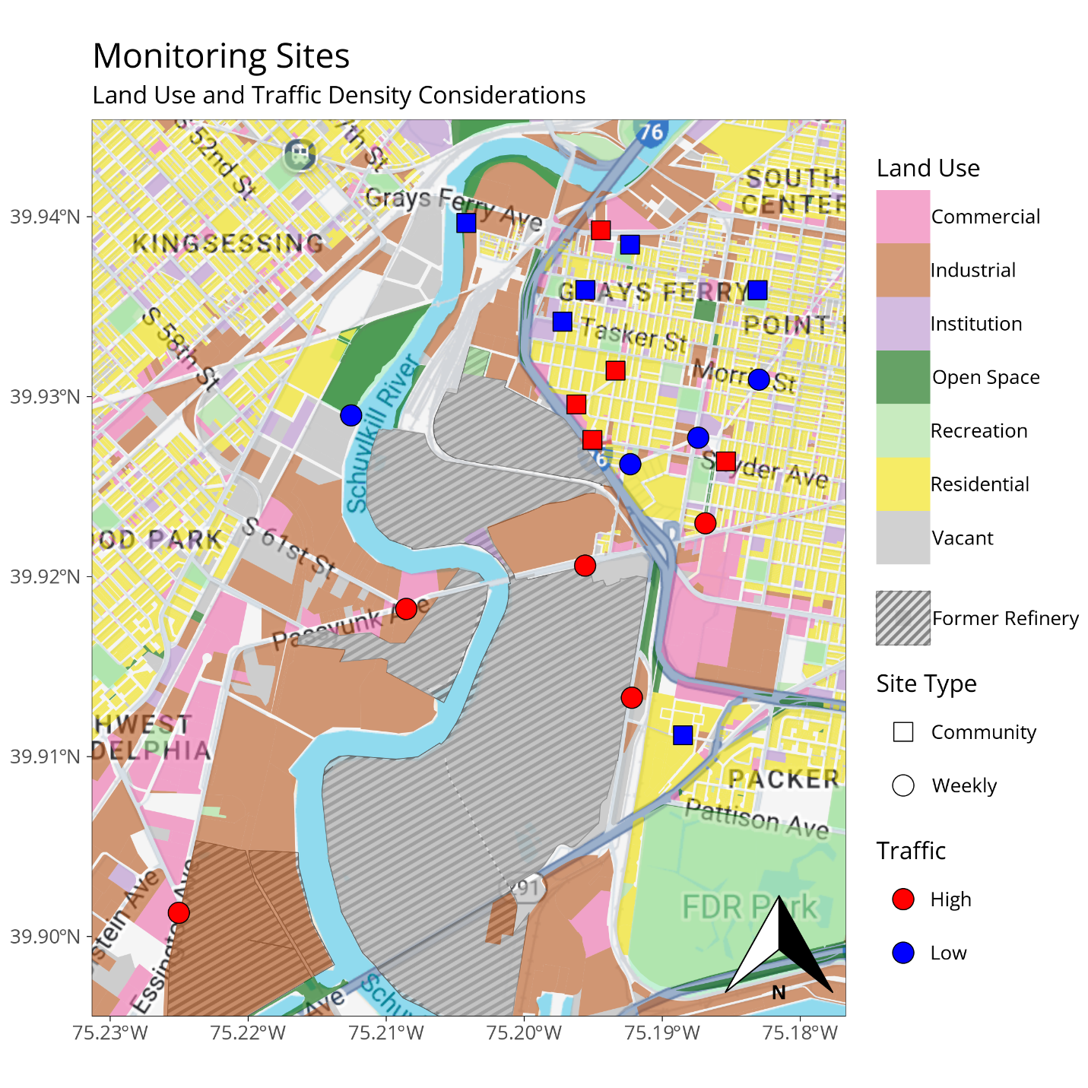
Figure 1. Monitoring site locations with local land use information, site traffic classification, site type (weekly vs. rotating), and the area of the former refinery site.
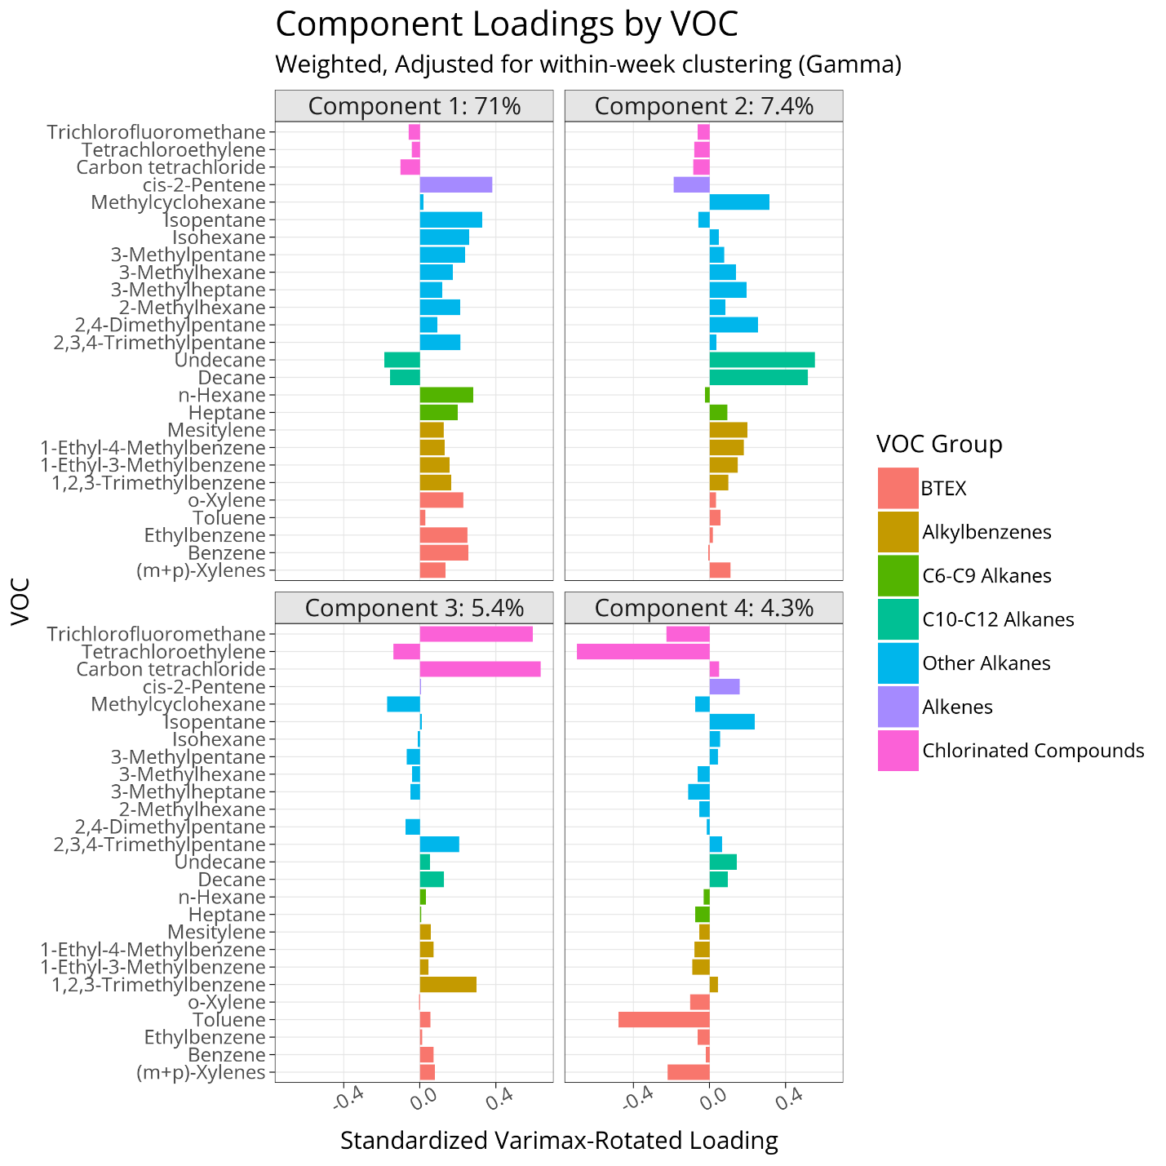
Figure 2. Component loadings from principal component analysis. Component 1 = mixed urban and industrial sources, fossil fuel combustion; component 2 = petroleum-based solvents; component 3 = legacy / background pollution; component 4 = chlorinated solvents.

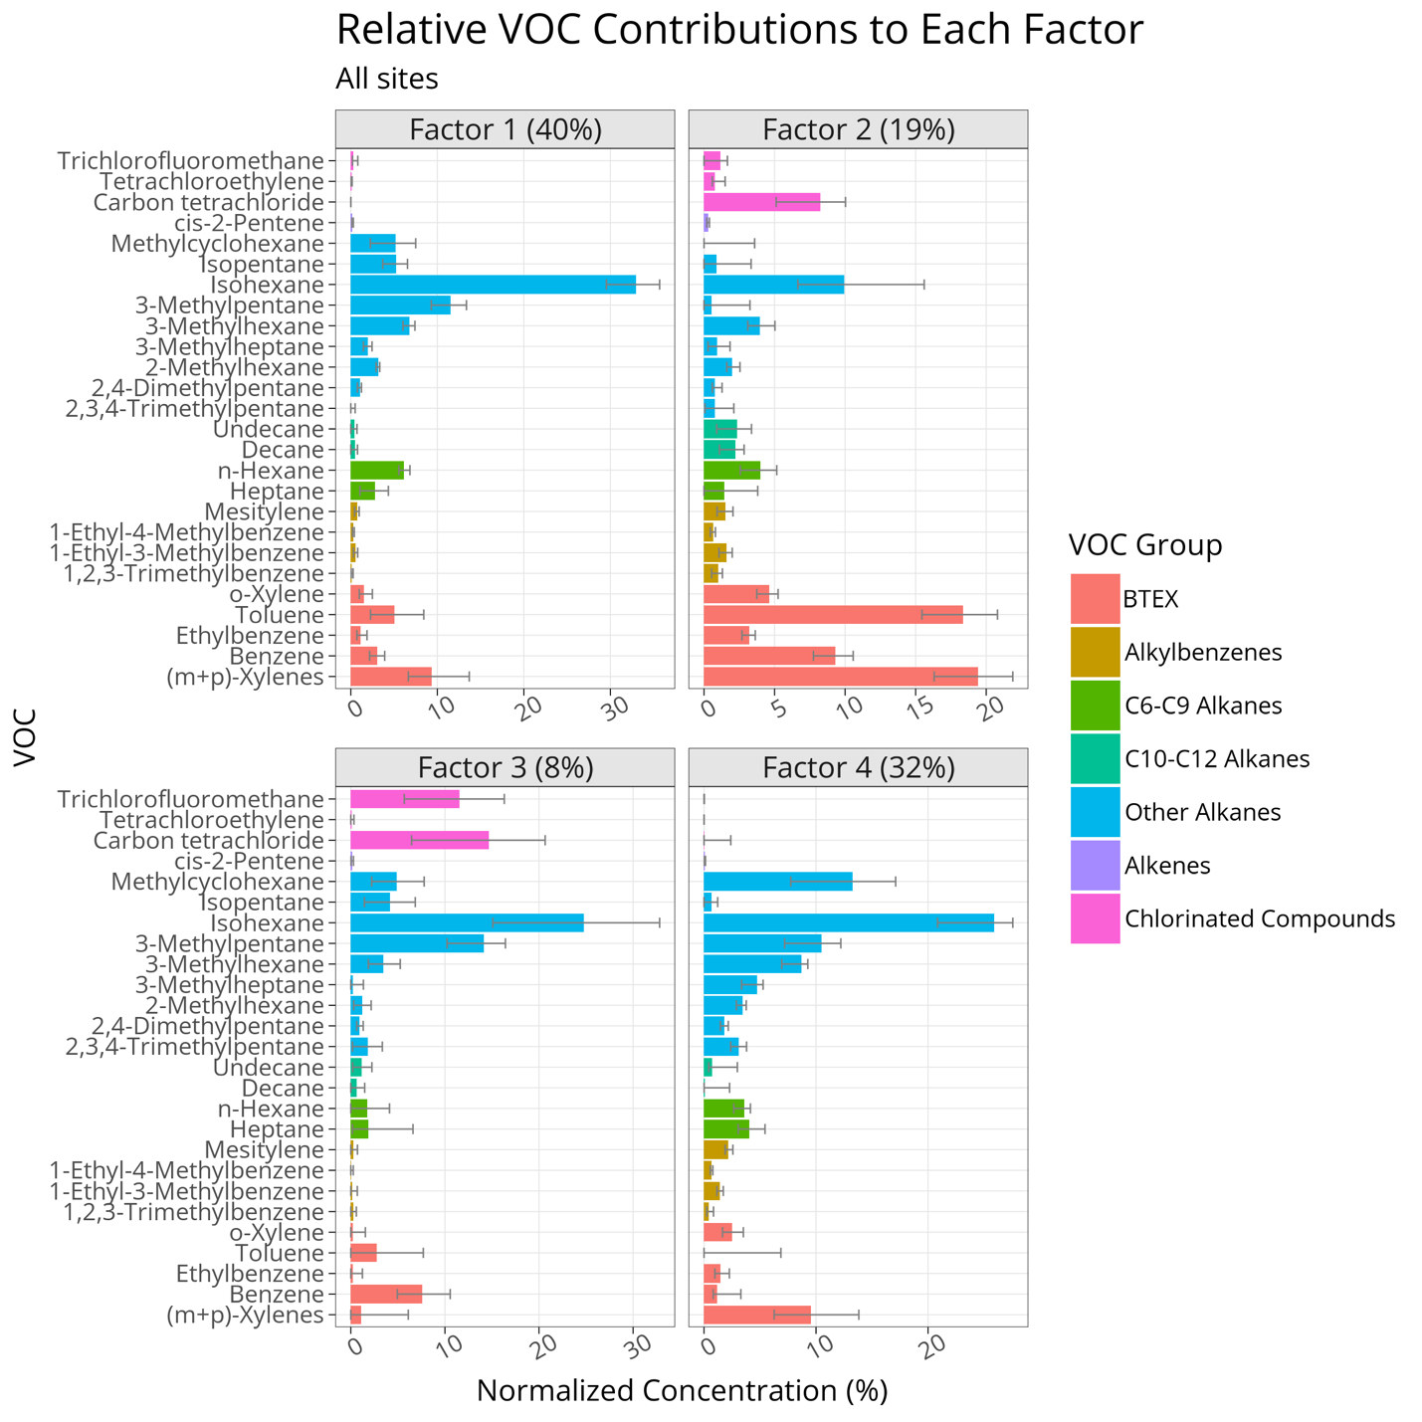

Figure 3. Concentration contribution (%) of each compound to PMF-derived factors, normalized to the median of 500 bootstrapped samples. Error bars showing the 5th and 95th percentiles of the bootstrapped distribution. The proportion of total predicted mass explained by each factor is shown in parentheses.

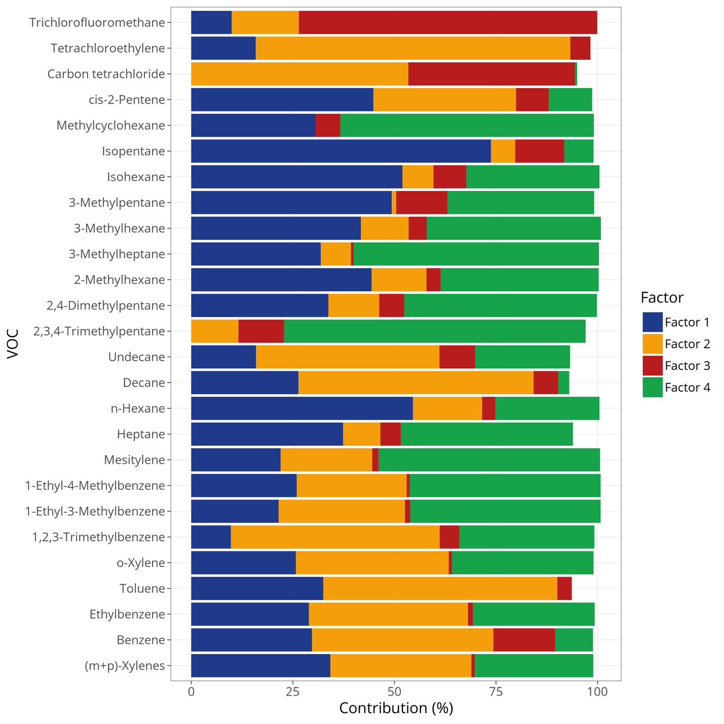

Figure 4. Percent of each VOC species mass explained by each factor in positive matrix factorization (PMF) analysis. Because the bar height indicates the median value from 500 bootstrapped samples, total percentages may not add up to 100%. Weekly sites are shown in bold. Factors were interpreted as follows: Factor 1 (blue) = mixed urban / industrial sources, fossil fuel combustion; factor 2 (yellow) = industrial solvents; factor 3 (red) = legacy emissions / background air pollution; factor 4 (green) = petroleum-based solvents.

