基于主成分机器学习算法的慢性肝病智能预测新方法
¹常炳国 ¹李玉琴 ²冯智超 ²姚山虎
(¹湖南大学信息科学与工程学院，长沙，湖南，410082；²中南大学湘雅三医院)
摘要：运用新一代信息技术快速预测慢性肝病机理和特征，是提高慢性肝病诊断率的有效途径。论文运用主成分机器学习算法，对描述慢性肝病多项指标属性项进行降维处理，结合神经网络学习，构建了慢性肝病预测模型。实验分析出125组20维慢性肝病患者的医学检验指标数据项，利用Receiver Operating Characteristic(简称ROC特征曲线)优选出13维数据项，作为慢性肝病敏感度高的检验指标属性项。通过主成分分析降至5维合成数据项。神经网络训练115组检验指标样本集，选择10组指标项作为测试样本。相比直接采用原始数据进行训练预测，采用本文方法后预测准确率提高了15.07%，且降低了系统的复杂度。
关键词：慢性肝病；主成分分析；优选指标；神经网络；智能预测
A New Intelligent Prediction of Chronic Liver Disease Based on Principal Component Analysis
¹Bingguo Chang ¹Yuqin Li ¹Zhichao Feng ²Shanhu Yao
(¹ School of information science and engineering of Hunan University; Department of Radiology;² Third Xiangya Hospital of Central South University 410082, Changsha)

Abstract: Using the new generation of information technology to predict the mechanism and characteristics of chronic liver disease is an effective way to improve its diagnosis. In this paper, we use the Principal Component Analysis (PCA) of the machine learning algorithm to reduce the dimensional indicators of chronic liver disease, combined with neural network learning to build a new intelligent prediction of chronic liver disease (IPCLD). The experiment studies 125 data sets of 20-dimensional indicators of chronic liver disease, uses Receiver Operating Characteristic (ROC curve) to select 13-dimensional more sensitive indicators, further reduces the dimension down to 5 by PCA. The neural network is trained with 115 traning data sets, and the remaining 10 data sets are used as test data sets. Compared with being trained by original data, the IPCLD improves 15.07 prediction accurancy and reduces the complexity.
Key words: Chronic Liver Disease; Principal Component Analysis; Neural Network; Intelligent Prediction

引言 1 Introduction
全球约4亿人遭受着慢性肝病的困扰[1]，慢性肝病是由于病毒、酒精、药物、自身免疫、遗传代谢等因素引起，以肝细胞炎症、坏死以及肝纤维化为主要病理改变的慢性疾病，其组织学改变及生化检测异常持续6个月以上。慢性肝病的种类多，例如，慢性乙型肝炎、慢性丙型肝炎、酒精性肝病等[2][3]。不同类型和严重程度的慢性肝病的临床表现、治疗药物以及疗效等医学行为都不尽相同。从而增加了慢性肝病的治疗难度。此外，慢性肝病的病因机理对于医学治疗的影响同样有着非常重要的作用[4]。慢性肝病产生的机理存在不确定性和复杂性，并且患者的个体之间的差异较大。因此，医院对不同的患者进行个性化治疗，以提高其治疗效果[5]。而快速预测和准确诊断慢性肝病是个性化治疗的关键所在。
More than 400 million people worldwide suffer from Chronic Liver Disease(CLD) [1]. CLD is caused by virus, alcohol, drugs, autoimmune, genetic metabolism and other factors. Its main pathology is liver cell inflammation, necrosis and liver fibrosis. Its histological changes and biochemical abnormal detection may persist for more than six months. Common CLD include the following categories: chronic hepatitis B, chronic hepatitis C, alcoholic liver disease [2] [3]. Different chronic liver diseases have different therapy, clinical results and other medical behavior. The etiology of CLD has a very important effect on the impact of medical treatment [4]. The etiology and mechanism of chronic liver disease is uncertain and complex, and differences between individual patients is large, for this situation, personalized therapy can improve the therapeutic effect [5]. Thus, how to predict quickly and diagnose accurately chronic liver disease is essential for the patients.

在慢性肝病的个性化治疗的过程中，患者往往需要检查跟之相关的多达80多项的检验指标信息。例如：血小板、总胆红素、丙氨酸氨基转移酶、肌酐等。在众多的信息中，如何能快速的根据患者的个体的特点来精确定位哪些指标对患者的病因有着至关重要的作用，是医院对症下药的关键所在。原始指标间往往存在信息冗余的情况，此外，过多的维度会增加问题分析的复杂性。通过ROC特征曲线[6]，能够初步优选出对慢性肝病敏感度较高的指标，以期减少系统的复杂性。运用主成分分析法[7][8][9]，挖掘患者患病严重程度对各个检验指标的影响，在不丢失绝大多数的信息的情况下，能够极大地降低维度。将降维后的指标信息输入到人工神经网络中，进行训练，从而构建出慢性肝病的智能预测模型[10]，为医院对慢性肝病的治疗提供了非常重要的技术支持。
In the process of individualized therapy of chronic liver disease, more than 80 test indicators need to be checked for the patients such as platelets, total bilirubin and alanine aminotransferase. Among so much information, how to registe quickly and accurately which test indicators play an important role is the key for medical therapy.There is redundant information in the original indicator normally, in addition, excessive dimensions would increase its complexity. However, the ROC characteristic curve [6] can choose indicators more sensitive to chronic liver disease preliminarily to reduce its complexity. And the principal component analysis (PCA) [7] [8] [9] can exploit the impact of test indicators on the severity of the disease, and reduce the dimension with preserving the vast majority of the information.Finally, the indicators after reducing the dimension should be trained into the artificial neural network to construct the intelligent prediction model of chronic liver disease [10], which provides very important technical support for the therapy of chronic liver disease.

数据集

2 Dataset

数据来源

2.1 Data sources
本文选择2008年3月-2016年5月入住湘雅三医院的31名患者，这些患者均最终确诊为不同严重程度的慢性肝病，所有患者均接受血常规、凝血四项、肝功能、肾功能检查。每个患者不同病程病情的检验独立，共计25154条检验记录。本文将不同病情病程的患者视为独立样本。
In this study, we selected 31 patients who were admitted to the Third Hospital of Xiangya from March 2008 to May 2016, these patients were eventually diagnosed with different severity of chronic liver disease. All patients were examined as blood routine examination, blood coagulation, liver function and kidney function. There are 25,154 test records totally since the same patient with different course of disease will be an independent sample in this paper.

数据集建立
根据湘雅三医院提供的患者数据，将所需的检验数据和诊断结果以及患者基本信息导入数据库中，选择20维检验指标对患者进行分析，检验指标包括：

2.2 Building Dataset
According to the information provided by Third Xiangya Hospital, the required test data and diagnostic results and the basic information of patients into the database, select the 20-dimensional test indicators to analyze the patient, test indicators include:
- 血常规：白细胞（WBC）、血红蛋白（Hb）、血小板（PLT）、红细胞（RBC）；
1. Blood routine examination: white blood cell(WBC), hemoglobin(Hb), platelet(PLT), red blood cell(RBC);
2.肝功能：总胆红素（TBIL）、直接胆红素（DBIL）、丙氨酸氨基转移酶（ALT）、天门冬氨酸氨基转移酶（AST）、总蛋白（TP）、白蛋白（ALB）、球蛋白（GLO）、白球蛋白比值（A/G）、总胆汁酸（TBA）、尿素（UREA）、肌酐（Cr）、尿酸（UA）、凝血酶时间（TT）、凝血酶原时间（PT）、凝血酶原国际标准化比值（INR）；
2.Liver function: total bilirubin(TBIL), conjugated bilirubin(DBIL), Alanine aminotransferase(ALT), aspartate aminotransferase (AST), Totalprotein (TP), albumin(ALB), Globulin (GLO), Albumin globulin ratio(A/G), total bile acid(TBA), Urea(UREA), Creatinine(Cr),
3.患者信息：年龄（AGE）、诊断结果（RESULT）。
3. Patient’s information: age (AGE), diagnostic results (RESULT).

数据预处理

数据整理
2.3 Data preprocessing
2.3.1 Data collation
本文统一将各检验指标的结果均保留两位小数，删除检验数据中的描述文字，例如，“复查”，“已核”等。医学上“凝血酶原国际标准化比值（INR）”和“国际标准化比值”是同一指标，本文中统一为“凝血酶原国际标准化比值（INR）”。原始数据中少量指标数据存在缺失现象，为避免分析不准确，本文将存在缺失值的记录删除。
This article unified the results of the test indicators are retained two decimal places, delete the test data in the description of the text, for example, "review", "nuclear" and so on. The "Standardized Proportion of Prothrombin International (INR)" and "International Standardized Ratio" are the same indicators, which are unified here as "International Standardization Ratio of Prothrombin (INR)". There is a missing phenomenon in the data of the original data. In order to avoid the inaccurate analysis, there will be missing records.

诊断结果量化处理
患者的医院诊断结果是通过文字描述，因此，需要将其量化，以便计算机分析处理。依据慢性肝病从肝炎、肝硬化、肝癌的逐步恶化演变过程，将患者的诊断结果量化为4种。“0”代表非慢性肝病；“1”代表肝炎；“2”代表肝硬化以及肝硬化后期；“3”代表恶性肿瘤以及肝癌。简单地用数值的方式表示诊断结果，并不利于区分结果的不同，为了拉大诊断结果之间的区别度，采用向量来表示。具体的量化结果如表 1。
2.3.2 Quantification of diagnostic results
The patient's hospital diagnosis results are described by words, so they need to be quantified for computer analysis and processing. According to chronic liver disease from hepatitis, cirrhosis, liver cancer gradually deterioration of the evolution process, the patient's diagnosis results are quantified into four kinds. "0" represents non-chronic liver disease; "1" represents hepatitis; "2" represents cirrhosis and late cirrhosis; "3" represents malignant tumor and liver cancer. Simply numerical representation of the diagnostic results, and is not conducive to differentiate the results, in order to widen the difference between the diagnostic results, the use of vector to represent. Specific quantification results are shown in Table 1.
表 1 诊断结果量化
检查结果 | 量化值(严重程度） | 向量表示方式 | 备注
帕金森病（PD）、胆囊结石 | 0 | (0,0,0) | 非慢性肝病
肝炎、肝炎肝硬化活动期 | 1 | (0,0,1) | 肝炎
肝硬化、乙肝肝硬化酒精性肝炎后肝硬化、乙型肝炎肝硬化 | 2 | (0,1,0) | 肝硬化
门脉高压症、消化道出血、乙肝肝硬化失代偿期 | 2 | (0,1,0) | 肝硬化后期
肝脏肿块 | 3 | (1,0,0) | 恶性肿瘤
肝恶性肿瘤、肝占位、肝占位病变 | 3 | (1,0,0) | 恶性肿瘤
PLC介入术后、肝癌（肝CA）术后 | 3 | (1,0,0) | 肝癌
肝癌（肝CA）、PLC（原发性肝癌） | 3 | (1,0,0) | 肝癌

降维处理
慢性肝病的检查指标过多，且指标与指标之间可能存在信息冗余。维度过多会增加慢性肝病的智能诊断和预测的复杂性。
3 dimension reduction processing
There are too many indicators of chronic liver disease, and there may be information redundancy between indicators and indicators. Too many dimensions will increase the complexity of intelligent diagnosis and prediction of chronic liver disease.

优选指标
依据表 1量化结果，利用ROC特征曲线对慢性肝病的相关指标进行分析，提取敏感度高的指标。ROC特征曲线是根据一系列不同的二分类方式（分界值或决定阈），以真阳性率（灵敏度）为纵坐标，假阳性率（1-特异性）为横坐标绘制的曲线。传统的诊断试验方法必须将试验结果分为两类，再进行统计分析。而ROC特征曲线的评价方法与传统的不同，可以依据实际情况，将试验结果划分为多个有序分类，如表1量化结果，试验结果分为0,1,2,3这四个级别。通过计算ROC特征曲线下的面积（AUC）进行比较，哪一个指标的AUC最大，代表这种指标的诊断价值最佳。ROC特征曲线如图1。
3.1 Preferred indicators
According to the results of Table 1, the ROC characteristic curve was used to analyze the related indexes of chronic liver disease, and the indexes with high sensitivity were extracted. The ROC characteristic curve is a plot of the true positive rate (sensitivity) as the ordinate and the false positive rate (1-specific) as the abscissa according to a series of different two subcategories (thresholds or thresholds). Traditional diagnostic test methods must be divided into two types of test results, and then statistical analysis. The evaluation method of ROC characteristic curve is different from traditional one. According to the actual situation, the test result can be divided into multiple order classification, as shown in Table 1, and the test result is divided into 0, 1, 2, 3. By comparing the area under the ROC characteristic curve (AUC), which index of the AUC maximum, on behalf of the diagnostic value of this indicator the best. The ROC characteristic curve is shown in Fig.
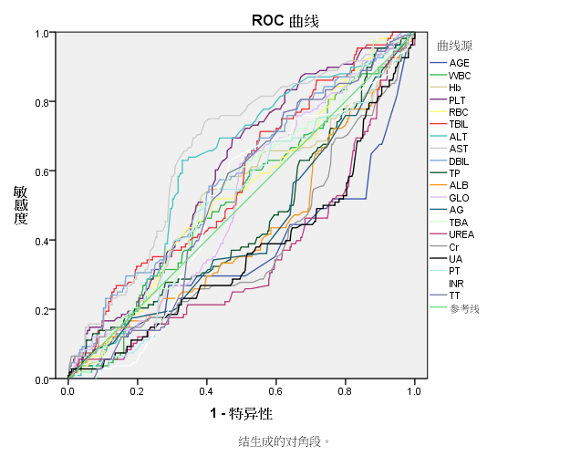
图 1 ROC特征曲线
通过ROC曲线分析结果显示，20项相关指标是AGE(0.357)、WBC(0.536)、Hb(0.542)、PLT(0.602)、RBC(0.542)、TBIL(0.587)、ALT(0.631)、AST(0.689)、DBIL(0.582)、TP(0.458)、ALB(0.421)、GLO(0.529)、A/G(0.429)、TBA(0.537)、UREA(0.347)、Cr(0.388)、UA(0.365)、PT(0.523)、INR(0.510)、TT(0.548).，括号内的数值是诊断结果的ROC曲线下面积。ROC特征值的大小代表了其对慢性肝病的敏感度，数值越大，则越敏感。本文选取ROC特征值大于0.5的13个指标，分别为：WBC、Hb、PLT、RBC、TBIL、ALT、AST、DBIL、GLO、TBA、PT、INR、TT，以便降低对慢性肝病的智能预测的复杂度。本文接下来针对优选出的13维检验指标进行主成分分析。
The results of ROC curve analysis showed that 20 related indexes were AGE (0.357), WBC (0.536), Hb (0.542), PLT (0.602), RBC (0.542), TBIL (0.587), ALT (0.631), AST (0.689 (0.377), Cr (0.388), UA (0.365), PT (0.52), TP (0.582), TP (0.458), ALB (0.421), GLO (0.529), A / G (0.429), TBA (0.537) (0.523), INR (0.510), TT (0.548). The values ​​in parentheses are the area under the ROC curve of the diagnostic results. The size of the ROC eigenvalues ​​represents the sensitivity to chronic liver disease, and the greater the value, the more sensitive it is. In this paper, 13 indicators with ROC eigenvalues ​​greater than 0.5 were selected: WBC, Hb, PLT, RBC, TBIL, ALT, AST, DBIL, GLO, TBA, PT, INR, TT, in order to reduce the intelligence prediction of chronic liver disease the complexity. In this paper, the principal component analysis is carried out for the preferred 13-D test index.

主成分分析
主成分分析是一种常用的线性降维的方法，它将一个具有一定相关性的高维向量X，通过一个特殊特征向量矩阵A，映射到一个无相关性的低维的向量PC，并且后者仅损失一些次要的信息，保留了绝大部分主要的信息。设X = (X₁,X₂,…,X_{p})’是p维变量，A为特征向量矩阵，则其线性变化是公式1。
3.2 Principal component analysis
Principal component analysis is a commonly used linear dimensionality reduction method, which maps a high-dimensional vector X with a certain correlation through a special eigenvector matrix A to a low-dimensional vector PC with no correlation and Only the loss of some minor information, retained most of the main information. Let X = (X1, X2, ..., Xp) 'be the p-dimensional variable, and A be the eigenvector matrix, then its linear change is Equation 1.
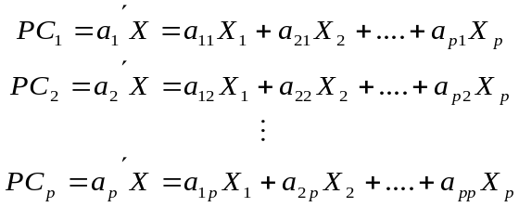 (1)
PC_{i}被称为第i主成分，每一个主成分都代表了原始数据的一部分信息。假设λ_{i}为PC_{i}的特征值，λ_{i}>λ_{j}(0<i<j≤p)。通常情况下会选用m (m < p)主成分来代表原始数据。主成分的个数m可以通过各个主成分的累计方差贡献率（Cumulative Variance Contribution Rate简称CVCR）以及特征值来确定。CVCR由公式2计算得出。PCi is called the i-th principal component, and each principal component represents part of the original data. Let λi be the eigenvalue of PCi, λi> λj (0 <i <j ≤ p). Normally, m (m <p) principal components are used to represent the original data. The number m of the principal components can be determined by the Cumulative Variance Contribution Rate (CVCR) and the eigenvalues ​​of the respective principal components. CVCR is calculated from Equation 2.
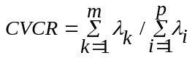 (2)
其中λ为各个主成分对应的特征值，m为选定的主成分个数，p为主成分总数。
Where λ is the eigenvalue corresponding to each principal component, m is the number of selected principal components, and p is the total number of principal components.
主成分个数的选定，需要综合考虑将原始数据降维和保留原始数据的绝大部分信息，因此需要保证CVCR大于等于某一阀值θ，从而达到所选取的主成分数目能够保留原始数据的绝大部分信息，本文选定θ≥80%。通过主成分分析，得出优选出的13维检验指标的主成分分析解释总变量如表 2。
The selection of the number of principal components, the need to consider the original data dimensionality and retain the original data of the vast majority of information, it is necessary to ensure that CVCR greater than or equal to a certain threshold θ, so as to achieve the selected number of principal components to retain the original data For most of the information, we selected θ ≥ 80%. Through the principal component analysis, the main variables of the 13-dimensional test index are given as shown in Table 2.
表 2主成分分析解释总变量
主成分 | 特征值 | 方差比重% | CVCR%
PC1 | 5.024 | 38.649 | 38.649
PC2 | 1.850 | 14.232 | 52.881
PC3 | 1.416 | 10.892 | 63.773
PC4 | 1.242 | 9.558 | 73.331
PC5 | 1.016 | 7.814 | 81.145
PC6 | 0.851 | 6.544 | 87.690
PC7 | 0.645 | 4.958 | 92.648
PC8 | 0.351 | 2.699 | 95.347
PC9 | 0.258 | 1.988 | 97.335
PC10 | 0.213 | 1.639 | 98.975
PC11 | 0.112 | 0.862 | 99.837
PC12 | 0.018 | 0.136 | 99.973
PC13 | 0.004 | 0.027 | 100.000

表2中，第一主成分的累计方差贡献率为38.649%。为了能够进一步降低维度，需要参考主成分对应的特征值。以主成分为横坐标，其对应的特征值为纵坐标的二维图被称为碎石图。由图 2可知，前5个主成分特征值较大，连线陡峭，主成分对应的特征值>1，所以提取5个主成分最合适，综合了大部分信息。
In Table 2, the cumulative variance contribution rate of the first principal component is 38.649%. In order to further reduce the dimension, we need to refer to the eigenvalues ​​corresponding to the principal components. The two-dimensional map with the main component as the abscissa and its corresponding eigenvalue is the ordinate. It can be seen from Fig. 2 that the eigenvalues ​​of the first five principal components are large and the connection is steep and the eigenvalues ​​of the principal components are> 1, so the extraction of the five principal components is most suitable and the most information is integrated.
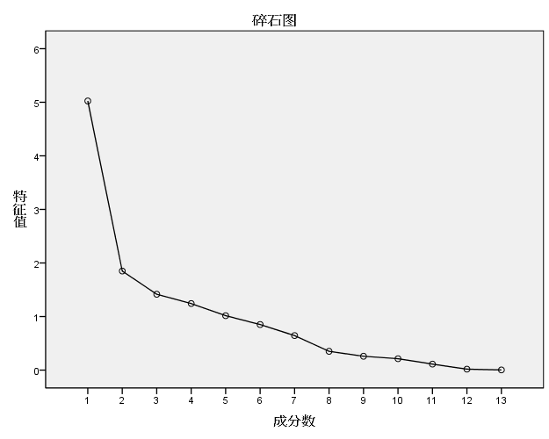
图 2 碎石图
表 3是根据主成分分析旋转后的成分载荷矩阵RLM，RLM的因子载荷的绝对值与主成分的相关性成正比关系，绝对值越大，则主成分的相关性越大。
The absolute value of the factor load of RLM is proportional to the correlation between the principal component and the absolute value is larger, and the correlation between the principal component is larger.
表 3主成分分析旋转后的成分载荷矩阵
 | PC1 | PC2 | PC3 | PC4 | PC5
WBC | 0.238 | 0.245 | -0.119 | 0.774 | -0.078
Hb | -0.278 | -0.094 | 0.897 | -0.135 | -0.109
PLT | -0.208 | -0.041 | -0.017 | 0.891 | 0.086
RBC | -0.086 | -0.221 | 0.897 | -0.012 | -0.178
TBIL | 0.529 | 0.495 | -0.011 | 0.278 | 0.546
ALT | 0.067 | 0.889 | -0.132 | 0.118 | -0.145
AST | 0.031 | 0.882 | -0.170 | 0.017 | 0.134
DBIL | 0.476 | 0.511 | -0.040 | 0.297 | 0.561
GLO | 0.108 | -0.093 | -0.303 | -0.065 | 0.771
TBA | 0.706 | 0.314 | 0.014 | -0.035 | 0.422
PT | 0.931 | 0.097 | -0.281 | 0.009 | 0.003
INR | 0.924 | 0.091 | -0.246 | 0.049 | -0.024
TT | 0.493 | -0.097 | -0.006 | -0.042 | 0.252
由表3推断出主成分的表达方程式如公式3。假设D_{nxm}是代表原始数据的矩阵，其中m=13。C_{mxe}是成分载荷矩阵的转置矩阵，其中e=5。另P=D_{nxm}*C_{mxe}矩阵P是原始数据矩阵通过主成分分析进行降维后的数据矩阵。至此，基于主成分分析的数据模型已经建立起来了，接下来的将对该数据模型通过神经网络构建出慢性肝病智能预测模型。
From Table 3, we deduce the expression equation of the principal component as shown in Equation 3. Assume that Dnxm is a matrix representing the original data, where m = 13. Cmxe is the transposed matrix of the component load matrix, where e = 5. The other P = Dnxm * Cmxe matrix P is the data matrix of the original data matrix after dimensionality reduction by principal component analysis. At this point, based on the principal component analysis of the data model has been established, the next will be the data model through the neural network to build intelligent prediction model of chronic liver disease.
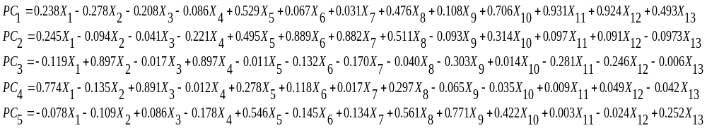（3）

智能预测模型

Intelligent Prediction Model
人工神经网络能够在预先给定的训练数据集进行自我训练，构建出用于预测测试数据集的结果的智能预测模型[11]。本文将利用BP(Back Propagation)神经网络[10]对原始数据集和降维后的精简数据集进行训练以及预测，并将结果进行对比。
The artificial neural network can self-train in a given training data set to construct an intelligent prediction model for predicting the results of the test data set [11]. In this paper, we use BP (Back Propagation) neural network [10] to train and forecast the original data set and the reduced data set after dimension reduction, and compare the results.

BP神经网络
图 3是单个神经元模型，X_{i}表示该神经元接受来自其他神经元的的刺激量，W_{i}表示刺激链路上的权重，yi为输出结果。f函数被称为激活函数，它是该神经元接受外界刺激的加权和的函数。图 4是BP神经网络拓扑结构，其学习过程如下：
- 输入层接受外界信号并将刺激传递给隐藏层；
- 隐藏层经过激活函数的处理后将刺激传递给输出层；
- 输出层整理最后刺激输出最终结果；
- 将输出结果与正确结果比较，得到误差。如果误差符合预期，则可结束，否则根据误差反馈到网络中，对链路权重进行修正，重复步骤1。
BP神经网络运用向后反馈的学习方式来不断地修正神经网络拓扑结构中的链路权重，通过多次迭代地进行训练，最终达到输出正确结果。
4.1 BP neural network
Figure 3 is a single neuronal model, Xi indicates that the neuron receives the stimulus from other neurons, Wi represents the weight on the stimulus link, and yi is the output. The f-function is called an activation function, which is a function of the weighted sum of the neurons receiving external stimuli. Figure 4 is the BP neural network topology, the learning process is as follows:
1. The input layer accepts external signals and passes the stimuli to the hidden layer;
2. The hidden layer is passed through the activation function to pass the stimulus to the output layer;
3. Output layer finishing the final output to stimulate the final results;
4. Compare the output with the correct result and get the error. If the error is in line with the expected, you can end, or according to the error feedback to the network, the link weight correction, repeat step 1.
BP neural network uses the backward feedback learning method to constantly correct the link weight in the neural network topology, through several iterations to train, and finally to output the correct results.
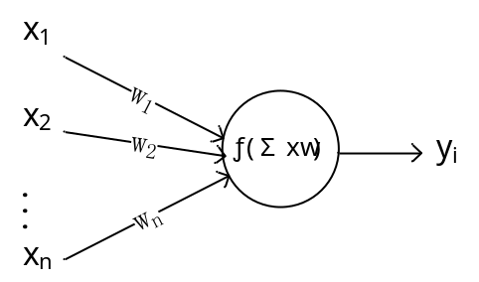
图 3 神经元模型
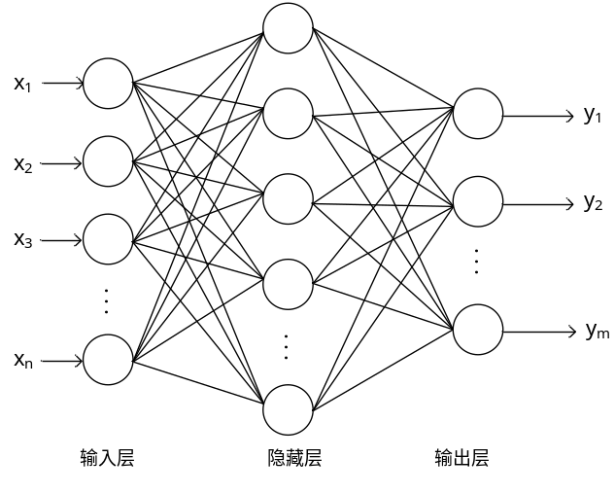
图 4 BP神经网络拓扑结构

构建智能预测模型
BP神经网络对网络拓扑结构敏感，不同的网络拓扑结构的处理问题能力有所不同。本文从125组数据中随机选择出115组作为训练样本集，剩下的10组数据作为测试样本集。BP神经网络的重要参数如下：（1）网络层数：（2）训练次数：500；（3）期望误差：0.0；（4）训练函数：trainlm函数；（5）链路权重调整函数：learngdm函数；（6）性能函数：mse函数。
4.2 build intelligent forecasting model
BP neural network is sensitive to network topology, and the ability of different network topology to deal with problems is different. In this paper, 115 sets of data were randomly selected from the 125 sets of data as the training sample set, and the remaining 10 sets of data were used as the test sample set. BP neural network important parameters are as follows: (1) network layer: (2) training times: 500; (3) expected error: 0.0; (4) training function: trainl
在保持上述BP神经网络拓扑结构和参数不变的情况下，本文将分别经过ROC优选与主成分分析降维后的精简数据集合和原始20维数据集合作为输入，以构建出智能预测模型，对测试样本进行验证。
In the case of maintaining the topology and parameters of BP neural network, this paper will construct the intelligent prediction model by combining the ROC optimization and the reduced data set and the original 20-dimensional data set after the principal component analysis, Test the sample to verify.
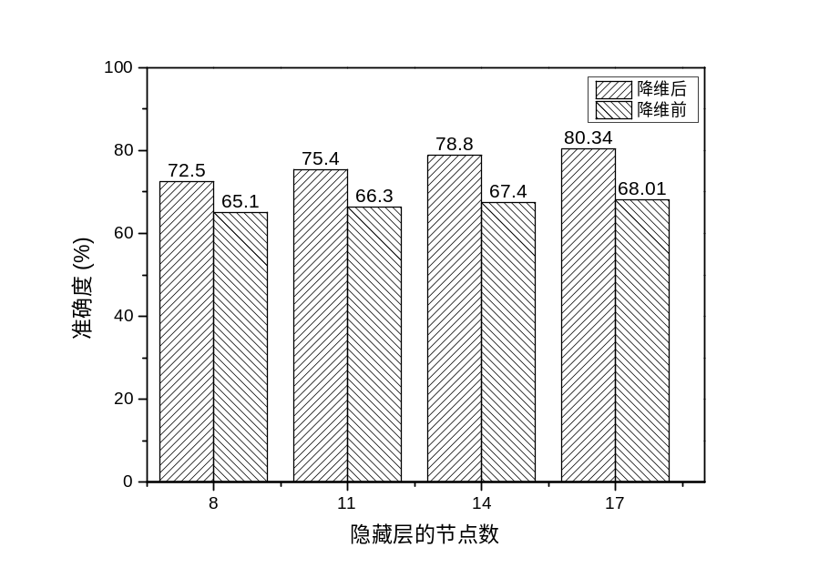
图 5 降维前和降维后的准确度对比
为了更客观地评估两者的准确度，实验中将会重复1000次实验，并且每一次实验时随机抽选训练样本，取每一次的结果平均值作为最终的准确度。图 5是隐藏层节点分别为8、11、14和17的使用降维前和降维后的数据作为BP神经网络的输入的对比图。
In order to more accurately assess the accuracy of the two, the experiment will be repeated 1000 times the experiment, and each experiment randomly selected training samples, take the average of each result as the final accuracy. Figure 5 is a comparison of the input of the hidden layer nodes with 8, 11, 14, and 17 using the data before and after dimension reduction as the input of the BP neural network.
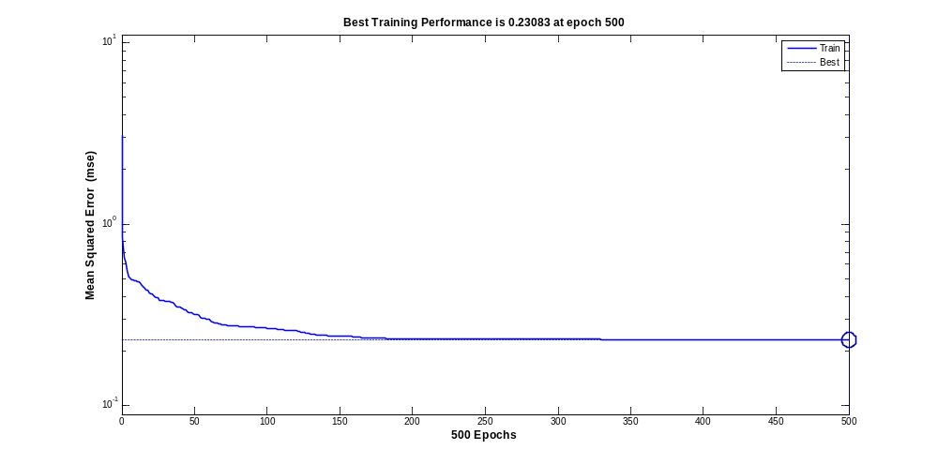
图 6 隐藏层的节点数为17，降维后的收敛速度
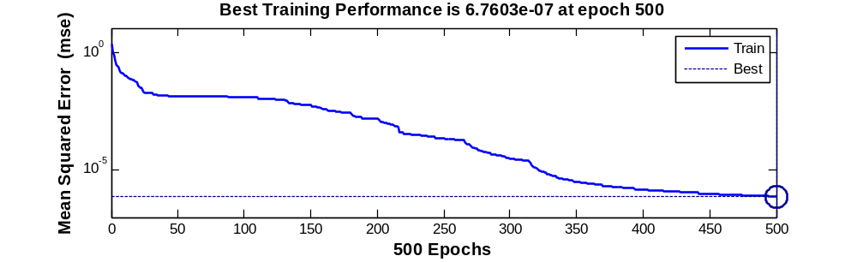
图 7隐藏层的节点数为17，降维前的收敛速度
图 6是采用ROC优选和主成分分析进行降维处理后的BP神经网络收敛图。横坐标为迭代次数，纵坐标为均方误差，虚线为最优均方误差参考线。图 7则是同等条件下以原始数据为输入的BP神经网络收敛图。对比上述两图易知前者比后者的收敛速度更快。
对比分析上述三张结果图得到以下结论：（1）降维后的预测准确度高于降维前，平均提高15.07%；（2）随着隐藏节点数的增加降维前和降维后的预测准确度都有所提高，后者提高的速度要优于前者；（3）BP神经网络在降维后收敛的速度快于降维前。
Figure 7 hidden layer node number 17, before the reduction of the convergence rate
Figure 6 is the BP neural network convergence diagram after dimension reduction with ROC optimization and principal component analysis. The abscissa is the number of iterations, the ordinate is the mean square error, and the dotted line is the optimal mean square error reference line. Figure 7 is the convergence of the BP neural network with the same data as input under the same conditions. It is easier to compare the above two graphs to the former than the latter.
(2) With the increase of the number of hidden nodes, the prediction accuracy of the reduced dimension is lower than that before the dimension reduction. (2) With the increase of the number of hidden nodes, the prediction accuracy is reduced by 15.07% (3) BP neural network converges faster than dimensionality before dimensionality reduction. (3) BP neural network is faster than that before reduction.

结论
慢性肝病的成因复杂，医学检查指标多，指标之间存在信息冗余和干扰，导致难于准确地智能预测慢性肝病。为了提高智能预测慢性肝病的准确度和降低系统复杂性，需要对慢性肝病的指标进行降维处理。指标的ROC特征曲线反映了其对慢性肝病的敏感程度，在AUC>0.5的情况下，AUC越接近于1，说明诊断效果越好。本文利用ROC特征曲线优选出了13维敏感度较高的指标。接着本文利用主成分分析方法进一步进行降维处理，在不损失主要信息和不影响智能预测的前提下，根据各个主成分的特征值的大小和累计方差贡献率选择了前5个主成分，从而将13维降至5维，极大地降低了智能预测慢性肝病的系统复杂性。最后，本文利用BP神经网络构建出智能预测慢性肝病模型。从125组数据中，随机选出115组作为训练样本集合进行BP神经网络训练，并将剩余的10组数据作为测试样本，用于验证智能预测模型的准确度。本文大量地重复上述训练和预测过程，以平均值作为最终的准确度，以提高智能预测模型的可信度。在同等条件下，对未经过降维处理的原始数据进行BP神经网络训练和预测，实验表明前者不但降低了系统的复杂性，同时提高了15.07%的准确度。因此，针对慢性肝病，本文的智能预测模型能达到一定精度和准确度，为医生的辅助诊断提供了可行的方法。
5 Conclusion
The causes of chronic liver disease are complex, there are many indicators of medical examination, there is information between the information redundancy and interference, resulting in difficult to accurately predict the chronic liver disease. In order to improve the accuracy of intelligent prediction of chronic liver disease and reduce system complexity, the need for weight reduction of chronic liver disease treatment. The ROC characteristic curve of the index reflects its sensitivity to chronic liver disease. In the case of AUC> 0.5, the closer the AUC is to 1, the better the diagnostic effect is. In this paper, the ROC characteristic curve is used to optimize the 13-dimensional sensitivity index. Then, the principal component analysis method is used to further reduce the dimension processing. Without the loss of the main information and the influence of the intelligent prediction, the first five principal components are selected according to the eigenvalues ​​of the principal components and the cumulative variance contribution rate. Will be reduced to 5 dimensions of 13 dimensions, greatly reducing the intelligence to predict the complexity of chronic liver disease system. Finally, this paper uses BP neural network to construct the model of intelligent prediction of chronic liver disease. From the 125 sets of data, 115 groups were randomly selected as the training sample set for BP neural network training, and the remaining 10 sets of data as a test sample, used to verify the accuracy of intelligent prediction model. This paper repeats the above training and prediction process in large numbers, with the average as the final accuracy to improve the reliability of the intelligent prediction model. Under the same conditions, BP neural network training and prediction of raw data without dimension reduction are carried out. The experiment shows that the former not only reduces the complexity of the system, but also improves the accuracy of 15.07%. Therefore, for the chronic liver disease, this paper's intelligent prediction model can achieve a certain accuracy and accuracy, for the doctor's auxiliary diagnosis provides a feasible method.

参考文献
References
- 世界卫生组织, http://www.who.int/campaigns/hepatitis-day/2016/event/zh/, 2016.
- 王恩成, 唐琳, 王健,等. 慢性乙型肝炎中医证候聚类分析研究[J]. 中国中西医结合杂志, 2014, 34(1):39-42.
- 曾艳丽, 李宽, 康谊,等. 丙型病毒性肝炎与酒精性肝病的研究现状[J]. 中国病毒病杂志, 2014(1):73-75.
- 华海清. 慢性乙型肝炎病因病机探讨[J]. 南京中医药大学学报, 2001, 17(4):210-211.
- 蔺鹏珍, 李国文, 李璞,等. 个性化治疗慢性乙型肝炎免疫清除期68例临床分析[J]. 中国社区医师, 2014(33):69-70.
- Fawcett T. An introduction to ROC analysis[J]. Pattern Recognition Letters, 2006, 27(8):861-874.
- Abdi H, Williams L J. Principal component analysis[J]. Wiley Interdisciplinary Reviews Computational Statistics, 2010, 2(4):433–459.
- Fletcher S. Machine learning.[J]. Scientific American, 2013, 309(2).
- Dietterich T G. Machine-Learning Research[J]. Ai Magazine, 1997, 18(4):97-136.
- Gaxiola F, Melin P, Valdez F, et al. Generalized type-2 fuzzy weight adjustment for backpropagation neural networks in time series prediction[J]. Information Sciences, 2014, 260(C):159-174.
- Schmidhuber J. Deep Learning in neural networks: An overview.[J]. Neural Networks, 2014, 61:85-117.

