Supplementary

1. Baselines

1.1 MiRNA-drug association prediction mask:
DLST-MDA: It integrates miRNA sequence/structure information and drug attribute information to predict miRNA–drug associations, reducing dependence on sparse known interaction graphs [1].
AGCLNDA: It incorporated LightGCN with learnable augmentation and denoising strategies to generate high-quality contrastive views for ncRNA–drug association prediction [2].
DLMVF: It learned latent representations from multiple complementary views, including miRNA attributes, drug attributes, and miRNA–drug interactions, and adaptively integrated these views through an attention mechanism [3].
ALRTGCL: It combines adaptive low-rank Transformer learning with graph contrastive learning to capture global dependencies while reducing computational complexity and alleviating sparsity/noise [4].
MGCNA: It constructed multi-view node representations by jointly modeling miRNA–drug association topology and attribute features, and employed multi-channel GCNs with attention-based aggregation to enhance representation learning [5].
MPHGNN: It constructs a miRNA-gene-drug heterogeneous network and uses metapath-guided GCN modules to capture higher-order semantic associations for miRNA-drug resistance prediction [6].

1.2 LncRNA-drug association prediction mask
AGCLNDA: It incorporated LightGCN with learnable augmentation and denoising strategies to generate high-quality contrastive views for ncRNA–drug association prediction [2].
DMGAT: It combines word2vec-based ncRNA/SMILES embeddings, diffusion maps, GCN feature extraction, heterogeneous GAT fusion, and reliable negative sampling for ncRNA–drug resistance prediction [7].
LDA-GAT: It constructs lncRNA–drug bipartite subgraphs and combines GCN with GAT to learn local and global graph representations from lncRNA and drug similarity networks for LDA prediction [8].
GraphSLA: It integrates similarity networks of small-molecule drugs and lncRNAs and systematically compares multiple graph learning models, including GNN, GCN, GAT, GraphSAGE, and SGConv, for small molecule–lncRNA association prediction [9].
DeepLDA: It predicts lncRNA–drug resistance associations by integrating lncRNA/drug similarity networks with deep neural networks and graph attention mechanisms to learn discriminative embeddings [10].
HGNNLDA: It applies the hypergraph neural network to obtain high-order neighbor information on the lncRNA hypergraph and the drug hypergraph, respectively, and utilizes a joint update mechanism to generate lncRNA embeddings and drug embeddings [11].

2. Ablation experiments

2.1 Ablation Experiments on Node Attributes
Table S1 and Table S2 presents the complete results of the feature ablation experiments described in Section 3.3.1. Different combinations of sequence- and structure-derived biological features were evaluated to assess their contributions to prediction performance.
Table S1. The ablation study results of different combinations of node features (miRNA-drug task).
Features | AUC | AUPR | ACC | PRE | REC | F1
Sequence | 0.9604 | 0.9293 | 0.9219 | 0.9138 | 0.9310 | 0.9224
Physicochemical | 0.9590 | 0.9374 | 0.9109 | 0.8970 | 0.9279 | 0.9122
Structure | 0.9546 | 0.0.246 | 0.9047 | 0.8909 | 0.9216 | 0.9060
Sequence + Structure | 0.9569 | 0.9315 | 0.9094 | 0.9122 | 0.9065 | 0.9094
Sequence + Physicochemical | 0.9622 | 0.9495 | 0.9172 | 0.9077 | 0.9277 | 0.9176
Structure + Physicochemical | 0.9547 | 0.9382 | 0.9078 | 0.8973 | 0.9224 | 0.9096
Fingerprint | 0.9618 | 0.9476 | 0.9203 | -0.8983 | 0.9508 | 0.9238
Descriptor | 0.9622 | 0.9497 | 0.9109 | 0.9074 | 0.9159 | 0.9116
All attributes | 0.9691 | 0.9570 | 0.9313 | 0.9164 | 0.9505 | 0.9331

Table S2. The ablation study results of different combinations of node features (lncRNA-drug task).
Features | AUC | AUPR | ACC | PRE | REC | F1
Sequence | 0.9502 | 0.9379 | 0.8815 | 0.8984 | 0.8583 | 0.8779
Physicochemical | 0.9520 | 0.9423 | 0.8854 | 0.8904 | 0.8763 | 0.8833
Structure | 0.9439 | 0.9307 | 0.8958 | 0.9045 | 0.8857 | 0.8950
Sequence + Structure | 0.9536 | 0.9461 | 0.8932 | 0.8987 | 0.8845 | 0.8915
Sequence + Physicochemical | 0.9487 | 0.9394 | 0.8802 | 0.8928 | 0.8649 | 0.8756
Structure + Physicochemical | 0.9548 | 0.9466 | 0.9036 | 0.9034 | 0.9034 | 0.9034
Fingerprint | 0.9560 | 0.9496 | 0.8880 | 0.9103 | 0.8634 | 0.8862
Descriptor | 0.9428 | 0.9301 | 0.8815 | 0.8839 | 0.8770 | 0.8804
All attributes | 0.9593 | 0.9582 | 0.9062 | 0.9034 | 0.9134 | 0.9074

2.2 Ablation Experiments on intermediate-node-induced virtual edge
Table S3 and Table S4 reports the complete experimental results of the virtual-edge construction ablation study discussed in Section 3.3.2.
Table S3. The ablation study results of intermediate-node-induced virtual edge (miRNA-drug task).
Ablation | AUC | AUPR | ACC | PRE | REC | F1
No-mid-node | 0.9507 | 0.9275 | 0.9078 | 0.8959 | 0.9257 | 0.9102
Disease | 0.9578 | 0.9314 | 0.9203 | 0.9121 | 0.9319 | 0.9219
mRNA | 0.9674 | 0.9531 | 0.9178 | 0.9144 | 0.9257 | 0.9200
Merged adjacency | 0.9601 | 0.9362 | 0.9230 | 0.9003 | 0.9478 | 0.9216
Disease + mRNA | 0.9691 | 0.9570 | 0.9313 | 0.9164 | 0.9505 | 0.9331

Table S4. The ablation study results of intermediate-node-induced virtual edge (lncRNA-drug task).
Ablation | AUC | AUPR | ACC | PRE | REC | F1
No-mid-node | 0.9371 | 0.9332 | 0.8792 | 0.8868 | 0.8731 | 0.8799
Disease | 0.9500 | 0.9444 | 0.8945 | 0.8920 | 0.8990 | 0.8955
mRNA | 0.9488 | 0.9429 | 0.8958 | 0.8964 | 0.8964 | 0.8964
Merged adjacency | 0.9521 | 0.9312 | 0.8908 | 0.8777 | 0.9082 | 0.8927
Disease + mRNA | 0.9593 | 0.9582 | 0.9062 | 0.9034 | 0.9134 | 0.9074

2.3 Ablation Experiments on transformer block structure
Table S5 and Table S6 summarizes the complete results of the Transformer architecture ablation experiments described in Section 3.3.3.
Table S5. The ablation study results of transformer block structure (miRNA-drug task).
Ablation | AUC | AUPR | ACC | PRE | REC | F1
No-attention | 0.9644 | 0.9513 | 0.9203 | 0.9146 | 0.9288 | 0.9217
No-Pre-LN | 0.9593 | 0.9490 | 0.9187 | 0.8931 | 0.9537 | 0.9224
No-Residual | 0.9518 | 0.9299 | 0.9172 | 0.9148 | 0.9177 | 0.9136
No-FFN | 0.9524 | 0.9368 | 0.9062 | 0.8902 | 0.9288 | 0.9091
No-relation-gate | 0.9642 | 0.9499 | 0.9187 | 0.9021 | 0.9412 | 0.9212
Full model | 0.9691 | 0.9570 | 0.9313 | 0.9164 | 0.9505 | 0.9331

Table S6. The ablation study results of transformer block structure (lncRNA-drug task).
Ablation | AUC | AUPR | ACC | PRE | REC | F1
No-attention | 0.9487 | 0.9428 | 0.8906 | 0.8995 | 0.8808 | 0.8901
No-Pre-LN | 0.9522 | 0.9507 | 0.8841 | 0.8728 | 0.8979 | 0.8852
No-Residual | 0.9392 | 0.9398 | 0.8776 | 0.8731 | 0.8822 | 0.8776
No-FFN | 0.9464 | 0.9434 | 0.8815 | 0.8811 | 0.8834 | 0.8823
No-relation-gate | 0.9494 | 0.9472 | 0.8893 | 0.8992 | 0.8782 | 0.8886
Full model | 0.9593 | 0.9582 | 0.9062 | 0.9034 | 0.9134 | 0.9074

3. Analysis of hyper-parameters

3.1 Analysis of the number of training epoch
The number of training epoch was selected from the set [100,200,250,300,350,400,450,500]. After experimental validation, 400 epochs were chosen for the miRNA-drug association prediction model, 120 epochs were chosen for the lncRNA-drug association prediction model.
Table S7. Analysis of the number of training epoch (miRNA-drug task).
Epoch | AUC | AUPR | ACC | PRE | REC | F1
100 | 0.9623 | 0.9452 | 0.9250 | 0.9107 | 0.9444 | 0.9273
200 | 0.9543 | 0.9205 | 0.9109 | 0.9018 | 0.9216 | 0.9116
250 | 0.9693 | 0.9556 | 0.9219 | 0.9077 | 0.9365 | 0.9219
300 | 0.9683 | 0.9442 | 0.9141 | 0.9194 | 0.9048 | 0.9120
350 | 0.9690 | 0.9524 | 0.9313 | 0.9169 | 0.9460 | 0.9313
400 | 0.9691 | 0.9570 | 0.9313 | 0.9164 | 0.9505 | 0.9331
450 | 0.9597 | 0.9331 | 0.9156 | 0.8988 | 0.9379 | 0.9179
500 | 0.9538 | 0.9477 | 0.9297 | 0.9108 | 0.9279 | 0.9294

Table S8. Analysis of the number of training epoch (lncRNA-drug task).
Epoch | AUC | AUPR | ACC | PRE | REC | F1
100 | 0.9500 | 0.9450 | 0.8919 | 0.8895 | 0.8918 | 0.8906
120 | 0.9539 | 0.9531 | 0.8997 | 0.8990 | 0.9013 | 0.9001
150 | 0.9560 | 0.9532 | 0.8906 | 0.8971 | 0.8831 | 0.8901
200 | 0.9515 | 0.9509 | 0.8841 | 0.8939 | 0.8731 | 0.8834
250 | 0.9499 | 0.9470 | 0.8815 | 0.9005 | 0.8612 | 0.8804
300 | 0.9472 | 0.9413 | 0.8776 | 0.8892 | 0.8613 | 0.8750
400 | 0.9485 | 0.9386 | 0.8828 | 0.8889 | 0.8750 | 0.8819

3.2 Analysis of learning rate $α$
The learning rate was selected via grid search from the sets [10⁻⁵, 5×10⁻⁵, 10⁻⁴, 5×10⁻⁴, 10⁻³, 5×10⁻³]. After evaluating model performance under each setting, 10⁻⁴ achieved the most stable and superior results, and was subsequently adopted for the final training.
Table S9. Analysis of learning rate $α$ (miRNA-drug task).
Lr | AUC | AUPR | ACC | PRE | REC | F1
0.00001 | 0.9608 | 0.9366 | 0.9203 | 0.9198 | 0.9226 | 0.9212
0.00005 | 0.9644 | 0.9530 | 0.9219 | 0.9099 | 0.9381 | 0.9238
0.0001 | 0.9691 | 0.9570 | 0.9313 | 0.9164 | 0.9505 | 0.9331
0.0005 | 0.9627 | 0.9437 | 0.9094 | 0.9052 | 0.9164 | 0.9108
0.001 | 0.9551 | 0.9325 | 0.9219 | 0.9193 | 0.9250 | 0.9221

Table S10. Analysis of learning rate $α$ (lncRNA-drug task).
Lr | AUC | AUPR | ACC | PRE | REC | F1
0.00001 | 0.9609 | 0.9595 | 0.8893 | 0.8880 | 0.9049 | 0.8923
0.00005 | 0.9518 | 0.9482 | 0.8958 | 0.8825 | 0.9145 | 0.8982
0.0001 | 0.9593 | 0.9582 | 0.9062 | 0.9034 | 0.9134 | 0.9074
0.0005 | 0.9420 | 0.9149 | 0.8880 | 0.8984 | 0.8750 | 0.8865
0.001 | 0.9517 | 0.9327 | 0.8997 | 0.8872 | 0.9171 | 0.9019

3.3 Analysis of the number of training batch
The training batch was selected via grid search from the sets [32, 64, 128, 256]. After evaluating model performance under each setting, batch=128 achieved the most stable and superior results, and was subsequently adopted for the final training.
Table S11. Analysis of training batch (miRNA-drug task).
Batch | AUC | AUPR | ACC | PRE | REC | F1
32 | 0.9567 | 0.9301 | 0.9022 | 0.9022 | 0.9022 | 0.9022
64 | 0.9549 | 0.9285 | 0.9176 | 0.9027 | 0.9382 | 0.9201
128 | 0.9691 | 0.9570 | 0.9313 | 0.9164 | 0.9505 | 0.9331
256 | 0.9691 | 0.9411 | 0.9180 | 0.9154 | 0.9225 | 0.9189

Table S12. Analysis of training batch (lncRNA-drug prediction task).
Batch | AUC | AUPR | ACC | PRE | REC | F1
32 | 0.9491 | 0.9387 | 0.8900 | 0.8821 | 0.8997 | 0.8908
64 | 0.9585 | 0.9534 | 0.8906 | 0.8950 | 0.8857 | 0.8903
128 | 0.9593 | 0.9582 | 0.9062 | 0.9034 | 0.9134 | 0.9074
256 | 0.9522 | 0.9440 | 0.8919 | 0.8915 | 0.8938 | 0.8926

4. LncRNA-miRNA association prediction by SVE-SRGT

4.1 Compared with other methods
To further assess the extensibility of SVE-SRGT beyond the primary ncRNA–drug association prediction tasks, we performed an auxiliary evaluation on lncRNA–miRNA association prediction. Four comparative methods were selected: CFHAN [12], HetGAT-LMI [13], MPGK-LMI [14], and LncTEC-Mir [15]. The detailed comparison results are presented in Table S13 and Fig. S1 illustrates the ROC and AUPR curves of SVE-SRGT and other models.

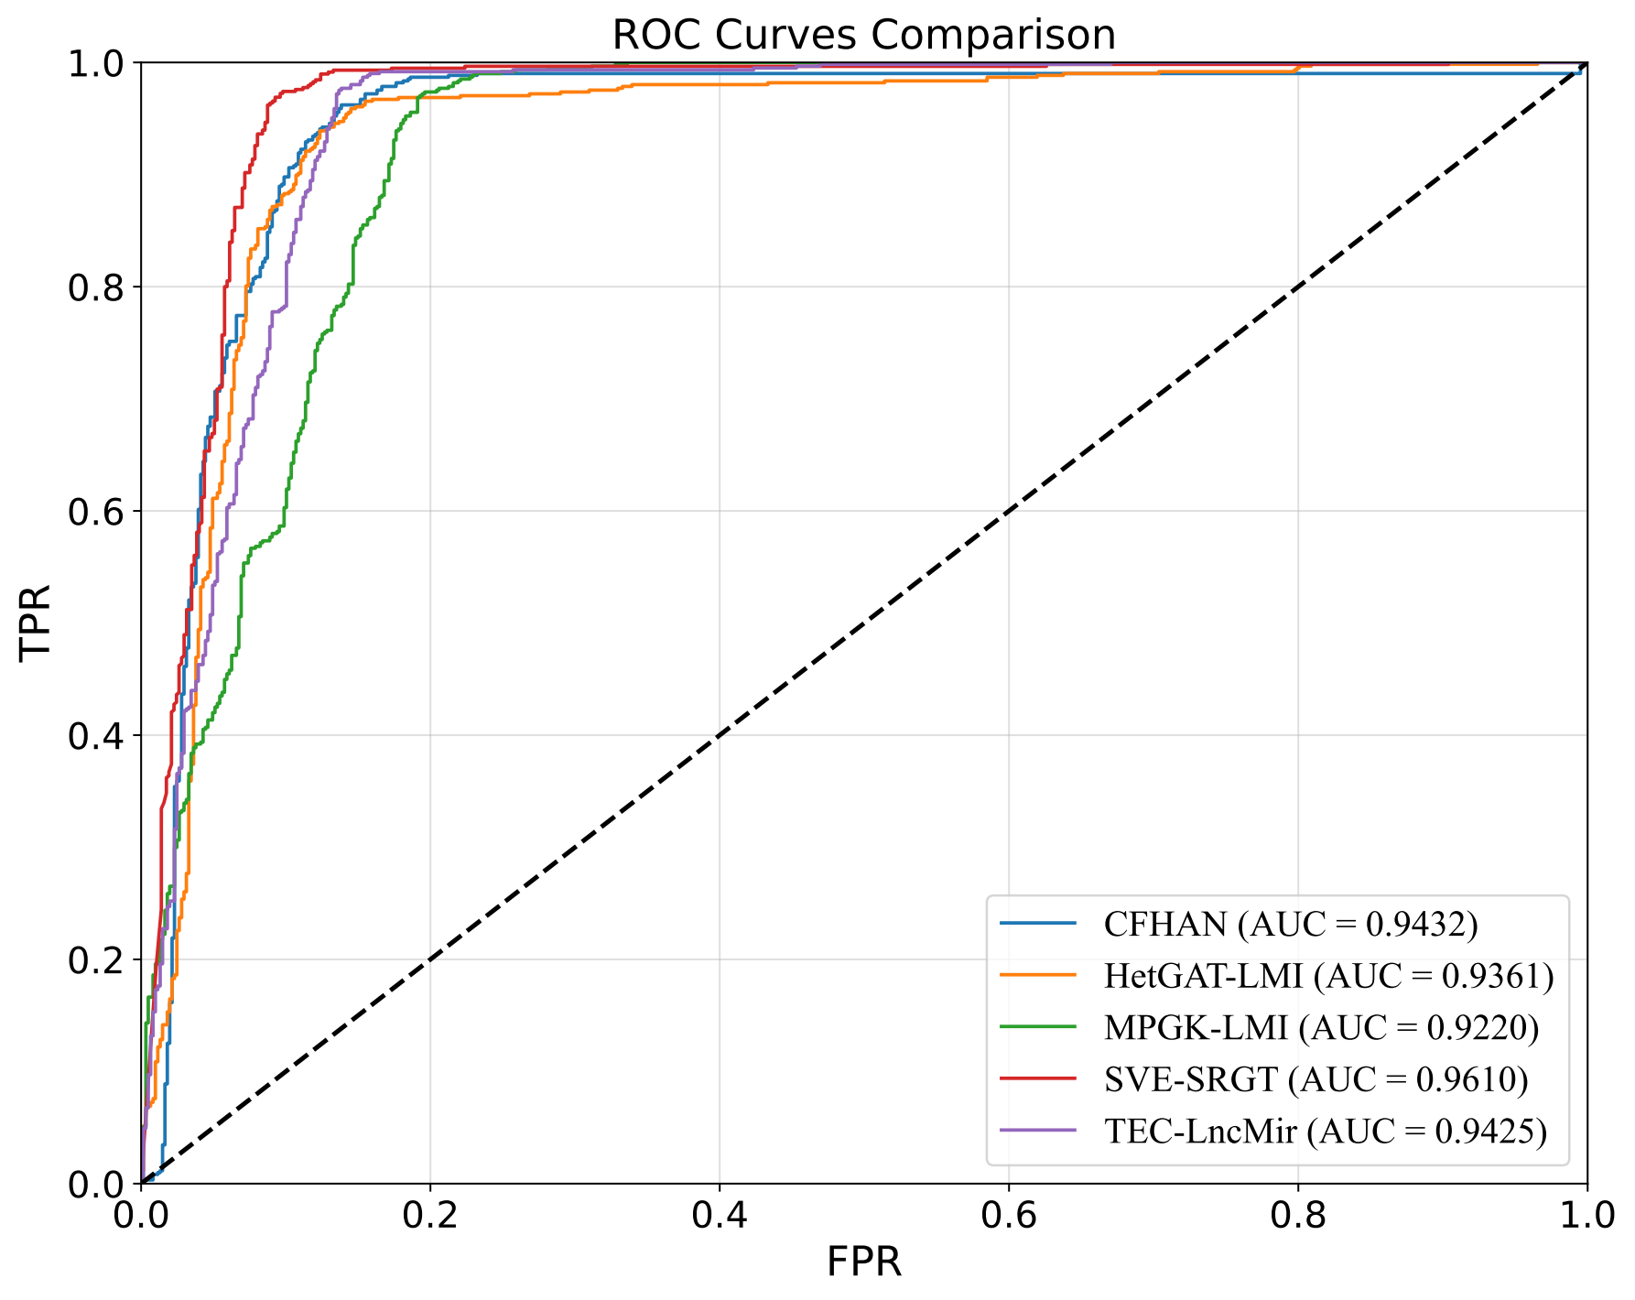
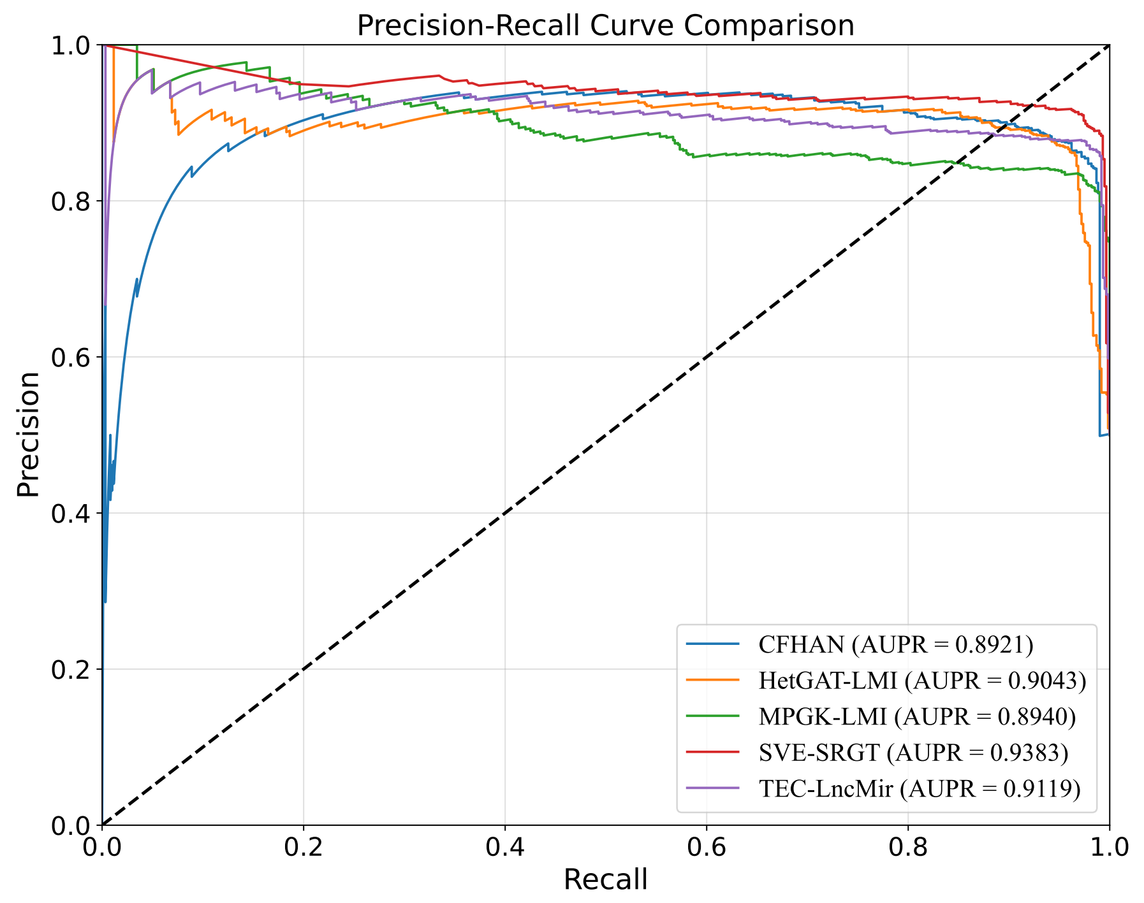
Fig. S1. ROC and PR curves of SVE-SRGT and other models.
Table S13. Performance of SVE-SRGT and other models for LMI prediction.
Methods | AUC | AUPR | ACC | PRE | REC | F1
HetGAT-LMI | 0.9361 | 0.9043 | 0.9012 | 0.8921 | 0.9127 | 0.9023
TEC-LncMir | 0.9424 | 0.9119 | 0.8756 | 0.8891 | 0.8583 | 0.8734
MPGK-LMI | 0.9220 | 0.8940 | 0.8814 | 0.8399 | 0.9423 | 0.8882
CFHAN | 0.9432 | 0.8921 | 0.8830 | 0.9043 | 0.8567 | 0.8799
SVE-SRGT | 0.9610 | 0.9383 | 0.9297 | 0.9165 | 0.9466 | 0.9313

References
[1] N. Sheng et al., “Deep-learning-based integration of sequence and structure information for efficiently predicting mirna–drug associations,” J Chem Inf Model, vol. 65, no. 11, pp. 5317-5326, 2025.
[2] Y. Fan, C. Zhang, X. Hu, Z. Huang, and L. Deng, “Agclnda: Enhancing the prediction of ncrna-drug resistance association using adaptive graph contrastive learning,” IEEE J Biomed Health Inform, vol. 29, no. 6, pp. 4524-4533, 2025.
[3] Y. Wang et al., “Attention-guided multiview deep learning framework uncovers mirna-drug associations for therapeutic discovery,” J Chem Inf Model, vol. 66, no. 3, pp. 1556-1565, 2026.
[4] Y. Li, S. Wang, Y. Zhang, C. Ren, Y. Liu, and S. Pang, “Alrtgcl: Adaptive low-rank transformer and graph contrastive learning for mirna–drug associations prediction in consumer healthcare,” IEEE Trans Consumer Electron, vol. 71, no. 3, pp. 7771 - 7783, 2025.
[5] Y. Li et al., “Multi-branch fusion graph neural network based on multi-head attention for childhood seizure detection,” Frontiers in Physiology, vol. 15, Art. no. 1439607, 2024.
[6] G. Huang, Y. Peng, S. Wu, H. Wei, and S. Liu, “Mphgnn: Metapath-guided heterogeneous graph neural network for mirna-drug resistance association prediction,” Briefings in Bioinformatics, vol. 27, no. 1, Art. no. bbag013, 2026.
[7] T. Liu et al., “Dmgat: Predicting ncrna-drug resistance associations based on diffusion map and heterogeneous graph attention network,” Briefings in Bioinformatics, vol. 26, no. 2, Art. no. bbaf179, 2025.
[8] P. Xu, C. Li, J. Yuan, Z. Bao, and W. Liu, “Predict lncrna-drug associations based on graph neural network,” Front Genet, vol. 15, Art. no. 1388015, 2024.
[9] A. Panghalia, P. Kumar, and V. Singh, “Graphsla: Graph machine learning for predicting small molecule-lncrna associations,” Artif Intell Chem, Art. no. 100094, 2025.
[10] M. Gao and X. Shang, “Identification of associations between lncrna and drug resistance based on deep learning and attention mechanism,” Front Microbiol, vol. 14, Art. no. 1147778, 2023.
[11] D. Liu et al., “Hgnnlda: Predicting lncrna-drug sensitivity associations via a dual channel hypergraph neural network,” IEEE/ACM Trans Comput Biol Bioinform, vol. 20, no. 6, pp. 3547-3555, 2023.
[12] Y. He et al., “Plant lncrna-mirna interaction prediction based on counterfactual heterogeneous graph attention network,” Interdiscip Sci, vol. 17, no. 2, pp. 244-256, 2025.
[13] R. Liu, Z. Wang, T. Han, L. Shao, and Q. Zhao, “Hetgat-lmi: Interpretable heterogeneous graph attention method for predicting lncrna–mirna interactions,” J Chem Inf Model, vol. 66, no. 1, pp. 796-807, 2025.
[14] J. Xie et al., “Lncrna–mirna interactions prediction based on meta‐path similarity and gaussian kernel similarity,” J Cell Mol Med, vol. 28, no. 19, Art. no. e18590, 2024.
[15] T. Yang, Y. He, and Y. Wang, “Introducing tec-lncmir for prediction of lncrna-mirna interactions through deep learning of rna sequences,” Briefings in Bioinformatics, vol. 26, no. 1, Art. no. baf046, 2025, doi: 10.1093/bib/bbaf046.

