《Java程序设计》实验报告11

学生姓名：李季鸿 班级：2021级计本（3）班 学号：20213002624
实验地点：9教404 指导教师：张春元
实验日期：2023-05-15 共2学时
实验环境：Win10+JDK1.8+ IntelliJ IDEA 2022.1.1

- 实验目的
掌握I/O编程一般方法和思想。
- 实验内容
- 用集成化开发工具完成实验教材P99实验2内容。
- 用集成化开发工具完成实验教材P102实验3内容。
- 请用循环语句编写一份九九乘法口决表，要求输出规范齐整。
- 实验过程
报告撰写具体要求：截屏显示或直接写出实验1至实验3的源码和运行结果。
实验内容（1）：
OutputWordMess.java:
package _11_.shiyan1;
import java.util.Vector;
/**
* \* Created with IntelliJ IDEA.
* \* @ProjectName: java_study_codes
* \* @FileName: OutputWordMess
* \* @author: li-jihong
* \* Date: 2023-05-15 17:11
*/
public class OutputWordMess{
public static void main(String args[]) {
Vector<String> allWord,noSameWord;
WordStatistic statistic =new WordStatistic();
statistic.setFileName("src/hello.txt");//本地绝对路径
statistic.wordStatistic(); //statistic调用wordStatistic()方法
allWord=statistic.getAllWord();
noSameWord=statistic.getNoSameWord();
System.out.println("共有"+allWord.size()+"个英文单词");
System.out.println("有"+noSameWord.size()+"个互不相同英文单词");
System.out.println("按出现频率排列:");
int count[]=new int[noSameWord.size()];//判断noSameWord.elementAt(i)相同出现的频率
for(int i=0;i<noSameWord.size();i++) {
String s1 = noSameWord.elementAt(i);
for(int j=0;j<allWord.size();j++) {
String s2=allWord.elementAt(j);
if(s1.equals(s2))
count[i]++;
}
}
for(int m=0;m<noSameWord.size();m++) { //按照频率排序
for(int n=m+1;n<noSameWord.size();n++) {
if(count[n]>count[m]) {
String temp=noSameWord.elementAt(m);
noSameWord.setElementAt(noSameWord.elementAt(n),m);
noSameWord.setElementAt(temp,n);
int t=count[m];
count[m]=count[n];
count[n]=t;
}
}
}
for(int m=0;m<noSameWord.size();m++) {
double frequency=(1.0*count[m])/allWord.size();
System.out.printf("%s:%-7.3f",noSameWord.elementAt(m),frequency);
}
}
}
WordStatistic.java:
package _11_.shiyan1;
import java.io.File;
import java.io.IOException;
import java.util.Scanner;
import java.util.Vector;
/**
* \* Created with IntelliJ IDEA.
* \* @ProjectName: java_study_codes
* \* @FileName: WordStatistic
* \* @author: li-jihong
* \* Date: 2023-05-15 17:11
*/
public class WordStatistic {
Vector<String> allWord, noSameWord;
File file = new File("src/english.txt");//按照实际路径创建该文本
Scanner sc = null;
String regex;
WordStatistic() {
allWord = new Vector<String>();
noSameWord = new Vector<String>();
//regex是由空格、数字和符号(!"#$%&'()*+,-./:;<=>?@[\]^_`{|}~)组成的正则表达式
regex = "[\\s\\d\\p{Punct}]+"; // p187正则表达式
try {
sc = new Scanner(file); //创建指向file的sc
sc.useDelimiter(regex); //sc调用useDelimiter(String regex)方法,向参数传递regex
} catch (IOException exp) {
System.out.println(exp.toString());
}
}
void setFileName(String name) {
file = new File(name);
try {
sc = new Scanner(file);
sc.useDelimiter(regex);
} catch (IOException exp) {
System.out.println(exp.toString());
}
}
public void wordStatistic() {
try {
while (sc.hasNext()) {
String word = sc.next();
allWord.add(word);
if (!noSameWord.contains(word)) noSameWord.add(word);
}
} catch (Exception e) {
}
}
public Vector<String> getAllWord() {
return allWord;
}
public Vector<String> getNoSameWord() {
return noSameWord;
}
}
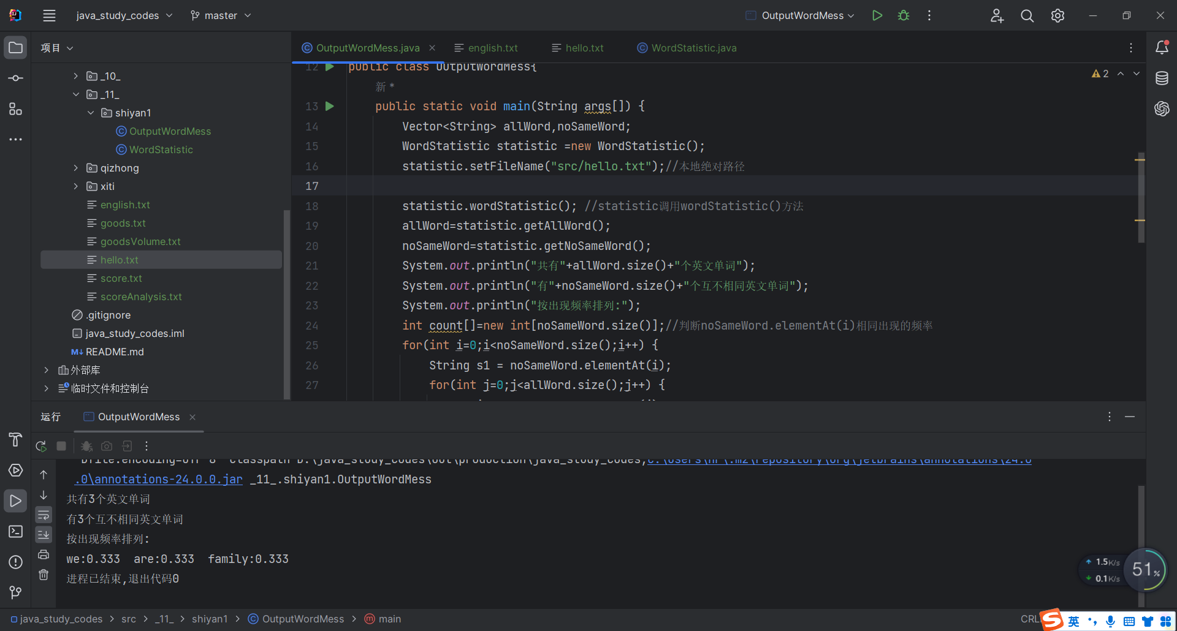
图11-1 实验一
实验后的练习
按字典顺序输出全部不相同的单词。
程序源代码：
import java.util.*;
public class DictionaryOutput {
public static void main(String args[]) {
Vector<String> allWord,noSameWord;
WordStatistic statistic=new WordStatistic();
statistic.setFileName("src/hello.txt");
statistic.wordStatistic();
allWord=statistic.getAllWord();
noSameWord=statistic.getNoSameWord();
System.out.println("一共有"+allWord.size()+"个英文单词");
System.out.println("有"+noSameWord.size()+"个不相同的英文单词");
System.out.println("按字典顺序排列:");
String s[]=new String [noSameWord.size()];
for(int i=0; i<noSameWord.size();i++) {
s[i]=noSameWord.elementAt(i);
}
Arrays.sort(s);
for(int i=0;i<noSameWord.size();i++) {
System.out.println(s[i]+" ");
}
}
}

程序运行结果：
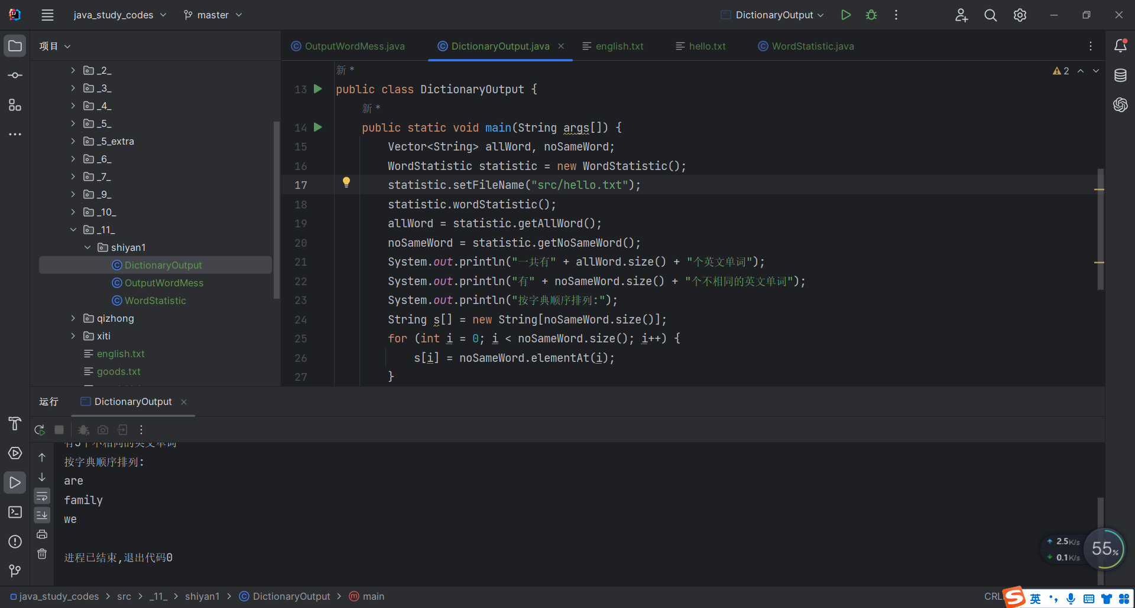
图11-2 实验1课后练习

实验内容（2）：
package _11_.shiyan2;
import java.io.File;
import java.io.FileInputStream;
import java.io.FileOutputStream;
import java.io.IOException;
import java.util.zip.ZipEntry;
import java.util.zip.ZipInputStream;
/**
* \* Created with IntelliJ IDEA.
* \* @ProjectName: java_study_codes
* \* @FileName: ReadZipFile
* \* @author: li-jihong
* \* Date: 2023-05-15 17:25
*/
public class ReadZipFile {
public static void main(String args[]) {
File f = new File("src/book.zip");
File dir = new File("src/mybook");
byte b[] = new byte[1024];
dir.mkdir();
try {
ZipInputStream in = new ZipInputStream(new FileInputStream(f));
ZipEntry zipEntry = null;
while ((zipEntry = in.getNextEntry()) != null) {
File file = new File(dir, zipEntry.getName());
FileOutputStream out = new FileOutputStream(file);
int n = -1;
System.out.println(file.getAbsolutePath() + "的内容：");
while ((n = in.read(b)) != -1) {
out.write(b, 0, n);
System.out.print(new String(b, 0, n, "UTF-8"));
}
out.close();
}
in.close();
} catch (IOException ee) {
System.out.println(ee);
}
}
}
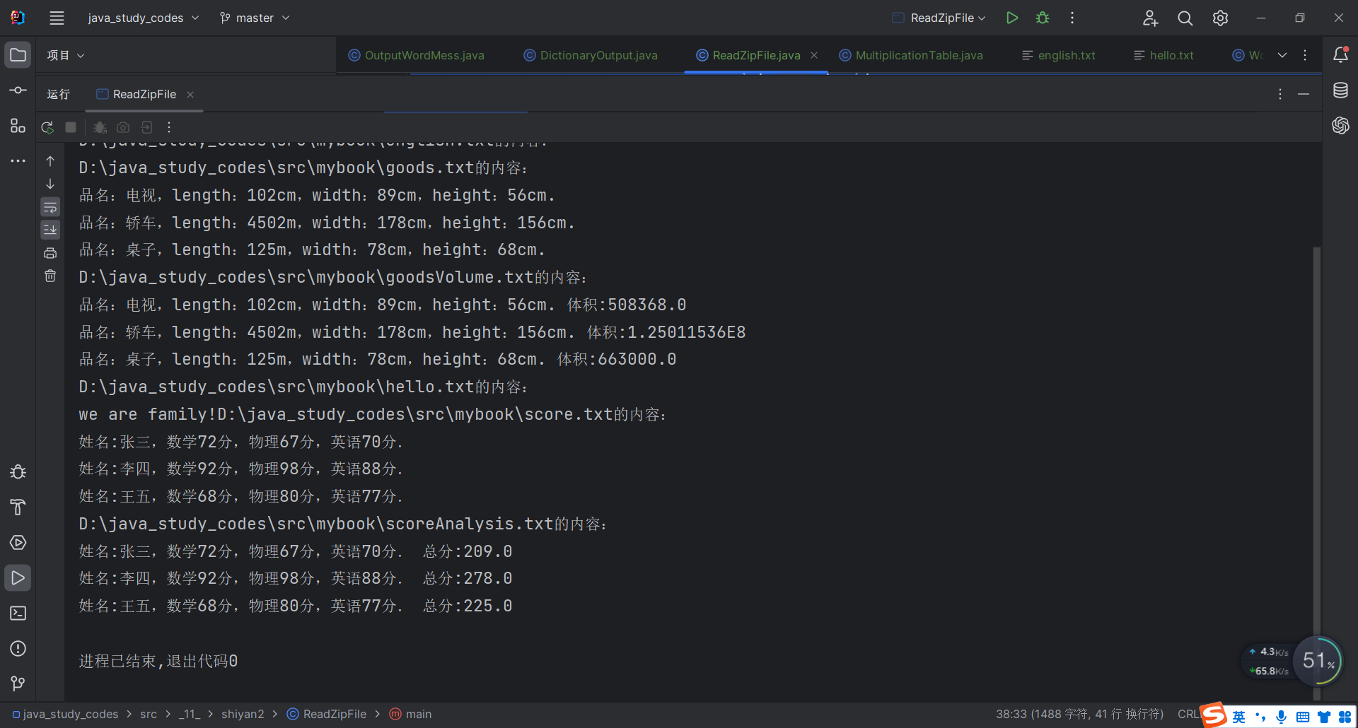
实验后的练习：
public class ReadZipFile {
public static void main(String args[]){
byte b[] = new byte[100];
JFileChooser jfc = new JFileChooser();
jfc.setDialogTitle("选择压缩文件");
jfc.setDialogType(JFileChooser.OPEN_DIALOG);
int r = jfc.showOpenDialog(new JFileChooser());
if(r==JFileChooser.APPROVE_OPTION){
File file = jfc.getSelectedFile();
try{
ZipEntry zipEntry = null;
ZipInputStream in = new ZipInputStream(new FileInputStream(file), Charset.forName("GBK"));
JFileChooser jfc_rec = new JFileChooser();
jfc_rec.setDialogTitle("选择存放的位置");
jfc_rec.setDialogType(JFileChooser.OPEN_DIALOG);
int r1 = jfc_rec.showSaveDialog(new JFileChooser());
if(r1 == JFileChooser.APPROVE_OPTION){
File dir = new File(jfc_rec.getSelectedFile().getAbsolutePath());
dir.mkdir();
JOptionPane.showMessageDialog(null, "文件将存放在"+dir.getAbsolutePath()+"文件夹中，是否确认", "确认存放地址", JOptionPane.WARNING_MESSAGE);
while((zipEntry = in.getNextEntry())!=null){
File parentFile = new File(dir,zipEntry.getName());
FileOutputStream out = new FileOutputStream(parentFile);
int n = -1;
System.out.println(file.getAbsolutePath()+"的内容：");
while((n=in.read(b,0,100))!=-1){
String str = new String(b,0,n);
System.out.println(str);
out.write(b,0,n);
}
out.close();
}
in.close();
}
}
catch (Exception exp){
}
}
}
}

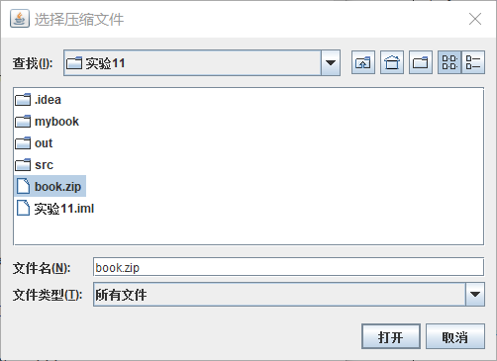
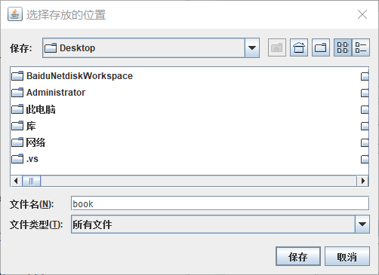
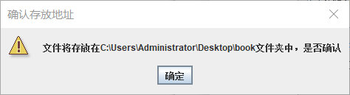
图1-2 实验结果

实验内容（3）：
package _11_.shiyan3;
/**
* \* Created with IntelliJ IDEA.
* \* @ProjectName: java_study_codes
* \* @FileName: MultiplicationTable
* \* @author: li-jihong
* \* Date: 2023-05-15 17:38
*/
public class MultiplicationTable {
public static void main(String[] args) {
// 控制乘数
for (int i = 1; i <= 9; i++) {
// 控制被乘数
for (int j = 1; j <= i; j++) {
System.out.print(j + " x " + i + " = " + (i * j) + "\t");
}
// 换行
System.out.println();
}
}
}
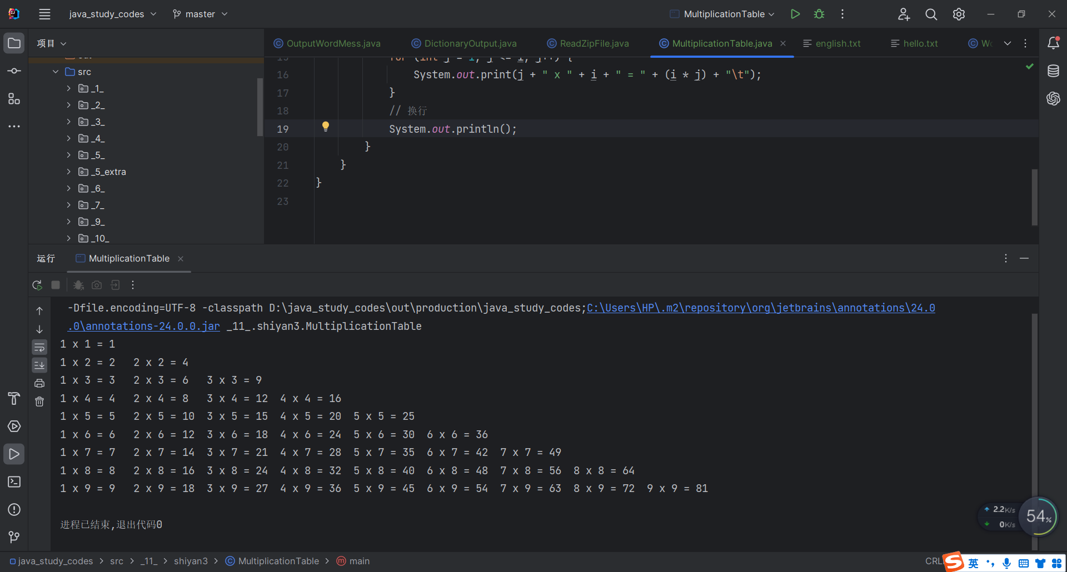
- 实验总结
写出实验中的心得体会（对第10章理论课重点简述）。

