《Java程序设计》实验报告12

学生姓名：李季鸿 班级：2021级计本（3）班 学号：20213002624
实验地点：9教404 指导教师：张春元
实验日期：2023-05-22 共2学时
实验环境：Win10+JDK1.8+ IntelliJ IDEA 2022.1.1

- 实验目的
学习数据库编程和多线程编程。
- 实验内容
- 用集成化开发工具完成实验教材P106实验1内容（数据库采用MySQL数据库）。
- 用集成化开发工具完成实验教材P108实验2内容（数据库采用MySQL数据库）。
- 用集成化开发工具完成实验教材P113实验1内容。
- 用集成化开发工具完成实验教材P115实验2内容。
- 实验过程
报告撰写具体要求：截屏显示或直接写出实验1至实验4的源码和运行结果。
实验内容（1）：
ComputerAverPrice.java:
package _12_.shiyan1;
import java.sql.*;
/**
* \* Created with IntelliJ IDEA.
* \* @ProjectName: java_study_codes
* \* @FileName: ComputerAverPrice
* \* @author: li-jihong
* \* Date: 2023-05-22 16:47
*/
public class ComputerAverPrice {
public static void main(String[] args) {
Connection con = null;
Statement sql;
ResultSet rs;
try{
Class.forName("com.mysql.cj.jdbc.Driver");
} catch (Exception e) {}
try{
con = DriverManager.getConnection("jdbc:mysql://localhost:3306/shiyan12?useSSL=TRUE", "root","");
} catch (SQLException e) {
System.out.println(e);
}
try{
sql = con.createStatement(ResultSet.TYPE_SCROLL_SENSITIVE,ResultSet.CONCUR_READ_ONLY);
rs = sql.executeQuery("select * from booklist");
rs.last();
int max = rs.getRow();
System.out.println("表中共有" + max + "条记录，随机抽取10条记录： ");
int [] a = RandomGetRecord.getRandomNUmber(max, 10);
float sum = 0;
for(int i : a){
rs.absolute(i);
float price = rs.getFloat(3);
sum = sum + price;
}
con.close();
System.out.println("平均价格：" + sum/a.length);
}
catch (SQLException e){}
}
}
RandomGetRecord.java:
package _12_.shiyan1;
import java.util.Random;
import java.util.Vector;
/**
* \* Created with IntelliJ IDEA.
* \* @ProjectName: java_study_codes
* \* @FileName: RandomGetRecord
* \* @author: li-jihong
* \* Date: 2023-05-22 16:30
*/
public class RandomGetRecord {
public static int[] getRandomNUmber(int max, int amount) {
Vector<Integer> vector = new Vector<Integer>();
for (int i = 1; i <= max; i++) {
vector.add(i);
}
int result[] = new int[amount];
while (amount > 0) {
int index = new Random().nextInt(vector.size());
int m = vector.elementAt(index);
vector.removeElementAt(index);
result[amount - 1] = m;
amount--;
}
return result;
}
}
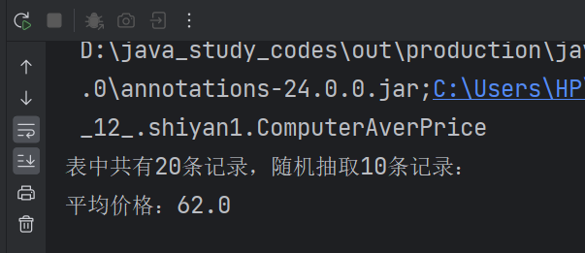
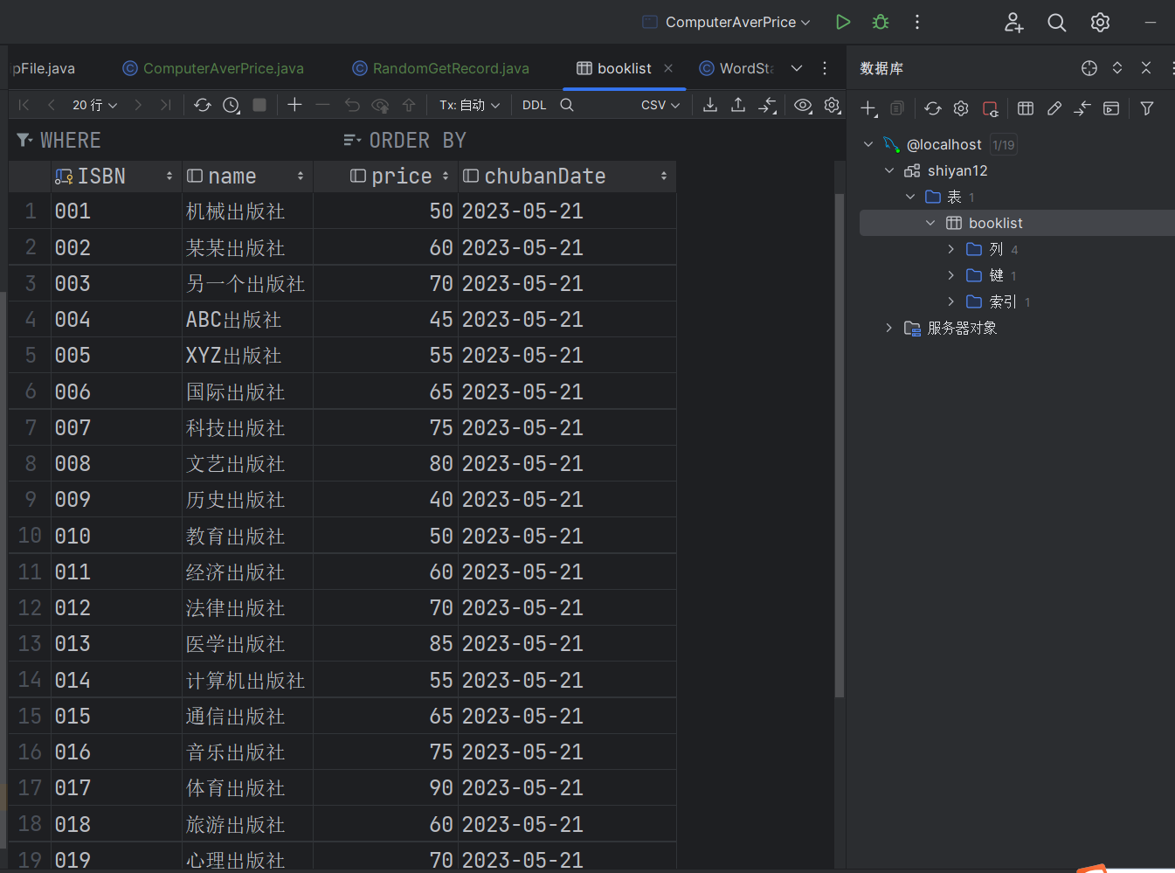
课后练习：
Students.java:
package _12_.shiyan1;
import java.sql.*;
import java.util.Random;
import java.util.Vector;
/**
* \* Created with IntelliJ IDEA.
* \* @ProjectName: java_study_codes
* \* @FileName: students
* \* @author: li-jihong
* \* Date: 2023-05-22 17:29
*/
public class Students {
public static void main(String args[]){
int wantRecordAmount = 20;
Random random = new Random();
try{
Class.forName("com.mysql.cj.jdbc.Driver");
}
catch (ClassNotFoundException e){
System.out.print(e);
}
Connection con;
Statement sql;
ResultSet rs;
try {
String uri = "jdbc:mysql://127.0.0.1:3306/shiyan12?user=root&password=123456&useSSL=true";
con = DriverManager.getConnection(uri);
sql = con.createStatement(ResultSet.TYPE_SCROLL_SENSITIVE,ResultSet.CONCUR_READ_ONLY);
rs = sql.executeQuery("SELECT * FROM score");
rs.last();
int count = rs.getRow();
Vector<Integer> vector = new Vector<Integer>();
for(int i=1;i<=count;i++){
vector.add(i);
}
int itemAmount = Math.min(wantRecordAmount,count);
System.out.println("随即抽取"+itemAmount+"条记录");
System.out.println("学生信息如下：");
double sum = 0,n = itemAmount;
while(itemAmount>0){
int randomIndex = random.nextInt(vector.size());
int index = (vector.elementAt(randomIndex)).intValue();
rs.absolute(index);
String name = rs.getString("name");
float grade = rs.getFloat("score");
System.out.println(name+":"+grade);
sum = sum +grade;
itemAmount--;
vector.removeElementAt(randomIndex);
}
con.close();
double aver = sum/n;
System.out.println("平均成绩："+aver+"分");
}
catch (SQLException e){
System.out.println(""+e);
}
}
}
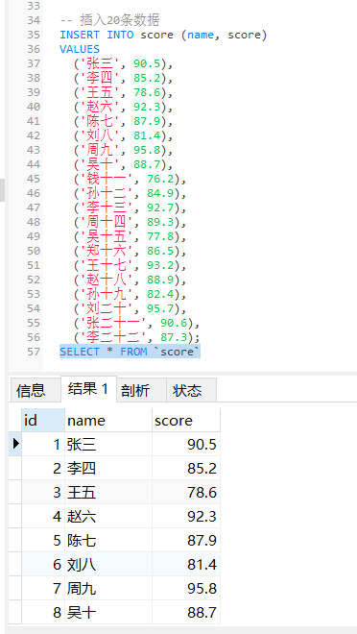
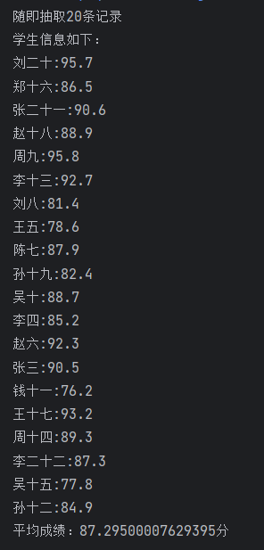
实验内容（2）：
TurnMoney.java:
package _12_.shiyan2;
/**
* \* Created with IntelliJ IDEA.
* \* @ProjectName: java_study_codes
* \* @FileName: TurnMoney
* \* @author: li-jihong
* \* Date: 2023-05-22 17:36
*/
import java.sql.*;
public class TurnMoney {
public static void main(String args[]) {
Connection con = null;
Statement sql;
ResultSet rs;
try {
double n = 100;
String uri = "jdbc:mysql://127.0.0.1:3306/shiyan12?user=root&password=123456&useSSL=true";
con = DriverManager.getConnection(uri);
con.setAutoCommit(false);
sql = con.createStatement();
rs = sql.executeQuery("SELECT * FROM car1 WHERE name = 'zhangsan'");
rs.next();
double amountOne = rs.getDouble("amount");
System.out.println("转账操作之前zhangsan的钱款数额：" + amountOne);
rs = sql.executeQuery("SELECT * FROM car2 WHERE name = 'lisi'");
rs.next();
double amountTwo = rs.getDouble("amount");
System.out.println("转账操作之前lisi的钱款数额：" + amountTwo);
amountOne = amountOne - n;
amountTwo = amountTwo + n;
sql.execute("UPDATE car1 SET amount = " + amountOne + " WHERE name = 'zhangsan'");
sql.execute("UPDATE car2 SET amount = " + amountTwo + " WHERE name = 'lisi'");
con.commit();
con.setAutoCommit(true);
rs = sql.executeQuery("SELECT * FROM car1 WHERE name = 'zhangsan'");
rs.next();
amountOne = rs.getDouble("amount");
System.out.println("转账操作之后zhangsan的钱款数额：" + amountOne);
rs = sql.executeQuery("SELECT * FROM car2 WHERE name = 'lisi'");
rs.next();
amountTwo = rs.getDouble("amount");
System.out.println("转账操作之后lisi的钱款数额：" + amountTwo);
con.close();
} catch (SQLException e) {
try {
con.rollback();
} catch (SQLException exp) {
}
System.out.println(e.toString());
}
}
}
转账前：
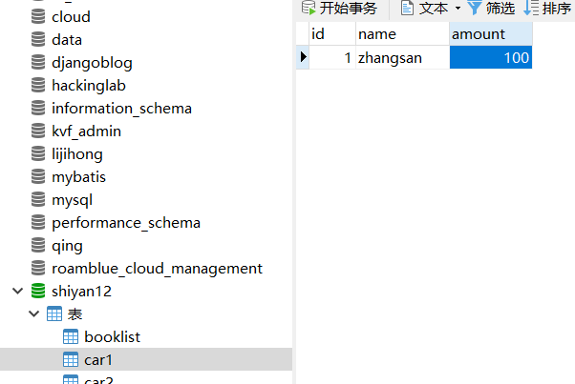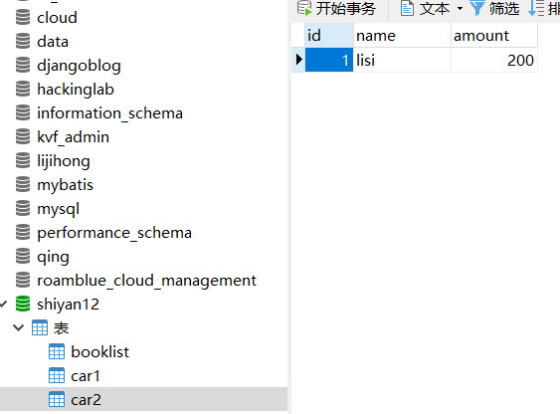
转账后：
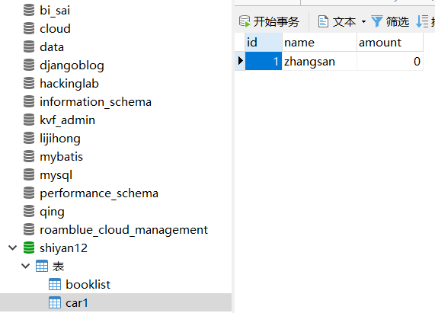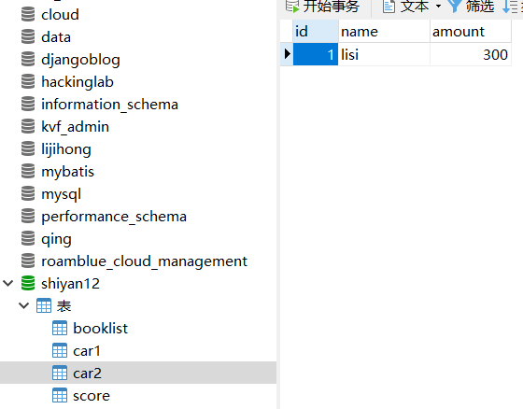

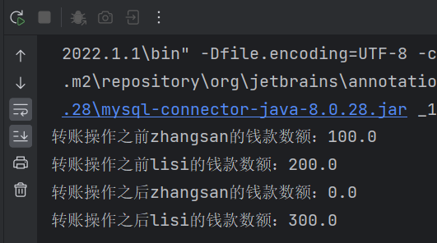
在上面基础上：
package _12_.shiyan2;
import java.sql.*;
public class NewTransaction {
public static void main(String[] args) {
Connection con = null;
Statement sql;
ResultSet rs;
try {
double amount = 500;
String uri = "jdbc:mysql://127.0.0.1:3306/shiyan12?user=root&password=123456&useSSL=true";
con = DriverManager.getConnection(uri);
con.setAutoCommit(false);
sql = con.createStatement();
rs = sql.executeQuery("SELECT * FROM car1 WHERE name = 'zhangsan'");
rs.next();
double zhangsanAmount = rs.getDouble("amount");
System.out.println("转账操作之前zhangsan的钱款数额：" + zhangsanAmount);
rs = sql.executeQuery("SELECT * FROM car2 WHERE name = 'lisi'");
rs.next();
double lisiAmount = rs.getDouble("amount");
System.out.println("转账操作之前lisi的钱款数额：" + lisiAmount);
if (zhangsanAmount >= amount) {
zhangsanAmount -= amount;
lisiAmount += amount;
sql.execute("UPDATE car1 SET amount = " + zhangsanAmount + " WHERE name = 'zhangsan'");
sql.execute("UPDATE car2 SET amount = " + lisiAmount + " WHERE name = 'lisi'");
System.out.println("转账成功！");
System.out.println("转账操作之后zhangsan的钱款数额：" + zhangsanAmount);
System.out.println("转账操作之后lisi的钱款数额：" + lisiAmount);
con.commit();
} else {
System.out.println("转账失败：zhangsan的钱款数额不足！");
con.rollback();
}
con.setAutoCommit(true);
con.close();
} catch (SQLException e) {
try {
con.rollback();
} catch (SQLException exp) {
}
System.out.println(e.toString());
}
}
}
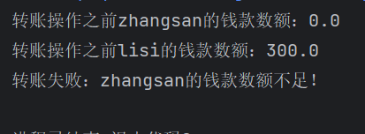
实验内容（3）：
Letter.java:
package _12_.shiyan3;
/**
* \* Created with IntelliJ IDEA.
* \* @ProjectName: java_study_codes
* \* @FileName: Letter
* \* @author: li-jihong
* \* Date: 2023-05-22 18:08
*/
public class Letter {
char c = '\0';
public void setChar(char c){
this.c = c;
}
public char getChar(){
return c;
}
}

TypeKey.java:
package _12_.shiyan3;
/**
* \* Created with IntelliJ IDEA.
* \* @ProjectName: java_study_codes
* \* @FileName: TypeKey
* \* @author: li-jihong
* \* Date: 2023-05-22 18:07
*/
public class TypeKey {
public static void main(String args[]){
System.out.println("键盘练习（输入#结束程序）：");
System.out.println("输入显示的字母（回车）\n");
Letter letter;
letter = new Letter();
GiveLetterThread giveChar;
InputLetterThread typeChar;
giveChar = new GiveLetterThread();
typeChar = new InputLetterThread();
giveChar.setLetter(letter);
giveChar.setSleepLength(3200);
typeChar.setLetter(letter);
giveChar.start();
typeChar.start();
}
}

GiveLetterThread.java:
package _12_.shiyan3;
/**
* \* Created with IntelliJ IDEA.
* \* @ProjectName: java_study_codes
* \* @FileName: GiveLetterThread
* \* @author: li-jihong
* \* Date: 2023-05-22 18:10
*/
public class GiveLetterThread extends Thread {
Letter letter;
char startChar = 'a', endChar = 'z';
int sleepLength = 5000;
public void setLetter(Letter letter) {
this.letter = letter;
}
public void setSleepLength(int n) {
sleepLength = n;
}
public void run() {
char c = startChar;
while (true) {
letter.setChar(c);
System.out.printf("显示的字符:%c \n ", letter.getChar());
try {
Thread.sleep(sleepLength);
} catch (InterruptedException e) {
}
c = (char) (c + 1);
if (c > endChar)
c = startChar;
}
}
}

InputLetterThread.java:
package _12_.shiyan3;
import java.util.Scanner;
/**
* \* Created with IntelliJ IDEA.
* \* @ProjectName: java_study_codes
* \* @FileName: InputLetterThread
* \* @author: li-jihong
* \* Date: 2023-05-22 18:11
*/
public class InputLetterThread extends Thread {
Scanner reader;
Letter letter;
int score = 0;
InputLetterThread() {
reader = new Scanner(System.in);
}
public void setLetter(Letter letter) {
this.letter = letter;
}
public void run() {
while (true) {
String str = reader.nextLine();
char c = str.charAt(0);
if (c == letter.getChar()) {
score++;
System.out.printf("\t\t输入对了，目前分数%d\n" ,score);
} else {
System.out.printf("\t\t输入错了，目前分数%d\n ", score);
}
if (c == '#')
System.exit(0);
}
}
}
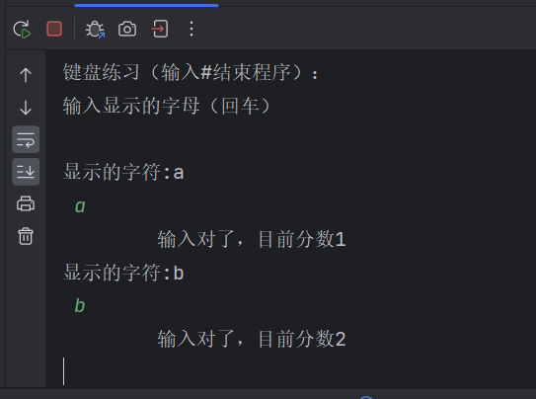

实验内容（4）：
TwoThreadGuessNumber.java:
package _12_.shiyan4;
/**
* \* Created with IntelliJ IDEA.
* \* @ProjectName: java_study_codes
* \* @FileName: TwoThreadGuessNumber
* \* @author: li-jihong
* \* Date: 2023-05-26 20:05
*/
public class TwoThreadGuessNumber {
public static void main(String args[]) {
Number number = new Number();
number.giveNumberThread.start();
number.guessNumberThread.start();
// number.guessNumberThread1.start();
// number.guessNumberThread2.start();
}
}
Number.java:
package _12_.shiyan4;
/**
* \* Created with IntelliJ IDEA.
* \* @ProjectName: java_study_codes
* \* @FileName: Number
* \* @author: li-jihong
* \* Date: 2023-05-26 20:06
*/
public class Number implements Runnable {
// private static int theNumber;
final int SMALLER = -1, LARGER = 1, SUCCESS = 8;
int realNumber, guessNumber, min = 0, max = 100, message = SMALLER;
// int guessNumber1, guessNumber2, min = 0, max = 100, message = SMALLER, message2 = SMALLER;
boolean pleaseGuess = false, isGiveNumber = false;
// boolean pleaseGuess = false, isGiveNumber = false, pleaseGuess2 = false, isGiveNumber2 = false;
Thread giveNumberThread, guessNumberThread;
// Thread giveNumberThread, guessNumberThread1, guessNumberThread2;
Number() {
giveNumberThread = new Thread(this);
guessNumberThread = new Thread(this);
// guessNumberThread1 = new Thread(this);
// guessNumberThread2 = new Thread(this);
}
public void run() {
for (int count = 1; true; count++) {
setMessage(count);
if (message == SUCCESS)
return;
}
}
// public void run() {
// for (int count = 1; true; count++) {
// setMessage(count);
// if (message == SUCCESS || message2 == SUCCESS)
// return;
// }
// }
public synchronized void setMessage(int count) {
if (Thread.currentThread() == giveNumberThread && isGiveNumber == false) {
realNumber = (int) (Math.random() * 100) + 1;
System.out.println("随机给你一个1至100之间的数，猜猜是多少？");
isGiveNumber = true;
pleaseGuess = true;
}
if (Thread.currentThread() == giveNumberThread) {
while (pleaseGuess == true)
try {
wait();
} catch (InterruptedException e) {
}
if (realNumber == guessNumber) {
message = SMALLER;
System.out.println("你猜小了");
} else if (realNumber < guessNumber) {
message = LARGER;
System.out.println("你猜大了");
} else {
message = SUCCESS;
System.out.println("恭喜，你猜对了");
}
pleaseGuess = true;
}
if (Thread.currentThread() == guessNumberThread && isGiveNumber == true) {
while (pleaseGuess == false)
try {
wait();
} catch (InterruptedException e) {
}
if (message == SMALLER) {
min = guessNumber;
guessNumber = (min + max) / 2;
System.out.println("A第" + count + "次猜这个数是：" + guessNumber);
} else if (message == LARGER) {
max = guessNumber;
guessNumber = (min + max) / 2;
System.out.println("A第" + count + "次猜这个数是：" + guessNumber);
}
pleaseGuess = false;
}
notifyAll();
}
}
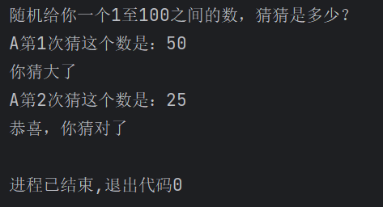

实验后的练习：
TwoThreadGuessNumber.java:
package _12_.shiyan4;
/**
* \* Created with IntelliJ IDEA.
* \* @ProjectName: java_study_codes
* \* @FileName: TwoThreadGuessNumber
* \* @author: li-jihong
* \* Date: 2023-05-26 20:05
*/
public class TwoThreadGuessNumber {
public static void main(String args[]) {
Number number = new Number();
number.giveNumberThread.start();
number.guessNumberThread1.start();
number.guessNumberThread2.start();
}
}
Number.java:
package _12_.shiyan4;
/**
* \* Created with IntelliJ IDEA.
* \* @ProjectName: java_study_codes
* \* @FileName: Number
* \* @author: li-jihong
* \* Date: 2023-05-26 20:06
*/
public class Number implements Runnable {
private static int theNumber;
final int SMALLER = -1, LARGER = 1, SUCCESS = 8;
// int realNumber, guessNumber, min = 0, max = 100, message = SMALLER;
int guessNumber1, guessNumber2, min = 0, max = 100, message = SMALLER, message2 = SMALLER;
// boolean pleaseGuess = false, isGiveNumber = false;
boolean pleaseGuess = false, isGiveNumber = false, pleaseGuess2 = false, isGiveNumber2 = false;
// Thread giveNumberThread, guessNumberThread;
Thread giveNumberThread, guessNumberThread1, guessNumberThread2;
Number() {
giveNumberThread = new Thread(this);
guessNumberThread1 = new Thread(this);
guessNumberThread2 = new Thread(this);
}
// public void run() {
// for (int count = 1; true; count++) {
// setMessage(count);
// if (message == SUCCESS)
// return;
// }
// }
public void run() {
for (int count = 1; true; count++) {
setMessage(count);
if (message == SUCCESS || message2 == SUCCESS)
return;
}
}
// public synchronized void setMessage(int count) {
//
// if (Thread.currentThread() == giveNumberThread && isGiveNumber == false) {
// realNumber = (int) (Math.random() * 100) + 1;
// System.out.println("随机给你一个1至100之间的数，猜猜是多少？");
// isGiveNumber = true;
// pleaseGuess = true;
// }
// if (Thread.currentThread() == giveNumberThread) {
// while (pleaseGuess == true)
// try {
// wait();
// } catch (InterruptedException e) {
// }
// if (realNumber == guessNumber) {
// message = SMALLER;
// System.out.println("你猜小了");
// } else if (realNumber < guessNumber) {
// message = LARGER;
// System.out.println("你猜大了");
// } else {
// message = SUCCESS;
// System.out.println("恭喜，你猜对了");
// }
// pleaseGuess = true;
// }
// if (Thread.currentThread() == guessNumberThread && isGiveNumber == true) {
// while (pleaseGuess == false)
// try {
// wait();
// } catch (InterruptedException e) {
// }
// if (message == SMALLER) {
// min = guessNumber;
// guessNumber = (min + max) / 2;
// System.out.println("A第" + count + "次猜这个数是：" + guessNumber);
// } else if (message == LARGER) {
// max = guessNumber;
// guessNumber = (min + max) / 2;
// System.out.println("A第" + count + "次猜这个数是：" + guessNumber);
// }
// pleaseGuess = false;
// }
// notifyAll();
// }
public synchronized void setMessage(int count) {
if (Thread.currentThread() == giveNumberThread && isGiveNumber == false) {
theNumber = (int) (Math.random() * 100) + 1;
System.out.println("随机给你一个1至100之间的数，猜猜是多少？" + theNumber);
isGiveNumber = true;
pleaseGuess = true;
pleaseGuess2 = true;
}
if (Thread.currentThread() == giveNumberThread) {
while (pleaseGuess == true || pleaseGuess2 == true)
try {
wait();
} catch (InterruptedException e) {
}
if (theNumber == guessNumber1 || theNumber == guessNumber2) {
message = SUCCESS;
System.out.println("恭喜，你猜对了");
return;
}
pleaseGuess = true;
pleaseGuess2 = true;
}
if (Thread.currentThread() == guessNumberThread1 && isGiveNumber == true) {
while (pleaseGuess == false)
try {
wait();
} catch (InterruptedException e) {
}
if (message == SMALLER) {
min = guessNumber1;
guessNumber1 = (min + max) / 2;
System.out.println("A第" + count + "次猜这个数是：" + guessNumber1);
} else if (message == LARGER) {
max = guessNumber1;
guessNumber1 = (min + max) / 2;
System.out.println("A第" + count + "次猜这个数是：" + guessNumber1);
}
if (theNumber > guessNumber1) {
message = SMALLER;
System.out.println("你猜小了");
} else if (theNumber < guessNumber1) {
message = LARGER;
System.out.println("你猜大了");
}
pleaseGuess = false;
}
if (Thread.currentThread() == guessNumberThread2 && isGiveNumber == true) {
while (pleaseGuess2 == false)
try {
wait();
} catch (InterruptedException e) {
}
if (message2 == SMALLER) {
min = guessNumber2;
guessNumber2 = (min + max) / 2;
System.out.println("B第" + count + "次猜这个数是：" + guessNumber2);
} else if (message2 == LARGER) {
max = guessNumber2;
guessNumber2 = (min + max) / 2;
System.out.println("B第" + count + "次猜这个数是：" + guessNumber2);
}
if (theNumber > guessNumber2) {
message2 = SMALLER;
System.out.println("你猜小了");
} else if (theNumber < guessNumber2) {
message2 = LARGER;
System.out.println("你猜大了");
}
pleaseGuess2 = false;
}
notifyAll();
}
}
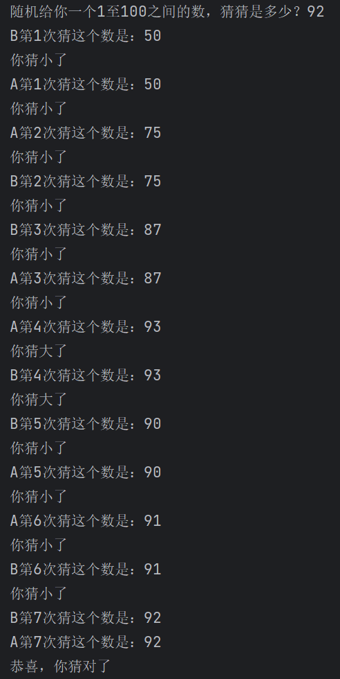
- 实验总结
写出实验中的心得体会（对第11章理论课重点简述）。
一、控制游标
.Statement sql=con.createStatement();创建的Statement对象的执行查询所获得的结果集的游标只能用过next()顺序向下移动。
为了得到一个游标可滚动的结果集，需使用下述方法获得一个Statement对象:
Statement stmt = con.createStatement(int type,int concurrency);
注: type参数用来指明游标滚动方式;concurrency参数用来指明是否用查询结果集更新数据库。
二、使用预处理语句
问题
Statement sql=con.createStatement();ResultSet rs = sql.executeQuery(sql语句);int ok = sql.executeUpdate(sql语句);
前面讲的查询或更新SQL语句在执行时需要事先由数据库中的SQL解释器解释成底层的内部命令才能运行，增大了数据库的负担，降低了执行的效率。
解决办法:采用“预处理语句+通配符”将要执行的SQL语句的一般形式提前解释好，真正运行时只需将通配符代表的具体值送进去即可。
三、java中使用mysql，使用预处理语句作用或者说好处是什么
在Java中使用MySQL数据库时，使用预处理语句（Prepared Statements）有以下好处：
1. 提高性能：预处理语句可以预编译SQL查询，并将其存储在数据库中，以便重复执行。这样可以减少每次执行查询时的解析和编译开销，从而提高查询的性能。
2. 防止SQL注入攻击：预处理语句使用参数化查询，将用户输入的数据作为参数传递给SQL语句，而不是将用户输入直接嵌入到SQL语句中。这样可以有效防止SQL注入攻击，因为参数化查询会对输入数据进行转义和验证，确保查询的安全性。
3. 简化SQL语句拼接：通过使用预处理语句，可以将SQL语句和参数分开处理，避免手动拼接SQL字符串。这样可以提高代码的可读性和可维护性，并降低出错的风险。
4. 提供数据类型安全性：预处理语句可以根据参数的数据类型进行类型检查和转换。这样可以确保传递给数据库的数据类型正确匹配，并减少数据转换错误的可能性。
5. 重复使用查询计划：预处理语句可以缓存查询计划，使其可重复使用。这在需要多次执行相同查询的情况下非常有用，避免了每次查询都重新生成查询计划的开销。
总而言之，使用预处理语句可以提高数据库查询的性能、安全性和可维护性。它是一种推荐的做法，特别是当需要执行频繁的SQL查询时。
四、事务及事务处理
✓ 事务由一组SQL语句组成。
✓ 事务处理是指：应用程序保证事务中的SQL语句要么全部 都执行，要么一个都不执行。
JDBC事务处理步骤(下述方法均来自数据库连接对象)
✓ 1. 用con.setAutoCommit(booean b)关闭自动提交模式 注：要先关闭自动提交模式，再获取Statement对象sql
✓ 2. 用con.commit()让事务中的全部语句生效 注：要先执行完事务中的sql语句，再执行commit()方法
✓ 3. 用con.rollback()处理事务失败 注：一般放在catch(){}语句块中

