**Numpy Python 3.6.3Heart Attack [Assume Numpy+MK is installed but accidentally uninstall for 2.7]**

1. **Make sure download the Numpy+MK version :** [**https://www.lfd.uci.edu/~gohlke/pythonlibs/#numpy**](https://www.lfd.uci.edu/~gohlke/pythonlibs/#numpy)
2. **If accidentally uninstall**
3. **Go back to > C:\Program Files\Python36\libs**
4. **Make sure the whl file is in it.**
5. 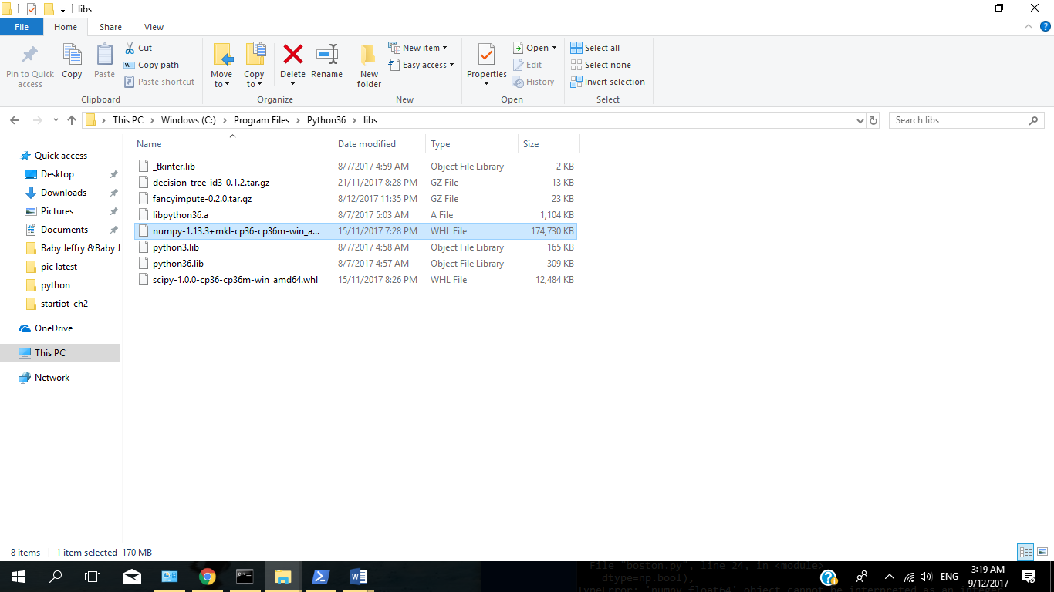
6. **Go to Windows Shell Power [RUN AS ADMIN]**
7. **REMEMBER COPY PASTE THE WHL FILE INTO WINDOWS/SYSTEM32 FILES**
8. 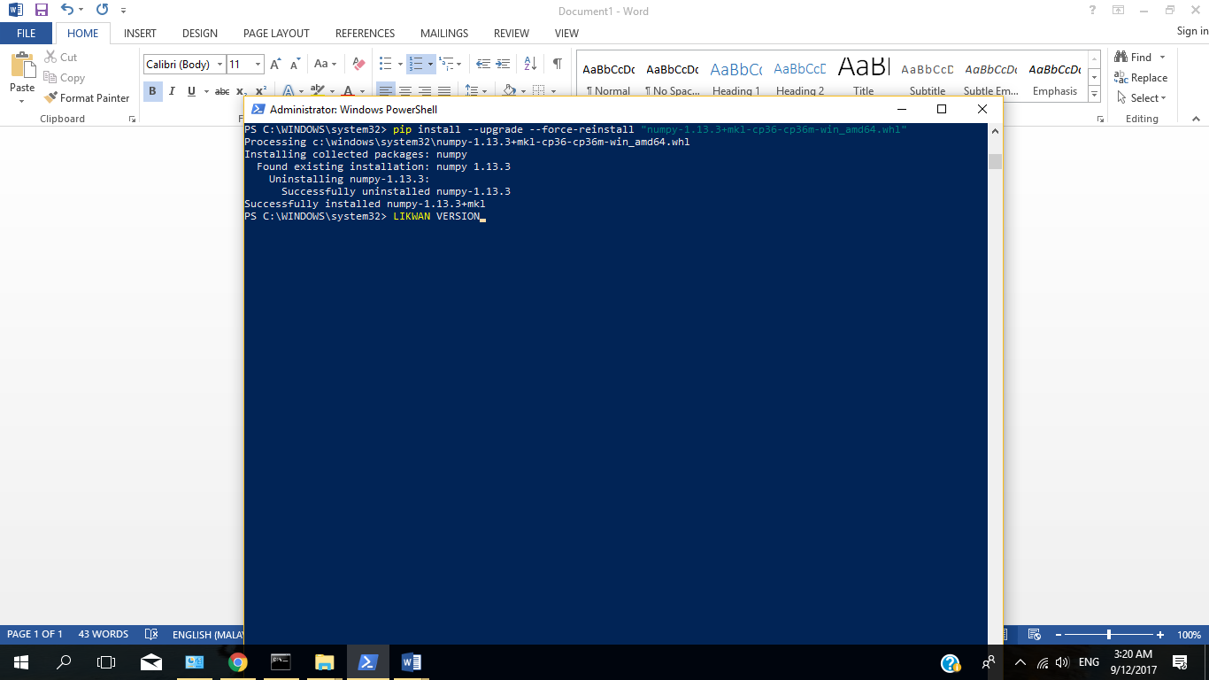
9. **THERE U GO :’D**