Networks formd by Bottlebrush copolymers: Double gyroid leaves while single diamond comes

Li Luyang, Frank S. Bates,* and Kevin D. Dorfman†

Department of Chemical Engineering and Materials Science, University of Minnesota -- Twin Cities, Minneapolis, Minnesota 55455, United States
ABSTRACT. Bottlebrush polymers

Perhaps the way to start is to prepare a short (no more than 1 page) outline of what will be covered. Bulleted points summarizing the (i) Introduction, (ii) technical approach, (iii), results, and (iv) consequences and outlook. I have copied Kevin in the event he has further guidance.

I. INTRODUCTION.
Block copolymers can self-assembly into many types of ordered materials at the nano scale. But the unit size, that is, the length of the simplest periodic unit is limited by the chain entangling. Changing the linear polymers with the bottlebrush polymers is an effective way of building the ordered structures with increasing unit cells.
Bottlebrush polymers are

II. TECHNICAL APPROACH

Sufficient detail for the work to be reproduced should be provided. Details can be supplemented by discussions in the Supplemental Material and/or Appendices.
E=hν (1)

A. Dissipative particle dynamics (DPD) simulation
Heading is centered, the first word is capitalized, and it is preceded by a roman capital letter and a period.

B. Molecular characterization
The heading is centered, the first word is capitalized, all italic, preceded by an Arabic number a period.

__________________________
a. Third subheading. The heading follows a paragraph indentation, first word capitalized, all italic, regular weight, preceded by a lowercase letter and period. Text immediately follows.

Letter or number preceding any subheading is not required if there is only one subheading at that level.

III. RESULTS
The Results section contains key data that support the conclusions and may be divided with subheadings (with the same formatting as subheadings listed in the Methods section).

Further data not crucial to a reader’s understanding of the associated paper can be presented in Supplemental Material and/or Appendices.

Figures should be numbered with Arabic numerals (1, 2, 3, etc.) and parts labeled with lowercase letters (a), (b), (c), etc. Each figure should be mentioned and discussed in the text. Parts of figures can be cited in the text, e.g., Fig. 1(a). Upon submission, figures can be placed where they are relevant within the text. Individual files for each figure should also be uploaded with the submission.

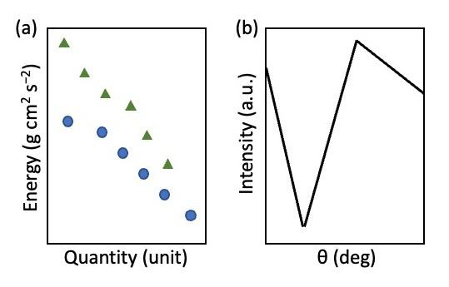
FIG 1. Caption.

Tables should be numbered with roman numerals (I, II, III, etc.).

TABLE I. Caption should be concise and descriptive. It should be self-contained and should not carry any footnote indicators. References can be cited in captions [1].

 | Header X | Header Yª | Header Z
Row 1 | entry | entry | entry
Row 2 | entry | entry | entry
Row 3 | entry | entry | b
Abbreviations should be defined.
Footnotes may cite a reference and should be superscript when they refer to an entry or heading, and they should be placed on line when they replace an entry.
ªReference [1].
^{b}Reference [2].

IV. CONSEQUENCES AND OUTLOOK
The Discussion section may be divided into subheadings and may be combined with the Results section.

ACKNOWLEDGMENTS
One paragraph provides acknowledgement to financial support.

If you chose to include a Supplemental Material file, please ensure that all references in the Supplemental Material also appear in the Reference section of the main paper. A reference for the Supplemental Material should be cited in the text. For example: see simulations based on parameters from the literature in the Supplemental Material [20].

Further examples of formats for other reference types can be found in the APS Journals Style Guide
[1] (journal article, one author) J. M. Smith, Phys. Rev. B 107, 1 (2023).
[2] (journal article, two authors) J. M. Smith and R. Brown, Phys. Rev. B 107, 1 (2023).
[3] (journal article, ten or fewer authors) J. M. Smith, R. Brown, C. Green, D. Jones, and A. Lee, Phys. Rev. B 107, 1 (2023).
[4] (journal article, length is constrained by four or more authors) J. M. Smith et al., Phys. Rev. B 107, 1 (2023).
.
.
.
[20] See Supplemental Material [url] for [brief description], which includes Refs. [21-24].
[21] [first reference in Supplemental Material not already in paper] ...
[24] [last reference in Supplemental Material not already in paper]

