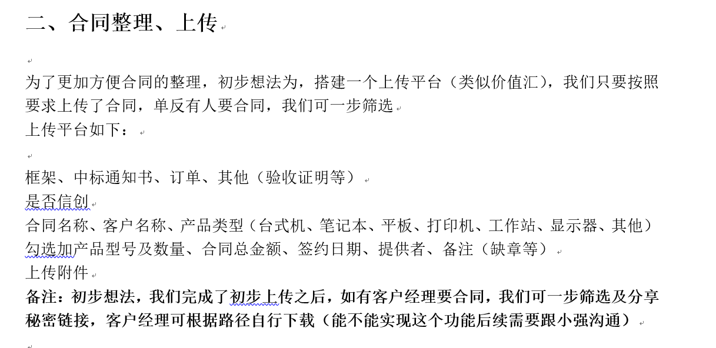

标案合同管理系统 contract

一、数据库设计

admin用户表

|  |  |  |  |  |
| --- | --- | --- | --- | --- |
| 名称 | 类型 | 长度 | 键 | 注释 |
| admin_id | varchar | 32 | 主键 | UUID |
| admin_name | varchar | 50 |  | 用户姓名 |
| admin_account | varchar | 50 |  | 用户账号 |
| admin_password | varchar | 50 |  | 密码 |
| admin_role | varchar | 50 | 外键-dictionary | 用户角色 |

dictionary_type字典类别表

|  |  |  |  |  |
| --- | --- | --- | --- | --- |
| 名称 | 类型 | 长度 | 键 | 注释 |
| type_id | varchar | 32 | 主键 | UUID |
| type_name | varchar | 50 |  | 字典类型名称 |
| type_edit | tinyint | 1 |  | 能否编辑 |

|  |  |  |
| --- | --- | --- |
| ADMIN_ROLE | 用户角色 | 0 |
| AGREEMENT_TYPE | 合同类型 | 1 |
| AGREEMENT_UPLOAD_TYPE | 合同上传类型 | 0 |
| PRODUCT_TYPE | 产品类型 | 1 |
| SHARE_TYPE | 分享类型 | 0 |
| LOG_TYPE | 日志类型 | 0 |

dictionary字典表

|  |  |  |  |  |
| --- | --- | --- | --- | --- |
| 名称 | 类型 | 长度 | 键 | 注释 |
| dictionary_id | varchar | 32 | 主键 | UUID |
| dictionary_code | varchar | 32 |  | 字典项代码 |
| dictionary_sort | int |  |  | 字典项排序 |
| dictionary_name | varchar | 50 |  | 字典项名称 |
| dictionary_type | varchar | 32 | 外键-dictionary_type. type_id | 字典类型 |
| dictionary_father | varchar | 32 | 外键-dictionary.dictionary_id | 字典父节点 |

|  |  |  |  |  |
| --- | --- | --- | --- | --- |
| admin_role_master | 1 | 1 | 超级管理员 | ADMIN_ROLE |
| admin_role_normal | 2 | 2 | 普通管理员 | ADMIN_ROLE |
| agreement_type_1 | 1 | 1 | 框架 | AGREEMENT_TYPE |
| agreement_type_2 | 2 | 2 | 中标通知书 | AGREEMENT_TYPE |
| agreement_type_3 | 3 | 3 | 订单 | AGREEMENT_TYPE |
| agreement_type_4 | 4 | 4 | 验收证明 | AGREEMENT_TYPE |
| agreement_type_5 | 5 | 5 | 其他 | AGREEMENT_TYPE |
| agreement_upload_type_admin | 1 | 1 | 管理员上传 | AGREEMENT_UPLOAD_TYPE |
| agreement_upload_type_user | 2 | 2 | 用户上传 | AGREEMENT_UPLOAD_TYPE |
| product_type_1 | 1 | 1 | 台式机 | PRODUCT_TYPE |
| product_type_2 | 2 | 2 | 笔记本 | PRODUCT_TYPE |
| product_type_3 | 3 | 3 | 平板 | PRODUCT_TYPE |
| product_type_4 | 4 | 4 | 打印机 | PRODUCT_TYPE |
| product_type_5 | 5 | 5 | 工作站 | PRODUCT_TYPE |
| product_type_6 | 6 | 6 | 显示器 | PRODUCT_TYPE |
| product_type_7 | 7 | 7 | 其他 | PRODUCT_TYPE |
| share_type_upload | 1 | 1 | 上传文件 | SHARE_TYPE |
| share_type_download | 2 | 2 | 下载文件 | SHARE_TYPE |
| log_type_login | 1 | 1 | 管理员登录 | LOG_TYPE |
| log_type_share_access | 2 | 2 | 进入分享页面 | LOG_TYPE |
| log_type_share_upload | 3 | 3 | 分享页面上传文件 | LOG_TYPE |
| log_type_share_download | 4 | 4 | 分享页面下载文件 | LOG_TYPE |
| log_type_share_add | 5 | 5 | 添加分享链接 | LOG_TYPE |
| log_type_share_update | 6 | 6 | 更新分享链接 | LOG_TYPE |
| log_type_share_delete | 7 | 7 | 删除分享链接 | LOG_TYPE |
| log_type_agreement_add | 8 | 8 | 添加合同 | LOG_TYPE |
| log_type_agreement_update | 9 | 9 | 修改合同 | LOG_TYPE |
| log_type_agreement_delete | 10 | 10 | 删除合同 | LOG_TYPE |

power_role 权限角色表

|  |  |  |  |  |
| --- | --- | --- | --- | --- |
| 名称 | 类型 | 长度 | 键 | 注释 |
| power_role_id | varchar | 32 | 主键 | UUID |
| power_id | varchar | 32 |  | 权限 |
| role_id | varchar | 32 | 外键-dictionary.dictionary_id | 角色 |

power 权限表

|  |  |  |  |  |
| --- | --- | --- | --- | --- |
| 名称 | 类型 | 长度 | 键 | 注释 |
| power_id | varchar | 32 | 主键 | UUID |
| power_name | varchar | 20 |  | 权限名称 |
| power_router | varchar | 60 |  | 权限路由 |
| power_level | int |  |  | 级别 |
| power_father | varchar | 32 |  | 父权限 |

agreement 合同表

|  |  |  |  |  |
| --- | --- | --- | --- | --- |
| 名称 | 类型 | 长度 | 键 | 注释 |
| agreement_id | varchar | 32 | 主键 | UUID |
| agreement_name | varchar | 100 |  | 合同名称 |
| agreement_type | varchar | 32 | 外键-dictionary.dictionary_id | 合同类型 |
| agreement_innovation | tinyint | 1 |  | 是否信创 |
| agreement_client | varchar | 50 |  | 客户名称 |
| agreement_amount | varchar | 50 |  | 总金额 |
| agreement_sign_date | datetime |  |  | 签约日期 |
| agreement_provider | varchar | 50 |  | 提供者 |
| agreement_text | text |  |  | 备注 |
| agreement_upload_type | varchar | 32 | 外键-dictionary.dictionary_id | 上传类型 |
| agreement_upload_admin | varchar | 100 | 当upload_type=admin时  外键-admin.admin_id | 上传人 |
| agreement_upload_date | datetime |  |  | 上传时间 |
| agreement_delete | tinyint | 1 |  | 是否删除 |
| agreement_extend | varchar | 32 |  | 文件扩展名 |

agreement_product

|  |  |  |  |  |
| --- | --- | --- | --- | --- |
| 名称 | 类型 | 长度 | 键 | 注释 |
| product_id | varchar | 32 | 主键 | UUID |
| product_agreement | varchar | 32 | 外键agreement- agreement_id | 所属合同 |
| product_type | varchar | 32 | 外键-dictionary.dictionary_id | 产品类型 |
| product_model | varchar | 100 |  | 产品型号 |
| product_number | varchar | 100 |  | 产品数量 |

share 分享表

|  |  |  |  |  |
| --- | --- | --- | --- | --- |
| 名称 | 类型 | 长度 | 键 | 注释 |
| share_id | varchar | 32 | 主键 | UUID |
| share_admin | varchar | 32 | 外键-admin.admin_id | 分享人 |
| share_type | varchar | 32 | 外键-dictionary.dictionary_id | 分享类型 |
| share_begin_date | datetime |  |  | 分享开始时间 |
| share_end_date | datetime |  |  | 分享结束时间 |
| share_has_password | tinyint | 1 |  | 是否密码保护 |
| share_password | varchar | 50 |  | 密码 |
| share_delete | tinyint | 1 |  | 是否删除 |

share_agreement

|  |  |  |  |  |
| --- | --- | --- | --- | --- |
| 名称 | 类型 | 长度 | 键 | 注释 |
| share_agreement_id | varchar | 32 | 主键 | UUID |
| share_id | varchar | 32 | 外键- share.share_id | 所属分享 |
| agreement_id | varchar | 32 | 外键- agreement.agreement_id | 分享开始时间 |

二、功能模块设计

管理员

1.用户管理

2.字典管理

3.日志管理

4.合同管理

5.分享管理

用户

1.分享查看

2合同上传