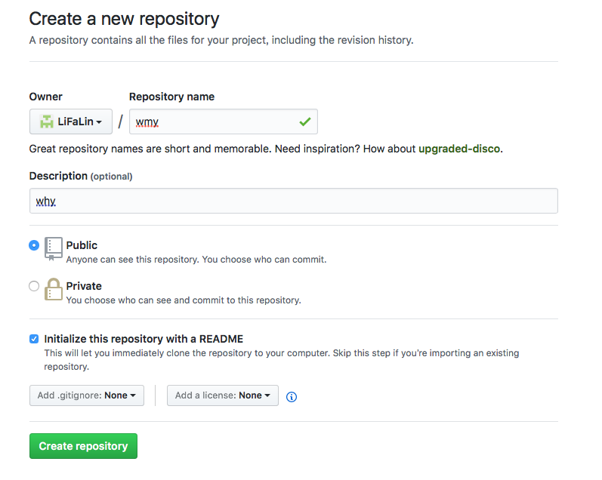

Last login: Thu May 4

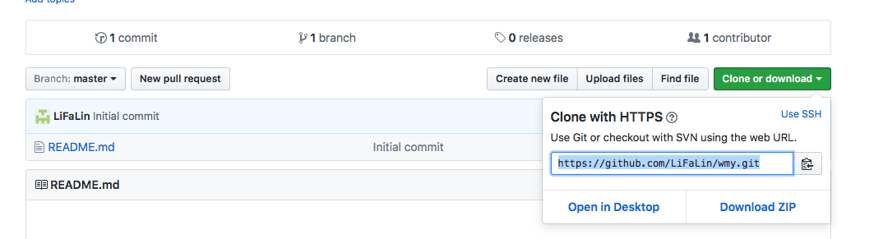



11:46:02 on ttys000

步骤一 先mkdir 创建一个远程仓库

lifalindeiMac:~ lifalin$ mkdir /Users/lifalin/Desktop/未命名文件夹\ 2

mkdir: /Users/lifalin/Desktop/未命名文件夹 2: File exists

步骤二 cd 仓库

lifalindeiMac:~ lifalin$ cd /Users/lifalin/Desktop/未命名文件夹\ 2

git clone

lifalindeiMac:未命名文件夹 2 lifalin$ git clone <https://github.com/LiFaLin/wmy.git>

Cloning into 'wmy'...

remote: Counting objects: 3, done.

remote: Total 3 (delta 0), reused 0 (delta 0), pack-reused 0

Unpacking objects: 100% (3/3), done.



在clone下来的文件里修改或者添加东西

步骤三 让git 成为一个仓库

lifalindeiMac:未命名文件夹 2 lifalin$ git init

Initialized empty Git repository in /Users/lifalin/Desktop/未命名文件夹 2/.git/

步骤四 添加名为origin master 的远程仓库

lifalindeiMac:未命名文件夹 2 lifalin$ git remote add origin master

lifalindeiMac:未命名文件夹 2 lifalin$

Last login: Thu May 4 11:41:53 on ttys000

步骤五 cd clone下来的文件

lifalindeiMac:~ lifalin$ cd /Users/lifalin/Desktop/未命名文件夹/qwe

步骤六

lifalindeiMac:qwe lifalin$ git status

On branch master

Your branch is up-to-date with 'origin/master'.

Untracked files:

(use "git add <file>..." to include in what will be committed)

"\345\221\250\346\212\245_\346\235\216\345\217\221\346\236\227.rtf"

nothing added to commit but untracked files present (use "git add" to track)

步骤七

lifalindeiMac:qwe lifalin$ git add .

步骤八

lifalindeiMac:qwe lifalin$ git status

On branch master

Your branch is up-to-date with 'origin/master'.

Changes to be committed:

(use "git reset HEAD <file>..." to unstage)

new file: "\345\221\250\346\212\245_\346\235\216\345\217\221\346\236\227.rtf"

步骤九

lifalindeiMac:qwe lifalin$ git commit -m “123"

[master cf19a86] 123

1 file changed, 14 insertions(+)

create mode 100644 “\345\221\250\346\212\245_\346\235\216\345\217\221\346\236\227.rtf"

步骤十

lifalindeiMac:qwe lifalin$ git pull https://github.com/LiFaLin/qwe.git

From https://github.com/LiFaLin/qwe

* branch HEAD -> FETCH_HEAD

Already up-to-date.

步骤十一

lifalindeiMac:qwe lifalin$ git remote add origin <https://github.com/LiFaLin/qwe.git>

fatal: remote origin already exists.

步骤十二

lifalindeiMac:qwe lifalin$ git push -u origin master

Counting objects: 3, done.

Delta compression using up to 4 threads.

Compressing objects: 100% (3/3), done.

Writing objects: 100% (3/3), 752 bytes | 0 bytes/s, done.

Total 3 (delta 0), reused 0 (delta 0)

To https://github.com/LiFaLin/qwe.git

7db6957..cf19a86 master -> master

Branch master set up to track remote branch master from origin.

lifalindeiMac:qwe lifalin$