i.MX6X Freescale Website Guide

by JohnLi(R64710)  
GSM FAE   
Freescale Semiconductor, Inc.  
Shanghai,

This application note shows how to get i.MX6X development resources from Freescale website.

We can enter Freescale i.MX website by the follow link <http://www.freescale.com/imx>, and after we input it into the IE address, it will remap to the new address of <http://www.freescale.com/webapp/sps/site/homepage.jsp?code=IMX_HOME&tid=vanIMX>.

And the website page will have all the i.MX chipsets access web links like the follows:

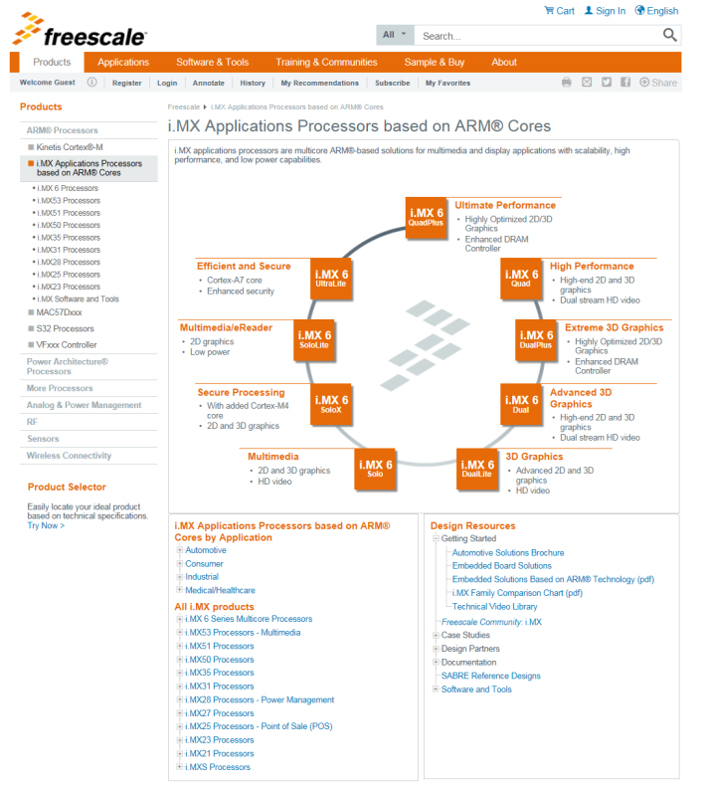

Contents

1 i.MX6Q/D Website Guide 3

1.1 i.MX6Q/D Documentation 4

1.2 i.MX6Q/D Software & Tools 8

2 i.MX6DL/S Website Guide 20

2.1 i.MX6DL/S Documentation 21

2.2 i.MX6DL/S Software & Tools 23

3 i.MX6SL Website Guide 27

3.1 i.MX6SL Documentation 28

3.2 i.MX6SL Software & Tools 30

4 i.MX6SX Website Guide 33

4.1 i.MX6SX Documentation 34

4.2 i.MX6SX Software & Tools 35

5 i.MX6UL Website Guide 40

5.1 i.MX6UL Documentation 41

6 i.MX6QP/DP Website Guide 42

6.1 i.MX6QP/DP Documentation 43

7 i.MX6 Android and Linux BSP and Demo Images 44

7.1 Android BSP and Demo Images 44

7.2 Linux BSP and Demo Images 45

And if we enter the i.MX6 serials Processors web link <http://www.freescale.com/webapp/sps/site/taxonomy.jsp?code=IMX6X_SERIES> , we will get the page like the follows:

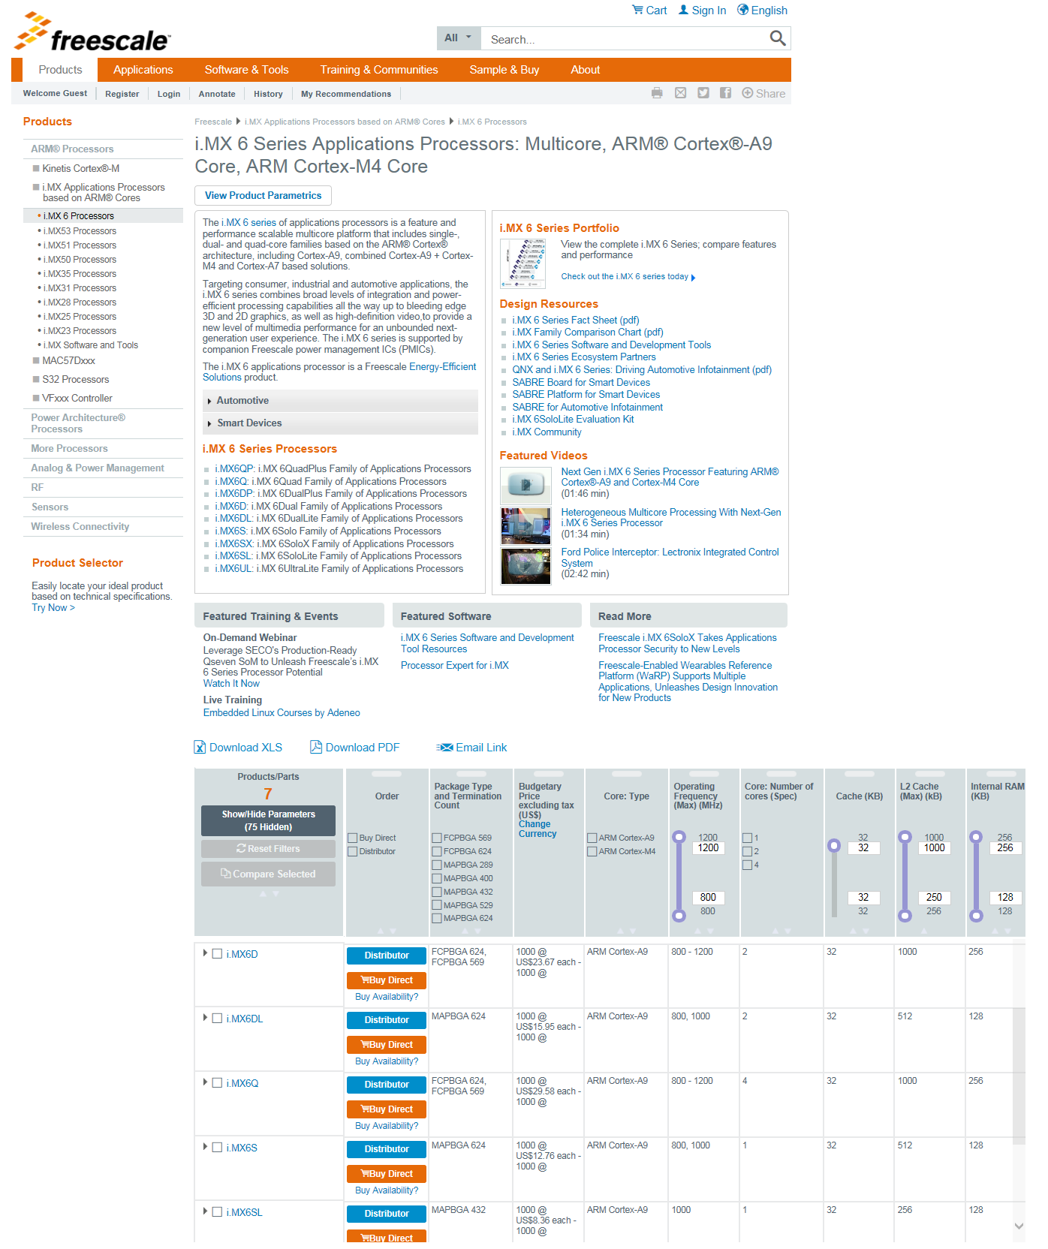

Which have all the i.MX6 series processors feature lists and website links.

# i.MX6Q/D Website Guide

We enter the i.MX6Q/D web link

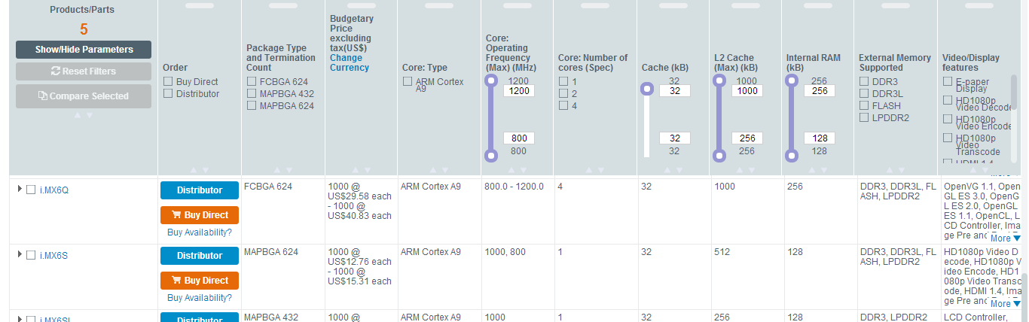

<http://www.freescale.com/webapp/sps/site/prod_summary.jsp?code=i.MX6Q>

its main page as follows:

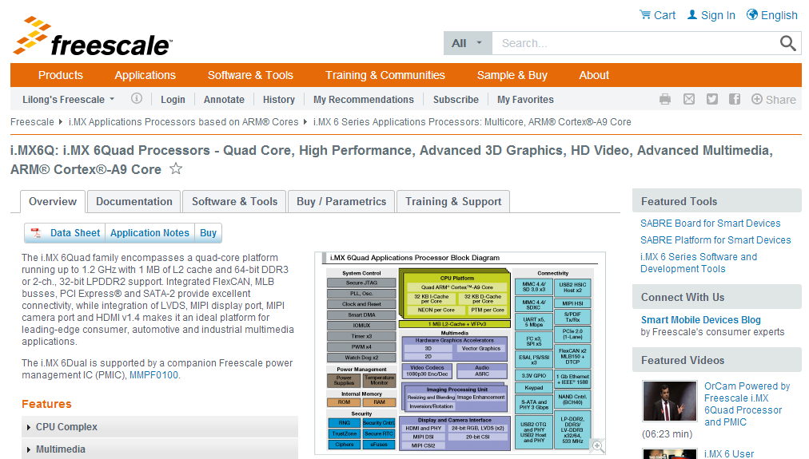

The Documentation and Software & Tools items are very important to get the design resource, and the Buy/Parametrics item will have the development board and chipset order information.

## i.MX6Q/D Documentation

We enter the Documentation item link: <http://www.freescale.com/webapp/sps/site/prod_summary.jsp?code=i.MX6Q&nodeId=018rH3ZrDRB24A&fpsp=1&tab=Documentation_Tab>, which will have our documentation materials include the Datasheet, Errata, Application Notes, Reference Manual, User guides, Fact Sheets and related supporting information.

### i.MX6Q/D Datasheet

We have i.MX6Q/D datasheets of automotive, consumer and industrial, the datasheet will have the chipset mark number, electrical, thermal and package information.

[IMX6DQCPOPEC](http://cache.freescale.com/files/32bit/doc/data_sheet/IMX6DQCPOPEC.pdf?fasp=1&WT_TYPE=Data%20Sheets&WT_VENDOR=FREESCALE&WT_FILE_FORMAT=pdf&WT_ASSET=Documentation&fileExt=.pdf)   
i.MX 6Dual/6Quad Consumer-PoP Applications Processor Data Sheet

[IMX6DQAEC](http://cache.freescale.com/files/32bit/doc/data_sheet/IMX6DQAEC.pdf?fpsp=1&WT_TYPE=Data%20Sheets&WT_VENDOR=FREESCALE&WT_FILE_FORMAT=pdf&WT_ASSET=Documentation)   
i.MX 6Dual/6Quad Automotive and Infotainment Applications Processors

[IMX6DQCEC](http://cache.freescale.com/files/32bit/doc/data_sheet/IMX6DQCEC.pdf?fpsp=1&WT_TYPE=Data%20Sheets&WT_VENDOR=FREESCALE&WT_FILE_FORMAT=pdf&WT_ASSET=Documentation)   
i.MX 6Dual/6Quad Applications Processors for Consumer Products

[IMX6DQIEC](http://cache.freescale.com/files/32bit/doc/data_sheet/IMX6DQIEC.pdf?fpsp=1&WT_TYPE=Data%20Sheets&WT_VENDOR=FREESCALE&WT_FILE_FORMAT=pdf&WT_ASSET=Documentation)   
i.MX 6Dual/6Quad Applications Processors for Industrial Products

### i.MX6Q/D Errata

Chipset Errata will show us our current version chipset bugs and rework method.

[IMX6DQCE](http://cache.freescale.com/files/32bit/doc/errata/IMX6DQCE.pdf?fpsp=1&WT_TYPE=Errata&WT_VENDOR=FREESCALE&WT_FILE_FORMAT=pdf&WT_ASSET=Documentation)   
Chip Errata for the i.MX 6Dual/6Quad

### i.MX6Q/D Application Notes

[AN4686](http://cache.freescale.com/files/32bit/doc/app_note/AN4686.pdf?fasp=1&WT_TYPE=Application%20Notes&WT_VENDOR=FREESCALE&WT_FILE_FORMAT=pdf&WT_ASSET=Documentation&fileExt=.pdf)  
Configuring Secure JTAG for the i.MX 6 Series Family of Applications Processors

[AN4629](http://cache.freescale.com/files/32bit/doc/app_note/AN4629.pdf?fasp=1&WT_TYPE=Application%20Notes&WT_VENDOR=FREESCALE&WT_FILE_FORMAT=pdf&WT_ASSET=Documentation&fileExt=.pdf)  
Fast Image Processing with i.MX 6 Series

[AN4467](http://cache.freescale.com/files/32bit/doc/app_note/AN4467.pdf?fasp=1&WT_TYPE=Application%20Notes&WT_VENDOR=FREESCALE&WT_FILE_FORMAT=pdf&WT_ASSET=Documentation&fileExt=.pdf)  
i.MX 6 Series DDR Calibration

[AN4589](http://cache.freescale.com/files/32bit/doc/app_note/AN4589.pdf?fasp=1&WT_TYPE=Application%20Notes&WT_VENDOR=FREESCALE&WT_FILE_FORMAT=pdf&WT_ASSET=Documentation&fileExt=.pdf)  
Configuring USB on i.MX 6 Series Processors

[AN5078](http://cache.freescale.com/files/32bit/doc/app_note/AN5078.pdf?fasp=1&WT_TYPE=Application%20Notes&WT_VENDOR=FREESCALE&WT_FILE_FORMAT=pdf&WT_ASSET=Documentation&fileExt=.pdf)  
Influence of Pin Setting on System Function and Performance

[AN4724](http://cache.freescale.com/files/32bit/doc/app_note/AN4724.pdf?fpsp=1&WT_TYPE=Application%20Notes&WT_VENDOR=FREESCALE&WT_FILE_FORMAT=pdf&WT_ASSET=Documentation)   
i.MX 6Dual/6Quad Product Usage Lifetime Estimates

[AN4952](http://cache.freescale.com/files/32bit/doc/app_note/AN4952.pdf?fasp=1&WT_TYPE=Application%20Notes&WT_VENDOR=FREESCALE&WT_FILE_FORMAT=pdf&WT_ASSET=Documentation)   
i.MX 6 Audio Clock Configuration Options

[AN4784](http://cache.freescale.com/files/32bit/doc/app_note/AN4784.pdf?fasp=1&WT_TYPE=Application%20Notes&WT_VENDOR=FREESCALE&WT_FILE_FORMAT=pdf&WT_ASSET=Documentation)   
AN4784: PCIe Certification Guide for i.MX 6Dual/6Quad and i.MX 6Solo/6DualLite - Application Note

[AN4397](http://cache.freescale.com/files/32bit/doc/app_note/AN4397.pdf?fpsp=1&WT_TYPE=Application%20Notes&WT_VENDOR=FREESCALE&WT_FILE_FORMAT=pdf&WT_ASSET=Documentation)  **//all the i.MX6 Serial can use the same PCB, this doc descript the hardware design difference**  
Common Hardware Design for i.MX 6Dual/6Quad and i.MX 6Solo/6DualLite

[AN4671](http://cache.freescale.com/files/32bit/doc/app_note/AN4671.pdf?fpsp=1&WT_TYPE=Application%20Notes&WT_VENDOR=FREESCALE&WT_FILE_FORMAT=pdf&WT_ASSET=Documentation)   
i.MX 6 Series HDMI Test Method for Eye Pattern and Electrical Characteristics

[AN4686](http://cache.freescale.com/files/32bit/doc/eng_bulletin/AN4686.pdf?fasp=1)   
Configuring Secure JTAG for the i.MX 6 Series Family of Applications Processors

[AN4629](http://cache.freescale.com/files/32bit/doc/app_note/AN4629.pdf?fpsp=1&WT_TYPE=Application%20Notes&WT_VENDOR=FREESCALE&WT_FILE_FORMAT=pdf&WT_ASSET=Documentation)   
Fast Image Processing with i.MX 6 Series

[AN4579](http://cache.freescale.com/files/32bit/doc/app_note/AN4579.pdf?fpsp=1&WT_TYPE=Application%20Notes&WT_VENDOR=FREESCALE&WT_FILE_FORMAT=pdf&WT_ASSET=Documentation) // **explain the thermal design**  
i.MX 6 Series Thermal Management Guidelines

[AN4581](http://cache.freescale.com/files/32bit/doc/app_note/AN4581.pdf?fpsp=1&WT_TYPE=Application%20Notes&WT_VENDOR=FREESCALE&WT_FILE_FORMAT=pdf&WT_ASSET=Documentation)   
Secure Boot on i.MX50, i.MX53, and i.MX 6 Series using HABv4

[AN4509](http://cache.freescale.com/files/32bit/doc/app_note/AN4509.pdf?fpsp=1&WT_TYPE=Application%20Notes&WT_VENDOR=FREESCALE&WT_FILE_FORMAT=pdf&WT_ASSET=Documentation)  **//explan the i.MX6D/Q power consumption in every working features.**  
i.MX 6Dual/6Quad Power Consumption Measurement

[AN4589](http://cache.freescale.com/files/32bit/doc/app_note/AN4589.pdf?fpsp=1&WT_TYPE=Application%20Notes&WT_VENDOR=FREESCALE&WT_FILE_FORMAT=pdf&WT_ASSET=Documentation)   
Configuring USB on i.MX 6 Series Processors

[AN4467](http://cache.freescale.com/files/32bit/doc/app_note/AN4467.pdf?fpsp=1&WT_TYPE=Application%20Notes&WT_VENDOR=FREESCALE&WT_FILE_FORMAT=pdf&WT_ASSET=Documentation) **//explain the ddr calibration method, need check with FSL FAE for DDR test calibration tools**  
i.MX 6 Series DDR Calibration

[AN4553](http://cache.freescale.com/files/32bit/doc/app_note/AN4553.pdf?fpsp=1&WT_TYPE=Application%20Notes&WT_VENDOR=FREESCALE&WT_FILE_FORMAT=pdf&WT_ASSET=Documentation)   
Using Open Source Debugging Tools for Linux on i.MX Processors

### i.MX6Q/D Chipset Reference Manuals

[IMX6DQRM](http://cache.freescale.com/files/32bit/doc/ref_manual/IMX6DQRM.pdf?fpsp=1&WT_TYPE=Reference%20Manuals&WT_VENDOR=FREESCALE&WT_FILE_FORMAT=pdf&WT_ASSET=Documentation)  //**i.MX6DQ reference manual for all the internal module description and registers define.**  
i.MX 6Dual/6Quad Applications Processor Reference Manual

[IMX6DQ6SDLSRM](https://www.freescale.com/webapp/Download?colCode=IMX6DQ6SDLSRM&appType=moderatedWithoutFAE&fpsp=1&WT_TYPE=Reference%20Manuals&WT_VENDOR=FREESCALE&WT_FILE_FORMAT=pdf&WT_ASSET=Documentation) SECURITYINFOIMAGE // **i.MX6DQ security related reference manual, need NDA approve.**  
Security Reference Manual for i.MX 6

### i.MX6Q/D Users Guides

[IMX6DQ6SDLHDG](http://cache.freescale.com/files/32bit/doc/user_guide/IMX6DQ6SDLHDG.pdf?fpsp=1&WT_TYPE=Users%20Guides&WT_VENDOR=FREESCALE&WT_FILE_FORMAT=pdf&WT_ASSET=Documentation)  **//i.MX6DQ hardware design user guide, include the schematic layout check points, hardware bring up…**  
Hardware Development Guide for i.MX 6Quad, 6Dual, 6DualLite, 6Solo Families of Applications

### Engineering Bulletins

[EB814](http://cache.freescale.com/files/32bit/doc/eng_bulletin/EB814.pdf?fasp=1&WT_TYPE=Engineering%20Bulletins&WT_VENDOR=FREESCALE&WT_FILE_FORMAT=pdf&WT_ASSET=Documentation&fileExt=.pdf)  
Minimum/Maximum ESR Requirement for i.MX 6Dual/6Quad Analog Regulators - EB814

[EB803](http://cache.freescale.com/files/microcontrollers/doc/eng_bulletin/EB803.pdf?fasp=1&WT_TYPE=Engineering%20Bulletins&WT_VENDOR=FREESCALE&WT_FILE_FORMAT=pdf&WT_ASSET=Documentation)   
i.MX 6Dual/6Quad Applications Processor Silicon Revsion 1.2 to 1.3 Comparison - EB802

[EB793](http://cache.freescale.com/files/32bit/doc/eng_bulletin/EB793.pdf?fpsp=1&WT_TYPE=Engineering%20Bulletins&WT_VENDOR=FREESCALE&WT_FILE_FORMAT=pdf&WT_ASSET=Documentation)   
MISRA Compliance in Freescale Automotive C Language Header Files - Engineering Bulletin

[EB792](http://cache.freescale.com/files/32bit/doc/eng_bulletin/EB792.xlsx?fpsp=1&WT_TYPE=Engineering%20Bulletins&WT_VENDOR=FREESCALE&WT_FILE_FORMAT=xlsx&WT_ASSET=Documentation)   
i.MX 6 Series Standardized Signal Name Map

[EB790](http://cache.freescale.com/files/32bit/doc/eng_bulletin/EB790.pdf?fasp=1&WT_TYPE=Engineering%20Bulletins&WT_VENDOR=FREESCALE&WT_FILE_FORMAT=pdf&WT_ASSET=Documentation)  
Configuration of Phase Fractional Dividers

### i.MX6Q/D Fact Sheets

[IMX6SRSFS](http://cache.freescale.com/files/32bit/doc/fact_sheet/IMX6SRSFS.pdf?fasp=1&WT_TYPE=Fact%20Sheets&WT_VENDOR=FREESCALE&WT_FILE_FORMAT=pdf&WT_ASSET=Documentation&fileExt=.pdf)    
i.MX 6 Series of Applications Processors - Fact Sheet

### i.MX6Q/D Brochures

[FREESCALEARM](http://cache.freescale.com/files/32bit/doc/brochure/FREESCALEARM.pdf?fasp=1&WT_TYPE=Brochures&WT_VENDOR=FREESCALE&WT_FILE_FORMAT=pdf&WT_ASSET=Documentation&fileExt=.pdf)   
Freescale Embedded Solutions Based on ARM Technology Guide

### i.MX6Q/D Product Change Notices

[PCN16354](http://cache.freescale.com/files/shared/doc/pcn/PCN16354.htm?fasp=1&WT_TYPE=Product%20Change%20Notices&WT_VENDOR=FREESCALE&WT_FILE_FORMAT=htm&WT_ASSET=Documentation&fileExt=.htm)   
i.MX 6Quad/6Dual Reference Manual Update

[PCN16355](http://cache.freescale.com/files/shared/doc/pcn/PCN16355.htm?fasp=1&WT_TYPE=Product%20Change%20Notices&WT_VENDOR=FREESCALE&WT_FILE_FORMAT=htm&WT_ASSET=Documentation&fileExt=.htm)   
i.MX 6Quad/6Dual Errata Document Update

### Supporting Information

***Note: This section contains some documents for BSP/Codec.***

[IMX6_L500_100_ANDROID_DOCS](https://www.freescale.com/webapp/Download?colCode=IMX6_L500_100_ANDROID_DOCS&location=null&fasp=1&WT_TYPE=Supporting%20Information&WT_VENDOR=FREESCALE&WT_FILE_FORMAT=gz&WT_ASSET=Documentation&fileExt=.gz) SECURITYINFOIMAGE   
i.MX6 Android L5.0.0_1.0.0 BSP Documentation

[IMX6L31428101RN](http://cache.freescale.com/files/32bit/doc/support_info/IMX6L31428101RN.pdf?fasp=1&WT_TYPE=Supporting%20Information&WT_VENDOR=FREESCALE&WT_FILE_FORMAT=pdf&WT_ASSET=Documentation&fileExt=.pdf)   
i.MX 6 Yocto Project L3.14.28_1.0.1 Patch Release Notes -Release Notes

[L3.10.53_1.1.0_LINUX_DOCS](https://www.freescale.com/webapp/Download?colCode=L3.10.53_1.1.0_LINUX_DOCS&location=null&fasp=1&WT_TYPE=Supporting%20Information&WT_VENDOR=FREESCALE&WT_FILE_FORMAT=gz&WT_ASSET=Documentation&fileExt=.gz) SECURITYINFOIMAGE   
i.MX 6Quad, i.MX 6Dual, i.MX 6DualLite, i.MX 6Solo and i.MX 6Sololite Linux BSP Documentation. Includes Release Notes,...

[L3.14.28_1.0.0_LINUX_DOCS](https://www.freescale.com/webapp/Download?colCode=L3.14.28_1.0.0_LINUX_DOCS&location=null&fasp=1&WT_TYPE=Supporting%20Information&WT_VENDOR=FREESCALE&WT_FILE_FORMAT=gz&WT_ASSET=Documentation&fileExt=.gz) SECURITYINFOIMAGE   
L3.14.28_1.0.0_LINUX_DOCS

[IMX6YOCTOPATCHRN](http://cache.freescale.com/files/32bit/doc/support_info/IMX6YOCTOPATCHRN.pdf?fasp=1&WT_TYPE=Supporting%20Information&WT_VENDOR=FREESCALE&WT_FILE_FORMAT=pdf&WT_ASSET=Documentation&fileExt=.pdf)   
i.MX 6Quad, i.MX 6Dual, i.MX 6DualLite, i.MX 6Solo and i.MX 6Sololite Linux L3.10.53_1.1.1 - Release Notes.

[IMX6_KK443_200_ANDROID_DOCS](https://www.freescale.com/webapp/Download?colCode=IMX6_KK443_200_ANDROID_DOCS&location=null&fasp=1&WT_TYPE=Supporting%20Information&WT_VENDOR=FREESCALE&WT_FILE_FORMAT=gz&WT_ASSET=Documentation&fileExt=.gz) SECURITYINFOIMAGE   
i.MX6 Android kk4.4.3_2.0.0 BSP Documentation

[IMX6LXPATCHRN](https://www.freescale.com/webapp/Download?colCode=IMX6LXPATCHRN&appType=license&location=null&fasp=1&WT_TYPE=Supporting%20Information&WT_VENDOR=FREESCALE&WT_FILE_FORMAT=pdf&WT_ASSET=Documentation&fileExt=.pdf) SECURITYINFOIMAGE   
i.MX 6Quad, i.MX 6Dual, i.MX 6DualLite, i.MX 6Solo and i.MX 6Sololite Linux BSP Documentation. Patch Release Notes

[IMX6_JB43_111_ANDROID_DOCS](https://www.freescale.com/webapp/Download?colCode=IMX6_JB43_111_ANDROID_DOCS&location=null&fasp=1&WT_TYPE=Supporting%20Information&WT_VENDOR=FREESCALE&WT_FILE_FORMAT=gz&WT_ASSET=Documentation&fileExt=.gz) SECURITYINFOIMAGE   
i.MX 6Quad, i.MX 6Dual, i.MX 6DualLite, i.MX 6Solo and i.MX 6Sololite Android BSP Documentation

[IMX6_KK442_100_ANDROID_DOCS](https://www.freescale.com/webapp/Download?colCode=IMX6_KK442_100_ANDROID_DOCS&location=null&fasp=1&WT_TYPE=Supporting%20Information&WT_VENDOR=FREESCALE&WT_FILE_FORMAT=gz&WT_ASSET=Documentation) SECURITYINFOIMAGE   
i.MX6 Android kk4.4.2_1.0.0 BSP Documentation

[L3.10.17_1.0.0_LINUX_DOCS](https://www.freescale.com/webapp/Download?colCode=L3.10.17_1.0.0_LINUX_DOCS&appType=license&location=null&fasp=1&WT_TYPE=Supporting%20Information&WT_VENDOR=FREESCALE&WT_FILE_FORMAT=gz&WT_ASSET=Documentation)  
Linux 3.10.17 BSP & MM Bundle

[IMX6_JB43_110_ANDROID_DOCS](https://cache.freescale.com/secured/32bit/doc/support_info/android_jb4.3_1.1.0-ga_doc.tar.gz?fileExt=.gz&__gda__=1397618307_2a4a86254ddfa2caac21d967121e60f6) SECURITYINFOIMAGE   
i.MX 6Quad, i.MX 6Dual, i.MX 6DualLite, i.MX 6Solo and i.MX 6Sololite Android jb4.3_1.1.0 BSP Documentation. Includes...

[L3.0.35_4.1.0_LINUX_DOCS](https://cache.freescale.com/secured/32bit/doc/support_info/L3.0.35_4.1.0_docs.tar.gz?fileExt=.gz&__gda__=1397559413_717d90d33ae6ddaa0031aa7b5a204721)  
i.MX 6Quad, i.MX 6Dual, i.MX 6DualLite, i.MX 6Solo and i.MX 6Sololite Linux BSP Documentation. Includes Release Notes,...

Most important content in this package is under this path:

L3.0.35_4.1.0_130816_docs\doc\mx6

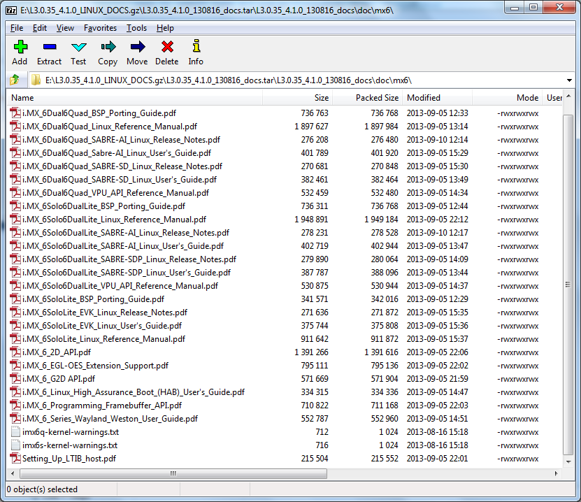

[L3.0.35_4.1.0_LINUX_MMDOCS](https://cache.freescale.com/secured/32bit/doc/support_info/Linux_Multimedia_Framework_Docs_MX6XUbuntu_3.0.7-2.tar.gz?fileExt=.gz&__gda__=1397559535_6e76391b9853f7261fb4a2f530ced81c) SECURITYINFOIMAGE   
i.MX 6Quad, i.MX 6Dual, i.MX 6DualLite, i.MX 6Solo and i.MX 6Sololite Linux Multimedia Codecs Documentation. Includes...

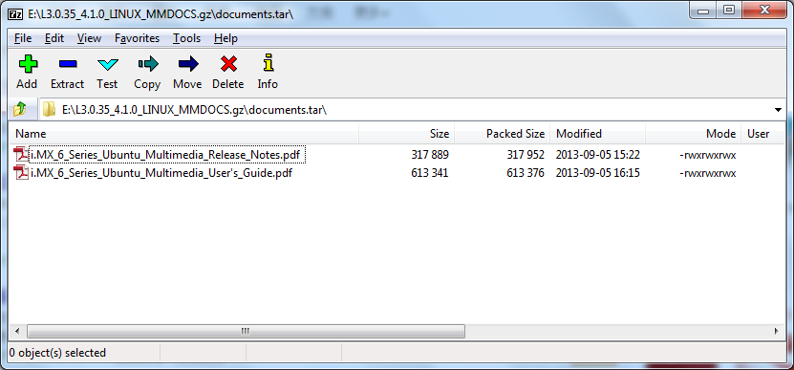

[IMX6_JB422_110_ANDROID_DOCS](https://cache.freescale.com/secured/32bit/doc/support_info/android_jb4.2.2_1.1.0-ga_doc.tar.gz?fileExt=.gz&__gda__=1397559626_b6eeeb41bdff1a4bad5c5cbf9560262d) SECURITYINFOIMAGE   
i.MX 6Quad, i.MX 6Dual, and i.MX 6DualLite Android jb4.2.2_1.1.0 BSP Documentation. Includes Release Notes, User's...

[IMX6_R13.41_ANDROID_DOC_BUNDLE](https://cache.freescale.com/secured/32bit/doc/support_info/imx-android-13.4.1_doc_bundle.tar.gz?fileExt=.gz&__gda__=1397618578_ca56acf081e97367149be25ff19afc89) SECURITYINFOIMAGE  
i.MX 6Quad, i.MX 6Dual, and i.MX 6DualLite Android 13.4.1 BSP Documentation. Android BSP Documentation. Includes...

[IMX_INFOCTR](http://cache.freescale.com/files/infocenter/IMX_INFOCTR.html?fpsp=1&WT_TYPE=Supporting%20Information&WT_VENDOR=FREESCALE&WT_FILE_FORMAT=html&WT_ASSET=Documentation) //**TIC support center**  
i.MX Infocenter—Online Documentation

[IMX6_R13.41_ANDROID_MM_RN](http://cache.freescale.com/files/32bit/doc/support_info/i_MX_Android_Codec_Release_Notes.html?fasp=1&WT_TYPE=Supporting%20Information&WT_VENDOR=FREESCALE&WT_FILE_FORMAT=html&WT_ASSET=Documentation)  
i.MX Android Codec Release Notes

## i.MX6Q/D Software & Tools

We enter into the Software & Tools item page: <http://www.freescale.com/webapp/sps/site/prod_summary.jsp?code=i.MX6Q&nodeId=018rH3ZrDRB24A&fpsp=1&tab=Design_Tools_Tab>

### i.MX6Q/D Reference Designs

[SABRE Platform for Smart Devices Reference Design Based on the i.MX 6 Series](http://www.freescale.com/webapp/sps/site/prod_summary.jsp?code=RDIMX6SABREPLAT)Favorite   
The Smart Application Blueprint for Rapid Engineering (SABRE) platform for smart devices allows you to evaluate the full multimedia performance capabilities of i.MX 6 series applications processors based on ARM® Cortex™-A9 technology.  The SABRE platform for smart devices provides a foundation ...

Enter it:

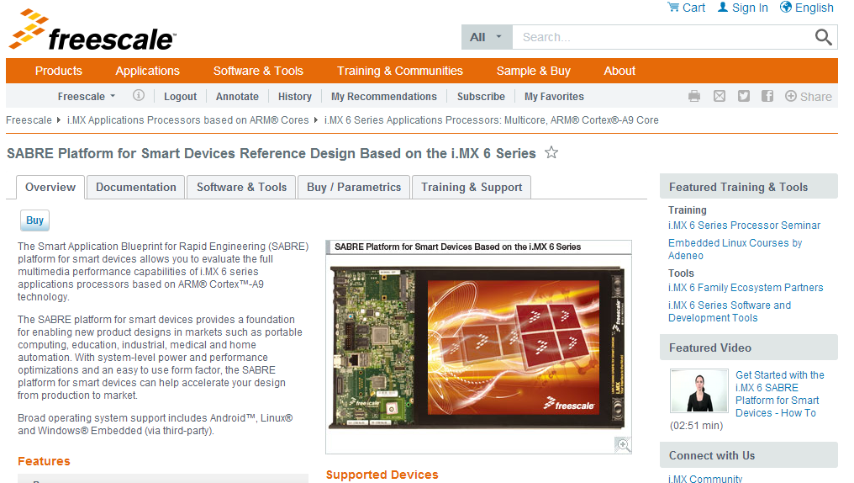

Press Buy:

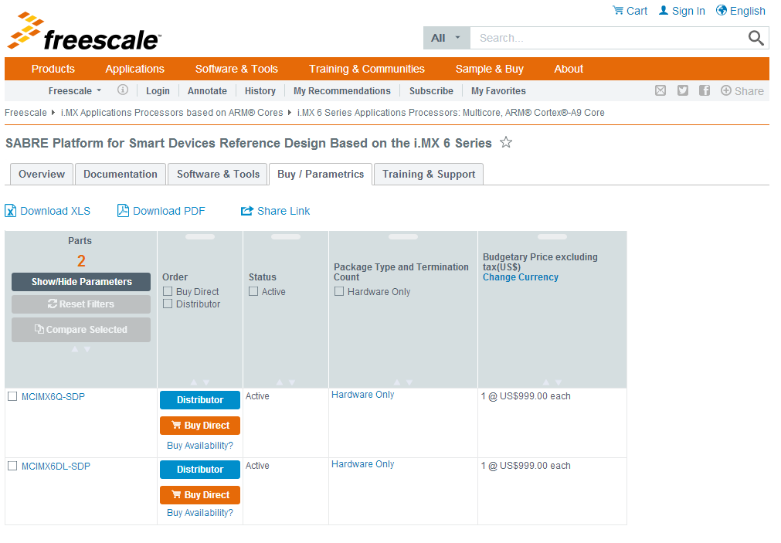

[SABRE Board for Smart Devices Reference Design Based on the i.MX 6 Series](http://www.freescale.com/webapp/sps/site/prod_summary.jsp?code=RDIMX6SABREBRD)Favorite   
Freescale's Smart Application Blueprint for Rapid Engineering (SABRE) board for smart devices introduces developers to multicore processing, low-power consumption and leading-edge multimedia and graphics applications on the i.MX 6 series applications processors. The SABRE board for smart devices simplifies product design ...

Enter it:

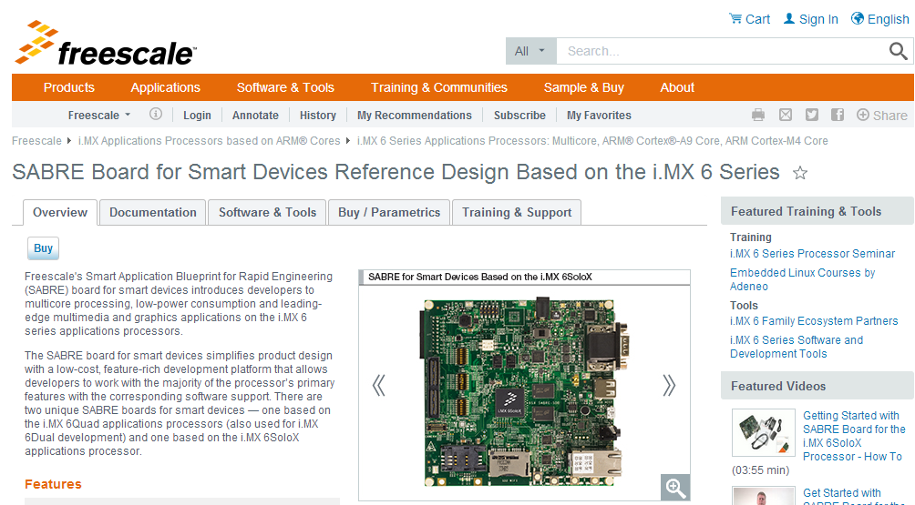

Press Buy:

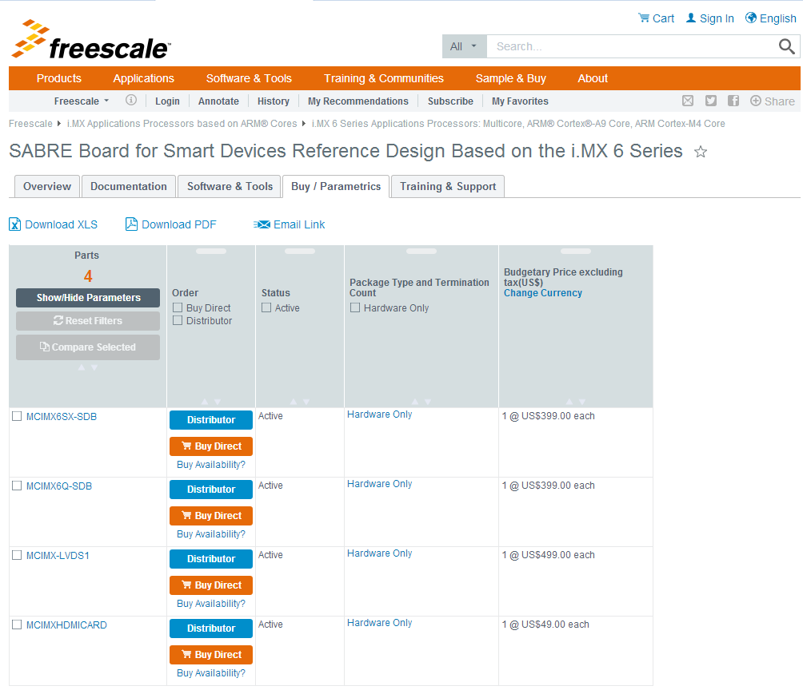

SDB board share the same PCB with SDP, but have no camera, LVDS and GPS module. Please note here SDB boards include i.MX6Q-SDB and i.MX6SX-SDB. LVDS part also could be ordered here.

[SABRE for Automotive Infotainment Based on the i.MX 6 Series](http://www.freescale.com/webapp/sps/site/prod_summary.jsp?code=RDIMX6SABREAUTO) Favorite  
The Smart Application Blueprint for Rapid Engineering (SABRE) for automotive infotainment offers a solid foundation for next-generation converged telematics and infotainment platform designs. Based on i.MX 6 series of applications processors, Freescale's most scalable implementation of the ARM® Cortex™-A9 CPU ...

Enter it:

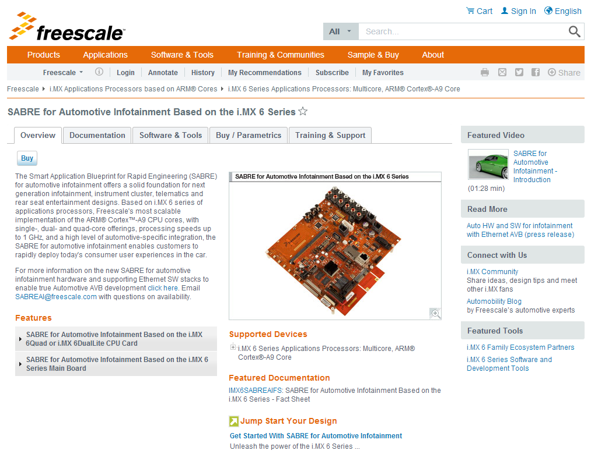

Press Buy:

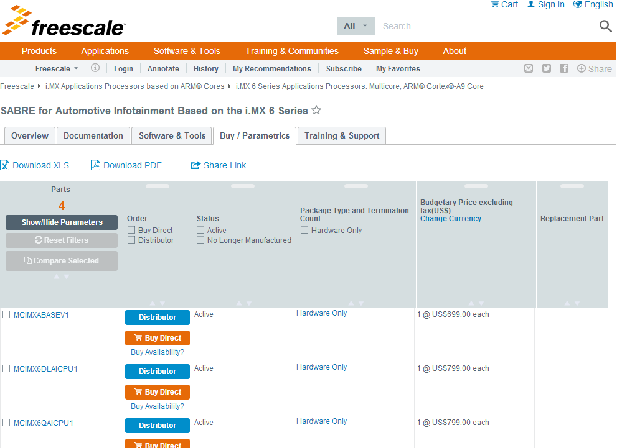

Which have the CPU board and automotive base board, And if need the automotive board LVDS display panel, we can enter the i.MX53 automotive board link to get the order name.

[SABRE for Automotive Infotainment Based on the i.MX 6 Series for Automotive AVB Development](http://www.freescale.com/webapp/sps/site/prod_summary.jsp?code=SABRE-AUTO-IMX6-RD2)Favorite  
PREPRODUCTION The latest version of the Smart Application Blueprint for Rapid Engineering (SABRE) for automotive infotainment offers a solid foundation for next-generation converged telematics and infotainment platform designs and enables true automotive AVB development with hardware and Ethernet SW solutions. ...

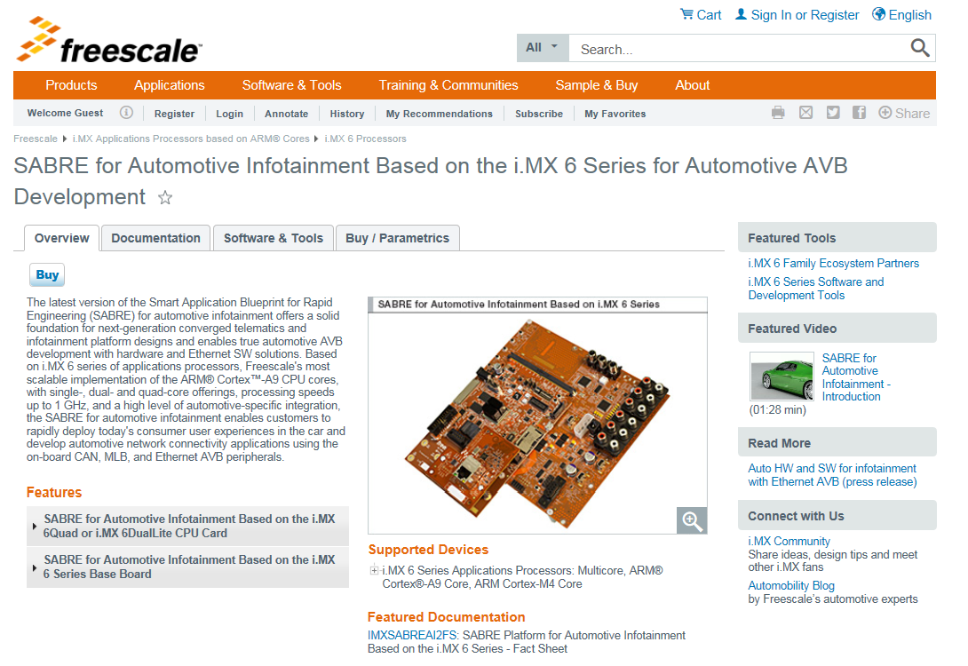

Press buy:

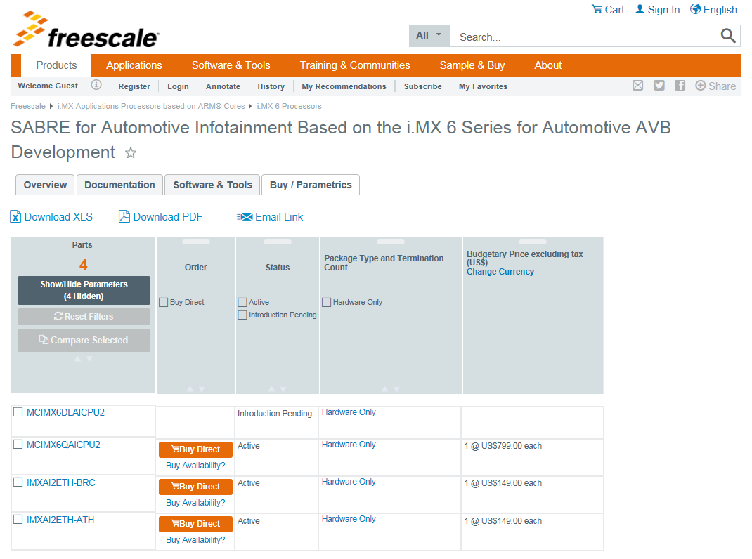

### i.MX6Q/D PCB and Schematics

[i.MX6_SABRE_AI_DESIGNFILES](https://www.freescale.com/webapp/sps/download/license.jsp?colCode=i.MX6_SABRE_AI_DESIGNFILES&appType=file1&location=null&DOWNLOAD_ID=null) SECURITYINFOIMAGE : Design files, including hardware schematics, layout files and BOM.   
**Size (K):** 32886 **Format:** zip **Rev #:** 1.0.2 **Modified:** 5/19/2014

[i.MX6_SABRE_SDP_DESIGNFILES](http://www.freescale.com/webapp/sps/site/prod_summary.jsp?code=i.MX6Q&nodeId=018rH3ZrDRB24A&fpsp=1&tab=Design_Tools_Tab) SECURITYINFOIMAGE : Design files, including hardware schematics, Gerbers, and OrCAD files..   
**Size (K):** 11725 **Format:** zip **Rev #:** C4 **Modified:** 10/15/2014

[iMX6_SABRE_SDB_DESIGNFILES](http://www.freescale.com/webapp/sps/site/prod_summary.jsp?code=i.MX6Q&nodeId=018rH3ZrDRB24A&fpsp=1&tab=Design_Tools_Tab) SECURITYINFOIMAGE : Design files, including hardware schematics, Gerbers, and OrCAD files..   
**Size (K):** 9585 **Format:** zip **Rev #:** C4 **Modified:** 10/15/2014

### i.MX6Q/D Programmers

[IMX-L5.0.0-MFG-TOOL](http://www.freescale.com/webapp/sps/site/prod_summary.jsp?code=i.MX6Q&fpsp=1&tab=Design_Tools_Tab) SECURITYINFOIMAGE : i.MX 6Family Manufacturing Toolkit for L5.0.0_1.0.0  
**Size (K):**36731 **Format:**gz **Rev #:**L5.0.0_1.0.0 **Modified:**6/2/2015

[IMX6_L3.10.53_MFG_TOOL](http://www.freescale.com/webapp/sps/site/prod_summary.jsp?code=i.MX6Q&fpsp=1&tab=Design_Tools_Tab) SECURITYINFOIMAGE : Set of applications for the Linux L3.10.53_1.1.0 BSP, designed to be used by graphics application developers to rapidly develop and port graphics applications. Includes applications, GPU Driver with vprofiler enabled and documentation.  
**Size (K):**240909 **Format:**gz **Rev #:**L3.10.53_1.1.0 **Modified:**4/10/2015

[IMX6_L3.14.28_MFG_TOOL](http://www.freescale.com/webapp/sps/site/prod_summary.jsp?code=i.MX6Q&fpsp=1&tab=Design_Tools_Tab) SECURITYINFOIMAGE : IMX6_L3.14.28_MFG_TOOL.   
**Size (K):**290397 **Format:**gz **Rev #:**L3.14.28_1.0.0 **Modified:**4/16/2015

[IMX_6DQ_MFG_TOOL](https://www.freescale.com/webapp/sps/download/license.jsp?colCode=IMX_6DQ_MFG_TOOL&appType=file1&location=null&DOWNLOAD_ID=null) SECURITYINFOIMAGE : Tool and documentation for downloading OS images to the i.MX 6Quad and i.MX6Dual.   
**Size (K):** 75779 **Format:** gz **Rev #:** L3.0.35_4.1.0 **Modified:** 9/5/2013

[IMX_6_MFG_L3.10.17_1.0.0_TOOL](http://www.freescale.com/webapp/sps/site/prod_summary.jsp?code=i.MX6Q&nodeId=018rH3ZrDRB24A&fpsp=1&tab=Design_Tools_Tab) SECURITYINFOIMAGE : i.MX 6Family Manufacturing Toolkit for L3.10.17.   
**Size (K**): 361429 **Format:** gz **Rev #:** L3.10.17_1.0.0 **Modified:** 5/8/2014

[IMX_6_MFG_L3.10.17_1.0.2_TOOL](http://www.freescale.com/webapp/sps/site/prod_summary.jsp?code=i.MX6Q&nodeId=018rH3ZrDRB24A&fpsp=1&tab=Design_Tools_Tab) SECURITYINFOIMAGE : Tool and documentation for downloading OS images to the i.MX 6 Family using the L3.10.17_1.0.2 BSP.   
**Size (K):**368839 **Format:**gz **Rev #:**L3.10.17_1.0.2 **Modified:**10/29/2014

[IMX_6_MFG_kk4.4.2_1.0.0_TOOL](http://www.freescale.com/webapp/sps/site/prod_summary.jsp?code=i.MX6Q&nodeId=018rH3ZrDRB24A&fpsp=1&tab=Design_Tools_Tab) SECURITYINFOIMAGE : i.MX 6Family Manufacturing Toolkit for kk4.4.2_1.0.0.   
**Size (K):**189945 **Format:**gz **Rev #:**KK4.4.2_1.0.0 **Modified:**7/14/2014

[IMX_KK4.4.3_MFG_TOOL](http://www.freescale.com/webapp/sps/site/prod_summary.jsp?code=i.MX6Q&fpsp=1&tab=Design_Tools_Tab) SECURITYINFOIMAGE : i.MX 6Family Manufacturing Toolkit for kk4.4.3_2.0.0  
**Size (K):**36796 **Format:**gz **Rev #:**kk4.4.3_2.0.0 **Modified:**2/6/2015

[IMX_MFG_TOOL_V2_SOURCE](https://www.freescale.com/webapp/sps/download/license.jsp?colCode=IMX_MFG_TOOL_V2_SOURCE&appType=file1&location=null&DOWNLOAD_ID=null) SECURITYINFOIMAGE : Source Code for the i.MX manufacturing tool used for downloading OS images to the i.MX 6 Processors.   
**Size (K):** 473 **Format:** zip **Rev #:** 2.3.2 **Modified:** 2/11/2014

### i.MX6Q/D SDK/VDK

[I.MX_6_VIVANTE_VDK_150_TOOLS](http://www.freescale.com/webapp/sps/site/prod_summary.jsp?code=i.MX6Q&nodeId=018rH3ZrDRB24A&fpsp=1&tab=Design_Tools_Tab) SECURITYINFOIMAGE : Applications for the Linux L3.10.17_1.0.0 BSP.   
**Size (K):** 41753 **Format:** tgz **Rev #:** 1.5.0 **Modified:** 5/16/2014

[IMX6_GPU_SDK](https://cache.freescale.com/secured/product/hardware_tools/gpu_sdk_v1.00.tar.gz?fileExt=.gz&__gda__=1397561020_7a5a748224270a3c97f617cf85298847) SECURITYINFOIMAGE : i.MX6 Graphics SDK – Includes sample, demo code, and documentation for working with the i.MX6X family graphics cores. Includes OpenVG, OpenGL ES, and GAL2D reference files.   
**Size (K):** 21065 **Format:** gz **Rev #:** 1.0.0 **Modified:** 1/25/2013

[i.MX 6Series Platform SDK](https://cache.freescale.com/secured/NMG/MAD/imx6_platform_sdk_v1.1.0.tgz?fileExt=.tgz&__gda__=1397561079_1cde7c35ce6954751a5724ab289f668b) SECURITYINFOIMAGE : Bare-metal SDK for the i.MX 6 series, including reusable drivers and tests for many peripherals, and much example code. Also includes register definition headers files, and register definitions for debuggers. BSD open source license.  
**Size (K):** 29865 **Format:** tgz **Rev #:** 1.1 **Modified:** 2/11/2013

A non-OS i.MX6X driver test codes.

### i.MX6Q/D Tools

[i.MX6D/Q/DL/S/SX GPU Tools-5.0.11P4.1](http://www.freescale.com/webapp/sps/site/prod_summary.jsp?code=i.MX6Q&fpsp=1&tab=Design_Tools_Tab) SECURITYINFOIMAGE : Set of desktop applications for the Linux L3.10.53-1.1.0-GA-5.0.11P4 BSP, designed to be used by graphics application developers to rapidly develop and port graphics applications. Includes desktop applications. Refer to i.MX_6_Graphics_User's_Guide_review.pdf for documentation.  
**Size (K):**79548 **Format:**zip **Rev #:**1.6.1 **Modified:**1/29/2015

[IMX6_IOMUX_TOOL](https://www.freescale.com/webapp/sps/download/license.jsp?colCode=IMX6_IOMUX_TOOL&appType=file1&location=null&DOWNLOAD_ID=null) SECURITYINFOIMAGE : Interactive i.MX Pin Mux Tool..   
**Size (K):** 5313 **Format:** zip **Rev #:** 3.4.0.3 **Modified:** 2/14/2013

Please still refer the document of i.MX6Q/D iomux table.

[IMX_CST_TOOL](http://www.freescale.com/webapp/sps/site/prod_summary.jsp?code=i.MX6Q&nodeId=018rH3ZrDRB24A&fpsp=1&tab=Design_Tools_Tab) SECURITYINFOIMAGE : Freescale Code Signing Tool for the High Assurance Boot library. Provides software code signing support designed for use with i.MX processors that integrate the HAB library in the internal boot ROM.   
**Size (K):** 3855 **Format:** tgz **Rev #:** 2.1.1 **Modified:** 10/13/2014

Please still refer the document of i.MX6Q/D security RM and HAB application notes.

### i.MX6Q/D BSDL

[IMX6_DQ_BSDL](https://www.freescale.com/webapp/sps/download/license.jsp?colCode=IMX6_DQ_BSDL&appType=file1&location=null&DOWNLOAD_ID=null) SECURITYINFOIMAGE : i.MX 6Quad and i.MX 6Dual BSDL File.   
**Size (K):** 64 **Format:** zip **Rev #:** 2 **Modified:** 1/15/2013

A Boundary scan file for manufacture ICT test.

### i.MX6Q/D IBIS

[IMX6_DQ_IBIS](https://www.freescale.com/webapp/sps/download/license.jsp?colCode=IMX6_DQ_IBIS&appType=file1&location=null&DOWNLOAD_ID=null) SECURITYINFOIMAGE : i.MX 6Quad and i.MX 6Dual IBIS File.   
**Size (K):** 17035 **Format:** zip **Rev #:** 1.4 **Modified:** 12/3/2013

Use for signals simulation.

### i.MX6Q/D BSP and Demo Images

[IMXANDROID](http://www.freescale.com/webapp/sps/site/prod_summary.jsp?code=IMXANDROID&fsrch=1): Android OS for i.MX Applications Processors. Freescale fully supports the Android™ operating system through board support packages for the i.MX range of application processors and featured tools such as SABRE for tablets. Freescale’s...  
**Format:**html **Modified:**6/4/2015

<http://www.freescale.com/webapp/sps/site/prod_summary.jsp?code=IMXANDROID&fsrch=1>

We could download android releases via above hyperlink. More details for the BSP release please refer to following chapter: i.MX6 Android and Linux BSP and Demo Images.

[IMXLINUX](http://www.freescale.com/webapp/sps/site/prod_summary.jsp?code=IMXLINUX&fsrch=1): Embedded Linux for i.MX Applications Processors. Quickly get your Linux based designs started with the full featured and energy efficient i.MX family of processors by using Freescale's Linux development tools. Our goal is to provide you with a...  
**Format:**html **Modified:**5/25/2015

<http://www.freescale.com/webapp/sps/site/prod_summary.jsp?code=IMXLINUX&fsrch=1>

We could download linux releases via above hyperlink. More details for the BSP release please refer to following chapter: i.MX6 Android and Linux BSP and Demo Images.

### i.MX6Q/D Software Codecs

[L3.14.28_1.0.0_AACP_CODECS](http://www.freescale.com/webapp/sps/site/prod_summary.jsp?code=i.MX6Q&fpsp=1&tab=Design_Tools_Tab) SECURITYINFOIMAGE : i.MX 6Quad, i.MX 6Dual, i.MX 6DualLite, i.MX 6Solo and i.MX 6Sololite Linux AAC Plus Codec    
**Size (K):**507000 **Format:**gz **Rev #:**L3.14.28_1.0.0 **Modified:**4/10/2015

[AACP_CODECS_ANDROID_13.41](http://www.freescale.com/webapp/sps/site/prod_summary.jsp?code=i.MX6Q&fpsp=1&tab=Design_Tools_Tab) SECURITYINFOIMAGE : AAC Plus Codec for i.MX 6Quad, i.MX 6Dual, and i.MX 6DualLite Android 13.4.1 BSP.   
**Size (K):**64 **Format:**gz **Rev #:**R13.4.1 **Modified:**12/12/2012

[IMX6-L500-100-AACP-CODEC-CODA](http://www.freescale.com/webapp/sps/site/prod_summary.jsp?code=i.MX6Q&fpsp=1&tab=Design_Tools_Tab) http://www.freescale.com/files/graphic/SECURITYINFOIMAGE.gif : AAC Plus Codec for i.MX 6Quad, i.MX 6Dual, i.MX 6DualLite, i.MX 6Solo i.MX 6Sololite and i.MX 6SX Android L5.0.0_1.0.0 BSP.  
**Size (K):**91 **Format:**gz **Rev #:**L5.0.0_1.0.0 **Modified:**6/2/2015

[IMX6_JB43_110_AACP_CODEC_CODA](https://cache.freescale.com/secured/32bit/software/imx_codecs/fsl_aacp_dec_jb4.3_1.1.0-ga.tar.gz?fileExt=.gz&__gda__=1397622397_372215ce2e666045138a467285d6ff66) SECURITYINFOIMAGE : AAC Plus Codec for i.MX 6Quad, i.MX 6Dual, i.MX 6DualLite, i.MX 6Solo and i.MX 6Sololite Android jb4.3_1.1.0.   
**Size (K):** 71 **Format:** gz **Rev #:** jb4.3_1.1.0 **Modified:** 12/20/2013

Android have no codec package except AACP, have include in the BSP release codes.

[IMX6_KK442_100_AACP_CODEC_CODA](http://www.freescale.com/webapp/sps/site/prod_summary.jsp?code=i.MX6Q&nodeId=018rH3ZrDRB24A&fpsp=1&tab=Design_Tools_Tab) SECURITYINFOIMAGE : AAC Plus Codec for i.MX 6Quad, i.MX 6Dual, i.MX 6DualLite, i.MX 6Solo and i.MX 6Sololite Android jb4.4.2_1.0.0 BSP  
**Size (K):** 89 **Format:** gz **Rev #:** jb4.4.2_1.0.0 **Modified:** 7/14/2014

[IMX6_KK443_200_AACP_CODEC_CODA](http://www.freescale.com/webapp/sps/site/prod_summary.jsp?code=i.MX6Q&fpsp=1&tab=Design_Tools_Tab) SECURITYINFOIMAGE : AAC Plus Codec for i.MX 6Quad, i.MX 6Dual, i.MX 6DualLite, i.MX 6Solo, i.MX 6Sololite and i.MX 6 SX Android KK4.4.3_2.0.0 BSP.  
**Size (K):**89 **Format:**gz **Rev #:**kk4.4.3_2.0.0 **Modified:**2/6/2015

[L3.0.101_4.1.1_AACP_CODECS](http://www.freescale.com/webapp/sps/site/prod_summary.jsp?code=i.MX6Q&nodeId=018rH3ZrDRB24A&fpsp=1&tab=Design_Tools_Tab) SECURITYINFOIMAGE : i.MX 6Quad, i.MX 6Dual, i.MX 6DualLite, i.MX 6Solo and i.MX 6Sololite Linux AAC Plus Codec.   
**Size (K):**521 **Format:**gz **Rev #:**L3.0.101_4.1.1. **Modified:**11/3/2014

[L3.0.101_4.1.1_MM_CODECS](http://www.freescale.com/webapp/sps/site/prod_summary.jsp?code=i.MX6Q&nodeId=018rH3ZrDRB24A&fpsp=1&tab=Design_Tools_Tab) SECURITYINFOIMAGE : i.MX 6Quad, i.MX 6Dual, i.MX 6DualLite, i.MX 6Solo and i.MX 6Sololite Linux Multimedia Codecs Sources.   
**Size (K):**13720 **Format:**gz **Rev #:**L3.0.101_4.1.1. **Modified:**11/3/2014

[L3.0.35_4.1.0_AACP_CODECS](https://www.freescale.com/webapp/sps/download/license.jsp?colCode=L3.0.35_4.1.0_AACP_CODECS&appType=file1&location=null&DOWNLOAD_ID=null) SECURITYINFOIMAGE : i.MX 6Quad, i.MX 6Dual, i.MX 6DualLite, i.MX 6Solo and i.MX 6Sololite Linux AAC Plus Codec.   
**Size (K):** 1378 **Format:** gz **Rev #:** L3.0.35_4.1.0 **Modified:** 9/5/2013

[L3.0.35_4.1.0_MM_CODECS](https://www.freescale.com/webapp/sps/download/license.jsp?colCode=L3.0.35_4.1.0_MM_CODECS&appType=file1&location=null&DOWNLOAD_ID=null) SECURITYINFOIMAGE : i.MX 6Quad, i.MX 6Dual, i.MX 6DualLite, i.MX 6Solo and i.MX 6Sololite Linux Multimedia Codecs Sources.   
**Size (K):** 60558 **Format:** gz **Rev #:** L3.0.35_4.1.0 **Modified:** 9/5/2013

Linux have MM codec package.

[L3.10.17_1.0.0_AACP_CODECS](http://www.freescale.com/webapp/sps/site/prod_summary.jsp?code=i.MX6Q&fpsp=1&tab=Design_Tools_Tab) SECURITYINFOIMAGE : AAC Plus Codec.   
**Size (K):** 495 **Format:** gz **Rev #:** L3.10.17_1.0.0 **Modified:** 5/8/2014

[L3.10.53_1.1.0_AACP_CODECS](http://www.freescale.com/webapp/sps/site/prod_summary.jsp?code=i.MX6Q&fpsp=1&tab=Design_Tools_Tab) SECURITYINFOIMAGE : i.MX 6Quad, i.MX 6Dual, i.MX 6DualLite, i.MX 6Solo, i.MX 6Sololite and i.MX 6SX Linux AAC Plus Codec  
**Size (K):**509 **Format:**gz **Rev #:**L3.10.53_1.1.0 **Modified:**1/23/2015

### i.MX6Q/D Updates and Patches

Which have the older patch on L3.0.35 elder version, and Android R13.4/13.4.1.

# i.MX6DL/S Website Guide

We enter the i.MX6DL/S web link

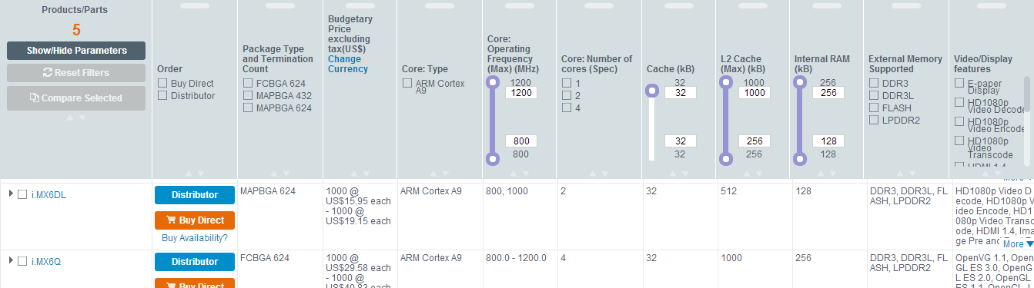

<http://www.freescale.com/webapp/sps/site/prod_summary.jsp?code=i.MX6DL&webpageId=129226228141673454B24A&nodeId=018rH3ZrDRB24A&fromPage=tax>

its main page as follows:

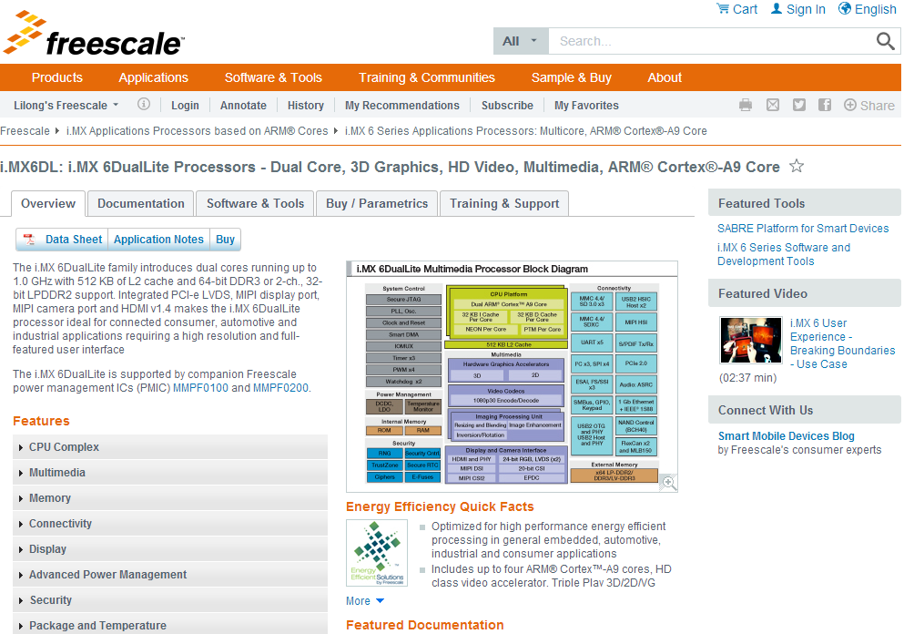

## i.MX6DL/S Documentation

<http://www.freescale.com/webapp/sps/site/prod_summary.jsp?code=i.MX6DL&nodeId=018rH3ZrDRB24A&fpsp=1&tab=Documentation_Tab>

### i.MX6DL/S Datasheet

[IMX6SDLAEC](http://cache.freescale.com/files/32bit/doc/data_sheet/IMX6SDLAEC.pdf?fpsp=1&WT_TYPE=Data%20Sheets&WT_VENDOR=FREESCALE&WT_FILE_FORMAT=pdf&WT_ASSET=Documentation)   
i.MX 6Solo/6DualLite Automotive and Infotainment Applications Processors

[IMX6SDLCEC](http://cache.freescale.com/files/32bit/doc/data_sheet/IMX6SDLCEC.pdf?fpsp=1&WT_TYPE=Data%20Sheets&WT_VENDOR=FREESCALE&WT_FILE_FORMAT=pdf&WT_ASSET=Documentation)   
i.MX 6Solo/6DualLite Applications Processors for Consumer Products

[IMX6SDLIEC](http://cache.freescale.com/files/32bit/doc/data_sheet/IMX6SDLIEC.pdf?fpsp=1&WT_TYPE=Data%20Sheets&WT_VENDOR=FREESCALE&WT_FILE_FORMAT=pdf&WT_ASSET=Documentation)   
i.MX 6Solo/6DualLite Applications Processors for Industrial Products

### i.MX6DL/S Errata

[IMX6SDLCE](http://cache.freescale.com/files/32bit/doc/errata/IMX6SDLCE.pdf?fpsp=1&WT_TYPE=Errata&WT_VENDOR=FREESCALE&WT_FILE_FORMAT=pdf&WT_ASSET=Documentation)   
Chip Errata for the i.MX 6Solo/6DualLite

### i.MX6DL/S Application Notes

### *Note: Most of the application notes for i.MX6DL/S share with the ones for i.MX6Q/D. We listed only the different part here:*

[AN4725](http://cache.freescale.com/files/32bit/doc/app_note/AN4725.pdf?fasp=1&Parent_nodeId=1337695836026701499367&Parent_pageType=product)   
AN4725, i.MX 6Solo/6DualLite Product Usage Lifetime Estimates - Application Note

[AN4576](http://cache.freescale.com/files/32bit/doc/app_note/AN4576.pdf?fpsp=1&WT_TYPE=Application%20Notes&WT_VENDOR=FREESCALE&WT_FILE_FORMAT=pdf&WT_ASSET=Documentation)   
i.MX 6DualLite Power Consumption Measurement

### i.MX6DL/S Chipset Reference Manuals

[IMX6SDLRM](http://cache.freescale.com/files/32bit/doc/ref_manual/IMX6SDLRM.pdf?fpsp=1&WT_TYPE=Reference%20Manuals&WT_VENDOR=FREESCALE&WT_FILE_FORMAT=pdf&WT_ASSET=Documentation)   
i.MX 6Solo/6DualLite Applications Processor Reference Manual

[IMX6DQ6SDLSRM](https://www.freescale.com/webapp/Download?colCode=IMX6DQ6SDLSRM&appType=moderatedWithoutFAE&fpsp=1&WT_TYPE=Reference%20Manuals&WT_VENDOR=FREESCALE&WT_FILE_FORMAT=pdf&WT_ASSET=Documentation) SECURITYINFOIMAGE // Special approval is required to access this file  
Security Reference Manual for i.MX 6

### i.MX6DL/S Users Guides

[IMX6DQ6SDLHDG](http://cache.freescale.com/files/32bit/doc/user_guide/IMX6DQ6SDLHDG.pdf?fpsp=1&WT_TYPE=Users%20Guides&WT_VENDOR=FREESCALE&WT_FILE_FORMAT=pdf&WT_ASSET=Documentation)   
Hardware Development Guide for i.MX 6Quad, 6Dual, 6DualLite, 6Solo Families of Applications

### Engineering Bulletins

[EB804](http://cache.freescale.com/files/microcontrollers/doc/eng_bulletin/EB804.pdf?fasp=1&WT_TYPE=Engineering%20Bulletins&WT_VENDOR=FREESCALE&WT_FILE_FORMAT=pdf&WT_ASSET=Documentation)   
i.MX 6Solo/6DualLite Application Processor Silicon Revision 1.1 to 1.2 Comparison - EB804

[EB793](http://cache.freescale.com/files/32bit/doc/eng_bulletin/EB793.pdf?fpsp=1&WT_TYPE=Engineering%20Bulletins&WT_VENDOR=FREESCALE&WT_FILE_FORMAT=pdf&WT_ASSET=Documentation)   
MISRA Compliance in Freescale Automotive C Language Header Files - Engineering Bulletin

[EB790](http://cache.freescale.com/files/32bit/doc/eng_bulletin/EB790.pdf?fasp=1&WT_TYPE=Engineering%20Bulletins&WT_VENDOR=FREESCALE&WT_FILE_FORMAT=pdf&WT_ASSET=Documentation)   
Configuration of Phase Fractional Dividers

### i.MX6DL/S Fact Sheet

[IMX6SRSFS](http://cache.freescale.com/files/32bit/doc/fact_sheet/IMX6SRSFS.pdf?fpsp=1&WT_TYPE=Fact%20Sheets&WT_VENDOR=FREESCALE&WT_FILE_FORMAT=pdf&WT_ASSET=Documentation)   
i.MX 6 Series of Applications Processors - Fact Sheet

### i.MX6DL/S Brochures

[FREESCALEARM](http://cache.freescale.com/files/32bit/doc/brochure/FREESCALEARM.pdf?fasp=1&WT_TYPE=Brochures&WT_VENDOR=FREESCALE&WT_FILE_FORMAT=pdf&WT_ASSET=Documentation&fileExt=.pdf)   
Freescale Embedded Solutions Based on ARM Technology Guide

### i.MX6DL/S Product Change Notices

[PCN16222](http://cache.freescale.com/files/shared/doc/pcn/PCN16222.htm?fasp=1&WT_TYPE=Product%20Change%20Notices&WT_VENDOR=FREESCALE&WT_FILE_FORMAT=htm&WT_ASSET=Documentation&fileExt=.htm)   
I.MX6DLS AUTO 2ND SITE FT (ASECL)

### Supporting Information

***Note: This section contains some documents for BSP/Codec.***

[IMX6_L500_100_ANDROID_DOCS](https://www.freescale.com/webapp/Download?colCode=IMX6_L500_100_ANDROID_DOCS&location=null&fasp=1&WT_TYPE=Supporting%20Information&WT_VENDOR=FREESCALE&WT_FILE_FORMAT=gz&WT_ASSET=Documentation&fileExt=.gz) http://www.freescale.com/files/graphic/SECURITYINFOIMAGE.gif   
i.MX6 Android L5.0.0_1.0.0 BSP Documentation

[IMX6L31428101RN](http://cache.freescale.com/files/32bit/doc/support_info/IMX6L31428101RN.pdf?fasp=1&WT_TYPE=Supporting%20Information&WT_VENDOR=FREESCALE&WT_FILE_FORMAT=pdf&WT_ASSET=Documentation&fileExt=.pdf)   
i.MX 6 Yocto Project L3.14.28_1.0.1 Patch Release Notes -Release Notes

[L3.10.53_1.1.0_LINUX_DOCS](https://www.freescale.com/webapp/Download?colCode=L3.10.53_1.1.0_LINUX_DOCS&location=null&fasp=1&WT_TYPE=Supporting%20Information&WT_VENDOR=FREESCALE&WT_FILE_FORMAT=gz&WT_ASSET=Documentation&fileExt=.gz) SECURITYINFOIMAGE   
i.MX 6Quad, i.MX 6Dual, i.MX 6DualLite, i.MX 6Solo and i.MX 6Sololite Linux BSP Documentation. Includes Release Notes,...

[L3.14.28_1.0.0_LINUX_DOCS](https://www.freescale.com/webapp/Download?colCode=L3.14.28_1.0.0_LINUX_DOCS&location=null&fasp=1&WT_TYPE=Supporting%20Information&WT_VENDOR=FREESCALE&WT_FILE_FORMAT=gz&WT_ASSET=Documentation&fileExt=.gz) http://www.freescale.com/files/graphic/SECURITYINFOIMAGE.gif   
L3.14.28_1.0.0_LINUX_DOCS

[IMX6YOCTOPATCHRN](http://cache.freescale.com/files/32bit/doc/support_info/IMX6YOCTOPATCHRN.pdf?fasp=1&WT_TYPE=Supporting%20Information&WT_VENDOR=FREESCALE&WT_FILE_FORMAT=pdf&WT_ASSET=Documentation&fileExt=.pdf)   
i.MX 6 L3.10.17_1.0.2 Yocto Project Patch Release Notes - Release Notes

[IMX6_KK443_200_ANDROID_DOCS](https://www.freescale.com/webapp/Download?colCode=IMX6_KK443_200_ANDROID_DOCS&location=null&fasp=1&WT_TYPE=Supporting%20Information&WT_VENDOR=FREESCALE&WT_FILE_FORMAT=gz&WT_ASSET=Documentation&fileExt=.gz) SECURITYINFOIMAGE   
i.MX6 Android kk4.4.3_2.0.0 BSP Documentation

[IMX6LXPATCHRN](https://www.freescale.com/webapp/Download?colCode=IMX6LXPATCHRN&appType=license&location=null&fasp=1&WT_TYPE=Supporting%20Information&WT_VENDOR=FREESCALE&WT_FILE_FORMAT=pdf&WT_ASSET=Documentation&fileExt=.pdf) SECURITYINFOIMAGE   
i.MX 6Quad, i.MX 6Dual, i.MX 6DualLite, i.MX 6Solo and i.MX 6Sololite Linux BSP Documentation. Patch Release Notes

[IMX6_JB43_111_ANDROID_DOCS](https://www.freescale.com/webapp/Download?colCode=IMX6_JB43_111_ANDROID_DOCS&location=null&fasp=1&WT_TYPE=Supporting%20Information&WT_VENDOR=FREESCALE&WT_FILE_FORMAT=gz&WT_ASSET=Documentation&fileExt=.gz) SECURITYINFOIMAGE   
i.MX 6Quad, i.MX 6Dual, i.MX 6DualLite, i.MX 6Solo and i.MX 6Sololite Android BSP Documentation

[IMX6_KK442_100_ANDROID_DOCS](https://www.freescale.com/webapp/Download?colCode=IMX6_KK442_100_ANDROID_DOCS&location=null&fasp=1&WT_TYPE=Supporting%20Information&WT_VENDOR=FREESCALE&WT_FILE_FORMAT=gz&WT_ASSET=Documentation) SECURITYINFOIMAGE   
i.MX6 Android kk4.4.2_1.0.0 BSP Documentation

[L3.10.17_1.0.0_LINUX_DOCS](https://www.freescale.com/webapp/Download?colCode=L3.10.17_1.0.0_LINUX_DOCS&appType=license&location=null&fasp=1&WT_TYPE=Supporting%20Information&WT_VENDOR=FREESCALE&WT_FILE_FORMAT=gz&WT_ASSET=Documentation) SECURITYINFOIMAGE   
Linux 3.10.17 BSP & MM Bundle

[IMX6_JB43_110_ANDROID_DOCS](https://www.freescale.com/webapp/Download?colCode=IMX6_JB43_110_ANDROID_DOCS&location=null&fasp=1&WT_TYPE=Supporting%20Information&WT_VENDOR=FREESCALE&WT_FILE_FORMAT=gz&WT_ASSET=Documentation) SECURITYINFOIMAGE   
i.MX 6Quad, i.MX 6Dual, i.MX 6DualLite, i.MX 6Solo and i.MX 6Sololite Android jb4.3_1.1.0 BSP Documentation. Includes...

[L3.0.35_4.1.0_LINUX_DOCS](https://cache.freescale.com/secured/32bit/doc/support_info/L3.0.35_4.1.0_docs.tar.gz?fileExt=.gz&__gda__=1397562963_420f8c73b1e10edff692b8c57986e6c6) SECURITYINFOIMAGE   
i.MX 6Quad, i.MX 6Dual, i.MX 6DualLite, i.MX 6Solo and i.MX 6Sololite Linux BSP Documentation. Includes Release Notes,...

[L3.0.35_4.1.0_LINUX_MMDOCS](https://cache.freescale.com/secured/32bit/doc/support_info/Linux_Multimedia_Framework_Docs_MX6XUbuntu_3.0.7-2.tar.gz?fileExt=.gz&__gda__=1397563065_5ef4bcb0853fcbbb4723af95a99f77d2) SECURITYINFOIMAGE   
i.MX 6Quad, i.MX 6Dual, i.MX 6DualLite, i.MX 6Solo and i.MX 6Sololite Linux Multimedia Codecs Documentation. Includes...

[IMX6_JB422_110_ANDROID_DOCS](https://www.freescale.com/webapp/Download?colCode=IMX6_JB422_110_ANDROID_DOCS&location=null&fasp=1&WT_TYPE=Supporting%20Information&WT_VENDOR=FREESCALE&WT_FILE_FORMAT=gz&WT_ASSET=Documentation) SECURITYINFOIMAGE   
i.MX 6Quad, i.MX 6Dual, and i.MX 6DualLite Android jb4.2.2_1.1.0 BSP Documentation. Includes Release Notes, User's...

[IMX6_R13.41_ANDROID_DOC_BUNDLE](https://www.freescale.com/webapp/Download?colCode=IMX6_R13.41_ANDROID_DOC_BUNDLE&location=null&fasp=1&WT_TYPE=Supporting%20Information&WT_VENDOR=FREESCALE&WT_FILE_FORMAT=gz&WT_ASSET=Documentation) SECURITYINFOIMAGE   
i.MX 6Quad, i.MX 6Dual, and i.MX 6DualLite Android 13.4.1 BSP Documentation. Android BSP Documentation. Includes...

[IMX_INFOCTR](http://cache.freescale.com/files/infocenter/IMX_INFOCTR.html?fpsp=1&WT_TYPE=Supporting%20Information&WT_VENDOR=FREESCALE&WT_FILE_FORMAT=html&WT_ASSET=Documentation)   
i.MX Infocenter—Online Documentation

[IMX6_R13.41_ANDROID_MM_RN](http://cache.freescale.com/files/32bit/doc/support_info/i_MX_Android_Codec_Release_Notes.html?fasp=1&WT_TYPE=Supporting%20Information&WT_VENDOR=FREESCALE&WT_FILE_FORMAT=html&WT_ASSET=Documentation)   
i.MX Android Codec Release Notes

## i.MX6DL/S Software & Tools

<http://www.freescale.com/webapp/sps/site/prod_summary.jsp?code=i.MX6DL&nodeId=018rH3ZrDRB24A&fpsp=1&tab=Design_Tools_Tab>

### i.MX6DL/S Reference Designs

[SABRE Platform for Smart Devices Reference Design Based on the i.MX 6 Series](http://www.freescale.com/webapp/sps/site/prod_summary.jsp?code=RDIMX6SABREPLAT) Favorite  
The Smart Application Blueprint for Rapid Engineering (SABRE) platform for smart devices allows you to hold in your hands and evaluate the full multimedia performance capabilities of i.MX 6 series applications processors based on ARM® Cortex™-A9 technology.  Targeted for any device ...

[SABRE for Automotive Infotainment Based on the i.MX 6 Series](http://www.freescale.com/webapp/sps/site/prod_summary.jsp?code=RDIMX6SABREAUTO) Favorite  
The Smart Application Blueprint for Rapid Engineering (SABRE) for automotive infotainment offers a solid foundation for next-generation converged telematics and infotainment platform designs. Based on i.MX 6 series of applications processors, Freescale's most scalable implementation of the ARM® Cortex™-A9 CPU ...

[SABRE for Automotive Infotainment Based on the i.MX 6 Series for Automotive AVB Development](http://www.freescale.com/webapp/sps/site/prod_summary.jsp?code=SABRE-AUTO-IMX6-RD2)Favorite   
PREPRODUCTION The latest version of the Smart Application Blueprint for Rapid Engineering (SABRE) for automotive infotainment offers a solid foundation for next-generation converged telematics and infotainment platform designs and enables true automotive AVB development with hardware and Ethernet SW solutions. ...

### i.MX6DL/S PCB and Schematics

[i.MX6_SABRE_AI_DESIGNFILES](https://www.freescale.com/webapp/sps/download/license.jsp?colCode=i.MX6_SABRE_AI_DESIGNFILES&appType=file1&location=null&DOWNLOAD_ID=null) SECURITYINFOIMAGE : Design files, including hardware schematics, layout files and BOM.   
**Size (K):** 32886 **Format:** zip **Rev #:** 1.0.2 **Modified:** 5/19/2014

### i.MX6DL/S Programmers

[IMX-L5.0.0-MFG-TOOL](http://www.freescale.com/webapp/sps/site/prod_summary.jsp?code=i.MX6DL&fpsp=1&tab=Design_Tools_Tab) http://www.freescale.com/files/graphic/SECURITYINFOIMAGE.gif : i.MX 6Family Manufacturing Toolkit for L5.0.0_1.0.0  
**Size (K):**36731 **Format:**gz **Rev #:**L5.0.0_1.0.0 **Modified:**6/2/2015

[IMX6_L3.10.53_MFG_TOOL](http://www.freescale.com/webapp/sps/site/prod_summary.jsp?code=i.MX6DL&fpsp=1&tab=Design_Tools_Tab) http://www.freescale.com/files/graphic/SECURITYINFOIMAGE.gif : Set of applications for the Linux L3.10.53_1.1.0 BSP, designed to be used by graphics application developers to rapidly develop and port graphics applications. Includes applications, GPU Driver with vprofiler enabled and documentation.  
**Size (K):**240909 **Format:**gz **Rev #:**L3.10.53_1.1.0 **Modified:**4/10/2015

[IMX6_L3.14.28_MFG_TOOL](http://www.freescale.com/webapp/sps/site/prod_summary.jsp?code=i.MX6DL&fpsp=1&tab=Design_Tools_Tab) http://www.freescale.com/files/graphic/SECURITYINFOIMAGE.gif : IMX6_L3.14.28_MFG_TOOL.   
**Size (K):**290397 **Format:**gz **Rev #:**L3.14.28_1.0.0 **Modified:**4/16/2015

[IMX_6DL_6S_MFG_TOOL](https://www.freescale.com/webapp/sps/download/license.jsp?colCode=IMX_6DL_6S_MFG_TOOL&appType=file1&location=null&DOWNLOAD_ID=null) SECURITYINFOIMAGE : Tool and documentation for downloading OS images to the i.MX 6DualLite and i.MX6Solo.   
**Size (K):** 73917 **Format:** gz **Rev #:** L3.0.35_4.1.0 **Modified:** 9/5/2013

[IMX_6_MFG_L3.10.17_1.0.0_TOOL](http://www.freescale.com/webapp/sps/site/prod_summary.jsp?code=i.MX6DL&nodeId=018rH3ZrDRB24A&fpsp=1&tab=Design_Tools_Tab) SECURITYINFOIMAGE : i.MX 6Family Manufacturing Toolkit for L3.10.17.   
**Size (K):** 361429 Format: gz **Rev #:** L3.10.17_1.0.0 **Modified:** 5/8/2014

[IMX_6_MFG_kk4.4.2_1.0.0_TOOL](http://www.freescale.com/webapp/sps/site/prod_summary.jsp?code=i.MX6DL&nodeId=018rH3ZrDRB24A&fpsp=1&tab=Design_Tools_Tab) SECURITYINFOIMAGE : i.MX 6Family Manufacturing Toolkit for kk4.4.2_1.0.0.   
**Size (K):**189945 **Format:**gz **Rev #:**KK4.4.2_1.0.0 **Modified:**7/14/2014

[IMX_KK4.4.3_MFG_TOOL](http://www.freescale.com/webapp/sps/site/prod_summary.jsp?code=i.MX6DL&fpsp=1&tab=Design_Tools_Tab) SECURITYINFOIMAGE : i.MX 6Family Manufacturing Toolkit for kk4.4.3_2.0.0  
**Size (K):**36796 **Format:**gz **Rev #:**kk4.4.3_2.0.0 **Modified:**2/6/2015

[IMX_MFG_TOOL_V2_SOURCE](https://www.freescale.com/webapp/sps/download/license.jsp?colCode=IMX_MFG_TOOL_V2_SOURCE&appType=file1&location=null&DOWNLOAD_ID=null) SECURITYINFOIMAGE : Source Code for the i.MX manufacturing tool used for downloading OS images to the i.MX 6 Processors.   
**Size (K):** 473 **Format:** zip **Rev #:** 2.3.2 **Modified:** 2/11/2014

### i.MX6DL/S SDK/VDK

[I.MX_6DL_S_VIVANTE_VDK_TOOLS](https://www.freescale.com/webapp/sps/download/license.jsp?colCode=I.MX_6DL_S_VIVANTE_VDK_TOOLS&appType=file1&location=null&DOWNLOAD_ID=null) SECURITYINFOIMAGE : i.MX6DL and i.MX6S Vivante VDK Tools.   
**Size (K):** 39752 **Format:** zip **Rev #:** 1.4.1 **Modified:** 1/4/2013

[I.MX_6_VIVANTE_VDK_150_TOOLS](http://www.freescale.com/webapp/sps/site/prod_summary.jsp?code=i.MX6DL&nodeId=018rH3ZrDRB24A&fpsp=1&tab=Design_Tools_Tab) SECURITYINFOIMAGE : Applications for the Linux L3.10.17_1.0.0 BSP.   
**Size (K):**41753 **Format:**tgz **Rev #:**1.5.0 **Modified:**5/16/2014

[IMX6_GPU_SDK](http://www.freescale.com/webapp/sps/site/prod_summary.jsp?code=i.MX6DL&nodeId=018rH3ZrDRB24A&fpsp=1&tab=Design_Tools_Tab) SECURITYINFOIMAGE : i.MX6 Graphics SDK – Includes sample, demo code, and documentation for working with the i.MX6X family graphics cores. Includes OpenVG, OpenGL ES, and GAL2D reference files.   
**Size (K):**21065 **Format:**gz **Rev #:**1.0.0 **Modified:**1/25/2013

[i.MX 6Series Platform SDK](https://cache.freescale.com/secured/NMG/MAD/imx6_platform_sdk_v1.1.0.tgz?fileExt=.tgz&__gda__=1397563553_30cadec435976ac042c021f6c1ed2880) SECURITYINFOIMAGE : Bare-metal SDK for the i.MX 6 series, including reusable drivers and tests for many peripherals, and much example code. Also includes register definition headers files, and register definitions for debuggers. BSD open source license.  
**Size (K):** 29865 **Format:** tgz **Rev #:** 1.1 **Modified:** 2/11/2013

### i. MX6DL/S Tools

[i.MX6D/Q/DL/S/SX GPU Tools-5.0.11P4.1](http://www.freescale.com/webapp/sps/site/prod_summary.jsp?code=i.MX6DL&fpsp=1&tab=Design_Tools_Tab) http://www.freescale.com/files/graphic/SECURITYINFOIMAGE.gif : Set of desktop applications for the Linux L3.10.53-1.1.0-GA-5.0.11P4 BSP, designed to be used by graphics application developers to rapidly develop and port graphics applications. Includes desktop applications. Refer to i.MX_6_Graphics_User's_Guide_review.pdf for documentation.  
**Size (K):**79548 **Format:**zip **Rev #:**1.6.1 **Modified:**1/29/2015

[IMX6_IOMUX_TOOL](http://www.freescale.com/webapp/sps/site/prod_summary.jsp?code=i.MX6DL&nodeId=018rH3ZrDRB24A&fpsp=1&tab=Design_Tools_Tab) SECURITYINFOIMAGE : Interactive i.MX Pin Mux Tool..   
**Size (K):**5313 **Format:**zip **Rev #:**3.4.0.3 **Modified:**2/14/2013

Please still refer the document of i.MX6DL/S iomux table.

[IMX_CST_TOOL](http://www.freescale.com/webapp/sps/site/prod_summary.jsp?code=i.MX6DL&fpsp=1&tab=Design_Tools_Tab) http://www.freescale.com/files/graphic/SECURITYINFOIMAGE.gif : Freescale Code Signing Tool for the High Assurance Boot library. Provides software code signing support designed for use with i.MX processors that integrate the HAB library in the internal boot ROM.   
**Size (K):**4827 **Format:**tgz **Rev #:**2.2 **Modified:**11/26/2014

Please still refer the document of i. MX6DL/S security RM and HAB application notes.

### i.MX6DL/S BSDL

[IMX6_DL_S_BSDL](https://www.freescale.com/webapp/sps/download/license.jsp?colCode=IMX6_DL_S_BSDL&appType=file1&location=null&DOWNLOAD_ID=null) SECURITYINFOIMAGE : i.MX 6DualLite and i.MX 6Solo BSDL File.   
**Size (K):** 21 **Format:** zip **Rev #:** 1.1 **Modified:** 7/3/2013

### i.MX6DL/S IBIS

[IMX6_DL_S_IBIS](https://www.freescale.com/webapp/sps/download/license.jsp?colCode=IMX6_DL_S_IBIS&appType=file1&location=null&DOWNLOAD_ID=null) SECURITYINFOIMAGE : i.MX 6DualLIte and i.MX 6Solo IBIS File.   
**Size (K):** 15626 **Format:** zip **Rev #:** 1.4. **Modified:** 12/4/2013

### i.MX6DL/S BSP and Demo Images

[IMXANDROID](http://www.freescale.com/webapp/sps/site/prod_summary.jsp?code=IMXANDROID&fsrch=1): Android OS for i.MX Applications Processors. Freescale fully supports the Android™ operating system through board support packages for the i.MX range of application processors and featured tools such as SABRE for tablets. Freescale’s...  
**Format:**html **Modified:**6/4/2015

<http://www.freescale.com/webapp/sps/site/prod_summary.jsp?code=IMXANDROID&fsrch=1>

We could download android releases via above hyperlink. More details for the BSP release please refer to following chapter: i.MX6 Android and Linux BSP and Demo Images.

[IMXLINUX](http://www.freescale.com/webapp/sps/site/prod_summary.jsp?code=IMXLINUX&fsrch=1): Embedded Linux for i.MX Applications Processors. Quickly get your Linux based designs started with the full featured and energy efficient i.MX family of processors by using Freescale's Linux development tools. Our goal is to provide you with a...  
**Format:**html **Modified:**5/25/2015

<http://www.freescale.com/webapp/sps/site/prod_summary.jsp?code=IMXLINUX&fsrch=1>

We could download linux releases via above hyperlink. More details for the BSP release please refer to following chapter: i.MX6 Android and Linux BSP and Demo Images.

### i.MX6DL/S Software Codecs

[AACP_CODECS_ANDROID_13.41](http://www.freescale.com/webapp/sps/site/prod_summary.jsp?code=i.MX6DL&nodeId=018rH3ZrDRB24A&fpsp=1&tab=Design_Tools_Tab) SECURITYINFOIMAGE : AAC Plus Codec for i.MX 6Quad, i.MX 6Dual, and i.MX 6DualLite Android 13.4.1 BSP.   
**Size (K):** 64 **Format:** gz **Rev #:** R13.4.1 **Modified:** 12/12/2012

[IMX6-L500-100-AACP-CODEC-CODA](http://www.freescale.com/webapp/sps/site/prod_summary.jsp?code=i.MX6DL&fpsp=1&tab=Design_Tools_Tab) http://www.freescale.com/files/graphic/SECURITYINFOIMAGE.gif : AAC Plus Codec for i.MX 6Quad, i.MX 6Dual, i.MX 6DualLite, i.MX 6Solo i.MX 6Sololite and i.MX 6SX Android L5.0.0_1.0.0 BSP.  
**Size (K):**91 **Format:**gz **Rev #:**L5.0.0_1.0.0 **Modified:**6/2/2015

[IMX6_JB43_110_AACP_CODEC_CODA](https://www.freescale.com/webapp/sps/download/license.jsp?colCode=IMX6_JB43_110_AACP_CODEC_CODA&appType=file1&location=null&DOWNLOAD_ID=null) SECURITYINFOIMAGE : AAC Plus Codec for i.MX 6Quad, i.MX 6Dual, i.MX 6DualLite, i.MX 6Solo and i.MX 6Sololite Android jb4.3_1.1.0.   
**Size (K):** 71 **Format:** gz **Rev #:** jb4.3_1.1.0 **Modified:** 12/20/2013

[IMX6_KK442_100_AACP_CODEC_CODA](http://www.freescale.com/webapp/sps/site/prod_summary.jsp?code=i.MX6DL&nodeId=018rH3ZrDRB24A&fpsp=1&tab=Design_Tools_Tab) SECURITYINFOIMAGE : AAC Plus Codec for i.MX 6Quad, i.MX 6Dual, i.MX 6DualLite, i.MX 6Solo and i.MX 6Sololite Android kk4.4.2_1.0.0 BSP  
**Size (K):**89 **Format:**gz **Rev #:**kk4.4.2_1.0.0 **Modified:**7/14/2014

[IMX6_KK443_200_AACP_CODEC_CODA](http://www.freescale.com/webapp/sps/site/prod_summary.jsp?code=i.MX6DL&fpsp=1&tab=Design_Tools_Tab) SECURITYINFOIMAGE : AAC Plus Codec for i.MX 6Quad, i.MX 6Dual, i.MX 6DualLite, i.MX 6Solo, i.MX 6Sololite and i.MX 6 SX Android KK4.4.3_2.0.0 BSP.  
**Size (K):**89 **Format:**gz **Rev #:**kk4.4.3_2.0.0 **Modified:**2/6/2015

[L3.0.101_4.1.1_AACP_CODECS](http://www.freescale.com/webapp/sps/site/prod_summary.jsp?code=i.MX6DL&nodeId=018rH3ZrDRB24A&fpsp=1&tab=Design_Tools_Tab) SECURITYINFOIMAGE : i.MX 6Quad, i.MX 6Dual, i.MX 6DualLite, i.MX 6Solo and i.MX 6Sololite Linux AAC Plus Codec.   
**Size (K):**521 **Format:**gz **Rev #:**L3.0.101_4.1.1. **Modified:**11/3/2014

[L3.0.101_4.1.1_MM_CODECS](http://www.freescale.com/webapp/sps/site/prod_summary.jsp?code=i.MX6DL&nodeId=018rH3ZrDRB24A&fpsp=1&tab=Design_Tools_Tab) SECURITYINFOIMAGE : i.MX 6Quad, i.MX 6Dual, i.MX 6DualLite, i.MX 6Solo and i.MX 6Sololite Linux Multimedia Codecs Sources.   
**Size (K):**13720 **Format:**gz **Rev #:**L3.0.101_4.1.1. **Modified:**11/3/2014

[L3.0.35_4.1.0_AACP_CODECS](https://www.freescale.com/webapp/sps/download/license.jsp?colCode=L3.0.35_4.1.0_AACP_CODECS&appType=file1&location=null&DOWNLOAD_ID=null) SECURITYINFOIMAGE : i.MX 6Quad, i.MX 6Dual, i.MX 6DualLite, i.MX 6Solo and i.MX 6Sololite Linux AAC Plus Codec.   
**Size (K):** 1378 **Format:** gz **Rev #:** L3.0.35_4.1.0 **Modified:** 9/5/2013

[L3.0.35_4.1.0_MM_CODECS](https://www.freescale.com/webapp/sps/download/license.jsp?colCode=L3.0.35_4.1.0_MM_CODECS&appType=file1&location=null&DOWNLOAD_ID=null) SECURITYINFOIMAGE : i.MX 6Quad, i.MX 6Dual, i.MX 6DualLite, i.MX 6Solo and i.MX 6Sololite Linux Multimedia Codecs Sources.   
**Size (K):** 60558 **Format:** gz **Rev #:** L3.0.35_4.1.0 **Modified:** 9/5/2013

[L3.10.17_1.0.0_AACP_CODECS](http://www.freescale.com/webapp/sps/site/prod_summary.jsp?code=i.MX6DL&nodeId=018rH3ZrDRB24A&fpsp=1&tab=Design_Tools_Tab) SECURITYINFOIMAGE : AAC Plus Codec.   
**Size (K):**495 **Format:**gz **Rev #:**L3.10.17_1.0.0 **Modified:**5/8/2014

[L3.10.53_1.1.0_AACP_CODECS](http://www.freescale.com/webapp/sps/site/prod_summary.jsp?code=i.MX6DL&fpsp=1&tab=Design_Tools_Tab) SECURITYINFOIMAGE : i.MX 6Quad, i.MX 6Dual, i.MX 6DualLite, i.MX 6Solo, i.MX 6Sololite and i.MX 6SX Linux AAC Plus Codec  
**Size (K):**509 **Format:**gz **Rev #:**L3.10.53_1.1.0 **Modified:**1/23/2015

### i.MX6Q/D Updates and Patches

Which have the older patch on L3.0.35 elder version, and Android R13.4/13.4.1.

# i.MX6SL Website Guide

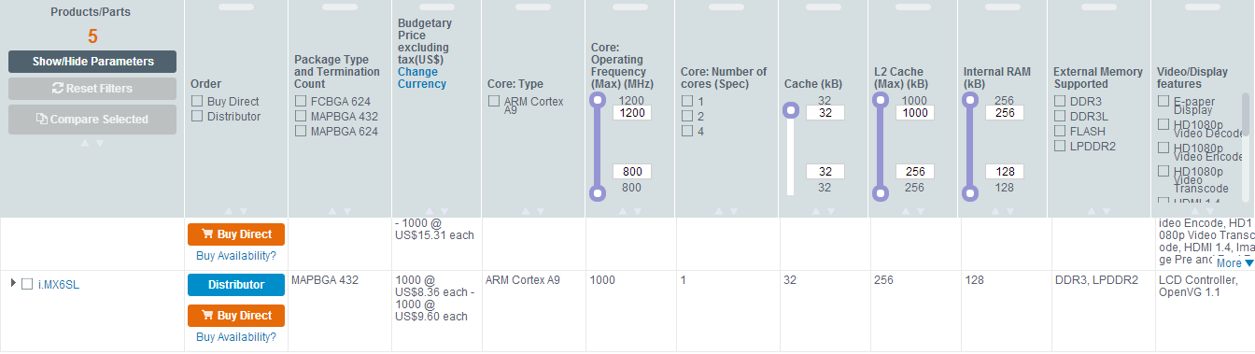

<http://www.freescale.com/webapp/sps/site/prod_summary.jsp?code=i.MX6SL&webpageId=129226228141673454B24A&nodeId=018rH3ZrDRB24A&fromPage=tax>

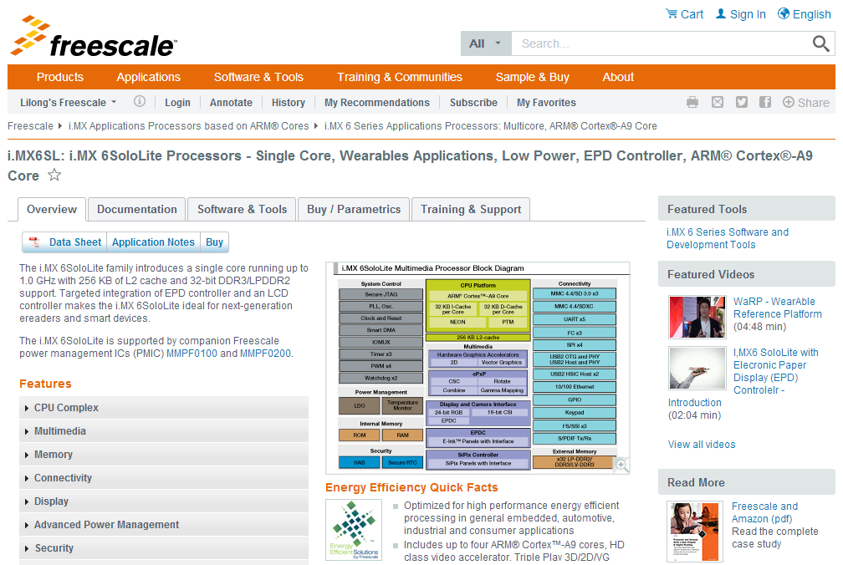

## i.MX6SL Documentation

<http://www.freescale.com/webapp/sps/site/prod_summary.jsp?code=i.MX6SL&nodeId=018rH3ZrDRB24A&fpsp=1&tab=Documentation_Tab>

### i.MX6SL Datasheet

[IMX6SLCEC](http://cache.freescale.com/files/32bit/doc/data_sheet/IMX6SLCEC.pdf?fpsp=1&WT_TYPE=Data%20Sheets&WT_VENDOR=FREESCALE&WT_FILE_FORMAT=pdf&WT_ASSET=Documentation)   
i.MX 6SoloLite Applications Processors for Consumer Products

### i.MX6SL Errata

[IMX6SLCE](http://cache.freescale.com/files/32bit/doc/errata/IMX6SLCE.pdf?fasp=1&WT_TYPE=Errata&WT_VENDOR=FREESCALE&WT_FILE_FORMAT=pdf&WT_ASSET=Documentation&fileExt=.pdf)   
Chip Errata for the i.MX 6SoloLite - Errata

### i.MX6SL Application Notes

### *Note: Most of the application notes for i.MX6SL share with the ones for i.MX6Q/D. We listed only the different part here:*

[AN5113](http://cache.freescale.com/files/analog/doc/app_note/AN5113.pdf?fasp=1&WT_TYPE=Application%20Notes&WT_VENDOR=FREESCALE&WT_FILE_FORMAT=pdf&WT_ASSET=Documentation&fileExt=.pdf)   
AN5113, Powering an i.MX 6SL Based System Using the PF3000 PMIC - Application Note

[AN4726](http://cache.freescale.com/files/32bit/doc/app_note/AN4726.pdf?fpsp=1&WT_TYPE=Application%20Notes&WT_VENDOR=FREESCALE&WT_FILE_FORMAT=pdf&WT_ASSET=Documentation)   
i.MX 6SoloLite Product Usage Lifetime Estimates

[AN4580](http://cache.freescale.com/files/32bit/doc/app_note/AN4580.pdf?fpsp=1&WT_TYPE=Application%20Notes&WT_VENDOR=FREESCALE&WT_FILE_FORMAT=pdf&WT_ASSET=Documentation)   
i.MX 6SoloLite Power Consumption Measurement

### i.MX6SL Chipset Reference Manuals

[IMX6SLRM](http://cache.freescale.com/files/32bit/doc/ref_manual/IMX6SLRM.pdf?fpsp=1&WT_TYPE=Reference%20Manuals&WT_VENDOR=FREESCALE&WT_FILE_FORMAT=pdf&WT_ASSET=Documentation)   
i.MX 6SoloLite Applications Processor Reference Manual

IMX6SLSRM SECURITYINFOIMAGE  // Need special approval for this document. No link provided here.  
IMX6SL, Applications Processor Security Reference Manual for i.MX 6SoloLite

### i.MX6SL Users Guides

[IMX6SLHDG](http://cache.freescale.com/files/32bit/doc/user_guide/IMX6SLHDG.pdf?fpsp=1&WT_TYPE=Users%20Guides&WT_VENDOR=FREESCALE&WT_FILE_FORMAT=pdf&WT_ASSET=Documentation)   
Hardware Development Guide for i.MX 6SoloLite Applications Processors - User Guide

### i.MX6SL Engineering Bulletins

[EB790](http://cache.freescale.com/files/32bit/doc/eng_bulletin/EB790.pdf?fasp=1&WT_TYPE=Engineering%20Bulletins&WT_VENDOR=FREESCALE&WT_FILE_FORMAT=pdf&WT_ASSET=Documentation)   
Configuration of Phase Fractional Dividers

### i.MX6SL Fact Sheets

[IMX6SRSFS](http://cache.freescale.com/files/32bit/doc/fact_sheet/IMX6SRSFS.pdf?fpsp=1&WT_TYPE=Fact%20Sheets&WT_VENDOR=FREESCALE&WT_FILE_FORMAT=pdf&WT_ASSET=Documentation)   
i.MX 6 Series of Applications Processors - Fact Sheet

[WARPFS](http://cache.freescale.com/files/32bit/doc/fact_sheet/WARPFS.pdf?fasp=1&Parent_nodeId=1337697660448712057781&Parent_pageType=product)   
Wearables Reference Platform (WaRP) - Fact Sheet

[IMX6SLEVKFS](http://cache.freescale.com/files/32bit/doc/fact_sheet/IMX6SLEVKFS.pdf?fasp=1&WT_TYPE=Fact%20Sheets&WT_VENDOR=FREESCALE&WT_FILE_FORMAT=pdf&WT_ASSET=Documentation&fileExt=.pdf)   
i.MX 6SoloLite Evaluation Kit - Fact Sheet

### i.MX6SL Brochures

[FREESCALEARM](http://cache.freescale.com/files/32bit/doc/brochure/FREESCALEARM.pdf?fasp=1&WT_TYPE=Brochures&WT_VENDOR=FREESCALE&WT_FILE_FORMAT=pdf&WT_ASSET=Documentation&fileExt=.pdf)   
Freescale Embedded Solutions Based on ARM Technology Guide

### i.MX6SL Product Change Notices

[PCN16356](http://cache.freescale.com/files/shared/doc/pcn/PCN16356.htm?fasp=1&WT_TYPE=Product%20Change%20Notices&WT_VENDOR=FREESCALE&WT_FILE_FORMAT=htm&WT_ASSET=Documentation&fileExt=.htm)   
i.MX 6SoloLite Errata Document Update

### Supporting Information

***Note: This section contains some documents for BSP/Codec.***

[IMX6_L500_100_ANDROID_DOCS](https://www.freescale.com/webapp/Download?colCode=IMX6_L500_100_ANDROID_DOCS&location=null&fasp=1&WT_TYPE=Supporting%20Information&WT_VENDOR=FREESCALE&WT_FILE_FORMAT=gz&WT_ASSET=Documentation&fileExt=.gz) http://www.freescale.com/files/graphic/SECURITYINFOIMAGE.gif   
i.MX6 Android L5.0.0_1.0.0 BSP Documentation

[IMX6L31428101RN](http://cache.freescale.com/files/32bit/doc/support_info/IMX6L31428101RN.pdf?fasp=1&WT_TYPE=Supporting%20Information&WT_VENDOR=FREESCALE&WT_FILE_FORMAT=pdf&WT_ASSET=Documentation&fileExt=.pdf)   
i.MX 6 Yocto Project L3.14.28_1.0.1 Patch Release Notes -Release Notes

[L3.10.53_1.1.0_LINUX_DOCS](https://www.freescale.com/webapp/Download?colCode=L3.10.53_1.1.0_LINUX_DOCS&location=null&fasp=1&WT_TYPE=Supporting%20Information&WT_VENDOR=FREESCALE&WT_FILE_FORMAT=gz&WT_ASSET=Documentation&fileExt=.gz) SECURITYINFOIMAGE   
i.MX 6Quad, i.MX 6Dual, i.MX 6DualLite, i.MX 6Solo and i.MX 6Sololite Linux BSP Documentation. Includes Release Notes,...

[L3.14.28_1.0.0_LINUX_DOCS](https://www.freescale.com/webapp/Download?colCode=L3.14.28_1.0.0_LINUX_DOCS&location=null&fasp=1&WT_TYPE=Supporting%20Information&WT_VENDOR=FREESCALE&WT_FILE_FORMAT=gz&WT_ASSET=Documentation&fileExt=.gz) http://www.freescale.com/files/graphic/SECURITYINFOIMAGE.gif   
L3.14.28_1.0.0_LINUX_DOCS

[IMX6YOCTOPATCHRN](http://cache.freescale.com/files/32bit/doc/support_info/IMX6YOCTOPATCHRN.pdf?fasp=1&WT_TYPE=Supporting%20Information&WT_VENDOR=FREESCALE&WT_FILE_FORMAT=pdf&WT_ASSET=Documentation&fileExt=.pdf)   
i.MX 6 L3.10.17_1.0.2 Yocto Project Patch Release Notes - Release Notes

[IMX6_KK443_200_ANDROID_DOCS](https://www.freescale.com/webapp/Download?colCode=IMX6_KK443_200_ANDROID_DOCS&location=null&fasp=1&WT_TYPE=Supporting%20Information&WT_VENDOR=FREESCALE&WT_FILE_FORMAT=gz&WT_ASSET=Documentation&fileExt=.gz) SECURITYINFOIMAGE   
i.MX6 Android kk4.4.3_2.0.0 BSP Documentation

[IMX6LXPATCHRN](https://www.freescale.com/webapp/Download?colCode=IMX6LXPATCHRN&appType=license&location=null&fasp=1&WT_TYPE=Supporting%20Information&WT_VENDOR=FREESCALE&WT_FILE_FORMAT=pdf&WT_ASSET=Documentation&fileExt=.pdf) SECURITYINFOIMAGE   
i.MX 6Quad, i.MX 6Dual, i.MX 6DualLite, i.MX 6Solo and i.MX 6Sololite Linux BSP Documentation. Patch Release Notes

[IMX6_JB43_111_ANDROID_DOCS](https://www.freescale.com/webapp/Download?colCode=IMX6_JB43_111_ANDROID_DOCS&location=null&fasp=1&WT_TYPE=Supporting%20Information&WT_VENDOR=FREESCALE&WT_FILE_FORMAT=gz&WT_ASSET=Documentation&fileExt=.gz) SECURITYINFOIMAGE   
i.MX 6Quad, i.MX 6Dual, i.MX 6DualLite, i.MX 6Solo and i.MX 6Sololite Android BSP Documentation

[IMX6_KK442_100_ANDROID_DOCS](https://www.freescale.com/webapp/Download?colCode=IMX6_KK442_100_ANDROID_DOCS&location=null&fasp=1&WT_TYPE=Supporting%20Information&WT_VENDOR=FREESCALE&WT_FILE_FORMAT=gz&WT_ASSET=Documentation) SECURITYINFOIMAGE   
i.MX6 Android kk4.4.2_1.0.0 BSP Documentation

[L3.10.17_1.0.0_LINUX_DOCS](https://www.freescale.com/webapp/Download?colCode=L3.10.17_1.0.0_LINUX_DOCS&appType=license&location=null&fasp=1&WT_TYPE=Supporting%20Information&WT_VENDOR=FREESCALE&WT_FILE_FORMAT=gz&WT_ASSET=Documentation) SECURITYINFOIMAGE   
Linux 3.10.17 BSP & MM Bundle

[IMX6_JB43_110_ANDROID_DOCS](https://cache.freescale.com/secured/32bit/doc/support_info/android_jb4.3_1.1.0-ga_doc.tar.gz?fileExt=.gz&__gda__=1397625885_0ef69cb974fd8a81a8ad033b1112443d) SECURITYINFOIMAGE   
i.MX 6Quad, i.MX 6Dual, i.MX 6DualLite, i.MX 6Solo and i.MX 6Sololite Android jb4.3_1.1.0 BSP Documentation. Includes...

[L3.0.35_4.1.0_LINUX_DOCS](https://cache.freescale.com/secured/32bit/doc/support_info/L3.0.35_4.1.0_docs.tar.gz?fileExt=.gz&__gda__=1397564342_be7c2efe7e5ca9d74499471542c35447) SECURITYINFOIMAGE   
i.MX 6Quad, i.MX 6Dual, i.MX 6DualLite, i.MX 6Solo and i.MX 6Sololite Linux BSP Documentation. Includes Release Notes,...

[L3.0.35_4.1.0_LINUX_MMDOCS](https://cache.freescale.com/secured/32bit/doc/support_info/Linux_Multimedia_Framework_Docs_MX6XUbuntu_3.0.7-2.tar.gz?fileExt=.gz&__gda__=1397564380_3992ae5cfa0b56e6357438d6fb16974a) SECURITYINFOIMAGE   
i.MX 6Quad, i.MX 6Dual, i.MX 6DualLite, i.MX 6Solo and i.MX 6Sololite Linux Multimedia Codecs Documentation. Includes...

[IMX6_R13.5_ANDROID_DOCS_BUNDLE](https://cache.freescale.com/secured/32bit/doc/support_info/imx-android-r13.5-ga_doc_bundle.tar.gz?fileExt=.gz&__gda__=1397564437_dea04b347abe891a634a9f0dc906a9cd) SECURITYINFOIMAGE   
i.MX 6 Sololite Android GA BSP Documentation.

[IMX_INFOCTR](http://cache.freescale.com/files/infocenter/IMX_INFOCTR.html?fpsp=1&WT_TYPE=Supporting%20Information&WT_VENDOR=FREESCALE&WT_FILE_FORMAT=html&WT_ASSET=Documentation)   
i.MX Infocenter—Online Documentation

## i.MX6SL Software & Tools

<http://www.freescale.com/webapp/sps/site/prod_summary.jsp?code=i.MX6SL&nodeId=018rH3ZrDRB24A&fpsp=1&tab=Design_Tools_Tab>

### i.MX6SL Reference Designs

[IMX6SLEVK](http://www.freescale.com/webapp/sps/site/prod_summary.jsp?code=IMX6SLEVK&fsrch=1): i.MX 6SoloLite Evaluation Kit. Freescale delivers the next installment in a line of highly-flexible, market-focused development tools with an Evaluation Kit (EVK) based on the i.MX 6SoloLite applications processor. The i.MX 6SoloLite is the first...  
**Format:** html **Modified:** 6/4/2013

### i.MX6SL PCB and Schematics

[iMX6SL_EVK_DESIGNFILES](https://www.freescale.com/webapp/sps/download/license.jsp?colCode=iMX6SL_EVK_DESIGNFILES&appType=file1&location=null&DOWNLOAD_ID=null) SECURITYINFOIMAGE : Design files, including hardware schematics, Gerbers, and OrCAD files..   
**Size (K):** 6034 **Format:** zip **Rev #:** 1 **Modified:** 11/12/2012

### i.MX6SL Programmers

[IMX-L5.0.0-MFG-TOOL](http://www.freescale.com/webapp/sps/site/prod_summary.jsp?code=i.MX6SL&fpsp=1&tab=Design_Tools_Tab) http://www.freescale.com/files/graphic/SECURITYINFOIMAGE.gif : i.MX 6Family Manufacturing Toolkit for L5.0.0_1.0.0  
**Size (K):**36731 **Format:**gz **Rev #:**L5.0.0_1.0.0 **Modified:**6/2/2015

[IMX6_L3.10.53_MFG_TOOL](http://www.freescale.com/webapp/sps/site/prod_summary.jsp?code=i.MX6SL&fpsp=1&tab=Design_Tools_Tab) SECURITYINFOIMAGE : Set of applications for the Linux L3.10.53_1.1.0 BSP, designed to be used by graphics application developers to rapidly develop and port graphics applications. Includes applications, GPU Driver with vprofiler enabled and documentation.  
**Size (K):**240909 **Format:**gz **Rev #:**L3.10.53_1.1.0 **Modified:**1/23/2015

[IMX6_L3.14.28_MFG_TOOL](http://www.freescale.com/webapp/sps/site/prod_summary.jsp?code=i.MX6SL&fpsp=1&tab=Design_Tools_Tab) http://www.freescale.com/files/graphic/SECURITYINFOIMAGE.gif : IMX6_L3.14.28_MFG_TOOL.   
**Size (K):**290397 **Format:**gz **Rev #:**L3.14.28_1.0.0 **Modified:**4/16/2015

[IMX_6SL_MFG_TOOL](https://www.freescale.com/webapp/sps/download/license.jsp?colCode=IMX_6SL_MFG_TOOL&appType=file1&location=null&DOWNLOAD_ID=null) SECURITYINFOIMAGE : Tool and documentation for downloading OS images to the i.MX 6SoloLite.   
**Size (K):** 53033 **Format:** gz **Rev #:** L3.0.35_4.1.0 **Modified:** 9/5/2013

[IMX_6_MFG_L3.10.17_1.0.0_TOOL](http://www.freescale.com/webapp/sps/site/prod_summary.jsp?code=i.MX6SL&nodeId=018rH3ZrDRB24A&fpsp=1&tab=Design_Tools_Tab) SECURITYINFOIMAGE : i.MX 6Family Manufacturing Toolkit for L3.10.17.   
**Size (K):** 361429 **Format:**gz **Rev #:** L3.10.17_1.0.0 **Modified:** 5/8/2014

[IMX_6_MFG_kk4.4.2_1.0.0_TOOL](http://www.freescale.com/webapp/sps/site/prod_summary.jsp?code=i.MX6SL&nodeId=018rH3ZrDRB24A&fpsp=1&tab=Design_Tools_Tab) SECURITYINFOIMAGE : i.MX 6Family Manufacturing Toolkit for kk4.4.2_1.0.0.   
**Size (K):**189945 **Format:**gz **Rev #:**KK4.4.2_1.0.0 **Modified:**7/14/2014

[IMX_KK4.4.3_MFG_TOOL](http://www.freescale.com/webapp/sps/site/prod_summary.jsp?code=i.MX6SL&fpsp=1&tab=Design_Tools_Tab) SECURITYINFOIMAGE : i.MX 6Family Manufacturing Toolkit for kk4.4.3_2.0.0  
**Size (K):**36796 **Format:**gz **Rev #:**kk4.4.3_2.0.0 **Modified:**2/6/2015

[IMX_MFG_TOOL_V2_SOURCE](https://www.freescale.com/webapp/sps/download/license.jsp?colCode=IMX_MFG_TOOL_V2_SOURCE&appType=file1&location=null&DOWNLOAD_ID=null) SECURITYINFOIMAGE : Source Code for the i.MX manufacturing tool used for downloading OS images to the i.MX 6 Processors.   
**Size (K):** 473 **Format:** zip **Rev #:** 2.3.2 **Modified:** 2/11/2014

### i.MX6SL Tools

[IMX6_IOMUX_TOOL](https://www.freescale.com/webapp/sps/download/license.jsp?colCode=IMX6_IOMUX_TOOL&appType=file1&location=null&DOWNLOAD_ID=null) SECURITYINFOIMAGE : Interactive i.MX Pin Mux Tool..   
**Size (K):** 5313 **Format:** zip **Rev #:** 3.4.0.3 **Modified:** 2/14/2013

[IMX_CST_TOOL](http://www.freescale.com/webapp/sps/site/prod_summary.jsp?code=i.MX6SL&fpsp=1&tab=Design_Tools_Tab) http://www.freescale.com/files/graphic/SECURITYINFOIMAGE.gif : Freescale Code Signing Tool for the High Assurance Boot library. Provides software code signing support designed for use with i.MX processors that integrate the HAB library in the internal boot ROM.   
**Size (K):**4827 **Format:**tgz **Rev #:**2.2 **Modified:**11/26/2014

### i.MX6SL SDK

[i.MX 6Series Platform SDK](https://cache.freescale.com/secured/NMG/MAD/imx6_platform_sdk_v1.1.0.tgz?fileExt=.tgz&__gda__=1397564674_4692da6b1bd8d15774925eca66a32d39) SECURITYINFOIMAGE : Bare-metal SDK for the i.MX 6 series, including reusable drivers and tests for many peripherals, and much example code. Also includes register definition headers files, and register definitions for debuggers. BSD open source license.  
**Size (K):** 29865 **Format:** tgz **Rev #:** 1.1 **Modified:** 2/11/2013

### i.MX6SL BSDL

[IMX6_SL_BSDL](https://www.freescale.com/webapp/sps/download/license.jsp?colCode=IMX6_SL_BSDL&appType=file1&location=null&DOWNLOAD_ID=null) SECURITYINFOIMAGE : i.MX 6SoloLite BSDL File.   
**Size (K):** 54 **Format:** html **Rev #:** 1 **Modified:** 11/9/2012

### i.MX6SL IBIS

[IMX6_SL_IBIS](https://www.freescale.com/webapp/sps/download/license.jsp?colCode=IMX6_SL_IBIS&appType=file1&location=null&DOWNLOAD_ID=null) SECURITYINFOIMAGE : i.MX 6SoloLite IBIS File.   
**Size (K):** 25706 **Format:** zip **Rev #:** 1 **Modified:** 11/9/2012

### i.MX6SL BSP and Demo Images

[IMXANDROID](http://www.freescale.com/webapp/sps/site/prod_summary.jsp?code=IMXANDROID&fsrch=1): Android OS for i.MX Applications Processors. Freescale fully supports the Android™ operating system through board support packages for the i.MX range of application processors and featured tools such as SABRE for tablets. Freescale’s...  
**Format:**html **Modified:**6/4/2015

<http://www.freescale.com/webapp/sps/site/prod_summary.jsp?code=IMXANDROID&fsrch=1>

We could download android releases via above hyperlink. More details for the BSP release please refer to following chapter: i.MX6 Android and Linux BSP and Demo Images.

[IMXLINUX](http://www.freescale.com/webapp/sps/site/prod_summary.jsp?code=IMXLINUX&fsrch=1): Embedded Linux for i.MX Applications Processors. Quickly get your Linux based designs started with the full featured and energy efficient i.MX family of processors by using Freescale's Linux development tools. Our goal is to provide you with a...  
**Format:**html **Modified:**5/25/2015

<http://www.freescale.com/webapp/sps/site/prod_summary.jsp?code=IMXLINUX&fsrch=1>

We could download linux releases via above hyperlink. More details for the BSP release please refer to following chapter: i.MX6 Android and Linux BSP and Demo Images.

### i.MX6SL Software Codecs

[IMX6-L500-100-AACP-CODEC-CODA](http://www.freescale.com/webapp/sps/site/prod_summary.jsp?code=i.MX6SL&fpsp=1&tab=Design_Tools_Tab) http://www.freescale.com/files/graphic/SECURITYINFOIMAGE.gif : AAC Plus Codec for i.MX 6Quad, i.MX 6Dual, i.MX 6DualLite, i.MX 6Solo i.MX 6Sololite and i.MX 6SX Android L5.0.0_1.0.0 BSP.  
**Size (K):**91 **Format:**gz **Rev #:**L5.0.0_1.0.0 **Modified:**6/2/2015

[IMX6_JB43_110_AACP_CODEC_CODA](https://www.freescale.com/webapp/sps/download/license.jsp?colCode=IMX6_JB43_110_AACP_CODEC_CODA&appType=file1&location=null&DOWNLOAD_ID=null) SECURITYINFOIMAGE : AAC Plus Codec for i.MX 6Quad, i.MX 6Dual, i.MX 6DualLite, i.MX 6Solo and i.MX 6Sololite Android jb4.3_1.1.0.   
**Size (K):** 71 **Format:** gz **Rev #:** jb4.3_1.1.0 **Modified:** 12/20/2013

[IMX6_KK442_100_AACP_CODEC_CODA](http://www.freescale.com/webapp/sps/site/prod_summary.jsp?code=i.MX6SL&nodeId=018rH3ZrDRB24A&fpsp=1&tab=Design_Tools_Tab) SECURITYINFOIMAGE : AAC Plus Codec for i.MX 6Quad, i.MX 6Dual, i.MX 6DualLite, i.MX 6Solo and i.MX 6Sololite Android KK4.4.2_1.0.0 BSP.  
Size (K): 89 Format: gz Rev #: KK4.4.2_1.0.0 Modified: 7/14/2014

[IMX6_KK443_200_AACP_CODEC_CODA](http://www.freescale.com/webapp/sps/site/prod_summary.jsp?code=i.MX6SL&fpsp=1&tab=Design_Tools_Tab) SECURITYINFOIMAGE : AAC Plus Codec for i.MX 6Quad, i.MX 6Dual, i.MX 6DualLite, i.MX 6Solo, i.MX 6Sololite and i.MX 6 SX Android KK4.4.3_2.0.0 BSP.  
**Size (K):**89 **Format:**gz **Rev #:**kk4.4.3_2.0.0 **Modified:**2/6/2015

[L3.0.101_4.1.1_AACP_CODECS](http://www.freescale.com/webapp/sps/site/prod_summary.jsp?code=i.MX6SL&nodeId=018rH3ZrDRB24A&fpsp=1&tab=Design_Tools_Tab) SECURITYINFOIMAGE : i.MX 6Quad, i.MX 6Dual, i.MX 6DualLite, i.MX 6Solo and i.MX 6Sololite Linux AAC Plus Codec.   
**Size (K):**521 **Format:**gz **Rev #:**L3.0.101_4.1.1. **Modified:**11/3/2014

[L3.0.101_4.1.1_MM_CODECS](http://www.freescale.com/webapp/sps/site/prod_summary.jsp?code=i.MX6SL&nodeId=018rH3ZrDRB24A&fpsp=1&tab=Design_Tools_Tab) SECURITYINFOIMAGE : i.MX 6Quad, i.MX 6Dual, i.MX 6DualLite, i.MX 6Solo and i.MX 6Sololite Linux Multimedia Codecs Sources.   
**Size (K):**13720 **Format:**gz **Rev #:**L3.0.101_4.1.1. **Modified:**11/3/2014

[L3.0.35_4.1.0_AACP_CODECS](https://www.freescale.com/webapp/sps/download/license.jsp?colCode=L3.0.35_4.1.0_AACP_CODECS&appType=file1&location=null&DOWNLOAD_ID=null) SECURITYINFOIMAGE : i.MX 6Quad, i.MX 6Dual, i.MX 6DualLite, i.MX 6Solo and i.MX 6Sololite Linux AAC Plus Codec.   
**Size (K):** 1378 **Format:** gz **Rev #:** L3.0.35_4.1.0 **Modified:** 9/5/2013

[L3.0.35_4.1.0_MM_CODECS](https://www.freescale.com/webapp/sps/download/license.jsp?colCode=L3.0.35_4.1.0_MM_CODECS&appType=file1&location=null&DOWNLOAD_ID=null) SECURITYINFOIMAGE : i.MX 6Quad, i.MX 6Dual, i.MX 6DualLite, i.MX 6Solo and i.MX 6Sololite Linux Multimedia Codecs Sources.   
**Size (K):** 60558 **Format:** gz **Rev #:** L3.0.35_4.1.0 **Modified:** 9/5/2013

[L3.10.17_1.0.0_AACP_CODECS](http://www.freescale.com/webapp/sps/site/prod_summary.jsp?code=i.MX6SL&nodeId=018rH3ZrDRB24A&fpsp=1&tab=Design_Tools_Tab) SECURITYINFOIMAGE : AAC Plus Codec.   
**Size (K):** 495 **Format:** gz **Rev #:** L3.10.17_1.0.0 **Modified:** 5/8/2014

[L3.10.53_1.1.0_AACP_CODECS](http://www.freescale.com/webapp/sps/site/prod_summary.jsp?code=i.MX6SL&fpsp=1&tab=Design_Tools_Tab) SECURITYINFOIMAGE : i.MX 6Quad, i.MX 6Dual, i.MX 6DualLite, i.MX 6Solo, i.MX 6Sololite and i.MX 6SX Linux AAC Plus Codec  
**Size (K):**509 **Format:**gz **Rev #:**L3.10.53_1.1.0 **Modified:**1/23/2015

### i.MX6SL Updates and Patches

[IMX6_R13.5_01_ANDROID_PATCHES](https://www.freescale.com/webapp/sps/download/license.jsp?colCode=IMX6_R13.5_01_ANDROID_PATCHES&appType=file1&location=null&DOWNLOAD_ID=null) SECURITYINFOIMAGE : Android 13.5.0-GA.01 patch release. It adds camera support (USB and CSI camera), provides some bug fixes, and includes some regular updates. The 13.5.0-GA.01 patch release is based on 13.5.0-GA..   
**Size (K):** 186882 **Format:** gz **Rev #:** R13.5-GA.01 **Modified:** 1/4/2013

# i.MX6SX Website Guide

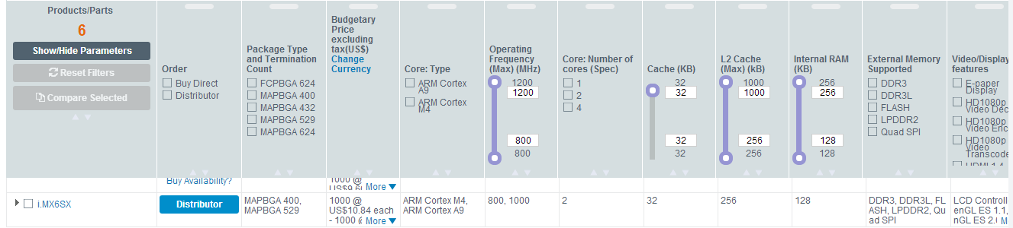

<http://www.freescale.com/webapp/sps/site/prod_summary.jsp?code=i.MX6SX>

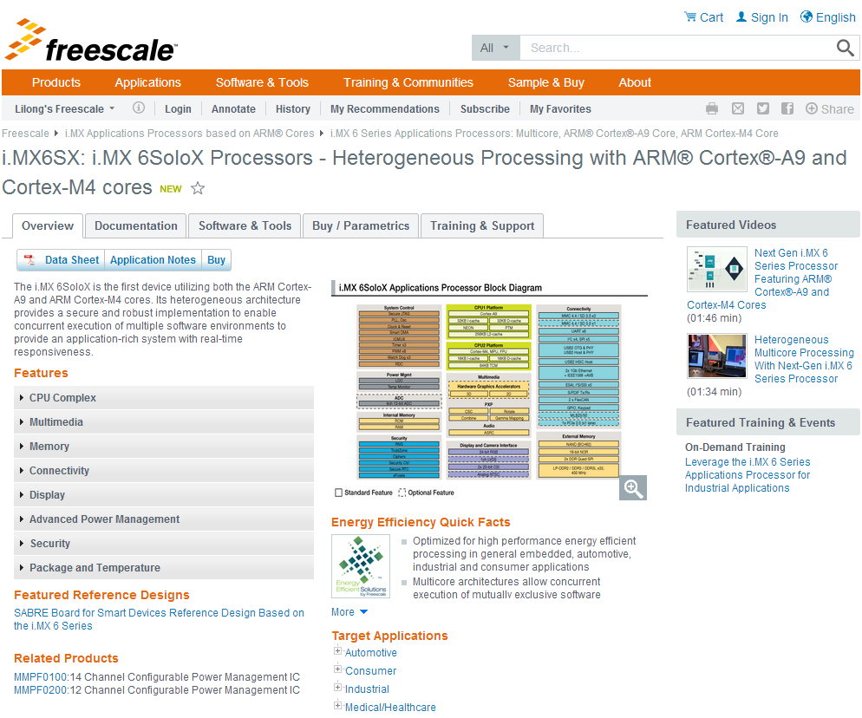

## i.MX6SX Documentation

<http://www.freescale.com/webapp/sps/site/prod_summary.jsp?code=i.MX6SX&fpsp=1&tab=Documentation_Tab>

### i.MX6SX Datasheet

[IMX6SXAEC](http://cache.freescale.com/files/32bit/doc/data_sheet/IMX6SXAEC.pdf?fasp=1&WT_TYPE=Data%20Sheets&WT_VENDOR=FREESCALE&WT_FILE_FORMAT=pdf&WT_ASSET=Documentation&fileExt=.pdf)   
i.MX 6SoloX Automotive and Infotainment Applications Processors - Data Sheet

[IMX6SXCEC](http://cache.freescale.com/files/32bit/doc/data_sheet/IMX6SXCEC.pdf?fasp=1&WT_TYPE=Data%20Sheets&WT_VENDOR=FREESCALE&WT_FILE_FORMAT=pdf&WT_ASSET=Documentation&fileExt=.pdf)   
i.MX 6SoloX Applications Processors for Consumer Products - Data Sheet

[IMX6SXIEC](http://cache.freescale.com/files/32bit/doc/data_sheet/IMX6SXIEC.pdf?fasp=1&WT_TYPE=Data%20Sheets&WT_VENDOR=FREESCALE&WT_FILE_FORMAT=pdf&WT_ASSET=Documentation&fileExt=.pdf)   
i.MX 6SoloX Applications Processors for Industrial Products - Data Sheet

### i.MX6SX Errata

[IMX6SXCE](http://cache.freescale.com/files/32bit/doc/errata/IMX6SXCE.pdf?fasp=1&WT_TYPE=Errata&WT_VENDOR=FREESCALE&WT_FILE_FORMAT=pdf&WT_ASSET=Documentation&fileExt=.pdf)   
Chip Errata for the i.MX 6SoloX Applications Processor - IMX6SXCE

### i.MX6SX Application Notes

[AN5127](http://cache.freescale.com/files/microcontrollers/doc/app_note/AN5127.pdf?fasp=1&WT_TYPE=Application%20Notes&WT_VENDOR=FREESCALE&WT_FILE_FORMAT=pdf&WT_ASSET=Documentation&fileExt=.pdf)   
How to Run the MQX™ RTOS on Various RAM Memories for i.MX 6SoloX - Application Note

[AN5050](http://cache.freescale.com/files/32bit/doc/app_note/AN5050.pdf?fasp=1&WT_TYPE=Application%20Notes&WT_VENDOR=FREESCALE&WT_FILE_FORMAT=pdf&WT_ASSET=Documentation&fileExt=.pdf)   
i.MX 6SoloX Power Consumption Measurement - AN5050

[AN4686](http://cache.freescale.com/files/32bit/doc/app_note/AN4686.pdf?fasp=1&WT_TYPE=Application%20Notes&WT_VENDOR=FREESCALE&WT_FILE_FORMAT=pdf&WT_ASSET=Documentation&fileExt=.pdf)   
Configuring Secure JTAG for the i.MX 6 Series Family of Applications Processors

[AN4629](http://cache.freescale.com/files/32bit/doc/app_note/AN4629.pdf?fasp=1&WT_TYPE=Application%20Notes&WT_VENDOR=FREESCALE&WT_FILE_FORMAT=pdf&WT_ASSET=Documentation&fileExt=.pdf)   
Fast Image Processing with i.MX 6 Series

[AN4589](http://cache.freescale.com/files/32bit/doc/app_note/AN4589.pdf?fasp=1&WT_TYPE=Application%20Notes&WT_VENDOR=FREESCALE&WT_FILE_FORMAT=pdf&WT_ASSET=Documentation&fileExt=.pdf)   
Configuring USB on i.MX 6 Series Processors

[AN4467](http://cache.freescale.com/files/32bit/doc/app_note/AN4467.pdf?fasp=1&WT_TYPE=Application%20Notes&WT_VENDOR=FREESCALE&WT_FILE_FORMAT=pdf&WT_ASSET=Documentation&fileExt=.pdf)   
i.MX 6 Series DDR Calibration

[AN5062](http://cache.freescale.com/files/32bit/doc/app_note/AN5062.pdf?fasp=1&WT_TYPE=Application%20Notes&WT_VENDOR=FREESCALE&WT_FILE_FORMAT=pdf&WT_ASSET=Documentation&fileExt=.pdf)   
i.MX 6SoloX Product Lifetime Usage Estimates - AN5062

[AN4815](http://cache.freescale.com/files/32bit/doc/app_note/AN4815.pdf?fasp=1&WT_TYPE=Application%20Notes&WT_VENDOR=FREESCALE&WT_FILE_FORMAT=pdf&WT_ASSET=Documentation&fileExt=.pdf)   
i.MX 6SoloX Migration Guide

[AN5078](http://cache.freescale.com/files/32bit/doc/app_note/AN5078.pdf?fasp=1&WT_TYPE=Application%20Notes&WT_VENDOR=FREESCALE&WT_FILE_FORMAT=pdf&WT_ASSET=Documentation&fileExt=.pdf)   
Influence of Pin Setting on System Function and Performance

[AN4553](http://cache.freescale.com/files/32bit/doc/app_note/AN4553.pdf?fasp=1&WT_TYPE=Application%20Notes&WT_VENDOR=FREESCALE&WT_FILE_FORMAT=pdf&WT_ASSET=Documentation&fileExt=.pdf)   
Using Open Source Debugging Tools for Linux on i.MX Processors

### i.MX6SX Chipset Reference Manuals

[IMX6SXRM](http://cache.freescale.com/files/32bit/doc/ref_manual/IMX6SXRM.pdf?fasp=1&WT_TYPE=Reference%20Manuals&WT_VENDOR=FREESCALE&WT_FILE_FORMAT=pdf&WT_ASSET=Documentation&fileExt=.pdf)   
i.MX 6SoloX Applications Processor Reference Manual

[IMX6SXSRM](https://www.freescale.com/webapp/Download?colCode=IMX6SXSRM&appType=moderatedWithoutFAE&fasp=1&WT_TYPE=Reference%20Manuals&WT_VENDOR=FREESCALE&WT_FILE_FORMAT=pdf&WT_ASSET=Documentation&fileExt=.pdf) SECURITYINFOIMAGE   
Security Reference Manual for the i.MX 6SoloX Applications Processor

### i.MX6SX Users Guides

[IMX6SXHDG](http://cache.freescale.com/files/32bit/doc/user_guide/IMX6SXHDG.pdf?fasp=1&WT_TYPE=Users%20Guides&WT_VENDOR=FREESCALE&WT_FILE_FORMAT=pdf&WT_ASSET=Documentation&fileExt=.pdf)   
Hardware Development Guide for i.MX 6SoloX Applications Processors - IMX6SXHDG

### Engineering Bulletins

[EB830](http://cache.freescale.com/files/32bit/doc/eng_bulletin/EB830.pdf?fasp=1&WT_TYPE=Engineering%20Bulletins&WT_VENDOR=FREESCALE&WT_FILE_FORMAT=pdf&WT_ASSET=Documentation&fileExt=.pdf)   
i.MX 6 Series Crystal Drive (24 MHz) - EB830

### i.MX6SX Fact Sheets

[IMX6SRSFS](http://cache.freescale.com/files/32bit/doc/fact_sheet/IMX6SRSFS.pdf?fasp=1&WT_TYPE=Fact%20Sheets&WT_VENDOR=FREESCALE&WT_FILE_FORMAT=pdf&WT_ASSET=Documentation&fileExt=.pdf)   
i.MX 6 Series of Applications Processors Fact Sheet

[IMX6SOLOXFS](http://cache.freescale.com/files/32bit/doc/fact_sheet/IMX6SOLOXFS.pdf?fasp=1&WT_TYPE=Fact%20Sheets&WT_VENDOR=FREESCALE&WT_FILE_FORMAT=pdf&WT_ASSET=Documentation&fileExt=.pdf)   
i.MX 6SoloX Applications Processor

### Supporting Information

***Note: This section contains some documents for BSP/Codec.***

[IMX6_L500_100_ANDROID_DOCS](https://www.freescale.com/webapp/Download?colCode=IMX6_L500_100_ANDROID_DOCS&location=null&fasp=1&WT_TYPE=Supporting%20Information&WT_VENDOR=FREESCALE&WT_FILE_FORMAT=gz&WT_ASSET=Documentation&fileExt=.gz) http://www.freescale.com/files/graphic/SECURITYINFOIMAGE.gif   
i.MX6 Android L5.0.0_1.0.0 BSP Documentation

[IMX6L31428101RN](http://cache.freescale.com/files/32bit/doc/support_info/IMX6L31428101RN.pdf?fasp=1&WT_TYPE=Supporting%20Information&WT_VENDOR=FREESCALE&WT_FILE_FORMAT=pdf&WT_ASSET=Documentation&fileExt=.pdf)   
i.MX 6 Yocto Project L3.14.28_1.0.1 Patch Release Notes -Release Notes

[L3.10.53_1.1.0_LINUX_DOCS](https://www.freescale.com/webapp/Download?colCode=L3.10.53_1.1.0_LINUX_DOCS&location=null&fasp=1&WT_TYPE=Supporting%20Information&WT_VENDOR=FREESCALE&WT_FILE_FORMAT=gz&WT_ASSET=Documentation&fileExt=.gz) SECURITYINFOIMAGE   
i.MX 6Quad, i.MX 6Dual, i.MX 6DualLite, i.MX 6Solo and i.MX 6Sololite Linux BSP Documentation. Includes Release Notes,...

[L3.14.28_1.0.0_LINUX_DOCS](https://www.freescale.com/webapp/Download?colCode=L3.14.28_1.0.0_LINUX_DOCS&location=null&fasp=1&WT_TYPE=Supporting%20Information&WT_VENDOR=FREESCALE&WT_FILE_FORMAT=gz&WT_ASSET=Documentation&fileExt=.gz) http://www.freescale.com/files/graphic/SECURITYINFOIMAGE.gif   
L3.14.28_1.0.0_LINUX_DOCS

[IMX6YOCTOPATCHRN](http://cache.freescale.com/files/32bit/doc/support_info/IMX6YOCTOPATCHRN.pdf?fasp=1&WT_TYPE=Supporting%20Information&WT_VENDOR=FREESCALE&WT_FILE_FORMAT=pdf&WT_ASSET=Documentation&fileExt=.pdf)   
i.MX 6Quad, i.MX 6Dual, i.MX 6DualLite, i.MX 6Solo and i.MX 6Sololite Linux L3.10.53_1.1.1 - Release Notes.

[IMX6_KK443_200_ANDROID_DOCS](https://www.freescale.com/webapp/Download?colCode=IMX6_KK443_200_ANDROID_DOCS&location=null&fasp=1&WT_TYPE=Supporting%20Information&WT_VENDOR=FREESCALE&WT_FILE_FORMAT=gz&WT_ASSET=Documentation&fileExt=.gz) SECURITYINFOIMAGE   
i.MX6 Android kk4.4.3_2.0.0 BSP Documentation

## i.MX6SX Software & Tools

<http://www.freescale.com/webapp/sps/site/prod_summary.jsp?code=i.MX6SX&fpsp=1&tab=Design_Tools_Tab>

### i.MX6SX Reference Designs

[SABRE Board for Smart Devices Reference Design Based on the i.MX 6 Series](http://www.freescale.com/webapp/sps/site/prod_summary.jsp?code=RDIMX6SABREBRD)Favorite   
Freescale's Smart Application Blueprint for Rapid Engineering (SABRE) board for smart devices introduces developers to multicore processing, low-power consumption and leading-edge multimedia and graphics applications on the i.MX 6 series applications processors. The SABRE board for smart devices simplifies product design ...

### i.MX6SX PCB and Schematics

[IMX6SOLOX-SABRESDB-DESIGNFILES](http://www.freescale.com/webapp/sps/site/prod_summary.jsp?code=RDIMX6SABREBRD&fpsp=1&tab=Design_Tools_Tab) SECURITYINFOIMAGE : Design files, including hardware schematics, Gerbers, and OrCAD files..   
**Size (K):**6690 **Format:**zip **Rev #:**0 **Modified:**2/24/2015

### i.MX6SX Programmers

[IMX-L5.0.0-MFG-TOOL](http://www.freescale.com/webapp/sps/site/prod_summary.jsp?code=i.MX6SX&fpsp=1&tab=Design_Tools_Tab) http://www.freescale.com/files/graphic/SECURITYINFOIMAGE.gif : i.MX 6Family Manufacturing Toolkit for L5.0.0_1.0.0  
**Size (K):**36731 **Format:**gz **Rev #:**L5.0.0_1.0.0 **Modified:**6/2/2015

[IMX6_L3.10.53_MFG_TOOL](http://www.freescale.com/webapp/sps/site/prod_summary.jsp?code=i.MX6SL&fpsp=1&tab=Design_Tools_Tab) SECURITYINFOIMAGE : Set of applications for the Linux L3.10.53_1.1.0 BSP, designed to be used by graphics application developers to rapidly develop and port graphics applications. Includes applications, GPU Driver with vprofiler enabled and documentation.  
**Size (K):**240909 **Format:**gz **Rev #:**L3.10.53_1.1.0 **Modified:**1/23/2015

[IMX6_L3.14.28_MFG_TOOL](http://www.freescale.com/webapp/sps/site/prod_summary.jsp?code=i.MX6SX&fpsp=1&tab=Design_Tools_Tab) http://www.freescale.com/files/graphic/SECURITYINFOIMAGE.gif : IMX6_L3.14.28_MFG_TOOL.   
**Size (K):**290397 **Format:**gz **Rev #:**L3.14.28_1.0.0 **Modified:**4/16/2015

[IMX_KK4.4.3_MFG_TOOL](http://www.freescale.com/webapp/sps/site/prod_summary.jsp?code=i.MX6SX&fpsp=1&tab=Design_Tools_Tab) SECURITYINFOIMAGE : i.MX 6Family Manufacturing Toolkit for kk4.4.3_2.0.0  
**Size (K):**36796 **Format:**gz **Rev #:**kk4.4.3_2.0.0 **Modified:**2/6/2015

### i.MX6SX IBIS

[IMX6SX_IBIS](http://www.freescale.com/webapp/sps/site/prod_summary.jsp?code=i.MX6SX&fpsp=1&tab=Design_Tools_Tab): i.MX 6SoloX IBIS files.   
**Size (K):**106544 **Format:**zip **Rev #:**0 **Modified:**3/2/2015

### i.MX6SX SDK

[i.MX6D/Q/DL/S/SX GPU Demo Framework SDK](http://www.freescale.com/webapp/sps/site/prod_summary.jsp?code=i.MX6SX&fpsp=1&tab=Design_Tools_Tab) http://www.freescale.com/files/graphic/SECURITYINFOIMAGE.gif : This package contains binary of Freescale GPU demo-framework 2.1 SDK source and tools to generate and build demo frame work applications.  
**Size (K):**68000 **Format:**zip **Rev #:**2.1 **Modified:**3/13/2015

### i.MX6SX BSP and Demo Images

[IMXANDROID](http://www.freescale.com/webapp/sps/site/prod_summary.jsp?code=IMXANDROID&fsrch=1): Android OS for i.MX Applications Processors. Freescale fully supports the Android™ operating system through board support packages for the i.MX range of application processors and featured tools such as SABRE for tablets. Freescale’s...  
**Format:**html **Modified:**6/4/2015

<http://www.freescale.com/webapp/sps/site/prod_summary.jsp?code=IMXANDROID&fsrch=1>

We could download android releases via above hyperlink. More details for the BSP release please refer to following chapter: i.MX6 Android and Linux BSP and Demo Images.

[IMXLINUX](http://www.freescale.com/webapp/sps/site/prod_summary.jsp?code=IMXLINUX&fsrch=1): Embedded Linux for i.MX Applications Processors. Quickly get your Linux based designs started with the full featured and energy efficient i.MX family of processors by using Freescale's Linux development tools. Our goal is to provide you with a...  
**Format:**html **Modified:**5/25/2015

<http://www.freescale.com/webapp/sps/site/prod_summary.jsp?code=IMXLINUX&fsrch=1>

We could download linux releases via above hyperlink. More details for the BSP release please refer to following chapter: i.MX6 Android and Linux BSP and Demo Images.

### Operating Systems for Cortex M4

[MQX](http://www.freescale.com/webapp/sps/site/prod_summary.jsp?code=MQX&fsrch=1): Freescale MQX™ Software Solutions. Freescale streamlines embedded design with a complimentary real-time operating system (RTOS) and software stacks. MQX RTOS includes a multitasking kernel with pre-emptive scheduling and fast interrupt...  
**Format:**html **Modified:**5/19/2015

Click the above hyperlink we will get:

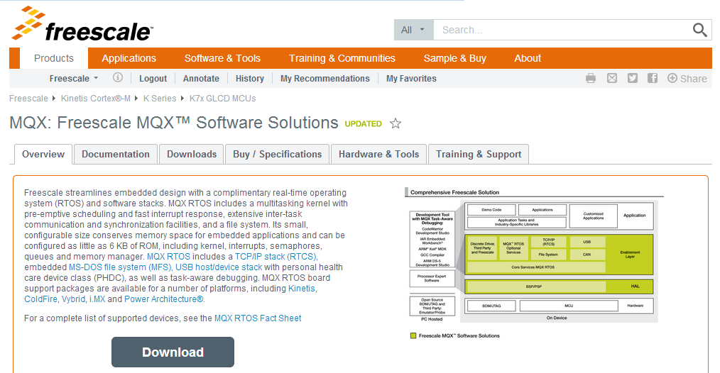

Click Download to get the MQX source codes:

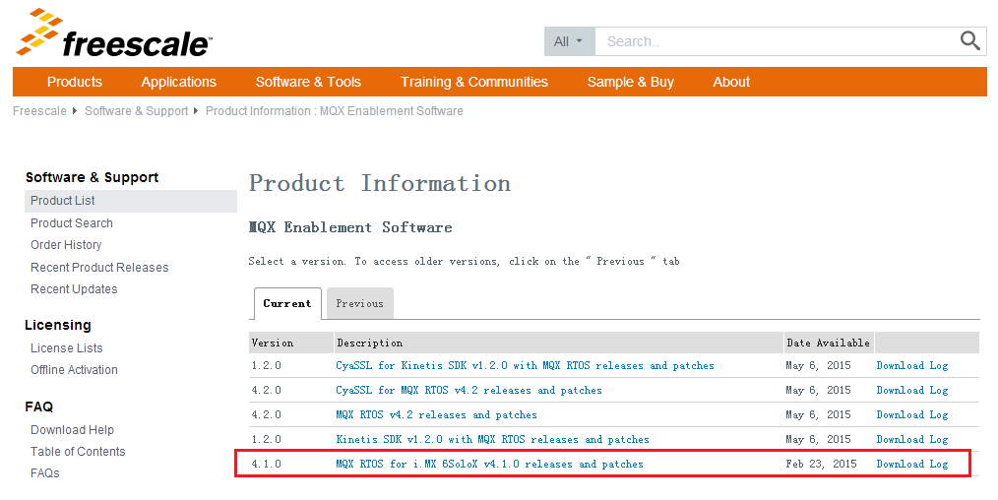

Please note for the release, there are both linux and windows versions as below. Please select corresponding version.

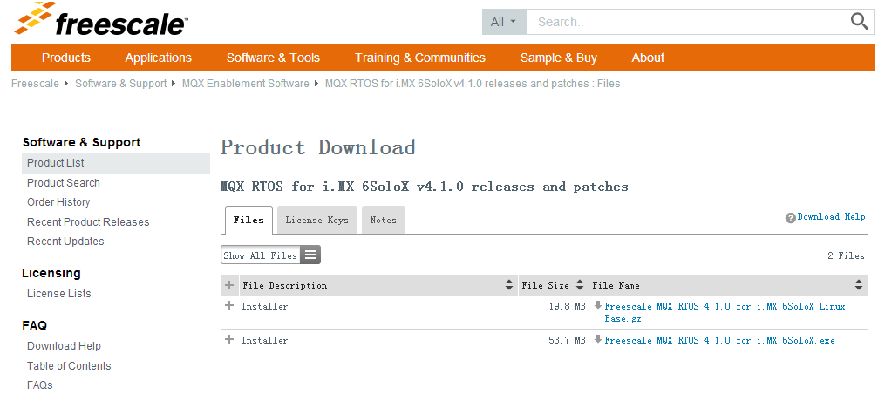

### i.MX6SX Software Codecs

[IMX6-L500-100-AACP-CODEC-CODA](http://www.freescale.com/webapp/sps/site/prod_summary.jsp?code=i.MX6SX&fpsp=1&tab=Design_Tools_Tab) http://www.freescale.com/files/graphic/SECURITYINFOIMAGE.gif : AAC Plus Codec for i.MX 6Quad, i.MX 6Dual, i.MX 6DualLite, i.MX 6Solo i.MX 6Sololite and i.MX 6SX Android L5.0.0_1.0.0 BSP.  
**Size (K):**91 **Format:**gz **Rev #:**L5.0.0_1.0.0 **Modified:**6/2/2015

[IMX6_KK443_200_AACP_CODEC_CODA](http://www.freescale.com/webapp/sps/site/prod_summary.jsp?code=i.MX6SX&fpsp=1&tab=Design_Tools_Tab) SECURITYINFOIMAGE : AAC Plus Codec for i.MX 6Quad, i.MX 6Dual, i.MX 6DualLite, i.MX 6Solo, i.MX 6Sololite and i.MX 6 SX Android KK4.4.3_2.0.0 BSP.  
**Size (K):**89 **Format:**gz **Rev #:**kk4.4.3_2.0.0 **Modified:**2/6/2015

[L3.10.53_1.1.0_AACP_CODECS](http://www.freescale.com/webapp/sps/site/prod_summary.jsp?code=i.MX6SX&fpsp=1&tab=Design_Tools_Tab) SECURITYINFOIMAGE : i.MX 6Quad, i.MX 6Dual, i.MX 6DualLite, i.MX 6Solo, i.MX 6Sololite and i.MX 6SX Linux AAC Plus Codec  
**Size (K):**509 **Format:**gz **Rev #:**L3.10.53_1.1.0 **Modified:**1/23/2015

# i.MX6UL Website Guide

We enter the i.MX6UL web link

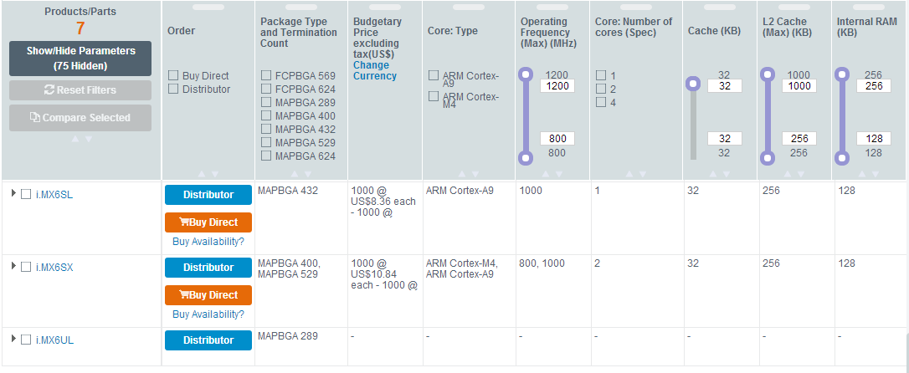

<http://www.freescale.com/webapp/sps/site/prod_summary.jsp?code=i.MX6UL>

its main page as follows:

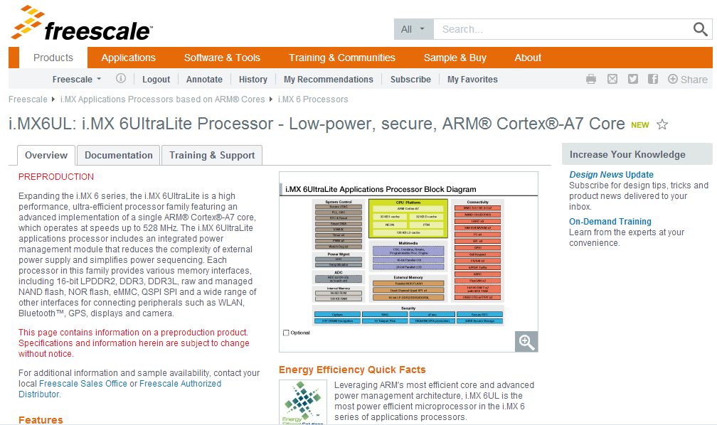

The Documentation and Software & Tools items are very important to get the design resource, and the Buy/Parametrics item will have the development board and chipset order information.

## i.MX6UL Documentation

We enter the Documentation item link: <http://www.freescale.com/webapp/sps/site/prod_summary.jsp?code=i.MX6UL&fpsp=1&tab=Documentation_Tab>, which will have our documentation materials include the Datasheet, Errata, Application Notes, Reference Manual, User guides, Fact Sheets and related supporting information.

### i.MX6UL Fact Sheets

[IMX6SRSFS](http://cache.freescale.com/files/32bit/doc/fact_sheet/IMX6SRSFS.pdf?fasp=1&WT_TYPE=Fact%20Sheets&WT_VENDOR=FREESCALE&WT_FILE_FORMAT=pdf&WT_ASSET=Documentation&fileExt=.pdf)   
i.MX 6 Series of Applications Processors Fact Sheet

[IMX6ULTRALITEFS](http://cache.freescale.com/files/32bit/doc/fact_sheet/IMX6ULTRALITEFS.pdf?fasp=1&WT_TYPE=Fact%20Sheets&WT_VENDOR=FREESCALE&WT_FILE_FORMAT=pdf&WT_ASSET=Documentation&fileExt=.pdf)   
i.MX 6UltraLite - Fact Sheet

# i.MX6QP/DP Website Guide

We enter the i.MX6QP/DP web link

<http://www.freescale.com/webapp/sps/site/prod_summary.jsp?code=i.MX6QP>

its main page as follows:

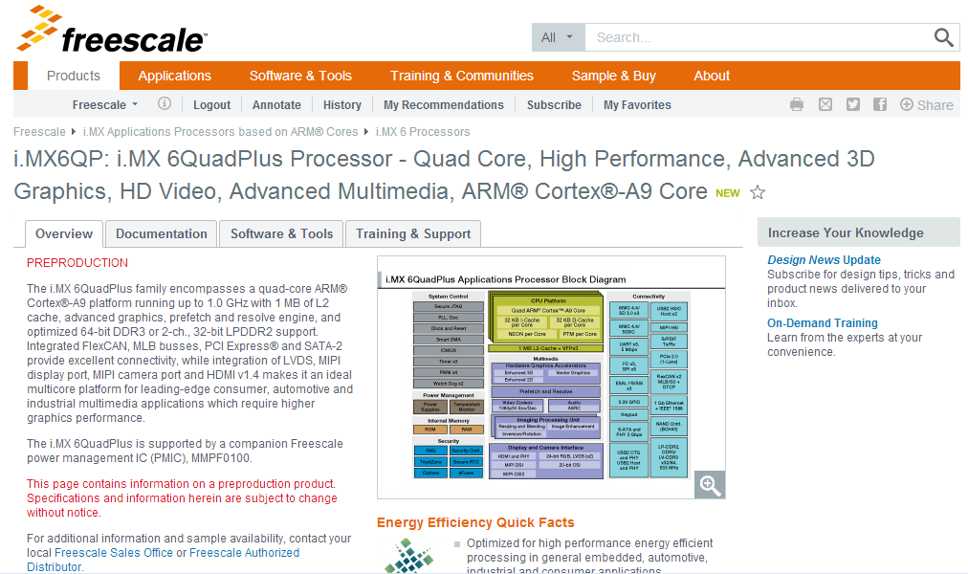

The Documentation and Software & Tools items are very important to get the design resource, and the Buy/Parametrics item will have the development board and chipset order information.

## i.MX6QP/DP Documentation

We enter the documentation item link:

<http://www.freescale.com/webapp/sps/site/prod_summary.jsp?code=i.MX6QP&fpsp=1&tab=Documentation_Tab>, which will have our documentation materials include the Datasheet, Errata, Application Notes, Reference Manual, User guides, Fact Sheets and related supporting information.

### i.MX6QP/DP Fact Sheets

[IMX6DUALQUADFS](http://cache.freescale.com/files/32bit/doc/fact_sheet/IMX6DUALQUADFS.pdf?fasp=1&WT_TYPE=Fact%20Sheets&WT_VENDOR=FREESCALE&WT_FILE_FORMAT=pdf&WT_ASSET=Documentation&fileExt=.pdf)   
i.MX 6Dual, i.MX 6DualPlus, i.MX 6Quad, i.MX 6QuadPlus - fact sheet

[IMX6SRSFS](http://cache.freescale.com/files/32bit/doc/fact_sheet/IMX6SRSFS.pdf?fasp=1&WT_TYPE=Fact%20Sheets&WT_VENDOR=FREESCALE&WT_FILE_FORMAT=pdf&WT_ASSET=Documentation&fileExt=.pdf)   
i.MX 6 Series of Applications Processors Fact Sheet

# i.MX6 Android and Linux BSP and Demo Images

## Android BSP and Demo Images

[IMXANDROID](http://www.freescale.com/webapp/sps/site/prod_summary.jsp?code=IMXANDROID&fsrch=1): Android OS for i.MX Applications Processors. Freescale fully supports the Android™ operating system through board support packages for the i.MX range of application processors and featured tools such as SABRE for tablets. Freescale’s...  
**Format:**html **Modified:**6/4/2015

<http://www.freescale.com/webapp/sps/site/prod_summary.jsp?code=IMXANDROID&fsrch=1>

We could download android releases via above hyperlink. Below are released android BSP and demo images.

IMX6-L500-100-ANDROID-SOURCE-BSP (REV L5.0.0_1.0.0)

i.MX 6Quad, i.MX 6Dual, i.MX 6DualLite, i.MX 6Solo i.MX 6Sololite and i.MX6SX Android L5.0.0_1.0.0 BSP, Source Code for BSP and Codecs.

**Date :** 6/2/2015 **Format :** gz **Size :** 94224K

IMX6-L500-100-ANDROID-DEMO-AI-BSP (REV L5.0.0_1.0.0)

i.MX 6Quad, i.MX 6Dual, i.MX 6DualLite, and i.MX 6Solo Android L5.0.0_1.0.0 BSP Binary Demo Files for the SABRE for Automotive Infotainment.

**Date :** 6/2/2015 **Format :** gz **Size :** 726208K

IMX6-L500-100_ANDROID_DEMO_EVK_BSP (REV L5.0.0_1.0.0)

i.MX 6Sololite Android L5.0.0_1.0.0 BSP Binary Demo Files for the SoloLite evaluation kit.

**Date :** 6/2/2015 **Format :** gz **Size :** 320651K

IMX6-L500-100-ANDROID-DEMO-SD-BSP (REV L5.0.0_1.0.0)

i.MX 6Quad, i.MX 6Dual, i.MX 6DualLite, and i.MX 6Solo Android L5.0.0_1.0.0 BSP Binary Demo Files for the SABRE Platform and SABRE Board for Smart...

**Date :** 6/2/2015 **Format :** gz **Size :** 783176K

IMX6-L500-100-ANDROID-DEMO-iMX6SX-BSP (REV L5.0.0_1.0.0)

i.MX 6SoloX Android L5.0.0_1.0.0 BSP Binary Demo Files.

**Date :** 6/2/2015 **Format :** gz **Size :** 990953K

IMX6_KK443_200_ANDROID_DEMO_EVK_BSP (REV KK4.4.3_2.0.0)

i.MX 6Sololite Android KK4.4.3_2.0.0 BSP demo files for the SoloLite evaluation kit.

**Date :** 2/6/2015 **Format :** gz **Size :** 666957K

IMX6_KK443_200_ANDROID_DEMO_AI_BSP (REV KK4.4.3_2.0.0)

i.MX 6Quad, i.MX 6Dual, i.MX 6DualLite, and i.MX 6Solo Android KK4.4.3_2.0.0 BSP Binary Demo Files for the SABRE for Automotive Infotainment.  
**Date :**2/6/2015 **Format:**gz  **Size :**1113826K

### IMX6_KK443_200_ANDROID_DEMO_SD_BSP (REV KK4.4.3_2.0.0)

i.MX 6Quad, i.MX 6Dual, i.MX 6DualLite, and i.MX 6Solo Android KK4.4.3_2.0.0 BSP Binary Demo Files for the SABRE Platform and SABRE Board for Smart Devices.  
**Date :**2/6/2015 **Format:**gz **Size :**1166696K

IMX6_KK443_200_ANDROID_SOURCE_BSP (REV KK4.4.3_2.0.0)

i.MX 6Quad, i.MX 6Dual, i.MX 6DualLite, i.MX 6Solo and i.MX 6Sololite Android KK4.4.3_2.0.0 BSP, Source Code for BSP and Codecs.  
**Date :**2/6/2015 **Format:**gz **Size :**66824K

IMX6_KK443_200_ANDROID_DEMO_iMX6SX_BSP (REV KK4.4.3_2.0.0)

i.MX 6SoloX Android KK4.4.3_2.0.0 BSP Binary Demo Files.**Date :** 2/13/2015 **Format :** gz **Size :** 1740826K

IMX6_SABRE_AI_KK442_100_ANDROID_DEMO_BSP (REV KK4.4.2_1.0.0)

i.MX 6Quad, i.MX 6Dual, i.MX 6DualLite, and i.MX 6Solo Android KK4.4.2_1.0.0 BSP Binary Demo Files for the SABRE for Automotive Infotainment.    
**Date :** 7/14/2014 **Format:** gz **Size :** 1101650K

IMX6SL_EVK_KK442_100_ANDROID_DEMO_BSP (REV KK4.4.2_1.0.0)

AAC Plus Codec for i.MX 6Quad, i.MX 6Dual, i.MX 6DualLite, i.MX 6Solo and i.MX 6Sololite Android KK4.4.2_1.0.0 BSP.

**Date :** 7/14/2014 **Format :** gz **Size :** 324229K

IMX6_SABRE_SD_KK442_100_ANDROID_DEMO_BSP (REV KK4.4.2_1.0.0)

i.MX 6Quad, i.MX 6Dual, i.MX 6DualLite, and i.MX 6Solo Android KK4.4.2_1.0.0 BSP Binary Demo Files for the SABRE Platform and SABRE Board for Smart Devices.  
**Date** **:** 7/14/2014 **Format:** gz **Size :** 1100441K

IMX6_KK442_100_ANDROID_SOURCE_BSP (REV KK4.4.2_1.0.0)

i.MX 6Quad, i.MX 6Dual, i.MX 6DualLite, i.MX 6Solo and i.MX 6Sololite Android KK4.4.2_1.0.0 BSP, Source Code for BSP and Codecs.   
**Date :**7/14/2014 **Format:**gz **Size :**52081K

IMX6_JB43_111_ANDROID_DEMO_BSP (REV JB4.3.0_1.1.1)

i.MX 6Quad, i.MX 6Dual, i.MX 6DualLite, i.MX 6Solo and i.MX 6Sololite Android Binary Demo Files.   
**Date :** 10/24/2014 **Format:** tar **Size :** 1062138K

IMX6_JB43_111_ANDROID_SOURCE_BSP (REV JB4.3.0_1.1.1)

i.MX 6Quad, i.MX 6Dual, i.MX 6DualLite, i.MX 6Solo and i.MX 6Sololite Android BSP Source Code Files.   
**Date :** 10/24/2014 **Format:** gz **Size :** 1195K

IMX6_JB43_110_ANDROID_DEMO_BSP (REV JB4.3_1.1.0)

i.MX 6Quad, i.MX 6Dual, i.MX 6DualLite, i.MX 6Solo and i.MX 6Sololite Android jb4.3_1.1.0 BSP Binary Demo Files.   
**Date :** 12/19/2013 **Format:** gz **Size :** 1056897K

IMX6_JB43_110_ANDROID_SOURCE_BSP (REV JB4.3_1.1.0)

i.MX 6Quad, i.MX 6Dual, i.MX 6DualLite, i.MX 6Solo and i.MX 6Sololite Android jb4.3_1.1.0 0 BSP, Documentation and Source Code for BSP and Codecs..   
**Date :** 12/19/2013 **Format:** gz **Size :** 274715K

## Linux BSP and Demo Images

[IMXLINUX](http://www.freescale.com/webapp/sps/site/prod_summary.jsp?code=IMXLINUX&fsrch=1): Embedded Linux for i.MX Applications Processors. Quickly get your Linux based designs started with the full featured and energy efficient i.MX family of processors by using Freescale's Linux development tools. Our goal is to provide you with a...  
**Format:**html **Modified:**5/25/2015

<http://www.freescale.com/webapp/sps/site/prod_summary.jsp?code=IMXLINUX&fsrch=1>

We could download linux releases via above hyperlink. Below are released linux BSP and demo images.

### [L3.14.28_1.0.0_iMX6QDLS_BUNDLE](https://www.freescale.com/webapp/Download?colCode=L3.14.28_1.0.0_iMX6QDLS_BUNDLE&appType=license&location=null&fpsp=1&WT_TYPE=Board%20Support%20Packages&WT_VENDOR=FREESCALE&WT_FILE_FORMAT=gz&WT_ASSET=Downloads&fileExt=.gz) (REV L3.14.28_1.0.0)

i.MX 6Quad, i.MX 6Dual, i.MX 6DualLite, i.MX 6Solo Linux Binary Demo Files and Linux BSP Documentation    
**Date :** 4/10/2015 **Format :** gz **Size :** 1479000K

### [L3.14.28_1.0.0_iMX6SL_BUNDLE](https://www.freescale.com/webapp/Download?colCode=L3.14.28_1.0.0_iMX6SL_BUNDLE&appType=license&location=null&fpsp=1&WT_TYPE=Board%20Support%20Packages&WT_VENDOR=FREESCALE&WT_FILE_FORMAT=gz&WT_ASSET=Downloads&fileExt=.gz) (REV L3.14.28_1.0.0)

i.MX 6Sololite, i.MXSoloEVK Linux Binary Demo Files and Linux BSP Documentation    
**Date :** 4/10/2015 **Format :** gz **Size :** 912000K

### [L3.14.28_1.0.0_iMX6SX_BUNDLE](https://www.freescale.com/webapp/Download?colCode=L3.14.28_1.0.0_iMX6SX_BUNDLE&appType=license&location=null&fpsp=1&WT_TYPE=Board%20Support%20Packages&WT_VENDOR=FREESCALE&WT_FILE_FORMAT=gz&WT_ASSET=Downloads&fileExt=.gz) (REV L3.14.28_1.0.0)

i.MX 6SoloX Linux Binary Demo Files and Linux BSP Documentation

**Date :** 4/10/2015 **Format :** gz **Size :** 1465000K

### [L3.10.53_1.1.0_iMX6QDLS_Bundle](https://www.freescale.com/webapp/Download?colCode=L3.10.53_1.1.0_iMX6QDLS_Bundle&appType=license&location=null&fpsp=1&WT_TYPE=Board%20Support%20Packages&WT_VENDOR=FREESCALE&WT_FILE_FORMAT=gz&WT_ASSET=Downloads&fileExt=.gz) (REV L3.10.53_1.1.0)

i.MX 6Quad, i.MX 6Dual, i.MX 6DualLite, i.MX 6Solo Linux Binary Demo Files and Linux BSP Documentation   
**Date :** 4/13/2015 **Format :** gz **Size :** 1384120K

### [L3.10.53_1.1.0_iMX6SL_Bundle](https://www.freescale.com/webapp/Download?colCode=L3.10.53_1.1.0_iMX6SL_Bundle&appType=license&location=null&fpsp=1&WT_TYPE=Board%20Support%20Packages&WT_VENDOR=FREESCALE&WT_FILE_FORMAT=gz&WT_ASSET=Downloads&fileExt=.gz) (REV L3.10.53_1.1.0)

i.MX 6Sololite, i.MXSoloEVK Linux Binary Demo Files and Linux BSP Documentation   
**Date :** 4/13/2015 **Format :** gz **Size :** 718848K

[L3.10.53_1.1.0_iMX6SX_Bundle](https://www.freescale.com/webapp/Download?colCode=L3.10.53-1.1.0-iMX6SX&appType=license&location=null&fpsp=1&WT_TYPE=Board%20Support%20Packages&WT_VENDOR=FREESCALE&WT_FILE_FORMAT=gz&WT_ASSET=Downloads&fileExt=.gz) (REV L3.10.53_1.1.0)

i.MX 6 SoloX Linux Binary Demo Files and Linux BSP Documentation.    
**Date :** 4/13/2015 **Format :** gz **Size :** 1373634K

[L3.10.17_1.0.2_iMX6QDLS_BUNDLE](http://www.freescale.com/webapp/sps/site/prod_summary.jsp?code=i.MX6Q&nodeId=018rH3ZrDRB24A&fpsp=1&tab=Design_Tools_Tab) (REV L3.10.17_1.0.2)

i.MX 6Quad, i.MX 6Dual, i.MX 6DualLite, i.MX 6Solo Linux Binary Demo Files and Linux BSP Documentation.   
**Date :** 10/29/2014 **Format:** gz  **Size :** 717480K

[L3.10.17_1.0.2_iMX6SL_BUNDLE](https://www.freescale.com/webapp/Download?colCode=L3.10.17_1.0.2_iMX6SL_BUNDLE&appType=license&location=null&fpsp=1&WT_TYPE=Board%20Support%20Packages&WT_VENDOR=FREESCALE&WT_FILE_FORMAT=gz&WT_ASSET=Downloads&fileExt=.gz) (REV L3.10.17_1.0.2)

i.MX 6Sololite, i.MXSoloEVK Linux Binary Demo Files and Linux BSP Documentation.   
**Date :** 10/29/2014 **Format :** gz **Size :** 712867K

[L3.10.17_1.0.0_IMX6QDLS_BUNDLE](http://www.freescale.com/webapp/sps/site/prod_summary.jsp?code=i.MX6Q&fpsp=1&tab=Design_Tools_Tab) (REV L3.10.17_1.0.0)

Source Code Download Steps Documentation and Demo Images.   
**Date :** 2/24/2015 **Format :** gz **Size :** 718879K

### [L3.10.17_1.0.0_IMX6SL_BUNDLE](https://www.freescale.com/webapp/Download?colCode=L3.10.17_1.0.0_IMX6SL_BUNDLE&appType=license&location=null&fpsp=1&WT_TYPE=Board%20Support%20Packages&WT_VENDOR=FREESCALE&WT_FILE_FORMAT=gz&WT_ASSET=Downloads&fileExt=.gz) (REV L3.10.17_1.0.0)

Source Code Download Steps Documentation and Demo Images.   
**Date :** 2/24/2015 **Format :** gz **Size :** 714420K

### [L3.0.101_4.1.1_IM6QDLS_BUNDLE](http://www.freescale.com/webapp/sps/site/prod_summary.jsp?code=i.MX6Q&nodeId=018rH3ZrDRB24A&fpsp=1&tab=Design_Tools_Tab) (REV L3.0.101_4.1.1)

i.MX 6Quad, i.MX 6Dual, i.MX 6DualLite, i.MX 6Solo Linux Binary Demo Files.   
**Date :** 11/3/2014 **Format :** gz **Size :** 376183K

### [L3.0.101_4.1.1_IM6SL_BUNDLE](https://www.freescale.com/webapp/Download?colCode=L3.0.101_4.1.1_IM6SL_BUNDLE&appType=license&location=null&fpsp=1&WT_TYPE=Board%20Support%20Packages&WT_VENDOR=FREESCALE&WT_FILE_FORMAT=gz&WT_ASSET=Downloads&fileExt=.gz) (REV L3.0.101_4.1.1)

i.MX 6 Sololite Linux Binary Demo Files.

**Date :** 11/3/2014 **Format :** gz **Size :** 369637K

[L3.0.101_4.1.1_SOURCE_BSP](http://www.freescale.com/webapp/sps/site/prod_summary.jsp?code=i.MX6Q&nodeId=018rH3ZrDRB24A&fpsp=1&tab=Design_Tools_Tab) (REV L3.0.101_4.1.1)

i.MX 6Quad, i.MX 6Dual, i.MX 6DualLite, i.MX 6Solo and i.MX 6Sololite Linux BSP Source Code Files.   
**Date :**11/3/2014 **Format:**gz **Size :**319113K

[L3.0.35_4.1.0_DEMO_IMAGE_BSP](https://www.freescale.com/webapp/sps/download/license.jsp?colCode=L3.0.35_4.1.0_DEMO_IMAGE_BSP&appType=file1&location=null&DOWNLOAD_ID=null) (REV L3.0.35_4.1.0)

i.MX 6Quad, i.MX 6Dual, i.MX 6DualLite, i.MX 6Solo and i.MX 6Sololite Linux Binary Demo Files.   
**Date :** 9/5/2013 **Format:** gz **Size :** 499987K

[L3.0.35_4.1.0_ER_SOURCE_BSP](https://www.freescale.com/webapp/sps/download/license.jsp?colCode=L3.0.35_4.1.0_ER_SOURCE_BSP&appType=file1&location=null&DOWNLOAD_ID=null) (REV L3.0.35_4.1.0)

i.MX 6Quad, i.MX 6Dual, i.MX 6DualLite, i.MX 6Solo and i.MX 6Sololite Linux BSP Source Code Files.   
**Date :** 9/5/2013 **Format:** gz **Size :** 1086744K

Linux LTIB source codes package.

[L3.0.35_4.1.0_UBUNTU_RFS_BSP](https://www.freescale.com/webapp/sps/download/license.jsp?colCode=L3.0.35_4.1.0_UBUNTU_RFS_BSP&appType=file1&location=null&DOWNLOAD_ID=null) (REV L3.0.35_4.1.0)

i.MX 6Quad, i.MX 6Dual, i.MX 6DualLite, i.MX 6Solo and i.MX 6Sololite Linux File System for the Ubuntu Images.   
**Date :** 9/5/2013 **Format:** tgz **Size :** 797055K

Version History:

|  |  |  |  |
| --- | --- | --- | --- |
| **Version** | **Date of change** | **Author** | **Comment** |
| 1.0 |  | Yueshu Li | Initial drop |
| 1.1 | 2014-04-15 | Taichun Yuan | Correct items/links and add version information |
| 1.2 | 2014-04-16 | Taichun Yuan | Add some new items for Android JB4.3 and delete some old items.. |
| 1.3 | 2014-07-15 | Lilong Liu | Update some web page displays and add newly released documents and SW images. |
| 1.4 | 2014-07-16 | Lilong Liu | Synchronized with the web site till 2014-07-16. |
| 1.5 | 2014-11-06 | Lilong Liu | Synchronized with the web site till 2014-11-06. |
| 1.6 | 2015-06-10 | Lilong Liu | Synchronized with the web site till 2015-06-10.  Add chapter 4-6: i.MX6 SX/UL/QP/DP Website Guide.  Add chapter 7: i.MX6 android and linux BSP and demo images. |
|  |  |  |  |

How to Reach Us:

Home Page:

www.freescale.com

Web Support:

http://www.freescale.com/support

USA/Europe or Locations Not Listed:

Freescale Semiconductor

Technical Information Center, EL516  
2100 East Elliot Road  
Tempe, Arizona 85284  
+1-800-521-6274 or +1-480-768-2130  
www.freescale.com/support

Europe, Middle East, and Africa:

Freescale Halbleiter Deutschland GmbH

Technical Information Center

Schatzbogen 7

81829 Muenchen, Germany

+44 1296 380 456 (English)

+46 8 52200080 (English)

+49 89 92103 559 (German)

+33 1 69 35 48 48 (French)

www.freescale.com/support

Japan:

Freescale Semiconductor Japan Ltd.

Headquarters

ARCO Tower 15F

1-8-1, Shimo-Meguro, Meguro-ku,

Tokyo 153-0064, Japan

0120 191014 or +81 3 5437 9125

support.japan@freescale.com

Asia/Pacific:

Freescale Semiconductor China Ltd.  
Exchange Building 23F  
No. 118 Jianguo Road  
Chaoyang District  
Beijing 100022  
China  
+86 010 5879 8000  
support.asia@freescale.com

For Literature Requests Only:

Freescale Semiconductor Literature   
 Distribution Center

P.O. Box 5405

Denver, Colorado 80217

1-800-441-2447 or 303-675-2140

Fax: 303-675-2150

LDCForFreescaleSemiconductor@hibbertgroup.com

Information in this document is provided solely to enable system and software implementers to use Freescale Semiconductor products. There are no express or implied copyright licenses granted hereunder to design or fabricate any integrated circuits or integrated circuits based on the information in this document.

Freescale Semiconductor reserves the right to make changes without further notice to any products herein. Freescale Semiconductor makes no warranty, representation or guarantee regarding the suitability of its products for any particular purpose, nor does Freescale Semiconductor assume any liability arising out of the application or use of any product or circuit, and specifically disclaims any and all liability, including without limitation consequential or incidental damages. “Typical” parameters which may be provided in Freescale Semiconductor data sheets and/or specifications can and do vary in different applications and actual performance may vary over time. All operating parameters, including “Typicals” must be validated for each customer application by customer’s technical experts. Freescale Semiconductor does not convey any license under its patent rights nor the rights of others. Freescale Semiconductor products are not designed, intended, or authorized for use as components in systems intended for surgical implant into the body, or other applications intended to support or sustain life, or for any other application in which the failure of the Freescale Semiconductor product could create a situation where personal injury or death may occur. Should Buyer purchase or use Freescale Semiconductor products for any such unintended or unauthorized application, Buyer shall indemnify and hold Freescale Semiconductor and its officers, employees, subsidiaries, affiliates, and distributors harmless against all claims, costs, damages, and expenses, and reasonable attorney fees arising out of, directly or indirectly, any claim of personal injury or death associated with such unintended or unauthorized use, even if such claim alleges that Freescale Semiconductor was negligent regarding the design or manufacture of the part.

Freescale and the Freescale logo are trademarks or registered trademarks of Freescale Semiconductor, Inc. in the U.S. and other countries. All other product or service names are the property of their respective owners. Microsoft and Windows are registered trademarks of Microsoft Corporation.

© Freescale Semiconductor, Inc. 2009. All rights reserved.