**Matlab科学计算语言及应用**

**21221学期**

第1次

实验报告

学号：3020234369

姓名 : 李佳林

班级 : 通信3班

题目：1、2、3、4、5、6

代码：

clear; clc;

a = 10

b = 2.5*10^23

c = 2 + 3i

d = exp((2*pi/3)*1i)

aVec = [3.14 15 9 26]

bVec = [2.17; 8; 28; 182]

cVec = 5: -0.2 : -5

dVec = logspace(0,1,101)

eVec = 'Hello'

aMat = 2*ones(9,9)

v = [1 2 3 4 5 4 3 2 1];

bMat = diag(v)

A = 1:100;

cMat = reshape(A,[10,10])

dMat = nan(3,4)

eMat = [13 -1 5;-22 10 -87]

fMat = randi([-3,3],5,3)

x = 1/(1 + exp(-((a-15)/6)))

y = (a^(1/2) + b^(1/21))^pi

z = log(real((c+d)*(c-d))*sin(a*pi/3))/c*c'

xMat = (aVec*bVec)*(aMat)^2

yMat = (bVec*aVec)

zMat = det(cMat)*(aMat*bMat).'

cSum = sum(cMat)

eMean = mean(eMat,2)

eMat(1,:) = [1 1 1]

cSub = cMat(2:9,2:9)

lin = 1:20;

rlin = ones(20,1);

rlin(2:2:end) = -1;

lin = lin.*rlin'

r = rand(1,5);

ind = find(r<0.5);

r(ind) = 0

实验结果及分析：

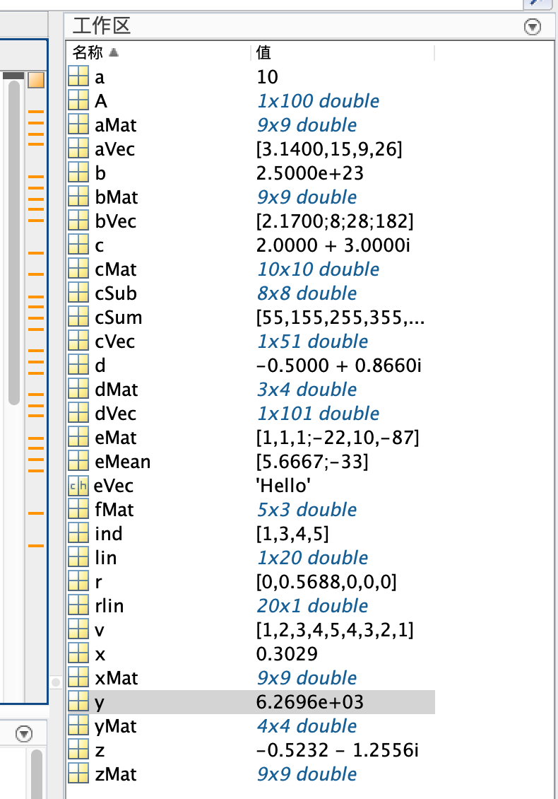

实验数据正常

题目：7

代码：

clear; clc;

figure

t = linspace(0,2*pi,100000);

plot(t,sin(t));

hold on

plot(t,cos(t),'g--','LineWidth',2);

xlabel('x')

ylabel('y')

title('SinandCos')

legend('sin(x)','cos(x)')

xlim([0 2*pi])

ylim([-1.4 1.4])

实验结果及分析：

实验数据正常，函数图像良好。

题目：8

代码：

clear; clc;

load classGrades

disp(namesAndGrades(1:5,:))

grades = namesAndGrades(:,2:end);

meanGrades = nanmean(grades);

meanMatrix = ones(38,1)*meanGrades;

curvedGrades = 60*(grades./meanMatrix);

meancurvedGrades = nanmean(curvedGrades);

disp(meancurvedGrades)

[row,col] = find(curvedGrades>100);

curvedGrades(row,col) = 100;

totleGrade = ceil(nanmean(curvedGrades,2));

letter = 'IHGFEDCBA';

indexs = totleGrade-min(totleGrade) + 1;

letterGrades(1:38) = letter(indexs);

str = ['Grades:',letterGrades];

disp(str)

实验结果及分析：

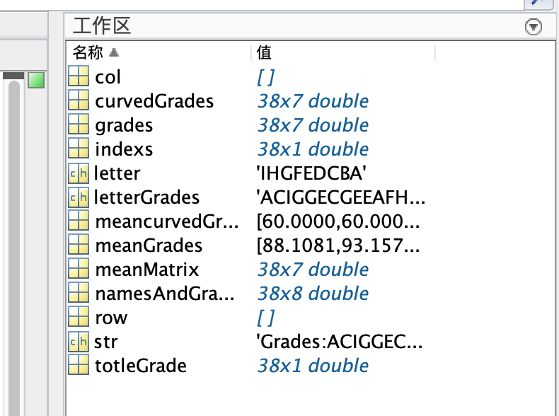

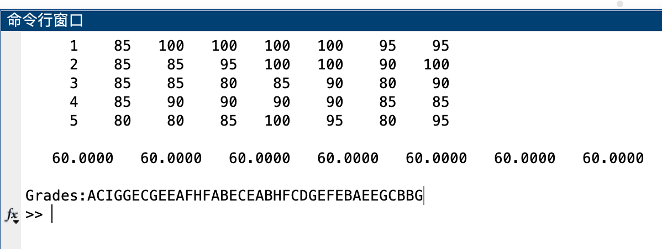

实验数据正常，没有出现换算后超出100分的情况，但仍做了处理。

题目：9

代码：

clear;

ballHight = 1.5;

G = 9.8;

velocityOfBall = 4;

Angle = 45;

t = linspace(0,1,1000);

x = velocityOfBall*cos(Angle*pi/180)*t;

y = ballHight + velocityOfBall*sin(Angle*pi/180)*t - (1/2)*G*t.^2;

ind = find(y<0,1);

xGround = x(ind);

str = ['The ball hits the ground at a distance of ' num2str(xGround) 'meters.'];

disp(str)

figure

plot(x, y)

xlabel('height');

ylabel('distance');

hold on

z = zeros(1,1000);

plot(x,z,'k--')

xlim([0 max(x)])

实验结果分析：

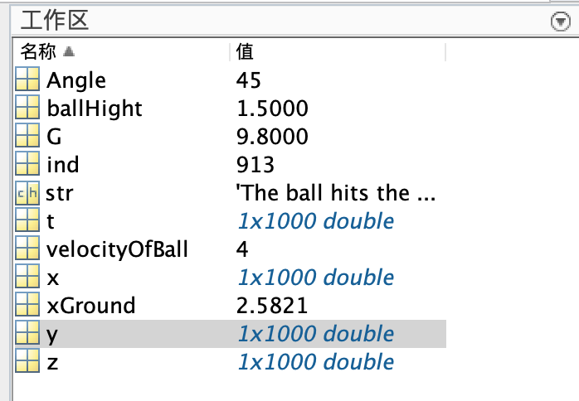

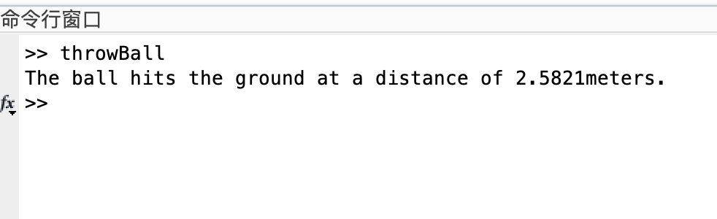

实验数据正常，图像良好。

题目：Optional Problems 2

代码：

clear; clc;

p = 0.99;

k = 1:1000;

geomSeries = p.^k;

G = 1/(1-p);

figure(1);

y = G*ones(1,1000);

plot(k,y,'r')

hold on

sumGeomSeries = cumsum(geomSeries);

plot(k,sumGeomSeries,'b')

xlabel('Index');

ylabel('Sum');

ylim([0 110]);

title('Convergence of geometric series with p=0.99');

legend('Infinite sumâ€™','Finite Sum');

p = 2;

n = 1:500;

pSeries = 1./(n.^p);

sumPSeries = cumsum(pSeries);

P = pi^2/6;

y = P*ones(500,1);

figure(2)

plot(n,y,'r')

hold on;

plot(n,sumPSeries,'b')

title('Convergence of p-series with p=2');

xlabel('Index');

ylabel('Sum');

实验结果分析：

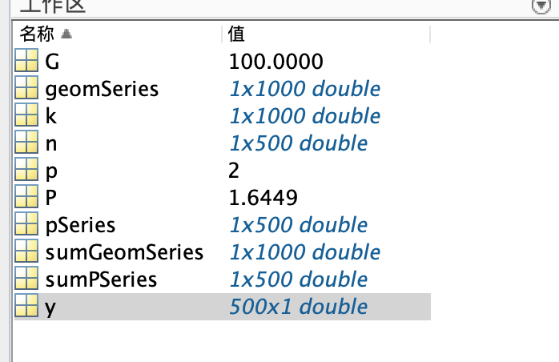

数据正常，图像良好。

题目：Optional Problems 3

代码：

clear; clc;

original = 'This is my top secret message!';

Rvector = randperm(length(original));

encoded = original(Rvector);

Temp = zeros(length(original),2);

Temp(:,1) = Rvector';

Temp(:,2) = 1:length(original);

Temp = sortrows(Temp);

decoded = Temp(:,2);

decoded = encoded(decoded);

disp(['original: ' original])

disp(['encoded: ' encoded])

disp(['decoded: ' decoded])

correct = strcmp(original,decoded);

disp(['Display the following string: Decoded correctly (1 true, 0 false): ' num2str(correct)])

实验结果分析：

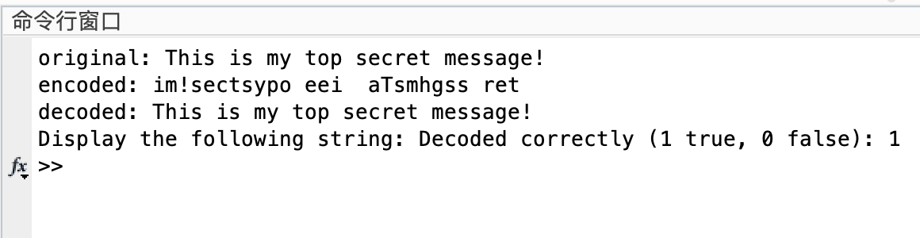

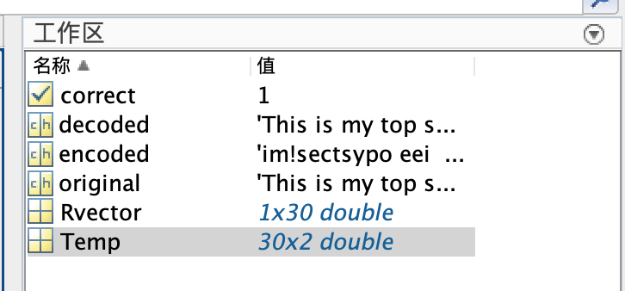

编解码正常。