Introduction
I create these movies to make some ads for some real and fictitious companies, and show my flash skills.
My target audiences are people who like surfing Internet, watching ads and finding some flash skills.
I design a PC screen and system, magic colors like black and purple color and I use a lot of PS pictures. Therefore, people will feel similar while using or watching these. For example, they consist of some Windows System’s sounds, nice texts and buttons. In three Home Pages, I use Windows System’s desktop, Player’s interface and File Folder’s interface respectively. A few limitations: clicking some desktop toolbar’s buttons like Electric Quantity and Input Method buttons are not allowed.
I use some external flash components like UILoader to load some pictures.

Preloader: a TV, actually a PC, changes screen, absorbs special materials. Then, system works.
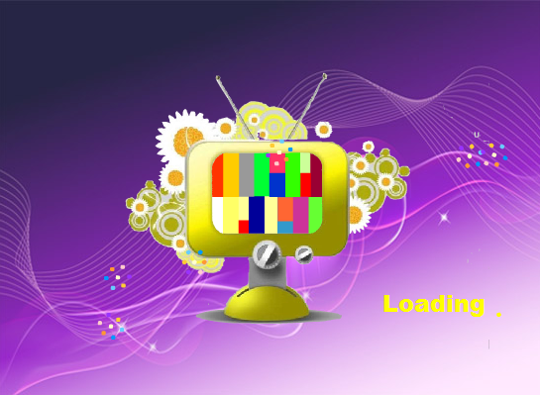
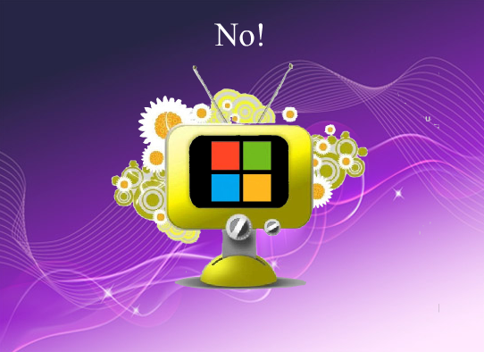
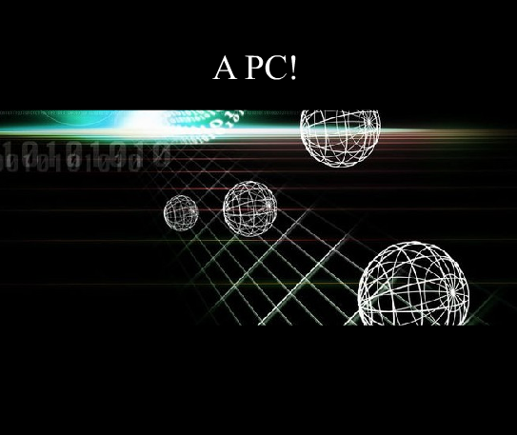

Main page: a desktop, including sound control, navigation and other buttons.
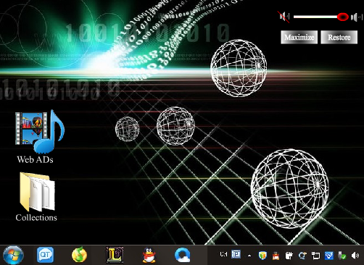

Ad home page: a player, including navigation and stop, replay and close buttons when ads play.
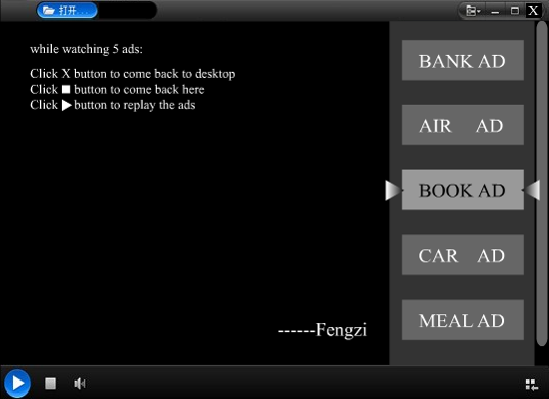

Skill home page: a file folder, including close buttons, navigation.
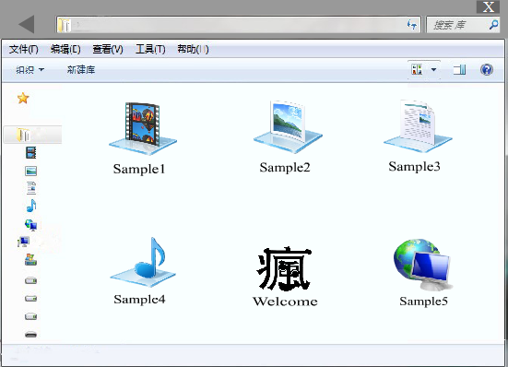

All of following ads include replay, stop and quit buttons.

Ad1: bank. mask, shadow, mc…
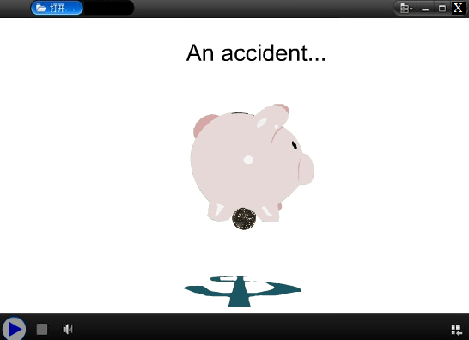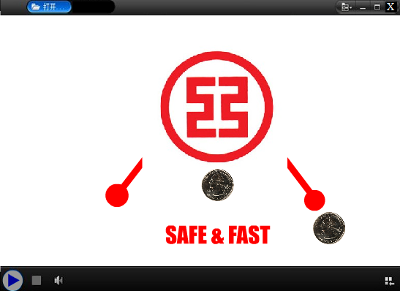
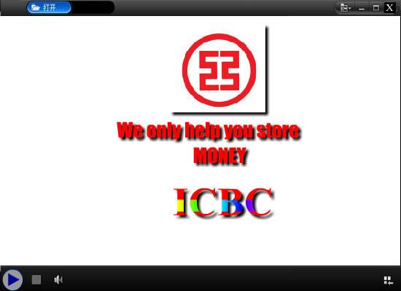

Ad2: plane. skeletal animation, mc, sounds…
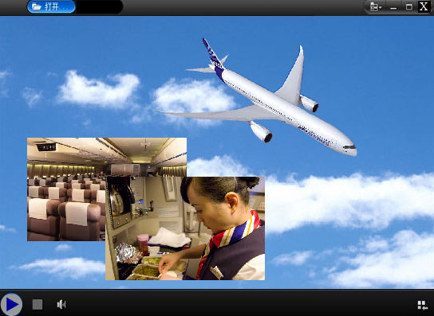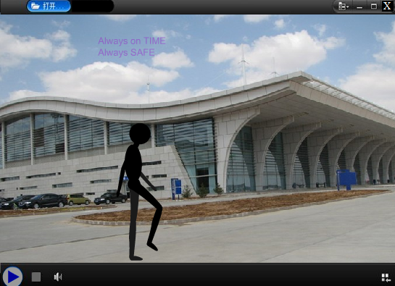
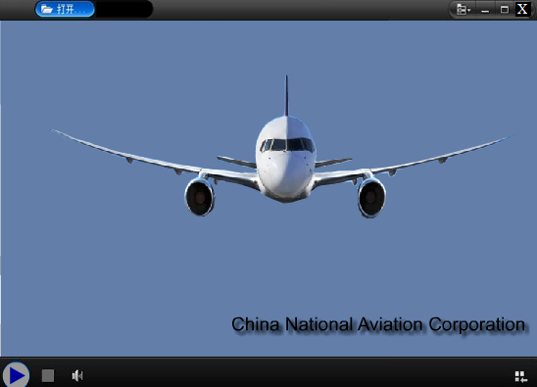

Ad3: book. rotating, mc, mask, sounds…
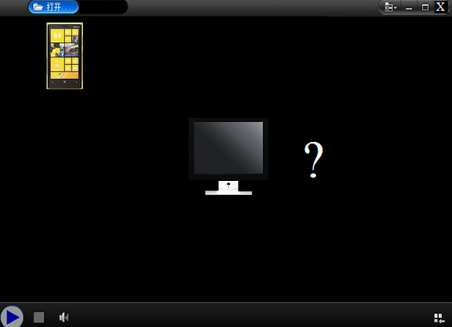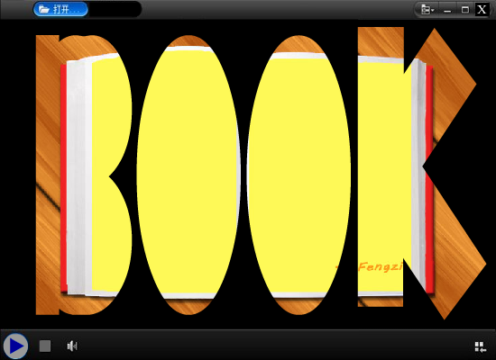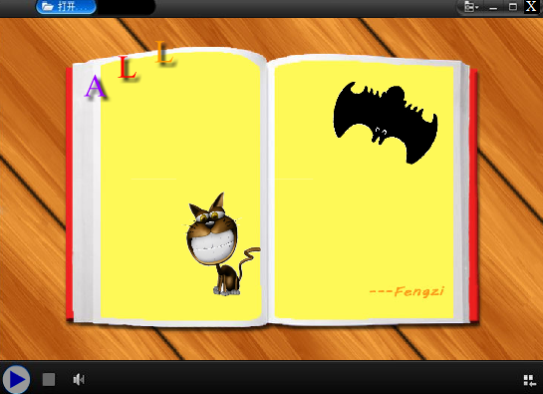

Ad4: car. mask, rotating, sounds…
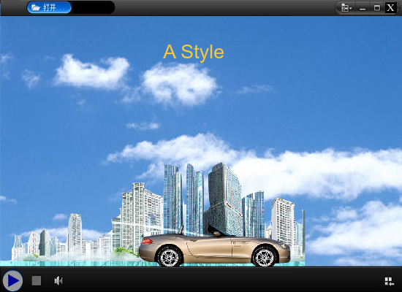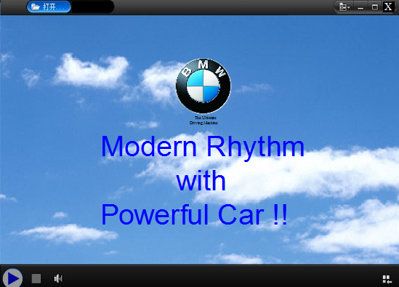

Ad5: meal. mc, sounds…
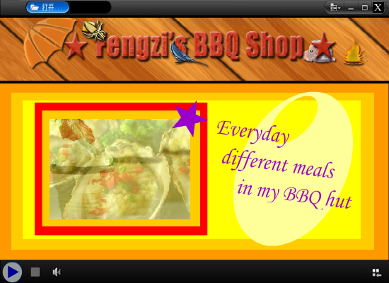

S1: flv, txt, next, check btns, URL.
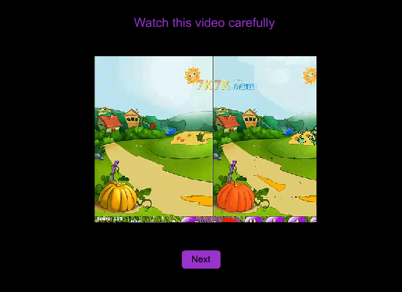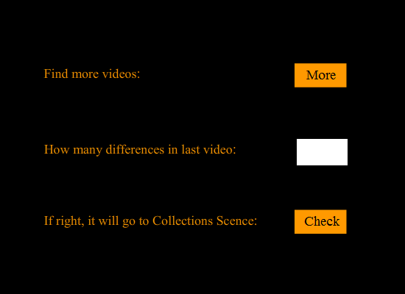

S2: quit, go btns, clock, match…
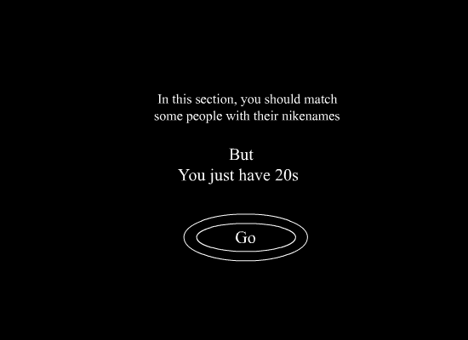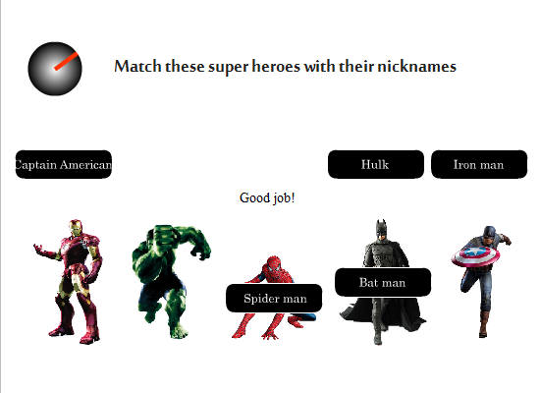
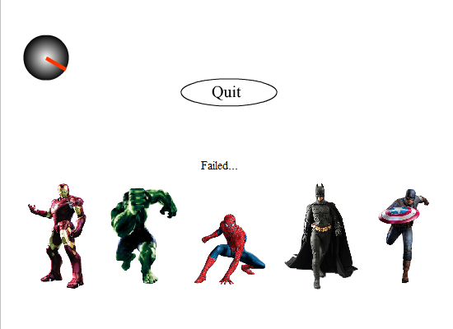

S3:print, back btns, mc, sounds…
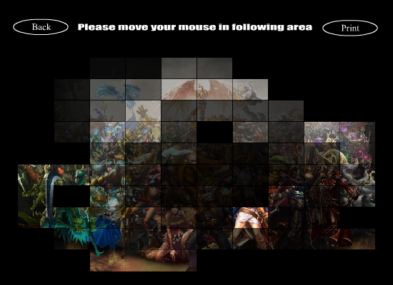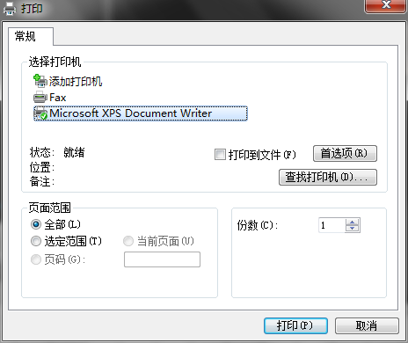

S4:back btn, mc, objects, sounds…
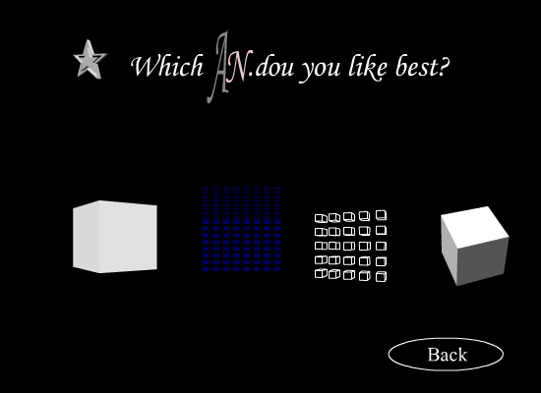

S5: UILoader, back, last, next btns, sounds…
