**CSC650 - Feasibility Report**

Graduate Student Group

September 13, 2019

American University

**This work complies with the AU honor code. We did not give or receive unauthorized help on this assignment.**

**TABLE OF CONTENTS**

**Client Overview 3**

**team 3**

**task overview 3**

**preliminary requirements 4**

**suggested deliverables 5**

**process 5**

**outline 6**

**visibility plan 8**

**business considerations 9**

**risk analysis 9**

**technical requirements 10**

# Client Overview

Our client for this project is Kristof Aldenderfer, Adjunct Professor for Physics and Director of the Design and Build Lab (DABL) at American University. He can be contacted at [kristof@american.edu](mailto:kristof@american.edu) or 202-885-6431.

# Team

Our team members are:

* Myles Russell mr7085a@student.american.edu
* Abdul Tarawally at4667a@student.american.edu
* Isabella Sims is3923a@student.american.edu
* Jiachen Yao jy3695a@student.american.edu
* Cliff Gallagher sg2563a@student.american.edu
* Li Jie Su ls8513a@student.american.edu

# Task Overview

We are developing a queuing and scheduling system in the Design and Build Lab (DABL) which will permit students to register for workshops and activities based on the specific tools (3D printers, laser-cutter, etc.) that they have completed training for. Ultimately, this will limit students to reserve tools that they have been certified to use. Students will be able to view the DABL website to learn availability of the tools for scheduling an appointment. This allows students to reserve tools online in comparison to the current system of first-come-first-serve. All reservation data will be used to evaluate machine use to determine specified analytics of tool use.

# Preliminary Requirements

The following requirements describe the client’s needs. The intent for this description is to describe break down the separate components of the system to illustrate how the team will approach the problem set.

**Types of requirements:**

**1.**  **User requirements (User story):** For this project, Students must be able to do the following:

* Login to DaBL website
* Register online to use a specific tool (3D printer, laser-cutter, etc.)
* Reserve tools they have completed training for
* Receive email confirmation after reservation

**2.** **Functional requirements:** inputs and outputs to the product:

* **Inputs:** Students must be able to register to use a tool using their name or address and unique student identification created by DaBL
* **Outputs:** Students might be able to receive an email confirmation after they have reserve to use a tool

**3. Non-functional requirements:** This describes any issues to include accuracy, dependability, security, usability, efficiency, performance, and maintainability:

* Student data must be kept secure
* Email notification will be sent to all those who have registered to use a tool when the system is down or out of service
* Student must be able to complete reservation under two minutes from the time they access DaBL website

# Suggested Deliverables

**Management Deliverables:**

1. **User Manual** - The user manual enables the users of the system to understand the functions provided by the system and how to use the system correctly and efficiently.
2. **Software License** - A license granting client use, but not ownership, of the software.

**Technical Deliverables:**

1. **Check-in reservation and Tool Check-in system** - Users login to the system and make reservations for a specific tool in DABL (3D printer, laser-cutter, box cutter). The website will interface with the local database in DABL to verify user certifications. This enables the scheduling system which will deny access and reject reservations for requested tools in DABL. Moreover, users can view availability of DABL tools.
2. **Scheduling and retention system** - Users can login to the system to make reservations and view the schedule to determine whether users are actively using the tools. Furthermore, any conflicts that occur in DABL, such as a power failure, the system will reflect issues on the schedule and update the website with such information.

# Process

For our project, we plan to incorporate elements of both a plan-driven and agile approach. Many of the conditions surrounding this project lend themselves to using the agile method. For instance, we are a small, co-located team that is able to communicate with each other easily and quickly over the Slack platform. We are developing a relatively small product, and using an incremental developmental approach that is feasible. Lastly, our client is willing to be a committed part of our project, and give us feedback throughout the iterations of the product that we develop throughout the process.

An incremental approach will allow us flexibility – meaning that if we discover an error in our design, we will more easily be able to change course and come up with a new design to solve the problem.

However, some aspects of this project do require a planned approach. The agile method is best suited to projects that do not require a lot of regulation by outside organizations, but there is an aspect of our project that is heavily regulated: student data privacy.

Our project involves maintaining a database of students who have access to DABL. It is our responsibility to make sure that we do not handle student data in an insecure way, or leave it open to exploitation. Upholding this responsibility will require some careful planning on our part, and the best time to do this planning will be before development of the project begins.

# Outline

|  |  |
| --- | --- |
| **Date** | **Deliverable** |
| Sept 27 | * Assign every student in existing DABL database a unique DABL ID * Build new, on-premise (of DABL) database that stores an entry for each student of consisting of these fields:   + AU ID   + DABL ID   + Permission (true or false) to use each tool * Create and run tests to ensure functionality |
| Oct 11 | * Create scheduling and reservation GUI on DABL website, allowing students to reserve a specific tool at a specific date and time, for a specific range of time * Create and run tests to ensure functionality |
| Oct 25 | * Build cloud-based database as back-end of DABL website to store entries consisting of:   + DABL ID   + Desired reservation time for equipment * Create and run tests to ensure functionality |
| Nov 8 | * Write scripts to query website’s database regarding whether student has a reservation at the time they tag into DABL. * Write scripts to query local database regarding whether student has completed the training to use each specific tool in DABL * If student has a reservation at that time, and they have completed the training to use the tool they want, allow them access to use that tool * Create and run tests to ensure functionality |
| Nov 22 | * Create email confirmation system that tells students when their reservation from the website has been successful * Create email notification system that tells users when system is down or out of service * Create and run tests to ensure functionality |
| Dec 11 | * Deliver working program, user manual, and license |

# Visibility Plan

In addition to weekly meetings (with the client) and bi-weekly meetings (group members only), our group will typically communicate on a daily basis through our slack channel. Group members may have separate meetings with those working with them on specific tasks. We have also set up a slack channel with our client (Kristof Aldendrfer), which we will use to update the client on an as-needed basis. This channel may also be used by both parties to ask and answer questions that were not addressed in weekly meetings. Individual questions/comments for the client may be communicated through other mediums but should be discussed with the team either via slack or at our next meeting.

**Communication Objectives**

* Engage in open discussion regarding software and details of said software
* Confirm that each member is contributing adequately to the project
* Ensure that all members are on the same page regarding the project and their role(s) in the project
* Collaborate on a technical level regarding the project (e.g. code)
* Share and vote on ideas, strategies, and suggestions regarding the project
* Review, revise, and critique progress made by individual members

Group meeting times:

* Wednesdays at 8 pm
* Thursday’s at 4 pm

Client meeting time:

* TBD

Any changes, revisions, or new additions to the project should be discussed and approved by all group members before implementation. In the event of a disagreement, there will be further discussion and equal opportunity for every member to advocate their position. Then, a majority vote will decide the outcome of the decision. Any modifications that cause the program to stray from the client's original request must be approved by the client. These modifications should only be considered upon finding that the segment in question is no longer feasible (be it technically or otherwise) in the timeframe provided.

# Business Considerations

It is the consensus of the group that all intellectual rights to the software in question will be maintained by its developers. With this, we will not be requesting or accepting payment of any kind from our client or his organization. For further business consideration details, please see the contract signed by each team member and the client.

# Risk Analysis

The following analysisillustrates the risk inherent to the completion of the project. Furthermore, it assesses risk based on the probability of the risk occurring (*insignificant*, *low*, *moderate*, *high*, or *very high*) and the impact the risk has to the completion of the project (*insignificant*, *tolerable*, *serious*, or *catastrophic*).

|  |  |  |
| --- | --- | --- |
| **Risk** | **Probability** | **Effects** |
| Network connectivity issues due to AU IT regulations | *moderate* | *catastrophic* |
| Software tools cannot be applied and integrated as planned | *low* | *serious* |
| Changes to the requirements require an entire overhaul of project | *low* | *serious* |
| Learning curve of project development requirements is too difficult | *low* | *tolerable* |
| The time required to complete development is underestimated | *moderate* | *tolerable* |

For the initial risk analysis, the group assesses the biggest risk in the development of this project is that AU IT regulations cannot be overcome - or are too ‘hacky’ to meet requirement availability and sustainability upon project completion. More specifically, the DABL network is unable to serve due to AU IT restrictions, which may possibly incur unforeseen issues with timing, security, and connectivity that could push timelines right.

# Probable Technical Requirements

The project is divided between two separate environments, utilizing two applications to verify and schedule students to use DABL equipment. These applications will be required to communicate using secure protocols that perform client-server authentication and user verification in a timely manner. Moreover, the DABL network does not serve and will rely on POSTing data to the DABL website in order to implement changes to the schedule. 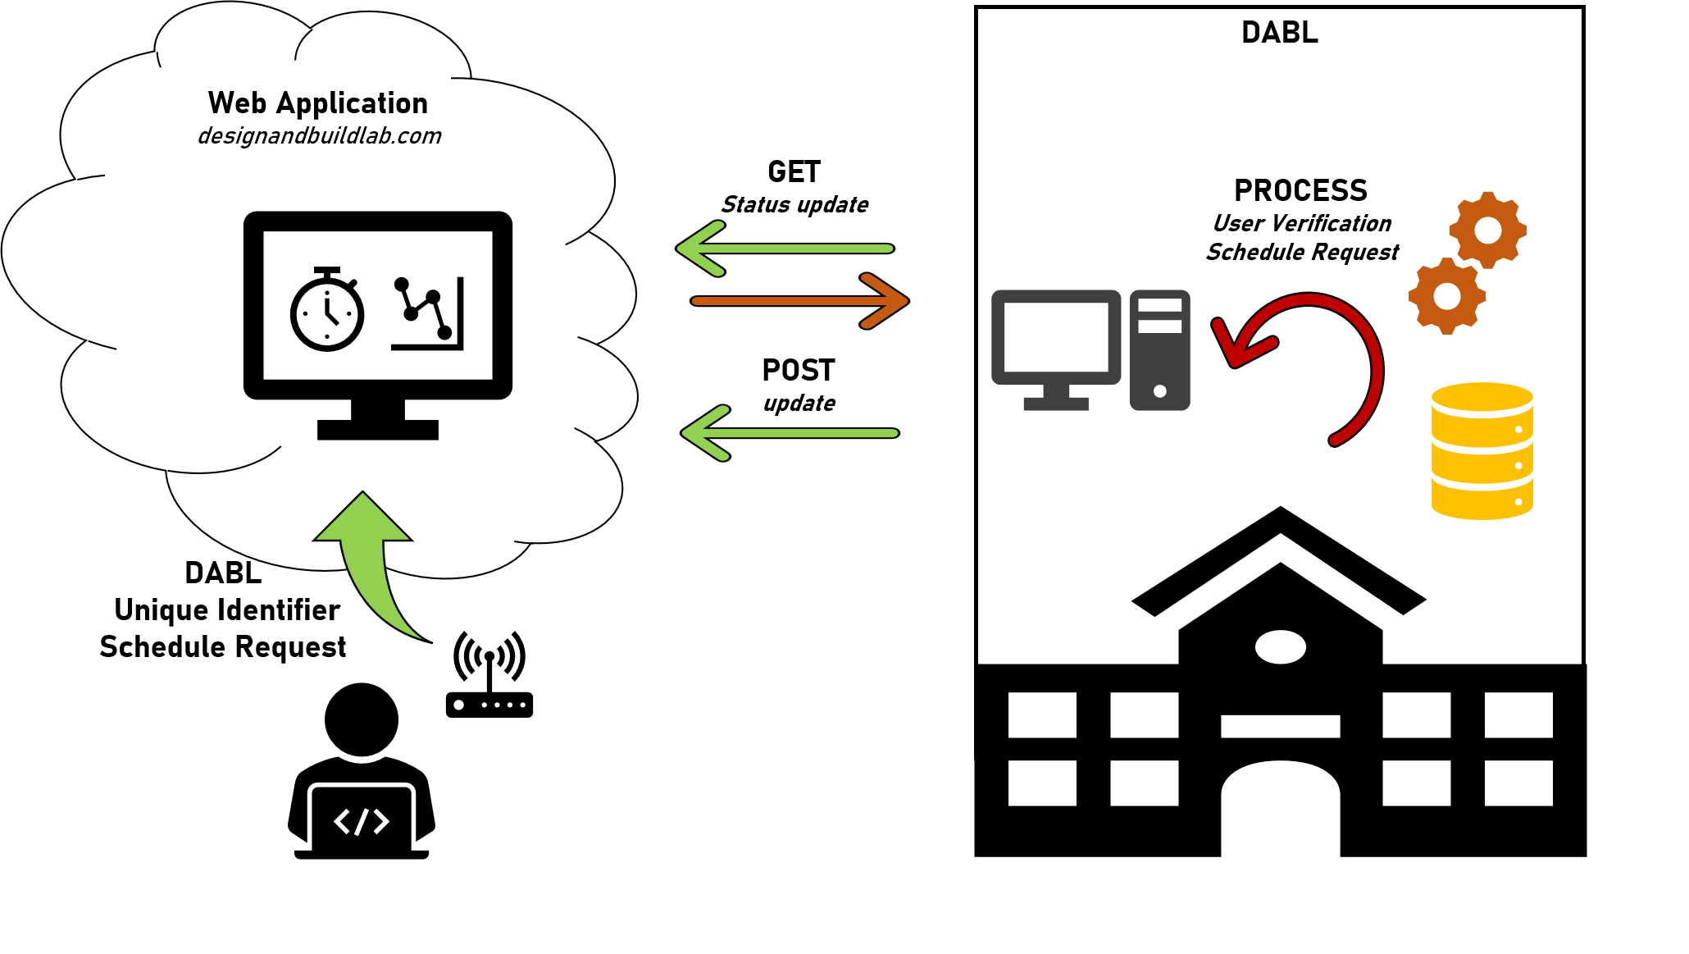

The DABL website uses a *php* framework, and serves to present information - rather than interact with the user. This requirement will require a few additions to meet specifications. First, using *HTML* and *Javascript,* a scheduling calendar will be designed, as well as a segment for user input of a DABL Unique Identifier (DUI) to be put into the scheduling system. Once a user has submitted a DUI, the web application will temporarily store it along with their request time in a database (type to be determined).

Currently, DABL utilizes an RFID reader to check in the user’s AU ID. This occurs in-person in the lab on AU campus. From there, the AU ID information is compared against a local *mysql* database to check if the user has an account and is certified to use the equipment. Project requirements will result in updates to include relevant information pertaining to user verification and scheduling .

A *python* application will be created to interface the database with the web application located on the open internet. Because the DABL computer cannot serve, it will be required to query for updates from the DABL website every minute. Therefore, the application will implement the processing logic that compares current and previous states to determine updates and follow-on actions. Specifically, user and schedule verification will be handled by the *python* application when a change in state has been observed, followed by a POST to the DABL website to implement the update. In order to implement secure communication between the DABL application and website so that the POST action cannot occur from other computers, the application will use openSSL libraries to authenticate client and server, and transfer data securely..