Key English Mock Test
Candidate name
Elene

Place of entry
BEIJING

Candidate Number
202604K0001

Session
APR2026

Result
Pass at Grade C
Overall Score
130
CEFR Level
Grade C

CEFR Level
Cambridge English Scale

Certificated
Results Reading Writing Listening Speaking

117
135
130

Level A1
B1
Grade A
137
Grade B
A2
Grade C
A1

Pass at Grade A 140 — 150
Results Score
Pass at Grade B 133 — 139
Pass at Grade C 120 — 132
Level A1 100 — 119
Candidates who take Key and score between 82 and 99 on the Cam bridge English Scale do not receive a result, CEFR level or certificate.
Cambridge English Scale scores below 82 are not reported for this ex amination.

Other

X the candidate was absent from part of the examination
Z the candidate was absent from all parts of the examination Pending a result cannot be issued at present, but will follow in due course
Withheld the candidate should contact their centre for information Exempt the candidate was not required to sit this part of the exami nation

Statement
- This analysis and scoring by the system are a strong indication of the test participant’s knowledge and ability in Cambridge Key/Preliminary tests, but do not represent the participant’s actual performance in the real K/P tests.
- Our system will keep highly confidential the test participant’s personal information and test results. The information and results will not be dis closed to any third party, except for written permission(s) from the test participant and/or his/her legal guardian(s), or official decree(s) from government agencies/judicial authorities.
- The completeness and safety of the test report should be strictly pro tected. Any act of editing, including but not limited to adding, deleting, and modifying,is prohibited. For any losses, direct or indirect, monetary or nonmonetary, caused by the misuse of the test report, we shall not be liable.
- All the contents of the test report can only be used for noncommer cial purposes. Without the specific and written consent, any use of the test report, including but not limited to illegal duplicating, distributing, demonstrating, uploading and downloading, is prohibited.
- For any infringement of the copyright of the test report and this System, we will reserve the related right for appeal.

THIS IS NOT A CERTIFICATE

READING

By Question Type

Question Type | Total Question | Correct | Incorrect | Scoring Rate
P1 Short Passage | 6 | 2 | 4 | 33%
P2 Matching | 7 | 5 | 2 | 71%
P3 Long Passage | 5 | 2 | 3 | 40%
P4 Cloze | 6 | 6 | 0 | 100%
P5 Sentence Completion | 6 | 4 | 2 | 67%

117分
学生目前阅读理解较弱，涉及问题如下：
1长短篇文本细节定位能力严重缺失P1、P3 大面积失分，反映出基础文本理解能力薄弱：对题干核心关键词敏感度极低，无法快速在原文定位答案区间；对 KET 高频同义替换识别能力不足，极易被干扰信息误导，无法精准抓取文本细节、提炼段落主旨，细节题、主旨题均大量失误。
2信息匹配能力稳定性不足P2 匹配题虽有基础得分，但仍存在失分问题，面对多组相似信息时，人物、观点的对应匹配精度不够，容易混淆相近选项，解题逻辑不够严谨。
3篇章逻辑把控能力不均衡仅完形填空的篇章逻辑应用扎实，长短篇阅读、句子补全中，对上下文语义衔接、逻辑关系的梳理能力薄弱。

WRITING

135分
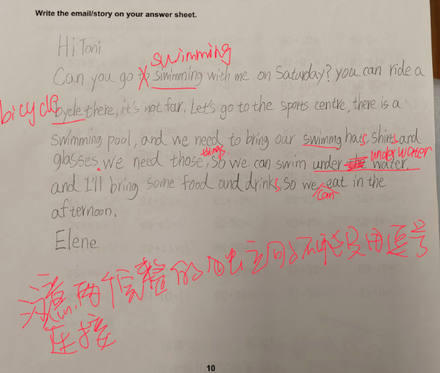
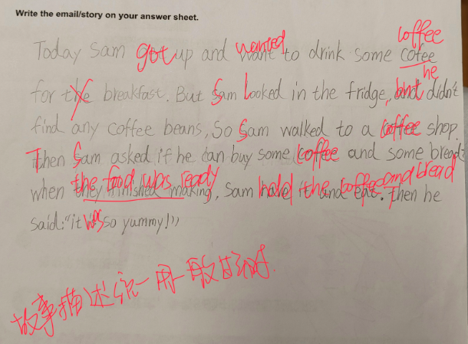
LISTENING

By Question Type

Question Type | Total Question | Correct | Incorrect | Scoring Rate
P1 Short Passage | 5 | 5 | 0 | 100%
P2 Monologue | 5 | 3 | 2 | 60%
P3 Long Passage | 5 | 4 | 1 | 80%
P4 Comprehensive Text | 5 | 5 | 0 | 100%
P5 Matching | 5 | 5 | 0 | 100%

137分
学生目前听力涉及问题如下：
1逻辑信号词敏感度不足，踩中 “转折陷阱”，存在对逻辑词反应迟缓的问题：听到前半段信息就直接选择，容易忽略转折后的真实答案。
2高密度信息下的信息处理与注意力持续性不足长
3偶有疏漏所有听力板块均存在极个别因连读、弱读、口语化缩略表达导致的关键单词听辨失误，属于基础听力细节的共性小瑕疵。

SPEAKING

KET Speaking Mock TestⅠ

Knowledge Point | Full Score | Score | Scoring Rate
Grammar and Vocabulary | 5 | 4.0 | 80%
Pronunciation | 5 | 3.5 | 70%
Interactive Communication | 5 | 3.5 | 70%
Global Achievement | 5 | 4.0 | 80%
130分
语法词汇：孩子基础表达扎实，整体口语输出稳定，仅表达中出现少量轻微语法小失误，后续针对性积累话题词汇、巩固常用句型即可完善。
语音语调：孩子单词发音准确规范，语音语调清晰流畅，语音基础十分出色，是本次测评的突出优势。互动交流：全程对话互动积极性很高，主动配合应答，交流节奏自然顺畅，后续作答可以保持这份自信，让语句衔接更连贯。
整体表现：整体题干理解能力较好，自身观点逻辑完整，给出的理由能够有效支撑自己的观点，答题框架合格；短板在于回答细节拓展不丰富、内容稍简；面对原因类问题时输出会有卡顿的现象，部分问答流畅性不够。

