**实验七、主题、母版、用户控件和Web控件**

1、设计用于显示商品类别和数量的用户控件

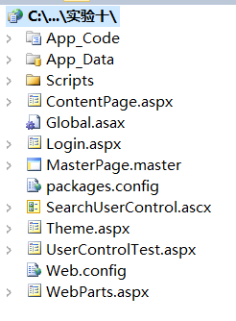

编写 Category.ascx 事件代码

protected void Page_Load(object sender, EventArgs e) {

var categories = from c in db.Category

join p in db.Product on c.CategoryId equals p.CategoryId

into product

select new

{

c.CategoryId,

c.Name,

ProductCount = product.Count()

};

gvProduct.DataSource = categories;

gvProduct.DataBind();

}

2、利用母版页重新设计MyPetShop各页面

public partial class MasterPage : System.Web.UI.MasterPage

{

MyPetShopDataContext db = new MyPetShopDataContext();

protected void Page_Load(object sender, EventArgs e)

{

if (Request.QueryString.Count != 0) {

Bind();

}

}

private void Bind() {

if (Request.QueryString["CategoryId"] != null) {

int categoryId = int.Parse(Request.QueryString["CategoryId"]);

var products = from p in db.Product

where p.CategoryId == categoryId

select p;

gvProduct gvProduct.DataSource = products;

gvProduct.DataBind();

}

}

}

3、利用Web部件技术设计网站首页

4、设计和应用主题

