实验一

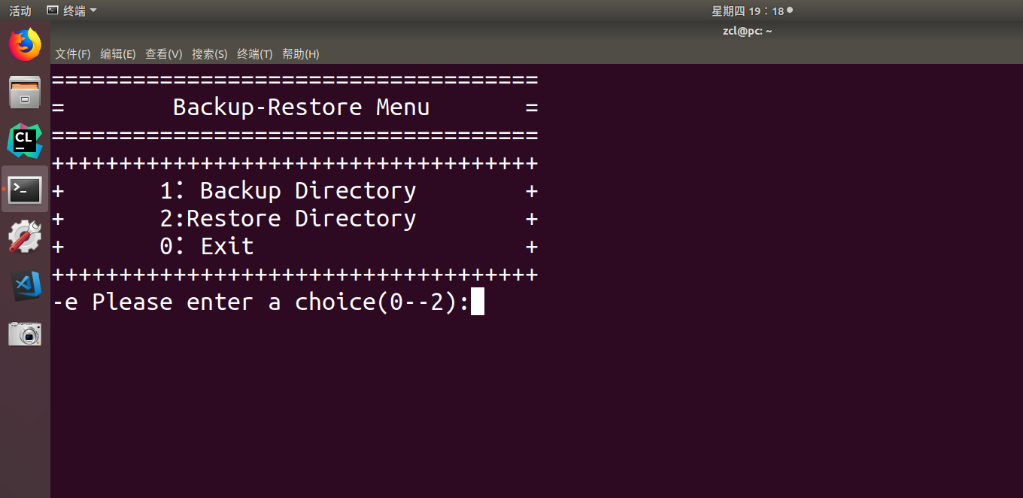

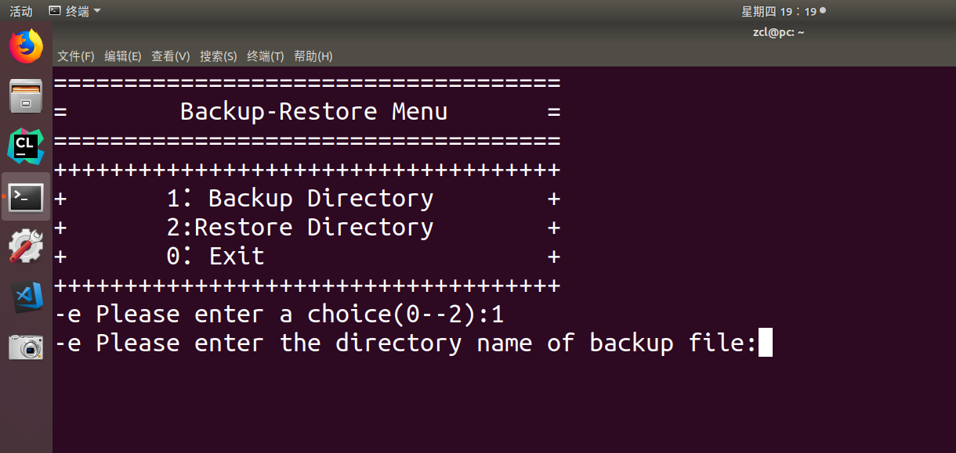

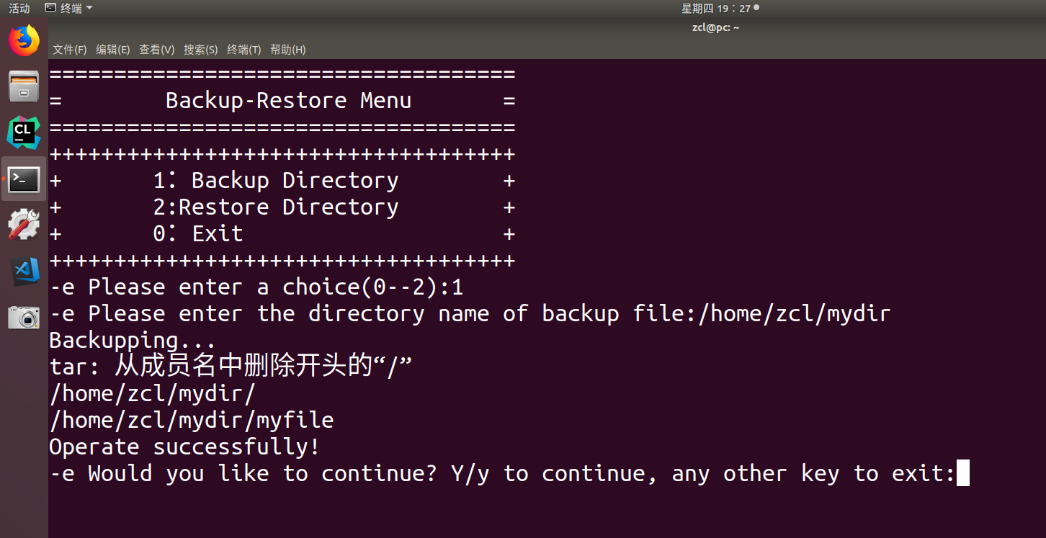

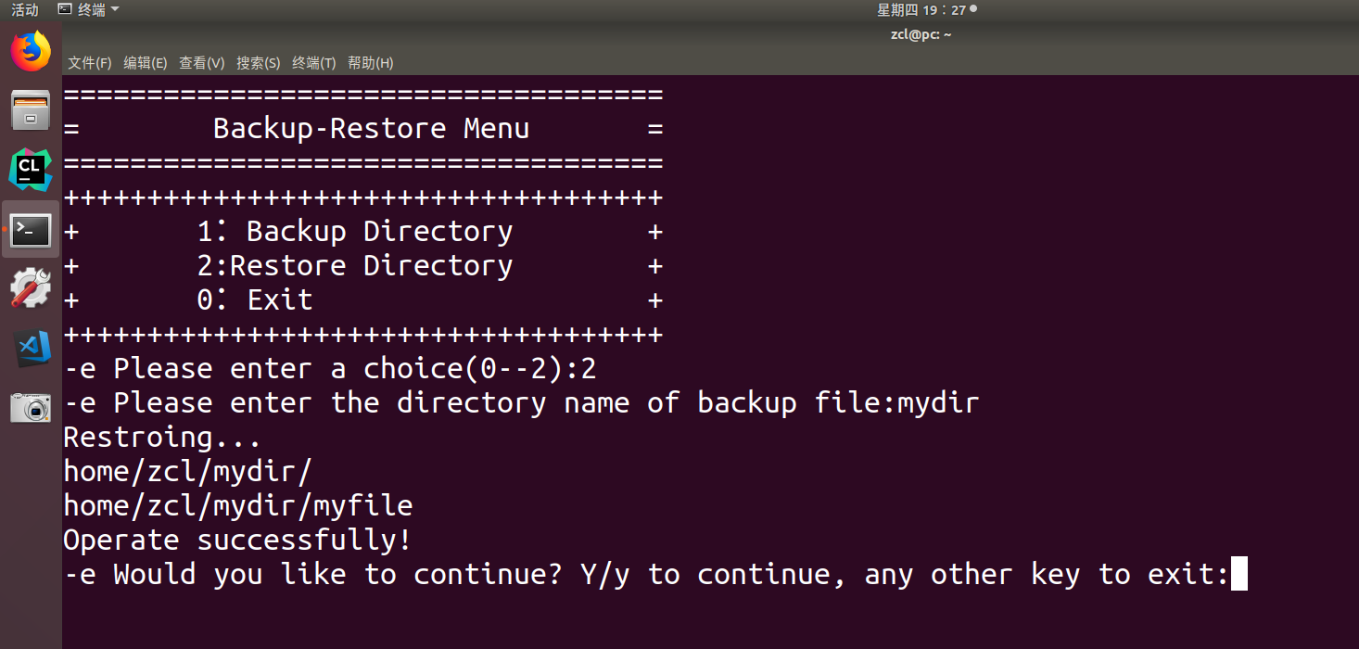

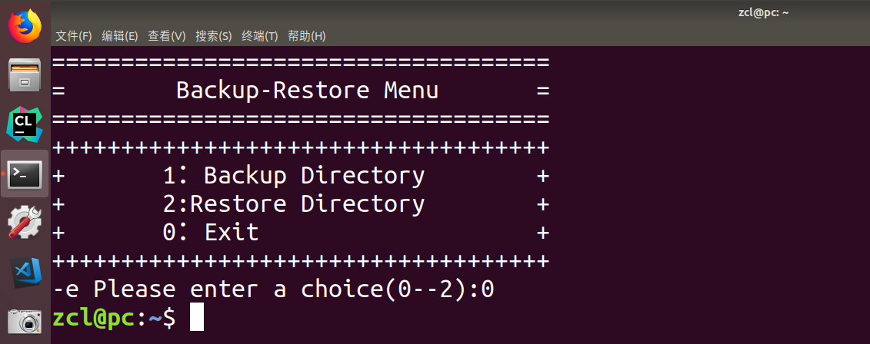

#!/bin/sh

#backup.sh

#备份目录函数

backupdir()

{

dirtest

echo "Backupping..."

tar zcvf /tmp/backup.tar.gz $DIRECTORY

}

#恢复目录函数

restoredir()

{

dirtest

echo "Restroing..."

tar xzvf /tmp/backup.tar.gz

}

#验证目录函数

dirtest()

{

#输入要备份的目录名

echo -e "Please enter the directory name of backup file:\c"

#读目录名

read DIRECTORY

#判断是否是目录

if [ ! -d $DIRECTORY ]

then

echo "Sorry, $DIRECTORY is not a directory!"

exit 1

fi

cd $DIRECTORY

}

clear

ANS=Y

while [ $ANS = Y -o $ANS = y ]

do

echo "===================================="

echo "= Backup-Restore Menu ="

echo "===================================="

echo "++++++++++++++++++++++++++++++++++++"

echo "+ 1：Backup Directory +"

echo "+ 2:Restore Directory +"

echo "+ 0：Exit +"

echo "++++++++++++++++++++++++++++++++++++"

echo -e "Please enter a choice(0--2):\c"

read CHOICE

case "$CHOICE" in

1) backupdir;;

2) restoredir;;

0) exit 1;;

*) echo "Invalid Choice!"

exit 1;;

esac

if [ $? -ne 0 ]

then

echo "Program encounter error!"

exit 2

else

echo "Operate successfully!"

fi

echo -e "Would you like to continue? Y/y to continue, any other key to exit:\c"

read ANS

clear

Done

实验二

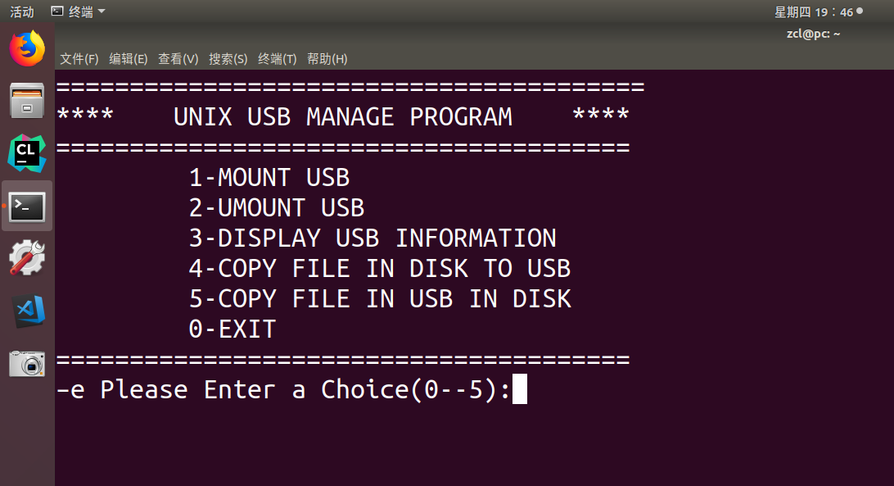

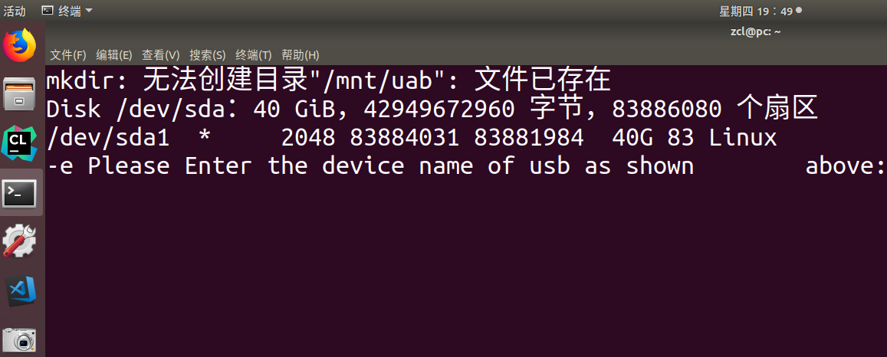

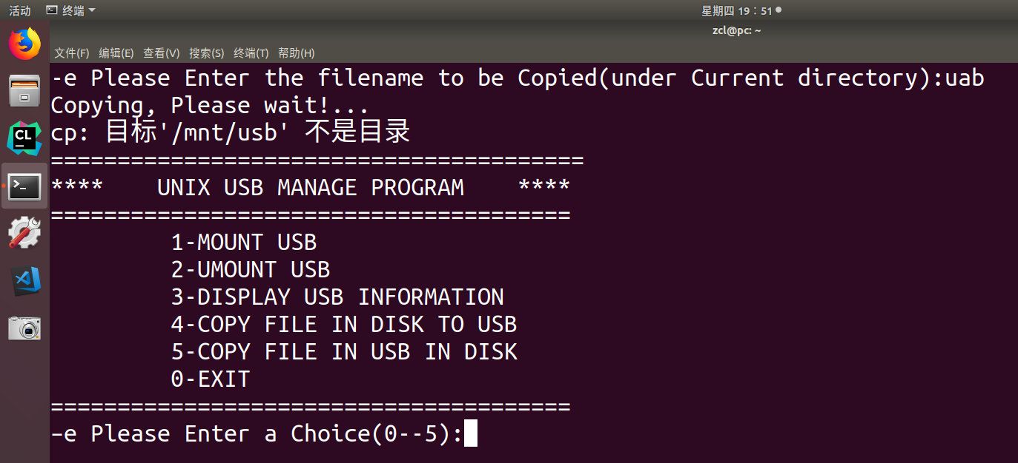

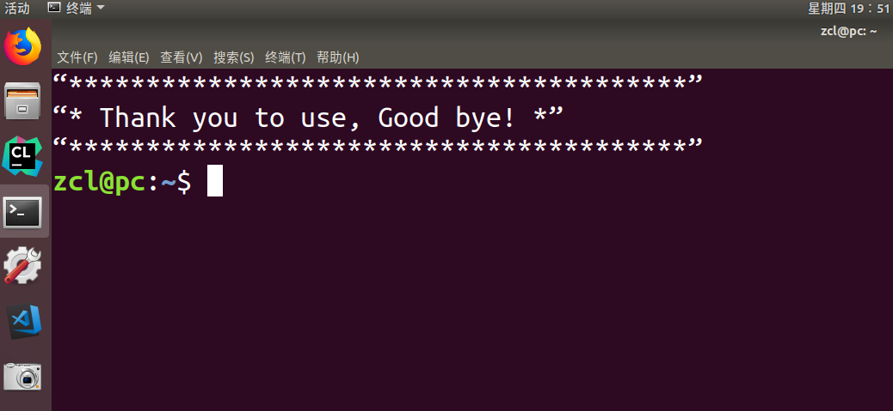

#! /bin/sh

#mountusb.sh

#退出程序函数

quit()

{

clear

echo “****************************************”

echo “* Thank you to use, Good bye! *”

echo “****************************************”

exit 0

}

#加载U盘承数

mountusb( )

{

clear

#在/mnt下创建usb目承

mkdir /mnt/uab

#查看U盘设备名称

/sbin/fdisk -l | grep /dev/sd

echo -e "Please Enter the device name of usb as shown above:\c"

read PARAMETER

mount /dev/$ PARANETER /mnt/usb

}

#卸载U盘函数

umountusb( )

{

clear

umount /mnt/usb

}

#显示u盘信息诵数

display()

{

clear

ls –l /mnt/usb

}

#拷贝硬盘文件到U盘函数

cpdisktousb()

{

clear

echo -e "Please Enter the filename to be Copied(under Current directory):\c"

read FILE

echo "Copying, Please wait!..."

cp $ FILE /mnt/usb

}

#拷贝口盘文件创硬盘函数

cpusbtodisk()

{

clear

echo –e "Please Enter the filename to be Copied in USB:\c"

read FILE

echo "Coping,Please wait!..."

cp /mnt/usb/$ FILE . #点（.）表示当前路径

}

clear

while true

do

echo "========================================"

echo "**** UNIX USB MANAGE PROGRAM ****"

echo "======================================="

echo " 1-MOUNT USB "

echo " 2-UMOUNT USB "

echo " 3-DISPLAY USB INFORMATION "

echo " 4-COPY FILE IN DISK TO USB "

echo " 5-COPY FILE IN USB IN DISK "

echo " 0-EXIT "

echo "======================================="

echo –e "Please Enter a Choice(0--5):\c"

read CHOICE

case $CHOICE in

1) mountusb;;

2) umountusb;;

3) display;;

4) cpdisktousb;;

5) cpusbtodisk;;

0) quit;;

*) echo "Invalid Choice! Correct Choice is(0--5)"

sleep 4

clear

esac

Done

实验三

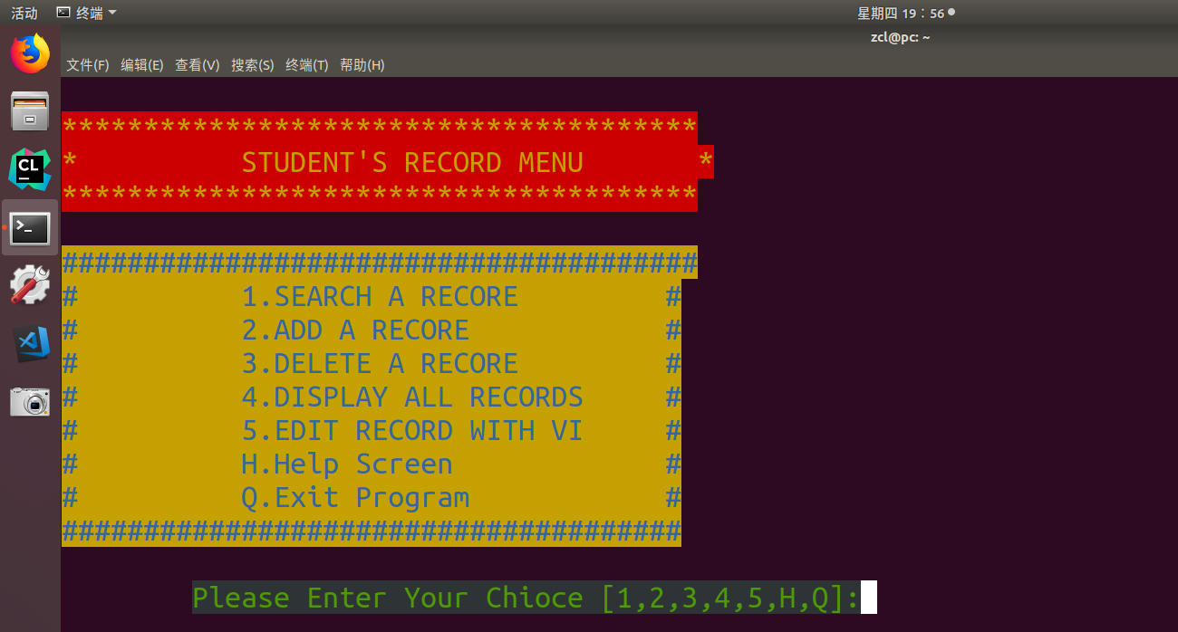

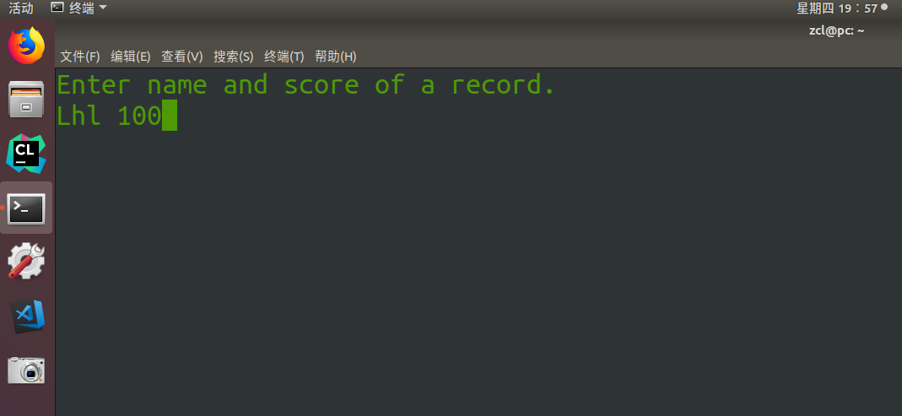

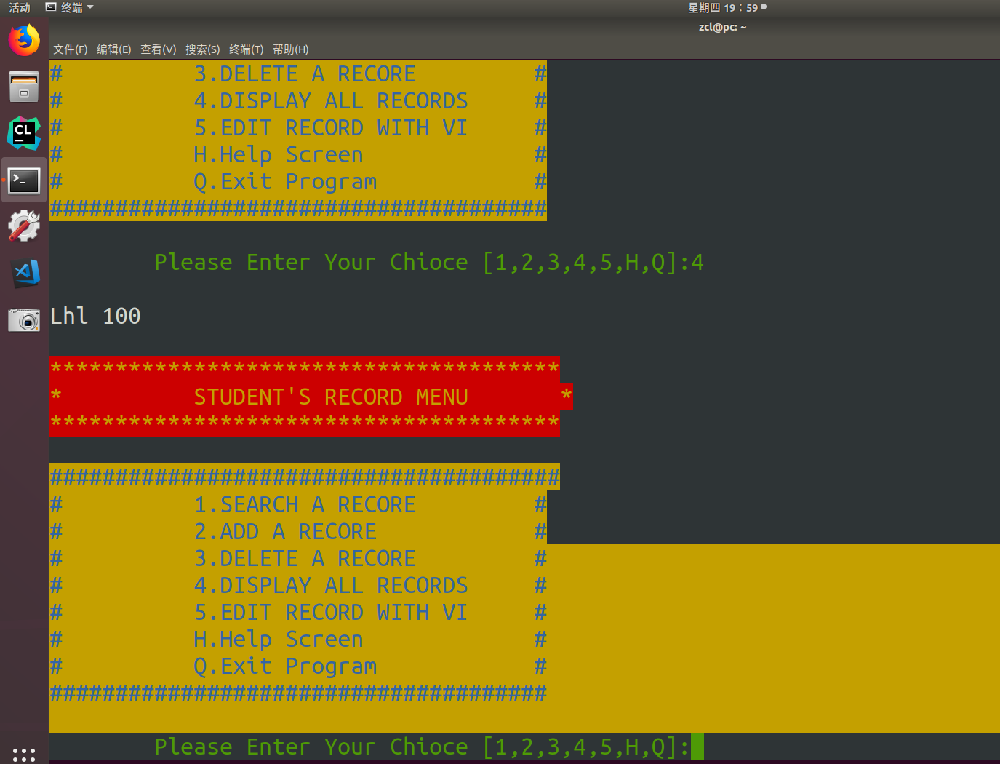

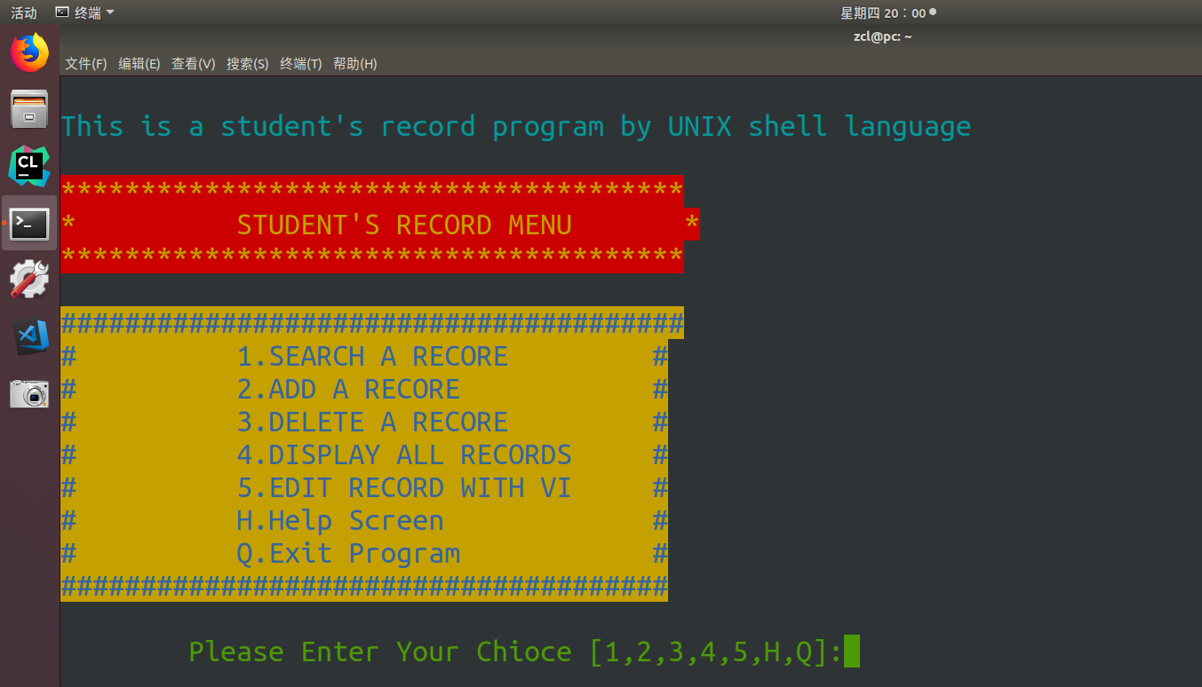

#score.sh

#!/bin/sh

#colour

colour()

{

case $1 in

black_white)

echo -e "\033[40;37m"

;;

black_green)

echo -e "\033[40;32m"

;;

black_cyan)

echo -e "\033[40;36m"

;;

red_yellow)

echo -e "\033[41;33m"

;;

yellow_blue)

echo -e "\033[43;34m"

;;

esac

}

#查询

search()

{

colour black_white

clear

echo -e "please enter name>>>\c"

read NAME

if [ ! -f ./record ]; then

echo "You must have some scores before you can search"

sleep 2

clear

return

fi

if [ -z "$NAME" ]; then

echo "You didn't enter a name!"

echo -e "Please Enter name >>>\c"

read NAME

fi

grep -i "$NAME" ./recore 2> /dev/null

case "$?" in

1)echo "Name not in record."

;;

2)echo "You didn't enter a name to search ";

sleep 2;

search;;

esac

}

add()

{

clear

echo "Enter name and score of a record."

echo -e "\c"

if [ ! -f ./record ]; then

touch record

fi

read NEWNAME

echo "$NEWNAME" >./record

}

delete()

{

clear

echo -e "Please Enter Name>>>c"

read NAME

if [ ! -f ./record ]; then

echo "This Name is not in record"

else

cp record record.bak

rm -f record

grep -v "$NAME" ./record.bak > record

rm -f record.bak

fi

}

display()

{

colour black_white

more ./record

}

edit()

{

vi ./record

}

help()

{

clear

colour black_cyan

echo "This is a student's record program by UNIX shell language"

}

quit()

{

clear

colour black_white

exit

}

clear

while true

do

colour red_yellow

echo "***************************************"

echo "* STUDENT'S RECORD MENU *"

echo "***************************************"

colour yellow_blue

echo "#######################################"

echo "# 1.SEARCH A RECORE #"

echo "# 2.ADD A RECORE #"

echo "# 3.DELETE A RECORE #"

echo "# 4.DISPLAY ALL RECORDS #"

echo "# 5.EDIT RECORD WITH VI #"

echo "# H.Help Screen #"

echo "# Q.Exit Program #"

echo "######################################"

colour black_green

echo -e -n "\tPlease Enter Your Chioce [1,2,3,4,5,H,Q]:\c"

read CHOICE

case $CHOICE in

1) search;;

2) add;clear;;

3) delete;clear;;

4) display;;

5) edit;clear;;

H|h) help;;

Q|q) quit;;

*) echo "Invalid Choice!";

sleep 2;

clear;;

esac

done