Arizona List Datasets & Data Analysis Summary
Database: PostgreSQL arizona_list
Data Coverage: 2004–2026

1. Database Overview
Before diving into analysis, we need to understand what we’re working with:
- how many records do we have?
- how many unique donors?
- and what time period does the data cover?

Approach
This is a baseline data quality check. We counted total donation records, unique donors, and the date range of the data. The key distinction here is between counting records and counting people — one donor who gives 10 times appears as 10 records but still counts as 1 person.

What We Found
Metric | Value
Total contribution records | 53,020
Unique donors | 7,769
Earliest donation on record | January 15, 2004
Most recent donation | April 9, 2026

2. Total Leadership Council Members

The Question
How many people in the database are Leadership Council (LC) members?
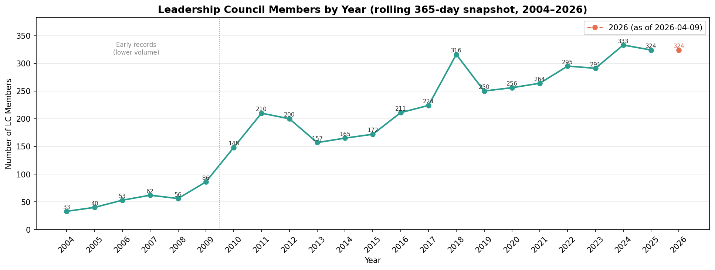
Each data point counts how many unique LC members gave at least once in the 365 days ending on that date.
- LC membership grew from 33 in 2004 to a peak of 316 in 2018, dipped during 2019–2021, then recovered to 333 in 2024.
- The current count as of April 2026 is 324.
- Early records (before ~2010) are incomplete and likely undercount actual membership — the post-2010 trend is more reliable.

3. Direct Mail Opportunity: People Without an Email Address

The Question
How many people in the database can only be reached by mail — making direct mail our only option for proactive outreach?

Approach
We built a four-step funnel, where each layer answers a distinct question:
All "Person" contacts in the database (79,830)
↓ Do they have a complete mailing address?
↓ Do they have no email on file?
↓ Have they not opted out of mail?
→ Core direct-mail-only audience
Each intermediate layer has its own value: the “complete address” count tells us our total direct mail capacity; the “no email” count tells us the full scope of our digital blind spot; the intersection gives us the actionable list.
For the address check, we required both a system-verified best address and confirmed that all address fields are filled in — not just a city name with no street.

What We Found
Metric | Count | Which means
Total “Person” contacts | 79,830 | Full database headcount
With a complete mailing address | 54,703 | All people who has a complete mailing address
No email on file | 19,319 | People who don’t have email in our system
Mailable + no email | 16,440 | Direct mail is the only way to reach them
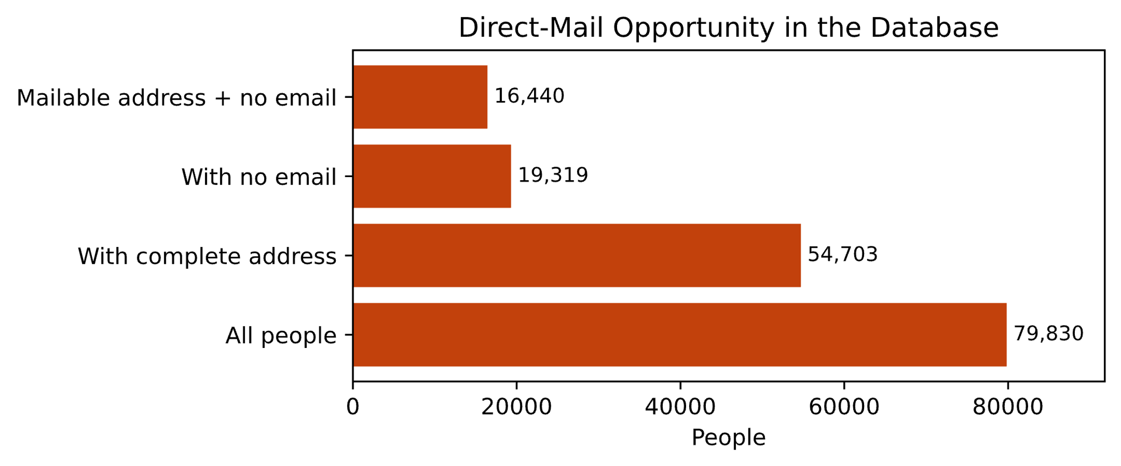
Direct Mail Opportunity
- 16,440 people cannot receive an email from us, we can only mail them for reaching out
- The gap between “no email” (19,319) and “mailable + no email” (16,440) shows that roughly 2,900 people have neither a usable email nor a complete mailing address

4. New Contacts Since January: Postcard Outreach

The Question
Among people added to the database since January 1, 2026, who has a complete mailing address but no email — and therefore needs a welcome postcard?

Approach
Rather than mailing all 16,440 people at once, we slice by recency to create a smaller, time-sensitive list. New contacts are most receptive shortly after being added to the system. This query is also designed to be repeatable — update the start date each quarter and it automatically produces a fresh list.

What We Found
6 people added since January 1, 2026, meet all criteria:
Name | City | State | Date Added | Source
Calderone, Dawna | Phoenix | AZ | 2026-03-30 | 26Sponsor
Melendez, Deanna | Prescott | AZ | 2026-02-26 | 2023 Direct Mail
Movahed, Reza | Tucson | AZ | 2026-02-26 | —
Bradford Coleman, Karyn | Little Rock | AR | 2026-01-19 | —
Figuroa, Lauren | Peoria | AZ | 2026-01-19 | —
Jewel, Jasmine | Flagstaff | AZ | 2026-01-19 | —
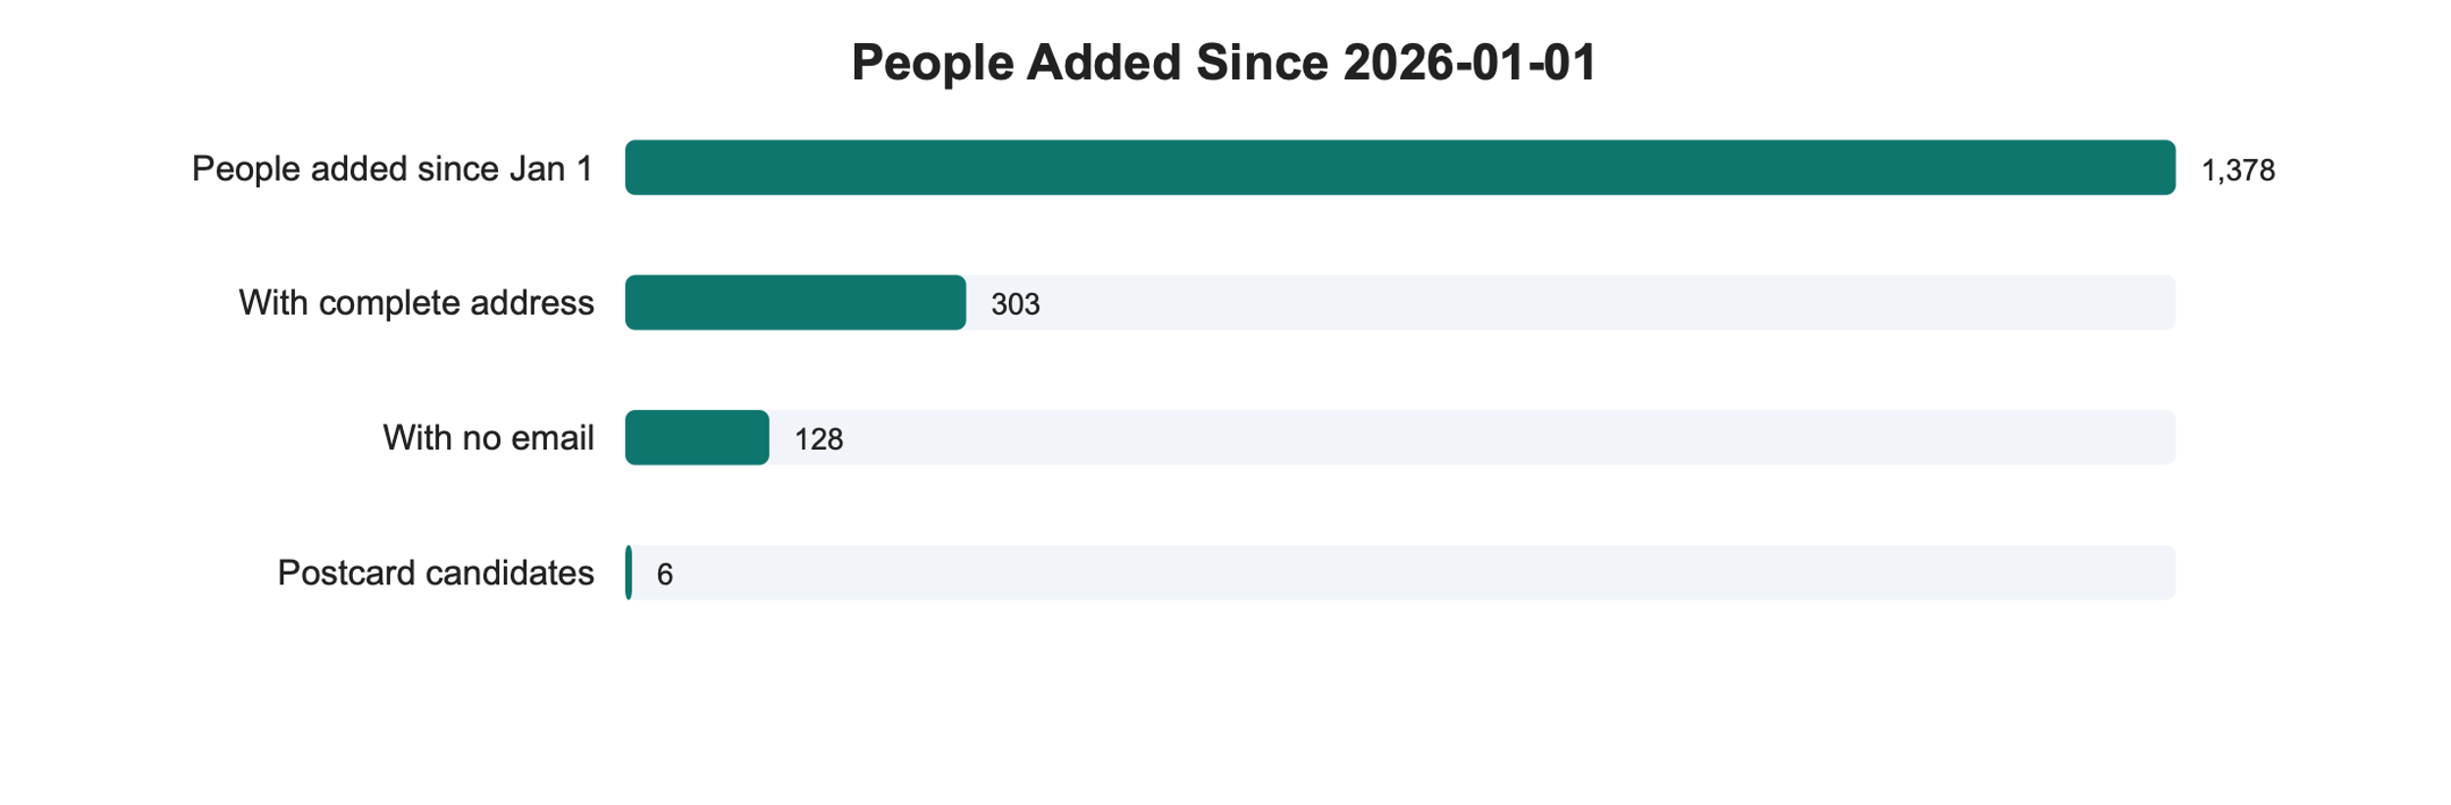

5. Lapsed Donor Identification and Priority Tiering

The Question
Which consistent donors have stopped giving? And among them, who should we prioritize for re-engagement outreach?

Approach
We need to find truly high-quality donors, not those who make a single donation and then stop giving. So we set up three qualification criteria here:
Criterion 1 — Consistency
giving_years ≥ 3 AND longest_streak ≥ 3
We require both because each catches a different failure mode: - Giving years alone misses the person who gave in 2010, 2016, and 2024, technically 3 years, but no pattern. - Streak alone misses the person who gave consistently for 3 years, stopped for 10, then gave once more. Together, they identify people who built a genuine, unbroken giving habit.
Criterion 2 — Lapse window
Last donation between 1 and 5 years ago
Under 1 year: they might just be early in their annual cycle, which means they are not truly lapsed. Over 5 years: the relationship has likely gone cold. Re-engagement cost is high, success rate is low. Out of scope for this campaign.
Criterion 3 — High value
At least one year with annual giving ≥ $250
To detect consecutive giving streaks, we used a mathematical pattern where a donor’s giving years are compared against a sequential counter — any break in the sequence reveals a gap in giving. The longest unbroken run is then used as the streak length.
Priority tier design — two dimensions crossed:
 | Lapsed ≤ 2 years | Lapsed 2–5 years
High value ($250+) | Tier 1 | Tier 2
Not high value | Tier 3 | Tier 4
Value outranks recency in the ordering. A donor who gave $500/year for a decade and lapsed 4 years ago is a stronger re-engagement prospect than someone who gave $50/year for 3 years and lapsed 6 months ago, even though the latter is more recent.

What We Found
Tier | Definition | Count
Tier 1 | High value + lapsed ≤ 2 years | 85
Tier 2 | High value + lapsed 2–5 years | 124
Tier 3 | Not high value + lapsed ≤ 2 years | 54
Tier 4 | Not high value + lapsed 2–5 years | 89
Total |  | 352
Cohort profile:
Metric | Average
Years of giving | 7.4 years
Longest consecutive streak | 5.3 years
Lifetime giving amount | $3,044
209 of the 352 (59%) have at least one $250+ giving year. This is a strong signal that this cohort has real re-engagement potential.
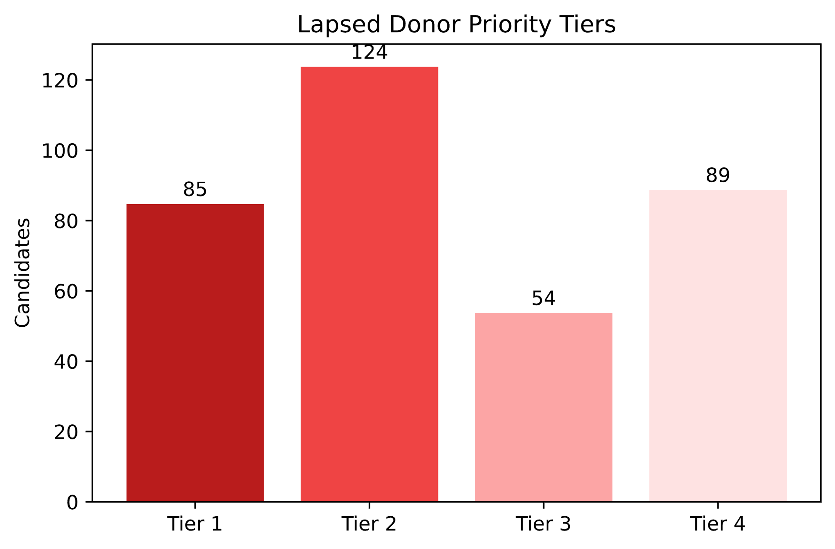
Lapsed Donor Priority Tiers
- 209 out of 352 lapsed donors (59%) have previously given $250 or more in a single year — these are high-value relationships worth investing in to recover.
- The average lapsed donor gave for 7.4 years with an average lifetime total of $3,044, indicating deep commitment before they stopped.
- Tier 1 (85 people) represents the most urgent opportunity: high-value donors who lapsed within the last 2 years, while the relationship is still relatively fresh.

6. Geographic Breakdown: Donor Giving by State

The Question
Where do our donors come from? How much does the typical donor give, and how does that vary by state?

Approach
Total donation amount alone will always make AZ look dominant — it’s where most of our donors live. But total dollars mix together two different things: how many donors a state has, and how much each person gives. To separate these, we use the median (the middle value for a typical donor) and the IQR (the range covering the middle 50% of donors) rather than simple averages, which are easily pulled up by a small number of very large gifts.

What We Found
State | Donors | Median lifetime giving
Washington D.C. | 60 | ~$300
New York | 30 | ~$200
California | 175 | ~$175
Colorado | 31 | ~$120
Arizona | 6,935 | ~$100
Washington, Illinois, Texas | 33–46 | ~$100
Oregon | 33 | ~$80

Chart
Donor lifetime giving by state:
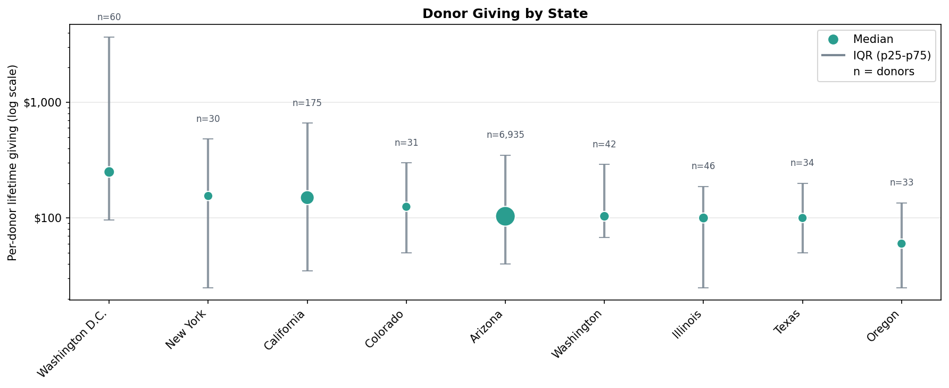

7. Geographic Breakdown: Donor Giving by ZIP Code

The Question
Which ZIP codes have the highest total giving?

Approach
We look at giving two ways: 1. total dollars raised (to find our most active ZIP codes) and per-donor giving (to find where our highest-capacity donors live). 2. A few very large gifts can skew totals, the Donor chart uses winsorized averages (average after removing the top and bottom 5%) alongside the median.
Top 20 ZIP Codes by total contribution amount: 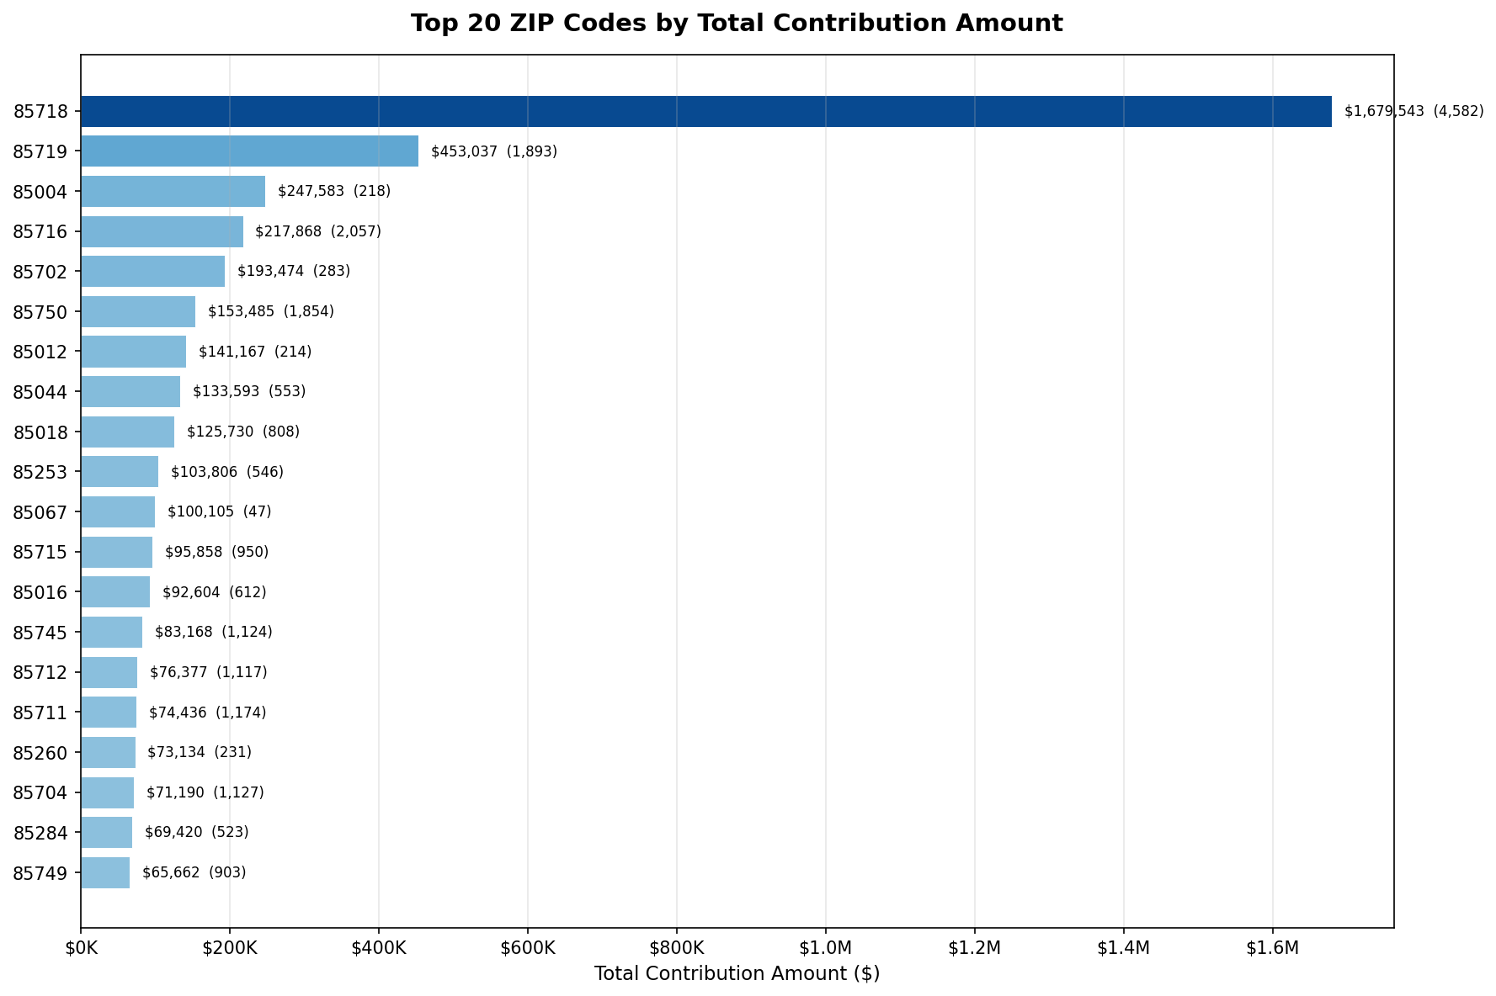
- ZIP 85718 (Tucson, Catalina Foothills) leads all ZIP codes with $1,679,543 — more than three times the second-place ZIP.
- The top five ZIP codes are all in the 857xx range, showing that giving is heavily concentrated in Tucson.
Top 20 ZIP Codes (excluding Pam Grissom — founder, not counted as a regular donor): 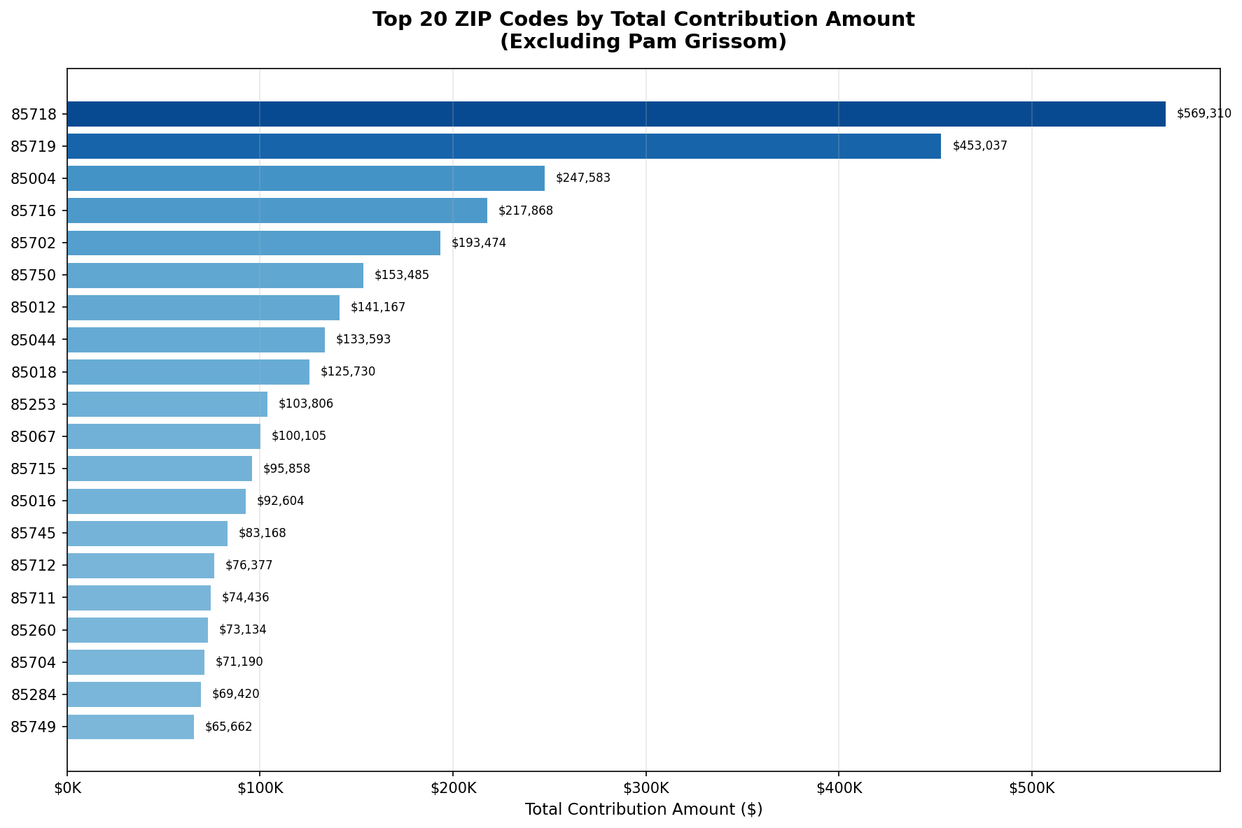
- After removing Pam Grissom’s contributions, 85718 drops from $1.68M to $569K — meaning she alone accounted for around $1M.
Donor lifetime giving by ZIP code: 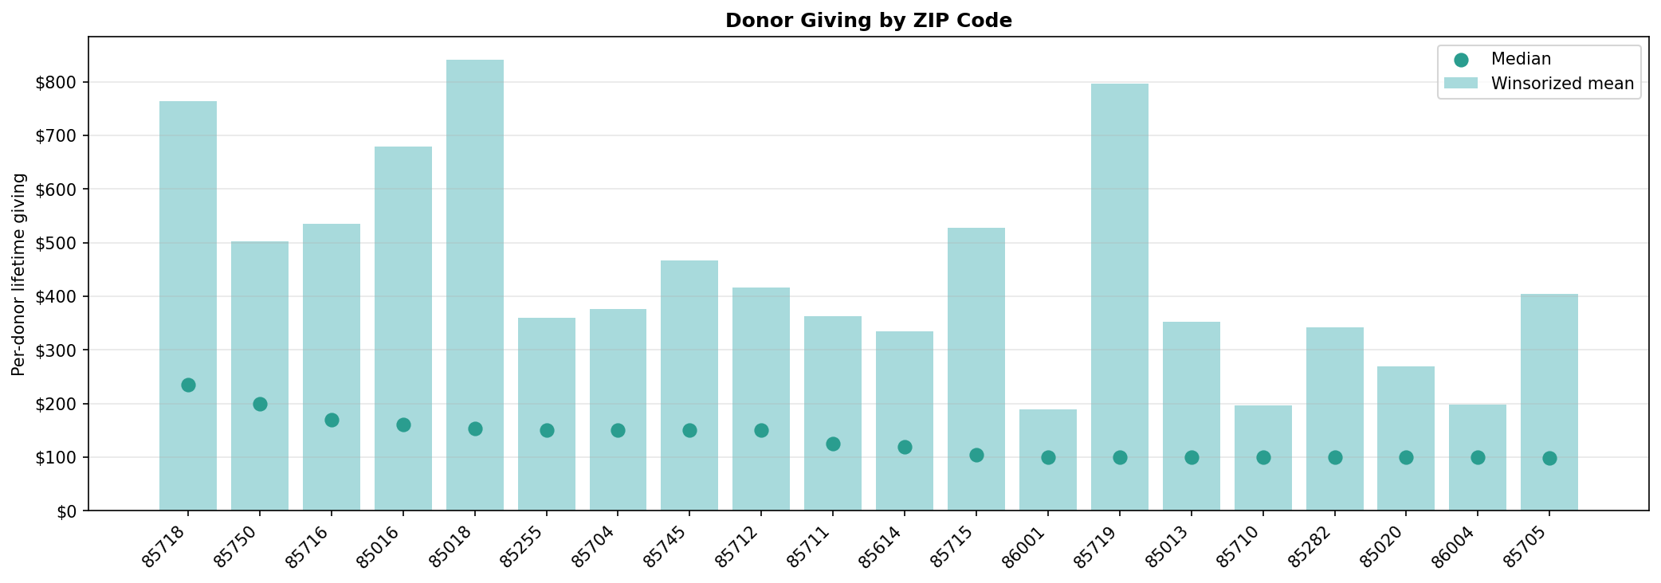
How to read this chart: The green dot is the median value. The bar is the winsorized average — the average after the top 5% and bottom 5% of donations are removed. This prevents a single $100,000 donor from inflating the number for their entire ZIP code. When the bar is much taller than the dot, it means the ZIP still has a few very large donors even after trimming.
- 85718 (Tucson north) and 85750 (Tucson northeast) lead on both median and average — the most concentrated source of high-value donors.
- 85018 (Phoenix, Arcadia area) has the highest winsorized average (~$840), driven by a small number of very large donors.
- In nearly every ZIP code, the average is well above the median, confirming that a few large donors exist in almost every neighborhood.
National donor location map: 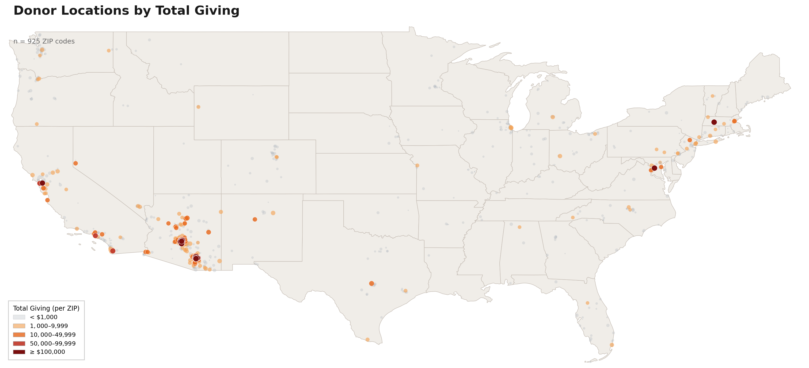
- Donors are spread across 925 ZIP codes nationwide but are heavily concentrated in the Tucson and Phoenix metro areas.
- A visible cluster on the East Coast (DC, MA, NY) matches the high per-donor giving seen in those states.

8. Geographic Breakdown: Per-Donor Giving by City and County

The Question
How does giving vary across Arizona cities and counties, both in terms of total activity and the quality of individual donors?
Donor lifetime giving by city: 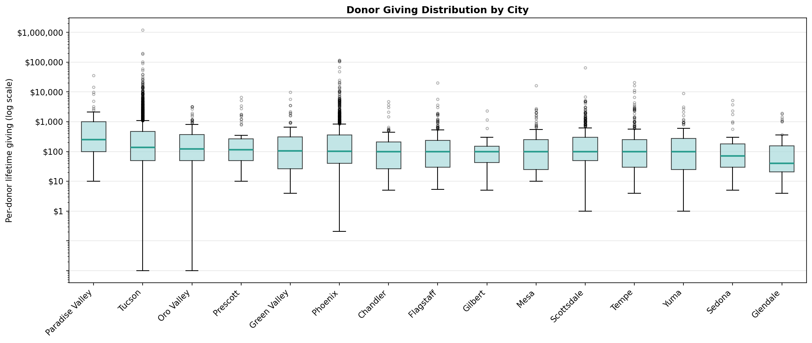
This box plot shows the full spread of lifetime giving for each city. The line in the middle of each box is the median; the box covers the middle 50% of donors; dots above are individual large donors.
- Paradise Valley has by far the highest median (~$250), with consistently high giving across the board.
- Tucson (2,682 donors) outperforms Phoenix on median giving (~$137 vs ~$100), despite being a similar type of city.
- Glendale has the lowest median (~$40), with many small-dollar donors.
Donor lifetime giving by county: 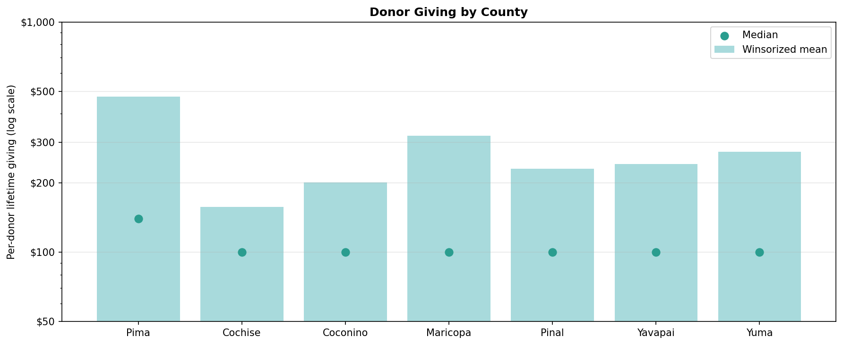
Bars are the winsorized average; green dots are the median.
- Pima County (Tucson area) has the highest median (~$140) and a large donor base — the strongest county overall.
- Maricopa County (Phoenix) has the most donors but a lower median (~$100), reflecting a broader and more varied donor base.
- All other counties cluster near $100 median, suggesting that $100 is the typical Arizona donor gift regardless of location.
- The gap between the bars and dots in every county shows that large donors exist everywhere — but they are most concentrated in Pima.

9. Donation Trends: Year-Over-Year Time Series

The Question
How have donation amounts and donation counts trended over time?

Approach
We tracked two metrics in parallel — total dollar amount and total number of donations — because they can move in different directions. A year with fewer but larger donations looks very different from a year with more but smaller donations.
Data is scoped to 2010–2026. Years before 2010 have sparse records.
Annual donation amount (line) and donation count (bar): 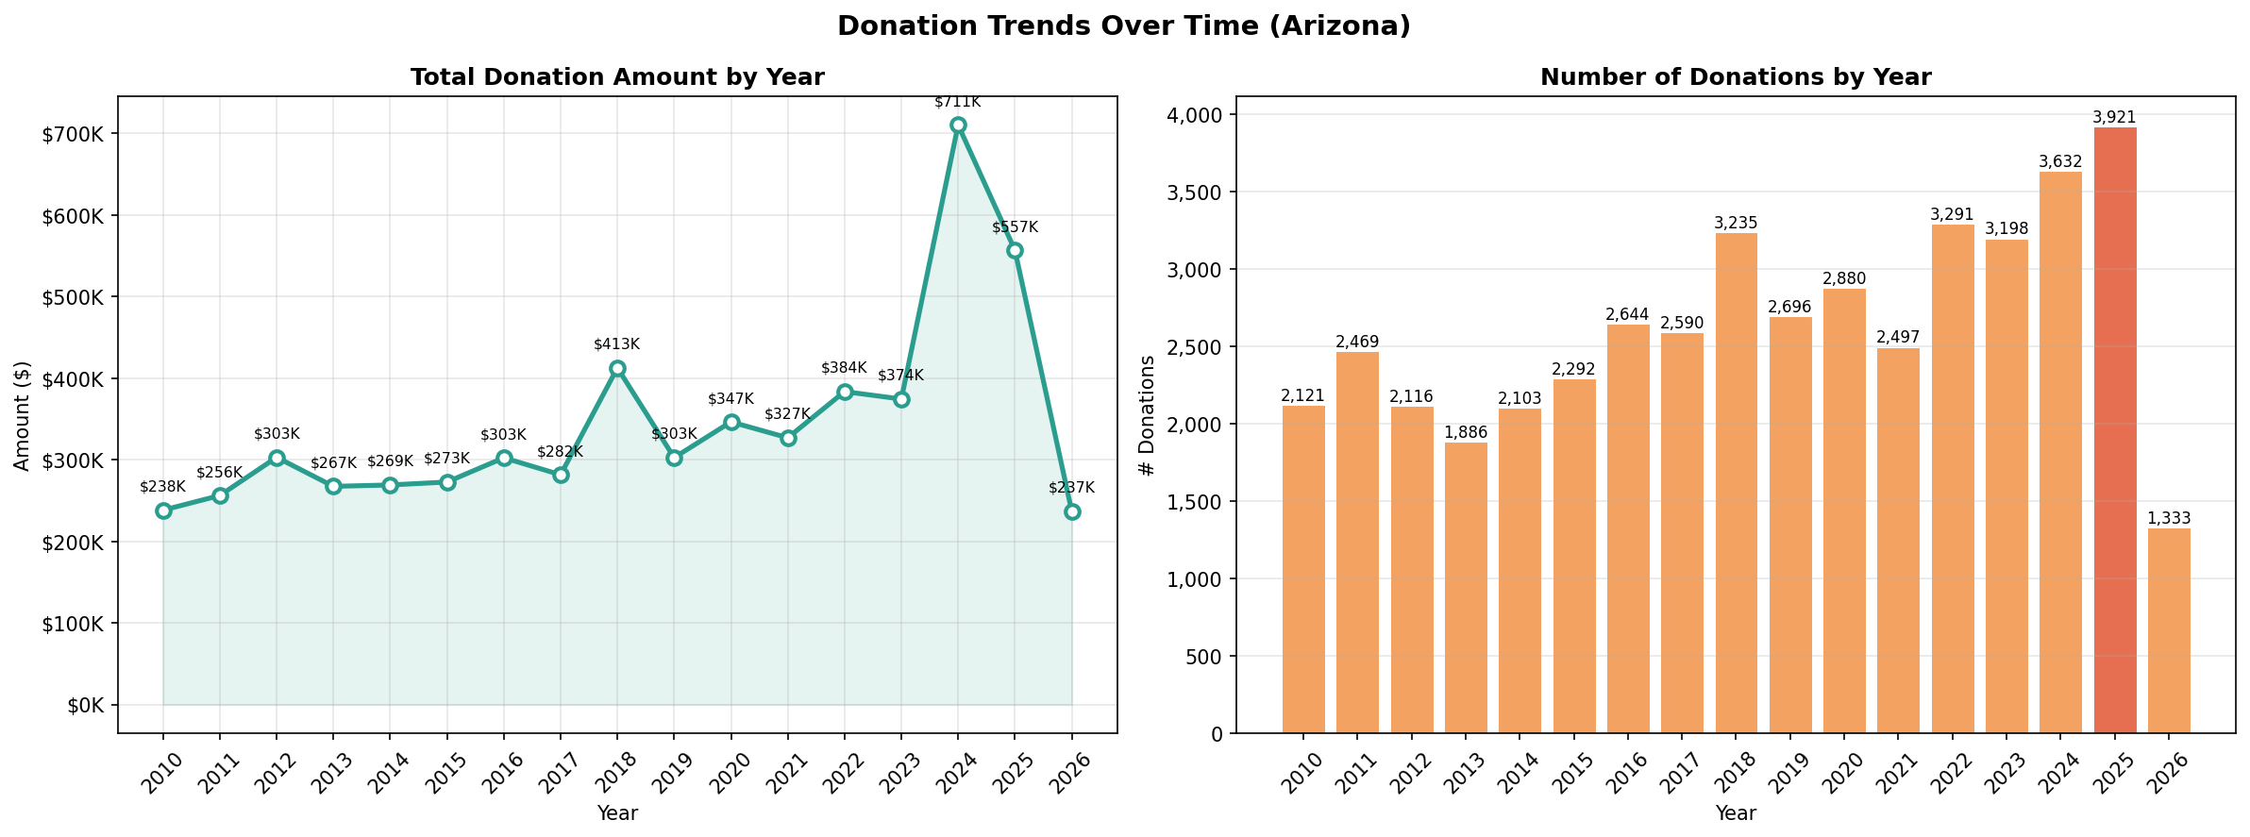
Year-by-year Donation summary table: 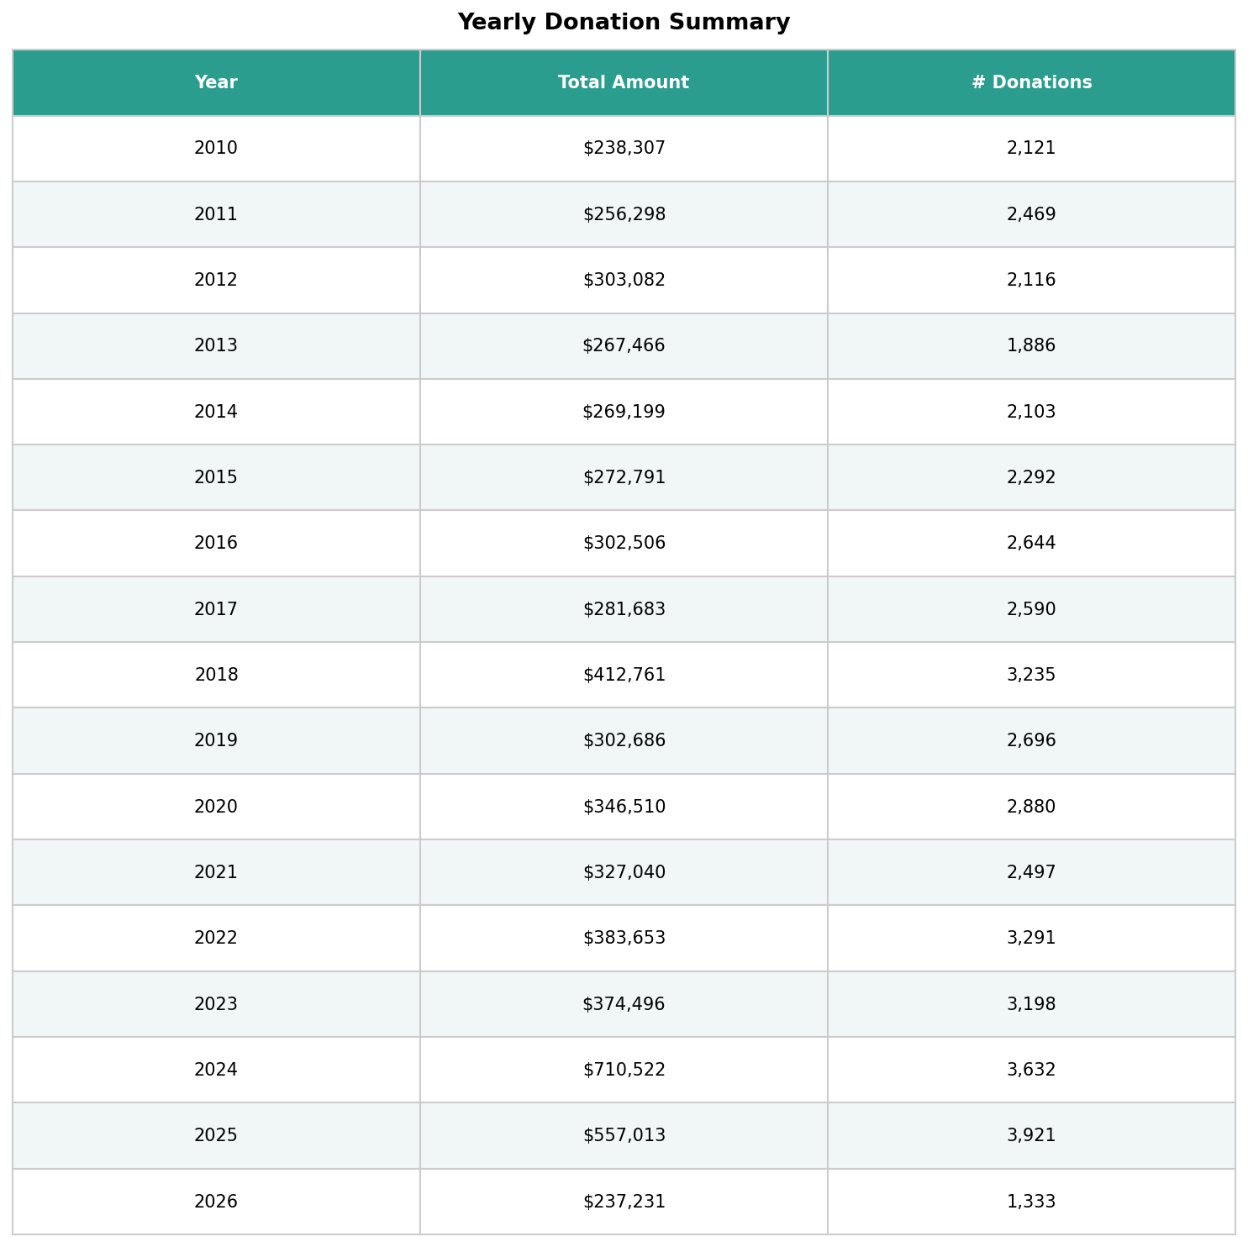

10. Top 10 Largest Individual & Organization Donations

The Question
What are the largest single donations ever recorded in the database, and who made them?

Approach
Pulled the top 10 rows from contributions ordered by amount descending, joined to contacts for donor details. Name display prioritizes the official organization name where available, then falls back to first and last name — to handle the mix of individual and organizational donors cleanly.
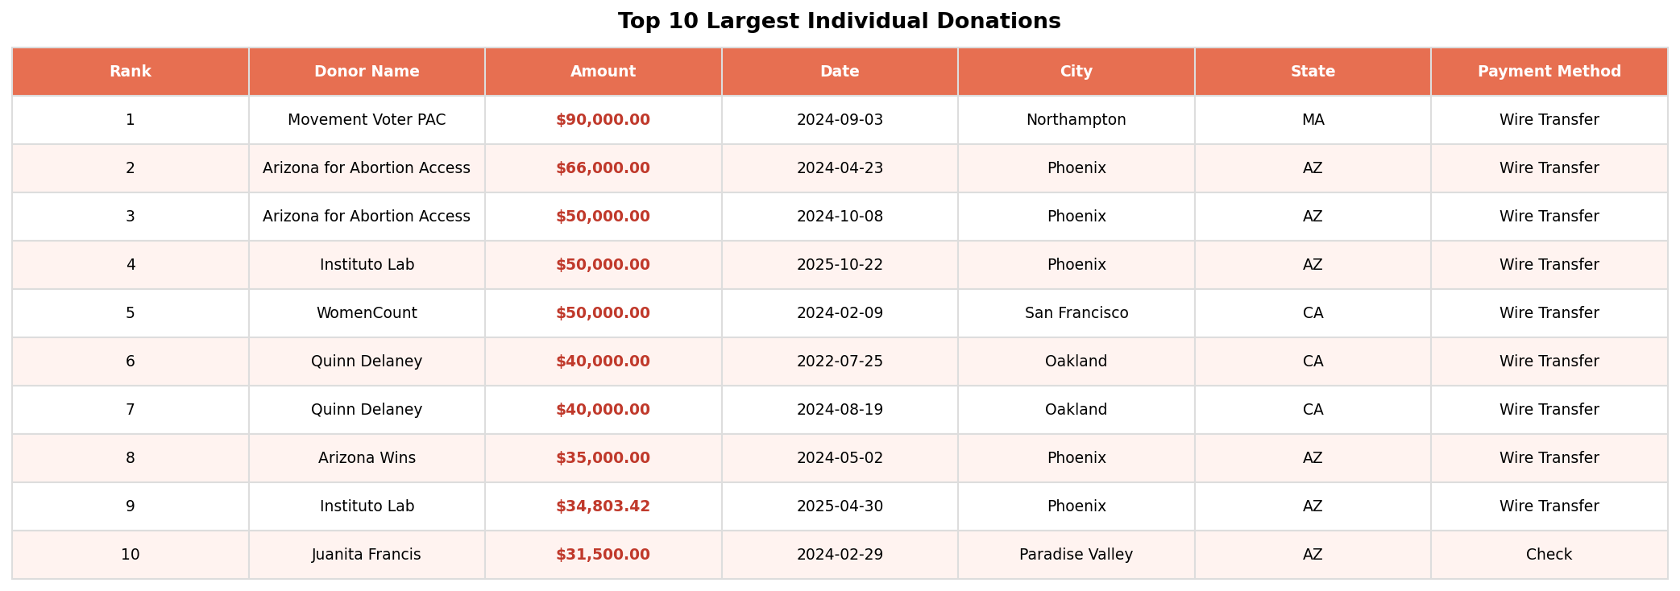
Top 10 Donations
- The largest single donation is $90,000 from Movement Voter PAC.
- Arizona for Abortion Access appears twice (rank 2 and 3).

Data source: PostgreSQL arizona_list database | Tools: Python (pandas, matplotlib, geopandas, SQLAlchemy, pgeocode)

