1. 原始信号

采样频率100000Hz

1. 低通滤波器
   1. Butter，采样频率100000Hz，截止频率1Hz，阶数8。

|  |  |
| --- | --- |
|  |  |

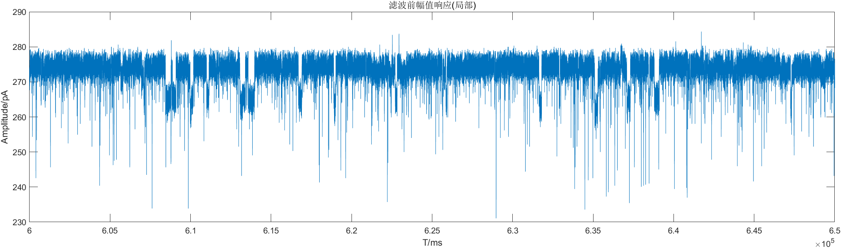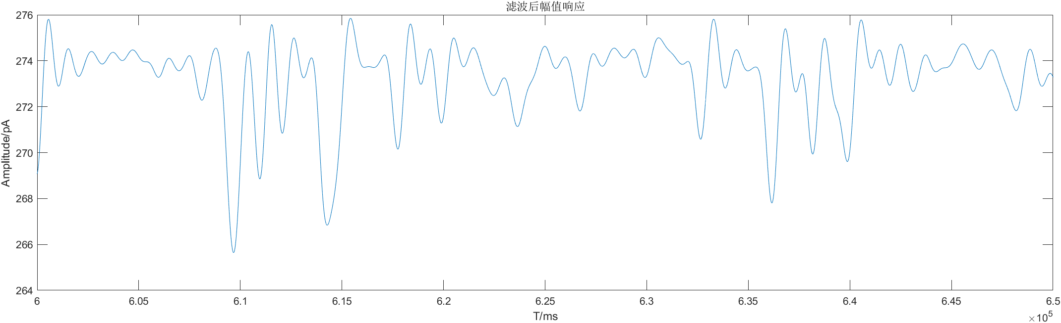

|  |  |
| --- | --- |
|  |  |

* 1. Butter，采样频率100000Hz，截止频率5Hz，阶数8。



* 1. Butter，采样频率100000Hz，截止频率8Hz，阶数8。



* 1. Butter，采样频率100000Hz，截止频率10Hz，阶数8。

|  |  |
| --- | --- |
|  |  |

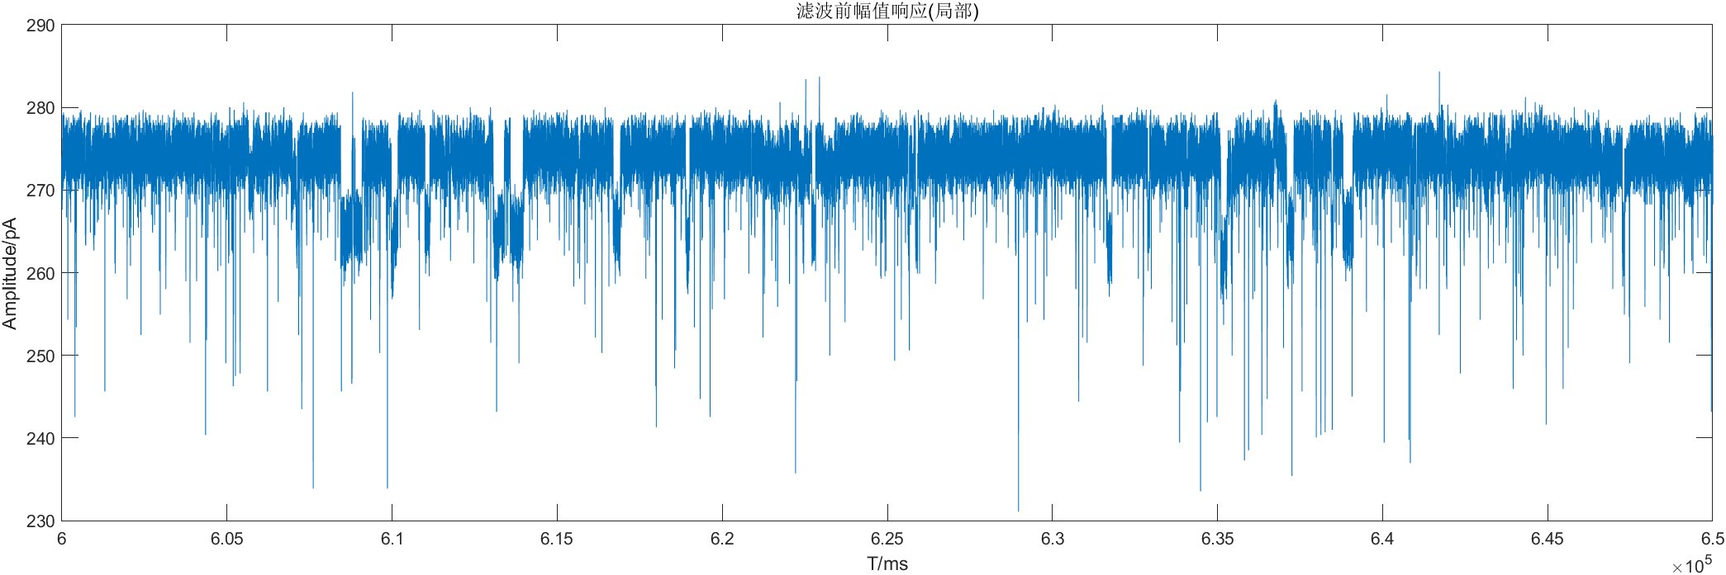



|  |  |
| --- | --- |
|  |  |

1. Butter，采样频率100000Hz，截止频率15Hz，阶数8。



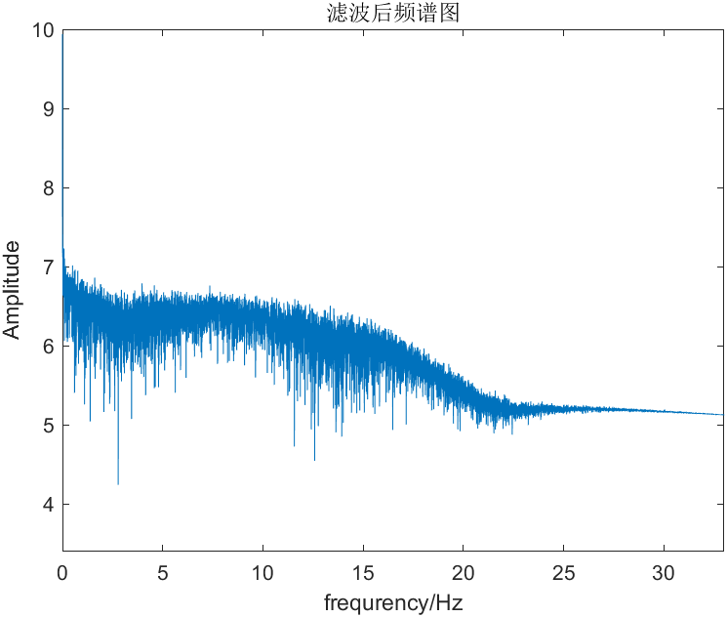

1. Butter，采样频率100000Hz，截止频率20Hz，阶数8。



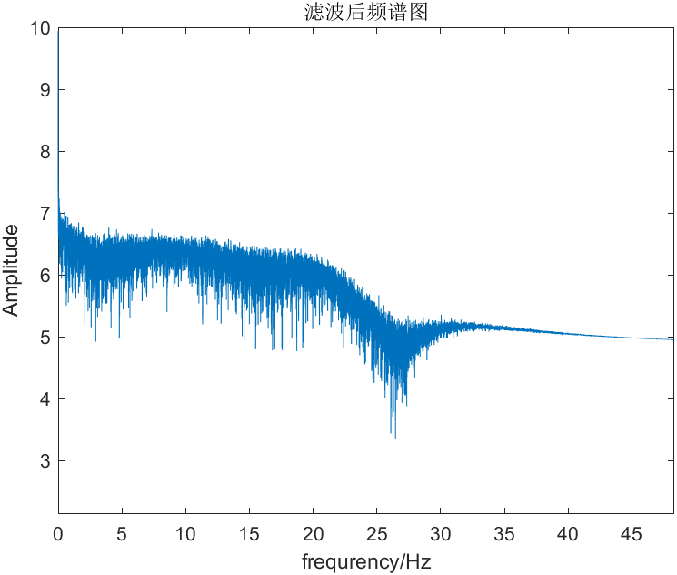

1. Butter，采样频率100000Hz，截止频率25Hz，阶数8。



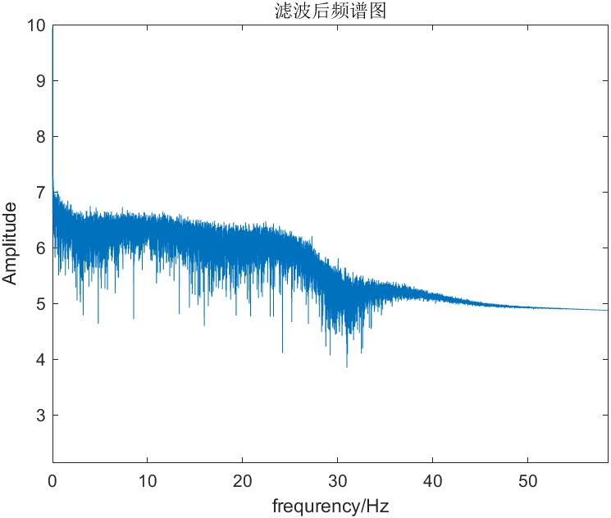

1. Butter，采样频率100000Hz，截止频率30Hz，阶数8。





* 1. Butter，采样频率100000Hz，截止频率50Hz，阶数8。

|  |  |
| --- | --- |
|  |  |

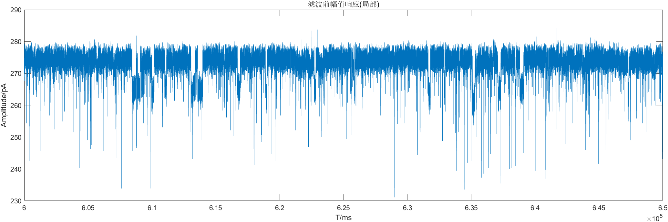



|  |  |
| --- | --- |
|  |  |

* 1. Butter，采样频率100000Hz，截止频率100Hz，阶数8。

赋值响应曲线

|  |  |
| --- | --- |
|  |  |

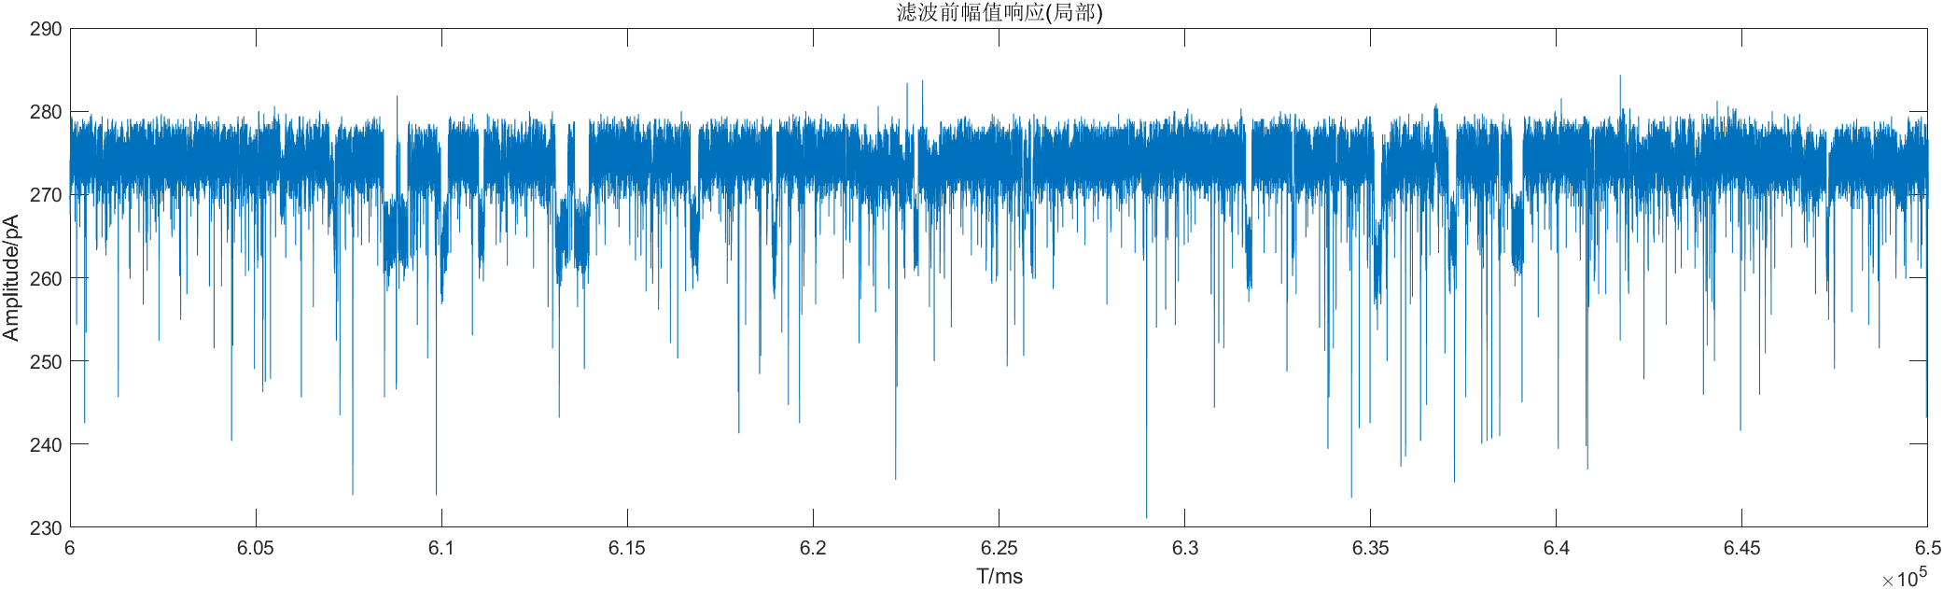



|  |  |
| --- | --- |
|  |  |

* 1. Butter，采样频率100000Hz，截止频率200Hz，阶数8。

|  |  |
| --- | --- |
|  |  |





|  |  |
| --- | --- |
|  |  |

* 1. Butter，采样频率100000Hz，截止频率250Hz，阶数8。

|  |  |
| --- | --- |
|  |  |

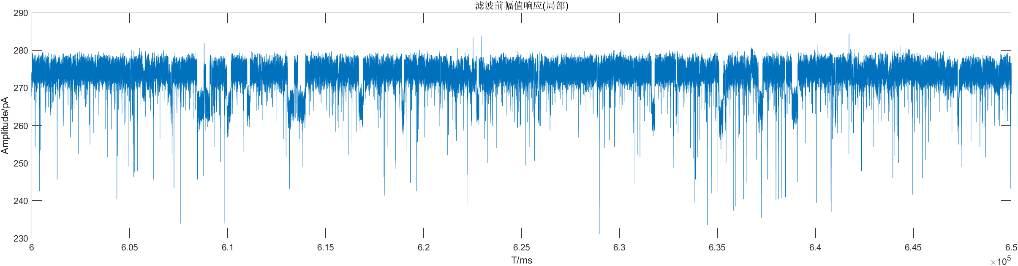



|  |  |
| --- | --- |
|  |  |

* 1. Butter，采样频率100000Hz，截止频率500Hz，阶数8。

|  |  |
| --- | --- |
|  |  |





|  |  |
| --- | --- |
|  |  |

* 1. Butter，采样频率100000Hz，截止频率1000Hz，阶数8。

|  |  |
| --- | --- |
|  |  |





    
    
    