# 手势识别绑定快捷键

## 基于

### 原理简介

使用mediapipe识别手部21个点,

使用tensorflow训练模型,根据21个点分出给定的手势

使用opencv-python提供的窗口展示画面.

识别出手势后使用keyboard按照设定自动按下指定的快捷键

使用PyQt5制作GUI,用户可通过桌面应用程序控制识别开启,关闭.

使用pyyaml读取保存的参数文件.

最后使用auto-py-to-exe操作pyinstaller打包文件

## 代码统计

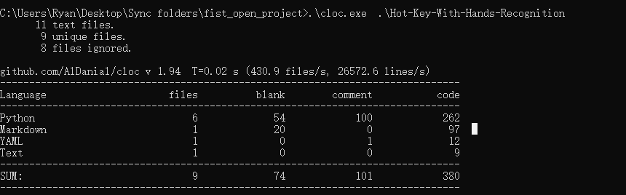

## 简介

这是一款基于手势识别绑定快捷键的应用.

他可以识别出你的手势,然后根据识别的

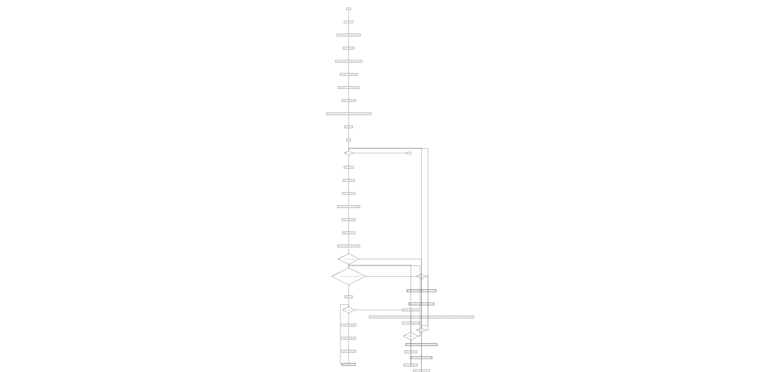

## 打包

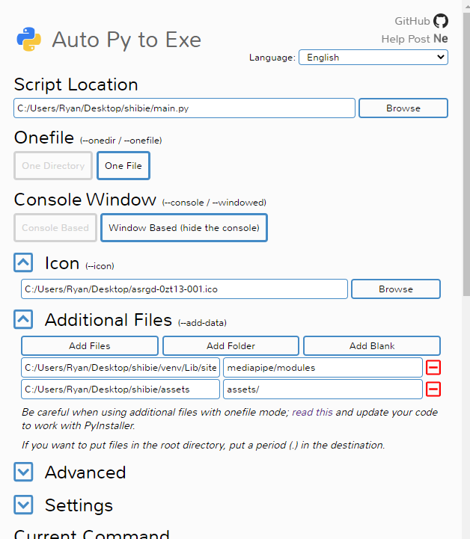

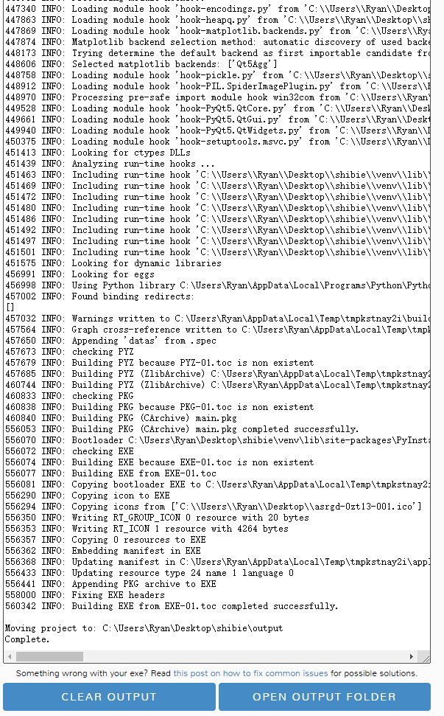



## 简介

### 目前最多可以识别出这些手势:

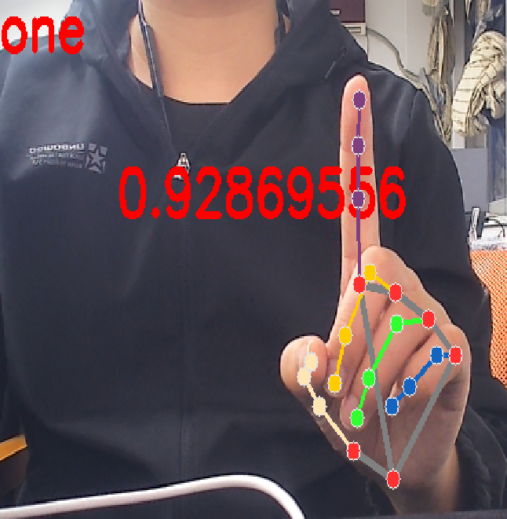

image-20221122185705967

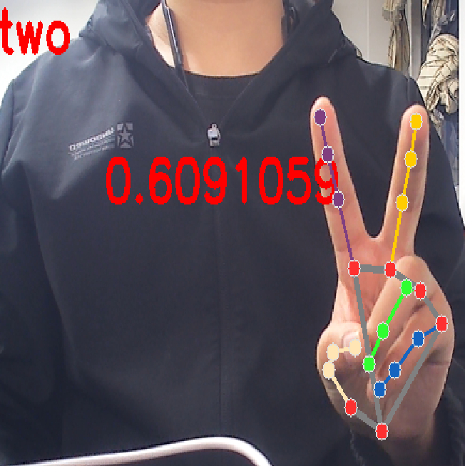

image-20221122185736690

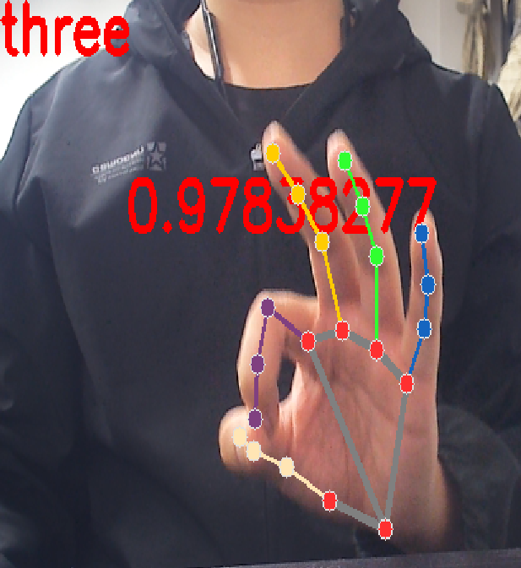

image-20221122185754782

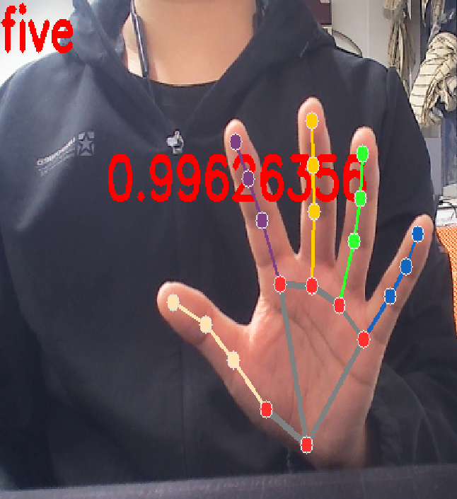

image-20221122185837820

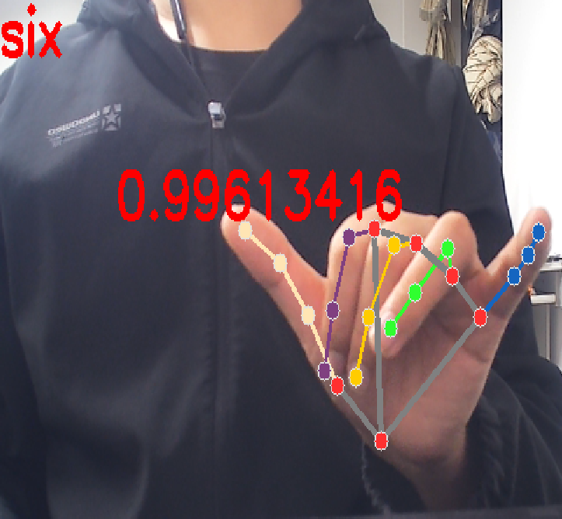

image-20221122185858200

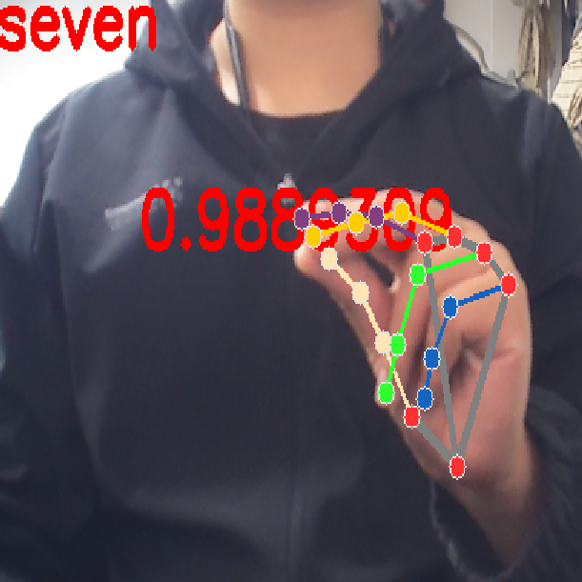

image-20221122185916507

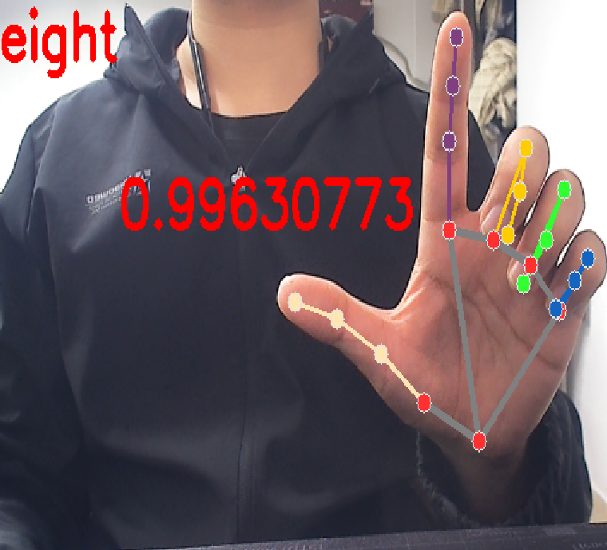

image-20221122185934707

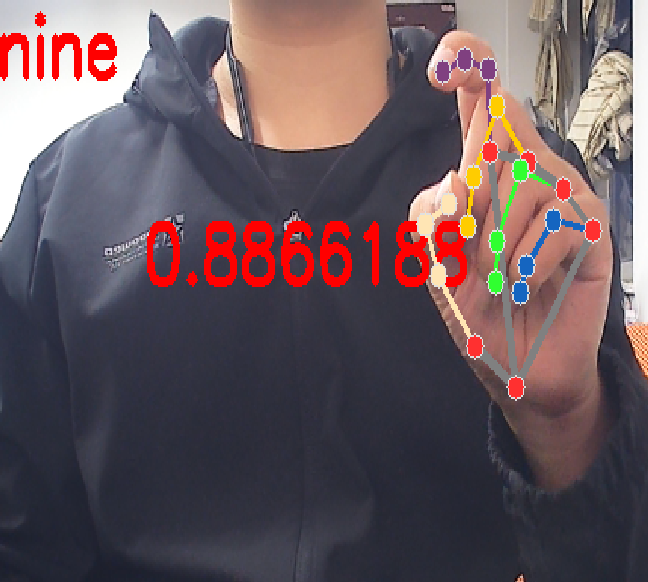

image-20221122185952538

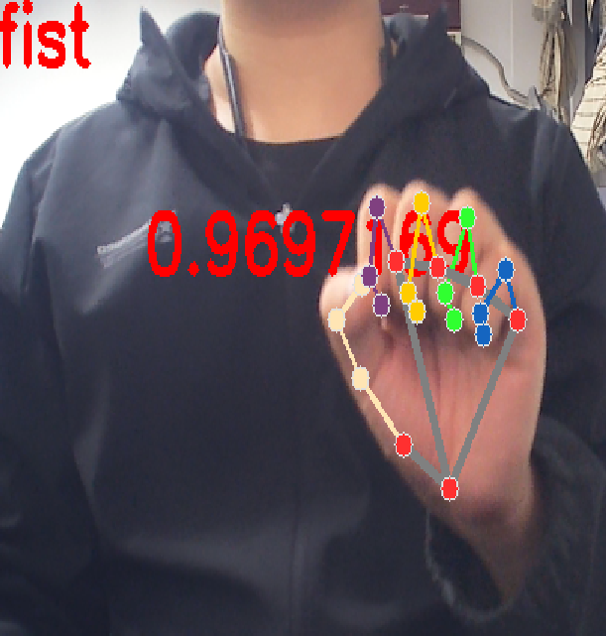

image-20221122190004002

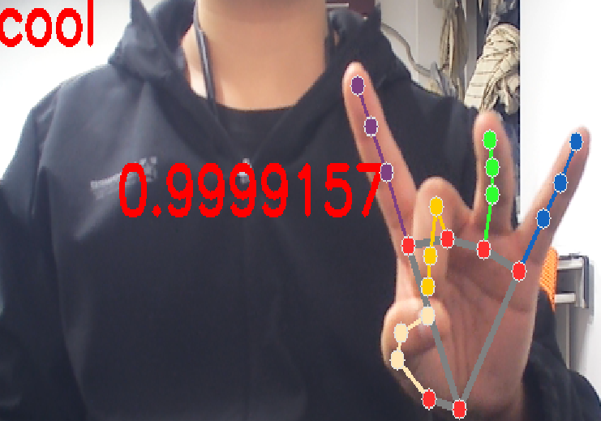

image-20221122190026476

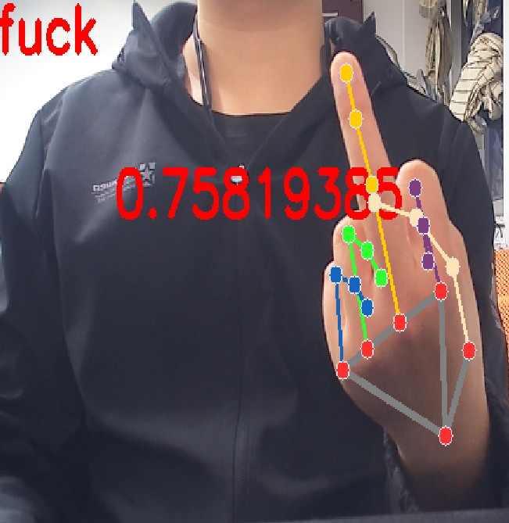

image-20221122190039590

## 函数介绍

#### 类

其中now_ges是共享给外部的变量,其它的是函数内部使用的变量

start_in_loop会在死循环中调用识别算法,直到全局控制位为False后退出.

start_in_thread是共享给外部的调用方法,每次调用会新开启一个线程运行start_in_loop方法.

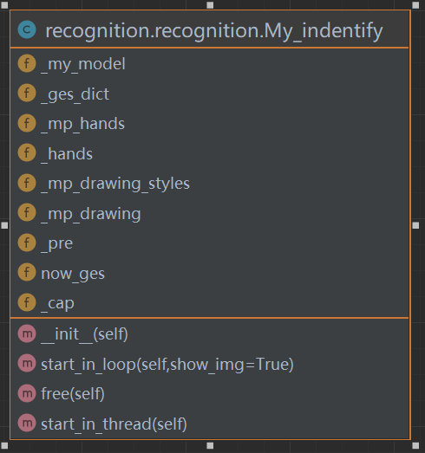

#### 初始化函数

def __init__(self):

def __init__(self):
  
 # self.ges_dict = np.load('assets/num_to_ss.npy', allow_pickle=True) #识别出来的手势是数字,需要用字典把序号转化成字符串,加载保存的对照表
  
 # self.ges_dict = self.ges_dict.tolist()
  
 self._ges_dict = {0: 'cool', 1: 'eight', 2: 'fist', 3: 'five',
  
 4: 'four', 5: 'fuck', 6: 'nine', 7: 'one', 8: 'seven',
  
 9: 'six', 10: 'three', 11: 'two'}
  
  
 print(self._ges_dict)
  
 self._my_model = load_model(resource_path('assets/my_train_12_gestures2')) # 加载训练好的tensorflow模型
  
 self._mp_drawing = mp.solutions.drawing_utils # 创建一个绘图工具
  
 self._mp_drawing_styles = mp.solutions.drawing_styles # 创建一个绘图样式
  
 self._mp_hands = mp.solutions.hands # 创建mediapipe框架读取特征点的初步工具，需要输入一个视频流，后通过自定义的tenslrflow神经网络获得手势预测值
  
 self._hands = self._mp_hands.Hands(model_complexity=0, min_detection_confidence=0.8, min_tracking_confidence=0.8)
  
 self.now_ges = 'none' #用于共享出去,给其他程序获得手势的标志位
  
 self._pre = [] # tensorflow模型预测输出为一个包含12个权值的list

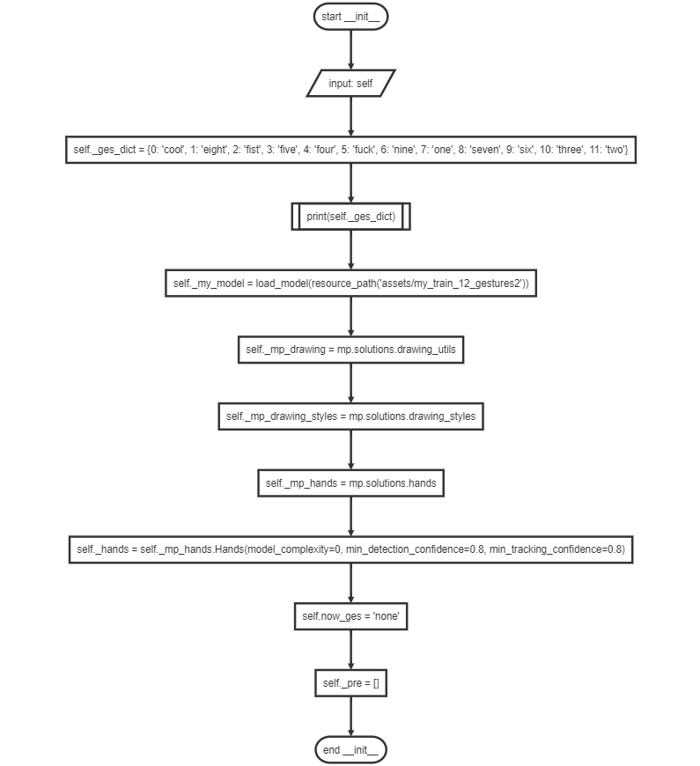

#### 开启大循环函数

def start_in_loop(self,show_img=True):

def start_in_loop(self,show_img=True):
  
 self._cap=cv2.VideoCapture(0)
  
 while True:
  
 if MyGlobalStates.__run__ is True:
  
 # time.sleep(0.05)
  
 # 从摄像头读一帧画面
  
 success, image = self._cap.read()
  
 if success:
  
 image = cv2.flip(image, 1)
  
 # 将图片设置为不可写，提升性能
  
 image.flags.writeable = False
  
 # 转换为RGB格式
  
 image = cv2.cvtColor(image, cv2.COLOR_BGR2RGB)
  
 # 调用mediapipe框架读取特征点，特征点为1个对象，保存在results中
  
 results = self._hands.process(image)
  
 # 打开图像可写的开关，将颜色由RGB转化成BGR,加速
  
 image.flags.writeable = True
  
 image = cv2.cvtColor(image, cv2.COLOR_RGB2BGR)
  
 # 获取手势预测值
  
 # 遍历results变量中的结果，将结果转化为nmupy数组格式输入神经网络进行预测
  
  
 if results.multi_hand_landmarks:
  
 # print(len(results.multi_hand_landmarks))
  
 for hand_landmarks in results.multi_hand_landmarks:
  
 landmark21 = []
  
 for i in range(21):
  
 x = hand_landmarks.landmark[i].x
  
 y = hand_landmarks.landmark[i].y
  
 z = hand_landmarks.landmark[i].z
  
 landmark21.append((x, y, z))
  
 landmark21_ = np.array([landmark21])
  
 # 输入神经网络进行预测，得到预测结果为每一种手势对应的概率
  
 pre = self._my_model.predict(landmark21_[:1])
  
 # 预测结果大于0.5认为结果可信，进入下一步判断，可更改该值获得更高或较低的可信度
  
 if np.max(pre) > 0.5:
  
 # 得到预测结概率最大的手势的编号
  
 ges_pre_p = np.argmax(pre)
  
 # 将手势编号通过字典转化为我们给他起名的字符串
  
 self.now_ges = self._ges_dict[ges_pre_p]
  
 # 显示我们预测的手势与概率
  
 if show_img:
  
 cv2.putText(image, str(np.max(pre)), (100, 200), 0, 1.3, (0, 0, 255), 3)
  
 cv2.putText(image, self.now_ges, (0, 100), 0, 1.3, (0, 0, 255), 3)
  
 # 将手部的特征点连线显示
  
 for hand_landmarks in results.multi_hand_landmarks:
  
 self._mp_drawing.draw_landmarks(
  
 image,
  
 hand_landmarks,
  
 self._mp_hands.HAND_CONNECTIONS,
  
 self._mp_drawing_styles.get_default_hand_landmarks_style(),
  
 self._mp_drawing_styles.get_default_hand_connections_style())
  
 else:
  
 self.now_ges='none'
  
 if show_img:
  
 cv2.namedWindow('Gesture Recognition Client', cv2.WINDOW_NORMAL)
  
 # 展示图片画面
  
 cv2.imshow('Gesture Recognition Client', image)
  
 # 按esc键退出
  
 if cv2.waitKey(5) & 0xFF == 27:
  
 break
  
 else:
  
 break
  
 self.free()



#### 在线程中开启

def start_in_thread(self):
  
 Thread(target=self.start_in_loop).start()#,name='recognizer')

#### 释放内存

def free(self):
  
 self._cap.release()
  
 cv2.destroyAllWindows()

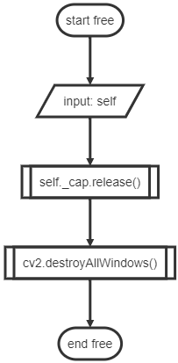

#### 加载快捷键

def load(file=resource_path("assets/bind.yml"))->dict:
  
 with open(file, 'r', encoding='utf-8') as f:
  
 binds = yaml.load(f.read(), Loader=yaml.FullLoader)
  
 f.close()
  
 return binds

#### 等待按键信号并按下快捷键

def waiting_to_press_and_release():
  
 global binds
  
 while True:
  
 if MyGlobalStates.__run__:
  
 if recognizer.now_ges in binds.keys():
  
 if binds[recognizer.now_ges]!='nothing':
  
 keyboard.press_and_release(binds[recognizer.now_ges])
  
 time.sleep(0.2)
  
 else:
  
 break

#### 重新加载

def reloads():
  
 global binds
  
 binds=load()

#### 在线程中开启

#等待开启的线程
  
def start_in_thread():
  
 Thread(target=waiting_to_press_and_release).start()

st3=>start: start start_in_thread
  
io5=>inputoutput: input: self
  
sub8=>subroutine: Thread(target=self.start_in_loop).start()
  
e10=>end: end start_in_thread
  
  
st3->io5
  
io5->sub8
  
sub8->e10

#### 加载UI

def set_UI(self):
  
 self.setWindowTitle("Hot-Key-With-Hands-Recognition-V0.1")
  
 # self.resize(400, 100)
  
 hlayout = QHBoxLayout()
  
 fromlayout = QFormLayout()
  
  
 self.state_label = QLabel('Status')
  
 self.state = QLabel(' OFF')
  
 self.btn_start = QPushButton('Start')
  
 self.btn_end = QPushButton('Close')
  
  
 hlayout.addWidget(self.state_label)
  
 hlayout.addWidget(self.state)
  
 hlayout.addWidget(self.btn_start)
  
 hlayout.addWidget(self.btn_end)
  
  
 fromlayout.addRow(hlayout)
  
 self.click_btns=[]
  
 self.edits=[]
  
 self.labels=[]
  
  
 l1=QLabel('one')
  
 l2=QLabel('two')
  
 l3=QLabel('three')
  
 l4=QLabel('four')
  
 l5=QLabel('five')
  
 l6=QLabel('six')
  
 l7=QLabel('seven')
  
 l8=QLabel('eight')
  
 l9=QLabel('nine')
  
 lfi=QLabel('fist')
  
 lfu=QLabel('fuck')
  
 lc=QLabel('cool')
  
  
 self.labels.append(l1)
  
 self.labels.append(l2)
  
 self.labels.append(l3)
  
 self.labels.append(l4)
  
 self.labels.append(l5)
  
 self.labels.append(l6)
  
 self.labels.append(l7)
  
 self.labels.append(l8)
  
 self.labels.append(l9)
  
 self.labels.append(lfi)
  
 self.labels.append(lfu)
  
 self.labels.append(lc)
  
  
 _one= MyLineEdit(binds['one'])
  
 _two = MyLineEdit(binds['two'])
  
 _three = MyLineEdit(binds['three'])
  
 _four = MyLineEdit(binds['four'])
  
 _five = MyLineEdit(binds['five'])
  
 _six = MyLineEdit(binds['six'])
  
 _seven= MyLineEdit(binds['seven'])
  
 _eight = MyLineEdit(binds['eight'])
  
 _nine= MyLineEdit(binds['nine'])
  
 _fist = MyLineEdit(binds['fist'])
  
 _fuck = MyLineEdit(binds['fuck'])
  
 _cool = MyLineEdit(binds['cool'])
  
  
 self.edits.append(_one)
  
 self.edits.append(_two)
  
 self.edits.append(_three)
  
 self.edits.append(_four)
  
 self.edits.append(_five)
  
 self.edits.append(_six)
  
 self.edits.append(_seven)
  
 self.edits.append(_eight)
  
 self.edits.append(_nine)
  
 self.edits.append(_fist)
  
 self.edits.append(_fuck)
  
 self.edits.append(_cool)
  
  
 # for e in self.edits:
  
 # e.setFocusProxy(Qt.NoFocus)
  
  
 for i in range(len(binds.keys())):
  
 vlayout = QHBoxLayout()
  
  
 btn=QPushButton('Save')
  
  
 self.click_btns.append(btn)
  
 # PATH = QLineEdit(self.edits[i])
  
 # PATH.setFocusPolicy(Qt.NoFocus) # 设置不可编辑
  
  
 vlayout.addWidget(self.labels[i])
  
 vlayout.addWidget(self.edits[i])
  
 fromlayout.addRow(btn,vlayout)
  
  
 self.setLayout(fromlayout)
  
 MyGlobalStates.__run__ = False



#### 设置回调函数

def set_callbacks(self):
  
 #绑定开始和结束按钮的按键,按下后修改全局状态标志位,修改开关状态的标签
  
 self.btn_start.clicked.connect(self.btn_start_callback)#这里差了一个回调函数
  
 self.btn_end.clicked.connect(self.btn_end_callback)
  
 self.edits[0].textChanged.connect(lambda: self.show_edits_change(0))
  
 self.edits[1].textChanged.connect(lambda: self.show_edits_change(1))
  
 self.edits[2].textChanged.connect(lambda: self.show_edits_change(2))
  
 self.edits[3].textChanged.connect(lambda: self.show_edits_change(3))
  
 self.edits[4].textChanged.connect(lambda: self.show_edits_change(4))
  
 self.edits[5].textChanged.connect(lambda: self.show_edits_change(5))
  
 self.edits[6].textChanged.connect(lambda: self.show_edits_change(6))
  
 self.edits[7].textChanged.connect(lambda: self.show_edits_change(7))
  
 self.edits[8].textChanged.connect(lambda: self.show_edits_change(8))
  
 self.edits[9].textChanged.connect(lambda: self.show_edits_change(9))
  
 self.edits[10].textChanged.connect(lambda: self.show_edits_change(10))
  
 self.edits[11].textChanged.connect(lambda: self.show_edits_change(11))
  
  
 for btn in self.click_btns:
  
 btn.clicked.connect(self.save_binds_and_reload)

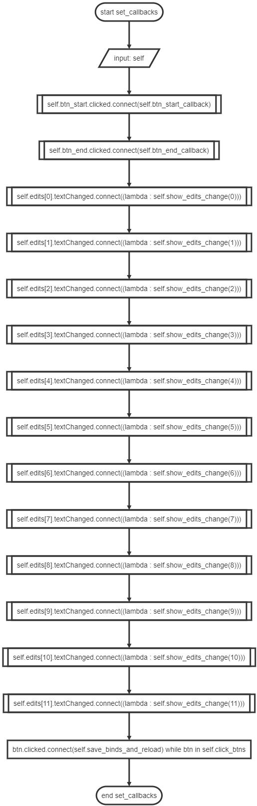

#### 每个回调函数

def btn_start_callback(self):
  
 if MyGlobalStates.__run__ == False:
  
 try:
  
 self.state.setText('On')
  
 MyGlobalStates.__run__=True
  
 recognizer.start_in_thread()
  
 start_in_thread()
  
 except Exception as e:
  
 QMessageBox.information(self, 'Error', e, QMessageBox.Ok)

def btn_end_callback(self):
  
 self.state.setText('Close')
  
 MyGlobalStates.__run__=False

def show_edits_change(self,idx):
  
 binds[list(binds.keys())[idx]]=self.edits[idx].text()

def save_binds_and_reload(self):
  
 with open(resource_path('assets/bind.yml'),'w',encoding='utf-8') as f:
  
 f.write("#ALL_Gesture: {0: 'cool', 1: 'eight', 2: 'fist', 3: 'five', 4: 'four', 5: 'fuck', 6: 'nine', 7: 'one', 8: 'seven', 9: 'six', 10: 'three', 11: 'two'}\n")
  
 #保存配置
  
 for k in binds.keys():
  
 f.write(f"{k}: {binds[k]}\n")
  
 f.close()
  
 reloads()
  
 QMessageBox.information(self, 'Saving Changes', 'Saved Successfully !', QMessageBox.Ok)

def closeEvent(self, a0: QtGui.QCloseEvent) -> None:
  
 MyGlobalStates.__run__=False

def start_gui():
  
 app = QApplication(sys.argv)
  
 form = Winform()
  
 form.show()
  
 sys.exit(app.exec_())