In original csv dataset we have 12 columns (1 target column and 11 input features), all of them are numerical.
We have 6 classes of target column “quality”: 3, 4, 5, 6, 7, 8. According to the task, we should union them into 3 classes: <=5: low, 6: medium, >=7: high

Missing data
This dataset has no missing data. And all data is numeric:
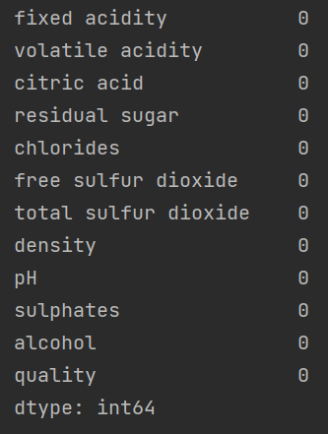

Duplicates
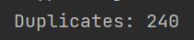
we delete them

Outliers
Potential outliers can be here:
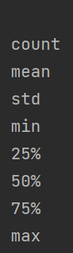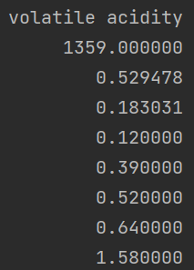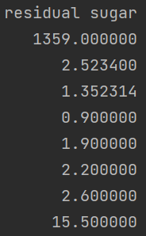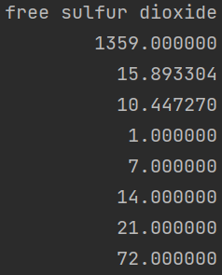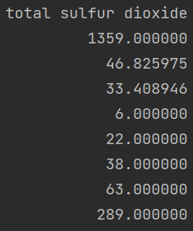
but probably this is because some sweet wines which contain many sugar and sulfur dioxide

Grouping quality
As the task says, we need to divide quality into 3 classes:
quality <=5: low, 6: medium, >=7: high
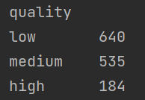
class | quality | samples | %
low | 3, 4, 5 | 640 | 47
medium | 6 | 535 | 39
high | 7, 8 | 184 | 14
total |  | 1359 | 100

Preprocessing
Encode: low->0, medium->1, high->1
Size of test data: 33%
“random_state” means that the same rows will be assigned to the training and test sets each time we run the code
“stratify” means that if there are 20% of samples are high, then Train and Test will have around 20% of high too


