With the python google app engine GUI installed,

Host the app locally using the GUI

To host on google, open CMD, navigate to the folder containing the app folder using cd and dir: e.g.

E:\NUS\Orbital\Python

To run:

appcfg.py –A (name of ID) update (name of folder)

appcfg.py –A testhelloworld-1309 update engineapp

To view the app:

(name of ID).appspot.com

testhelloworld-1309.appspot.com

*Note: There’s actually a way to add something to the system path variable in your system’s environment such that you won’t need to navigate to the source file to run the appcfg.py, but I’m not exactly sure how to. Know it’s something to do under the environment variables settings but not sure what to add from there.

Alternatively, can just use GAE’s python GUI and click “deploy” for to deploy it onto the appspot site.

Downloaded the test telegram bot resource at: <https://github.com/yukuku/telebot>

Made a new project called teletestbot

Made a new bot on telegram called testbot, @orbitaltestbot.

Amend the application in app.yaml to the google GAE project ID:

[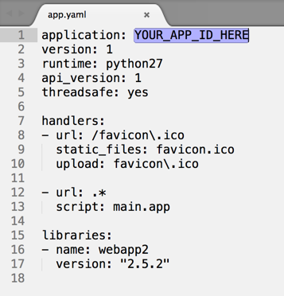](https://camo.githubusercontent.com/05e4b30f716eea7160a256b16541d09e61466fec/687474703a2f2f692e696d6775722e636f6d2f6d397952774e772e706e67)

Open main.py file using a good text editor. Change the YOUR_BOT_TOKEN_HERE to the token you get from @botfather at step 6, and save the file.

[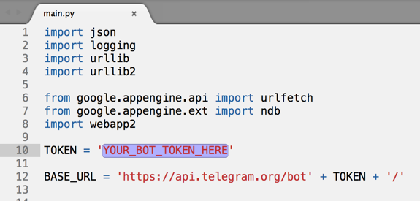](https://camo.githubusercontent.com/28b5fb8236c32625e133175e0c604d7c5c644590/687474703a2f2f692e696d6775722e636f6d2f6f4e46456473702e706e67)

Deploy the app with the GAE python GUI

Open with:

<http://teletestbot-1323.appspot.com/me> *Note the /me needs to be included!

Now, go to https://project-id.appspot.com/set_webhook?url=https://project-id.appspot.com/webhook (replace bothproject-ids with the Project ID you set on step 16).

Result:

{"ok": true, "result": true, "description": "Webhook was set"}