

Module: ST0280 Cloud and Service Computing

Class: DIT/FT/3A/23

Lecturer: Mr Ji Pengxiang

Submission Date: 07/02/2021

Team members:

Li Tianchu (1828568)

Li Zhangyi ()

Wong Qing Er ()

Gabriel Chen ()

Sun Xiao Tang ()

1. Application Features
   1. Basic Features

* View and change subscription plan





* Perform CRUD operations and comment on Talents

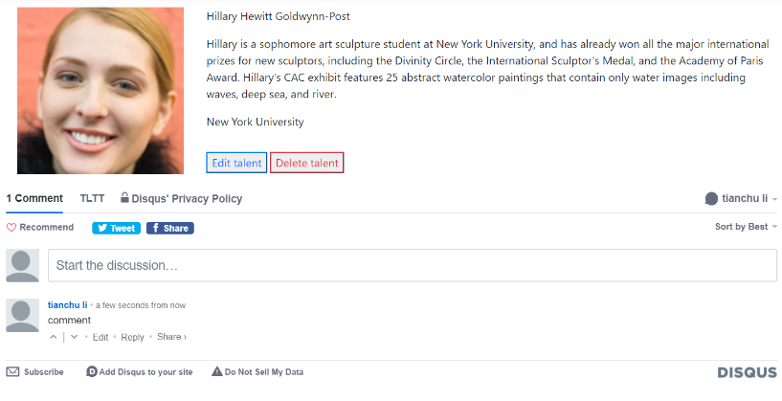

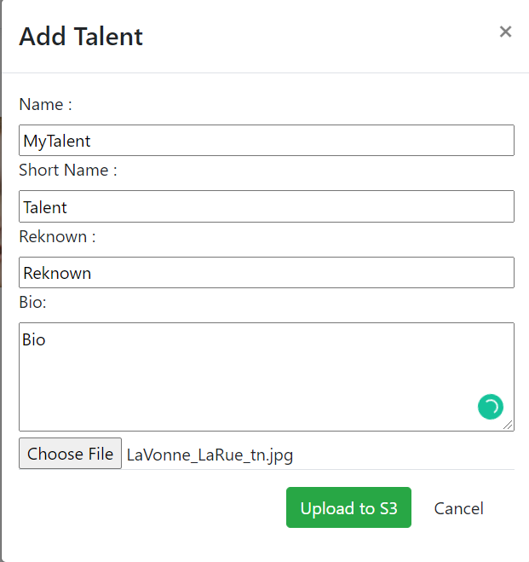

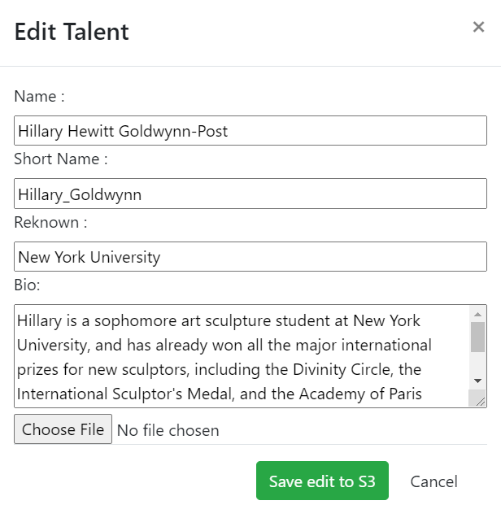

* Image recognition for talent photo
  1. Additional Features
* User Authentication

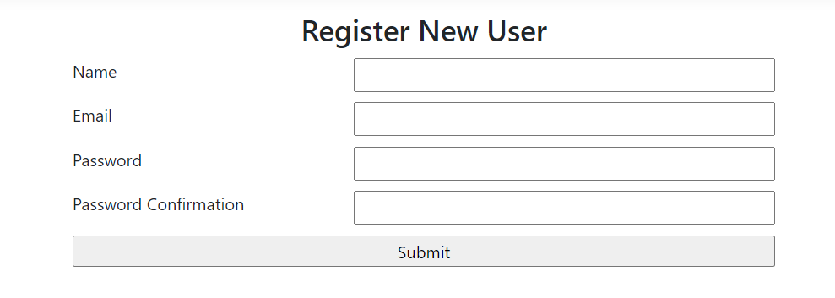

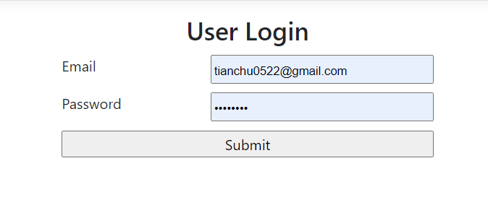



* Recommendation
* Serverless API Architecture with Amazon Lambda and API Gateway

See 2.7 and 2.8

1. Web Services
   1. Amazon EC2 (Client Hosting)

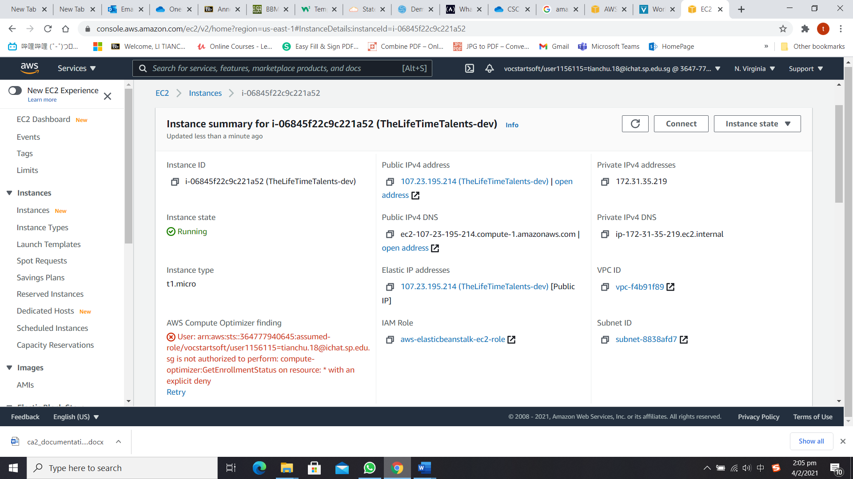

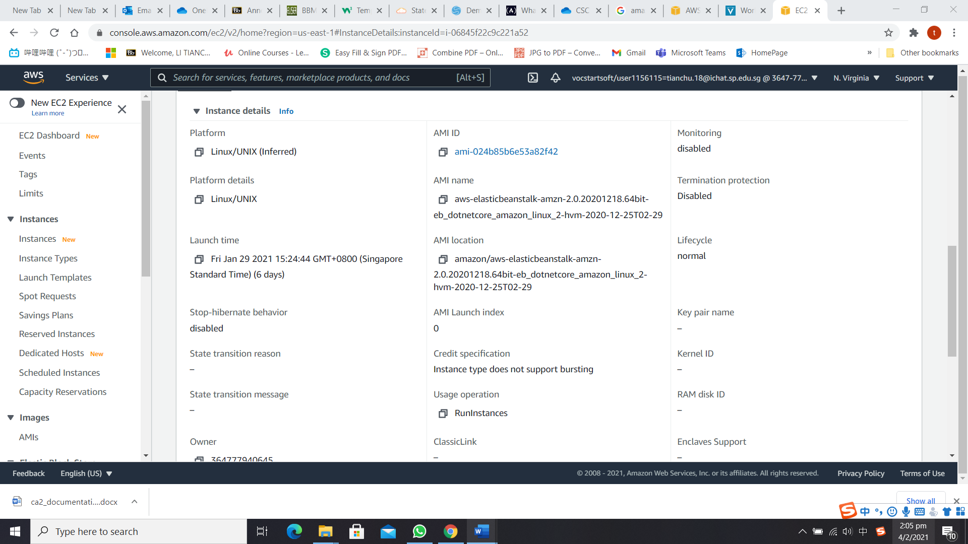

* 1. Google Identity Platform (Identity Management)

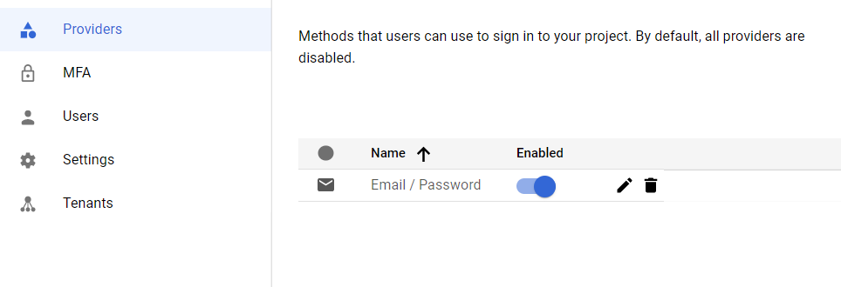

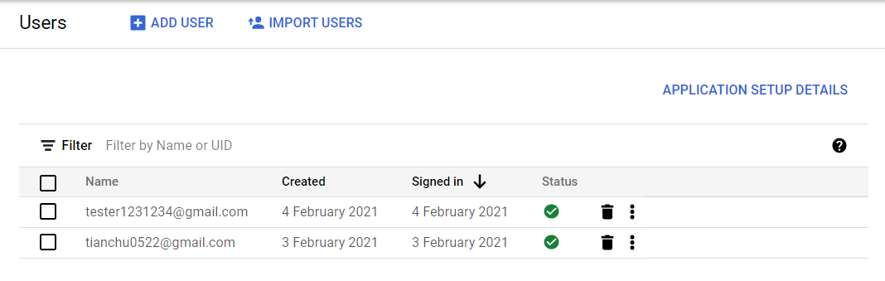

* 1. Amazon S3 (Image Storage)
  2. Amazon RDS (SQL Database)

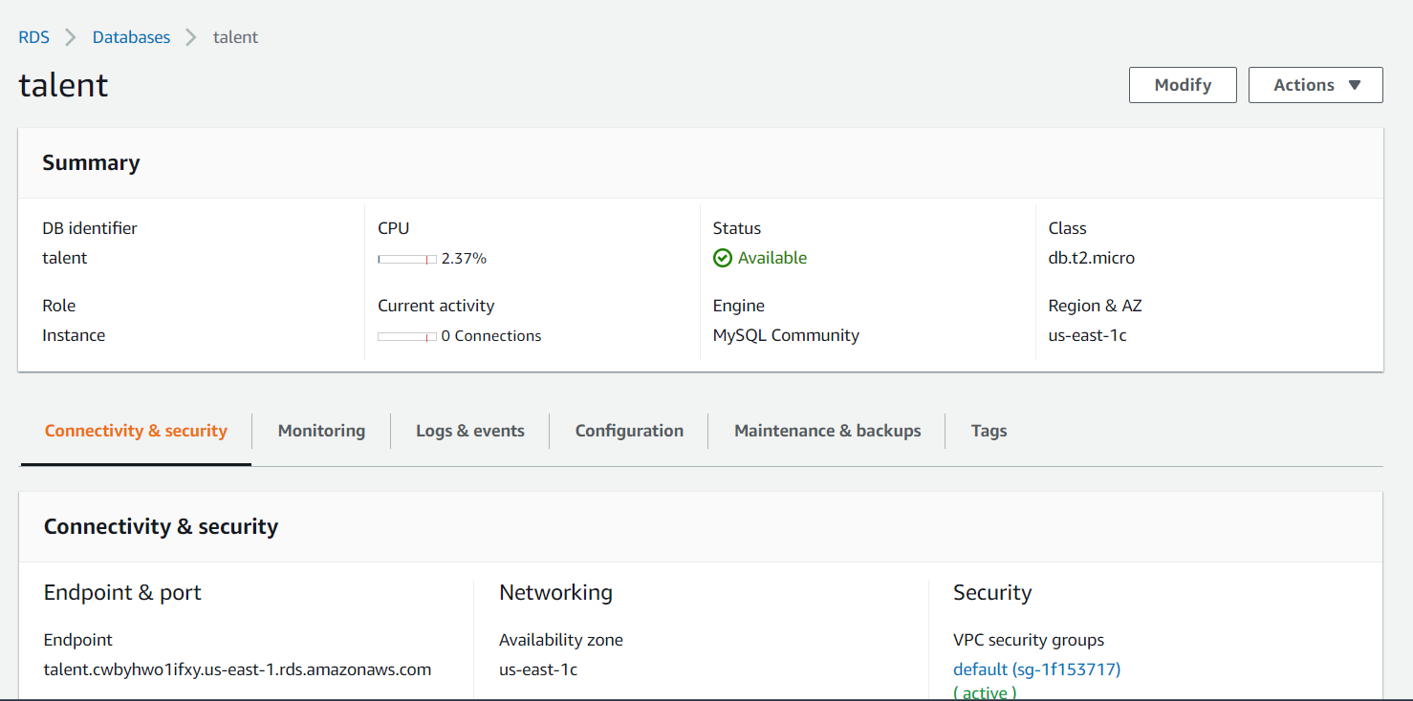

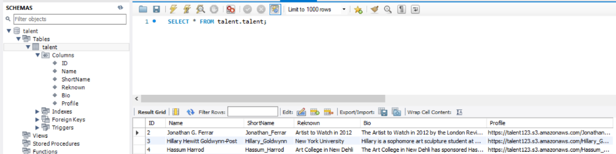

* 1. Amazon DynamoDB (No-SQL Database)

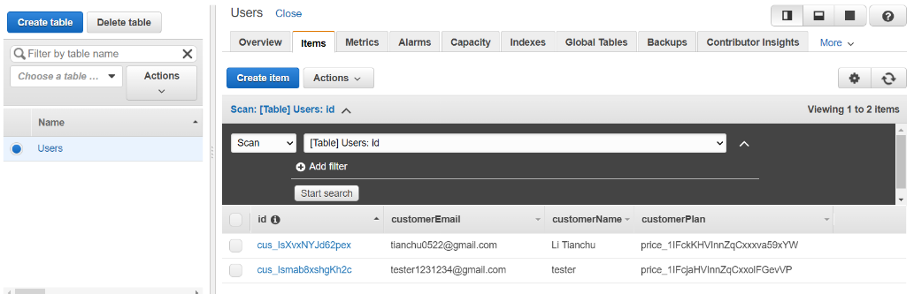

* 1. Amazon Redshift (Data Warehouse)
  2. Amazon Lambda (API Hosting)

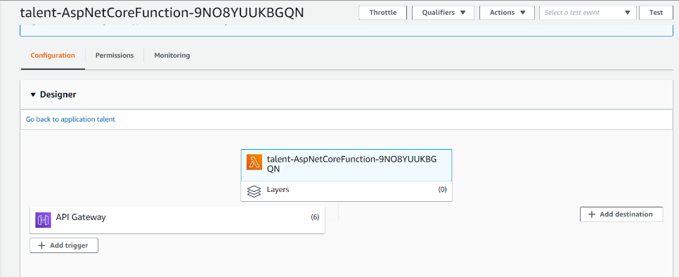

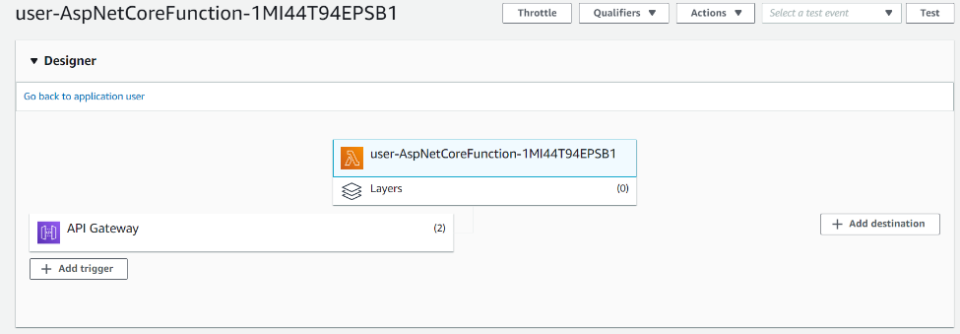

* 1. Amazon API Gateway & CloudWatch (API Management and Logging)

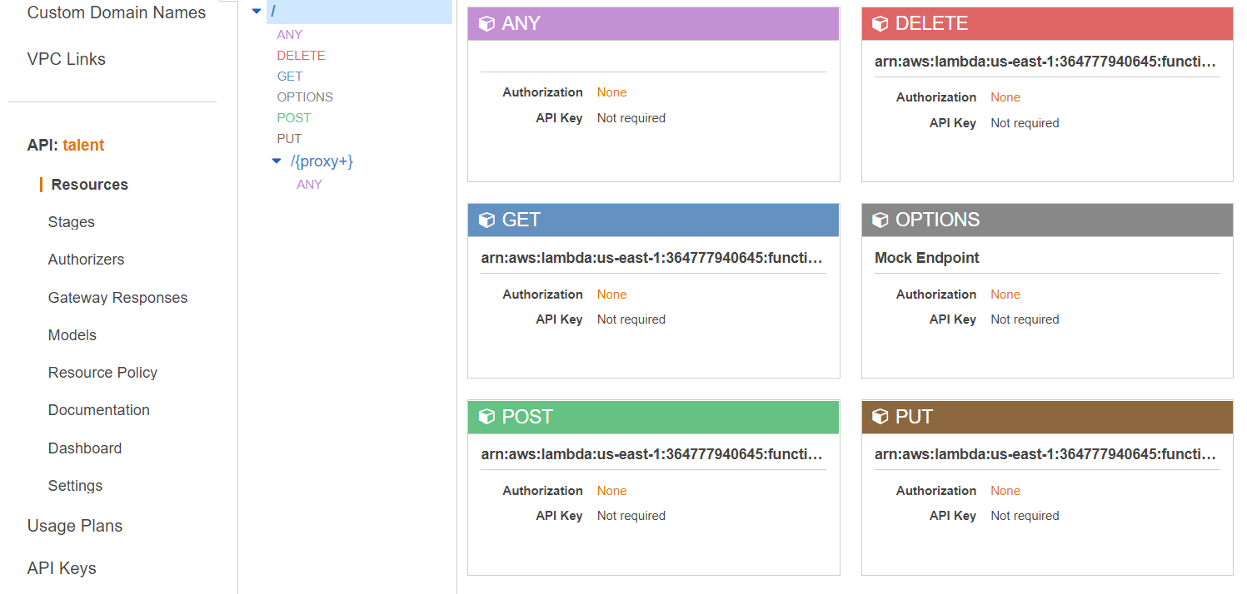

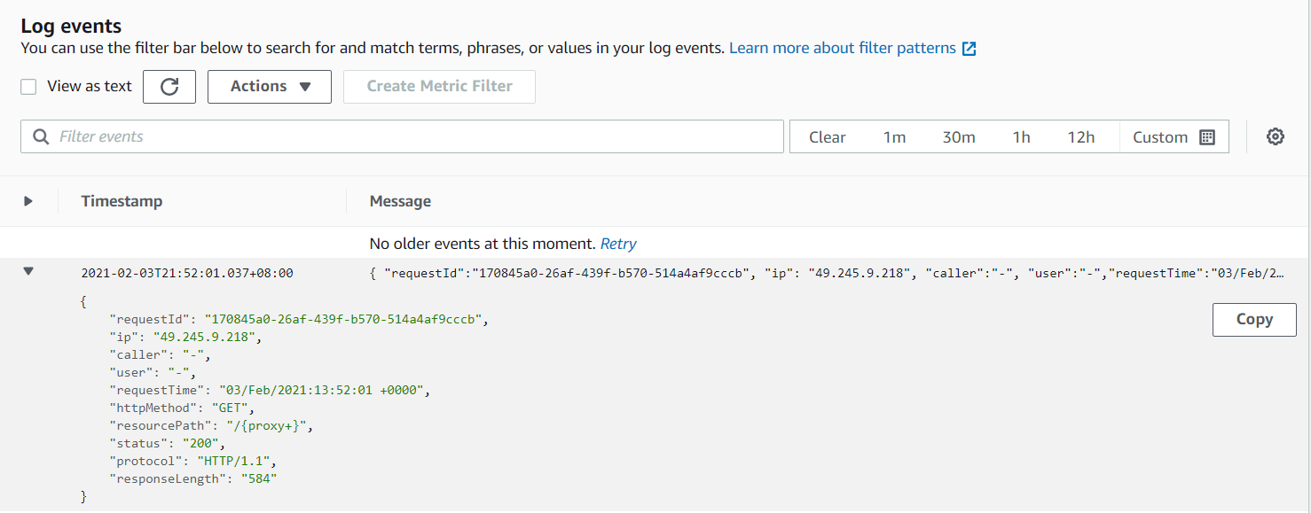

* 1. Clarifai (Image Recognition)
  2. Stripe (Payment Management)

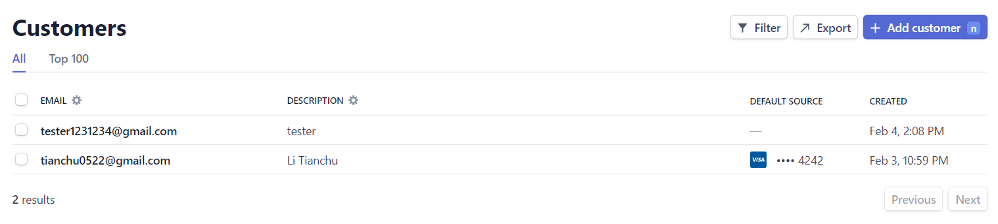

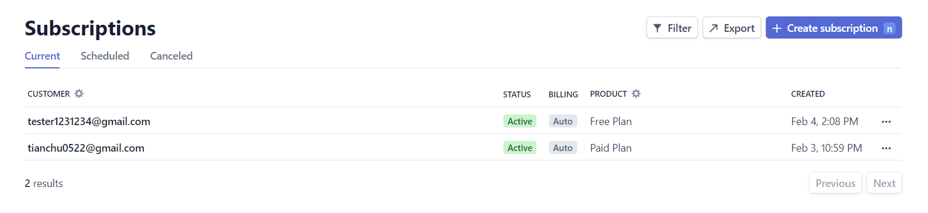

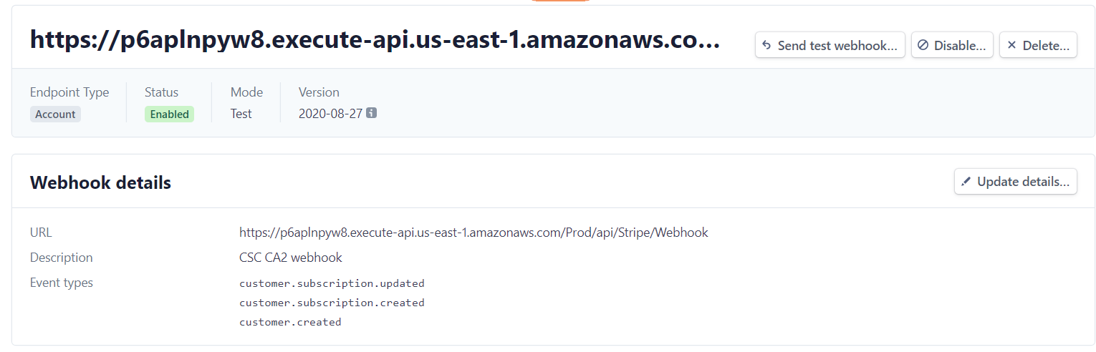

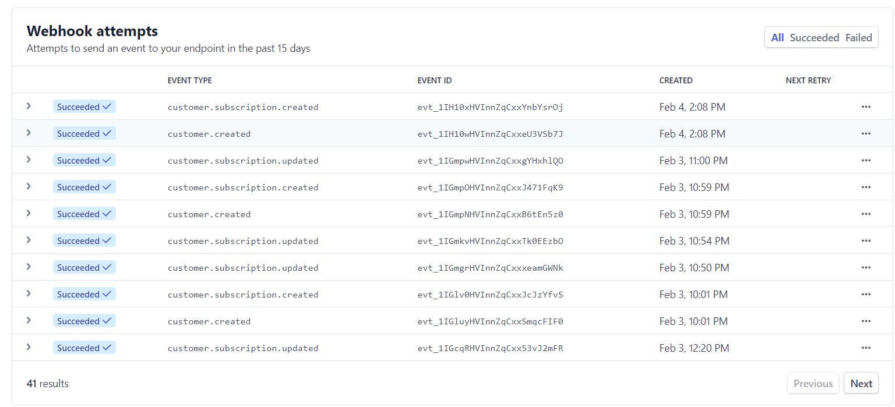

* 1. Disqus (Discussion Management)
  2. Recombee (Recommendation)

1. Cross Browser Testing
2. API Documentation
   1. GetAllTalent

|  |  |
| --- | --- |
| API | GetAllTalent |
| Endpoint | https://rcfl5otx2c.execute-api.us-east-1.amazonaws.com/Prod |
| URL | /api/Talent/GetAllTalent |
| Method | GET |
| Query Params | / |
| Body(Type:Json) | / |
| Success Status Code | 200 |
| Response Json Sample | [      {          "id": 2,          "name": "Jonathan G. Ferrar",          "shortName": "Jonathan_Ferrar",          "profile": "https://talent123.s3.amazonaws.com/Jonathan_Ferrar_tn.jpg",          "bio": "The Artist to Watch in 2012 by the London Review, Johnathan has already sold one of the highest priced-commissions paid to an art student, ever on record. The piece, entitled Gratitude Resort, a work in oil and mixed media, was sold for $750,000 and Jonathan donated all the proceeds to Art for Peace, an organization that provides college art scholarships for creative children in developing nations",          "reknown": "Artist to Watch in 2012"      },      {          "id": 3,          "name": "Hillary Hewitt Goldwynn-Post",          "shortName": "Hillary_Goldwynn",          "profile": "https://talent123.s3.amazonaws.com/Hillary_Goldwynn_tn.jpg",          "bio": "Hillary is a sophomore art sculpture student at New York University, and has already won all the major international prizes for new sculptors, including the Divinity Circle, the International Sculptor's Medal, and the Academy of Paris Award. Hillary's CAC exhibit features 25 abstract watercolor paintings that contain only water images including waves, deep sea, and river.",          "reknown": "New York University"      },  ] |
| Screen Shot |  |

* 1. GetTalentById

|  |  |
| --- | --- |
| API | GetTalentById |
| EndPoint | https://rcfl5otx2c.execute-api.us-east-1.amazonaws.com/Prod |
| URL | /api/Talent/GetTalentById/{id:int} |
| Method | GET |
| Query Params | / |
| Body(Type:Json) | / |
| Success Status Code | 200 |
| Response Json Sample | {      "id": 2,      "name": "Jonathan G. Ferrar",      "shortName": "Jonathan_Ferrar",      "profile": "https://talent123.s3.amazonaws.com/Jonathan_Ferrar_tn.jpg",      "bio": "The Artist to Watch in 2012 by the London Review, Johnathan has already sold one of the highest priced-commissions paid to an art student, ever on record. The piece, entitled Gratitude Resort, a work in oil and mixed media, was sold for $750,000 and Jonathan donated all the proceeds to Art for Peace, an organization that provides college art scholarships for creative children in developing nations",      "reknown": "Artist to Watch in 2012"  } |
| Screen Shot |  |

* 1. PostTalent

|  |  |
| --- | --- |
| API | PostTalent |
| EndPoint | https://rcfl5otx2c.execute-api.us-east-1.amazonaws.com/Prod |
| URL | /api/Talent/PostTalent |
| Method | POST |
| Query Params | / |
| Body(Type:Json) | {  “Name”: “Example Name”,  “ShortName”: “Example”,  “Reknown”:”Example Reknown”,  “Bio”:”Example Bio”,  “Profile”:”http://example.com/example.jpg”  } |
| Success Status Code | 200 |
| Response Json Sample | / |
| Screen Shot |  |

* 1. PutTalent

|  |  |
| --- | --- |
| API | PutTalent |
| EndPoint | https://rcfl5otx2c.execute-api.us-east-1.amazonaws.com/Prod |
| URL | /api/Talent/PutTalent/{id:int} |
| Method | PUT |
| Query Params | / |
| Body(Type:Json) | {  “Name”: “Updated Name”,  “ShortName”: “Updated”,  “Reknown”:” Updated Reknown”,  “Bio”:” Updated Bio”,  “Profile”:”http://example.com/updatedexample.jpg”  } |
| Success Status Code | 200 |
| Response Json Sample | / |
| Screen Shot |  |

* 1. DeleteTalent

|  |  |
| --- | --- |
| API | DeleteTalent |
| EndPoint | https://rcfl5otx2c.execute-api.us-east-1.amazonaws.com/Prod |
| URL | /api/Talent/DeleteTalent/{id:int} |
| Method | DELETE |
| Query Params | / |
| Body(Type:Json) | / |
| Success Status Code | 200 |
| Response Json Sample | / |
| Screen Shot |  |

* 1. GetUser

|  |  |
| --- | --- |
| API | GetUser |
| EndPoint | https://p6aplnpyw8.execute-api.us-east-1.amazonaws.com/Prod |
| URL | /api/DynamoDb/GetUser |
| Method | GET |
| Query Params | customerId : string |
| Body(Type:Json) | / |
| Success Status Code | 200 |
| Response Json Sample | {      "users": [          {              "id": "cus_IsXvxNYJd62pex",              "customerEmail": "tianchu0522@gmail.com",              "customerName": "Li Tianchu",              "plan": "price_1IFckKHVInnZqCxxxva59xYW"          }      ]  } |
| Screen Shot |  |

* 1. AddUser

|  |  |
| --- | --- |
| API | AddUser |
| EndPoint | https://p6aplnpyw8.execute-api.us-east-1.amazonaws.com/Prod |
| URL | /api/DynamoDb/AddUser |
| Method | POST |
| Query Params | customerId: string  email: string  name: string  plan: string |
| Body(Type:Json) | / |
| Success Status Code | 200 |
| Response Json Sample | / |
| Screen Shot |  |

* 1. UpdateUser

|  |  |
| --- | --- |
| API | UpdateUser |
| EndPoint | https://p6aplnpyw8.execute-api.us-east-1.amazonaws.com/Prod |
| URL | /api/DynamoDb/UpdateUser |
| Method | PUT |
| Query Params | customerId: string  plan: string |
| Body(Type:Json) | / |
| Success Status Code | 200 |
| Response Json Sample | {      "id": "cus_example",      "customerEmail": **null**,      "customerName": **null**,      "plan": "updatedPlan"  } |
| Screen Shot |  |

* 1. GetAllProducts

|  |  |
| --- | --- |
| API | GetAllProducts |
| EndPoint | http://thelifetimetalents-dev.us-east-1.elasticbeanstalk.com |
| URL | /stripe/GetAllProducts |
| Method | GET |
| Query Params | / |
| Body(Type:Json) | / |
| Success Status Code | 200 |
| Response Json Sample | {      "contentType": **null**,      "serializerSettings": **null**,      "statusCode": **null**,      "value": [          {              "id": "prod_IrLRYTKAywOcaJ",              "priceId": "price_1IFckKHVInnZqCxxxva59xYW",              "name": "Paid Plan",              "amount": 10          },          {              "id": "prod_IrLQrqavLCirBD",              "priceId": "price_1IFcjaHVInnZqCxxolFGevVP",              "name": "Free Plan",              "amount": 0          }      ]  } |
| Screen Shot |  |

* 1. GetSubscription

|  |  |
| --- | --- |
| API | GetSubscription |
| EndPoint | http://thelifetimetalents-dev.us-east-1.elasticbeanstalk.com/ |
| URL | /stripe/GetSubscription |
| Method | GET |
| Query Params | customerId : string |
| Body(Type:Json) | / |
| Success Status Code | 200 |
| Response Json Sample | {      "contentType": **null**,      "serializerSettings": **null**,      "statusCode": **null**,      "value": [          {              "id": "sub_IsXvzfDc6kQ0kH",              "prodId": "prod_IrLRYTKAywOcaJ",              "priceId": "price_1IFckKHVInnZqCxxxva59xYW"          }      ]  } |
| Screen Shot |  |

* 1. GetCustomer

|  |  |
| --- | --- |
| API | GetCustomer |
| EndPoint | http://thelifetimetalents-dev.us-east-1.elasticbeanstalk.com/ |
| URL | /stripe/GetCustomer |
| Method | GET |
| Query Params | email : string |
| Body(Type:Json) | / |
| Success Status Code | 200 |
| Response Json Sample | {      "contentType": **null**,      "serializerSettings": **null**,      "statusCode": **null**,      "value": [          {              "id": "cus_IsXvxNYJd62pex",              "name": "Li Tianchu",              "amount": 1000          }      ]  } |
| Screen Shot |  |

* 1. AddCustomer

|  |  |
| --- | --- |
| API | Add Customer |
| EndPoint | http://thelifetimetalents-dev.us-east-1.elasticbeanstalk.com/ |
| URL | /stripe/AddCustomer |
| Method | POST |
| Query Params | email:string  name:string |
| Body(Type:Json) | / |
| Success Status Code | 200 |
| Response Json Sample | / |
| Screen Shot |  |

1. System Diagram