Executable Error: Reference source not found

Integrated AI Chat bot in LMS

AI Budgerigar.

Table of Contents

1. Introduction 3
1.1 Purpose 3
1.2 Scope 4
1.3 Definitions, Acronyms and Abbreviations 4
1.4 References 4
1.5 Overview 4
2. Architectural Representation 5
3. Architectural Goals and Constraints 5
3.1 Technical Platform 6
3.2 Transaction 6
3.3 Security 6
3.4 Persistence 6
3.5 Reliability/Availability (failover) 6
3.6 Performance 7
3.7 Internationalization (i18n) 7
3.8 AI Integration and API Key Management 7
3.9 Scalability & Flexibility 7
4. Use-Case View 8
4.1 Student Use Cases 8
4.2 Administrators Use Cases 8
4.3 Use-Case Realizations 9
5. Logical View 9
5.1 Overview 9
5.2 Architecturally Significant Design Packages 11
6. Process View 14
7. Deployment View 15
8. Implementation View 15
8.1 Overview 15
8.2 Layers 15
9. Data View 16
10. Size and Performance 16
11. Quality 17

Introduction
The Canvas Intelligent Plugin aims to provide an integrated learning and teaching solution for students, teachers, and administrators. This plugin integrates artificial intelligence technology to help users manage courses more effectively, enhance learning outcomes, and optimize teaching processes.
As stated in the companion article, a RUP Software Architect will typically perform height major steps in order to define a global architecture, and each time an activity is completed, a specific section of the SAD is enriched accordingly.

Architectural activities | Software Architecture Document
Step 1 - Identify and prioritize significant Use-Cases | Section 4
Step 2 - Define the candidate architecture | Section 3, 5.1, 10, 11
Step 3 - Define the initial Deployment Model | Section 7
Step 4 - Identify key abstractions | Section 9
Step 5 - Create an Analysis Model | Section 5
Step 6 - Create the Design Model | Section 5
Step 7 - Document concurrency mechanisms | Section 6, 7
Step 8 - Create the Implementation Model | Section 8

Purpose
The Software Architecture Document (SAD) provides a comprehensive architectural overview of the Canvas Intelligent Plugin. It presents a number of different architectural views to depict different aspects of the system. It is intended to capture and convey the significant architectural decisions which have been made on the system.

In order to depict the software as accurately as possible, the structure of this document is based on the “4+1” model view of architecture [KRU41].

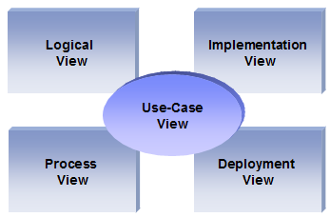
The “4+1” View Model allows various stakeholders to find what they need in the software architecture.

Scope
The scope of this SAD is to depict the architecture of the Canvas Intelligent Plugin.

Definitions, Acronyms and Abbreviations

RUP: Rational Unified Process
UML: Unified Modeling Language
SAD: Software Architecture Document

References

[KRU41]: The “4+1” view model of software architecture, Philippe Kruchten, November 1995, http://www3.software.ibm.com/ibmdl/pub/software/rational/web/whitepapers/2003/Pbk4p1.pdf

[RSA]: IBM Rational Software Architect
http://www-306.ibm.com/software/awdtools/architect/swarchitect/index.html

[RUP]: The IBM Rational Unified Process : http://www-306.ibm.com/software/awdtools/rup/index.html

[RUPRSA]: Developing a J2EE Architecture with Rational Software Architect using the Rational Unified Process®, IBM DeveloperWorks, Jean-Louis Maréchaux, Mars 2005, http://www-128.ibm.com/developerworks/rational/library/05/0816_Louis/

Overview

In order to fully document all the aspects of the architecture, the Software Architecture Document contains the following subsections.
Section 2: describes the use of each view
Section 3: describes the architectural constraints of the system
Section 4: describes the functional requirements with a significant impact on the architecture
Section 5: describes the most important use-case realization. Will contain the Analysis Model and the Design Model
Section 6: describes design’s concurrency aspects
Section 7: describes how the system will be deployed. Will contain the Deployment Model
Section 8: describes the layers and subsystems of the application
Section 9: describes any significant persistent element. Will contain the Data Model
Section 10: describes any performance issues and constraints
Section 11: describes any aspects related to the quality of service (QoS) attributes

Architectural Representation

This document details the architecture using the views defined in the “4+1” model [KRU41], but using the RUP naming convention. The views used to document the Canvas Intelligent Plugin are:

Logical view
Audience: Designers.
Area: Functional Requirements: describes the design's object model. Also describes the most important use-case realizations including student and administrator use cases.
Related Artifacts: Design model

Process view
Audience: Integrators.
Area: Non-functional requirements: describes the design's concurrency and synchronization aspects.
Related Artifacts: (no specific artifact).

Implementation view
Audience: Programmers.
Area: Software components: describes the layers and subsystems of the application.
Related Artifacts: Implementation model, components

Deployment view
Audience: Deployment managers.
Area: Topology: describes the mapping of the software onto the hardware and shows the system's distributed aspects.
Related Artifacts: Deployment model.

Use Case view
Audience: all the stakeholders of the system, including the end-users.
Area: describes the set of scenarios and/or use cases that represent some significant, central functionality of the system including student and administrator use cases.
Related Artifacts : Use-Case Model, Use-Case documents

Data view (optional)
Audience: Data specialists, Database administrators
Area: Persistence: describes the architecturally significant persistent elements in the data model.
Related Artifacts: Data model.

Architectural Goals and Constraints

This section outlines the software requirements and objectives that significantly impact the architecture of the LMS (Learning Management System) integrated with an AI chatbot. The architecture is designed to ensure scalability, reliability, security, and ease of integration with various AI tools.

Technical Platform

The LMS will be built using the Spring ecosystem, with Spring Boot serving as the core framework to facilitate rapid development and deployment. The application will be containerized using Docker and orchestrated using Kubernetes to ensure scalability and fault tolerance. The platform will leverage PostgreSQL for relational data storage and ElasticSearch for full-text search capabilities. The architecture will also consider the integration of AI services via RESTful APIs or gRPC.

Transaction

Given the transactional nature of the LMS, particularly in handling student assessments, submissions, and AI-driven interactions, Spring’s transaction management will be crucial. The system will utilize Spring’s declarative transaction management to ensure data consistency and integrity. In scenarios involving multiple microservices, a distributed transaction management solution such as Spring Cloud Sleuth or a Saga pattern will be employed to manage transactions across services.

Security

Security is paramount in an LMS, especially one handling sensitive educational data and user information. The architecture will incorporate Spring Security to address various security needs:

- Authentication & Authorization: Implemented through Spring Security with OAuth2.0 support, allowing role-based access controls (e.g., student, instructor, admin).
- Confidentiality & Data Integrity: All sensitive data (such as user information and payment details) will be encrypted using Spring Security’s cryptographic modules. End-to-end encryption will be enforced.
- Auditing & Non-repudiation: Logs of all critical actions (e.g., exam submissions, API key usage) will be maintained through Spring Boot Actuator and centralized logging systems like ELK Stack.

Persistence

Data persistence will be a flexible component of the architecture:

PostgreSQL or MySQL may be chosen as the relational database management system.
In cases where Spring Boot is used, Spring Data JPA will manage data access, whereas MyBatis will be employed in a traditional SSM setup.
ElasticSearch may be integrated for enhanced search capabilities, particularly for AI-driven functionalities.
Caching solutions like Redis or Hazelcast may be introduced to optimize data retrieval.

Reliability/Availability (failover)

The LMS requires high reliability and availability:

- High availability may be supported via Kubernetes orchestration, ensuring automatic failover and load balancing.
- Stateless services, where possible, will facilitate quick recovery and scaling.
- The system is designed for near-continuous availability, with provisions for maintenance during non-peak hours.

Performance

The system's performance, particularly in AI interactions and high user concurrency, will be a priority:

- Response Time: Key operations should complete within 1 second to maintain user experience.
- Concurrency: The architecture will support high concurrency, potentially leveraging Spring WebFlux for reactive programming in Spring Boot or optimized traditional handling in an SSM setup.
- Scalability: Horizontal scalability will be achieved through containerization and orchestration.

Internationalization (i18n)

The LMS must support multiple languages:

- Spring Boot’s internationalization capabilities (MessageSource) will be used, or equivalent setups in the SSM framework.
- The application will be designed to handle various locales, ensuring flexibility in AI responses and other content.

AI Integration and API Key Management

AI Model Deployment:

- Prebuilt Models: Initial deployment will utilize pre-trained transformer models, accessible through APIs like ollama.com or OpenAI.
- Fine-Tuning: Fine-tuning of models will be done on-premise using high-performance machines (e.g., MacBook with M1/M2 chips) or through cloud services like Vertex AI, which offers up to $300 in free credits.
- Data Augmentation & RAG: The architecture will support RAG (Retrieval-Augmented Generation) techniques by integrating PostgreSQL with PGVector for embedding vector storage, enhancing the AI’s contextual understanding of course materials. This will require vectorizing course materials and feeding them into the AI model for improved performance.
- Model Training Infrastructure: If more significant AI customizations are needed, the architecture will allow model training using platforms like LM Studio. The stack includes Milvue as an alternative for embedding and vectorization.

API Key Management:

Secure Management: API keys for accessing AI services will be securely managed using Spring Cloud Config with encryption or a dedicated secrets management tool like HashiCorp Vault. Rate limiting, monitoring, and usage analytics will be implemented using Spring Cloud Gateway.

AI Communication:
Routing and Traffic Management: The architecture will incorporate Spring Cloud Gateway or similar tools to manage the communication between the LMS and AI services, ensuring scalability and handling of traffic surges.

Scalability & Flexibility

The architecture will prioritize scalability, allowing horizontal scaling of both the AI components and the core LMS functionalities. Integration with Docker and Kubernetes will ensure containerization and orchestration for seamless deployments across environments.

Use-Case View

This section lists use cases or scenarios from the use-case model if they represent some significant, central functionality of the final system. Use cases are mainly divided into two types: those related to students and those related to administrators. This section will explain these two types of use cases separately.

Student Use Cases

Students will connect to the LMS system and open the AI Chatbox to access AI-related features, such as: ask questions to AI and receive quick answers (smart chat functionality), self-assess to understand their learning status and get system feedback (knowledge testing integration), search for courses, exercises, multilingual translations for personalized learning (learning resource provision). Then the AI Service will process these requests and provide output.

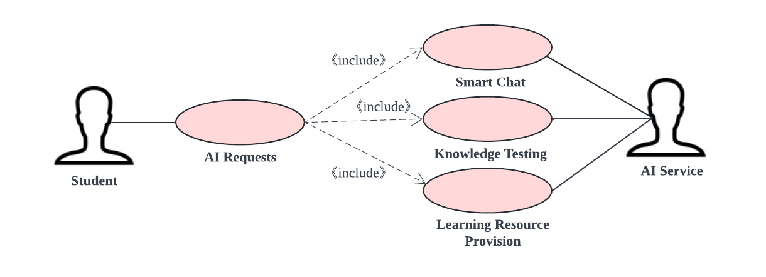

Administrators Use Cases

The administrator can connect to the LMS system, open the AI Chatbox for AI-related functions, such as: analyze system performance through AI reports (system performance monitoring), and then the AI Service will generate an AI report. At the same time, the administrator also can collect user behavior data to understand user preferences (user data tracking), and the data analyzer will process the student data and provide outputs.

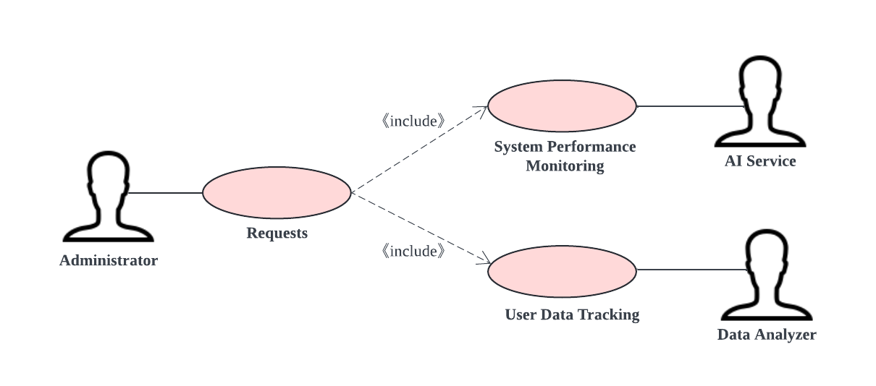

Use-Case Realizations

Refers to section 5.2 to see how design elements provide the functionalities identified in the significant use-cases.

Here are some Extending Use Cases:
- Student Use Cases:
- Error Handling:
Extension: If the AI fails to process a request or doesn't understand the query.
Extension Point: After "AI Requests" are made.
Trigger: AI service returns a response: "I can't understand your question".
- Alternative Learning Resources:
Extension: Suggest alternative resources when requested ones are unavailable.
Extension Point: After "Learning Resource Provision".
Trigger: No resources found matching the student's query.

- Administrator Use Cases:
- Audit Trail:
Extension: Generate an audit trail for user behavior and system performance metrics.
Extension Point: After "System Performance Monitoring" and "User Data Tracking".
Trigger: Upon completion of data analysis.
- Anomaly Detection:
Extension: Detect and alert anomalies in system performance or user behavior.
Extension Point: During "System Performance Monitoring" and "User Data Tracking".
Trigger: Detection of patterns that deviate from the norm.

Logical View

Overview

The LMS AI chatbot application is divided into layers based on the N-tier architecture.
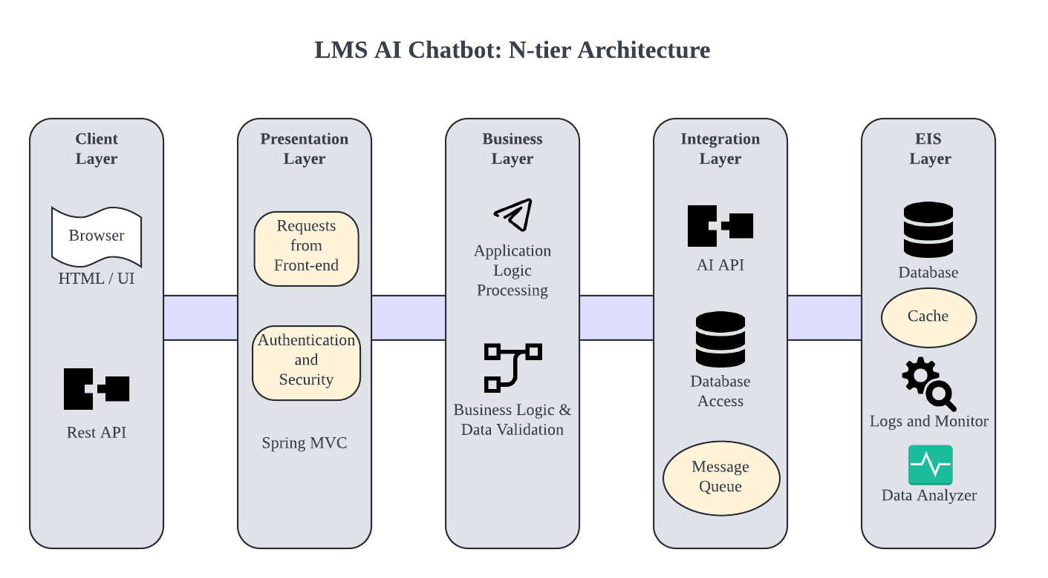

从这开始
The layering model of the online catering application is based on a responsibility layering strategy that associates each layer with a particular responsibility.
This strategy has been chosen because it isolates various system responsibilities from one another, so that it improves both system development and maintenance.

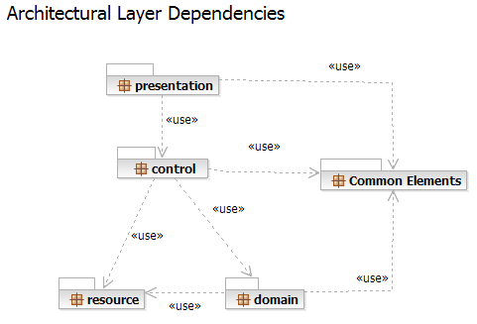

Each layer has specific responsibilities.
- The presentation layer deals with the presentation logic and the pages rendering
- The control layer manages the access to the domain layer
- The resource layer (integration layer) is responsible for the access to the enterprise information system (databases or other sources of information)
- The domain layer is related to the business logic and manages the accesses to the resource layer.
- The Common Elements layer gathers the common objects reused through all the layers

External services are reused for AI functionalities.

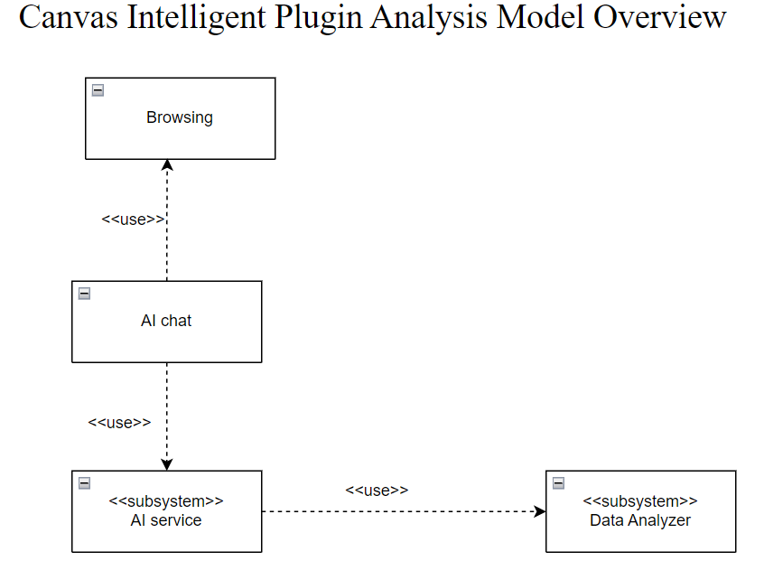

Architecturally Significant Design Packages

Student chat

This package is responsible for all the logic related to the student interaction. It provides AI features and the necessary components to access the external services.

Analysis Model

Participants:

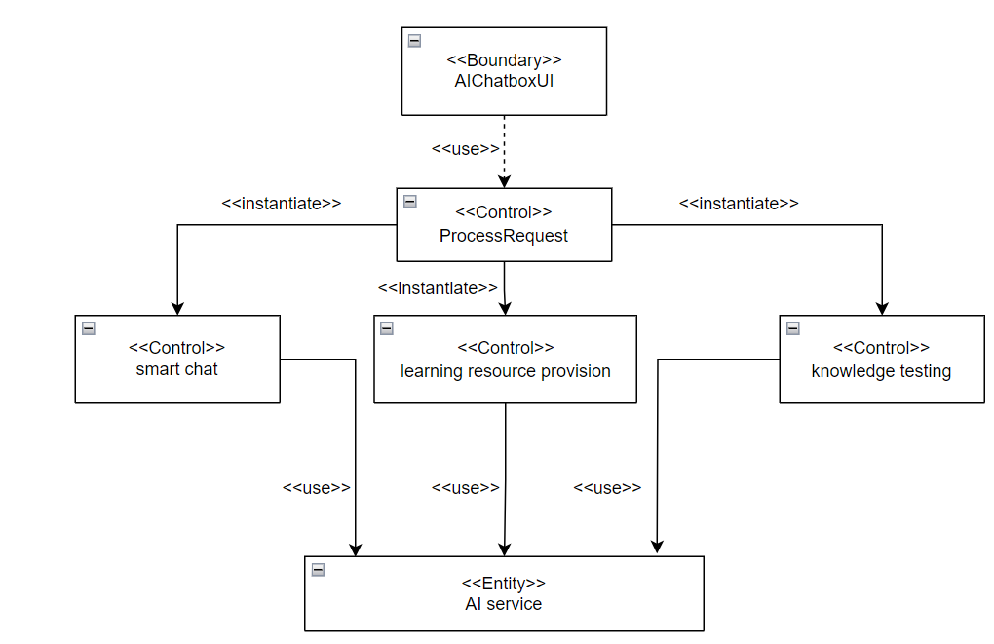

Basic Flow:

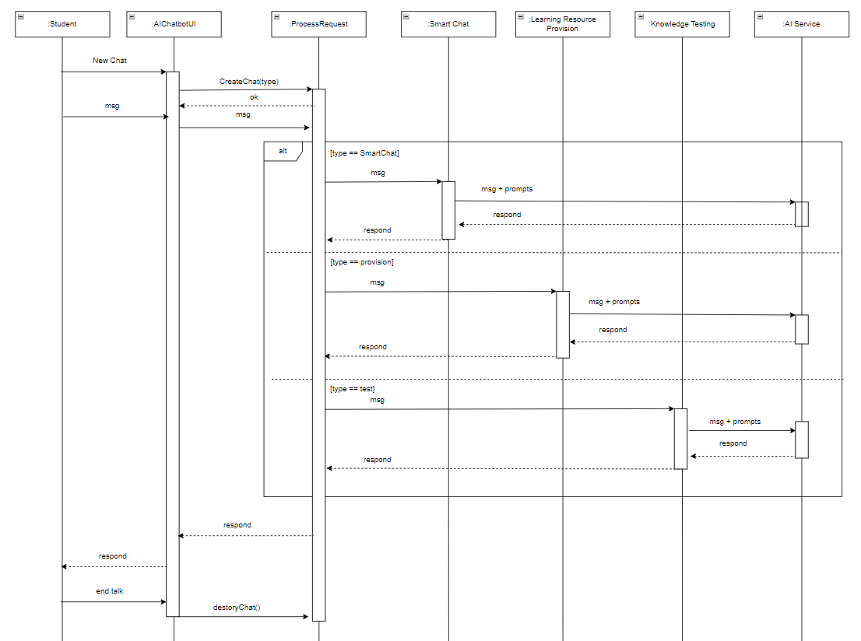

Design Model

Process Delivery

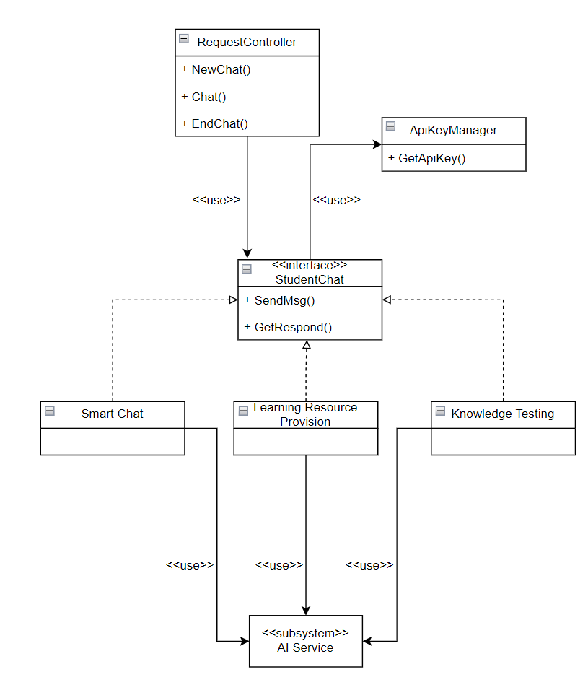

Process View

There’s only one process to take into account. The J2EE model automatically handles threads which are instances of this process.

到这结束

Deployment View

Global Overview
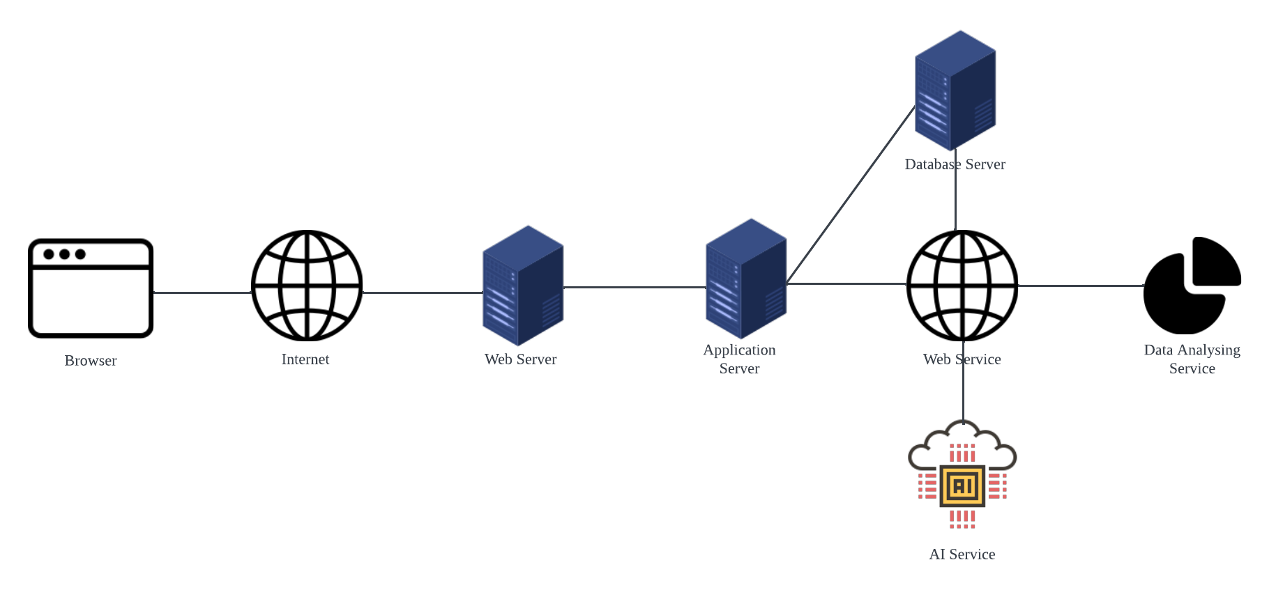

The above model will be deployed using Docker and Render.

Implementation View

Overview

The Implementation view describes the physical composition of the implementation, including Implementation Subsystems and Implementation Elements (directories and files, including source code, data, and executable files). Generally, the layers of the implementation view align with those defined in the logical view. This section briefly introduces the five Implementation layers and provides a concise executable architecture.

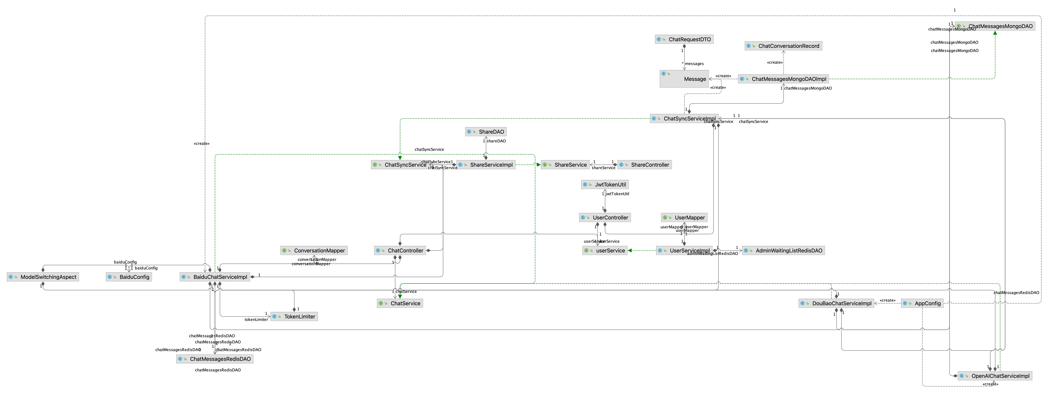

Layers

Presentation Layer
The Presentation layer includes everything necessary for user interactions, encompassing the graphical user interface (GUI).

Control Layer
The Control layer comprises all elements required to interact with the domain layer or, when suitable, directly with the resource layer.

Resource Layer
The Resource layer includes the components necessary to facilitate communication between the business tier and the information systems, such as databases and AI services.

Domain layer
The Domain layer encompasses all elements associated with business logic, incorporating all subsystems that address the requirements of a specific business domain. Additionally, it includes the business object model.
.

Common Elements Layer
The Common Element layer houses components that are utilized across multiple layers.

Data View
The key data elements related to the Canvas Intelligent Plugin are:

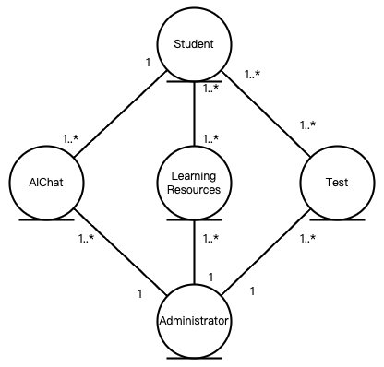

Size and Performance

Volumes:
- An average of 40000-45000 students actively interacting with the AI daily.
- Intensive data exchanges during peak hours, particularly when quizzes are conducted or when assignment deadlines approach.
Performance:
- Response time from the AI, including data retrieval and processing of natural language queries, should be under 5 seconds to ensure a smooth user experience.
- Quiz generation and feedback mechanisms must be efficient, capable of handling multiple simultaneous users without significant delays.

Quality
- Scalability: The system must handle increases in user interactions, especially during exam periods or assignment deadlines. Scalability will be achieved using cloud-based services that dynamically adjust resources.
- Reliability and Availability: Critical for continuous access, especially during peak usage. Implementations of redundancy, regular backups, and failover strategies will ensure high availability.
- Portability: The system should be adaptable to various educational environments with minimal modifications. Using standard web technologies ensures compatibility across platforms.
- Security: Secure authentication and authorization are crucial to protect student data and interaction logs. Standard security practices like HTTPS, data encryption, and regular security audits will be employed.

