Circuit Analysis
Laboratory Exercise No. 1
Resistor’s Color Code and Measurement

I. Introduction
The objectives of this laboratory are
i. to learn how to use the resistor color code to choose the correct resistors;
ii.; to learn how to use DM3058E Digital Multi-meter;
iii. to learn how to use GWINSTEK GPE-4323C DC Power Supply.
II. Resistor Color Code
The resistors you are using have five colored bands (some types have four or six bands). The first three bands indicate the three significant figures, which means the first band indicates the first number of the resistance; the second band indicates the second number of the resistance and the third band indicates the third number of the resistance. The forth band is the decimal multiplier —— in other words, it is the number of zeros after the first three numbers. The last band is the tolerance of the resistance, for example, gold, indicates that the resistor is accurate to ± 5%. Some manufactures used to paint another color band after the tolerance band indicating the reliability of the products, such a resistor is shown in Figure 1. In Table 1, the decimal point is replaced by the decimal multiplier—— instead of saying 2.2k, we write 2k2. This is because it is easy to 'lose' the decimal point- sometimes, on older power resistors, the value was written on with a paint which could literally drop off. Here is an example. The colored bands of a resistor are brown, black, red and gold. The first band, brown is a '1'. The second band, black, is a zero '0'. The third band, red, is a 2——this means that there are two zeros '00' after the first two numbers. So the value is 1000 ohms or 1 kilo ohms (1k). The last band means that the nominal 1k value could actually lie anywhere between 1k - 5% (950 ohms) and 1k + 5% (1,050 ohms). This is usually near enough to 1k for most applications.
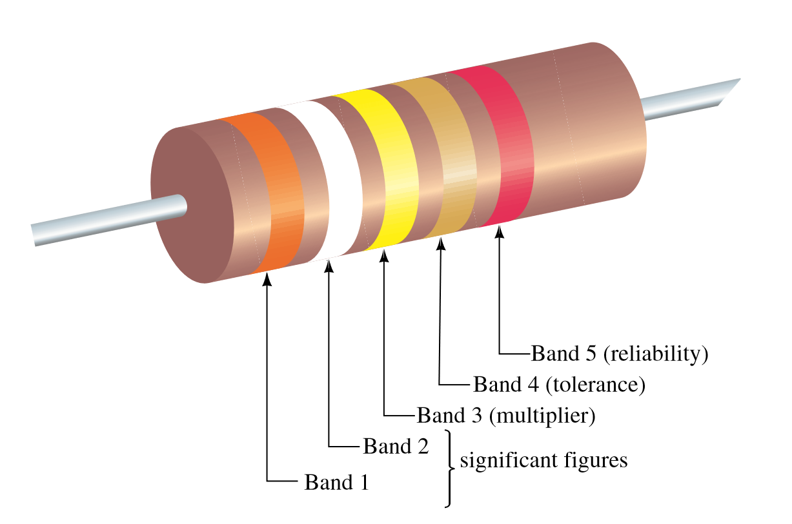
Figure 1. Resistor color code
III. DM3058E Digital Multi-meter
This instrument is used to measure voltage, current, and resistance. The measured value is displayed on a 5 ½ digit Liquid Crystal Display (LCD). The 3058E Digital Multi-meter (DMM) is controlled by a number of interlocked pushbuttons. Connections to the circuit being investigated are made via two of the four terminals. Measurement range can be selected in two ways: press the button Auto , DMM will choose the suitable range automatically; or press the button or to increase or decrease the range by hand which can get more accurate reading.
To measure a DC voltage, press the button 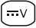 , and connect test leads as shown in the figure 1; red test lead to the Input-HI Terminal (positive point in the circuit being measured), and the black test lead to the Input-LO Terminal (negative point in the circuit).
To measure a AC voltage, press the button 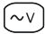 , and connect test leads as shown in the figure 2; red test lead to the Input-HI Terminal, and the black test lead to the Input-LO Terminal.
To measure a DC current, press the button , and connect test leads as shown in the figure 3; red test lead to the Input-I Terminal, and the black test lead to the Input-LO Terminal.
To measure a AC current, press the button , and connect test leads as shown in the figure 4; red test lead to the Input-I Terminal, and the black test lead to the Input-LO Terminal.

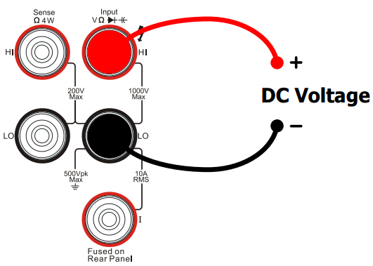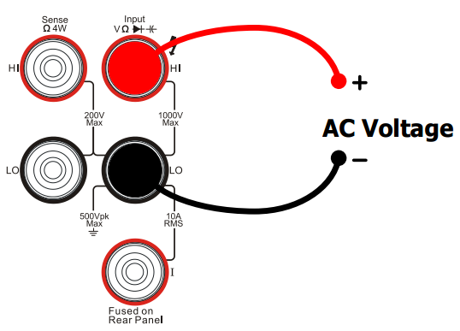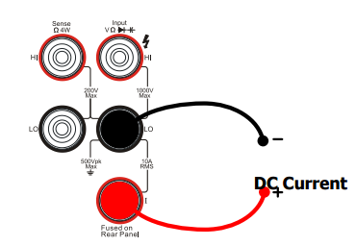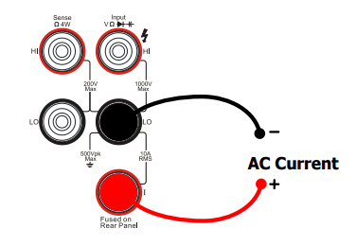
Fig. 1. DC Voltage Measurement Fig. 2. AC Voltage Measurement Fig. 3. DC Current Measurement Fig. 4. AC Current Measurement

To measure a 2-wire Resistance, press the button 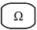 , and connect test leads as shown in the figure 5; red test lead to the Input-HI Terminal, and the black test lead to the Input-LO Terminal.
To measure a 4-wire Resistance, press the button  , and connect test leads as shown in the figure 6; red test lead to the Input-HI Terminal, and the black test lead to the Input-LO Terminal.
To measure a Capacitance, press the button 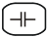 , and connect test leads as shown in the figure 7; red test lead to the Input-HI Terminal, and the black test lead to the Input-LO Terminal.
To test Continuity, press the button  , and connect test leads as shown in the figure 8; red test lead to the Input-HI Terminal, and the black test lead to the Input-LO Terminal.
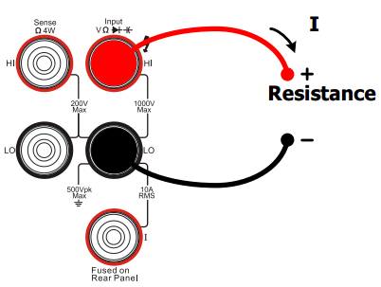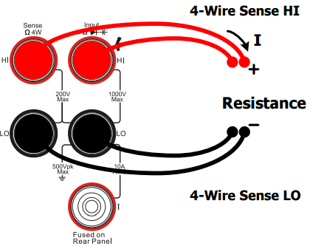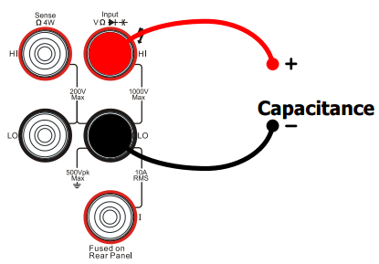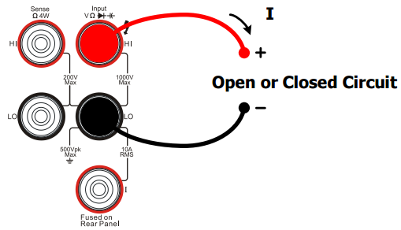
Fig. 5. Resistance Measurement Fig. 6. Resisitance Measurement Fig. 7.Capacitance Measurement Fig. 8. Continuity Testing
To test a Diode, press the button  , and connect test leads as shown in the figure 9; red test lead to the Input-HI Terminal, and the black test lead to the Input-LO Terminal.
To measure Frequency/Period, press the button  for frequency measurement ,one more push for period measurement, and connect test leads as shown in the figure 10; red test lead to the Input-HI Terminal, and the black test lead to the Input-LO Terminal.
To measure a Sensor, press the button  , and for Voltage, Resistance, Thermocouple and Frequency Sensor, connect test leads as shown in the figure 11; red test lead to the Input-HI Terminal, and the black test lead to the Input-LO Terminal. For Current Sensor, connect test leads as shown in the figure 12; red test lead to the Input-I Terminal, and the black test lead to the Input-LO Terminal.
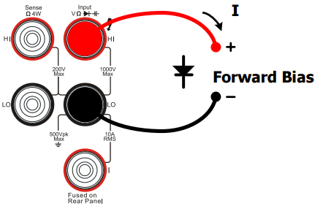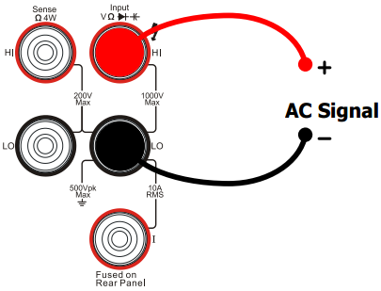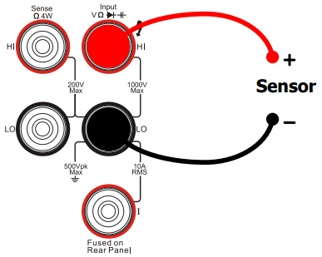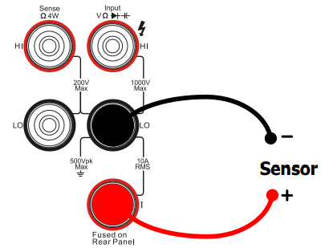
Fig. 9. Diode Testing Fig. 10. Frequency/Period Measurement Fig. 11. Sensor Measurement Fig. 12. Current Sensor Measurement
When a current of up to 1 amp is to be measured the DMM must be connected in series with the circuit being measured so that the current flowing through the circuit flows through the DMM. To do this the circuit must be broken and the DMM inserted across the break, the left hand Red terminal being connected to the more positive point in the circuit, and the Black terminal to the more negative. If the current were to flow in the opposite direction, then the minus sign would be displayed. When the resistance of a circuit is to be measured, care must be taken to ensure that there are no parallel paths around the component being measured. The DMM is switched on or off using the Green pushbutton.
♦ We will now use the DMM to measure the resistance of the resisters. Switch the DMM on by pressing the Green pushbutton in.
Lab Section 1
a) Take out all resistors from the small plastic bag for this exercise. Using the resistor color code chart from your Component Data Lab Sheet or the chart you search on internet.
b) Select resistors with the following resistance values: R1: 2k2 2,200; R2: 47k 47,000; R3: 220k 220,000; R4: 100R 100; R5: 1M 1,000,000.
Use multi-meter to measure the resistance of R1 – R5 and fill in Table 1.

Table 1
Resisitors | Value in Kilohms  /Megohms | Value in Ohms | Color codes | Measured value | Tolerance  %
R1 | 2k2 | 2,200
R2 | 47k | 47,000
R3 | 220k | 220,000
R4 | 100R | 100
R5 | 1M | 1,000,000
R_{totle} | … |  | …

c) When you have sorted out the resistors you need, use the long-nosed pliers to bend the wire 'legs' of the resistors at right angles so the wires will go through the correct holes in the board.

Figure 1: Circuit Diagram of the resistors
d) Measure the equivalent resistance of the five resistors (i.e., total resistance)
f) Compute the equivalent resistance of the five resistors (i.e., total resistance)
g) Compare the computed total resistance with the total resistance measured experimentally.
IV. GWINSTEK GPE-4323C DC Power Supply.
Most electronic circuits need a power source. In portable equipment this power may be supplied from a battery. A mobile phone is usually powered from a battery which can be recharged, whereas a television remote controller derives its power from non-rechargeable cells.
The GPE Power Supply can provide four separate power sources. Two of these can be set independently to supply the voltage from 0 to 32 volts dc with the current limit from 0 to 3 A, the third power can be set to supply the voltage from 0 to 5 volts dc with 1 A current limit, and the fourth power can be set to supply the voltage from 0 to 15 volts dc with 1 A current limit.

The supply is switched on (I) or off (0) by the pushbutton switch at the bottom left hand side of the front panel marked POWER. The four variable power supply outputs can be switched on or off using the small green pushbutton located above CH3 on the right hand side marked On/Off. When the output is on, the button light will be light (yellow), and at the bottom of the screen, it shows ON, otherwise it shows OFF. The terminals are marked ‘+’ and ‘-’. The color Red is coded for positive and Black for negative. The Green terminal located at the bottom middle of the panel is connected to the Mains Earth (Note, it’s not the ‘0’ potential reference (or Ground). Don’t connect it to the Ground in your circuit.) As CH1 and CH2 outputs are fully floating they can be connected in series (connected inside, the small black pushbuttons between the first row of rotary controls are in the positions of left button-out and right button-in) to produce a double voltage of CH1, or in parallel (both of the small black pushbuttons are in the positions of button-in) to provide a double current of CH1. Any (single) terminal can be connected to the Ground.
Above the row of terminals, you will see three rows of six rotary controls. The first two on the left hand side are used to set the voltage output value and the current limit for CH1. The two controls on the right hand side are used to control CH2 variable supply. The third control on the left hand side is used to set the voltage for CH4, and the third control on the right hand side is used to set the voltage for CH3. Channel switches are controlled by the two small black pushbuttons marked CH1/CH4 and CH2/CH3, respectively, located between the second row of rotary controls.
To use this power supply, you have to set the variables first and then output the power.
- Make sure the output pushbutton (marked On/Off) is in off position (pushbutton out). The displays (on screen) across the left top of the instrument now indicate the voltage value and the current limit you are setting. Use the knob marked Voltage to set the voltage to an exact value you want. Use the knob marked Current to set the current limit before the circuit is connected.
- Push the output pushbutton in, the power will output to the terminals you set just now. The displays show now the voltage at the terminals and the current flowing through the circuit.
NOTE: If the current that the circuit tries to draw from the power supply is higher than the value set by the current limit, the power supply will automatically switch to a constant current mode and adjust its output voltage to maintain the current at the preset level. When the power supply is in the constant current mode the displays will show CC on the corresponding CH, otherwise it will show CV— constant voltage mode.
You can also see a small black button beside the green one marked Set View and Lock. Push the button in and you can review the value of voltage and current you have set for corresponding channel. Push the button for more than 2 seconds, the set voltage will be locked in case the power supply be changed by mistaken touch of the controls. Push the button for more than 2 seconds again, the set voltage will be unlocked.
Lab Section 2
- We will now set up the power supply to the following specification.
CH1 output voltage = 12 V dc. CH1 current limit = 1 A dc.
CH2 output voltage = 8 V dc. CH2 current limit = 0.2 A dc.
CH3 output voltage = 5 V dc.
CH4 output voltage = 6 V dc.
CH1 +CH2 output voltage = 20 V dc, CH1 current limit = 1 A dc.
CH1 in series mode output voltage = 24 V dc, CH1 current limit = 1 A dc.
Before the Mains Power switch is turned on, ensure that the output pushbutton is in the off position (out), and rotate the two CURRENT knobs fully clockwise. (This sets the current limit to maximum).
Turn the Mains Power switch on (I), and adjust CH1 output voltage to 12 V. Set the current limit to 1 A. Similarly, set CH2 output to 8 V, and use the CURRENT knob to set the maximum current to 0.2 A. Switch to CH3 and CH4 and set 5 V and 6 V, respectively. 20 V can be achieved by connecting CH1+ to CH2−, and 24 V by setting series button.
Note that all four outputs are floating, that is to say that they are not connected to Earth. Each output could be envisaged as a separate "battery", one giving 12 volts, one 8 volts, one 5 volts and one 6 volts.
When you set each of the above voltages, use voltmeter to measure each voltage and fill the results in Table2.
- Apply 12V to the circuit shown in Figure 1 and measure the voltages and currents shown in Figure 2. How the results agree with KCL and KVL?
Figure 2: Circuit Diagram of the measurement
Table 2
Voltage set | Voltage measurement | Current  measurement | KCL  Conclusion | KVL  Conclusion
12V |  | A
8V |  | A₁
5V |  | A₂
6V
20V
24V
V₁
V₂

V. Report Submission
You need to complete the tasks required in this lab section and fill in the forms according to Table 1 and Table 2. Take a picture of your combination of resistors on the breadboard according to Figure1. Then attach the picture to your paper.

