Report: Security and Relation-forming in Multi-Agent System

LiXizhi
The CKC honored school of Zhejiang University
email: LiXizhi@zju.edu.cn

Chair of the Supervisory Committee:
Professor He Qinming
Department of Computer Science, Zhejiang University

Abstract:
This article reports on a MAS related project which is registered and partially sponsored in Zhejiang University. The project aims to develop a solution for safe communication and automated relation-forming among all intelligent objects in an ubiquitous computing environment. Security and relationship forming are intertwined issues which calls for both a smart design of communication interface and an accurate and comprehensive logic of knowledge presentation and processing. The first part of the article reports on Web Agent Framework (or WAF), which is a MAS system developed by us and was included in the initial schedule of the current project as a testing environment. The second part of the article reports on the ongoing work that the author is currently undertaking. In it, all relevant information of concurrent research and research emphasis world wide is discussed. The objectives towards an innovative framework of security and relation-forming in MAS are listed, with functional descriptions followed. As a continuation of this MAS project, the author is currently working on the Parallel Oriented Language (POL), which will be another method of approaching roughly the same problem. A discussion of this new language is included in the Conclusion section.

Key words: MAS, ubiquitous computing, POL.

Introduction
In the ubiquitous computing environment, intelligent objects are generally implemented as structured society of agents that may be embedded in stationary or mobile devices. They needs to safely communicate with each other and serve people they are assigned to. Automaticity is achieved by allowing those agents to automatically establish various kinds of relationships with other foreign agents in its physical vicinity or on the network. By doing so, we can distribute controls of all those objects to individual agent, so that they can learn from the behavior of their human master and work together. The key problem here is two intertwined issues namely security and relation-forming.

We already have many good authentification patterns in computer network security from serious ones (like public key infrastructure or PKI) to casual ones (like symmetric key infrastructure). Each of them gives a different level of security. However, the most secured one isn’t always the best choice. When applying them, we need to draw a careful compromise between risks and flexibility, rigidity and simplicity. So designing a new algorithm of security is not the goal in resolving critical information and behavior protection in Multi-Agent System, rather the goal is how those existing patterns could be automatically tailored and used in the unique way that intelligent agents interact.

Intelligent agents are designed to server only people they are told to. And if multiple agents share controls or forms a hierarchical society, they need to be sure that such restrictions are not violated. Relation-forming in multi-agent systems deals with all kinds of relationships among agents, while ensuring that they are offering services to authorized people and that the flow of information (speech between agents) are in a safe environment (not easily eavesdropped or decrypted).

We aim to develop a solution for safe communication and automated relation-forming among all intelligent objects in an ubiquitous computing environment. It calls for both a smart design of communication interface and an accurate and comprehensive logic of knowledge presentation and processing. The first part of the article reports on Web Agent Framework (or WAF), which is a MAS system developed by us and was included in the initial schedule of the current project as a testing environment. The second part of the article reports on the ongoing work that the author is currently undertaking. In it, all relevant information of concurrent research and research emphasis world wide is discussed. The objectives towards an innovative framework of security and relation-forming in MAS are listed, with functional descriptions followed.

Part 1: Web agent framework
This sub-project was planned by me as early as March, 2003 and was finished in release 1.0 in September 1st, 2003. Some successive update versions are developed in September, October until the current version 1.2. The other people who are in my developing team are named in the acknowledgement section.

Introduction

WAF or Web Agent Framework can generally be regarded as a personal information publishing tool. However, it’s built upon multi-agent system(MAS) architecture and is initially designed to run in a ubiquitous computing environment that we are approaching. Although some of those objectives are modified in its development phase, it yet evolves to encompass a much wider range of functionality than common information publishing tools. For example, it offers the ability to establish relationships between different publishing nodes (creating a virtual map of human-relationships on the web), rich client tools for submitting and downloading messages published by other people, and an agent interface for other possibilities of utilizing the new framework… In many ways, WAF reflects a form of interactive environment between human and machines where intelligent computing networks are ubiquitous in the near future.

origin and background
The project of WAF originates from a very common necessity: building a new personal website that includes all my legacy files on the network(e.g. my old websites, articles, messages, FTP, email, etc) and that I can easily publish new artifacts and granting them granulated access right so that only authorized individuals could read them. To sum up, it’s about managing a private network for a certain individual(master). This kind of network will become increasingly common in the near future and will gradually include more interactive, randomly accessible devices, such as mobile or embedded electronics at home or in office, etc.

From the above deliberation, we propose the idea of employing one or more intelligent agents to maintain each private network. Once such personal information agent is established, it not only meets all the above requirements, but also elicits another possibility, that is to establish relationships between those agents. Such kind of relationships are appointed by the human being who is the master of the agent. So the final agent network will most likely reflect human relationships or utility relationships in the real world. To visualize and utilize this intelligent network, we can further design client software on mobile devices or PCs that could visit and download those relationships, or even reorganize them on the user’s computer.

Before this, popular web publishing tools such as web log(blog)[1] generally use a combination of active server page, HTML redirection, embedded scripts, email and FTP. Only limited functions like search and redirect are available on host servers; Few client tools, excluding general purpose ones like those for FTP and emails, are available, yet they only provide a limited extension of the functions exposed by the server.

Using the concept of agent to build the framework is no coincident. New applications of agent technology in information age is burgeoning with more and more realistic prospective. So it’s sometimes easy to equate WAF with other old tools some of which also begin to embrace agent technology, such as Google, WebLog(blog), ICQ, UDDI, human resource tools, etc. However, WAF differs from them with a different objective. WAF tries to depict the main form of highly interactive environment among ubiquitous intelligent networks in the not-so-far future. It does not exist to replace web hyperlinks, nor does it overlap with key words search engine provided by Google; Instead, WAF proposes a new way of communication and interaction between human and networks that is more suitable for networked intelligent devices.

Web Agent Framework
WAF, currently in its release 1.1, is a personal information publishing tool that have realized the above functionalities. The tool suite includes two packages: web agent server and client agent software.

The web agent server is responsible for the logics of web agent. Each sever can accommodate one or more web agents which may be used to maintain information for one or several users(masters). Its interface includes a set of web pages where users can hire new agent to serve them, and a set of web methods among which the most important is Speech(). It provides the means for all web agents in the network (including client agents) to communicate with one another. The user could choose to install its own web agent server, or register on a trusted web agent server on the network (See Fig 2.1).
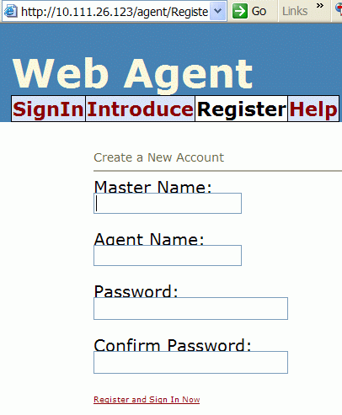
Fig 2.1 Register a new web agent [from WAF Release1.1]

After registering on any WAF web server, you are given a master account and a string like this one http://www.waf.org/agent/agent.asmx?user=Mike[12], this URL address identifies your agent on the web.

The client agent software is installed on each user’s PC and is used to visit, download and organize the agent network. The current client (clientAgent) can communicate with those web agents and request agent relationships all of which can be displayed in a tree graph and stored in a 2-D map(see Fig 2.2).
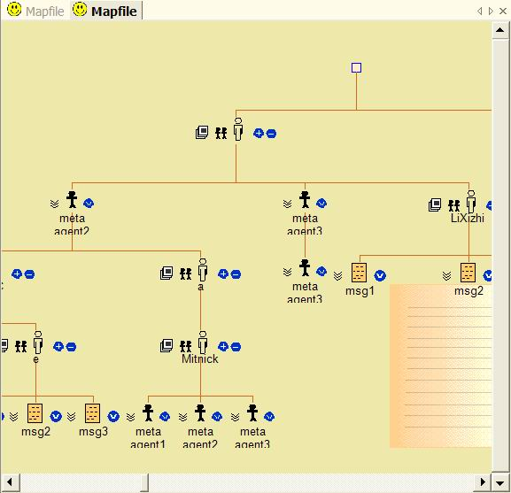
Fig 2.2 Agent relationships in a 2-D map [from WAF Release1.1]

WAF needs to have a large user group to have all its potential capabilities exploited. Meanwhile, it’s the kind of application that will most hopefully bring large group of users to the vicinity of agent-based software applications. Its design not only caters to concurrent applications of intelligent agent in mobile and embedded devices, but also could easily adopt most standards and techniques developed for agent development in recent years, such as the standard for agent communication language[7], model of distributed trust management[2] used in agent systems. Other independent projects based on agent technology such as those found in E-learning and E-business, will also benefit from an enlarged user group of agent-based software.

Application Scenarios
Now let’s take a look at some real world application scenarios. All the 2D-map files for those examples can be found in the Tutorial files of our current release R1.1 and be viewed in the off-line mode.

Scenario 1: Campus Network
Briefing: This scenario illustrates how you can request information from agents in the network.
[A election from the Tutorial of WAF R1.1]

Suppose you are a student in Zhejiang university. Let’s now try making a piece of synthesized campus newspaper in your mapview using drag and drop functionality. It shall contains a piece of news in your college, separate homework information from the teacher in your school, and a list of newly uploaded movies in your campus FTP. After creating this map file, you can have your client application to collect those information from each of its agent provider on the web when you load this map file next time (possibly every morning).

For simplicity, let’s imagine there are so many people in the agent framework in your campus network that each of your teacher has an agent, your college provides an agent that offers college news and one schoolmate provide information about new movies on his agent.
Now all you have to do is to drag those news from their provider agent into one map view and save to disk(see Fig 3.1). Next time you open the map file, messages will be fetched from their providers.
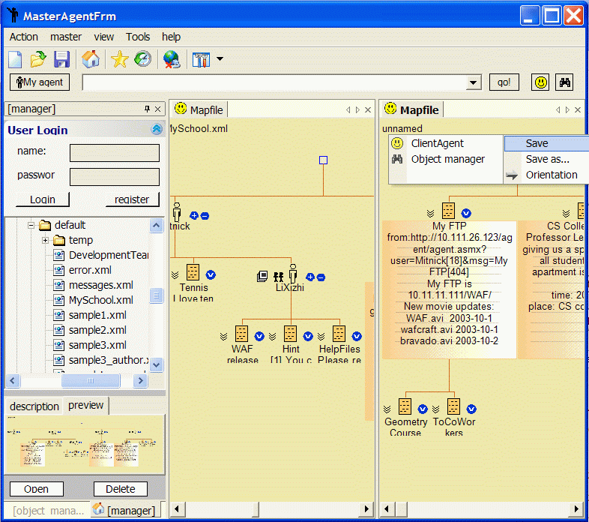
Fig 3.1 Make a synthesized newspaper from different agents.

Scenario 2: Personal Information Management for University Teachers
[A selection from the WAF’s document- Introduction to Potential Users.doc]
Nowadays, professors use the internet/intranet to publish information for himself and for his students (including potential ones). A student may need to get assignment online from all his teachers daily. Another student may be browsing the web to find professors that share the same interest as his.
One autonomous approach is that the professors build their different websites separately.
Another approach is that someone stands out to build a comprehensive campus website with index/search pages for visitors and customizable pages for all registered teachers.
Both of them have their advantages and disadvantages. Even the combination is not the ideal solution. Now with web agent, the problem is solved, providing even more functions than what has been realized in both models. We start by adopting the first approach where the professors are willing to build their personalized website. Next, we advise them to register an agent and include a link to it in his current website and set it to oversee the website for its master (the professor). Agent will maintain relationship with other agents that may possibly represent other professors, a department of the school or even other related people inside or outside the university. Besides, the agent exposes web services that enable anyone with slight knowledge of web programming to build personalized client application or, with a database manager, to build centralized searchable database out of it. A developed client agent-browser and a filter can help common visitors browse through the agent network in a graphical manner. A visitor may jump from one agent to another in a 2D-map which continuously keeps track of the path as the user visit each agent. Once he is interested in a certain agent, he can immediately jump to its master’s website to know more about it.

WAF architecture
The WAF program is to populate the agent society on the web with this specially-designed agent for civilian info-management and service providing. It simulates relationships between real human beings. The relationship could be browsed in a tree-like manner graphically, which is the exploratory way of accessing the agent network.

Speeches between different agents are through an XML based agent communication language(and .Net Web method is used as the transferring mechanism). For information protection, we have designed a simplified version of Public Key Infrastructure and a key-based trust distribution mechanism. However, in current release, we only distinguish between full access and read only access.

Since this article is only an introduction to WAF, we will not cover in depth the underlying architecture. For more information, please refer to the WAF Reference section.

Design
Fig 4.1 shows the deployment view of the web agent framework.
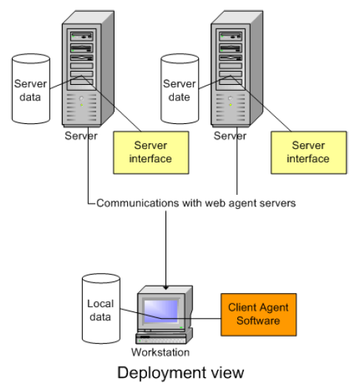
Fig 4.1 Deployment view

Server part:
Information for each agent are stored on the web servers which can also be in a distributed manner. Each web server can host one or many agents. The server by defaults provide a basic web page for each agent. So there are two items on the server that are provided to the user. First is the agent stored in the database, second is a webpage which load and display the agent information. The user may have other resources such as personal websites and emails on the internet elsewhere, they don’t need to be on the agent server, however the agent uses hyperlinks to save their addresses, descriptions, or even functions. The registration process on the server page is such a process of creating a blank agent on the server. When you create an agent, you must also specify the master who owns the agent. Note that you can use the same master account to create multiple agents on the same server. Each agent is given a unique address which can be understood and used by Client Agent to find it on the web.
Speech (web method on the server) is used as the communication means for client agent to get/sent messages with the web agent.
Client part:
The client agent is actually a client program that help the users to access the networks of agents on the web (possibly on thousands of servers worldwide). A typical scenario is that the user enter the address of an agent he attains possibly by browsing other people’s website or by accessing other agents. If the address is valid, the agent’s brief information will be downloaded from the web to the client and displayed as an node in the map view. You can then click on the node to access various information and functionalities provided by that agent, such as what kinds of friends it has, what kinds of messages it provides, does it has any other websites that its master wants you to know, etc. Note that your browsing will almost never be stopped by just visiting one agent. You can go on visiting the sub nodes (other agents or messages) which will be expanded when you click on the appropriate icon, and the result is a relationship maps that are defined by each individuals on the web and displayed in a single map view in the manner you choose. You can go on customizing the node when they are downloaded such as drag and drop to the same window or in another window. The map file can be saved to your disk for later use.

The download and upload rule on the client is intuitive. Since every time you download a node, all the information about the node is stored in a local database referenced by the node’s URL. Next time, when you reload the map or open the exact URL in another window, the information from the local database will be loaded instead of downloading it again from the web, the former of which increases browsing speed and avoids data replication(the user is well-informed through interactive dialogs of the whole process undertaking).The upload rule is also easy to understand. You need to have the master’s permission (binding key) in order to successfully update an agent on the web. Note that everything you see on the mapview is the exact image of the node on the web, except for custom node. The implication is that once you execute an upload related command and you see the information on your screen has changed accordingly, then you are guaranteed an successful update, since an upload is always followed by a download command to refresh the mapview.

Xml-based Agent Communication Language
Agent Communication Language(ACL) in the current version does not conform to any agent communication language standard. We have designed our own ACL which is effective for this system. All messages are mapped to XML text according to a predefined schema when it’s transferred through the network. For example, the following XML message is used to get an agent message in WAF.

<speech to="Jimmy" subject="[MSG:read]">
<body>
<agent />
<master />
<message subject="[257] tennins" type = 21 keys="<key name=Ten value=key1234/>">
… …
</message>
</body>
</speech>

For more information, please refer to the WAF Reference section.

Information Protection in WAF
we have designed a simplified version of Public Key Infrastructure and a key-based trust distribution mechanism for information protection. However, in current release, we only distinguish between full access and read only access.

In the key-based trust distribution mechanism, a web agent can install any number of locks on each protected item. We can imagine each item to be placed in separate rooms. The agent will then install locks to the door of each room that needs protection. Each lock has its corresponding keys; any one who needs to get an item in a room needs to have at least one key to any of the locks installed on its door. Web agent will then distribute different keys to different agents whom it grants the permission to. The same kind of lock may be installed on several rooms, so that a single key is needed to open all of them. Each web agent may possess many keys both from himself or received from the other agents. Keys are automatically managed among agents(the user needn’t know them).

The level of security achieved in this mechanism is the same as we protecting our own items in reality using locks, while the former is more flexible. For example, once a key is given to someone, trust is distributed from you to the receiver who may continue the trust distribution by passing the same key to a third person. The item holder may change the lock if he finds the chain of trust is no longer safe.

For more information, please refer to the WAF Reference section.

Ongoing Work
We will conform to standard ACL such as FIPA in our next version. The current web agent is reactive agent, they will not act on their own initiative. The next version will design proactive agent with more intelligence. The physical position of an agent may change, leading to invalid relationships kept by other agents. An automatic relationship reestablishment mechanism will be developed through agent speech. The trust distribution is still not ideal, since all access right are predefined. However, if a more rigid certification method could work with the current one, there will need no human intervention and shorten the certification time. Since we use .Net Framework as our developing platform, there is no development platform for WAF.

Part 2: A framework of security and relation-forming in MAS
All things proposed by me in this part is in its immature form. I am planning to design a new framework of security and relation-forming in MAS and apply it to the Web Agent Framework. Some research result are summarized in its most concise form, and a list of objectives that the new framework is aiming at is proposed with its function description followed.

Concurrent research and research emphasis

New approaches and notes by the author
The following notes keep those original ideas that comes to me, when I was reading research papers in the areas covered by this project.

About ontology
The problem: different MAS may have its own ontology. Agent Communication Language standard only defines semantics but poses no restriction on the using of ontology. How an agent react if he finds that he can not understand the ontology in other agent’s messages?
Possible solution: Drawing analog between this problem and the real world situation when we can not understand what the other person is talking about.
- Asking the others to decompose sentences into simpler ones or rephrase the sentence. (all messages should be designed to be decomposable and interchangeable in different forms, while retaining its meaning)
- Resolving to a dictionary. (Should an agent have a reliable reference to a dictionary agent who could provide word translating services. However, new dictionary specification needs to be designed so that it is understandable by a computer program. )
- Asking people around. The agent could delegate the message completely to the human being.(A translation specification should be designed so that an agent message can be mapped to a human readable format, and vice versa)
- Asking another broker agent around to interpret the message. (The agent should trust the broker and perform what ever actions the broker requested. In most cases, the broker may be an agent with high intelligence who have master-slave relationships with the questing agent. )
- Asking the other agent who send the message to find a broker for himself. (This step occurs when the receiver can not solve the problem through all above steps. Then the agent who send the messages has to find a broker. This is the case when the same service is offered by several agents who speak their own languages. E.g. One speaks French, the other Chinese)

Note: agent identification
Provided that everything that is communicated has a possibility to be eavesdropped and counterfeited, the only safe way of identifying an agent is by creating unique symbols on each of the agent that generally believed to be hard to imitate. In the real world, the symbols are the genetic features on our body like iris, fingerprint and voice. In the virtual world, symbols are some digital things like private key used in the PKI. But just like in the real world, we still rely on insecure information for identification. Serious authentification method are used with care for its complexity, long response time and high cost [3,4].

Formal Method Vs. Visions
Articles that are published on International Journals about MAS and ubiquitous computing during the last two years can be classified into two categories. First is the Formal method category. Within it, people design concrete agent standard based on a few known theories, like BDI(Believe/Desire/Intention) or more generally a state machine that keeps a changing mental state. A lot of formal methods are proposed in modeling, designing, and actually building MAS that conforms to a set of rules. Other people try to build an agent-wrapper over anything that’s old or to be developed[1]. They combine the disciplines in both object-oriented programming and MAS building tools. The result is a hierarchy of agent types which together constitute a structured society. The second category which told visionary stories about MAS, usually find their place in ubiquitous computing[6]. They cannot wait to illustrate their ideas. Instead, they either go directly into an elaboration of their unfinished stories or even theories, or sidestep most formal methods, and go directly into real world samples[7].

Interface: how to integrate the physical world and cyber space
The paradigm described in the WAF is an good interface to the cyber space. One additional information that each agent may provide in its interface is those agents in its physical vicinity or who are currently contacting him.

Interval state modeling: The inertial rule
When modeling our agent’s knowledge presentation of the cyber space, we regard an action as one entity. In other words, all actions in the agent’s world takes no time to complete[8]. However, if we observe the physical world around us, we would see that objects in it can be modeled as being in one of three states. (1) Beginning of an action(event) (2) an interval state(a stable period) (3) End of the action(event). For example, a car may just start o move, or is moving, or come to a full stop; A light bulb may be turned on, or powered on, or just turned off. At each level of scale, things can best be described with three states instead of one. If agent broadcasts messages and perceives the world using interval-state presentation, instead of single event presentation, repeated patterns in cooperative behaviors in MAS can be discovered and learned faster and much easier.

The Ubiquitous security and relation-forming design

Design goals
Relation-forming:
- Proactive discovery of new intelligent devices
- Multiple transfer protocols
- Ready for processing any incoming request and form relationship such as defined in the set R(see below).
- Internal mental state should be able to generate new relationships and remove invalid ones when a precondition is met.
- Compatibilities with FIPA ACL. Designing Ontology that is suitable for this project

Security:
- Authentification mechanism that works together with relation-forming rules.
- Different levels of certification applied selectively to agent nodes(which may be simple reactive devices or complex machines which have a mental state).

The Set R: (The set of relationships supported)
Before we define set R, we will first define a high level presentation of agent in state machine notations[5]. The set of all agents is defined as {agent}, and each agent is represented by the tuple <State, ∑, In, Out, Service, ∆>.
- State: mental state of the agent. It includes the all session data(S), protected information (I) and controls of available actions(A) that the agent can perform. The set I and A are just repository items that the agent can use or perform. S is the set of mental configurations of the agents.
- ∑: alphabet in the agent’s language.
- In: Accepted input, can be further defined as a language(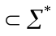) accepted by this agent.
- Out: Output (action control signal or speech).
- ∆: Is a deterministic transitional function from 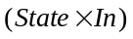 to 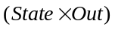
- Service: The set of services 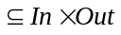.
. So a service of an agent is any sequential pair of input and output.

Now we will define set R. R is the set of all relationships that agent may keep in its mental state(State). We use the notation. Believe(agent1, p1) to denote that agent1 believe that proposition p1 is true. In other words, there has to be a certain place in the configuration of agent1’s mental state to mark this belief. Each agent may have a set R maintained in its mental state.(In notation, 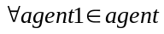(Believe(agent1, “the relations in set R of agent1 should be applied to its behaviors”));

Set R is the Union of the following subsets:
R={R_service, R_acquiantance, R_sharedMaster, R_competitve, R_inclusive, R_cooperative, R_ affiliate, R_ animus, R_dependsOn}

Set name \ attri | Tuple/description | Character of the whole Set
R_service | <agent1, service0, agent2> agent1 is willing to offer service0 to agent2 | service0{<agent1, agent2>} is reflective, and transitive.
R_acquaintance | <agent1, agent2> agent1 regards agent2 as an acquaintance
R_sharedMaster | <agent1, master0, agent2> both agent have the same master. Master0 is a protected item in State set. | Master0{<agent1, agent2>}is reflective, transitive, and symmetric
R_competitve | <agent1, service0, agent2> agent1, agent2 are both willing to offer service0. R_competitve and R_service are mutual exclusive | service0{<agent1, agent2>} is transitive.
R_inclusive | <agent1, agent2> agent1 offers all the services that agent2 offers | Reflective, transitive
R_cooperative | <agent1, service0, agent2> both agent need the other’s help in order to complete service0. | service0{<agent1, agent2>} is Reflective
R_ affiliate | <agent1, agent2> agent1 has full control over agent2’s output. And agent2 will offer all services it has to agent1 | Reflective and transitive
R_ animus | <agent1, agent2> they will not respond to one another.
R_dependsOn | <agent1, service0, agent2> agent1 depends on agent2 to complete service0. However, we do not know if <agent1, service0, agent2> is true. | Transitive

Conclusion
Multi-agent system has been used successfully in fields such as computational market place, weather forecasting, information collecting and querying, and many role-based simulation environments. The agent society is growing faster than ever. Many people see the precipitating needs of employing agent to help people.

As the internet becomes more open, dynamic and intelligent, the live participants in it will no longer be human only. Intelligent agents will eventually come and share the cyber space with us.

This research project covers both theoretical and pragmatic issues that will be necessary to bring Multi-Agent based systems into the ubiquitous computing environment. At the core of the theoretical research are solutions to establish secure relationships among agents and agent systems automatically or semi-automatically. On the other hand, the pragmatic research deals with issues of how agent networks could be useful to human-beings and how they can gradually gain their expected position on the internet. A tentative software framework called Web Agent Framework (WAF) is developed to illustrate the idea; also, factors of building a successful agent system are discussed.

Parallel Oriented Language
An important conclusion drawn from the research on relation-forming in MAS is that both symbolic tools and software development tools needs to be enhanced to support automatic programming of extensive relationship-based models in concurrent threads. This leads to the idea of developing a computer language that is dedicated to this task. As apposed to object-oriented language (OOL), the new language is called parallel-oriented language (POL), in which the basic building block is parallel model other than class. As a continuation of this MAS project, the author is currently working on POL, which will be another method of approaching roughly the same problem as in MAS. POL reinvents the wheel to include language-based network topology model, while retaining the traditional C language syntax as much as possible. Unlike library-based parallel language such as MPI [15], POL is modeling the network computing resources on a much higher level. There has been a large gap between languages that are too low level, requiring specification of many details that obscure the meaning of the algorithm, and languages that are too high-level, making the performance implications of various constructs unclear. In sequential computing many standard languages such as C or Pascal do a reasonable job of bridging this gap, but in parallel languages building such a bridge has been significantly more difficult.

POL takes up the difficult job of developing a completely parallel oriented language. It’s NOT an extension of the ANSI C language designed specially for programming parallel computations on common networks of heterogeneous computers. Rather, it’s a language that has C style syntax, but with completely different programming models.

The goal of POL is not so much to speed up solving a particular problem than to make software resources inherently distributed over different computers work together, which is the main goal of distributed computing. So POL is not a substitute of Parallel library or Parallel Language like MPI [15] and mPC [16].

Interestingly, the initial idea of POL comes not from making MAS development easier, but from my personal needs to simulate a large neuron network with algorithms of any complexity. Traditional neuron network is simulated through a set of class libraries, which greatly limited the simulation complexity. POL’s programming model enables us to build sophisticated networks of concurrent or simulated-concurrent executing nodes. Its programming model allows programmers to visualize, model or adjust network topology in a graphic-enabled editing environment.

Acknowledgement
My advisor Prof.He gave me the opportunity to write the first version of part1 in this paper. Other members who have aided me in developing WAF project are Wangtian, JiaJuncheng, LiuWeili. Also thanks to LiLixuan whose excellent editorial work made the Chinese version of part 1 available in time. I also owe much to my family for their spiritual support. As the project is generally hard to explain, there is not much appreciation from its reviewers. However, my father always encourage me to go on with the work and share the same vision with me.

Reference

- T.Finin, A.Joshi, Intelligent Agent For Mobile and embeded devices, International Journal of Cooperative Information System(2002)
- F.Bergenti and A.Poggi, Ubiquitous Information Agent, International Journal of Cooperative Information System(2002)
- Michael Wooldridge. An Introduction to MultiAgent Systems. Published by John Wiley & Sons, 2002. http://www.csc.liv.ac.uk/~mjw/pubs/imas/
- Haw Siang Hon. Agent Communication Language. ISE. 2001.
- Bart Bauwens. XML-based Agent Communication: VPN Provisioning as a Case study. www.alcatel.com
- www.fipa.org. FIPA Abstract Architecture Specification. Foundation for Intelligent Physical Agents:SC00001L. 2002
- Antonio Moreao. Provision of agent-based health care services. AI communication.vol 16,no 3,2003.
- M.Vieoli. Observation approach to ACLS. Applied Articifial Intelligence.vol 16,no 9-10.
- Editorial. A risk modeling methodology. Computer Security Journal.vol xix,no 3, 2003.
- Lee Barken. Web vulnurability: Wired equivalent privacy. Computer Security Journal. vol xix,no 3, 2003.
- Anthong. RAMASD: A semi-automatic method for designing agent organizations. The knowledge engineering review. Vol 17, no 4.
- Irene. The evoluation of objects into hyper-objects: will it be most harmless?. Personal and Ubiquitous Computing. Vol 7,no 3-4,2003.
- Tatsuo. Pervasive servers: a framework for creating a society of appliances. Personal and Ubiquitous Computing. Vol 7,no 3-4,2003.
- Claudio. Interval scripts: a programming paradigm for interactive environment and agents. Personal and Ubiquitous Computing. Vol 7,no 1, 2003.
- IBM, MPI: Message Passing Interface
- mPC, http://www.ispras.ru/~mpc/tutorial/tutor-engl.html

