A Proposal of Evaluation Framework for Higher Education

Xizhi Li  The CKC honors School of  Zhejiang University, P.R. China  LiXizhi@zju.edu.cn | Hao Lin  The CKC honors School of  Zhejiang University, P.R. China  paullinhao@yahoo.com.cn

Abstract:
In traditional education evaluation system, the goal is to compress as much information as possible and try to use a few summative numbers, or one if possible, to represent the performance of different individuals. The regression formulae used to generate these numbers are scarcely convincing. An inadequate or unnecessary evaluation to the individual performance will lead to negative effect on the quality of its future work and the overall atmosphere among comparable people who work and learn together. In contrast, we believe a reasonable evaluation framework is to provide as much information about the individual as possible and reveal it in an ease-to-access manner to the individual as well as people who are interested in it. In the proposed web agent based evaluation framework, the focus of education evaluation shifts from information regression to information aggregation. Specifically, the work is motivated by our experiences in the CKC honors School of Zhejiang University, an honors program for elite undergraduate students.
Key words: Agent technology, Education, Evaluation

Introduction
In higher education system, there are diverse individuals who learn, teach and innovate in a highly competitive environment. For each undertaking, there is its corresponding evaluation measurement, some of which are being used to rate the performance. The psychological state and satisfaction of an individual consists both of its exploration process [6] and the expectation or result of the evaluation. An inadequate or unnecessary evaluation to the individual performance will lead to negative effect on the quality of its future work and the overall atmosphere among comparable people who work and learn together. Human beings and their relationships are usually adapted to technologies. Hence it is possible to increase the comfort of people in higher education by adopting more reasonable evaluation technologies [1, 5]. In this paper, we will propose a web agent based evaluation framework to facilitate the communication and evaluation experiences for college students. Specifically, the work is motivated by our own experiences in the CKC honors School [2] of Zhejiang University, an honors program for elite undergraduate students.

In traditional education evaluation system, the goal is to compress as much information as possible and try to use a few numbers, or one if possible, to represent the performance of different individuals. The regression formulae used to generate these numbers are scarcely convincing. In contrast, the philosophy of our proposed evaluation framework is to provide as much information about the individual as possible and reveal it in an ease-to-access manner to the individual as well as people who are interested. In our proposal, the focus of education evaluation shifts from information regression to information aggregation. This calls for the employment of new evaluation technologies and the cooperation from students and teachers.
Available information
Contracted information
Prospective information
(2)Revealing techniques
(1)Irreversible regressional techniques
Sampling
Averaging over time
Averaging over subjects
Induction & feedbacks
- Two directions in evaluation techniques for individual performance

Figure 1 recognizes the two aforementioned opposite directions in evaluation technologies. The triangle denotes all the information available, deductible and reducible from a certain individual. The red line through the middle of the triangle denotes the available information from the information source (i.e. the individual being evaluated). Despite the vast information space at this level, the first (traditional) approach tries to reduce all available information to a minimum through several pre designed irreversible filters such as sampling through various tests, averaging over test marks and averaging over average test marks at different time. In contrast, the second approach tries to provide more information than the available information that the individual could provide by himself or herself. It not only provides information that the individual already exhibits, but also gives prospective information such as what he or she could possibly behave or achieve in its future. Prospective information might be provided by formative feedbacks [8] from peers and other qualified individuals, etc.

In the old days and present, the first (regressional) approach is dominant in almost all education systems [7]. Its negative effect has never been alleviated, if not aggravated, in modern times. However, in the information age, it is technically possible to shift the focus of education evaluation to the second (aggregation) approach. We believe the trend of education evaluation will be the emergence of various intermediate (intelligence) technologies and frameworks which make the second approach dominant in all education systems.

We envisage the future of education evaluation as building an information sharing space on the web, where each undertaking by the individual is, automatically or with minimum effort from the individual, recorded to the information space and available for other people to compare and use. It is like a semi-automatic autobiography generation system with an intelligent interface. This special autobiography during education is annotated by feedbacks or evaluations on the quality and quantity of the individual’s contributions and potentials to the academic society or the professional industrial. In section 1.1, we will give some necessary background of CKC college which we have studied (in); next we will analyze the need of college students and enumerate deficiencies in its current evaluation model; then in section 2, we will propose our web agent based evaluation framework with discussion followed.

Background of CKC school
The work in this paper is motivated by our own student experiences at CKC School. Chu Kechen Honors College [2] (CKC College) is comprised of Mixed Honors Class（designed for engineering students）, Science Honors Class and Art Honors Class. Each year about 5% of the total entering students are selected into the three programs according to their majors, based on their high school GPA, performance in screening tests and personal interviews. Special curricula are developed to help students build up a broad academic background in engineering, natural science or liberal arts. Textbooks and references in English are used in many courses. Students are encouraged to register for different courses in various departments and join graduate lectures in advance. A strict evaluation system is applied and only qualified students can accomplish the education program in Science Honors Class and thus be awarded the certificate.

From the third year of the Science Honors Class program, students continue their study in different departments and many start their research work under the instruction of the most outstanding professors. Through vigorous training, they gain rich research experiences.

The Student Model
In order to develop the evaluation framework, it is important to generalize the model of learners. The student model should reflect the learning and research experiences as the student undergoes various stages during his or her higher education. Based on the engineering undergraduates in the CKC college, a three-phase student model is given in Table I.

Table I: Learning stages, their characteristics and evaluation methods in Engineering Education
 | Knowledge acquisition and blind exploration | Need-driven or goal-driven creative development | Research-oriented or Professional undertakings
Cooperation Style | Individual | Individual and/or Group | Group: leadership and membership
Education Focus | Foundation and Inspiration | Practices and Challenging goals | Self-directed learning, Research-oriented supervision, independent work and unique goals.
Most Needed Things | Good teachers, books, diverse curricula, special lectures, etc. | Good tutorials, Free time, Initiatives, Cooperation and Opportunity. | Information Acquisition and Work Sharing, Freedom to carry out independent research.
Least Needed Things | Exams and peer pressure | Restrictions on practices and Premature evaluation. | Deadlines and restrictions on the selection of research topic.
Major Evaluations In | Course works and understandings | Scientific, technical or organizational skills and experience gained. | Personal work publicized (but not necessarily published).
Primarily Evaluated by | Instructors and Agents | Peers And Friends | Colleagues and Supervisors
Best Graded by | Self Evaluation after problem solving and its feedbacks. | Self promotion And Peer Evaluation | Self promotion on sharable works
Notes: The darker the color in each cell, the more problematic the current approach is.

In the columns, three phases of learning and researching experiences are listed. They are (1) Knowledge acquisition and blind exploration, (2) Need-driven or goal-driven creative development. (3) Research-oriented or professional undertakings. In the rows, the characteristics and opinions formed by students during the corresponding phase are listed, such as the education focus, things that students needed most from the college, things that students needed least, the most suitable evaluations for students’ performance, the most desirable grading system, etc.

In phase (1) or during the freshman and sophomore years, students are mostly engaged in knowledge acquisition through rigorous course works almost in parallel. Students are usually inspired by things learned from books or instructors. Some talented students might explore a little bit deeper on a few selected topics than the average, but the explorations performed at this stage are mostly informal or blind. In phase (2) or the junior year, students are equipped with sufficient knowledge to carry out some practical projects. In other words, students are thirsty for practice of their newly acquired skills, and need internal or external motivations to participate in the development of some real projects. Many students can propose original frameworks to be implemented with their technical skills and through teamwork. Some also choose to participate in competitions such as Math Modeling Competition, ACM programming contest, Software development contest, etc. They are all need-driven or goal-driven projects. The difference is that some are driven by the goals of the individual; some are by goals in a competition or course project. In phase (3) or the senior year, students begin to carry out their own researches and wrote their own research papers and technology development reports. Some students may have roles in graduate-level research groups or internships elsewhere. Students mainly focus on an intensive research or technology development thesis experience. Independent works and unique personal goals at this phase will prepare the individual for innovative research and/or professional creative practices after its graduation.

One conclusion drawn from the student model is that the student’s education experiences differentiate very quickly as the time pass by. Hence, the evaluation for students’ performance becomes harder, and the number of people who are qualified to evaluate the work of the student also dwindles. The technologies for evaluation need to adapt to the changes in an individual’s education experiences. In some cases, such as those in phase (2) and (3), when the works of different people are not comparable, it is better not to perform unnecessary evaluation or differentiation. As we will propose later, the ideal way of evaluation in such cases is by information revealing, rather than information hiding. I.e. if we can not evaluate something uniformly by a quantitative method, we had better reveal them in its integrity and allow qualified people to evaluate in their own interests.

The deficiencies in current model
At CKC college, students are being officially evaluated in a largely passive manner and are easily influenced by the change in the evaluation policies. The criteria for evaluating students are both simple and monotonous. A strong emphasis on test scores neither reflects students’ overall quality nor stimulates them to explore in their fields of interests. As we have stated above, the current system tends to hide information and use a few simple criteria to represent the performance of different individuals statistically. However, trying to interpret every attribute of a student in terms of digits would lead to superficial and even false notions. For instance, students would probably lose enthusiasm in participating in academic activities or in their curricula and classify their courses from “important” to “trivial” ones according to their credits and difficulty. Many people are not conscious about such false judgments, because they believe statistics is always “scientific”.

Another problem emerges as many students are trying to publish papers at an early stage. However, some of them have neglected the basic abilities required in their research fields. As in many institutions, the number of published papers is a crucial criterion in evaluation of one’s academic ability, many students feel uneasy if they have not published a certain number of essays. Therefore, publication becomes their ultimate goal of doing research, rather than a natural channel of releasing their well-formed thoughts. Moreover, due to the increasing pressure, students tend to work out their essays hastily and the quality of such papers is not guaranteed.

In all, the current evaluation model does not pay enough attention to the natural needs of the individuals. At the same time, it imposes on them its own material interests, such as the number of scholarships, honors, job opportunities, etc.

Using agent technology in information revealing
In previous section, we mentioned that a more reasonable evaluation framework is based on information revealing rather than information regression; we also summarized some requirements and problems with current approaches. In this section, we will propose our own framework based on information revealing techniques; specifically we will see (1) how to convert available information into web accessible format (2) how to publish them to the web for evaluation (3) why certification and privacy are automatically guaranteed (4) the exploration and evaluation process.
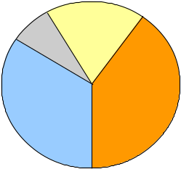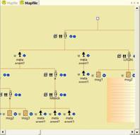
Web content with semantics

Local database
Web database
Web database
Personal web agents
on the Internet
Available information from the user, such as text, images, multimedia files, etc
Self evaluation
Publishing
Web agent framework
Exploration &
peer evaluation
Client agent interface
feedbacks
Directory Robot
synchronization
- Illustration of the web agent based evaluation framework
Figure 2 shows an illustrative view of the web agent based evaluation framework. It is an iterative process of five phases as shown in the center disk of the figure. Around the disk are the underlying technological frameworks which enabled the corresponding tasks in each phase (colors are also matched between the evaluation tasks and their enabling technologies). The evaluation process begins by self evaluation, in which a software agent helps the user to convert his information to web content in its local database. The web content is then published to the web and managed by a web agent on the network. The web agents (managing information for different users) form a web agent framework on the network. Each web agent has an intelligent interface to provide information to users and other agents. Any user (potential readers) could use a browser-like application (client agent interface) to access the web agent framework. The user interface of the agent browser is designed in such a manner that the user feels like interacting with individual agent on the web. Web agents usually reference each other, therefore providing a mean of navigation. Visitors can leave feedbacks to the web agents, which in turn will influence the self evaluation process. Hence, another cycle of evaluation begins. More details are given in the following sub sections.

Self evaluation
In the narrow sense, we define self evaluation in the framework to be the process of revealing personal information to the public. During self evaluation, the individual writes about (promotes) himself for the public and is responsible for the accuracy of what has been told. There are two constituents to supervise the accuracy of information during self evaluation. First is the publicity, because inaccurate information tends to be discovered quickly when it goes public. Second is the reference, because when information is referencing each other, fraudulency can be uncovered by traversing the reference graph. In the web agent framework, we will see later how information can reference each other in the public network.

One of the major tasks of self evaluation is helping the user to convert his personal information to web accessible format. The common form of personal information includes text, images, multimedia files, etc. which are usually available in the user’s hard disk. Therefore, a simple software agent called Directory Robot is designed to complete this task. It automatically searches available information in a user specified directory and sub directories on his or her hard disk, categorizing and annotating artifacts with human supervisions in the form of question-answer dialogs, and stores these artifacts as well as some layout information in a local database for use later by accompanying web pages and web agents. This is a semi-automatic way of constructing a semantic website from a user specified directory. Figure 3 shows a snapshot.
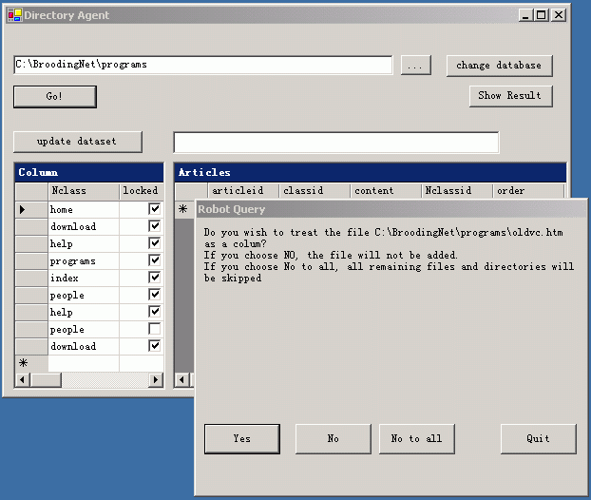
- A simple Directory Robot
Systematic experiments have been done on how self-evaluation influences students’ academic performances [10]. These studies have revealed two facts: one is that students of a certain level are able to accurately assess their own abilities and performances; the other is that such self-evaluation helps students have a better understanding of themselves and thus improve their academic records. Therefore, the doubt on students’ ability or attitude in self-assessing is actually unnecessary.

A closer inspection reveals that “self-evaluation” in this literature, which is a combination of assessing one’s specific ability, assessing one’s specific work, organizing one’s thoughts and presenting it in written form, etc., is of higher level than what is generally referred to. At least two positive results are expected: first, it helps students study on their initiatives; second, it fosters more interaction between the students and other related people.

The traditional method in evaluating students’ academic performances, especially during the stage of “knowledge acquisition”, is based largely on tests. Usually, students submit test papers and teacher responds with a score. The interaction ceases where the score is given; very few students and fewer teachers still care about the test afterwards. “Self-evaluation” solves this problem by stimulating the interest in the students’ side. Here, students can take initiative to review their past works and re-organize their thoughts, propose new approaches, present ideas on a particular issue, and publish them online. Peer review and supervision from instructors are involved in this framework following self-evaluation.

Publishing personal information
When the user’s information has been prepared for evaluation in the previous step, it is ready to be published by a web agent on a public network such as the Internet or Intranet. To complete this task, we can use the web agent framework or WAF [3, 4] which we developed as a general agent framework. In WAF, a master can have one or several web agents which will serve and represent this master on the web.

To join the agent community, one needs either to find an available web agent server (WAS) on the network or run its own server with server package installed. Normally one will see a page like Figure 4 (left). After registering on any WAF web server, one is given a master account and an address of the web agent like the string http://10.111.11.123/agent/agent.asmx?user=Mike[12]. A single master account can have multiple web agents to work for him or her on the web.
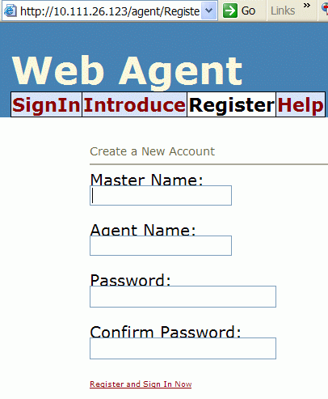 | 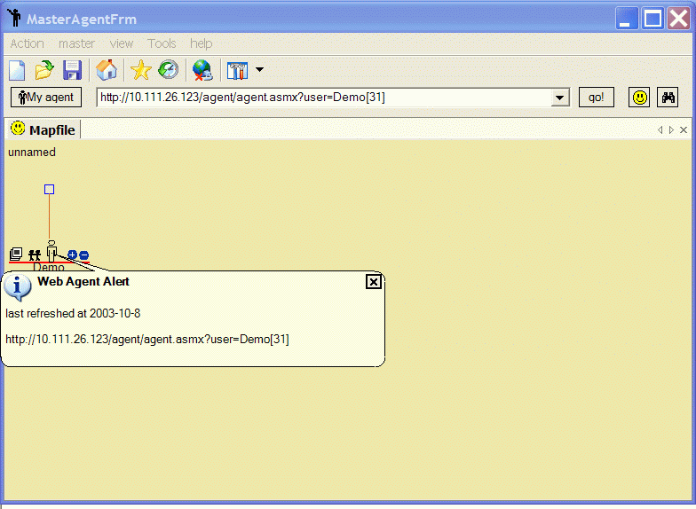
- Publishing personal information with web agent framework.
(Left: registration page; Right: browser interface)

Web agent framework and exploration
Web agent framework or WAF is a web-alike topology multi-agent system application. It aims to create a visible virtual human relationship network on the Internet.
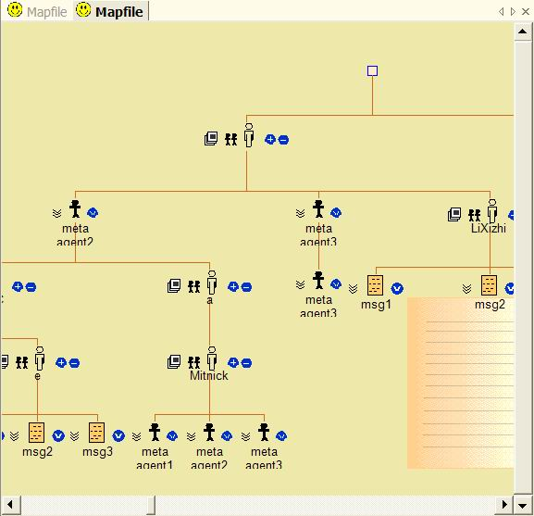 | 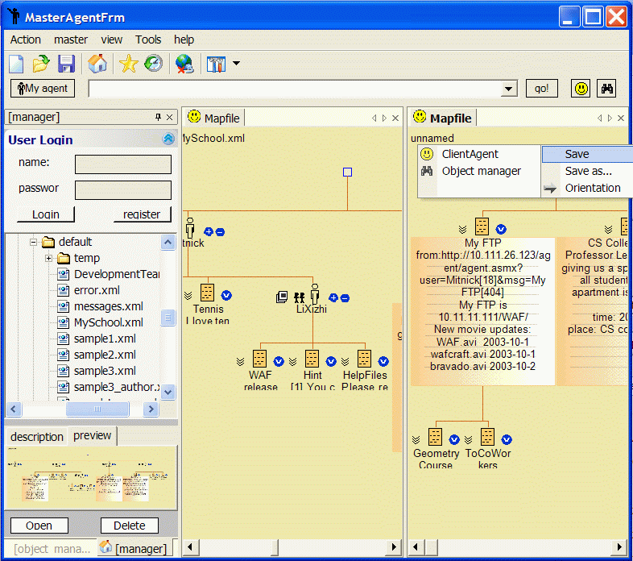
- (Left) Users leave an off-line tree graph of visited agents and artifacts as they navigate through the agent network. (Right) Several map files and user’s interaction with agents or managed information in these graph files.
In WAF, user’s navigation path can be visualized in an off-line tree graph (See Figure 5 (Left)). The client explorer of WAF will remember each visited agent as well as any downloaded artifacts such as a piece of information or a group of other related agents (e.g. friend agents). It allows reconfiguration of the topology of all these intelligent agents as well as data resources on the client side and save them into local map files. Agents and information in these map files can be updated automatically when they are reactivated or re-opened from the history records kept in the local memory pool(database); they can later be used as the starting point of a new navigation or just provide a group of related web services to its user (See Figure 5 (Right)). Hence, WAF can be served as a new form of peer review environment, with each object (individual) presented by a customizable agent entity on the screen.

Evaluation feedbacks
Most feedbacks are formative and offline. They are usually provided by human visitors or other web agents (on behalf of its users) in the form of comments to specific artifacts. Feedbacks provide a mean for people to hear opinions about their past works and change the attitude in their previous self evaluation. Feedbacks can also produce new references between individuals. It is likely that further relationships will be established between the two sides in the real world.

In general, there are two kinds of people who will respond to self-evaluation: peers who conduct comparable research and professors who supervise student’s works. Feedbacks from them are professional and helpful for the improvement of one’s academic performance.

For a group of students who pursue a mutual academic purpose, WAF can provide a place for communication, information sharing and evaluation. On the one hand, by presenting original ideas and commenting on others’ works, students can better cooperate with each other; on the other hand, every one is under the supervision of its peers which in turn helps each individual keep a sense of responsibility and teamwork.

According to psychological and educational research [10], peer-assessment may result in friendship-marking (over-marking) and thus lack fairness or objectiveness. Therefore, comparable people outside a particular group are introduced into the review process. These outsiders might not have the same academic background, yet their opinions will increase the objectiveness. Peer review (from open groups of people) also adds value [11]. Timely and detailed feedback from peers would help people think from more perspectives and produce more meaningful thoughts.

Professors can also supervise their students’ academic progress and perform most of their functions through WAF. With the use of agent technology, they can track the status of specific works carried out by their students, and provide comments, instructions and suggestions if necessary. At the same time, WAF also provides a channel for individual academic communication between students and professors. In all, feedback is an indispensable part in self-evaluation.

We have also noticed that an online research project can be extended both in time and space by a network of web agents. People who are linked to the project may acquire interest and knowledge in common fields. As the online discussion goes on, the number of participants will increase and the spatial extension occurs. Once an academic link is established between individuals, it is likely to last longer than the duration of the project, especially when similar discussions take place.

A Discussion and conclusion
People tend to compare with each other in their comparable works. This automated comparison is a natural reaction of the human brain and is necessary for further communication among comparable people. The visibility of individual information and effectiveness of information sharing plays an important role during this comparison process. To increase the comfort of people and foster active evaluation and communication, we need a more reasonable and open evaluation framework for people in the education systems.

In this paper, we have tentatively proposed a web agent based evaluation framework. We tried to answer the question: what current technologies will bring to the future evaluation system. And our conclusion is almost surprising: the focus of education evaluation will shift from information regression (such as producing summative numbers) to information aggregation (such as revealing individual works and potentials).

Another characteristic of the proposed evaluation framework is that it is tightly integrated with personal and inter-personal development. E.g. it combines publication, discussion, assessment and re-cognition in a single place and enables (also encourages) students to satisfy their own natural needs. We hope that our work would draw the necessary attention of education reformers and that some concrete actions could be carried out.

Reference:
- Paul Penfield, Jr. and Richard C. Larson, “Education via Advanced Technologies” IEEE Trans on Education. Vol. 39, No. 3, Aug 1996.
- CKC homepage, http://ckc.zju.edu.cn
- Xizhi Li. “An HCI Template for Distributed Applications”. International Conference on Computational Intelligence 2004.
- Xizhi Li, Qinming He. “WAF: an Interface Web Agent Framework”. International Conference on Information Technology 2004.
- David McCann, et al. “Educational technology in higher education”, Higher education division, Mar 1998.
- Critina Conati and Jill Fain Lehman,” Toward a Model of Student Education in Microworlds”, CogSci’93.
- Alfred P. Rovai, “A practical framework for evaluating online distance education programs”, Internet and Higher Education 6 (2003) 109–124.
- Robert S. Thompson, “Relative Validity Of Peer And Self-Evaluations In Self-directed Interdependent Work Teams”, ASEE/IEEE Frontiers in Education Conference (2001).
- Mark Burgin, “Technology in education”, ASEE/IEEE Frontiers in Education Conference (1999)
- D. Sluijsmans, F.Dochy and G.Moerkerke, “Creating a New Learning Environment by Using Self-, Peer-, and Co-assessment”, Learning Environment Research（1998）
- Jack McGourty, Peter Dominick and Richard R. Reilly, “Incorporating Student Peer Review and Feedback into the Assessment Process”, Proceedings of Frontiers In Education Conference (FIE’98)

Notes to reviewers:
We are senior undergraduates from Zhejiang University. We experience the pros and cons in current education evaluation system and are enthusiastic to propose a new evaluation framework to compensate the old ones.
A short movie of web agent framework can be downloaded at
[screen capture codec] http://www.lixizhi.net/webagent/IntroMedia/TSCC.exe
[movie file] http://www.lixizhi.net/webagent/IntroMedia/preface.avi

