A2

np.random.seed(2016)

num_pods=100

max_pod_connected=95

min_pod_connected=15

num_cores=5

num_slots=80

capacity_choices=[50, 400]

capacity_probs=[0.9, 0.1]

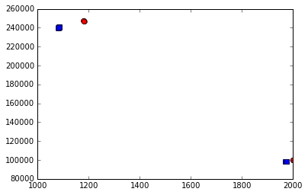Pareto curve

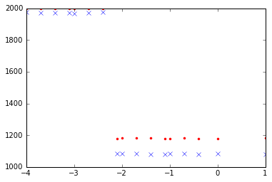Connection

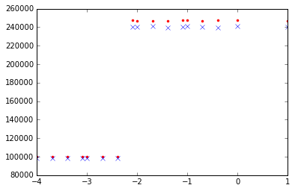 Throughput

A2

np.random.seed(2016)

num_pods=100

max_pod_connected=95

min_pod_connected=15

num_cores=5

num_slots=120

capacity_choices=[50, 400]

capacity_probs=[0.9, 0.1]

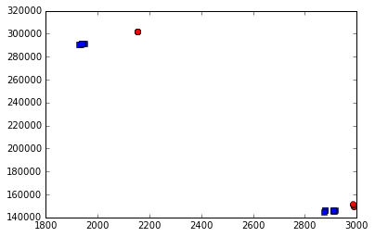Pareto

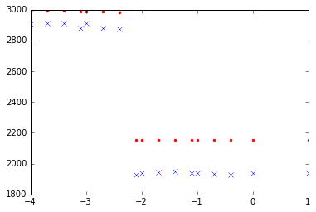connection

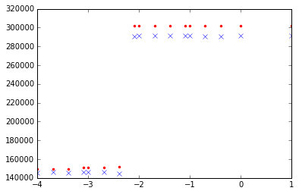throughput

A2

np.random.seed(2016)

num_pods=100

max_pod_connected=55

min_pod_connected=55

num_cores=5

num_slots=80

capacity_choices=[50, 400]

capacity_probs=[0.9, 0.1]

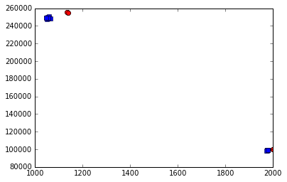Pareto

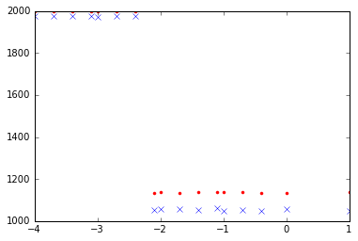Connection

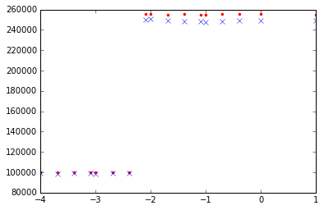Throughput

A2

np.random.seed(2016)

num_pods=100

max_pod_connected=95

min_pod_connected=15

num_cores=5

num_slots=80

capacity_choices=[50, 400]

capacity_probs=[0.5, 0.5]

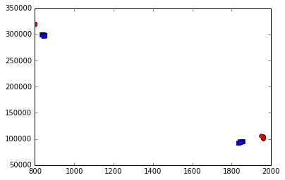

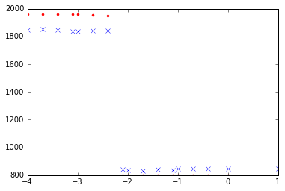

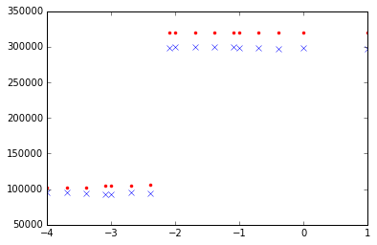

A2

np.random.seed(2016)

num_pods=100

max_pod_connected=95

min_pod_connected=15

num_cores=5

num_slots=80

capacity_choices=[50, 400]

capacity_probs=[0.3, 0.7]

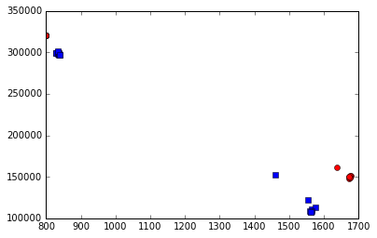

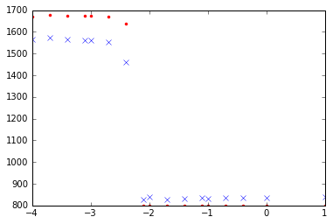

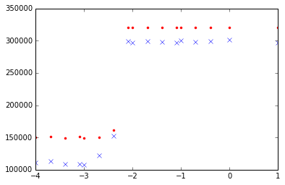

A2

np.random.seed(2016)

num_pods=100

max_pod_connected=95

min_pod_connected=15

num_cores=5

num_slots=80

capacity_choices=[50, 400]

capacity_probs=[0.2, 0.8]

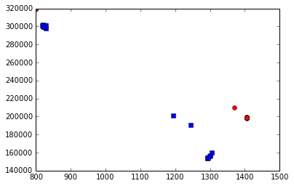

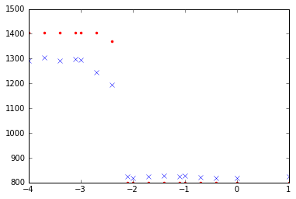

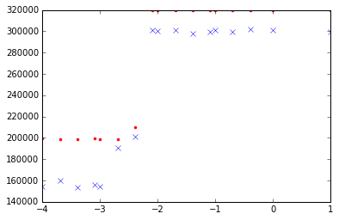

A2

np.random.seed(2016)

num_pods=100

max_pod_connected=35

min_pod_connected=15

num_cores=5

num_slots=80

capacity_choices=[50, 400]

capacity_probs=[0.9, 0.1]

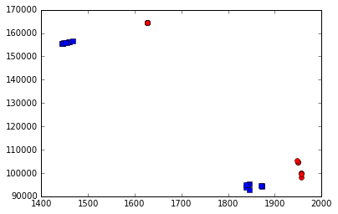

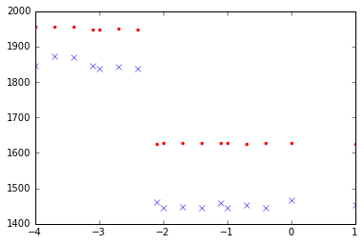

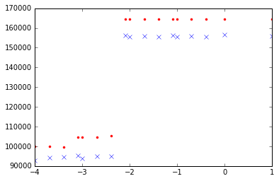f

A2

np.random.seed(2016)

num_pods=100

max_pod_connected=95

min_pod_connected=15

num_cores=5

num_slots=160

capacity_choices=[50, 400]

capacity_probs=[0.9, 0.1]

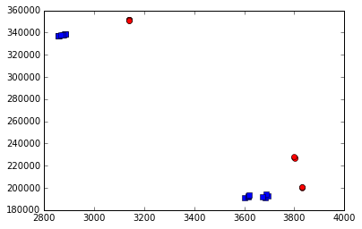

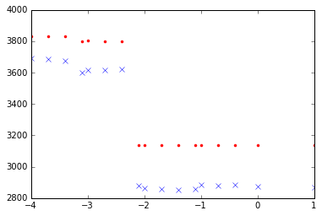

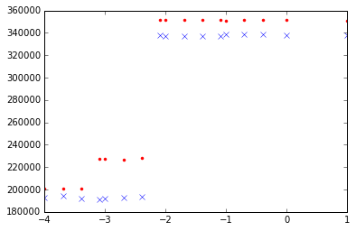

A2

np.random.seed(2016)

num_pods=100

max_pod_connected=95

min_pod_connected=15

num_cores=5

num_slots=200

capacity_choices=[50, 400]

capacity_probs=[0.9, 0.1]

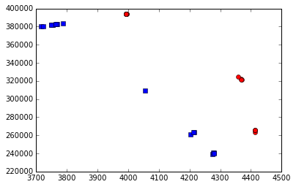

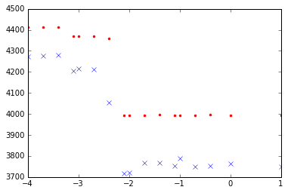

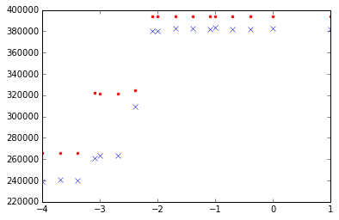

A2

np.random.seed(2016)

num_pods=100

max_pod_connected=95

min_pod_connected=15

num_cores=5

num_slots=200

capacity_choices=[50, 400]

capacity_probs=[0.9, 0.1]







A2

np.random.seed(2016)

num_pods=100

max_pod_connected=35

min_pod_connected=15

num_cores=5

num_slots=80

capacity_choices=[50, 400]

capacity_probs=[0.9, 0.1]







A2

np.random.seed(2016)

num_pods=100

max_pod_connected=35

min_pod_connected=10

num_cores=5

num_slots=80

capacity_choices=[50, 400]

capacity_probs=[0.9, 0.1]

