Internet GoMoKu (Connect-5) Game

20% of total mark (Group working)

Demo Time: March 25, 2019

GoMoKu (Connect-5) is a chess game. The game board is a 10×10 grid area, as shown below. The rules are:
- The game is for two players, one with black stone and the other with white stone. The .GIF files for background, black stone and white stone can be downloaded with this assignment sheet.
- The game alternates from one player to the other. Each player makes his move by clicking the small square on his chess board. A stone (black or white) will immediately appear on the display of both sides.
- A player wins the game if he gets 5 his stones in a row vertically, horizontally, or diagonally.
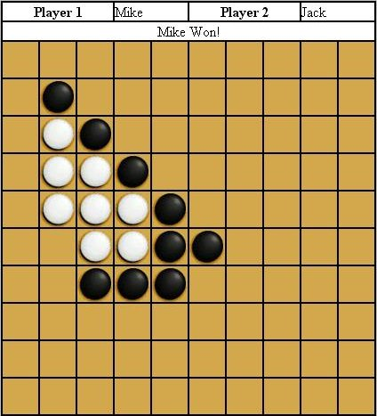
You are required to develop the GoMoKu game for Web players. The players use web browsers to play the game. The display should include players’ names, a result field, and the chess board.
The system follows the client-server model. The client is implemented as a Java applet. The server, also implemented in Java language, runs on the web server site (because applets can only make socket connections to its home site). The communication between the client and the server is via Stream sockets.
The client is basically only a graphical interface. It waits for the player to make a move. Once a player makes a move, it simply passes the data to the server. The server will record the move made by this player, and inform the other player about this move. The server judges the end of the game and informs both players the result. The server must be able to support several pairs of players concurrently.
Your system must be able to tolerate invalid moves (e.g., a player makes another move before his opponent moves). For unspecified design and implementation details, make your own reasonable decisions.
You are to demonstrate your system at demo time. Late submission cannot be entertained. You must hand in the following documents at your demonstration time:
- A copy of design document (2 pages maximum), started with your names or student numbers, and URL address (of the game). The document should include the system structure, client-server communication, support of multiple players concurrently, and other design and implementation issues.
- A hard copy of full program list (client and server).

Your assignment will be assessed on the following criteria:
- documentation (20%)
- interface design (20%)
- implementation (source code) and programming styles (60%)

A system which is not working will have no more than 50% of the total mark; and a system which works properly (with minimum required functionality) will have at least 50% of the total mark.

