Preliminary insights into the use of pottery and culinary practices at Guijiabao site in southwest China

Li-Ying Wang1,✉, Kuei-chen Lin1, and Zhiqing Zhou2

26 May, 2024

Mixed crops of millet and rice are thought to have been introduced to southwest China in the Neolithic period. Despite the recovery of both millet and rice grains, the varying proportions observed across the area underscore the complexity of the process of agricultural dispersal. Further investigation is needed to understand how new crops were integrated into southwest China, characterized by diverse environmental conditions and landscapes. This study explores pottery use in southwest Sichuan through a preliminary analysis of lipid residues in pottery from the Guijiabao site using organic geochemical analyses. The site, situated in the middle Hengduan mountain ranges, presents well-preserved stratigraphic records spanning from the Neolithic to the historical period, providing valuable insights into local subsistence practices in a highland environment. The results reveal that broomcorn millet was processed in a pot, with the majority of potsherds showing mixed sources including ruminant adipose fats. This suggests that animals might have played an important role in the local diet, alongside the consumption of millet. These culinary practices also indicate a subsistence strategy relying on hunting to a certain degree in the high-altitude region of southwest China, even after the introduction of crops.

1 Institute of History and Philology, Academia Sinica  
2 Chengdu Institute of Cultural Relics and Archaeology

✉ Correspondence: [Li-Ying Wang <[liyingw@asihp.net](mailto:liyingw@asihp.net)>](mailto:liyingw@asihp.net)<[liyingw15@gmail.com>](mailto:liyingw15@gmail.com%3e)

Keywords: Southwest China; Neolithic period; Lipid residue analysis; Compound-specific carbon isotope analysis; Pottery; Culinary practices

Highlights:

Lipid residue analysis suggested the pottery was used as cooking pots at Guijiabao and Gaoshan.

The biomarker for broomcorn millet was identified in a Guijiabao potsherd.

Ruminant adipose fats were identified in the majority of potsherds.

Animals could be an important food source in a highland setting alongside crops.

# 1 Introduction

The movement of Neolithic populations has long been discussed in archaeology to understand the processes of agricultural diffusion (Bellwood, 2005). In southwest China, the emergence of farming practices is thought to be associated with migrating populations from central or north China in the Neolithic period (Deng, 2018; Zhao and Chen, 2011). Crop remains found in prehistoric southwest China, including foxtail millet (*Setaria italica*), broomcorn millet (*Panicum miliaceum*), and rice (*Oryza sativa*), can be traced back to as early as 5000 BP in southwest Sichuan and around 4600 BP in west Yunnan (Dal Martello, 2022; Deng, 2018; Jiang et al., 2016; Museum, 1981; Zhang and Hung, 2010). Despite different views on the routes of agricultural dispersal (d’Alpoim Guedes et al., 2013; d’Alpoim Guedes and Hein, 2018; Huan et al., 2022; Liu et al., 2022), it is generally believed that mixed farming was the main agricultural practice in southwest China (Deng, 2018). However, more studies are still needed to understand how farming communities interacted with diverse environments, especially in an area characterized by high landscape diversity, including high mountains, plateaus, basins, and terraces.

This study primarily focuses on the Guijiabao site located in the Hengduan Mountain ranges, a region in southwest China that connects the Tibetan Plateau to the northwest, the Sichuan Basin to the east, and the Yunnan Plateau to the south. As a crucial passage for population movement, the Hengduan Mountain ranges and valleys not only facilitate material exchange (Hein, 2016; 2014; Ma et al., 2021; Tong, 1986), but also contribute to the spread of agriculture further to mainland Southeast Asia since the Neolithic period (Liu et al., 2022; Stevens and Fuller, 2017). Guijiabao is a key site with the so far earliest Neolithic human occupation in this region, dating to 5000 BP and continuing to the historical period about 500 BP. (Chengdu et al, 2017; Hao et al., 2022; Huan et al., 2022; Liangshan et al., 2017). The occupational history at Guijiabao provides a unique opportunity to explore questions related to subsistence since the Neolithic period in a mountainous area. For instance, what role did agriculture play in local environments? What other resources were obtained in addition to crops? In this study, we present our preliminary analyses of archaeological potsherds from the Guijiabao site using organic residue analysis of lipids. For comparison, we also applied the same method to a sample from the Gaoshan site on the Chengdu Plain.

The increasing application of organic residue analysis demonstrates its efficacy in understanding ancient pottery use (Kimpe et al., 2004; Mayyas et al., 2022), human subsistence strategies (Kwak and Kim, 2020), and culinary practices across a region over time (Craig et al., 2011; Junno et al., 2020; Suryanarayan et al., 2021; Zhang et al., 2022). Although remains of animal bones and plants offer evidence of subsistence, their preservation heavily depends on environmental conditions. Geographical regions with seasonal heavy precipitation and acidic sediments like Sichuan (Li, 1989), often result in poor preservation of archaeological remains. In such cases, organic residue analysis is a potent instrument for investigating ancient food practices by directly examining residues in pottery; however, it has never been applied to materials from this region. Organic residues, particularly lipids, exhibit remarkable preservation in the porous fabric of pottery for thousands of years. This preservation is attributed to the protection provided by clay matrices, preventing lipids from microbiological degradation and water leaching (Dudd et al., 1999; Evershed, 2008a, 1993; Miller et al., 2020; Roffet-Salque et al., 2017).

By identifying lipid compositions and conducting compound-specific carbon isotope analysis, archaeologists are able to distinguish lipid origins between plant oils, ruminant fats, dairy products, and aquatic/marine resources (Copley et al., 2005; Craig et al., 2007; Evershed et al., 1994). Recent studies have successfully identified various plant types processed in archaeological vessels, including broomcorn millet (Bossard et al., 2013; Ganzarolli et al., 2018; Heron et al., 2016), starchy plants (Shoda et al., 2018), and cereals (Colonese et al., 2017; Hammann and Cramp, 2018). Several applications to ancient pottery in China also highlight the robustness of this approach in understanding regional cooking practices (Han et al., 2022; Lyu et al., 2024; Shoda et al., 2018), discerning distinct subsistence strategies between low- and high-altitude zones in the Tibetan Plateau (Zhang et al., 2022), and exploring the impact of nomadic pastoralism in northwest China (Sun et al., 2023). In this study, we aim to investigate pottery use and culinary practices in the middle Hengduan mountains, with a specific focus on ceramics from the Guijiabao site to gain insights into local subsistence.

# 2 Geographical and Cultural Background of Guijiabao in Yanyuan Basin

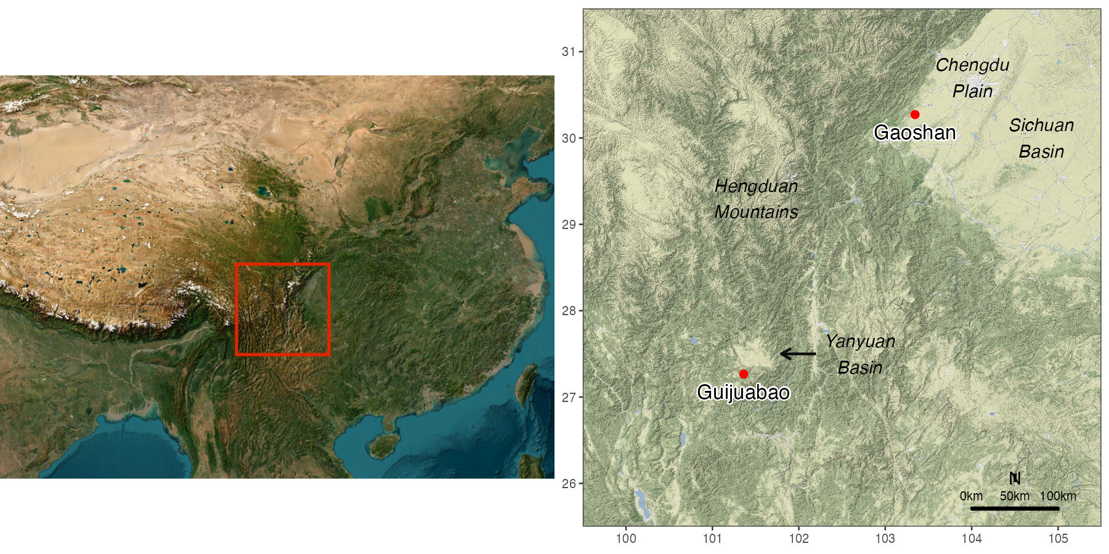

Figure 2.1: The archaeological sites, Guijiabao and Gaoshan, and other locations in southwest China that are mentioned in this study. Map data is from Leaflet and naturalearthdata.com

Guijiabao is located in the southwest of Yanyuan County in Sichuan Province, southwest China (Figure 2.1), with an elevation of around 2400 m (Chengdu et al., 2017). Yanyuan is a pull-apart basin surrounded by mountains in the central east part of the Hengduan Mountain ranges. The initial survey at Guijiabao in 2015 and subsequent excavations from 2016 to 2019 uncovered abundant archaeological materials and features, such semi-subterranean and ground houses, post holes, ash pits, ditches, and burials, suggesting a settlement site (Chengdu et al., 2017; Hao et al., 2022). According to radiocarbon dates, the site had been occupied from the Neolithic period (5000-3700 BP), continued to the Bronze Age (3200-2700 BP) and the historical period from the late North Song to early Ming dynasties (1200-500 BP) (Hao et al., 2022; Huan et al., 2022). The Neolithic period can be further divided into two subphases, 5000-4500 BP and 4500-3700 BP, differing in artifact assemblages and ceramic styles.

The common ceramic vessel forms at Guijiabao include pots, jars, urns, bowls, and basins, with some exhibiting charred surfaces, indicating their potential use for cooking purposes. This research also attempts to confirm that these pottery vessels were used as cooking or storage wares. The representative ceramic styles in the Neolithic period are grayish high-tempered fine ware and reddish-brown coarse ware with cord-marked or basket-impressed patterns (Chengdu et al., 2017; Hao et al., 2022). Some ceramic decorations present northern styles, while others with incised geometric patterns and impressed dot patterns resemble those found in western Yunnan, indicative of close relationships between Guijiabao and both of its northern and southern neighboring areas (Chengdu et al., 2017). The flotation analysis of soil samples from the 2015 excavation at Guijiabao demonstrates the predominance of cultivated broomcorn millet and foxtail millet during the Neolithic (Chengdu et al., 2016). Rice grains were also identified in later excavations from the Neolithic period based on macrobotanical evidence and phytolith analysis (Hao et al., 2022; Huan et al., 2022), though in a smaller number than millet. In addition to plants, faunal remains such as deer, birds, pigs, horses, and fish were also found at the site (Zhou et al., 2019), but a detailed analysis of their temporal and spatial distribution is still ongoing.

To compare the culinary practices in different ecological zones, we examined a sample from the Gaoshan site in southwest Chengdu Plain, an alluvial plain in Sichuan close to the Tibetan Plateau (Figure 2.1). Excavations at the Gaoshan site reveal abundant materials, including ceramics, stone artifacts, animal and plant remains, and archaeological features such as house foundations, walls, burials, ash pits, ditches, and a well (Chengdu, 2017; He et al., 2020; Jiang and Yan, 2017; Zhou et al., 2015). According to similar pottery forms and styles, the Gaoshan site can be dated to the early Baodun period, the earliest Neolithic culture (ca. 4700-3700 BP) in the Chengdu Plain (Chengdu, 2017). The primary subsistence strategy at the Gaoshan site could have been rice farming with pig husbandry, supplemented by millet cultivation (He et al., 2020; Jiang and Yan, 2017; Lee et al., 2020), which gradually decreased in importance than rice (X. Wang et al., 2023). It is suggested that the spread of rice farming into Sichuan occurred at least 4700 years ago through population migration from the Middle and Lower Yangzi valleys (Zhang and Hung, 2010).

While mixed agriculture of millet and rice was practiced in southwest China, variations in their proportions across the region have been observed. Macro-botanical and phytolith analyses of the Guijiabao site indicate that millet was the primary crop, aligning with findings at the Yingpanshan site and Guiyuanqiao site in Sichuan (d’Alpoim Guedes and Wan, 2015; Zhao and Chen, 2011). Conversely, botanical evidence from numerous sites in the Chengdu plain suggests a prevalence of rice, as seen at the Gaoshan and Baodun sites (d’Alpoim Guedes et al., 2013; Jiang and Yan, 2017), and the Baiyangcun site in Yunnan (Chengdu et al., 2014; Jiang et al., 2016). Moreover, while most research focuses on agricultural practices, there is a lack of clarity regarding other resources utilized by early farmers in new environments. This study aims to address this gap by examining direct evidence from pottery residues, using geochemical techniques to provide insights into culinary practices through a case study in southwest China.

# 3 Materials and methods

## 3.1 Sampling

As a preliminary study to assess the feasibility of employing organic geochemical approaches, we collected five pottery fragments from cultural layers in the residential area of Guijiabao (Table 3.1). For comparison, one fragment was sampled from Gaoshan. Those pottery fragments represent typical types with well-defined contexts, with their radiocarbon dates ranging from the early phase of Neolithic period (ca. 5000-4500 BP) to the historical period (ca. 1200-500 BP). The pottery fragments are mostly bases and fine sand-tempered, with a few displaying impressed decorations. By examining potsherds from the early and late periods at Guijiabao, we aim to investigate the applicability of this approach to determine the pottery use across time periods.

Table 3.1: A list of the pottery sherds that were analyzed in this study. The sherd labeled ‘SYG’ indicates potsherds from the Guijiabao site, while the label ‘CDG’ refers to those from the Gaoshan site

| Sherd label | Site/ Field Season | Analyzed part | Time period | Ceramic Description |
| --- | --- | --- | --- | --- |
| SYG-TN13-E22-1 | Guijiabao/ 2017 | base | Historical | gray 7.5YR5/2, coarse temper, impressed decoration |
| SYG-TN13-E22-2#1 | Guijiabao/ 2017 | base-body | Neolithic | red 2.5YR5/2, fine temper, chars on exterior side |
| SYG-TN13-E22-2#2 | Guijiabao/ 2017 | base-body | Neolithic | gray 7.5YR5/3, fine temper, chars on interior side |
| SYG-TN13-E23-3 | Guijiabao/ 2017 | base-body | Neolithic | gray 7.5YR4/3, fine temper |
| SYG-3 | Guijiabao/ 2016 | base | Historical | gray 7.5YR4/1, fine temper |
| CDG-062 | Gaoshan/ 2015 | base-body | Neolithic | gray 7.5YR4/2, coarse temper, cord-marked, chars on exterior side |

## 3.2 Lipid extraction

The surface (~1mm) of each potsherd was removed to prevent external contamination from the environment and handling (Craig et al., 2004). Approximately 3.5 grams of powder from the interior potsherd surface were extracted with a mixture of dichloromethane/methanol solution (9:1 v/v) using accelerated solvent extraction (ASE Dionex 350; at 100 °C) (McClure et al., 2018). To obtain a higher yield, free fatty acids were recovered from bound lipids through saponification, which was conducted by adding 10 mL of 1M KOH in methanol and 1 mL water to the extracts and heating at 70 °C overnight (Craig et al., 2004; Kałużna-Czaplińska et al., 2016). Saponified extracts were acidified with 6M hydrochloric acid (HCl), and the acid fraction was extracted using hexane ( mL). A 5% aliquot of the extract was treated with 20 uL N,O-bis(trimethylsilyl)trifluoroacetamide (BSTFA) containing 1% v/v trimethylchlorosilane (TMCS), and heated at 70 °C for one hour. After drying under a stream of nitrogen, the derivatized sample was dissolved in toluene for gas chromatography mass spectrometry (GC-MS).

The remaining 95% aliquot was fractioned using solid phase extraction (Aminopropyl, NH2, column with 0.5 g sorbent) with 8 mL dichloromethane:Isopropyl alcohol (3:1), 8 mL 4% acetic acid in ethyl ether, and 6 mL methanol. The second fraction was methylated to produce fatty acid methyl esters (FAMEs) with 1 mL dry hexane and 2 mL 10% (v/v) acetyl chloride in dry methanol, and heated at 70 °C overnight. The FAME derivatives were extracted with hexane ( mL). About a 5% aliquot was analyzed by gas chromatography with flame-ionization detection (GC-FID) for quantification, and the remaining sample was analyzed using gas chromatography combustion isotope ratio mass spectrometry (GC-C-IRMS) (Craig et al., 2007; Evershed et al., 1994). Analytical blanks were prepared and analyzed using the same procedure as the pottery samples to monitor potential contamination sources from solvents and reagents. Internal standards, FA C21:0 and 5-α Cholestane or n-tetratriacontane, were added before and after the lipid extraction.

## 3.3 GC methods

The GC-MS analysis was performed using an Agilent 7683 B series gas chromatograph attached to an Agilent 5975 inert mass selective detector (Agilent technologies, USA). Samples were injected in splitless mode at 320 °C. Compounds were separated with a VF-17ms column (60 m length, 0.25 mm i.d., 0.25 μm film thickness; J&W Scientific, USA). The carrier gas was helium flowing at a rate of 1.3 ml/min. The oven temperature was set at 90 °C for 1 minute, then increased at a rate of 5 °C/min to 320 °C and held for 23 minutes. In addition to scan mode, a selected ion monitoring (SIM) mode was used to further detect miliacin (olean-18-en-3β-ol methyl ether; *m/z* 189, 204, 231, 425, 440) (Heron et al., 2016). The oven temperature was set at 50 °C for 1 min, then raised at a rate of 10°C/min to 310 °C and held for 15 min. An authentic standard of miliacin was also run to monitor the retention time.

The GC-FID analysis of FAMEs was carried out using an Agilent 6890N gas chromatograph equipped with a PTV inlet in splitless mode (Agilent technologies, USA). The carrier gas was helium flowing at a rate of 1.6 ml/min. The GC system was an Agilent 6890N equipped with a programmed temperature vaporization (PTV) inlet in splitless mode. The GC oven was set at 90°C for 1.3 minute, then raised at a rate of 5°C/min to 320°C and held for 22 minutes. The GC-C-IRMS analyses of FAMEs of palmitic (C16:0) and stearic (C18:0) were conducted using a Thermo Delta V Plus mass spectrometer linked to a GC Trace 1310 through an Isolink Interface (Thermo Fisher Scientific, USA) in splitless mode. Separation was carried out using the same model of column for GC-MS. Helium was used as a gas carrier with a constant flow rate of 1.24 ml/min. The oven temperature was set at 90 °C for 1.5 minutes, then raised at a rate of 5 °C/min to 320 °C and held for 18 minutes.

The data generated by these analyses and R code used for visualizations are openly available at <https://osf.io/46bpf/> for research reproducibility and transparency (Marwick, 2017; Marwick and Wang, 2022).

# 4 Results

The total lipid concentrations of potsherds at Guijiabao and Gaoshan range from 6.99 to 48.4 μg/g, with an average of 18.77 μg/g (Table 4.1). Lipid yields from all potsherds are above interpretable concentrations (5 μg/g) (Evershed, 2008b), suggesting those ceramics should be associated with food processing. The main compounds were saturated fatty acids with an even number of carbons, particularly C16:0 (palmitic acid) and C18:0 (stearic acid), commonly derived from animal fats and plant oils (Figure 4.1). Unsaturated fatty acid, C18:1, was detected in all samples and dominant in three, but we are unable to distinguish the C18:1 types based on current methods. The most interesting finding is that milliacin, the compound specific to broomcorn millet (Bossard et al., 2013; Ganzarolli et al., 2018; Heron et al., 2016), was identified in one Neolithic sample (SYG-TN13-E22-2#2) from Guijiabao (Figure 4.2). This sample has a wider range of fatty acids from C12:0 to C30:0 (48.4 μg/g), where long-chain fatty acids could originate from plant sources (Copley et al., 2005; Post-Beittenmiller, 1996). Overall, the dominance of C16:0 and C18:0 in most samples suggests that the lipids extracted from our samples were significantly degraded.

Table 4.1: Quantitative data of fatty acid (FA) composition (μg/g) for each pottery sample based on GC-FID analysis

| FA | SYG-TN13-E22-1 | SYG-TN13-E22-2#1 | SYG-TN13-E22-2#2 | SYG-TN13-E23-3 | SYG-3 | CDG-062 |
| --- | --- | --- | --- | --- | --- | --- |
| C12:0 | - | - | 0.13 | - | - | - |
| C13:0 | - | - | 0.03 | - | - | - |
| C14:0 | 0.13 | 0.09 | 0.4 | 0.38 | 0.12 | 1.3 |
| C15:0 | - | - | 0.14 | - | - | 0.84 |
| C16:0 | 3.5 | 2.01 | 32.24 | 3.91 | 2.84 | 7.29 |
| C17:0 | - | - | 0.12 | - | - | 0.27 |
| C18:1 | 3.95 | 2.54 | 0.68 | 7.28 | 2.52 | 1.86 |
| C18:0 | 4.16 | 2.06 | 5.56 | 4.68 | 3.07 | 3.57 |
| C19:0 | - | - | 3.04 | - | - | - |
| C20:0 | - | - | 1.48 | 0.37 | 0.14 | 0.83 |
| C22:0 | 0.51 | 0.28 | 1.45 | 1.36 | 0.16 | 1.23 |
| C23:0 | - | - | 0.53 | - | - | - |
| C24:0 | - | - | 1.74 | 0.82 | - | 0.18 |
| C26:0 | - | - | 0.35 | - | - | - |
| C27:0 | - | - | 0.08 | - | - | - |
| C28:0 | - | - | 0.2 | - | - | - |
| C30:0 | - | - | 0.22 | - | - | - |
| total | 12.24 | 6.99 | 48.4 | 18.79 | 8.86 | 17.37 |

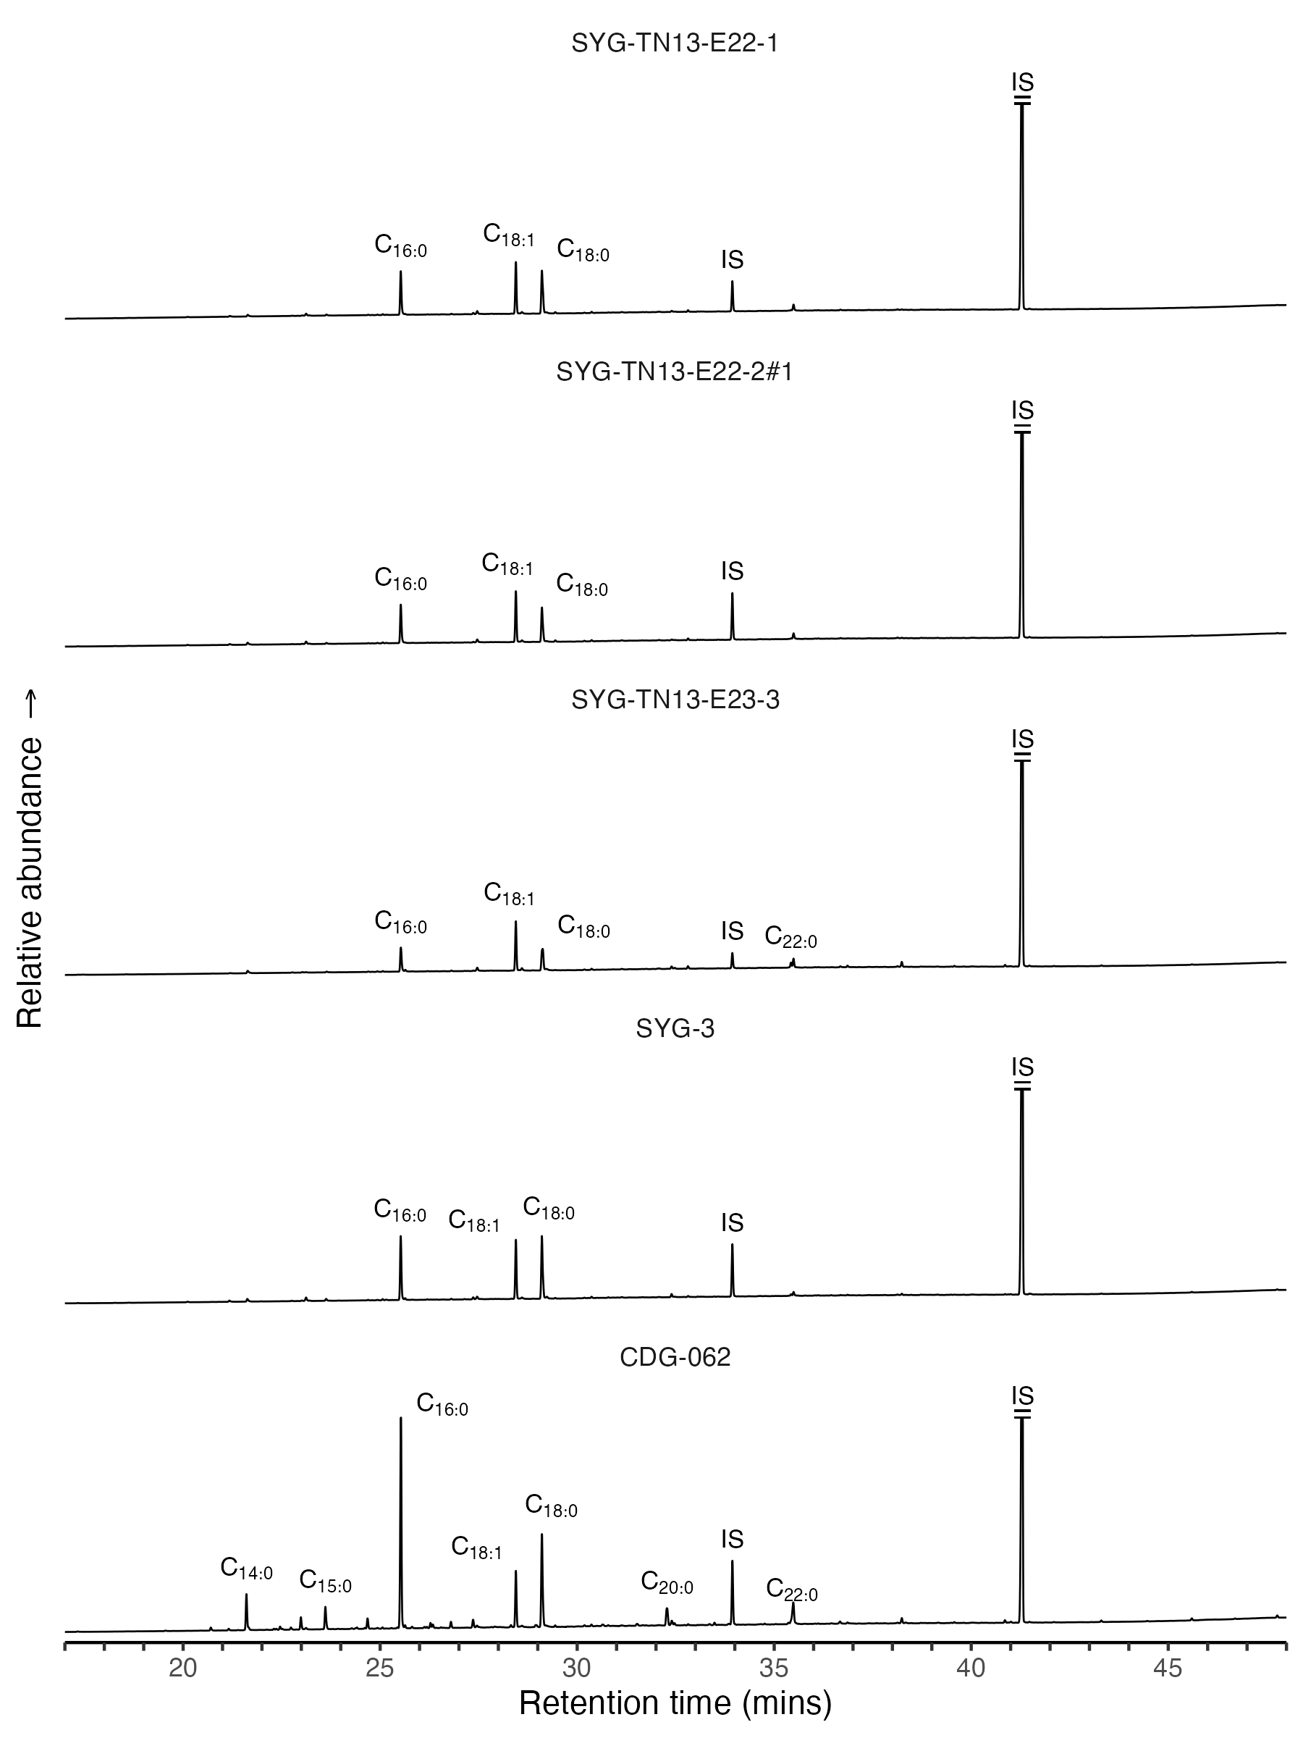

Figure 4.1: Partial total ion current (TIC) chromatograms of pottery samples from Guijiabao and Gaoshan. ‘Cn:x’ refers to fatty acid with n carbon atoms and x double bonds. ‘IS’ indicates internal standard used for quantification, including FA C21:0 and 5-α Cholestane

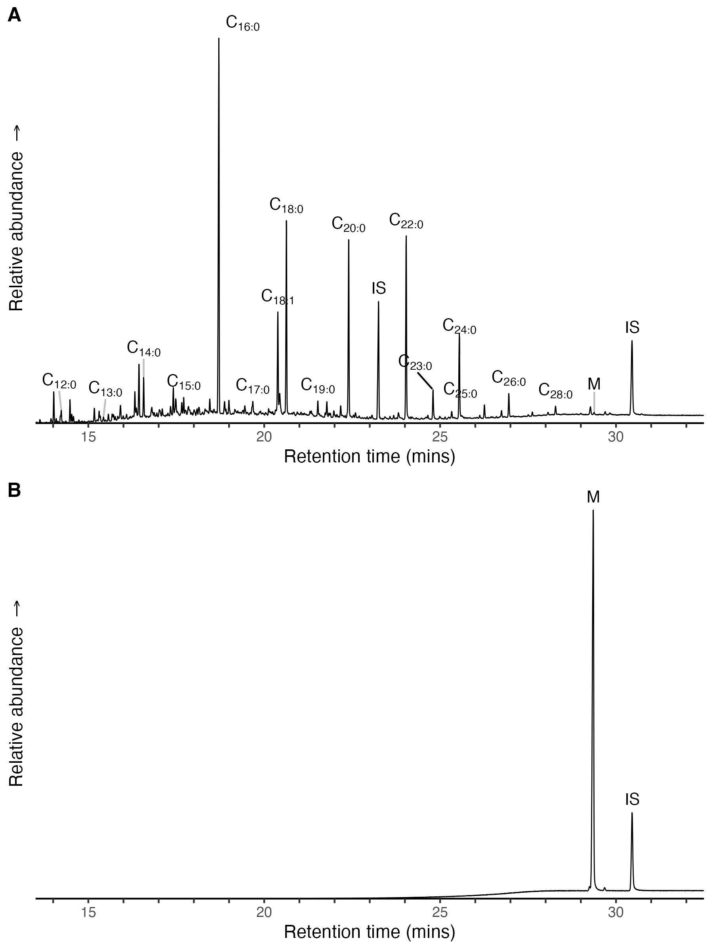

Figure 4.2: A: Partial total ion current (TIC) chromatogram of a Guijiabao sample, SYG-TN13-E22-2#2, showing the presence of long-chain fatty acids and miliacin. Cn:x refers to fatty acid with n carbon atoms and x double bonds; IS indicates internal standards (FA C21:0 and n-tetratriacontane); M refers to miliacin. B: Partial TIC chromatogram of miliacin (olean-18-en-3β-ol ME) with n-tetratriacontane as internal standard

To identify the sources of degraded lipids, we conducted compound-specific carbon isotope analysis of C16:0 and C18:0 using GC-C-IRMS. This technique has proven useful to distinguish fat origin between ruminant, non-ruminant, ruminant dairy products, C3 plants, C4 plants, and marine resources based on their stable carbon isotope values (hereafter δ13C) (Dunne et al., 2012; Evershed, 2008a). For example, the δ13C values from marine sources or C4 plants are more enriched than those from ruminant adipose fat and C3 plants due to different metabolic or photosynthetic pathways (Copley et al., 2003; Cramp and Evershed, 2014; Meier-Augenstein, 2002). The values of δ13C16:0 and δ13C18:0 were plotted based on global modern references for the assessment of their origin. To minimize potential bias introduced from differential δ13C values across geographical regions, the values of δ13C16:0 and Δ13C (δ13C18:0 - δ13C16:0) were also plotted for identification of animal fats (Copley et al., 2003; Salque et al., 2013). Although it is hard to identify the exact food category in this case due to the limited accessibility to local animal bones or fats as reference samples, references from neighboring areas with cautious comparison still allow meaningful interpretation.

The isotope data shows that δ13C16:0 values range from -29.33 to -23.83 ‰, δ13C18:0 values vary from -30.71 to -26.29 ‰, and Δ13C values are between 0.06 and -2.46 ‰. Three potsherds from Guijiabao and Gaoshan fall within the global reference range for ruminant adipose fat, where one sample from Guijiabao (SYG-TN13-E22-2#2) has a more enriched δ13C16:0 (-23.83 ‰) than others. The enriched δ13C suggests that the diet of ruminants contains both C4 and C3 plants (Figure 4.3: B), while the depleted δ13C is related to a more C3 plant diet. While marine resources could potentially contribute to enriched δ13C values, the inland location of Guijiabao, situated approximately 1000 km away from the current South China Sea coast, restricts this possibility.

One specimen (SYG-TN13-E23-3) with Δ13C of 0.06 falls within the range for non-ruminant fats (Figure 4.3: B). Its relatively depleted δ13C~ values (δ13C16:0 of -28.29 ‰ and δ13C18:0 of -28.22 ‰) reflect input of C3 plants, terrestrial animals, or freshwater resources (Lucquin et al., 2016; Shoda et al., 2018). The two specimens (SYG-TN13-E22-1 and SYG-3) dating to the historical period clustered within a narrow range of δ13C16:0 (-28.39 to -27.89 ‰) and δ13C18:0 (-29 to -28.63 ‰) near the reference line, showing a mixing source of ruminant and non-ruminant fat (Copley et al., 2003). A mixture of lipids from different sources is possible because δ13C values could be influenced by multiple distinct products, such as ruminant fats and plants, in the same cooking event or separate cooking events over time (Evershed et al., 2002).

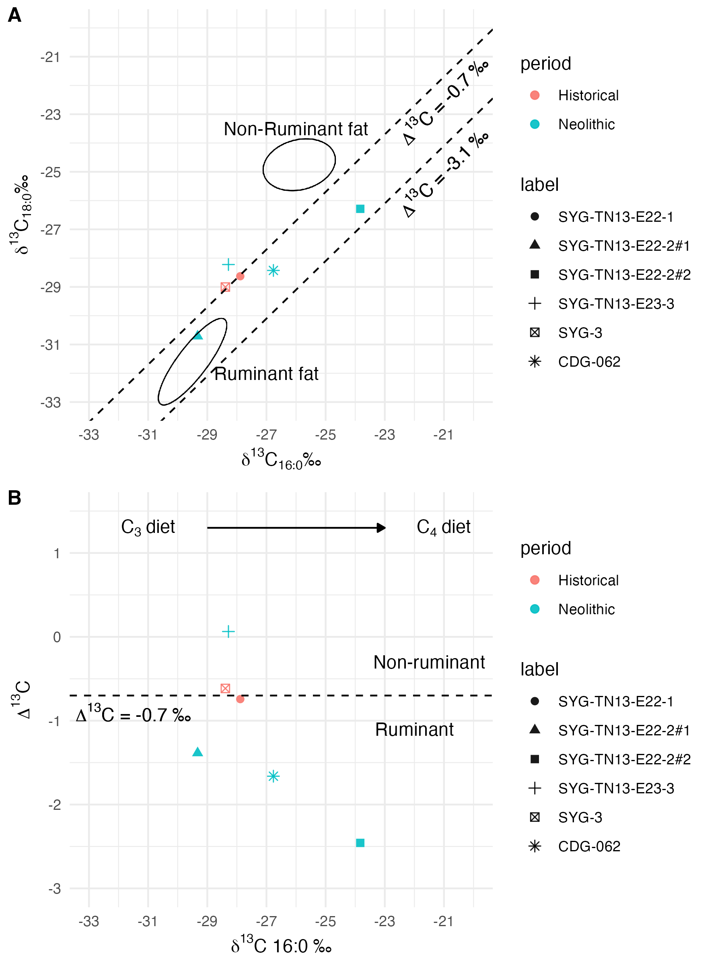

Figure 4.3: A: The distribution of stable carbon isotopes for C16:0 and C18:0. The ellipses represent modern animal references fed on a C3 diet (Copley et al. 2003). B: The Δ13C (δ13C18:0-16:0) values are plotted against δ13C16:0 values. The dash lines represent cut-offs for ruminant, non-ruminant, and ruminant dairy fats based on Suryanarayan et al. 2021

# 5 Discussion

Lipids extracted from potsherds at Guijiabao and Gaoshan all exceed interpretative amounts, with their profiles revealing the processing of both animal and plant products. This confirms the role of the pottery as cooking vessels or food storage at both sites. The generally low lipid concentrations (<20 μg/g) in five out of the six samples may be attributed to the bottom parts of vessels, which might absorb fewer residues compared to other parts, such as the rims, during cooking events (Charters et al., 1993; Evershed, 2008b; Kwak and Kim, 2020). Additional factors contributing to the low lipid yields could be post-depositional processes (Correa-Ascencio and Evershed, 2014), or diverse methods of food preparation, including grilling or air-drying (Zhang et al., 2022). We recognize challenges for interpreting our results due to the small sample size and the lack of a direct local reference from faunal bones at Guijiabao. These limitations constrain a thorough comparison of various types of evidence at the site. Despite these restrictions, the overall pattern of lipid profiles with isotopic values offers valuable insights into culinary practices.

Neolithic potsherds from Guijiabao and Gaoshan (ca. 5000-4500 BP) reveal food contents, including ruminant adipose fat (n= 3) and non-ruminant fat (n= 1). The ruminant adipose (Δ13C from -1.39 to -2.46 ‰) could have originated from deer, goat/sheep, or cattle based on the faunal remains from the site (Zhou et al., 2019) and archaeological contexts in northwest China (Sun et al., 2023), alongside a modern database (Evershed et al., 2002). At Guijiabao, the ruminants’ diet includes C3 plants (SYG-TN13-E22-2#1), and a mixture of C3 and C4 plants (SYG-TN13-E22-2#2). A C3 diet is supported by the predominance of C3 weeds, such as *Pennisetum* and *Chenopodiaceae* (Chengdu et al., 2016). Some species in *Chenopodiaceae* can undergo C4 photosynthesis in arid environments (Chasan et al., 2022; Rudov et al., 2020), which may explain the mixture of plant types in SYG-TN13-E22-2#2. The direct input from C4 plants could be another reason for the mixed signal, as we have identified millet in the same sample. The husbandry of ruminant animals detected in the samples remains unclear. It is also likely that those potsherds showing ruminant signal represent mixtures of non-ruminant adipose fats, such as those from aquatic resources, and ruminant milk fats (Evershed, 2008a). Considering the finding of hunting tools at Guijiabao, such as stone balls and arrowheads (Chengdu et al., 2020; Hao et al., 2022), with the abundance of wild ruminants in the natural settings of the Hengduan mountain ranges, such as deer, mutton, and yaks (Chen et al., 2020; He et al., 2020; Zhang et al., 2022; Zhang et al., 2016), it is plausible that subsistence at the site involving hunting to a certain degree.

The non-ruminant fat (SYG-TN13-E23-3) could originate from C3 plants or freshwater resources, based on similar isotopic ranges reported for Neolithic pottery in eastern China (Lyu et al., 2024; Shoda et al., 2018), and a global database (Steele et al., 2010). Possible source of C3 plants could include rice and wild weeds, supported by the presence of rice phytolichs and a small portion of carbonized seeds of wild weeds, such as *Pennisetum*, identified from the residential area at Guijiabao (Chengdu et al., 2016; Hao et al., 2022; Huan et al., 2022). A further detection of biomarkers for starchy plants with a specific derivatization method for lipid compounds will be necessary to assess the presence of rice oil (Shoda et al., 2018). Although freshwater resources might be another source of non-ruminant fats according to the finding of fish bones and net sinkers at Guijiabao (Liangshan et al., 2017), lipid molecular evidence for fish, such as ω-(o-alkylphenyl)alkanoic acids and isoprenoid fatty acids (Cramp and Evershed, 2014), was absent in our samples. The absence of these molecules could result from either their actual absence, or poor preservation of those compounds in archaeological contexts in general. Thus, we are unable to exclude the possibility of freshwater resources.

The possibility of terrestrial animal input for the non-ruminant fat, such as wild boar, cannot be ruled out. The isotopic values of the non-ruminant sample align with those of reference fats from modern wild boars in western Japan (Lucquin et al., 2016) and in the southeast Tibetan Plateau (Zhang et al., 2022). Although horses could be another non-ruminant fat source, it is less likely to have been part of the local diet in southwest China during the Neolithic period, given the only sporadic occurrences in the south (Zhang et al., 2022). Domesticated horses probably did not appear in southwest China until the Dian culture period (4th century BC to 1st century AD) in eastern Yunnan (Chiou-Peng, 2004; Lei et al., 2009), a period approximately 3000 years later than the Neolithic Guijiabao. Ongoing research on faunal remains from the site will provide more details for further discussion.

Our preliminary data reveals the predominance of ruminants fed on a C3 and C3/C4 diet in pottery vessels during the Neolithic period, suggesting a potentially more significant role of ruminants in local culinary practices than previously thought. Most studies have primarily focused on mixed farming of millet and rice as the main economy in southwest China after the introduction of agricultural in the Neolithic period (Deng, 2018). At Guijiabao, domesticated crops, especially broomcorn millet, constitute the majority of plants based on macro- and micro- botanical analyses (Chengdu et al., 2016; Huan et al., 2022). Nitrogen and carbon isotope analysis of human bones also suggests a more C4 diet (Lin et al., 2022). Additionally, stone knives found at the site might be potentially be used for farming practices (Hao et al., 2022; Lin et al., 2022; Zhou et al., 2019). In our study, a Neolithic potsherd containing the lipid compound of broomcorn millet provides direct evidence of millet processing at Guijiabao. Our non-ruminant specimen (SYG-TN13-E23-3), noted above, might indicate the processing of rice, though further analysis is needed for confirmation. It is important to note that lipid signatures of plants tend to be weak due to microbial degradation or being masked by animal fats (Colonese et al., 2017; Evershed, 2008b), possibly explaining why only one specimen in our sample had a non-ruminant signal. Nevertheless, the processing of ruminant meats in pottery, with unearthed hunting tools, suggests that animal hunting could be an essential subsistence strategy alongside crop consumption. This may also be a strategy adapted to highlands with cold environments where meat consumption is common (Zhang et al., 2022), or to reduce the impact of potential crop failure (B. Wang et al., 2023).

The two historical potsherds (ca. 1200-500 BP) from Guijiabao demonstrates mixtures of ruminant adipose and non-ruminant fats, implying a potential increase in the exploitation of C3 plants, pigs, or freshwater resources compared to the Neolithic period. In addition to rice, the source of C3 plants could also have included wheat, which was introduced into the region during the late Bronze Age (ca. 2,800–2000 cal. BP) (Huan et al., 2022). It is surprising that ruminant adipose fat, rather than non-ruminant fat, was detected in the Gaoshan potsherd, given the predominance of domestic pigs in the faunal assemblage at the site (He et al., 2020). One possibility might be our Gaoshan potsherd is an outlier, potentially not representative of the broader dietary patterns. Another plausible explanation could be that the isotopic values of ruminant adipose fat result from a mixture of non-ruminant adipose fats and ruminant milk fats. This possibility may be supported by the slightly enriched δ13C in the Gaoshan sample, suggesting minor contributions from non-ruminant fats, such as those from pigs (Evershed et al., 2002). Although determining changes in culinary practices over time and regional differences would require a larger sample size, our results contribute to improving our understanding of direct food practices during the spread of agriculture into southwest China through organic residues in ceramic vessels.

# 6 Conclusion

This paper presents preliminary results investigating pottery use and culinary practices at Guijiabao in the Yanyuan area, middle Hengduan mountain range, through organic residue analyses. Despite the small sample size, our results reveal a relatively diverse range of food categories cooked in pottery during the Neolithic period, including ruminant adipose fats, plants such as broomcorn millet, and non-ruminant sources. In the historical period, mixtures of ruminant adipose fats and non-ruminant fats were identified. Non-ruminant fats could have originated from C3 plants, pigs, or freshwater resources.

While a mixed crop of millet and rice is generally regarded as the main subsistence in southwest China, our findings show that other food sources, such as ruminant adipose fats, were also cooked in pottery. The detection of ruminant fats in Guijiabao samples might suggest the importance of meat consumption, an aspect often overlooked after the introduction of crops. Our results also correspond to an abundance of hunting tools at the site, implying that hunting and fishing might have played a crucial part in the local subsistence strategy, supplementing millet/rice farming. This sheds light on subsistence practices in the highlands of the Hengduan Mountains. Although our preliminary data has limitations for a comprehensive interpretation, the results demonstrate the feasibility of lipid identifications with compound-specific stable isotope analysis to estimate food content processed in ceramic vessels at Guijiabao. A more systematic sampling of potsherds across different phases and pottery types will contribute to a clearer understanding of diet and subsistence in southwest China in the future.

# 7 Acknowledgements

We thank the Chengdu Municipal Institute of Cultural Relics and Archaeology for their permission to access and analyze the pottery samples. Special thanks to Julian Sachs in the Department of Oceanography at the University of Washington for his support in letting us use their laboratory for lipid extraction and analysis. We also thank Matthew Wolhowe for his suggestions and assistance with the GC-based machines. Thanks to Yin-Ru Chiang and his team in the Biodiversity Research Center, and the Institute of Plant and Microbial Biology at Academia Sinica, Taiwan for their suggestions during the experiment. We appreciate the valuable comments provided by the anonymous reviewers, which helped improve this paper. This work was supported by the National Science and Technology Council (MOST 109-2410-H-001-009-MY2) and the Institute of History and Philology, Academia Sinica.

# 8 References

Bellwood, P., 2005. First farmers: The origins of agricultural societies. John Wiley & Sons.

Bossard, N., Jacob, J., Le Milbeau, C., Sauze, J., Terwilliger, V., Poissonnier, B., Vergès, E., 2013. Distribution of miliacin (olean-18-en-3-ol methyl ether) and related compounds in broomcorn millet (Panicum miliaceum) and other reputed sources: Implications for the use of sedimentary miliacin as a tracer of millet. Organic geochemistry 63, 48–55.

Charters, S., Evershed, R.P., Goad, L.J., Leyden, A., Blinkhorn, P.W., Denham, V., 1993. Quantification and distribution of lipid in archaeological ceramics: Implications for sampling potsherds for organic residue analysis and the classification of vessel use. Archaeometry 35, 211–223.

Chasan, R., Klimscha, F., Spiteri, C., Rosenberg, D., 2022. Foodways of an agro-pastoral community: Organic residue analysis of pottery and stone vessels at Middle Chalcolithic Tel Tsaf. Journal of Archaeological Science: Reports 43, 103491.

Chen, N., Ren, L., Du, L., Hou, J., Mullin, V.E., Wu, D., Zhao, X., Li, C., Huang, J., Qi, X., others, 2020. Ancient genomes reveal tropical bovid species in the Tibetan Plateau contributed to the prevalence of hunting game until the late Neolithic. Proceedings of the National Academy of Sciences 117, 28150–28159.

[Chengdu et al.] Chengdu Municipal Institute of Cultural Relics and Archaeology, Museum of Liangshan Yi Autonomous Prefecture, and Xichang Cultural Relics Management Institute, 2014. Xichang shi Henglanshan yizhi 2014 nian fuxuen jieguo ji chubu yanjiu [results and preliminary study of the flotation carried out at the Henglanshan site in Xichang in 2014], in: Chengdu Municipal Institute of Cultural Relics (Ed.), Chengdu Kaogu Faxian 2014 [Archaeological Discoveries in Chengdu 2014]. Beijing: Kexue chubanshe, pp. 115–134.

[Chengdu et al.] Chengdu Municipal Institute of Cultural Relics and Archaeology, Museum of Liangshan Yi Autonomous Prefecture, and Yanyuan Cultural Relics Management Institute, 2020. Yanyuan xian Guijiabao yizhi 2017 nian I qu fajiao jianbao [brief report on the zone I of the site of Guijiabao in Yanyuan County in 2017], in: Chengdu Municipal Institute of Cultural Relics (Ed.), Chengdu Kaogu Faxian [Archaeological Discoveries in Chengdu] 2018. Beijing: Kexue chubanshe, pp. 19–55.

[Chengdu et al.] Chengdu Municipal Institute of Cultural Relics and Archaeology, Museum of Liangshan Yi Autonomous Prefecture, and Yanyuan Cultural Relics Management Institute, 2016. 2015 nian Yanyuan xian Guijiabao yizhi, Daozuomiao yizhi chutu zhiwu yicun fenxi baogao [analytical report of the archaeobotanical remains from the sites of Guijiabao and Daozuomiao in Yanyuan County in 2015], in: Chengdu Municipal Institute of Cultural Relics (Ed.), Chengdu Kaogu Faxian [Archaeological Discoveries in Chengdu] 2014. Beijing: Kexue chubanshe, pp. 147–154.

[Chengdu et al.] Chengdu Municipal Institute of Cultural Relics, Archaeology and Museum of Liangshan Yi Autonomous Prefecture, and Yanyuan Cultural Relics Management Institute, 2017. Yanyuan xian Guijiabao yizhi 2015 niandu diaocha shijue jianbao [brief report of the survey and test excavation of the site of Guijiabao in Yanyuan County in 2015], in: Chengdu Municipal Institute of Cultural Relics (Ed.), Chengdu Kaogu Faxian [Archaeological Discoveries in Chengdu] 2015. Beijing: Kexue chubanshe, pp. 147–162.

[Chengdu] Chengdu Municipal Institute of Cultural Relics and Archaeology, 2017. Chengdu shi Dayi xian Gaoshan gucheng 2014 nian fajue jianbao [brief report on the excavation at Gaoshan walled site in the dayi county, chengdu, in 2014]. Kaogu [Archaeology] 4, 3–13.

Chiou-Peng, T., 2004. Horsemen in the Dian culture of Yunnan, in: Katheryn, M., Linduff, Y.S. (Eds.), Gender and Chinese Archaeology. Altamira Press Walnut Creek, pp. 289–314.

Colonese, A.C., Hendy, J., Lucquin, A., Speller, C.F., Collins, M.J., Carrer, F., Gubler, R., Kühn, M., Fischer, R., Craig, O.E., 2017. New criteria for the molecular identification of cereal grains associated with archaeological artefacts. Scientific Reports 7, 6633.

Copley, M., Bland, H.A., Rose, P., Horton, M., Evershed, R., 2005. Gas chromatographic, mass spectrometric and stable carbon isotopic investigations of organic residues of plant oils and animal fats employed as illuminants in archaeological lamps from Egypt. Analyst 130, 860–871.

Copley, M.S., Berstan, R., Dudd, S.N., Docherty, G., Mukherjee, A.J., Straker, V., Payne, S., Evershed, R.P., 2003. Direct chemical evidence for widespread dairying in prehistoric Britain. Proceedings of the National Academy of Sciences 100, 1524–1529.

Correa-Ascencio, M., Evershed, R.P., 2014. High throughput screening of organic residues in archaeological potsherds using direct acidified methanol extraction. Analytical Methods 6, 1330–1340.

Craig, O.E., Forster, M., Andersen, S.H., Koch, E., Crombé, P., Milner, N.J., Stern, B., Bailey, G.N., Heron, C.P., 2007. Molecular and isotopic demonstration of the processing of aquatic products in northern European prehistoric pottery. Archaeometry 49, 135–152.

Craig, O.E., Love, G.D., Isaksson, S., Taylor, G., Snape, C.E., 2004. Stable carbon isotopic characterisation of free and bound lipid constituents of archaeological ceramic vessels released by solvent extraction, alkaline hydrolysis and catalytic hydropyrolysis. Journal of Analytical and Applied Pyrolysis 71, 613–634.

Craig, O.E., Steele, V.J., Fischer, A., Hartz, S., Andersen, S.H., Donohoe, P., Glykou, A., Saul, H., Jones, D.M., Koch, E., others, 2011. Ancient lipids reveal continuity in culinary practices across the transition to agriculture in Northern Europe. Proceedings of the National Academy of Sciences 108, 17910–17915.

Cramp, L.J., Evershed, R.P., 2014. Reconstructing aquatic resource exploitation in human prehistory using lipid biomarkers and stable isotopes, in: Holland, H., Turekian, K. (Eds.), Treatise on Geochemistry: Archaeology and Anthropology. Amsterdam: Elsevier, pp. 319–339.

d’Alpoim Guedes, J., Hein, A., 2018. Landscapes of prehistoric northwestern Sichuan: From early agriculture to pastoralist lifestyles. Journal of Field Archaeology 43, 121–135.

d’Alpoim Guedes, J., Jiang, M., He, K., Wu, X., Jiang, Z., 2013. Site of Baodun yields earliest evidence for the spread of rice and foxtail millet agriculture to south-west China. Antiquity 87, 758–771.

d’Alpoim Guedes, J., Wan, J., 2015. Sichuan Shifangshi Guiyuanqiao yizhi fuxuan jieguo yu fenxi [flotation results and analysis at Guiyuanqiao site, Shifang City, Sichuan Province]. Sichuan Wenwu [Sichuan Cultural Relics] 5, 81–87.

Dal Martello, R., 2022. The origins of multi-cropping agriculture in Southwestern China: Archaeobotanical insights from third to first millennium BC Yunnan. Asian Archaeology 6, 65–85.

Deng, Z., 2018. The origin of foxtail and broomcorn millet and its southward dispersal in early period. Chinese Journal of Social Sciences 8, 1–9.

Dudd, S.N., Evershed, R.P., Gibson, A.M., 1999. Evidence for varying patterns of exploitation of animal products in different prehistoric pottery traditions based on lipids preserved in surface and absorbed residues. Journal of Archaeological Science 26, 1473–1482.

Dunne, J., Evershed, R.P., Salque, M., Cramp, L., Bruni, S., Ryan, K., Biagetti, S., Lernia, S. di, 2012. First dairying in green Saharan Africa in the fifth millennium BC. Nature 486, 390–394.

Evershed, R.P., 2008a. Organic residue analysis in archaeology: The archaeological biomarker revolution. Archaeometry 50, 895–924.

Evershed, R.P., 2008b. Experimental approaches to the interpretation of absorbed organic residues in archaeological ceramics. World Archaeology 40, 26–47.

Evershed, R.P., 1993. Biomolecular archaeology and lipids. World archaeology 25, 74–93.

Evershed, R.P., Arnot, K.I., Collister, J., Eglinton, G., Charters, S., 1994. Application of isotope ratio monitoring gas chromatography–mass spectrometry to the analysis of organic residues of archaeological origin. Analyst 119, 909–914.

Evershed, R.P., Dudd, S.N., Copley, M.S., Mutherjee, A., 2002. Identification of animal fats via compound specific 13C values of individual fatty acids: Assessments of results for reference fats and lipid extracts of archaeological pottery vessels. Documenta praehistorica 29, 73–96.

Ganzarolli, G., Alexander, M., Arnau, A.C., Craig, O.E., 2018. Direct evidence from lipid residue analysis for the routine consumption of millet in Early Medieval Italy. Journal of archaeological science 96, 124–130.

Hammann, S., Cramp, L.J., 2018. Towards the detection of dietary cereal processing through absorbed lipid biomarkers in archaeological pottery. Journal of Archaeological Science 93, 74–81.

Han, B., Sun, Z., Chong, J., Lyu, N., Rao, H., Yang, Y., 2022. Lipid residue analysis of ceramic vessels from the Liujiawa site of the Rui State (early Iron Age, north china). Journal of Quaternary Science 37, 114–122.

Hao, X., Zhou, Z., Liu, L., Tian, J., 2022. The Neolithic occupants in the Yanyuan Basin: Excavation of the burials at the Guijiabao site, Sichuan Province, Southwest China. Archaeological Research in Asia 29, 100341.

He, K.Y., Liu, X.Y., Chen, J., Q., Z.Z., L., L., 2020. Sichuan Dayi xian Gaoshan gucheng yizhi chutu xinshiqi shidai dongwu guge yicun [analysis on the animal bones unearthed at the Gaoshan walled site in Dayi County, Sichuan]. Sichuan Wenwu [Sichuan Cultural Relics] 1, 87–106.

Hein, A., 2016. Local developments on the eastern rim of the Tibetan Plateau: The prehistoric Anning River Valley. Archaeological Research in Asia 5, 72–87.

Hein, A.M., 2014. Interregional contacts and geographic preconditions in the prehistoric Liangshan Region, Southwest China. Quaternary International 348, 194–213.

Heron, C., Shoda, S., Breu Barcons, A., Czebreszuk, J., Eley, Y., Gorton, M., Kirleis, W., Kneisel, J., Lucquin, A., Müller, J., others, 2016. First molecular and isotopic evidence of millet processing in prehistoric pottery vessels. Scientific Reports 6, 38767.

Huan, X., Deng, Z., Zhou, Z., Yan, X., Hao, X., Bu, Q., Lu, H., 2022. The emergence of rice and millet farming in the Zang-Yi Corridor of Southwest China dates back to 5000 years ago. Frontiers in Earth Science 10, 874649.

Jiang, M., Hu, T., Bu, Q., Wang, H., 2016. Xichang shi Henglanshan yizhi 2011 nian ji 2013 nian fuxuen jieguo jianbao [brief results of the flotation carried out at the Henglanshan site in Xichang in 2011 and 2013], in: Cultural Relics, C.M.I. of (Ed.), Chengdu Kaogu Yanjiu [Archaeological Research in Chengdu] v.3. Beijing: Kexue chubanshe, pp. 503--515.

Jiang, M., Yan, X., 2017. Chengdu pingyuan shiqian shiqi zhiw kaogu de shijian yu sikao: Yi Baodun gucheng yizhihe Gaoshan gucheng yizhi weili [practice and reflection on archaeobotany in the prehistoric Chengdu Plain: Exemplified by the Baodun and Gaoshan walled sites]. Zhongguo wenhua yichan [China Cultural Heritage] 6, 69–74.

Junno, A., Isaksson, S., Hirasawa, Y., Kato, H., Jordan, P.D., 2020. Evidence of increasing functional differentiation in pottery use among Late Holocene maritime foragers in northern Japan. Archaeological Research in Asia 22, 100194.

Kałużna-Czaplińska, J., Rosiak, A., Kwapińska, M., Kwapiński, W., 2016. Different analytical procedures for the study of organic residues in archeological ceramic samples with the use of gas chromatography-mass spectrometry. Critical reviews in analytical chemistry 46, 67–81.

Kimpe, K., Drybooms, C., Schrevens, E., Jacobs, P., Degeest, R., Waelkens, M., 2004. Assessing the relationship between form and use of different kinds of pottery from the archaeological site Sagalassos (southwest Turkey) with lipid analysis. Journal of Archaeological Science 31, 1503–1510.

Kwak, S., Kim, G., 2020. Understanding ancient human subsistence through the application of organic residue analysis on prehistoric pottery vessels from the Korean Peninsula. Journal of Conservation Science 36, 244–254.

Lee, C.-Y., Lin, K.-C., Zhou, Z., Chen, J., Liu, X., Yuan, H., Wang, P.-L., 2020. Reconstructing subsistence at the Yingpanshan and Gaoshan sites in Sichuan province, China: Insights from isotope analysis on bone samples and charred crop remains. Archaeometry 62, 172–186.

Lei, C., Su, R., Bower, M., Edwards, C.J., Wang, X., Weining, S., Liu, L., Xie, W., Li, F., Liu, R., others, 2009. Multiple maternal origins of native modern and ancient horse populations in China. Animal Genetics 40, 933–944.

Li, M.S., 1989. Hengduan shanqu turang quhua [soil zones in the Hengduan Mountain region]. Shandi xuebao [Journal of Mountain Science] 7, 38–46.

[Liangshan et al.] Museum of Liangshan and Yanyuan Cultural Relics Management Institute and Chengdu Municipal Institute of Cultural Relics and Archaeology, 2017. 2015 nian Yanyuan pen di kao gu diao cha jian bao [brief report of the survey of archaeological sites in the Yanyuan Basin in 2015], in: Chengdu Municipal Institute of Cultural Relics (Ed.), Chengdu Kaogu Faxian [Archaeological Discoveries in Chengdu] 2015. Beijing: Kexue chubanshe, pp. 116–132.

Lin, K., Lee, C.-Y., Wang, P.-L., 2022. A multi-isotope analysis on human and pig tooth enamel from prehistoric Sichuan, China, and its archaeological implications. Archaeological and Anthropological Sciences 14, 1–25.

Liu, L., Chen, J., Wang, J., Zhao, Y., Chen, X., 2022. Archaeological evidence for initial migration of Neolithic Proto Sino-Tibetan speakers from Yellow River valley to Tibetan Plateau. Proceedings of the National Academy of Sciences 119, e2212006119.

Lucquin, A., Gibbs, K., Uchiyama, J., Saul, H., Ajimoto, M., Eley, Y., Radini, A., Heron, C.P., Shoda, S., Nishida, Y., others, 2016. Ancient lipids document continuity in the use of early hunter-gatherer pottery through 9,000 years of Japanese prehistory. Proceedings of the National Academy of Sciences 113, 3991–3996.

Lyu, N., Yan, L., Wang, T., Lin, L., Rao, H., Yang, Y., 2024. Characterization of pottery foodcrusts through lipid and proteomic analyses: A case study from the Xiawan site in Yixing city, East China. Journal of Archaeological Science 161, 105902.

Ma, M., Lu, Y., Dong, G., Ren, L., Min, R., Kang, L., Zhu, Z., Li, X., Li, B., Yang, Z., others, 2021. Understanding the transport networks complex between South Asia, Southeast Asia and China during the late Neolithic and Bronze Age. The Holocene 09596836221131698.

Marwick, B., 2017. Computational reproducibility in archaeological research: Basic principles and a case study of their implementation. Journal of Archaeological Method and Theory 24, 424–450. <https://doi.org/10.1007/s10816-015-9272-9>

Marwick, B., Wang, L.-Y., 2022. How to align disciplinary ideals with actual practices: Transparency and openness in archaeological science, in: Watrall, E., Goldstein, L. (Eds.), Digital Heritage and Archaeology in Practice: Data, Ethics, and Professionalism. University Press of Florida, pp. 194–219.

Mayyas, A., Douglas, K., Al-Qudah, M., Al-Ajlouny, F., Kreshan, D., 2022. Lipid markers in archaeological pottery vessels excavated at Jneneh site, in North-Central Jordan. Journal of Archaeological Science: Reports 43, 103410.

McClure, S.B., Magill, C., Podrug, E., Moore, A.M., Harper, T.K., Culleton, B.J., Kennett, D.J., Freeman, K.H., 2018. Fatty acid specific 13C values reveal earliest Mediterranean cheese production 7,200 years ago. PLoS One 13, e0202807.

Meier-Augenstein, W., 2002. Stable isotope analysis of fatty acids by gas chromatography–isotope ratio mass spectrometry. Analytica Chimica Acta 465, 63–79.

Miller, M.J., Whelton, H.L., Swift, J.A., Maline, S., Hammann, S., Cramp, L.J., McCleary, A., Taylor, G., Vacca, K., Becks, F., others, 2020. Interpreting ancient food practices: Stable isotope and molecular analyses of visible and absorbed residues from a year-long cooking experiment. Scientific reports 10, 13704.

Museum, Y.P., 1981. Yunnan Binchuan Baiyangcun yizhi [the site of Baiyangcun in Binchuan, Yunnan]. Kaogu Xuebao [Acta Archaeological Sinica] 3, 349–368.

Post-Beittenmiller, D., 1996. Biochemistry and molecular biology of wax production in plants. Annual review of plant biology 47, 405–430.

Roffet-Salque, M., Dunne, J., Altoft, D.T., Casanova, E., Cramp, L.J., Smyth, J., Whelton, H.L., Evershed, R.P., 2017. From the inside out: Upscaling organic residue analyses of archaeological ceramics. Journal of Archaeological Science: Reports 16, 627–640.

Rudov, A., Mashkour, M., Djamali, M., Akhani, H., 2020. A review of C4 plants in southwest Asia: An ecological, geographical and taxonomical analysis of a region with high diversity of C4 eudicots. Frontiers in plant science 11, 546518.

Salque, M., Bogucki, P.I., Pyzel, J., Sobkowiak-Tabaka, I., Grygiel, R., Szmyt, M., Evershed, R.P., 2013. Earliest evidence for cheese making in the sixth millennium BC in northern Europe. Nature 493, 522–525.

Shoda, S., Lucquin, A., Sou, C.I., Nishida, Y., Sun, G., Kitano, H., Son, J., Nakamura, S., Craig, O.E., 2018. Molecular and isotopic evidence for the processing of starchy plants in Early Neolithic pottery from China. Scientific reports 8, 1–9.

Steele, V.J., Stern, B., Stott, A.W., 2010. Olive oil or lard?: Distinguishing plant oils from animal fats in the archeological record of the eastern Mediterranean using gas chromatography/combustion/isotope ratio mass spectrometry. Rapid Communications in Mass Spectrometry 24, 3478–3484.

Stevens, C.J., Fuller, D.Q., 2017. The spread of agriculture in eastern asia: Archaeological bases for hypothetical farmer/language dispersals. Language Dynamics and Change 7, 152–186.

Sun, N., Ma, Q., Han, B., Yang, Y., 2023. New insights into the subsistence strategies of the northwest frontier of the Western Zhou Dynasty (1046–771 BCE) through pottery lipid analysis. Archaeological and Anthropological Sciences 15, 80.

Suryanarayan, A., Cubas, M., Craig, O.E., Heron, C.P., Shinde, V.S., Singh, R.N., O’Connell, T.C., Petrie, C.A., 2021. Lipid residues in pottery from the Indus Civilisation in northwest India. Journal of archaeological science 125, 105291.

Tong, E., 1986. Shi lun wo guo cong dongbei zhi xinan de biandi banyuexing wenhua chuanbodai [the notion of the crescent-shaped cultural-communication belt stretching from the Northeast to the Southwest China], in: Wenwu chubanshe (Ed.), Wenwu Yu Kaogu Lunwenji [Proceedings of Cultural Relics and Archaeology]. Beijing: Wenwu chubanshe, pp. 17–43.

Wang, B., Liu, H., Liu, Y., Sun, Z., Chen, X., Hein, A., 2023. Patterns of spread and adoption of millet agriculture along the eastern rim of the Tibetan Plateau: Archaeobotanical evidence from Houzidong, Southwest China (4200–4000 cal. BP). Archaeological Research in Asia 35, 100448.

Wang, X., Liu, X., Yan, X., Jiang, M., Zhou, Z., Chen, J., Jin, G., 2023. Baodun wenhua zaoqi de nongye shijian —lai zi Dayi Gaoshan gucheng yizhi de zhiwu yicun zhengju [agricultural practices of the early Baodun Culture: From the perspective of the plant remains at Gaoshan site in Dayi County, Sichuan Province]. Disiji yanjiu [Quaternary Sciences] 43(5), 1429–1443.

Zhang, C., Hung, H., 2010. The emergence of agriculture in southern China. Antiquity 84, 11–25.

Zhang, Y., Gao, Y., Yang, J., Wang, Y., Wang, Y., Sun, Q., Chen, S., Wang, Q., Ran, J., He, W., others, 2022. Patterns in pottery use reveal different adaptive strategies between lower and higher altitude regions on the Tibetan Plateau: Chemical evidence from pottery residues. Journal of Archaeological Science 138, 105544.

Zhang, Y., Lu, Y., Yindee, M., Li, K.-Y., Kuo, H.-Y., Ju, Y.-T., Ye, S., Faruque, M.O., Li, Q., Wang, Y., others, 2016. Strong and stable geographic differentiation of swamp buffalo maternal and paternal lineages indicates domestication in the China/Indochina border region. Molecular ecology 25, 1530–1550.

Zhao, Z.J., Chen, J., 2011. Sichuan Maoxian Yingpanshan yizhi fuxuan jieguo ji fenxi [results of the flotation carried out at Yingpanshan site in Maoxian County, Sichuan]. Nanfang Wenwu [Relics from South] 3, 60–67.

Zhou, Z.Q., Chen, J., Liu, X.Y., Bai, T.Y., 2015. Quyu xitong diaocha fangfa zai Chengdu pingyuan dayizhi juluo kaogu zhong de shijian yu shouhuo -yi Gaoshan gucheng yizhi weili [the practice and harvest of the systematic regional survey on the large settlements of the Chengdu Plain: Exemplified by the Gaoshan walled site]. Zhongguo wenhua yichan [China Cultural Heritage] 6, 32–37.

Zhou, Z., Sun, C., Tian, J., Liu, X., 2019. Sichuan Yanyuan Guijiabao yizhi [Guijiabao site in the Yanyuan County, Sichuan], in: Cultural Relics, C.M.I. of (Ed.), Zhongguo Zhongyao Kaogu Faxian [Major Archaeological Discoveries in China] 2018. Beijing, pp. 36–38.