Investigating Neolithic pottery use from Guijiabao in the Yanyuan Basin in southwestern China using organic residue analysis

Li-Ying Wang1,✉, Kuei-chen Lin1, and Zhiqing Zhou2

16 April, 2023

The spread of new crops or terrestrial animals across areas in southwestern China during the Neolithic period is one of the important archaeological issues to understand the process of adoption of new culinary practices in this region. It is widely accepted that rice was introduced into southwest China in 4700 BP at the latest and millets came even earlier. However, to what extent new crops were used by local peoples at that time remains unclear. The excavation of Guijiabao in the Yanyuan basin in southwestern China uncovered abundant materials with well-preserved stratigraphic records and has provided a unique opportunity to understand the local adoption of new crops. To further understand pottery use and food practices at Guijiabao, we investigated organic residues preserved in potsherds using lipid biomarker identification and compounds-specific stable isotope analysis. The results show signals of terrestrial animals in most potsherds and a C3 plant source in one potshard, during the Neolithic period. Our case study indicates that hunting might have been the primary means for obtaining subsistence, supplemented by rice/millet farming. This study also demonstrates an approach using organic residue analysis to explore the extent of the adoption of farming during the Neolithic period in southwestern China.

1 Institute of History and Philology, Academia Sinica  
2 Chengdu Institute of Cultural Relics and Archaeology

✉ Correspondence: [Li-Ying Wang <[liyingw@asihp.net](mailto:liyingw@asihp.net)>](mailto:liyingw@asihp.net)

Keywords: Southwestern China; Neolithic period; Lipid residue analysis; Stable isotope analysis; Ceramics; Culinary practices

Highlights: These are the highlights.

# 1 Introduction

Movements of people between geographically distinct areas are usually accompanied by the exchange of goods, technology, or ideas that could have cultural or economic impacts on local people groups involved in the interactions (Burmeister, 2000). The Hengduan Mountain ranges and valleys in southwestern China are geographical areas that connect the Qinghai-Tibetan Plateau and the Yunnan–Guizhou Plateau and by which movement to these plateaus must occur. They play an important role in the cultural exchanges and spread of crops into southwestern China and even further to mainland Southeast Asia (Hao et al., 2022; Lin et al., 2022; Ma et al., 2021; Tong, 1986). Despite a long-standing debate on the routes of rice/millet dispersal from northwest China and the middle Yangtze valley to southwestern China (d’Alpoim Guedes et al., 2013; d’Alpoim Guedes and Hein, 2018; Liu et al., 2022), it is widely accepted that mixed farming was practiced in southwestern Sichuan around 4700 BP and in western Yunnan before 4600 BP (Chen et al., 2015; Dal Martello, 2022; Hao et al., 2022; Jiang et al., 2016; Museum, 1981; Zhang and Hung, 2010). The Hengduan Mountain regions in the Neolithic period are therefore essential for understanding the processes of agricultural expansion. Recent archaeological evidence from the Yanyuan Basin in the middle Hengduan Mountains further reveals that millet and rice were present at roughly the same period as the grains found in Sichuan (Hao et al., 2022; Huan et al., 2022). However, to what extent the two crops were incorporated into the local diet is still not fully understood.

To explore whether new crops or terrestrial animals became important food sources during the Neolithic period in the Yanyuan Basin, we investigated food residues within ceramic vessels from Guijiabao, a long-term occupation settlement with complete temporal sequences from the Neolithic period to the historical period in Yanyuan that have been excavated so far (Cultural Relics et al., 2020, 2017). The new evidence at Guijiabao reveals that millet and rice were both present there in the Neolithic period around 5000 BP, earlier than previously thought (Cultural Relics et al., 2016), and millet could have already been part of the local diet (Lin et al., 2022). Although some of these analyses suggest the presence of mixed millet/rice farming (Huan et al., 2022), we still lack direct evidence of culinary practices during this period. To understand the extent of consuming new crops or terrestrial animals at Guijiabao, we ask the questions: What were the culinary practices that can be deduced by the pottery? Can we identify the new crops or terrestrial animals that were incorporated into the local food diets during the Neolithic period? We answer these questions by examining potsherds using organic residue analysis, which allows us to directly explore food cooked or processed in ceramic vessels.

The recent growing application of organic residue analysis demonstrates its usefulness in understanding ancient pottery use (Kimpe et al., 2004; Mayyas et al., 2022), human subsistence strategies, or culinary practices across a region over time (Craig et al., 2011; Junno et al., 2020; Kwak and Kim, 2020; Suryanarayan et al., 2021; Zhang et al., 2022). Examining organic residues, particularly lipids, enables archaeologists to investigate ancient food practices through lipid distributions and specific lipid compounds as biomarkers for tracing food origins (Copley et al., 2005; Whelton et al., 2021). This is possible due to the protection of clay matrices from microbiological degradation and water leaching, which allows lipid molecules to accumulate and be well preserved in the porous fabric of pottery for over a thousand years (Evershed, 2008a, 1993; Roffet-Salque et al., 2017). In this study, we detected and identified lipid residues absorbed into the ceramic matrix that can reveal the original contents cooked or stored in a vessel during its lifetime of use (Dudd et al., 1999; Miller et al., 2020). Through our case study, we attempt to investigate culinary practices during a period of frequent cultural interactions that accompanied agricultural expansion.

# 2 Geographical and Cultural Background of Guijiabao in Yanyuan Basin

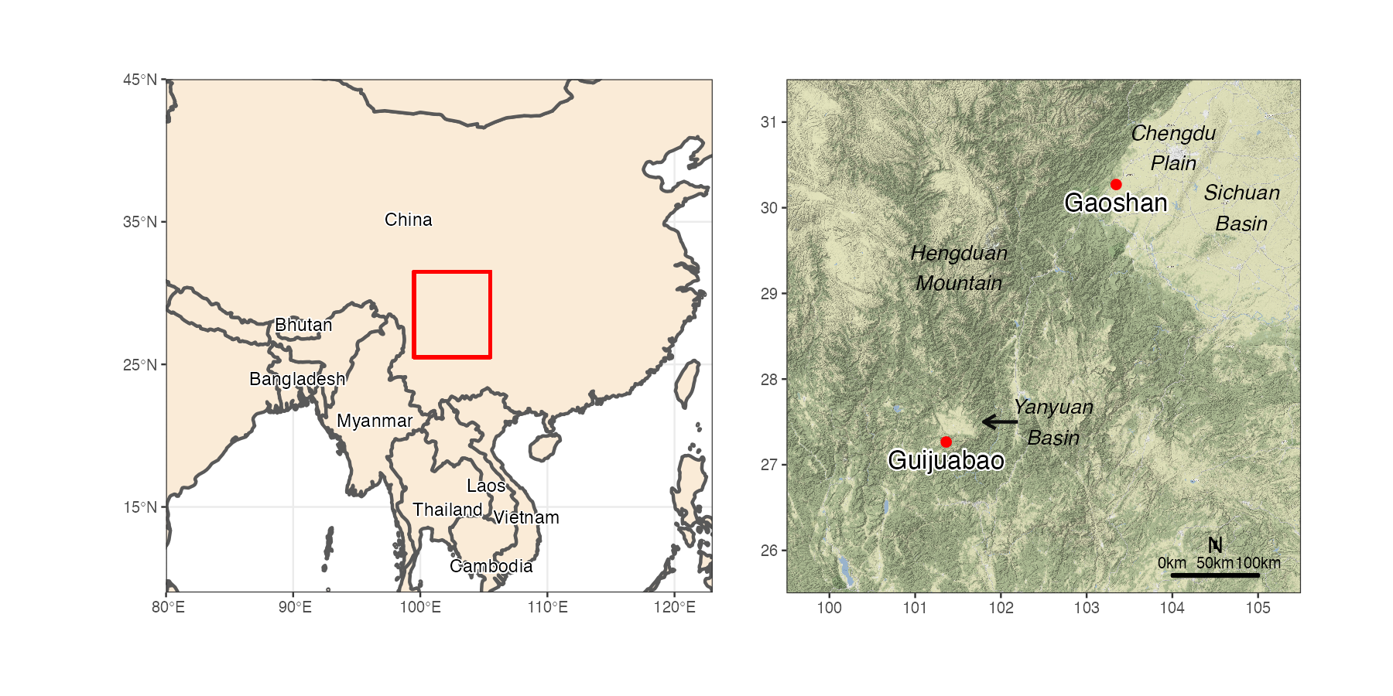

Figure 2.1: The archaeological sites Guijiabao and Gaoshan and other locations in southwestern China that are mentioned in this study. Map data is from naturalearthdata.com

We focus on the Guijiabao site located in the Yanyuan Basin, which is a pull-apart basin in the middle eastern part of the Hengduan Mountain ranges (Figure 2.1). The Guijiabao site allows us to understand the early adoption of agriculture because of its uniqueness and rarity: it contains complete cultural components from the Neolithic period to the historical period in that region (Cultural Relics et al., 2017; Liangshan Yi Autonomous Prefecture et al., 2017). A survey in 2015 and subsequent excavations from 2016 to 2019 revealed abundant archaeological materials and features, such as semi-subterranean houses, ground houses, post holes, ash pits, ditches, and burials, suggesting that Guijiabao was a settlement site (Hao et al., 2022). The chronology of the Guijiabao site can be divided into three phases, the Neolithic period (5000-3700 BP), the Bronze Age (3200-2700 BP), and the late North Song to early Ming dynasties (1200-500 BP) based on 19 radiocarbon dates from plant remains and a human bone. For the Neolithic period, it can be further divided into two subphases, 5000-4500 BP and 4500-3700 BP, according to the content of artifact assemblages and ceramic forms and styles that were identified (Hao et al., 2022).

The common vessel forms unearthed at the Guijiabao site include jars, urns, bowls, and basins. The representative ceramic styles in the Neolithic period are grayish high-tempered fine ware and reddish brown coarse ware with decorations such as cord-marked and basket-impressed patterns (Cultural Relics et al., 2017; Hao et al., 2022). Some ceramic decorations present northern styles, and some ceramics with incised geometric patterns and impressed dot patterns resemble those found in western Yunnan, indicative of relationships between the Guijiabao site and sites in Yunnan and the southern part of the Hengduan Mountains (Cultural Relics et al., 2017). Plant remains reveal that cultivated crops were dominated by foxtail millet (*Setaria italica*) and broomcorn millet (*Panicum miliaceum*) based on flotation samples collected from ash pits and stratigraphic layers that can be traced back to 5000 BP (Cultural Relics et al., 2016; Hao et al., 2022). This corresponds to a C4-based diet based on isotopic analysis of four human bones (Lin et al., 2022). In addition to millet, a smaller number of rice grains (*Oryza sativa*) has also been found in ash pits, where the earliest one dates to 4700 BP (Hao et al., 2022). A detailed phytolith analysis for soil samples dating to the Neolithic period (5000-3700 BP) further suggests the presence of rice phytoliths throughout the temporal sequences (Huan et al., 2022).

To compare the culinary practices in different ecological zones, we examined a sample from the Gaoshan site in the southwestern Chengdu Plain, an alluvial plain in the western Sichuan Basin at the foot of the Qinghai-Tibetan Plateau (Figure 2.1). Excavations at the Gaoshan site reveal abundant materials, including ceramics, stone artifacts, animal and plant remains, and archaeological features such as house foundations, walls, burials, ash pits, ditches, and a well (Cultural Relics and Archaeology, 2017; He et al., 2020; Jiang and Yan, 2017; Zhou et al., 2015). According to similar pottery forms and styles, the Gaoshan site can be dated to the early Baodun period, the earliest Neolithic culture (ca. 4700-3700 BP) in the Chengdu Plain (Cultural Relics and Archaeology, 2017). The primary subsistence strategy at the Gaoshan site could have been rice cultivation with pig husbandry, supplemented by millet cultivation (He et al., 2020; Jiang and Yan, 2017; Lee et al., 2020). It is suggested that the spread of rice farming into the Sichuan area occurred at least 4700 years ago from people moving from the Middle and Lower Yangzi valleys to the Sichuan area (Zhang and Hung, 2010).

Although the recent findings at the Guijiabao and Gaoshan sites support mixed agriculture as the primary subsistence strategy, it is still unclear how much millet or rice was included in the local diets during the Neolithic period. The macro-botanical and phytolith analyses of the Guijiabao site show that millet was the major crop, similar to the findings at the Yingpanshan site in Sichuan (Zhao and Chen, 2011). However, plant remains from many sites in southwestern China reveal a predominance of rice, such as at the Gaoshan and Baodun sites in Sichuan (Jiang and Yan, 2017) and Baiyangcun sites in Yunnan (Cultural Relics et al., 2014; Jiang et al., 2016). This indicates that there were variations in agricultural practices in southwestern China. To better understand the extent of the adoption of new crops, organic residue analysis of ceramics is a useful approach since we can directly study food residues related to culinary practices, including food preparation, processing, and cooking. This provides another way to examine the expansion of agriculture in the Yanyuan area.

# 3 Materials and methods

## 3.1 Samples

We selected ceramic fragments that were identified as typical from the Guijiabao and Gaoshan sites. The fragments date to the Neolithic (around 4500 BP) and historical (around 1000 BP) (Table 3.1), which were determined from known contexts based on radiocarbon dating. Ceramic fragments from the Guijiabao site were excavated from trench 13 excavated during the 2017 field season, along with one fragment from the 2016 season. The pottery samples are mostly gray base fragments with fine sand temper, of which a few have impressed decorations. Although their original forms could not be recovered, the evidence of chars on some fragments and their contexts in cultural layers suggest that these ceramics were used in daily life (Cultural Relics et al., 2017; Hao et al., 2022). This research also attempts to confirm that these pottery vessels were used as cooking/storage wares for food.

Table 3.1: A list of the pottery sherds that were analyzed in this study. The sherd labeled ‘SYG’ indicates potsherds from the Guijiabao site, while the label ‘CDG’ refers to those from the Gaoshan site

| Sherd label | Field season | Analyzed part | Time period | Ceramic Description |
| --- | --- | --- | --- | --- |
| SYG-TN13-E22-1 | 2017 | base-body | historical | gray 7.5YR5/2, coarse temper, impressed decoration |
| SYG-TN13-E22-2#1 | 2017 | base-body | Neolithic | red 2.5YR5/2, fine temper |
| SYG-TN13-E22-2#2 | 2017 | base-body | Neolithic | gray 7.5YR5/3, fine temper, chars on interior side |
| SYG-TN13-E23-3 | 2017 | base-body | Neolithic | gray 7.5YR4/3, fine temper |
| SYG-3 | 2016 | base | historical | gray 7.5YR4/1, fine temper |
| CDG-062 | 2015 | body | Neolithic | gray 7.5YR4/2, coarse temper, cord-marked, chars on exterior side |

## 3.2 Methods

We detected and identified lipid compounds using gas chromatography mass spectrometry (GC-MS) and quantified lipids using gas chromatography with flame-ionization detection (GC-FID). To distinguish the source of the common fatty acids, palmitic (C16:0) and stearic (C18:0), which are found in most animals and plants, we identified their stable carbon isotope characteristics using gas chromatography combustion isotope ratio mass spectrometry (GC-C-IRMS). The stable carbon isotope ratio for individual lipid compounds is a powerful indicator of the origins of fatty acids since different food categories, such as terrestrial animals, marine animals, and plants, have specific ranges of δ13C values (Craig et al., 2007, 2004; Evershed et al., 1994).

For sample processing, the surface of each potsherd was removed to prevent external contamination from environmental factors and handling during excavation or post-excavation analysis. Approximately 3.5 grams of powdered samples were extracted with a mixture of dichloromethane/methanol solution (9:1 v/v) using accelerated solvent extraction (ASE Dionex 350; at 100 °C). We conducted saponification by adding 10 mL of 1M KOH in methanol and 1 mL water to the extracts and heating them in an oven at 70 °C overnight. Saponified extracts were acidified with 6M hydrochloric acid (HCl), and the acid fraction was extracted using hexane ( mL). A 5% aliquot of each sample was derivatized using 20 uL N,O-bis(trimethylsilyl)trifluoroacetamide (BSTFA) with 1% v/v trimethylchlorosilane (TMCS), and heated at 70 °C for one hour. After drying under a stream of nitrogen, the derivatized sample was dissolved in toluene prior to GC-MS.

The remaining 95% aliquot was fractioned using solid phase extraction (Aminopropyl, NH2, column with 0.5 g sorbent) with 8 mL dichloromethane:Isopropyl alcohol (3:1), 8 mL 4% acetic acid in ethyl ether, and 6 mL methanol. The second fraction was methylated to produce fatty acid methyl esters (FAMEs) with 1 mL dry hexane and 2 mL 10% (v/v) acetyl chloride in dry methanol, and heated at 70 °C overnight. The FAME derivatives were extracted with hexane ( mL) and then blown down with nitrogen streams. About 5% aliquot dissolved in toluene was analyzed by GC-FID for quantification, and the remaining sample was analyzed using GC-C-IRMS. With each batch of samples, we prepared analytical blanks to check for potential contamination sources that might have come from solvents and reagents. Internal standards were added before and after the lipid extraction for quantification.

The GC-MS analysis was performed using an Agilent 7683 B series gas chromatograph attached to an Agilent 5975 inert mass selective detector. Samples were injected in splitless mode at 320 °C, and compounds were separated with a VF-17ms column (60 m length, 0.25 mm i.d., 0.25 μm film thickness). The carrier gas was helium set at a constant flow rate of 1.3 ml/min. The temperature of the oven was set at 90 °C and held for 1 minute and then was increased at a rate of 5 °C/min to 320 °C, where it was held for 23 minutes. The GC-FID analysis for the FAME samples was carried out using Agilent 6890N gas chromatograph equipped with a PTV inlet in splitless mode. The carrier gas was helium flowing at a rate of 1.6 ml/min. The GC system was an Agilent 6890N equipped with a programmed temperature vaporization (PTV) inlet in splitless mode. The GC oven was set at 90°C and held for 1.3 minute, and then was raised to 320°C at a rate of 5°C/min. The final temperature was set for 22 minutes. The GC-C-IRMS analyses of FAMEs of individual fatty acids were conducted using a Thermo Delta V Plus mass spectrometer linked to a GC Trace 1310 through an Isolink Interface. The sample injection volume was 1 ul in toluene and was injected in splitless mode. Separation was carried out using the same model of column for GC-MS and the GC oven temperature was set at 90 °C for 1.5 minutes and then was raised at a rate of 5 °C/min to 320 °C, with an 18-minute hold. Helium was used as a gas carrier with a constant flow rate of 1.24 ml/minute.

The raw data and R code used for visualizations contained in this paper and R Markdown documents are available online at <https://github.com/LiYingWang/GJBpottery> to enable research reproducibility and transparency (Marwick, 2017; Marwick and Wang, 2022).

# 4 Results

The GC-MS analysis for organic residues extracted from potsherds found at the Guijiabao and Gaoshan sites revealed that the presence of lipid compounds were above interpretable concentrations (5 μg/g) (Evershed, 2008b), but were in relatively small amounts in the majority of the potsherds (Table 4.1]. The lipid profiles show that the main compounds in most potsherds were saturated fatty acids with an even number of carbons, particularly C16:0 (palmitic acid), C18:0 (stearic acid), and monounsaturated fatty acid C18:1 (oleic acid) (Figure 4.1). These fatty acids commonly exist in animal fat and plant oil. They are also generally degraded from larger molecules, such as triacylglycerols, due to oxidation and microbial degradation after long-term burial processes (Dudd et al., 1998; Eerkens, 2007). High concentrations of medium-chain fatty acids (C16:0 and C18:0) with an even-over-odd carbon chain length predominance indicate that the organic residues in our potsherds were highly degraded during post-depositional processes. In addition, a number of potsherds had higher contents of C18:1 compared to C18:0 and C16:0, such as SYG-TN13-E23-3. A higher content of C18:1 and C16:0 with a lower content of C18:0 might indicate the origin of plant oils (Copley et al., 2005; Mayyas, 2018). However, we may still need to examine their isotopic values to confirm their sources.

Table 4.1: Quantitative data of fatty acid (FA) composition (μg/g) for each pottery sample based on GC-FID analysis

| FA | SYG-TN13-E22-1 | SYG-TN13-E22-2#1 | SYG-TN13-E22-2#2 | SYG-TN13-E23-3 | SYG-3 | CDG-062 |
| --- | --- | --- | --- | --- | --- | --- |
| C14:0 | 0.13 | 0.09 | 0.4 | 0.38 | 0.12 | 1.3 |
| C15:0 | - | - | 0.14 | - | - | 0.84 |
| C16:0 | 3.5 | 2.01 | 32.24 | 3.91 | 2.84 | 7.29 |
| C17:0 | - | - | 0.12 | - | - | 0.27 |
| C18:1 | 3.95 | 2.54 | 0.68 | 7.28 | 2.52 | 1.86 |
| C18:0 | 4.16 | 2.06 | 5.56 | 4.68 | 3.07 | 3.57 |
| C19:0 | - | - | 3.04 | - | - | - |
| C20:0 | - | - | 1.48 | 0.37 | 0.14 | 0.83 |
| C22:0 | 0.51 | 0.28 | 1.45 | 1.36 | 0.16 | 1.23 |
| C23:0 | - | - | 0.53 | - | - | - |
| C24:0 | - | - | 1.74 | 0.82 | - | 0.18 |
| C26:0 | - | - | 0.35 | - | - | - |
| C27:0 | - | - | 0.08 | - | - | - |
| C28:0 | - | - | 0.2 | - | - | - |
| C30:0 | - | - | 0.22 | - | - | - |
| C32:0 | - | - | 0.41 | - | - | - |

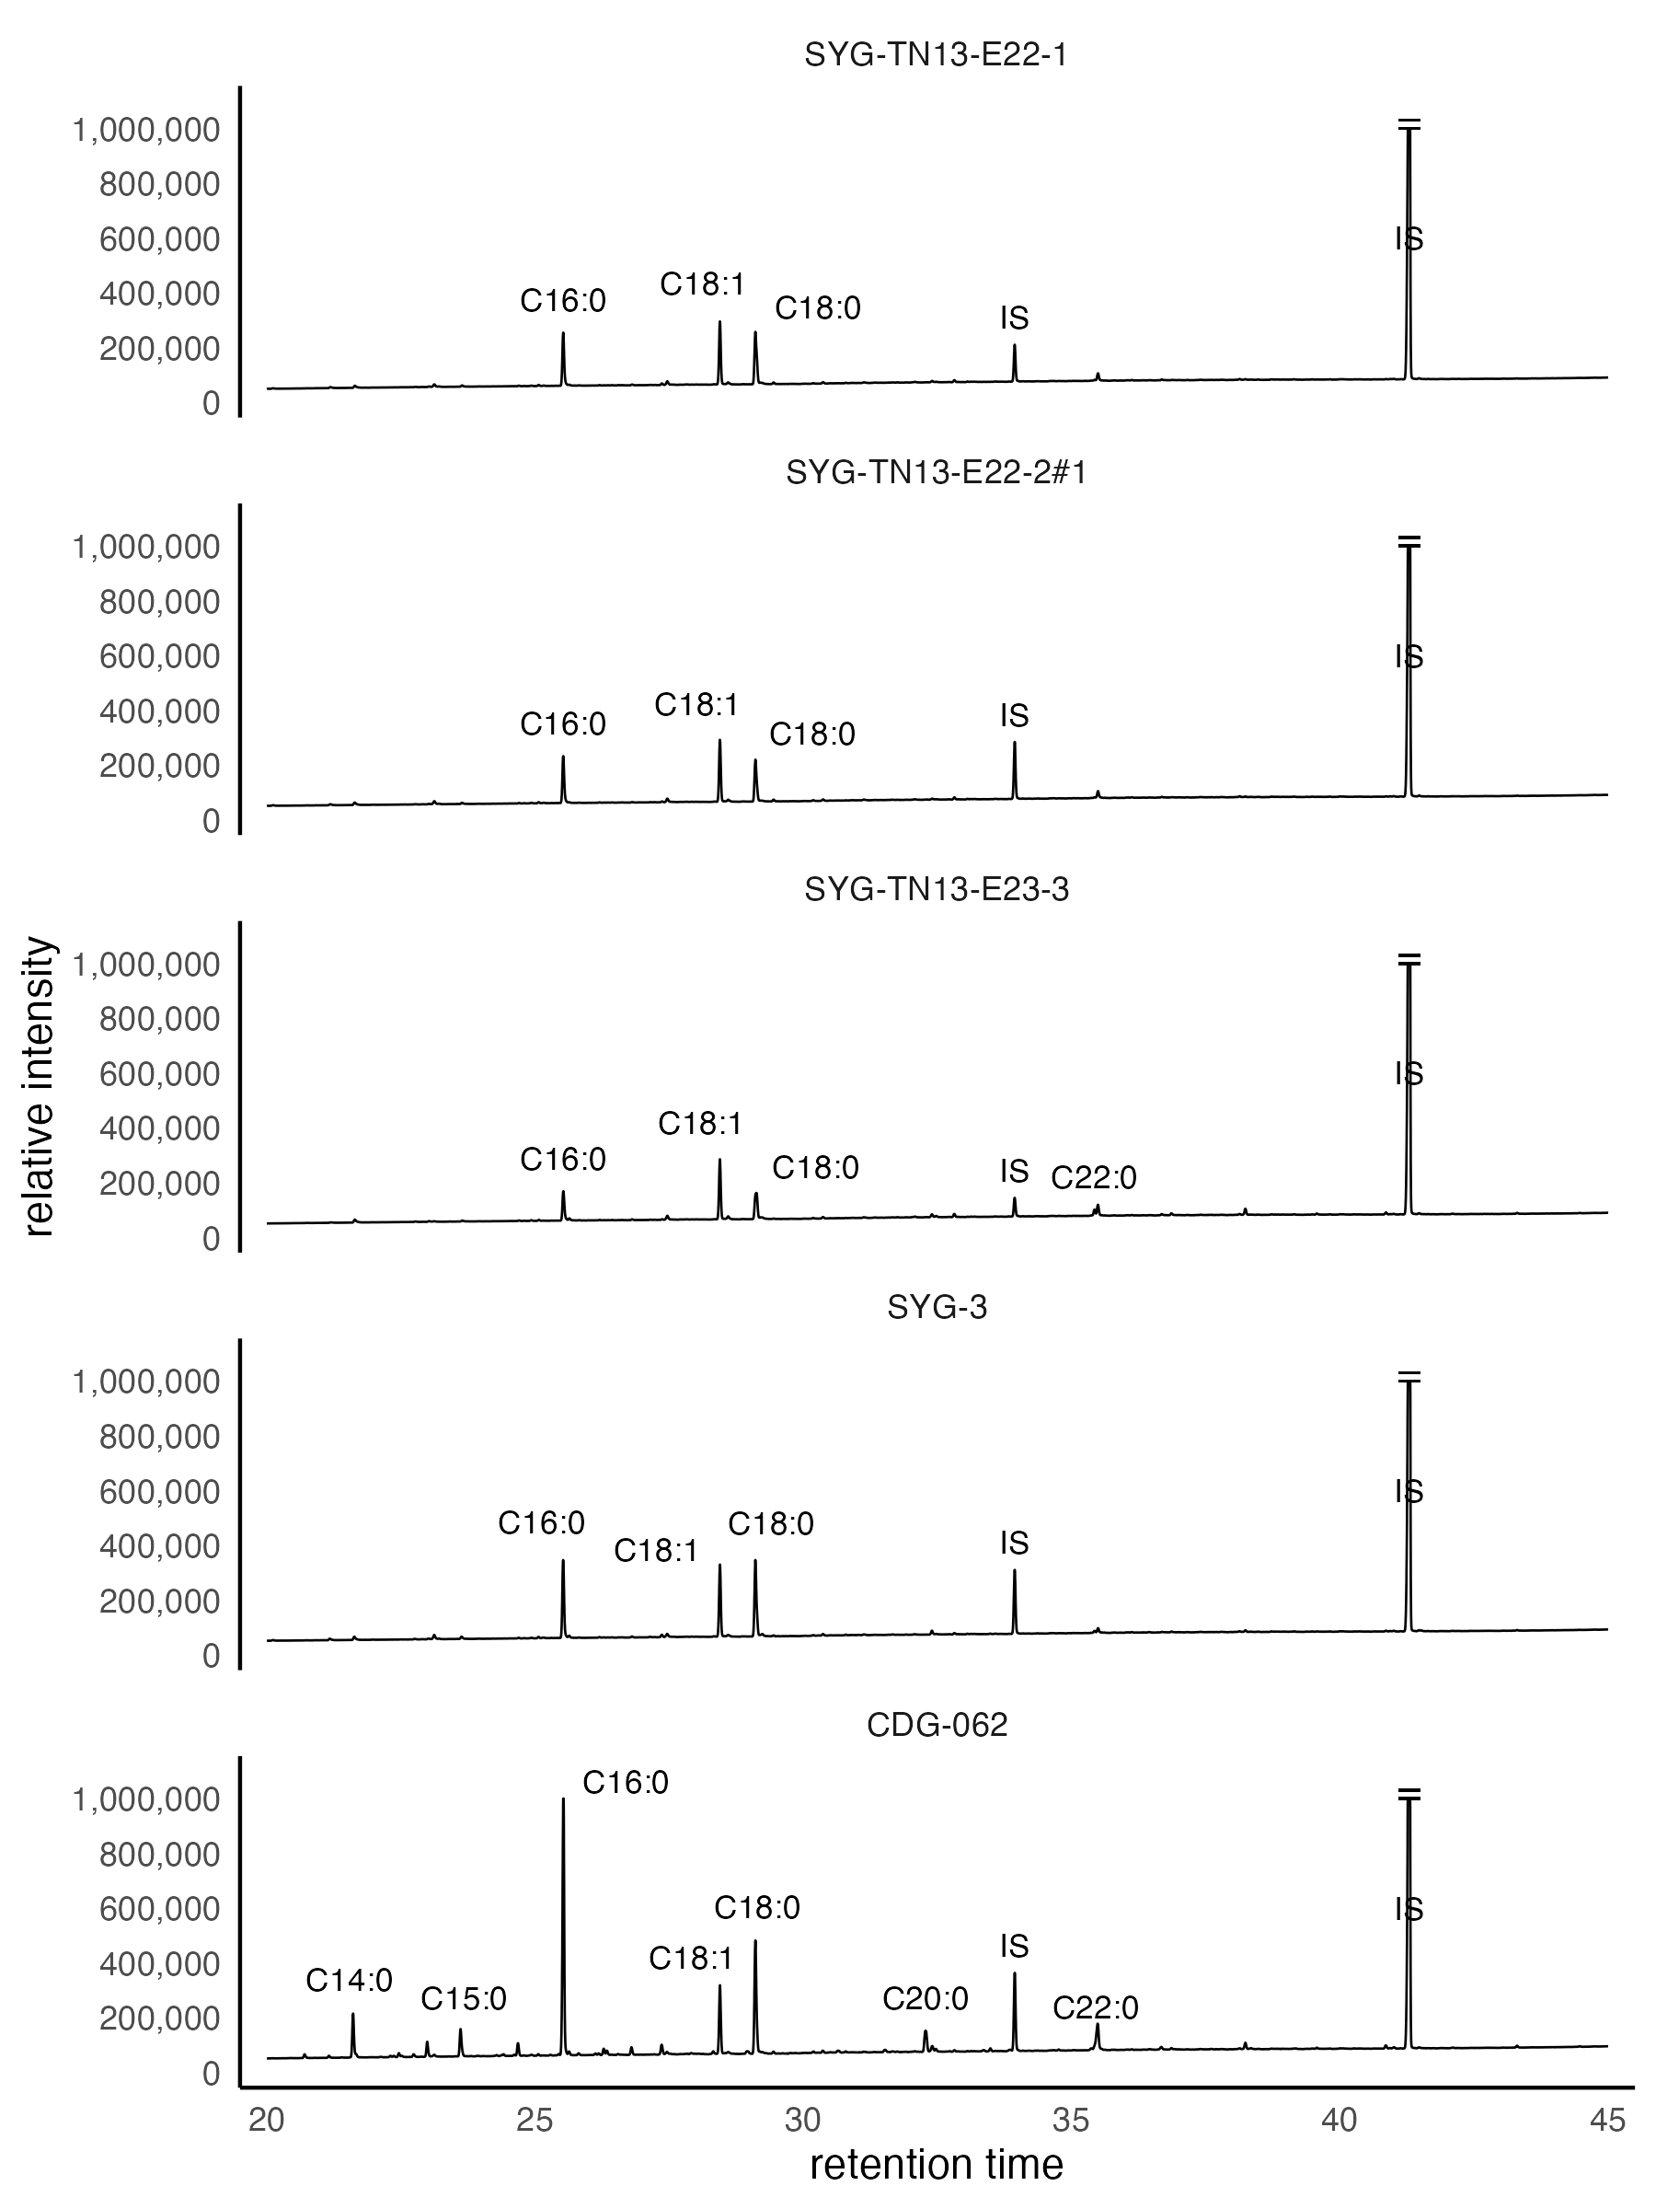

Figure 4.1: GC-MS chromatograms of fatty acids extracted from four potsherds from the Guijiabao and Gaoshan sites. ‘Cn:x’ refers to fatty acid with n carbon atoms and x double bonds. ‘IS’ indicates internal standard used for quantification, including FA C21:0 and 5-α Cholestane

One pottery sample (SYG-TN13-E22-2#2) has much higher lipid concentrations (about 51.25 μg/g) than the rest of the samples. A higher yield of lipids might relate to the texture and type of ceramic used or better archaeological contexts for preservation. This sample also has a charred interior surface, indicative of a function associated with food processing. Long-chain fatty acids from C20:0 to C32:0 are present in that sample, with an even-over-odd carbon chain length predominance, but in lower amounts than in medium-chain components (Figure 4.2). The existence of long-chain fatty acids with a high amount of C16:0 relative to C18:0 might be related to plant waxes (Copley et al., 2005; Post-Beittenmiller, 1996). However, it could also be associated with degraded animal fat based on a strong predominance of medium-chain fatty acids (Dudd et al., 1998; Whelton et al., 2018). Overall, the GC-MS results demonstrate strong evidence of degraded animal fats.

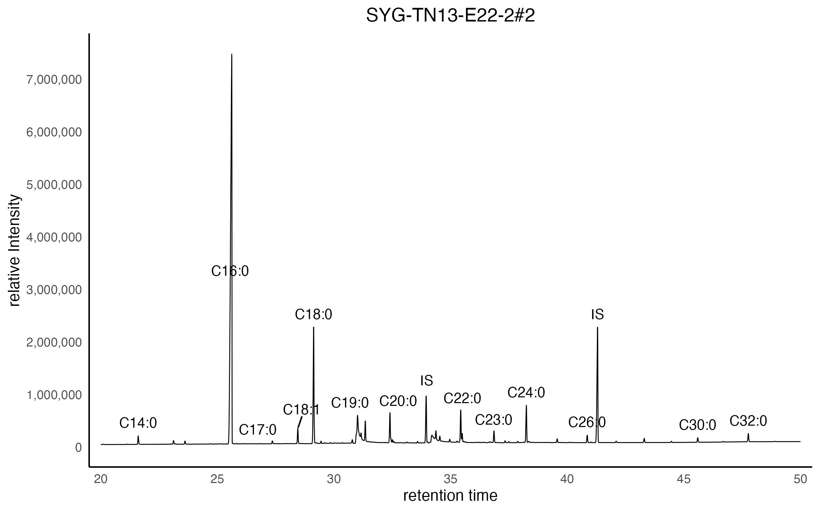

Figure 4.2: The MS chromatogram of the potsherd from the Guijiabao site shows the presence of long-chain fatty acids. ‘Cn:x’ refers to fatty acid with n carbon atoms and x double bonds. ‘IS’ indicates internal standards used for quantification, including FA C21:0 and 5-α Cholestane

To identify the sources of degraded animal fats, we conducted isotope analysis to obtain stable carbon isotope compositions, δ13C values of C16:0 and C18:0, using GC-C-IRMS. The δ13C values of C16:0 and C18:0 have proven useful to distinguish between ruminant adipose, non-ruminant adipose, and ruminant dairy fats based on the different ways dietary carbon sources are utilized by different fat types (Copley et al., 2003; Dunne et al., 2012; Evershed, 2008a). To reduce the bias caused by differential δ13C values across geographical regions, we used the Δ13C (δ13C18:0 - δ13C16:0) values to determine the sources of degraded fats (Evershed, 2008a; Salque et al., 2013). The carbon isotope values for C16:0 and C18:0 have a distribution between -30.71 and -23.83, and their Δ13C values range from -2.46 ‰ to 0.06 ‰. The Δ13C values were plotted according to the global reference database for the identification of their origins (Dunne et al., 2012; Evershed, 2008a; Suryanarayan et al., 2021).

The results show that the majority of the potsherd samples from the Guijiabao site contain fatty acids from ruminant adipose fats, with one potsherd sample (SYG-TN13-E23-3) indicating a non-ruminant adipose fat origin (Figure 4.3: A). Analysis of the potsherd from the Gaoshan site (CDG-062) indicates ruminant adipose fats as well. The potsherds (SYG-TN13-E22-1 and SYG-3) from the Guijiabao site dating to the historical period were plotted on the reference line between ruminant adipose and non-ruminant, indicative of the mixing of these two origins (Copley et al., 2003; Dudd and Evershed, 1998; Suryanarayan et al., 2021). Furthermore, the potsherd representing non-ruminant adipose fats has a relatively low 13C value (Figure 4.3: B), which is consistent with the value range of C3/terrestrial plants or freshwater fish (Kwak and Kim, 2020; Shoda et al., 2018). This also corresponds to the lipid distribution of the same potsherd detected by GC-MS, reflecting a possible plant origin based on the GC-MS results. Although the referenced isotopic values should be ideally adjusted in terms of local environments, they could still provide useful information for determining food categories.

In general, most potsherd samples containing ruminant adipose fats have depleted δ13C values consistent with the δ13C values of C3/terrestrial plants, suggesting these ruminant animals seemed to have consumed mainly C3 plants. There is only one Neolithic potsherd (SYG-TN13-E22-2#2) with a relatively large δ13C value, suggesting a C4-based diet for the ruminant animal.

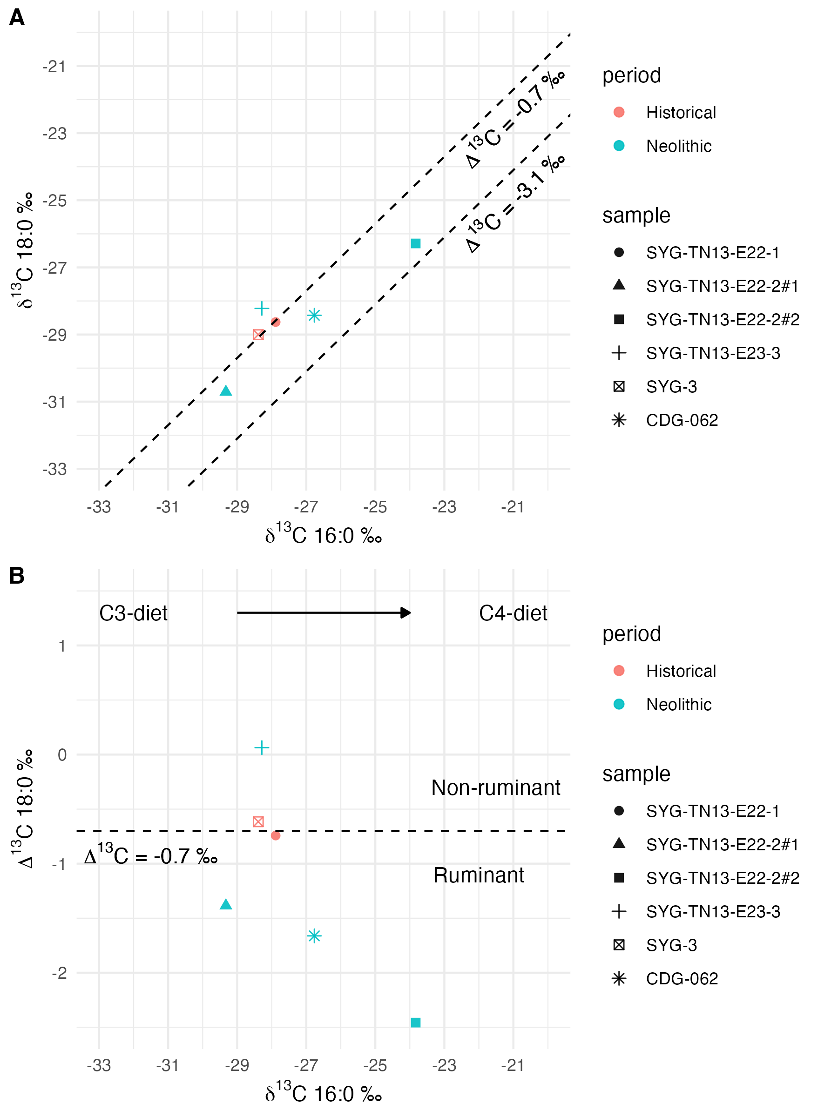

Figure 4.3: A: The distribution of stable carbon isotopes for C16:0 and C18:0. B: The Δ13C (δ13C18:0-16:0) values are plotted against δ13C16:0 values

# 5 Discussion

The aim of this paper is to explore whether new crops, such as C4 plants (e.g., millets) and C3 plants (e.g., rice), or animals (e.g., pigs/horses) became an essential part of the local diet in Yanyuan during the Neolithic period. Our results show that food residues in potsherds from the sites at Guijiabao and Gaoshan were dominated by ruminant fats during the Neolithic period. Moreover, it is striking to discover that non-ruminant fats in a Guijiabao potsherd might have originated from C3 plants (see below). Although the lipid yields in most of our samples are generally low, interpretative amounts of yields from all of our samples support the assumption that these ceramics were used as cooking or storage vesssels. The low lipid yield could be attributed to the bottom of the vessels, where there were fewer residues than other parts of the vessel, for example, the rim (Charters et al., 1993; Evershed, 2008b; Kwak and Kim, 2020). But we also found that one sample from the vessel bottom dated to the Neolithic period contains a richer composition of long-chain fatty acids compared with those in other samples, reflecting better preservation or a much higher lipid yield. We recognize that there are limitations and challenges for determining lipid sources over time or differences across regions due to our small sample sizes and a lack of local modern references for animal fats and plant oils. In addition, a detailed analysis of faunal remains from the Guijiabao site is still in progress, which may constrain a comprehensive comparison between different types of evidence. Nevertheless, the general pattern of lipid profiles could still provide informative clues for a better understanding of culinary practices at the Guijiabao site.

While it has been determined that millets (C4 plants), including foxtail and broomcorn millets, were the dominant cereals, according to recent macro-botanical and phytolith studies at Guijiabao (Cultural Relics et al., 2016; Hao et al., 2022; Huan et al., 2022), we did not detect any lipid residues associated with C4 plants in our samples. Surprisingly, we identified non-ruminant fats from a Guijiabao potsherd that might have been from terrestrial plants/C3 plants, based on similar isotopic values reported by other studies in East Asia (Kwak and Kim, 2020; Shoda et al., 2018). According to the results from flotation analysis at the Guijiabao site, it is possible that the source of C3 plants is rice or native wild weeds, such as pennisetum and chenopodiaceae. However, the seeds of wild weeds only account for a small part of the floral assemblage derived from flotation (Cultural Relics et al., 2016). Despite stone knives and tools that were also found at the sites that might have been related to farming practices, more studies are needed to confirm their usage for harvesting crops (Hao et al., 2022; Lin et al., 2022; Zhou et al., 2019). Another possible source for non-ruminant fats could have been freshwater fish, a possibility which can be supported by the finding of fish bones and net sinkers at Guijiabao (Liangshan Yi Autonomous Prefecture et al., 2017). But we did not identify any lipid biomarkers related to aquatic resources, such as long-chain -(o-alkylphenyl) alkanoic acids or phytanic acid (Cramp and Evershed, 2014; Evershed et al., 2008; Hansel et al., 2004; Lucquin et al., 2016), from our potsherds.

The ruminant fats identified in the Neolithic potsherds (ca. 4500 BP) from the Guijiabao and Gaoshan sites could have been derived from deer, sheep, or horses that were fed on a C3 diet, based on their isotopic values that are consistent with global references (Evershed et al., 2002; Mileto et al., 2017). This finding, especially the consumption of deer, also corresponds with unearthed faunal remains from the sites and the local natural environments. Stone artifacts found at the site, including stone balls and arrowheads, further indicate hunting activities (Cultural Relics et al., 2020; Hao et al., 2022). However, whether horse was part of local food choices in southwestern China around 4500 years ago is doubtful. First, the Pleistocene and Neolithic sites having wild horse bones are primarily concentrated in northern China, with only sporadic sites in the south (Yuan and Flad, 2006). Second, domesticated horses first found in southwestern China date to the Dian culture (4th century BC to 1st century AD) in eastern Yunnan (Chiou-Peng, 2004; Lei et al., 2009), which is 3000 years later than the Neolithic period that we are focusing on. Thus, supported by faunal evidence, deer was most likely the predominant local food choices. It is also possible that local wild bovids, such as yaks or water buffalo, were food sources during this period, as these animals have been found in sites in southwestern China (Chen et al., 2020; Zhang et al., 2016).

We observed a mixture of ruminant fats and C3 plants, based on analyses of a number of Guijiabao potsherds that date to the historical period (ca. 1000 BP). It appears that C3 plants could have been processed more in the historical period than they could have been in the Neolithic period. In addition to rice, the source of C3 plants could also have included wheat, since it was introduced into the region during the historical period (Jiang and Yan, 2017). A larger sample size is needed to determine whether there was a change in diet over time. The overall depleted δ13C values for potsherd samples associated with ruminant fats suggest that C3 plants might have been an important food source for local animals. Despite direct C4 plant signals not being found, analysis of one Guijiabao potsherd shows the source of C4 plant-fed ruminants during the Neolithic period. This indicates that either C3 or C4 plants could have been the food source for ruminants, but whether those animals were domesticated is unknown. The zooarchaeological analysis of faunal bones from Guijiabao is still in progress, the results of which could provide more details about local animal species for comparison.

In general, based on our results, ruminant fats from local wild animals, such as deer, were the predominant food source during the Neolithic period for peoples at Guijiabao. A subsistence that relied on hunting to a certain degree could be plausible, given the abundance of wild animals in the natural settings of the Hengduan mountain ranges, as indicated by the faunal remains from the Yingpanshan site (He et al., 2020). Crop cultivation could have been adopted as a supplement to local food sources when it was introduced in the Neolithic period, but crops might have only accounted for a small proportion of the food sources. A previous study using isotopic analysis of human bones suggests that the diet at the Guijiabao site was a C4-based diet (Lin et al., 2022), but we only identified a signal from C3 plants from one pottery sample without any signal from C4 plants. This inconsistency could have resulted from different sampling strategies or from the sample size issue, where our results reflect only a small portion of food content. Nevertheless, our results suggest that farming practices during the Neolithic period might not have been adopted as much as we previously thought. An approach analyzing organic residues may only provide a narrow perspective on local diets, but it could improve our current understanding of food practices through presence of food residues that were cooked in ceramic vessels. A large-scale organic residue analysis of ceramics across different pottery forms in a wider region would offer insight into temporal and regional variations in the local diet during the Neolithic period in southwestern China.

# 6 Conclusion

Our case study on organic residues in pottery fragments from the sites at Guijiabao and Gaoshan in southwestern China reveals the presence of lipids that can be analyzed to determine food sources. The foods cooked in the ceramics included ruminant fats and terrestrial plants during the Neolithic period, when millet and rice spread into southwestern China. The source of terrestrial plants could have been C3 plants, implying the cooking of rice or other wild weeds in the pots. However, the evidence of direct cooking of either C3 or C4 plants shows that the amount of C3/C4 plants cooked is not in proportion to the large quantity of plant remains found at the Guijiabao site, especially C4 plants such as millet. Instead, ruminant fats from local animals, such as wild deer, could have been a common food source during the Neolithic period. This suggests that hunting might have been an important part of local subsistence strategy, supplemented by rice/millet farming when they were introduced. Our results from the Guijiabao site could represent a subsistence strategy for adapting to the natural environment of the Hengduan Mountains. We recognize the limitations of our interpretation of the local diet due to the small sample size. Nevertheless, our study could offer an approach using organic residue analysis to determine food choices and explore the extent of the adoption of farming when rice/millet agriculture first spread into the Yanyuan area during the Neolithic period. A more systematic sampling of potsherds across different phases and pottery types may give a clear picture of diet and subsistence in southwestern China during the Neolithic period of transition.

# 7 Acknowledgements

We thank the Chengdu Municipal Institute of Cultural Relics and Archaeology for their permission to access and analyze the pottery samples. We thank Julian Sachs in the Department of Oceanography at the University of Washington for his support in letting us use their laboratory for sample preparation and for conducting lipid extraction and analysis. We thank Matthew Wolhowe for his suggestions and assistance with the GC-based machines. We also want to express our gratitude to the anonymous reviewers for their comments that helped us improve this paper. This research is sponsored by the National Science and Technology Council (MOST 109-2410-H-001-009-MY2).

# 8 References

Burmeister, S., 2000. Archaeology and migration: Approaches to an archaeological proof of migration. Current anthropology 41, 539–567.

Charters, S., Evershed, R.P., Goad, L.J., Leyden, A., Blinkhorn, P.W., Denham, V., 1993. Quantification and distribution of lipid in archaeological ceramics: Implications for sampling potsherds for organic residue analysis and the classification of vessel use. Archaeometry 35, 211–223.

Chen, C., Zhang, J., Yang, Y., 2015. The spread of cultivated rice into Southwest China. Journal of Anthropology and Archaeology 3, 65–77.

Chen, N., Ren, L., Du, L., Hou, J., Mullin, V.E., Wu, D., Zhao, X., Li, C., Huang, J., Qi, X., others, 2020. Ancient genomes reveal tropical bovid species in the Tibetan Plateau contributed to the prevalence of hunting game until the late Neolithic. Proceedings of the National Academy of Sciences 117, 28150–28159.

Chiou-Peng, T., 2004. Horsemen in the Dian culture of Yunnan, in: Katheryn, M., Linduff, Y.S. (Eds.), Gender and Chinese Archaeology. Altamira Press Walnut Creek, pp. 289–314.

Copley, M., Bland, H.A., Rose, P., Horton, M., Evershed, R., 2005. Gas chromatographic, mass spectrometric and stable carbon isotopic investigations of organic residues of plant oils and animal fats employed as illuminants in archaeological lamps from Egypt. Analyst 130, 860–871.

Copley, M.S., Berstan, R., Dudd, S.N., Docherty, G., Mukherjee, A.J., Straker, V., Payne, S., Evershed, R.P., 2003. Direct chemical evidence for widespread dairying in prehistoric Britain. Proceedings of the National Academy of Sciences 100, 1524–1529.

Craig, O.E., Forster, M., Andersen, S.H., Koch, E., Crombé, P., Milner, N.J., Stern, B., Bailey, G.N., Heron, C.P., 2007. Molecular and isotopic demonstration of the processing of aquatic products in northern European prehistoric pottery. Archaeometry 49, 135–152.

Craig, O.E., Love, G.D., Isaksson, S., Taylor, G., Snape, C.E., 2004. Stable carbon isotopic characterisation of free and bound lipid constituents of archaeological ceramic vessels released by solvent extraction, alkaline hydrolysis and catalytic hydropyrolysis. Journal of Analytical and Applied Pyrolysis 71, 613–634.

Craig, O.E., Steele, V.J., Fischer, A., Hartz, S., Andersen, S.H., Donohoe, P., Glykou, A., Saul, H., Jones, D.M., Koch, E., others, 2011. Ancient lipids reveal continuity in culinary practices across the transition to agriculture in Northern Europe. Proceedings of the National Academy of Sciences 108, 17910–17915.

Cramp, L.J., Evershed, R.P., 2014. Reconstructing aquatic resource exploitation in human prehistory using lipid biomarkers and stable isotopes, in: Holland, H., Turekian, K. (Eds.), Treatise on Geochemistry: Archaeology and Anthropology. Amsterdam: Elsevier, pp. 319–339.

Cultural Relics, C.M.I. of, Archaeology, 2017. Chengdu shi Dayi xian Gaoshan gucheng 2014 nian fajue jianbao [brief report on the excavation at Gaoshan walled site in the dayi county, chengdu, in 2014]. Kaogu [Archaeology] 4, 3–13.

Cultural Relics, C.M.I. of, Archaeology, Liangshan Yi Autonomous Prefecture, M. of, Institute, X.C.R.M., 2014. Xichang shi Henglanshan yizhi 2014 nian fuxuen jieguo ji chubu yanjiu [results and preliminary study of the flotation carried out at the Henglanshan site in Xichang in 2014], in: Chengdu Municipal Institute of Cultural Relics (Ed.), Chengdu Kaogu Faxian 2014 [Archaeological Discoveries in Chengdu 2014]. Beijing: Kexue chubanshe, pp. 115–134.

Cultural Relics, C.M.I. of, Archaeology, Liangshan Yi Autonomous Prefecture, M. of, Institute, Y.C.R.M., 2020. Yanyuan xian Guijiabao yizhi 2017 nian I qu fajiao jianbao [brief report on the zone I of the site of Guijiabao in Yanyuan County in 2017], in: Cultural Relics, C.M.I. of (Ed.), Chengdu Kaogu Faxian [Archaeological Discoveries in Chengdu] 2018. Beijing: Kexue chubanshe, pp. 19–55.

Cultural Relics, C.M.I. of, Archaeology, Liangshan Yi Autonomous Prefecture, M. of, Institute, Y.C.R.M., 2017. Yanyuan xian Guijiabao yizhi 2015 niandu diaocha shijue jianbao [brief report of the survey and test excavation of the site of Guijiabao in Yanyuan County in 2015], in: Cultural Relics, C.M.I. of (Ed.), Chengdu Kaogu Faxian [Archaeological Discoveries in Chengdu] 2015. Beijing: Kexue chubanshe, pp. 147–162.

Cultural Relics, C.M.I. of, Archaeology, Liangshan Yi Autonomous Prefecture, M. of, Institute, Y.C.R.M., 2016. 2015 nian Yanyuan xian Guijiabao yizhi, Daozuomiao yizhi chutu zhiwu yicun fenxi baogao [analytical report of the archaeobotanical remains from the sites of Guijiabao and Daozuomiao in Yanyuan County in 2015], in: Cultural Relics, C.M.I. of (Ed.), Chengdu Kaogu Faxian [Archaeological Discoveries in Chengdu] 2014. Beijing: Kexue chubanshe, pp. 147–154.

d’Alpoim Guedes, J., Hein, A., 2018. Landscapes of prehistoric northwestern Sichuan: From early agriculture to pastoralist lifestyles. Journal of Field Archaeology 43, 121–135.

d’Alpoim Guedes, J., Jiang, M., He, K., Wu, X., Jiang, Z., 2013. Site of Baodun yields earliest evidence for the spread of rice and foxtail millet agriculture to south-west China. Antiquity 87, 758–771.

Dal Martello, R., 2022. The origins of multi-cropping agriculture in Southwestern China: Archaeobotanical insights from third to first millennium BC Yunnan. Asian Archaeology 6, 65–85.

Dudd, S.N., Evershed, R.P., 1998. Direct demonstration of milk as an element of archaeological economies. Science 282, 1478–1481.

Dudd, S.N., Evershed, R.P., Gibson, A.M., 1999. Evidence for varying patterns of exploitation of animal products in different prehistoric pottery traditions based on lipids preserved in surface and absorbed residues. Journal of Archaeological Science 26, 1473–1482.

Dudd, S.N., Regert, M., Evershed, R.P., 1998. Assessing microbial lipid contributions during laboratory degradations of fats and oils and pure triacylglycerols absorbed in ceramic potsherds. Organic geochemistry 29, 1345–1354.

Dunne, J., Evershed, R.P., Salque, M., Cramp, L., Bruni, S., Ryan, K., Biagetti, S., Lernia, S. di, 2012. First dairying in green Saharan Africa in the fifth millennium BC. Nature 486, 390–394.

Eerkens, J.W., 2007. Organic residue analysis and the decomposition of fatty acids in ancient potsherds, in: Eerkens, J., Barnard, H. (Eds.), Theory and Practice in Archaeological Residue Analysis. British Archaeological Reports, pp. 90–98.

Evershed, R.P., 2008a. Organic residue analysis in archaeology: The archaeological biomarker revolution. Archaeometry 50, 895–924.

Evershed, R.P., 2008b. Experimental approaches to the interpretation of absorbed organic residues in archaeological ceramics. World Archaeology 40, 26–47.

Evershed, R.P., 1993. Biomolecular archaeology and lipids. World archaeology 25, 74–93.

Evershed, R.P., Arnot, K.I., Collister, J., Eglinton, G., Charters, S., 1994. Application of isotope ratio monitoring gas chromatography–mass spectrometry to the analysis of organic residues of archaeological origin. Analyst 119, 909–914.

Evershed, R.P., Copley, M.S., Dickson, L., Hansel, F.A., 2008. Experimental evidence for the processing of marine animal products and other commodities containing polyunsaturated fatty acids in pottery vessels. Archaeometry 50, 101–113.

Evershed, R.P., Dudd, S.N., Copley, M.S., Mutherjee, A., 2002. Identification of animal fats via compound specific 13C values of individual fatty acids: Assessments of results for reference fats and lipid extracts of archaeological pottery vessels. Documenta praehistorica 29, 73–96.

Hansel, F.A., Copley, M.S., Madureira, L.A., Evershed, R.P., 2004. Thermally produced -(o-alkylphenyl) alkanoic acids provide evidence for the processing of marine products in archaeological pottery vessels. Tetrahedron letters 45, 2999–3002.

Hao, X., Zhou, Z., Liu, L., Tian, J., 2022. The Neolithic occupants in the Yanyuan Basin: Excavation of the burials at the Guijiabao site, Sichuan Province, Southwest China. Archaeological Research in Asia 29, 100341.

He, K.Y., Liu, X.Y., Chen, J., Q., Z.Z., L., L., 2020. Sichuan Dayi xian Gaoshan gucheng yizhi chutu xinshiqi shidai dongwu guge yicun [analysis on the animal bones unearthed at the Gaoshan walled site in Dayi County, Sichuan]. Sichuan Wenwu [Sichuan Cultural Relics] 1, 87–106.

Huan, X., Deng, Z., Zhou, Z., Yan, X., Hao, X., Bu, Q., Lu, H., 2022. The emergence of rice and millet farming in the Zang-Yi Corridor of Southwest China dates back to 5000 years ago. Frontiers in Earth Science 10, 874649.

Jiang, M., Hu, T., Bu, Q., Wang, H., 2016. Xichang shi Henglanshan yizhi 2011 nian ji 2013 nian fuxuen jieguo jianbao [brief results of the flotation carried out at the Henglanshan site in Xichang in 2011 and 2013], in: Cultural Relics, C.M.I. of (Ed.), Chengdu Kaogu Yanjiu [Archaeological Research in Chengdu] v.3. Beijing: Kexue chubanshe, pp. 503--515.

Jiang, M., Yan, X., 2017. Chengdu pingyuan shiqian shiqi zhiw kaogu de shijian yu sikao: Yi Baodun gucheng yizhihe Gaoshan gucheng yizhi weili [practice and reflection on archaeobotany in the prehistoric Chengdu Plain: Exemplified by the Baodun and Gaoshan walled sites]. Zhongguo wenhua yichan [China Cultural Heritage] 6, 69–74.

Junno, A., Isaksson, S., Hirasawa, Y., Kato, H., Jordan, P.D., 2020. Evidence of increasing functional differentiation in pottery use among Late Holocene maritime foragers in northern Japan. Archaeological Research in Asia 22, 100194.

Kimpe, K., Drybooms, C., Schrevens, E., Jacobs, P., Degeest, R., Waelkens, M., 2004. Assessing the relationship between form and use of different kinds of pottery from the archaeological site Sagalassos (southwest Turkey) with lipid analysis. Journal of Archaeological Science 31, 1503–1510.

Kwak, S., Kim, G., 2020. Understanding ancient human subsistence through the application of organic residue analysis on prehistoric pottery vessels from the Korean Peninsula. Journal of Conservation Science 36, 244–254.

Lee, C.-Y., Lin, K.-C., Zhou, Z., Chen, J., Liu, X., Yuan, H., Wang, P.-L., 2020. Reconstructing subsistence at the Yingpanshan and Gaoshan sites in Sichuan province, China: Insights from isotope analysis on bone samples and charred crop remains. Archaeometry 62, 172–186.

Lei, C., Su, R., Bower, M., Edwards, C.J., Wang, X., Weining, S., Liu, L., Xie, W., Li, F., Liu, R., others, 2009. Multiple maternal origins of native modern and ancient horse populations in China. Animal Genetics 40, 933–944.

Liangshan Yi Autonomous Prefecture, M. of, Institute, Y.C.R.M., Cultural Relics, C.M.I. of, Archaeology, 2017. 2015 nian Yanyuan pen di kao gu diao cha jian bao [brief report of the survey of archaeological sites in the Yanyuan Basin in 2015], in: Cultural Relics, C.M.I. of (Ed.), Chengdu Kaogu Faxian [Archaeological Discoveries in Chengdu] 2015. Beijing: Kexue chubanshe, pp. 116–132.

Lin, K., Lee, C.-Y., Wang, P.-L., 2022. A multi-isotope analysis on human and pig tooth enamel from prehistoric Sichuan, China, and its archaeological implications. Archaeological and Anthropological Sciences 14, 1–25.

Liu, L., Chen, J., Wang, J., Zhao, Y., Chen, X., 2022. Archaeological evidence for initial migration of Neolithic Proto Sino-Tibetan speakers from Yellow River valley to Tibetan Plateau. Proceedings of the National Academy of Sciences 119, e2212006119.

Lucquin, A., Gibbs, K., Uchiyama, J., Saul, H., Ajimoto, M., Eley, Y., Radini, A., Heron, C.P., Shoda, S., Nishida, Y., others, 2016. Ancient lipids document continuity in the use of early hunter-gatherer pottery through 9,000 years of Japanese prehistory. Proceedings of the National Academy of Sciences 113, 3991–3996.

Ma, M., Lu, Y., Dong, G., Ren, L., Min, R., Kang, L., Zhu, Z., Li, X., Li, B., Yang, Z., others, 2021. Understanding the transport networks complex between South Asia, Southeast Asia and China during the late Neolithic and Bronze Age. The Holocene 09596836221131698.

Marwick, B., 2017. Computational reproducibility in archaeological research: Basic principles and a case study of their implementation. Journal of Archaeological Method and Theory 24, 424–450. <https://doi.org/10.1007/s10816-015-9272-9>

Marwick, B., Wang, L.-Y., 2022. How to align disciplinary ideals with actual practices: Transparency and openness in archaeological science, in: Watrall, E., Goldstein, L. (Eds.), Digital Heritage and Archaeology in Practice: Data, Ethics, and Professionalism. University Press of Florida, pp. 194–219.

Mayyas, A., Douglas, K., Al-Qudah, M., Al-Ajlouny, F., Kreshan, D., 2022. Lipid markers in archaeological pottery vessels excavated at Jneneh site, in North-Central Jordan. Journal of Archaeological Science: Reports 43, 103410.

Mayyas, A.S., 2018. Organic residues in ancient pottery sherds from sites in Jordan. Mediterranean Archaeology & Archaeometry 18.

Mileto, S., Kaiser, E., Rassamakin, Y., Evershed, R.P., 2017. New insights into the subsistence economy of the Eneolithic Dereivka culture of the Ukrainian North-Pontic region through lipid residues analysis of pottery vessels. Journal of Archaeological Science: Reports 13, 67–74.

Miller, M.J., Whelton, H.L., Swift, J.A., Maline, S., Hammann, S., Cramp, L.J., McCleary, A., Taylor, G., Vacca, K., Becks, F., others, 2020. Interpreting ancient food practices: Stable isotope and molecular analyses of visible and absorbed residues from a year-long cooking experiment. Scientific reports 10, 13704.

Museum, Y.P., 1981. Yunnan Binchuan Baiyangcun yizhi [the site of Baiyangcun in Binchuan, Yunnan]. Kaogu Xuebao [Acta Archaeological Sinica] 3, 349–368.

Post-Beittenmiller, D., 1996. Biochemistry and molecular biology of wax production in plants. Annual review of plant biology 47, 405–430.

Roffet-Salque, M., Dunne, J., Altoft, D.T., Casanova, E., Cramp, L.J., Smyth, J., Whelton, H.L., Evershed, R.P., 2017. From the inside out: Upscaling organic residue analyses of archaeological ceramics. Journal of Archaeological Science: Reports 16, 627–640.

Salque, M., Bogucki, P.I., Pyzel, J., Sobkowiak-Tabaka, I., Grygiel, R., Szmyt, M., Evershed, R.P., 2013. Earliest evidence for cheese making in the sixth millennium BC in northern Europe. Nature 493, 522–525.

Shoda, S., Lucquin, A., Sou, C.I., Nishida, Y., Sun, G., Kitano, H., Son, J., Nakamura, S., Craig, O.E., 2018. Molecular and isotopic evidence for the processing of starchy plants in Early Neolithic pottery from China. Scientific reports 8, 1–9.

Suryanarayan, A., Cubas, M., Craig, O.E., Heron, C.P., Shinde, V.S., Singh, R.N., O’Connell, T.C., Petrie, C.A., 2021. Lipid residues in pottery from the Indus Civilisation in northwest India. Journal of archaeological science 125, 105291.

Tong, E., 1986. Shi lun wo guo cong dongbei zhi xinan de biandi banyuexing wenhua chuanbodai [the notion of the crescent-shaped cultural-communication belt stretching from the Northeast to the Southwest China], in: Wenwu chubanshe (Ed.), Wenwu Yu Kaogu Lunwenji [Cultural Relics and Archaeology]. Beijing: Wenwu chubanshe, pp. 17–43.

Whelton, H.L., Hammann, S., Cramp, L.J., Dunne, J., Roffet-Salque, M., Evershed, R.P., 2021. A call for caution in the analysis of lipids and other small biomolecules from archaeological contexts. Journal of Archaeological Science 132, 105397.

Whelton, H.L., Roffet-Salque, M., Kotsakis, K., Urem-Kotsou, D., Evershed, R.P., 2018. Strong bias towards carcass product processing at Neolithic settlements in northern Greece revealed through absorbed lipid residues of archaeological pottery. Quaternary International 496, 127–139.

Yuan, J., Flad, R., 2006. Research on early horse domestication in China, in: Mashkour, M. (Ed.), Equids in Time and Space: Papers in Honour of Vera Eisenmann. Oxford: Oxbow, pp. 147–154.

Zhang, C., Hung, H., 2010. The emergence of agriculture in southern China. Antiquity 84, 11–25.

Zhang, Y., Gao, Y., Yang, J., Wang, Y., Wang, Y., Sun, Q., Chen, S., Wang, Q., Ran, J., He, W., others, 2022. Patterns in pottery use reveal different adaptive strategies between lower and higher altitude regions on the Tibetan Plateau: Chemical evidence from pottery residues. Journal of Archaeological Science 138, 105544.

Zhang, Y., Lu, Y., Yindee, M., Li, K.-Y., Kuo, H.-Y., Ju, Y.-T., Ye, S., Faruque, M.O., Li, Q., Wang, Y., others, 2016. Strong and stable geographic differentiation of swamp buffalo maternal and paternal lineages indicates domestication in the China/Indochina border region. Molecular ecology 25, 1530–1550.

Zhao, Z.J., Chen, J., 2011. Sichuan Maoxian Yingpanshan yizhi fuxuan jieguo ji fenxi [results of the flotation carried out at Yingpanshan site in Maoxian County, Sichuan]. Nanfang Wenwu [Relics from South] 3, 60–67.

Zhou, Z.Q., Chen, J., Liu, X.Y., Bai, T.Y., 2015. Quyu xitong diaocha fangfa zai Chengdu pingyuan dayizhi juluo kaogu zhong de shijian yu shouhuo -yi Gaoshan gucheng yizhi weili [the practice and harvest of the systematic regional survey on the large settlements of the Chengdu Plain: Exemplified by the Gaoshan walled site]. Zhongguo wenhua yichan [China Cultural Heritage] 6, 32–37.

Zhou, Z., Sun, C., Tian, J., Liu, X., 2019. Sichuan Yanyuan Guijiabao yizhi [Guijiabao site in the Yanyuan County, Sichuan], in: Cultural Relics, C.M.I. of (Ed.), Zhongguo Zhongyao Kaogu Faxian [Major Archaeological Discoveries in China] 2018. Beijing, pp. 36–38.

### 8.0.1 Colophon

This report was generated on 2023-04-16 02:38:00 using the following computational environment and dependencies:

#> ─ Session info ───────────────────────────────────────────────────────────────  
#> setting value  
#> version R version 4.2.1 (2022-06-23)  
#> os macOS Big Sur ... 10.16  
#> system x86_64, darwin17.0  
#> ui X11  
#> language (EN)  
#> collate en_US.UTF-8  
#> ctype en_US.UTF-8  
#> tz America/Los_Angeles  
#> date 2023-04-16  
#> pandoc 2.19.2 @ /Applications/RStudio.app/Contents/Resources/app/quarto/bin/tools/ (via rmarkdown)  
#>   
#> ─ Packages ───────────────────────────────────────────────────────────────────  
#> package * version date (UTC) lib source  
#> assertthat 0.2.1 2019-03-21 [1] CRAN (R 4.2.0)  
#> backports 1.4.1 2021-12-13 [1] CRAN (R 4.2.0)  
#> bookdown 0.32 2023-01-17 [1] CRAN (R 4.2.0)  
#> broom 1.0.0 2022-07-01 [1] CRAN (R 4.2.0)  
#> cachem 1.0.6 2021-08-19 [1] CRAN (R 4.2.0)  
#> callr 3.7.1 2022-07-13 [1] CRAN (R 4.2.0)  
#> cellranger 1.1.0 2016-07-27 [1] CRAN (R 4.2.0)  
#> cli 3.6.0 2023-01-09 [1] CRAN (R 4.2.0)  
#> codetools 0.2-18 2020-11-04 [1] CRAN (R 4.2.1)  
#> colorspace 2.0-3 2022-02-21 [1] CRAN (R 4.2.0)  
#> cowplot * 1.1.1 2020-12-30 [1] CRAN (R 4.2.0)  
#> crayon 1.5.1 2022-03-26 [1] CRAN (R 4.2.0)  
#> DBI 1.1.3 2022-06-18 [1] CRAN (R 4.2.0)  
#> dbplyr 2.2.1 2022-06-27 [1] CRAN (R 4.2.0)  
#> devtools 2.4.4 2022-07-20 [1] CRAN (R 4.2.0)  
#> digest 0.6.29 2021-12-01 [1] CRAN (R 4.2.0)  
#> dplyr * 1.0.10 2022-09-01 [1] CRAN (R 4.2.0)  
#> ellipsis 0.3.2 2021-04-29 [1] CRAN (R 4.2.0)  
#> evaluate 0.15 2022-02-18 [1] CRAN (R 4.2.0)  
#> fansi 1.0.3 2022-03-24 [1] CRAN (R 4.2.0)  
#> farver 2.1.1 2022-07-06 [1] CRAN (R 4.2.0)  
#> fastmap 1.1.0 2021-01-25 [1] CRAN (R 4.2.0)  
#> forcats * 0.5.1 2021-01-27 [1] CRAN (R 4.2.0)  
#> fs 1.5.2 2021-12-08 [1] CRAN (R 4.2.0)  
#> gargle 1.2.0 2021-07-02 [1] CRAN (R 4.2.0)  
#> generics 0.1.3 2022-07-05 [1] CRAN (R 4.2.0)  
#> ggplot2 * 3.4.1 2023-02-10 [1] CRAN (R 4.2.0)  
#> glue 1.6.2 2022-02-24 [1] CRAN (R 4.2.0)  
#> googledrive 2.0.0 2021-07-08 [1] CRAN (R 4.2.0)  
#> googlesheets4 1.0.0 2021-07-21 [1] CRAN (R 4.2.0)  
#> gtable 0.3.0 2019-03-25 [1] CRAN (R 4.2.0)  
#> haven 2.5.0 2022-04-15 [1] CRAN (R 4.2.0)  
#> here * 1.0.1 2020-12-13 [1] CRAN (R 4.2.0)  
#> highr 0.9 2021-04-16 [1] CRAN (R 4.2.0)  
#> hms 1.1.1 2021-09-26 [1] CRAN (R 4.2.0)  
#> htmltools 0.5.3 2022-07-18 [1] CRAN (R 4.2.0)  
#> htmlwidgets 1.5.4 2021-09-08 [1] CRAN (R 4.2.0)  
#> httpuv 1.6.5 2022-01-05 [1] CRAN (R 4.2.0)  
#> httr 1.4.3 2022-05-04 [1] CRAN (R 4.2.0)  
#> jsonlite 1.8.0 2022-02-22 [1] CRAN (R 4.2.0)  
#> knitr 1.39 2022-04-26 [1] CRAN (R 4.2.0)  
#> labeling 0.4.2 2020-10-20 [1] CRAN (R 4.2.0)  
#> later 1.3.0 2021-08-18 [1] CRAN (R 4.2.0)  
#> lifecycle 1.0.3 2022-10-07 [1] CRAN (R 4.2.0)  
#> lubridate 1.8.0 2021-10-07 [1] CRAN (R 4.2.0)  
#> magrittr 2.0.3 2022-03-30 [1] CRAN (R 4.2.0)  
#> memoise 2.0.1 2021-11-26 [1] CRAN (R 4.2.0)  
#> mime 0.12 2021-09-28 [1] CRAN (R 4.2.0)  
#> miniUI 0.1.1.1 2018-05-18 [1] CRAN (R 4.2.0)  
#> modelr 0.1.8 2020-05-19 [1] CRAN (R 4.2.0)  
#> munsell 0.5.0 2018-06-12 [1] CRAN (R 4.2.0)  
#> pillar 1.8.0 2022-07-18 [1] CRAN (R 4.2.0)  
#> pkgbuild 1.3.1 2021-12-20 [1] CRAN (R 4.2.0)  
#> pkgconfig 2.0.3 2019-09-22 [1] CRAN (R 4.2.0)  
#> pkgload 1.3.0 2022-06-27 [1] CRAN (R 4.2.0)  
#> png 0.1-7 2013-12-03 [1] CRAN (R 4.2.0)  
#> prettyunits 1.1.1 2020-01-24 [1] CRAN (R 4.2.0)  
#> processx 3.7.0 2022-07-07 [1] CRAN (R 4.2.0)  
#> profvis 0.3.7 2020-11-02 [1] CRAN (R 4.2.0)  
#> promises 1.2.0.1 2021-02-11 [1] CRAN (R 4.2.0)  
#> ps 1.7.1 2022-06-18 [1] CRAN (R 4.2.0)  
#> purrr * 0.3.4 2020-04-17 [1] CRAN (R 4.2.0)  
#> R6 2.5.1 2021-08-19 [1] CRAN (R 4.2.0)  
#> ragg 1.2.2 2022-02-21 [1] CRAN (R 4.2.0)  
#> Rcpp 1.0.9 2022-07-08 [1] CRAN (R 4.2.0)  
#> readr * 2.1.2 2022-01-30 [1] CRAN (R 4.2.0)  
#> readxl 1.4.0 2022-03-28 [1] CRAN (R 4.2.0)  
#> remotes 2.4.2 2021-11-30 [1] CRAN (R 4.2.0)  
#> reprex 2.0.1 2021-08-05 [1] CRAN (R 4.2.0)  
#> rlang 1.0.6 2022-09-24 [1] CRAN (R 4.2.0)  
#> rmarkdown 2.16 2022-08-24 [1] CRAN (R 4.2.0)  
#> rprojroot 2.0.3 2022-04-02 [1] CRAN (R 4.2.0)  
#> rstudioapi 0.13 2020-11-12 [1] CRAN (R 4.2.0)  
#> rvest 1.0.2 2021-10-16 [1] CRAN (R 4.2.0)  
#> scales 1.2.0 2022-04-13 [1] CRAN (R 4.2.0)  
#> sessioninfo 1.2.2 2021-12-06 [1] CRAN (R 4.2.0)  
#> shiny 1.7.2 2022-07-19 [1] CRAN (R 4.2.0)  
#> stringi 1.7.8 2022-07-11 [1] CRAN (R 4.2.0)  
#> stringr * 1.4.1 2022-08-20 [1] CRAN (R 4.2.0)  
#> systemfonts 1.0.4 2022-02-11 [1] CRAN (R 4.2.0)  
#> textshaping 0.3.6 2021-10-13 [1] CRAN (R 4.2.0)  
#> tibble * 3.1.8 2022-07-22 [1] CRAN (R 4.2.0)  
#> tidyr * 1.2.0 2022-02-01 [1] CRAN (R 4.2.0)  
#> tidyselect 1.1.2 2022-02-21 [1] CRAN (R 4.2.0)  
#> tidyverse * 1.3.2 2022-07-18 [1] CRAN (R 4.2.0)  
#> tzdb 0.3.0 2022-03-28 [1] CRAN (R 4.2.0)  
#> urlchecker 1.0.1 2021-11-30 [1] CRAN (R 4.2.0)  
#> usethis 2.1.6 2022-05-25 [1] CRAN (R 4.2.0)  
#> utf8 1.2.2 2021-07-24 [1] CRAN (R 4.2.0)  
#> vctrs 0.5.2 2023-01-23 [1] CRAN (R 4.2.0)  
#> withr 2.5.0 2022-03-03 [1] CRAN (R 4.2.0)  
#> xfun 0.37 2023-01-31 [1] CRAN (R 4.2.0)  
#> xml2 1.3.3 2021-11-30 [1] CRAN (R 4.2.0)  
#> xtable 1.8-4 2019-04-21 [1] CRAN (R 4.2.0)  
#> yaml 2.3.5 2022-02-21 [1] CRAN (R 4.2.0)  
#>   
#> [1] /Library/Frameworks/R.framework/Versions/4.2/Resources/library  
#>   
#> ──────────────────────────────────────────────────────────────────────────────

The current Git commit details are:

#> Local: master /Users/EmilyWang/Desktop/School document/LW-Papers/GJBpottery  
#> Remote: master @ origin (git@github.com:LiYingWang/GJBpottery.git)  
#> Head: [e0704d7] 2023-04-16: reorganize data files