Characterization of the microbial and fungal communities in ancient pottery from Neolithic southwestern China

Li-Ying Wang1,✉, Kuei-Chen Lin1, Zhiqing Zhou2, and Yin-Ru Chiang1

February 3, 2024

1 Academia sinica  
2 Chengdu Institute of Cultural Relics and Archaeology

✉ Correspondence: [Li-Ying Wang <liying15@gmail.com>](mailto:liying15@gmail.com)

## Alpha Diversity

Table S1: Pairwise comparison of Richness index (the number of observed OTUs) using ANOVA

| region | group1 | group2 | n1 | n2 | p | p.signif |
| --- | --- | --- | --- | --- | --- | --- |
| V1 | control | pot-interior | 3 | 6 | 0.259000 | ns |
| V1 | control | pot-exterior | 3 | 6 | 0.051900 | ns |
| V1 | pot-interior | pot-exterior | 6 | 6 | 0.272000 | ns |
| V1 | control | soil | 3 | 5 | 0.006950 | ** |
| V1 | pot-interior | soil | 6 | 5 | 0.030900 | * |
| V1 | pot-exterior | soil | 6 | 5 | 0.219000 | ns |
| V4 | control | pot-interior | 3 | 6 | 0.768000 | ns |
| V4 | control | pot-exterior | 3 | 6 | 0.535000 | ns |
| V4 | pot-interior | pot-exterior | 6 | 6 | 0.687000 | ns |
| V4 | control | soil | 3 | 5 | 0.000000 | **** |
| V4 | pot-interior | soil | 6 | 5 | 0.000000 | **** |
| V4 | pot-exterior | soil | 6 | 5 | 0.000000 | **** |
| V6 | control | pot-interior | 3 | 6 | 0.415000 | ns |
| V6 | control | pot-exterior | 3 | 6 | 0.274000 | ns |
| V6 | pot-interior | pot-exterior | 6 | 6 | 0.722000 | ns |
| V6 | control | soil | 3 | 5 | 0.000501 | *** |
| V6 | pot-interior | soil | 6 | 5 | 0.000593 | *** |
| V6 | pot-exterior | soil | 6 | 5 | 0.001220 | ** |
| ITS1 | control | pot-interior | 3 | 6 | 0.489000 | ns |
| ITS1 | control | pot-exterior | 3 | 6 | 0.399000 | ns |
| ITS1 | pot-interior | pot-exterior | 6 | 6 | 0.849000 | ns |
| ITS1 | control | soil | 3 | 5 | 0.034700 | * |
| ITS1 | pot-interior | soil | 6 | 5 | 0.068100 | ns |
| ITS1 | pot-exterior | soil | 6 | 5 | 0.095400 | ns |

Table S2: Pairwise comparison of Shannon diversity indices using ANOVA

| region | group1 | group2 | n1 | n2 | p | p.signif |
| --- | --- | --- | --- | --- | --- | --- |
| V1 | control | pot-interior | 3 | 6 | 1.89e-01 | ns |
| V1 | control | pot-exterior | 3 | 6 | 3.45e-02 | * |
| V1 | pot-interior | pot-exterior | 6 | 6 | 2.67e-01 | ns |
| V1 | control | soil | 3 | 5 | 6.12e-02 | ns |
| V1 | pot-interior | soil | 6 | 5 | 4.21e-01 | ns |
| V1 | pot-exterior | soil | 6 | 5 | 7.90e-01 | ns |
| V4 | control | pot-interior | 3 | 6 | 3.02e-01 | ns |
| V4 | control | pot-exterior | 3 | 6 | 3.95e-02 | * |
| V4 | pot-interior | pot-exterior | 6 | 6 | 1.69e-01 | ns |
| V4 | control | soil | 3 | 5 | 8.05e-05 | **** |
| V4 | pot-interior | soil | 6 | 5 | 1.12e-04 | *** |
| V4 | pot-exterior | soil | 6 | 5 | 1.92e-03 | ** |
| V6 | control | pot-interior | 3 | 6 | 1.74e-01 | ns |
| V6 | control | pot-exterior | 3 | 6 | 5.76e-02 | ns |
| V6 | pot-interior | pot-exterior | 6 | 6 | 4.57e-01 | ns |
| V6 | control | soil | 3 | 5 | 5.69e-02 | ns |
| V6 | pot-interior | soil | 6 | 5 | 4.29e-01 | ns |
| V6 | pot-exterior | soil | 6 | 5 | 9.32e-01 | ns |
| ITS1 | control | pot-interior | 3 | 6 | 7.47e-01 | ns |
| ITS1 | control | pot-exterior | 3 | 6 | 8.02e-01 | ns |
| ITS1 | pot-interior | pot-exterior | 6 | 6 | 9.29e-01 | ns |
| ITS1 | control | soil | 3 | 5 | 2.93e-01 | ns |
| ITS1 | pot-interior | soil | 6 | 5 | 3.67e-01 | ns |
| ITS1 | pot-exterior | soil | 6 | 5 | 3.25e-01 | ns |

## Including Plots

You can also embed plots, for example:

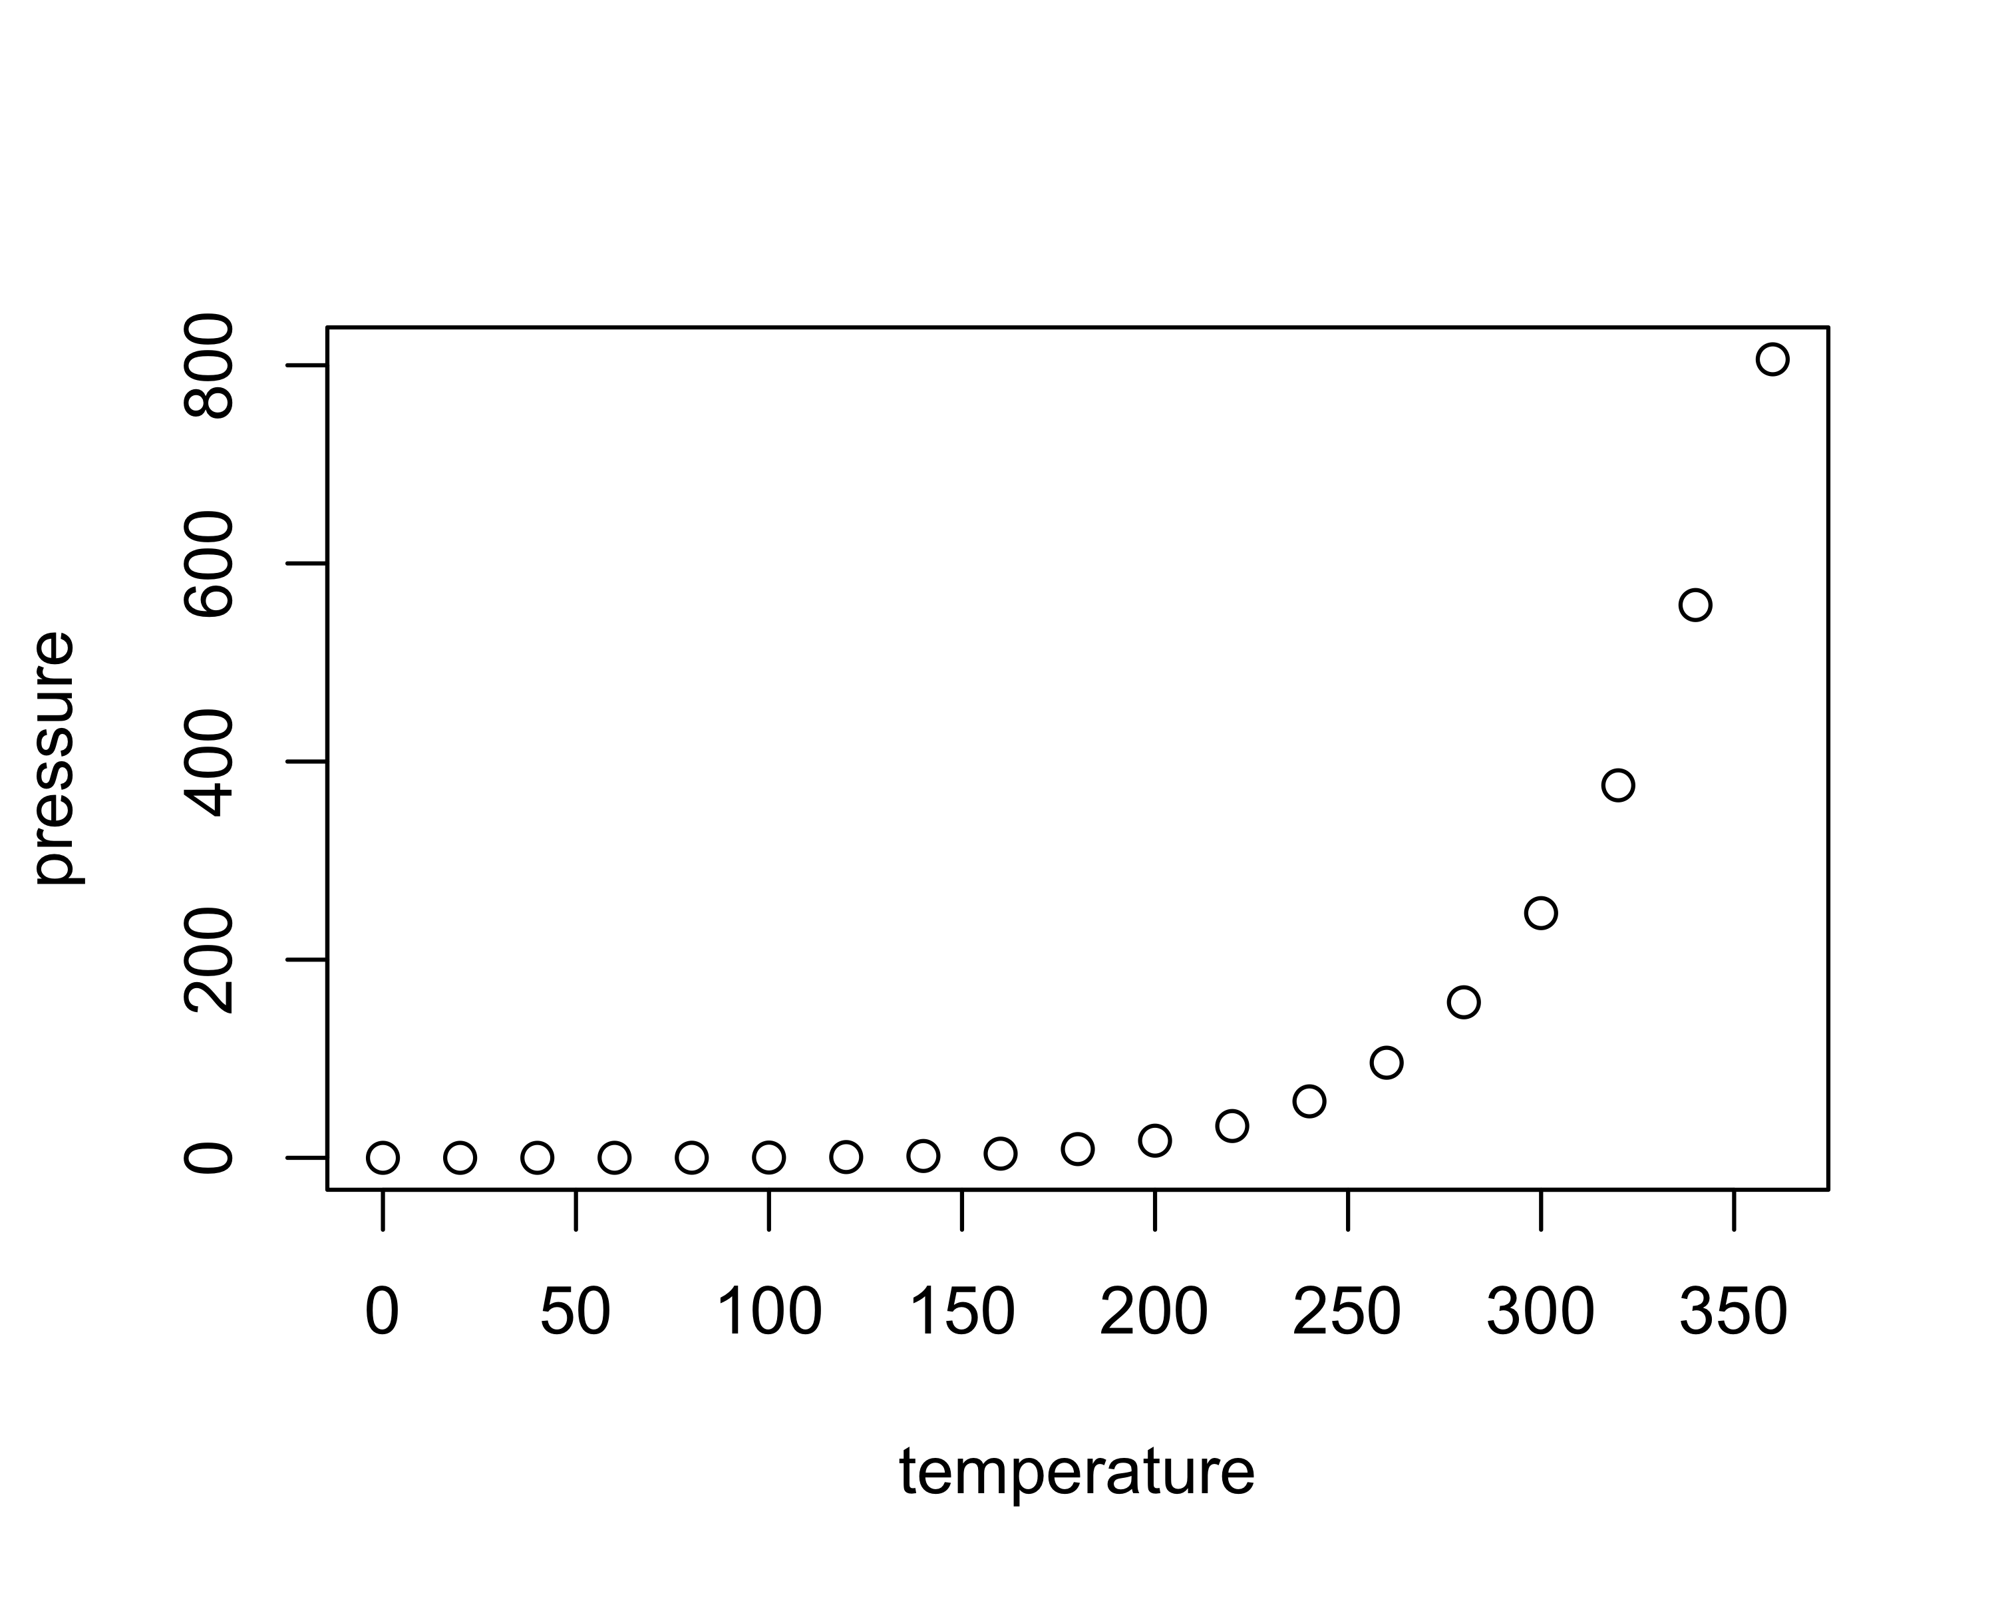

Note that the echo = FALSE parameter was added to the code chunk to prevent printing of the R code that generated the plot.