A Bayesian approach to burial networks to infer social changes in northeastern Taiwan during the European colonization period

Li-Ying Wang

Ben Marwick

17 February, 2021

Burials provide valuable information to study social structures based on the assumption that burials and associated grave goods can represent social roles and relations in a society. To study social relationships, network analysis has been increasingly applied to archaeological data to explore network structures and patterns to infer interactions and relationships between entities. Statistical approaches to network analysis, such as exponential random graph models (ERGMs), provide a way to test hypotheses on dynamic processes of network formation. However, the computational difficulty and sensitivity to uncertainties limits the application of ERGMs. In this paper, we introduce a Bayesian framework on ERGMs that enables an efficient computational process, effective quantification of uncertainty, and robust model evaluation of network properties. We tested a hypothesis of social change relative to the arrival of Europeans by studying burial data from Kiwulan, an Iron Age site in northeastern Taiwan. The results indicate a transition in the process that led to the formation of the burial network, from ties based on ritual objects to wealth objects, and a more centralized structure with increased social differentiation after European presence in the 17th century. Our case study demonstrates the effectiveness of Bayesian network analysis for archaeological data, and expands the use of burials in understanding the impacts of colonial presence on Indigenous groups in a pericolonial context.

# Introduction

Network analysis has been increasingly used by archaeologists to understand past relationships, interactions, and structures of observed phenomena by visualizing and analyzing rational data (Brandes et al., 2013; Mills, 2017; Peeples, 2019). The recent development of modeling approaches enable hypothesis testing for the intercorrelations between individual elements and overall structures inherent in networks (Brughmans, 2013; Brughmans and Peeples, 2018; Freeman, 2004; Salvini, 2010). By comparing hypothesized networks with the observed network, network modeling can answer anthropological questions related to exchange (Crabtree, 2015; Gjesfjeld and Phillips, 2013), diffusion (Östborn and Gerding, 2015), or social transformation (Mills et al., 2013) in a statistical way. Among network modeling methods, exponential random graph models (ERGMs) are stochastic models for investigating the process of network formation through dependence assumptions for relationships and simulations for network patterns (Ghafouri and Khasteh, 2020; Handcock et al., 2008; Harris, 2013). Since relationships in a network emerging relative to their position in a network can be hypothesized, ERGMs are promising to evaluate dynamic social processes behind observed archaeological networks (Brughmans et al., 2014). However, computational difficulties and the sensitivity to uncertainties to some extent limits the practical applications of ERGMs, where results could be challenging for interpretation (Caimo and Friel, 2014).

In this paper, we go beyond ERGMs with a novel Bayesian approach that can alleviate the computational issues in ERGMs to better interpret the process of network formation for past phenomena. Using burial data from an Iron Age site in northeastern Taiwan as a case study, we explore social changes by investigating the formation of material connections between burials. Social changes in Indigenous societies, when faced with colonial powers, are commonly observed in many parts of the world, especially European colonies where Indigenous economic, cultural, or socio-political aspects were substantially impacted (Dietler, 2005; Silliman, 2005; Voss, 2005). Recent studies demonstrate that the indirect effect of colonialism, or involvement in long-distance trade, could also have impacts on Indigenous societies, this is known as a pericolonial context (Acabado, 2017; Trabert, 2017; Wang and Marwick, 2020). To explore social changes, burials are important evidence to understand past societies because material culture and biological records of burial behaviors can represent the social ranking or identities of the deceased, and social relations between them (Binford, 1971; Drennan et al., 2010; Saxe, 1970). Burial treatments can further indicate social complexity or inequality where foreign goods from long-distance trade were used by Indigenous people to express status (Carter, 2015; Dolfini, 2019).

Usually, burial studies are based on characterizing each physical trace or burial variable, such as biological records, grave forms and goods, or ritual behaviors, and finally combining those individual observations to infer past societies (Byrd and Monahan, 1995; Seikel, 2011). Here we treat burials as a complex network based on the assumption that a network is a patterned aggregation that includes individual elements (i.e. individual burials), pair-wise relationships (the dyads, for example burials with similar types and amounts of grave goods), and an overall structure showing global patterns represented in the data (Brandes et al., 2013). Our case study illustrates how a Bayesian approach to network modeling provides new insights for studying the formation of archaeological networks and allows testing on theoretical assumptions to better understand dynamic social processes.

# Exponential random graph models in a Bayesian framework

Exponential random graph models (ERGMs) first appeared in archaeology with Brughmans et al. (2014), who studied Iron age settlement patterns in Southern Spain by modeling inter-settlement visibility networks and visual control at 159 sites. By fitting models with the observed network of archaeological data, they proposed that ERGMs is a promising method for exploration and hypothesis testing for social processes. Similarly, Amati et al. (2019) modeled three networks consisting of 15 sites (AD 100 to 400) in the Caribbean to explore interaction mechanisms, including proximity, inter-cultural items, and pottery types. By comparing hypothesized networks with the observed sites, they found that the presence of hub sites can be efficiently explained by multiple interdependent mechanisms instead of only one variable exclusively.

However, those studies also point out some limitations of ERGMs, such as sensitivity to missing data and less able to handle uncertainty. Also, it is difficult in ERGMs to estimate model parameters and interpret the result due to intractable likelihood normalizing constants and model degeneracy (Caimo and Friel, 2014; Jin et al., 2013). A normalizing constant is a function of the model parameter for making probability distributions integrate to one, which becomes harder to compute with a larger set of networks (Caimo and Gollini, 2017). This is also termed “doubly intractable” since both the likelihood normalizing constant and the marginal likelihood (the evidence of the posterior) are hard to derive (Caimo and Friel, 2013; Lyne et al., 2015). Model degeneracy is another issue where probability models tend to overestimate a small number of extreme graphs by assigning too much weight, e.g., in extreme cases such as empty (all nodes unconnected) or complete graphs (all nodes connected) (Caimo and Friel, 2014; Schweinberger, 2011). One solution to these limitations is available by implementing ERGMs by means of a Bayesian framework.

Bayesian approaches to ERGMs are effective tools for network modeling by incorporating prior information about the network configurations (details in Supplementary Online Materials) to better understand dependencies of network variables and improve computational issues in ERGMs (Caimo et al., 2017; Lehmann et al., 2020). Prior information is derived from previous data or assumptions of our data. The advantage that Bayesian modeling has over traditional ERGMs is the application of Markov chain Monte Carlo (MCMC) simulation using the approximate exchange algorithm (Caimo and Friel, 2011). With the exchange algorithm, Bayesian ERGMs avoid doubly-intractable computations by directly sampling from the not normalized part of the posterior, which alleviates the computational problems and gives better convergence results. This enables us to deal with complicated dependence patterns with ease, providing better estimations for complex social network models with heterogeneous data (Caimo et al., 2017; Snijders et al., 2006). By fitting an ERMG with the approximate exchange algorithm, a Bayesian approach generates posterior probabilities that incorporate our sample data and prior information that estimates the effect of each ERGM parameter in our models (Caimo and Lomi, 2015; Nemmers et al., 2019). This allows uncertainty quantification by examining the posterior mean and 95% credible intervals (Caimo and Gollini, 2017). In addition, Bayesian approaches are useful to deal with missing data, which is often a problem leading to misinterpretation of networks, especially for archaeological studies. Koskinen et al. (2010) shows that the effect of missing data can be reduced with Bayesian modeling that can predict, on average, 80% of the ties when a third of data is missing.

# Background

## A Case Study from Northeastern Taiwan

We use a Bayesian ERGM to study social changes in a pericolonial context at Kiwulan, an Iron Age site in northeastern Taiwan (Figure 1), which was occupied from the 14th to 19th centuries. This occupation period includes the time before the European arrival, the presence of the Spanish and the Dutch in the 17th century, and finally a large wave of Han Chinese in the 19th century (Chen, 2007). Our general model proposes that the influence of a colonial power, combined with high local values attached to imported goods, leads to increased social inequality due to competition among individuals (Brumfiel, 1994; Clark and Blake, 1994). Increased social inequality associated with the use of foreign prestige goods is recognized as network strategies for gaining power (Blanton et al., 1996; Feinman, 2000). Network-based societies are identified in some places in Asia with involvement in long-distance trade (Carter, 2015; Liu and Chen, 2006; Ueda et al., 2016). The observed uneven distribution of burial goods at Kiwulan may be explained as a result of unequal access to trade goods when Indigenous societies became more involved in the complex trade network stimulated by Europeans.

The features of network-based societies include the accumulation of prestige goods, wealth differentiation, and trade monopolization through individual networks (Blanton et al., 1996; Feinman, 2000), while corporate-based societies stress communal ritual elements, shared power, and wealth differentiation, if any, would be associated with corporate groups, such as age groups (Siegel, 1999). Using the theoretical framework of corporate-network strategies, or horizontal hierarchy, we test a hypothesis that changes from a corporate mode (a structure showing more subgroups with less wealth differentiation ) to a network mode (a centralized structure with more wealth differentiation) can be observed in the Kiwulan burial network after European arrival. We ask: (1) did European colonial activities result in increased social inequality in Indigenous society in ways that can be detected by analysis of burial networks? (2) if so, what are the major variables affecting or forming unequal social positions that might hint at social heterogeneity? By answering these questions, this case study helps to expand our understanding of European colonial effects on Indigenous groups in a pericolonial context.

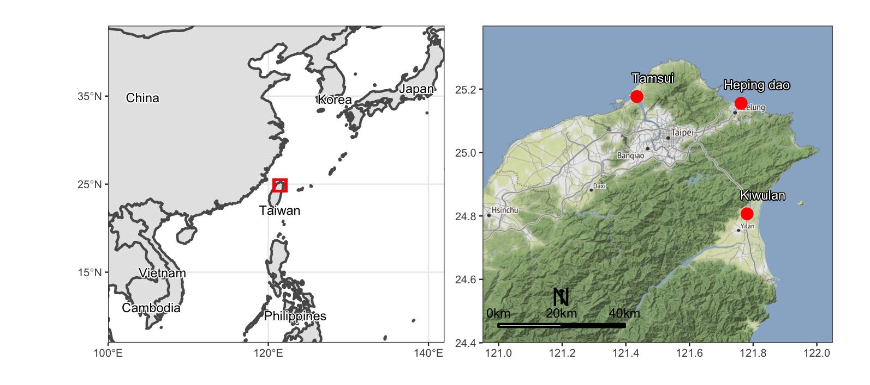

Figure 1: The location of Kiwulan and the European forts at Heping dao and Tamsui in northern Taiwan (modified from Wang and Marwick, 2020). Map data from naturalearthdata.com.

## Materials

We analyzed burial data collected from the excavation reports, and the original fieldwork notes for the upper component of Kiwulan (1350-1850 AD) (Chen, 2007). A total of 90 burials were unearthed from adjacent squares that provide continuous stratigraphic sections suitable for temporal comparison (Figure 2). The preservation of human remains at Kiwulan was generally poor, so we have incomplete age and sex data (details in Supplementary Online Materials) and lack health status data. Burials are oriented in an east-west direction on the north side of the residential area, which is indicated by post-holes and *in-situ* wooden posts, suggesting a well-organized spatial arrangement of houses. Previous studies report an uneven distribution of prestige goods across burials without agreement about whether this uneven distribution hints at vertical social differences. For example, Cheng (2008) interpreted the unequal distribution of glass beads, especially the gold-foil beads between burials, as evidence for hierarchy, indicating a stratified society. However, Hsieh (2012) suggested a relatively egalitarian structure based on the comparative analysis of the frequencies of all burial goods. She found that the burials with rare prestige goods were usually associated with elders, which might indicate achieved, rather than inherited, status. One important limitation of these previous studies is that they did not use analytical units suitable for comparing the phases before and after European arrival. Here, we adopt a new chronological framework for the burials to test if network configurations differ from the pre-European period (before European colonization) to the post-European period (during and after European colonization until arrival of Han Chinese immigrants).

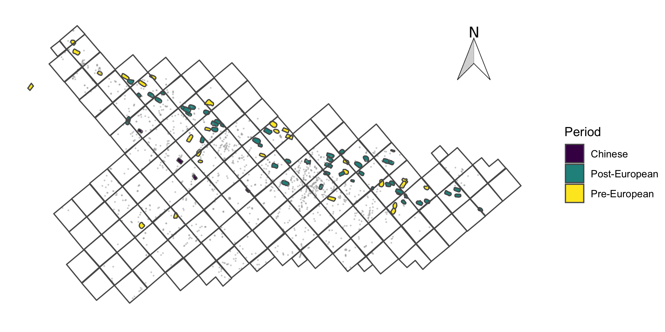

Figure 2: Map illustrating the location of burials by periods at the central excavation area of Kiwulan (each square is 4 X 4 meters). The gray dots are post holes.

To compare burial networks, we assigned burials to the pre-European period (n = 29), European and post-European period (n = 49). Our assignments are based on an established fine-grained chronology that was reexamined and cross-validated by diagnostic materials, stratigraphic data, depth, and radiocarbon ages (for more details see Wang and Marwick, 2020). We excluded burials from the Chinese phase (n = 4) due to the smaller sample size. We also excluded 8 burials that were heavily disturbed by modern construction because we cannot determine their chronology.

Based on the assumption that social status and associated relations can be represented by sharing similar prestige goods (cf. Coward, 2013, p. 252), we built networks where burials (nodes in the network) that are linked when they have the same prestige goods in common. The prestige goods we identified include gold-foil beads, carnelian beads, glass beads, Chinese porcelains, stonewares, gold foils, and fish-shaped ornaments. These items are considered as high-value across different archaeological contexts based on their rarity and descriptions in historical records (Cheng, 2008; Hsieh, 2012, 2009; Wang, 2011). European historical accounts mentioned that those items were treated as prestige goods in Indigenous culture (Borao Mateo, 2009; Li and Wu, 2006). For example, a Spanish priest described a Spanish soldier exchanging carnelian beads for natural resources with local Indigenous people, because of the beads’ high value in Indigenous culture (Li and Wu, 2006). In addition, Spanish visitors observed that an Indigenous person possessing more imported goods may have been recognized as having higher status in their community (Li and Wu, 2006).

# Methods

## Hypothesis and construction of networks

Our pericolonial impact hypothesis is that differential access to foreign prestige goods after the European presence led to increased social inequality at Kiwulan, where social structure changed from a more corporate strategy to a more network strategy (Blanton et al., 1996; Drennan et al., 2010; Feinman, 2000). This would be reflected by the pattern of intercorrelations of foreign prestige goods in burial networks. If social inequality gradually increased as we hypothesize, then we expect to observe a network structure with higher centralization (or popularity) and less transitivity (or clustering), along with associations with wealth accumulation, indicative of a network-based society. In contrast, the network before the European arrival will show low centralization and high transitivity, associated with ritual element, or age/sex groups to indicate a corporate-based society. To test this hypothesis, we use Bayesian ERGMs to model the formation of network ties and the underlying mechanisms that shape relationships between people at Kiwulan. By comparing networks from the pre-European period and the post-European period we can examine the effects of foreign contact on community relationships at Kiwulan.

Trade beads are commonly found across burials with substantial differences in quantities, so we described each burial as having one of four levels, high, upper-middle, lower-middle, and low, according to their distributions across all burials (details in Supplementary Online Materials). For less frequent prestige goods, including imported ceramics, gold foils, and fish-shaped ornaments, we linked two burials when they both possess each type of goods (i.e. presence or absence). Node attributes here include osteologically determined age and sex, cultural data, such as ritual pottery, and a burial value index. Ritual pottery was identified as locally made ceramics placed above an individual. Those pots mostly have soot on vessel exteriors and charred residues on interiors that are interpreted as vessels for funeral feasting (Hsieh, 2009). We calculated our burial value by summing values of all types of prestige goods in each burial context. For example, for gold-foil beads, we take the total number of burials (90) and divide by number of burials with gold-foil beads (46), to give a value of 90/46 = 1.96. We repeat this for each type of prestige item. For each burial we sum these values of each type of prestige item to get a burial value (Jorgensen, 1991).

We then assigned the burials into three ranks according to breaks in the distribution of burial values, high (>24.7, top 10 percent), above average (16-24.7), and below average (<16), as an index of wealth (details in Supplementary Online Materials). Since burials tend to have multiple prestige goods in common, the network ties are weighted instead of binary (the value 1 represents a tie and the value 0 otherwise) (Snijders, 2011). For example, if two burials have both low quantity of glass beads and porcelain in common, the tie is given a value of 2. Our networks are non-directed, which means a mutual relationship where the tie between any two actors is bidirectional. The networks constructed based on these principles show that the network after the European presence has more node connectivity in general with some nodes having a larger number of connections (Figure 3).

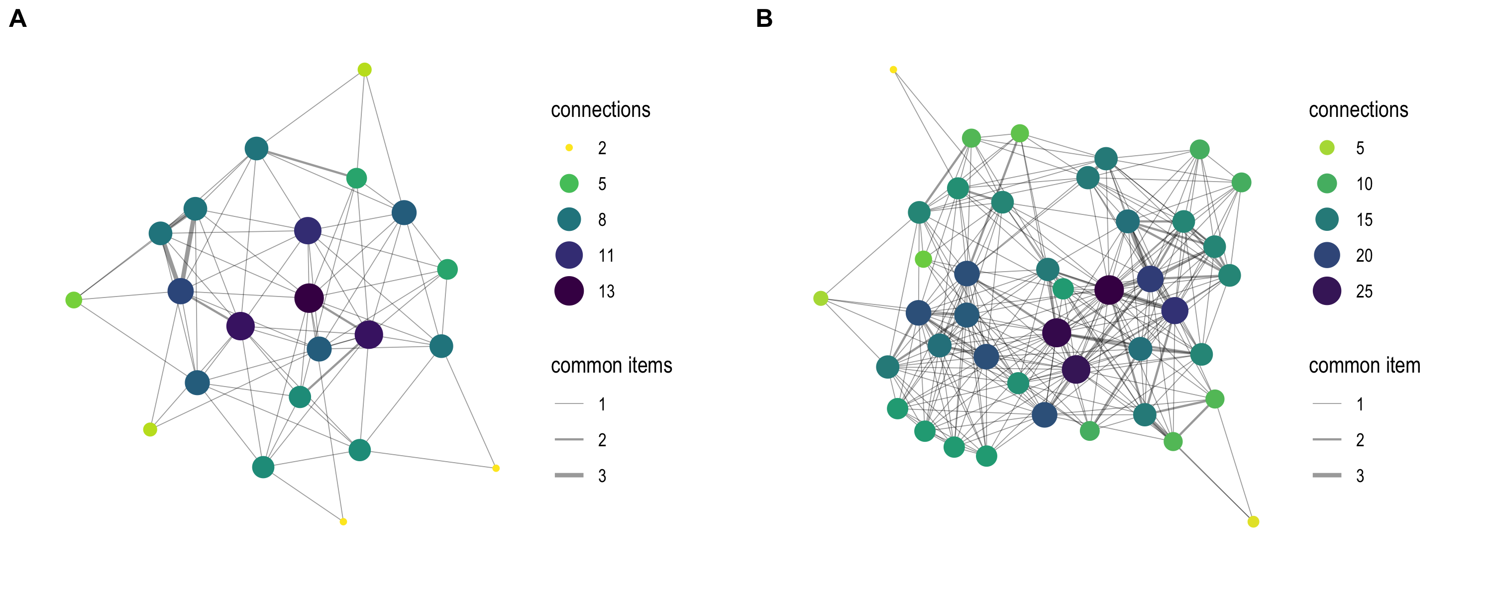

Figure 3: A: Burial network before the European arrival, B: Burial network after the European arrival. The size of each node is proportional to node degrees or the number of connections to a node. The thickness of tie represents the number of goods in common between two nodes.

## Model specification in a Bayesian framework

We quantify the relations among burials and test our hypothesis of social change using the R programming language (R Core Team, 2019) with the bergm package (Caimo and Friel, 2014). Table 1 lists the network parameters we used for dependence assumptions that define our models (Morris et al., 2008). Every parameter in an ERGM has an associated algorithm for computing the probability of observing relations in terms of prestige goods between two burials. Based on our hypothesis, we model a network with increased social inequality to be represented by endogenous network effects: low transitivity and high centralization. We include burial-specific attributes as covariate effects for homophily, such as age, sex, ritual activity, and the degree of wealth, to explore the importance of these variables in tie forming. For example, if age-homophily is important here, then people of the same age should have the same burial goods. We also include the physical distance between burials as an indicator of a kinship-based relations since the deceased from the same family were buried nearby (Li and Wu, 2006). Our model may reveal the emergence of social inequality via the presence of a few individuals as network centers, having more relations with others, with more wealth differentiation after the European arrival.

Table 1: Network parameters in ERGMs used for model specifications with associated archaeological interpretation for burial relations. ERGM terminology is from the R package statnet (Handcock, 2008; Morris, 2008)

|  |  |  |
| --- | --- | --- |
| Network variable | Configuration (ERGM term) | Archaeological Interpretation |
| Density/inter-relation | Edges (edges) | constituent element of the network |
| Age-homophily | Uniform homophily (nodematch) | burials in the same age tend to have similar goods |
| Sex-homophily | Uniform homophily (nodematch) | burials in the same sex tend to have similar goods |
| Ritual-homophily | Uniform homophily (nodematch) | burials having ritual practice tend to have similar goods |
| Wealth-homophily | Uniform homophily (nodematch) | burials in the same wealth rank tend to have similar goods |
| Transitivity/clustering | Geometrically weighted edgewise shared partner (gwesp) | burials being connected with a third burial |
| Centralization/popularity | Geometrically weighted degree distribution (gwdegree) | burials being connected with multiple partners |
| Physical distance | Dyadic covariate (dyadcov) | burials close to each other tend to have simialr goods |

## Choice of prior values to evaluate our anthropological model

Normal distributions for the priors are typical in network analysis studies that assume networks to have low density and high transitivity, as are commonly found in the real world (Caimo et al., 2017). Thus, we specified the prior of the edge density parameter to low for both network models, which follows a normal distribution with mean at -3, and standard deviations at 3 (i.e (N(-3, 3))). For covariates about biological features, such as age, sex, we specified a vague prior (N(0, 5)) for both models to explore their effects. For physical distance between burials, we also set a vague prior effect (N(0, 1)) to explore whether there is kinship-based proximity, e.g. stronger correlations for shorter distances. To evaluate our anthropological model of increased social inequality over time based on assumptions of corporate-network strategies (Drennan et al., 2010; Feinman, 2000), we incorporated different prior information for the network variables that are meaningful for social inequality, especially for transitivity and centralization. We set the priors to higher transitivity (N(2, 2)), lower centralization (N(-2, 3)), and higher covariate effect of ritual activity (N(1, 5)) for the network before European contact to indicate less social differentiation and stress ritual element shared in corporate groups. Conversely, we set the priors for the network after European arrival to lower transitivity (N(1, 3)), higher centralization (N(2, 3)), and higher covariate effect of burial values (N(2, 3)) to model an increased social differentiation.

# Reproducibility and open source materials

The entire R code (R Core Team, 2019) used for all the analysis and visualizations contained in this paper is included in the Supplementary Online Materials at <https://doi.org/xxx/xxx> to enable re-use of materials and improve reproducibility and transparency (Marwick, 2017). Also in this version-controlled compendium (Marwick et al., 2018) are the raw data for all the visualizations and tests reported here. All of the figures, tables, and statistical test results presented here can be independently reproduced with the code and data in this repository. The code is released under the MIT license, the data as CC-0, and figures as CC-BY, to enable maximum re-use.

# Results

We examine the estimates from the posterior distributions to compare their differences in structure of the simulated networks (Table 2; Figure 4). For nodal covariates in the pre-European model, the ritual element represent by pots (ritual-homophily) has a significant effect on the formation of relations between burials. On the other hand, the wealth rank, represented by burial values (wealth-homophily), has a negative effect. This demonstrates that burials in the pre-European period with ritual pottery tend to form relations, but burials in the same wealth level tend not to. Despite positive mean values for some covariates, such as age and sex, their confidence intervals include zero, so they do not show a significant influence. Similarly, the dyadic covariate, physical distance, shows no significant effect, indicating that physical proximity between burials does not reflect similarity in burial treatment. For the endogenous network effects, transitivity presents a significant positive effect, while centralization demonstrates a negative effect. The high positive value for transitivity suggests a tendency of burials with similar burial goods to be clustered as connected communities, indicative of the presence of multiple corporate groups sharing burial goods in common. In contrast, the strong negative centralization shows there is a tendency toward decentralization that reflects most burials having a similar number of ties, without any prominent burials. This might imply that individuals have equal access to the flow of trade goods.

Table 2: Estimated posterior means, medians, and 95% confidence intervals for each network parameter of two models. Confidence intervals that do not include zero indicate significant effects of parameters (Caimo, 2017). Posterior means are generally close to posterior medians.

| parameter | pre-European | | | | post-European | | | |
| --- | --- | --- | --- | --- | --- | --- | --- | --- |
|  | mean | median | 2.5% | 97.5% | mean | median | 2.5% | 97.5% |
| Density | -24.6 | -24.6 | -25.6 | -23.4 | -14.6 | -14.6 | -15.1 | -14.2 |
| Age-homophily | 0.3 | 0.4 | -0.2 | 0.9 | 0.1 | 0.1 | -0.2 | 0.5 |
| Sex-homophily | 0.3 | 0.3 | -0.4 | 0.8 | -0.1 | -0.1 | -0.5 | 0.2 |
| Ritual-homophily | 1.9 | 1.9 | 0.6 | 2.7 | -0.0 | -0.0 | -0.4 | 0.3 |
| Wealth-homophily | -0.1 | -0.1 | -0.6 | 0.4 | 0.5 | 0.6 | 0.1 | 0.9 |
| Transitivity | 13.8 | 13.9 | 12.9 | 14.5 | 3.6 | 3.6 | 3.5 | 3.8 |
| Centralization | -17.8 | -17.9 | -18.7 | -16.1 | 5.0 | 4.9 | 4.4 | 5.5 |
| Physical distance | 0.0 | 0.0 | -0.0 | 0.1 | 0.0 | 0.0 | -0.0 | 0.0 |

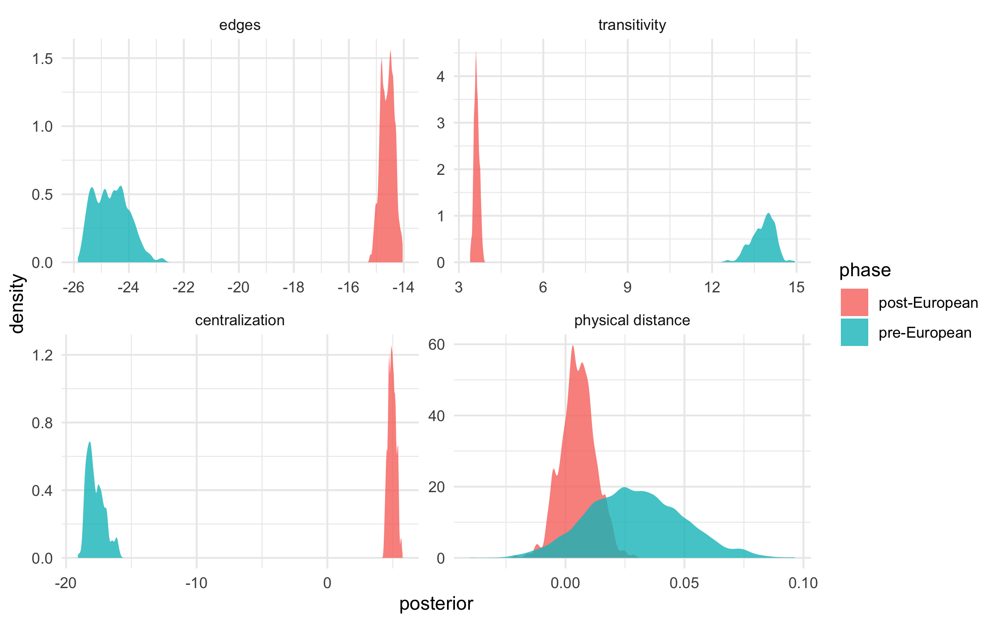

Figure 4: Posterior density estimates for the parameters associated with edges, gwesp, gwdegree, and distance-dyadcov by phases. The pre-European group presents remarkable larger values for the gwesp, but lower values for the edges and gwdegree parameters compared to the post-European group. The distance parameters overlap between two groups. Both posterior estimates present generally symmetric distributions.

After the arrival of Europeans, the nodal covariates of wealth rank show significant positive effects, while the ritual and sex variables have negative effects. This indicates that burials in the same wealth level tend to be more connected with each other. On the contrary, the same sex burials, and burials with ritual pottery in common tend, not to have relations. In the post-European burials there are no significant effects for variables of age and physical distance. Similar to the pre-European network, transitivity demonstrates a significant positive effect, but much weaker than in the pre-European network. In contrast, centralization has a significantly higher positive effect than the pre-European network. This means there is a tendency toward centralization that reflects a limited number of burials having many more ties than others. This implies more access to trade goods and the increased wealth accumulation and display behaviors in burial events. In general, the post-European network model has a smaller transitivity effect and a positive centralization effect compared to the pre-European network model. This may suggest a reduced tendency toward clustering but high tendency toward centralization after the European presence.

One key difference between the pre-European and post-European networks is their size, with 29 burials compared to 49 burials. To understand the robustness of comparison between two networks, we used a vertex bootstrap technique to cross-validate the results of our Bayesian ERGMs. The vertex bootstrap is a non-parametric method that conducts resampling for all vertices (i.e. node) to quantify standard errors and estimate sampling variability in the network statistics of interest (Chen et al., 2019; Roberts et al., 2021; Snijders and Borgatti, 1999). This enables the evaluation of uncertainty for networks and tests the difference between multiple networks of different sizes by examining their confidence intervals for the network population. We used the vertex bootstrap to compute endogenous network statistics, including density, centralization, and transitivity for our two networks. We explored the sample size effect by removing nodes at certain percentages (5-40%) for both networks and comparing their confidence intervals. The results demonstrate a consistent difference between the two networks up to 30% node removals (Figure 5). This indicates that the network variables under investigation are robust to the different network size of our sample. Figure 5 also shows consistency with our earlier finding of negative centralization in the pre-European period and positive centralization in the post-European period, over several conditions of node removal. Similarly consistent with our earlier result, the vertex bootstrap shows no significant difference on density and transitivity.

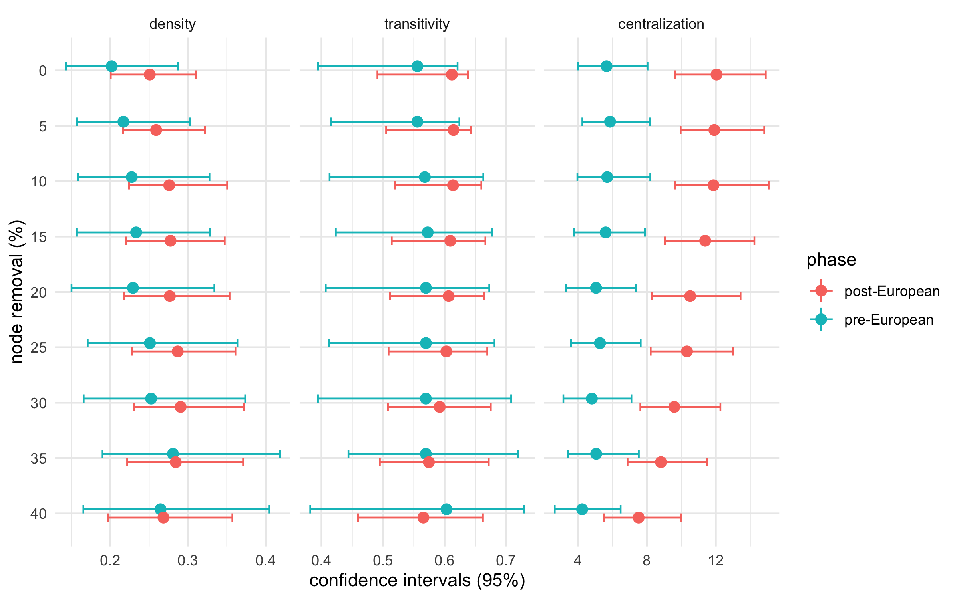

Figure 5: Results of the vertex bootstrap analysis by three network variables, showing the 95% bootstrap confidence intervals for the bootstrapped (n = 1000) networks, for each category of node removal. The 0% node removal category is the original data for the two phases. Networks with nonoverlapping confidence intervals indicate a significant difference between the two phases for that network variables.

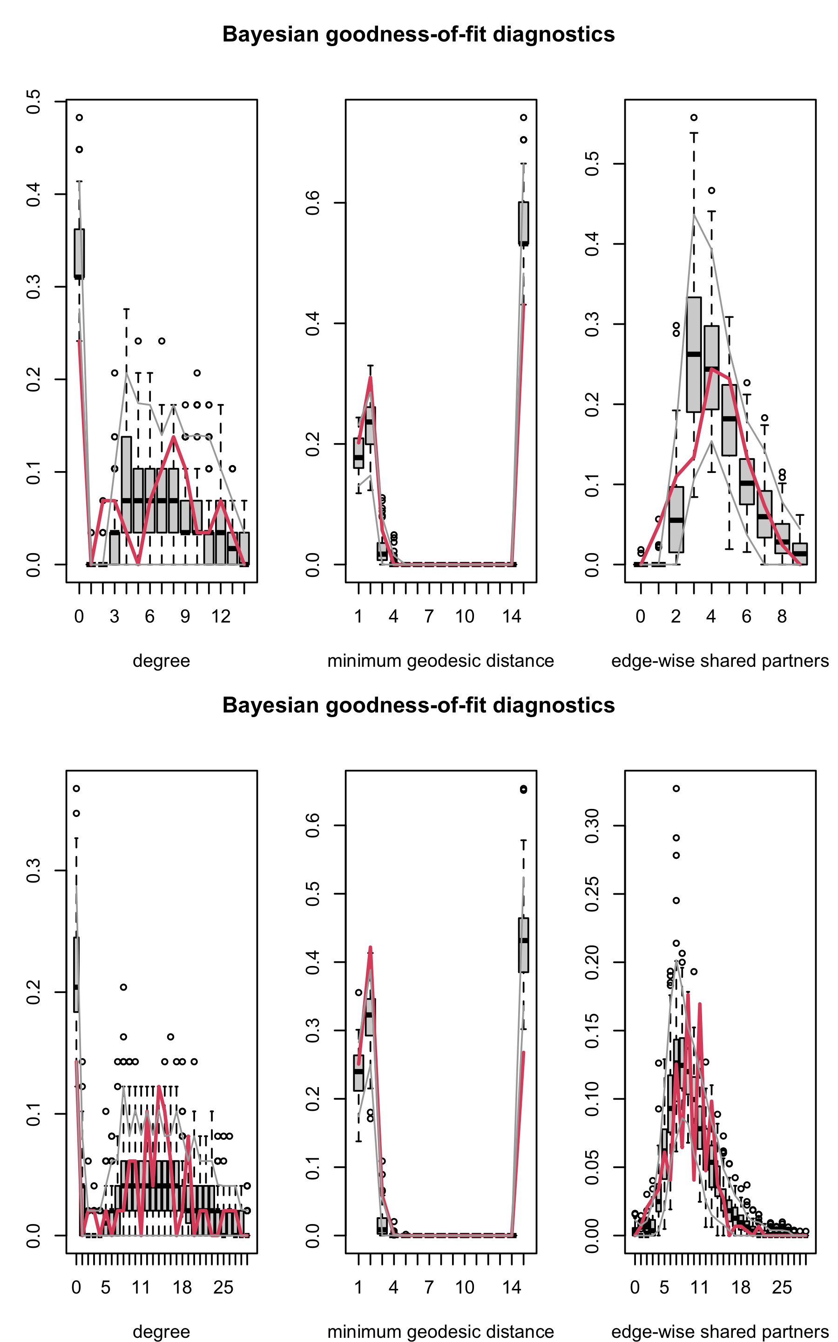

Figure 6: Goodness-of-fit diagnostics for the pre-European model (top) and the post-European model (below). Boxplots represent distributions calculated on 100 network graphs simulated from the estimated posterior distribution. Red lines represent distributions of observed networks, and gray lines show the 95% intervals.

Our computational models reproduce networks that resemble the structural features of our observed networks. Bayesian goodness of fit (GOF) diagnostics plots (Figure 6) demonstrate that both models fit the observed networks very well for the minimum geodesic distance distribution (i.e. the number of edges between node pairs in a shortest path, Hunter et al. (2008)) and the degree distribution. For edgewise shared partner distribution, despite some observations falling outside the 95% interval, the fit is generally good with most observations within it. We also compared the first three distribution moments of each observed distribution and their corresponding simulated distributions, represented by means. Figure 7 shows that modeled values from the pre-European network are slightly closer to the observed values for the mean and the variance of distributions, compared to the values from the post-European network. In general, this demonstrates a slightly better fit between model and data for the pre-European network.

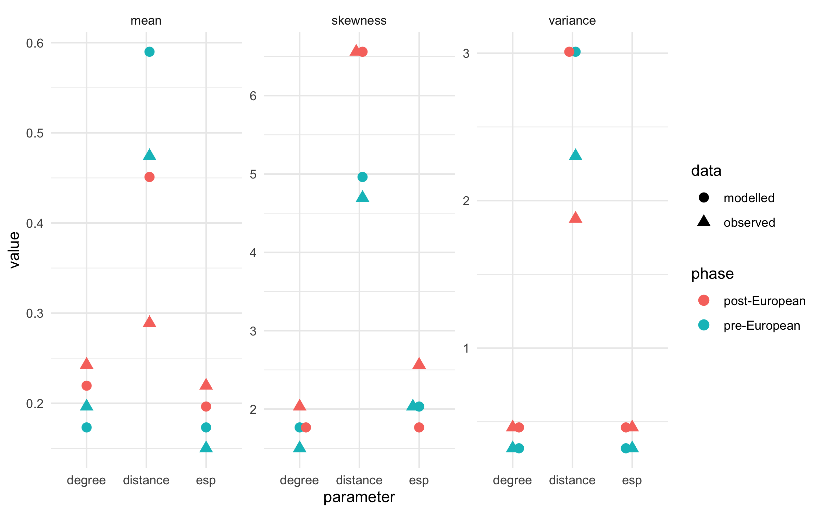

Figure 7: Distribution moments (mean, skewness, and variance) calculated on the observed data and simulated distributions for the pre- and post-European models.

# Discussion

A striking finding in our results is the change in network properties of Kiwulan burials from a more cohesive network with multiple subgroups toward a more centralized network with concentration of connections among fewer burials after the European arrival in the 17th century. This supports our pericolonial impact model that Kiwulan changed from a more corporate-based to a more networked-based society, as indicated in the grave goods and burial attributes. A corporate-based society, as we interpret the pre-European situation at Kiwulan, stresses shared power between individuals, communal rituals, and social inequality, if any, would be associated with groups (Drennan et al., 2010; Feinman, 2000; Feinman et al., 2000). In contrast, a network-based society, as we interpret the post-European data from Kiwulan, presents wealth accumulation through individual networks, prestige goods manipulation, and trade monopolization (Blanton et al., 1996). It should be noted that the corporate-network continuum represents a dynamic process with different degrees of hierarchical complexity instead of static ideal-type stages (Feinman, 2000).

Network covariates give insights into the socio-cultural factors that were associated with the acquisition and distribution of foreign prestige goods. Our results indicate that the major factor contributing to burial networks is ritual for the pre-European network, and wealth for the post-European network. We interpret these results as illustrating different social and economic mechanisms influencing relations between burials for the two periods. Before European arrival, ritual behaviors were important factors that structured the interconnections of prestige goods in the burial contexts. This might imply that ritual could be a status indicator at the time before foreign goods were first introduced to Indigenous societies. After the European presence was established, status indicators shifted from ritual to wealth differences. Moreover, geographical proximity, implying some kinship association, has not effect on sharing similar prestige items between burials for both phases. This may suggest that the use of prestige items is more individual-oriented instead of kinship-based. Demographic information, such as age and sex, do not have any effects on network formation for the pre-European network and only sex shows a negative effect for the post-European network. This may also support a shift to more wealth and individual-based status competition without sex differences, in the later phase. But we also note that no effects could be due to the unavailability of age and sex values for many burials in our sample.

We used burial data as a proxy to explore social relations reflected by interconnections of prestige goods based on assumptions that burials can represent social structures (Binford, 1971; Saxe, 1970), and individuals with similar prestige goods reflect similar access to trade, exchange, and gifting networks (eg. Coward, 2013, p. 252). We argue that the social relations at Kiwulan changed because of contact with European colonial powers and associated foreign trade. This argument is supported by changes in burial network structures through time. It should be noted that manipulation of burial rituals by the living can cause a disconnect between a person’s status in life and their status represented by burial contexts (Hodder, 1980; Pearson, 1982). However, this issue can be reduced by comparing the results with evidence from other archaeological contexts, such as residential areas (Chapman, 2003). Previous studies of trade ornaments from the residential area of Kiwulan suggests an uneven spatial distribution when the Europeans were active in northern Taiwan that hints at an increased social differentiation (Wang and Marwick, 2020). This is consistent with the result of a more centralized burial network after the presence of Europeans, that supports a connection between a burial and the social role of the living person. Also, ethnographic records support our interpretation of burial goods as prestige goods or status items in the local Indigenous culture (Borao Mateo, 2009; Li and Wu, 2006), so the interrelations represented by the flow of these goods observed in the burial data likely reflect social contexts of the living people at Kiwulan.

# Conclusion

We presented a novel approach for studying burials to interpret social structures using ERGMs within a Bayesian framework. This case study demonstrates the methodological benefits of Bayesian inference on ERGMs to inform and enhance studies of relational data in archaeology. A Bayesian framework can reduce the effects of small sample size or missing data commonly present in archaeological data by incorporating prior information and MCMC estimations. Another valuable feature of Bayesian network modeling is the ability to set prior values to evaluate competing anthropological models, enabling a comparison of anthropologically-relevant models, rather than testing a hypothesis of no difference or randomness. Bayesian network modeling can be applied to a wide range of archaeological data to examine the formation of relationships using robust probabilistic inference. This enables insights into the dynamic processes of relationship formation and the underlying factors of historical trajectories of socio-cultural phenomena.

We examined social changes in a European pericolonial context in northeastern Taiwan. We tested the hypotheses of changes in burial networks at Kiwulan with the evaluation of both endogenous and exogenous network effects. The results support our model that the relationship between burials changed after the European colonization period in the 17th century. Before the arrival of Europeans, the burial network has a tendency of more clustered subgroups with pottery as ritual practice as the key formation mechanism. After European arrival, the network has a tendency of centralization relative to the rarity of goods. We interpret the changes in formation mechanisms of networks, from ritual practice to wealth levels, as an increase in wealth accumulation behaviors, stimulated by the European presence and its associated long-distance trade network. This aligns with changes in horizontal hierarchy represented by corporate-network societies, that demonstrates different degrees of social inequality in relation to different strategies for achieving power (Feinman, 2000). Using burial data with historical documents, we are to better understand indirect European impacts in understudied pericolonial contexts of East Asia (e.g. Acabado, 2017; Trabert, 2017).

# Acknowledgments

We would like to thank the Yilan County Cultural Affairs Bureau in Taiwan for permitting access to the data used in this paper. We thank the excavation team of Kiwulan led by Yu-pei Chen for their post-excavation analysis and detailed documentation about burials that enable this study. We also thank Alberto Caimo and Steven M. Goodreau for the discussion regarding the methods at the earliest stage of analysis. This work was supported in part by the travel grant from the Department of Anthropology at the University of Washington and the Doctoral Dissertation Fellowship from the Chiang Ching-kuo Foundation for International Scholarly Exchange (Project #DF009-A-18). We thank Ben Fitzhugh and Peter Lape for their insightful comments on an early draft. We also acknowledge comments from anonymous reviewers that have greatly improved this manuscript.

##### 0.0.0.0.1 pagebreak

# References

Acabado, S., 2017. The archaeology of pericolonialism: Responses of the “unconquered” to Spanish conquest and colonialism in Ifugao, Philippines. International Journal of Historical Archaeology 21, 1–26.

Amati, V., Mol, A., Shafie, T., Hofman, C., Brandes, U., 2019. A framework for reconstructing archaeological networks using exponential random graph models. Journal of Archaeological Method and Theory 1–28.

Binford, L., 1971. Mortuary practices: Their study and their potential. In approaches to the social dimensions of mortuary practices, in: Brown, J. (Ed.), Approaches to the Social Dimensions of Mortuary Practices. Memoirs of the Society for American Archaeology., pp. 6–29.

Blanton, R.E., Feinman, G.M., Kowalewski, S.A., Peregrine, P.N., 1996. A dual-processual theory for the evolution of Mesoamerican civilization. Current anthropology 37, 1–14.

Borao Mateo, J.E., 2009. The Spanish experience in Taiwan, 1626-1642 the Baroque ending of a Renaissance endeavor. Hong Kong University Press, Hong Kong.

Brandes, U., Robins, G., McCranie, A., Wasserman, S., 2013. What is network science? Network science 1, 1–15.

Brughmans, T., 2013. Thinking through networks: A review of formal network methods in archaeology. Journal of Archaeological Method and Theory 20, 623–662.

Brughmans, T., Keay, S., Earl, G., 2014. Introducing exponential random graph models for visibility networks. Journal of Archaeological Science 49, 442–454.

Brughmans, T., Peeples, M.A., 2018. Network science. The Encyclopedia of Archaeological Sciences 1–4.

Brumfiel, E.M., 1994. Factional competition and political development in the New World: An introduction, in: Brumfiel, E.M., Fox, J. (Eds.), Factional Competition and Political Development in the New World. Cambridge: Cambridge University Press, pp. 3–13.

Byrd, B.F., Monahan, C.M., 1995. Death, mortuary ritual, and Natufian social structure. Journal of Anthropological Archaeology 14, 251–287.

Caimo, A., Friel, N., 2014. Bergm: Bayesian exponential random graphs in R. Journal of Statistical Software 61, 1–25.

Caimo, A., Friel, N., 2013. Bayesian model selection for exponential random graph models. Social Networks 35, 11–24.

Caimo, A., Friel, N., 2011. Bayesian inference for exponential random graph models. Social Networks 33, 41–55.

Caimo, A., Gollini, I., 2017. Bayesian computational algorithms for social network analysis. QSAR/QSPR.

Caimo, A., Lomi, A., 2015. Knowledge sharing in organizations: A Bayesian analysis of the role of reciprocity and formal structure. Journal of Management 41, 665–691.

Caimo, A., Pallotti, F., Lomi, A., 2017. Bayesian exponential random graph modelling of interhospital patient referral networks. Statistics in medicine 36, 2902–2920.

Carter, A.K., 2015. Beads, exchange networks and emerging complexity: A case study from Cambodia and Thailand (500 bce-ce 500). Cambridge Archaeological Journal 25, 733.

Chapman, R., 2003. Death, society and archaeology: The social dimensions of mortuary practices. Mortality 8, 305–312.

Chen, Y., Gel, Y.R., Lyubchich, V., Nezafati, K., 2019. Snowboot: Bootstrap methods for network inference. arXiv preprint arXiv:1902.09029.

Chen, Y.-p., 2007. Qi wu lan yi zhi qiang jiu fa jue bao gao [Report on the archaeological excavations at Ki-Wu-Lan site]. Lanyang museum, Yilan, Taiwan.

Cheng, C.-f., 2008. Qi wu lan yi zhi yu she nei yi zhi chu tu bo li zhu de xiang guan yan jiu [Studies of glass beads excavated from Kivulan and Shenei site, Taiwan] (Master’s thesis).

Clark, J.E., Blake, M., 1994. The power of prestige: Competitive generosity and the emergence of rank societies in lowland Mesoamerica, in: Brumfiel, E.M., Fox, J. (Eds.), Factional Competition and Political Development in the New World. Cambridge: Cambridge University Press, pp. 17–33.

Coward, F., 2013. Grounding the net: Social networks, material culture and geography in the Epipalaeolithic and Early Neolithic of the Near East (  21,000–6,000 cal bce), in: Knappett, C. (Ed.), Network Analysis in Archaeology: New Regional Approaches to Interaction. Oxford University Press, Oxford, pp. 247–280.

Crabtree, S.A., 2015. Inferring ancestral Pueblo social networks from simulation in the central Mesa Verde. Journal of Archaeological Method and Theory 22, 144–181.

Dietler, M., 2005. The archaeology of colonization and the colonization of archaeology: Theoretical challenges from an ancient Mediterranean colonial encounter, in: Stein, G. (Ed.), The Archaeology of Colonial Encounters: Comparative Perspectives. NM: Sch. Am. Res. Press, Santa Fe, pp. 33–68.

Dolfini, A., 2019. From the Neolithic to the bronze age in Central Italy: Settlement, burial, and social change at the dawn of metal production. Journal of Archaeological Research 1–54.

Drennan, R.D., Peterson, C.E., Fox, J.R., 2010. Degrees and kinds of inequality, in: Feinman, G., Price, T.D. (Eds.), Pathways to Power: New Perspectives on the Emergence of Social Inequality. Springer, pp. 45–76.

Feinman, G.M., 2000. Corporate/network: New perspectives on models of political action and the Puebloan Southwest, in: Schiffer, M.B. (Ed.), Social Theory in Archaeology. University of Utah Press, pp. 31–51.

Feinman, G.M., Lightfoot, K.G., Upham, S., 2000. Political hierarchies and organizational strategies in the Puebloan Southwest. American Antiquity 449–470.

Freeman, L., 2004. The development of social network analysis. A Study in the Sociology of Science.

Ghafouri, S., Khasteh, S.H., 2020. A survey on exponential random graph models: An application perspective. PeerJ Computer Science 6, e269.

Gjesfjeld, E., Phillips, S.C., 2013. Evaluating adaptive network strategies with geochemical sourcing data: A case study from the kuril islands. Network analysis in archaeology: New approaches to regional interaction 281–305.

Handcock, M.S., Hunter, D.R., Butts, C.T., Goodreau, S.M., Morris, M., 2008. Statnet: Software tools for the representation, visualization, analysis and simulation of network data. Journal of statistical software 24, 1548.

Harris, J.K., 2013. An introduction to exponential random graph modeling. Sage Publications.

Hodder, I., 1980. Social structure and cemeteries: A critical appraisal, in: Rahtz, P., Dickinson, T., Watts, L. (Eds.), Anglo-Saxon Cemeteries. Oxford: British Archaeological Reports 82, pp. 6–29.

Hsieh, E., 2012. You pei zang pin de liang hua yan jiu kan qi wu lan yi zhi shang wen hua ceng zao qi nei bu de she hui guan xi [Exploring the social relation: A quantitative analysis of burial goods for upper culture layer of Kiwulan site].

Hsieh, E., 2009. Yi lan qi wu lan yi zhi chu tu wai lai tao ci qi zhi xiang guan yan jiu [The study of imported ceramics excavated at the Ki-Wu-Lan site, I-lan] (Master’s thesis).

Hunter, D.R., Handcock, M.S., Butts, C.T., Goodreau, S.M., Morris, M., 2008. Ergm: A package to fit, simulate and diagnose exponential-family models for networks. Journal of statistical software 24, nihpa54860.

Jin, I.H., Yuan, Y., Liang, F., 2013. Bayesian analysis for exponential random graph models using the adaptive exchange sampler. Statistics and its interface 6, 559.

Jorgensen, L., 1991. Castel Trosina and Nocera Umbr, a chronological and social analysis of family burial practices in Lombard Italy (6^ th-8^ thCent. AD). Acta Archaeologica 62.

Koskinen, J.H., Robins, G.L., Pattison, P.E., 2010. Analysing exponential random graph (p-star) models with missing data using Bayesian data augmentation. Statistical Methodology 7, 366–384.

Lehmann, B.C., Henson, R.N., Geerligs, L., White, S.R., others, 2020. Characterising group-level brain connectivity: A framework using Bayesian exponential random graph models. bioRxiv 665398.

Li, Y.-z., Wu, M.-z., 2006. Qing zai xi ban ya ren zai tai wan, 1626-1642 [the Spanish in Taiwan]. Taiwan Historica, Nantou.

Liu, L., Chen, X., 2006. Sociopolitical change from Neolithic to Bronze Age China 149–176.

Lyne, A.-M., Girolami, M., Atchadé, Y., Strathmann, H., Simpson, D., others, 2015. On Russian roulette estimates for Bayesian inference with doubly-intractable likelihoods. Statistical science 30, 443–467.

Marwick, B., 2017. Computational reproducibility in archaeological research: Basic principles and a case study of their implementation. Journal of Archaeological Method and Theory 24, 424–450. <https://doi.org/10.1007/s10816-015-9272-9>

Marwick, B., Boettiger, C., Mullen, L., 2018. Packaging data analytical work reproducibly using R (and friends). The American Statistician 72, 80–88.

Mills, B.J., 2017. Social network analysis in archaeology. Annual review of anthropology 46, 379–397.

Mills, B.J., Clark, J.J., Peeples, M.A., Haas, W.R., Roberts, J.M., Hill, J.B., Huntley, D.L., Borck, L., Breiger, R.L., Clauset, A., others, 2013. Transformation of social networks in the late pre-hispanic us southwest. Proceedings of the National Academy of Sciences 110, 5785–5790.

Morris, M., Handcock, M.S., Hunter, D.R., 2008. Specification of exponential-family random graph models: Terms and computational aspects. Journal of statistical software 24, 1548.

Nemmers, T., Narayan, A., Banerjee, S., 2019. Bayesian modeling and uncertainty quantification for descriptive social networks. Statistics and its interface 12, 181.

Östborn, P., Gerding, H., 2015. The diffusion of fired bricks in Hellenistic Europe: A similarity network analysis. Journal of Archaeological Method and Theory 22, 306–344.

Pearson, P., 1982. Mortuary practices, society and ideology: An ethnoarchaeological study, in: Hodder, I. (Ed.), Symbolic and Structural Archaeology. Cambridge.

Peeples, M.A., 2019. Finding a place for networks in archaeology. Journal of Archaeological Research 27, 451–499.

R Core Team, 2019. R: A language and environment for statistical computing. R Foundation for Statistical Computing, Vienna, Austria.

Roberts, J.M., Yin, Y., Dorshorst, E., Peeples, M.A., Mills, B.J., 2021. Assessing the performance of the bootstrap in simulated assemblage networks. Social Networks 65, 98–109. <https://doi.org/https://doi.org/10.1016/j.socnet.2020.11.005>

Salvini, A., 2010. Symbolic interactionism and social network analysis: An uncertain encounter. Symbolic Interaction 33, 364–388.

Saxe, A., 1970. Social dimensions of mortuary practices (PhD thesis). University of Michigan.

Schweinberger, M., 2011. Instability, sensitivity, and degeneracy of discrete exponential families. Journal of the American Statistical Association 106, 1361–1370.

Seikel, K., 2011. Mortuary contexts and social structure at Nan Madol, Pohnpei. The Journal of Island and Coastal Archaeology 6, 442–460.

Siegel, P.E., 1999. Contested places and places of contest: The evolution of social power and ceremonial space in prehistoric Puerto Rico. Latin American Antiquity 209–238.

Silliman, S.W., 2005. Culture contact or colonialism? Challenges in the archaeology of Native North America. American Antiquity 55–74.

Snijders, T.A., 2011. Statistical models for social networks. Annual Review of Sociology 37.

Snijders, T.A., Borgatti, S.P., 1999. Non-parametric standard errors and tests for network statistics. Connections 22, 161–170.

Snijders, T.A., Pattison, P.E., Robins, G.L., Handcock, M.S., 2006. New specifications for exponential random graph models. Sociological methodology 36, 99–153.

Trabert, S., 2017. Considering the indirect effects of colonialism: Example from a great plains middle ground. Journal of Anthropological Archaeology 48, 17–27.

Ueda, K., Wibisono, S.C., Harkantiningsih, N., Lim, C.S., 2016. Paths to power in the early stage of colonialism: An archaeological study of the sultanate of Banten, Java, Indonesia, the seventeenth to early nineteenth century. Asian Perspectives 89–119.

Voss, B.L., 2005. From Casta to Californio: Social identity and the archaeology of culture contact. American Anthropologist 107, 461–474.

Wang, L.-Y., 2011. Yilan Kiwulan yizhi chutu zhuangshipin zhi xiangguan yanjiu [A research of ornaments excavated at Kiwulan site, I-lan] (Master’s thesis).

Wang, L.-Y., Marwick, B., 2020. Trade ornaments as indicators of social changes resulting from indirect effects of colonialism in northeastern Taiwan. Archaeological Research in Asia.

##### 0.0.0.0.2 pagebreak

### 0.0.1 Colophon

This report was generated on 2021-02-17 23:02:55 using the following computational environment and dependencies:

#> ─ Session info ───────────────────────────────────────────────────────────────  
#> setting value   
#> version R version 4.0.3 (2020-10-10)  
#> os macOS Catalina 10.15.7   
#> system x86_64, darwin17.0   
#> ui X11   
#> language (EN)   
#> collate en_US.UTF-8   
#> ctype en_US.UTF-8   
#> tz America/Los_Angeles   
#> date 2021-02-17   
#>   
#> ─ Packages ───────────────────────────────────────────────────────────────────  
#> ! package * version date lib source   
#> P assertthat 0.2.1 2019-03-21 [?] CRAN (R 4.0.2)  
#> P backports 1.2.1 2020-12-09 [?] CRAN (R 4.0.2)  
#> P base64enc 0.1-3 2015-07-28 [?] CRAN (R 4.0.2)  
#> P Bergm * 5.0.2 2020-11-12 [?] CRAN (R 4.0.2)  
#> P bitops 1.0-6 2013-08-17 [?] CRAN (R 4.0.2)  
#> P bookdown 0.21 2020-10-13 [?] CRAN (R 4.0.2)  
#> P broom 0.7.3 2020-12-16 [?] CRAN (R 4.0.2)  
#> P callr 3.5.1 2020-10-13 [?] CRAN (R 4.0.2)  
#> P cellranger 1.1.0 2016-07-27 [?] CRAN (R 4.0.2)  
#> P class 7.3-18 2021-01-24 [3] CRAN (R 4.0.2)  
#> P classInt 0.4-3 2020-04-07 [?] CRAN (R 4.0.2)  
#> P cli 2.2.0 2020-11-20 [?] CRAN (R 4.0.2)  
#> P coda 0.19-4 2020-09-30 [?] CRAN (R 4.0.2)  
#> P codetools 0.2-16 2018-12-24 [3] CRAN (R 4.0.3)  
#> P colorspace 2.0-0 2020-11-11 [?] CRAN (R 4.0.2)  
#> P conquer 1.0.2 2020-08-27 [?] CRAN (R 4.0.2)  
#> P cowplot * 1.1.1 2020-12-30 [?] CRAN (R 4.0.2)  
#> P crayon 1.3.4 2017-09-16 [?] CRAN (R 4.0.2)  
#> P data.table 1.13.6 2020-12-30 [?] CRAN (R 4.0.2)  
#> P DBI 1.1.1 2021-01-15 [?] CRAN (R 4.0.2)  
#> P dbplyr 2.0.0 2020-11-03 [?] CRAN (R 4.0.2)  
#> P DEoptimR 1.0-8 2016-11-19 [?] CRAN (R 4.0.2)  
#> P desc 1.2.0 2018-05-01 [?] CRAN (R 4.0.2)  
#> P devtools 2.3.2 2020-09-18 [?] CRAN (R 4.0.2)  
#> P digest 0.6.27 2020-10-24 [?] CRAN (R 4.0.2)  
#> P dplyr * 1.0.3 2021-01-15 [?] CRAN (R 4.0.2)  
#> P e1071 1.7-4 2020-10-14 [?] CRAN (R 4.0.2)  
#> P ellipsis 0.3.1 2020-05-15 [?] CRAN (R 4.0.2)  
#> P ergm * 3.11.0 2020-10-14 [?] CRAN (R 4.0.2)  
#> P ergm.count * 3.4.0 2019-05-15 [?] CRAN (R 4.0.2)  
#> P evaluate 0.14 2019-05-28 [?] CRAN (R 4.0.1)  
#> P fansi 0.4.2 2021-01-15 [?] CRAN (R 4.0.2)  
#> P farver 2.0.3 2020-01-16 [?] CRAN (R 4.0.2)  
#> P flextable * 0.6.2 2021-01-25 [?] CRAN (R 4.0.2)  
#> forcats * 0.5.1 2021-01-27 [1] CRAN (R 4.0.3)  
#> P foreign 0.8-80 2020-05-24 [3] CRAN (R 4.0.3)  
#> P fs 1.5.0 2020-07-31 [?] CRAN (R 4.0.2)  
#> P gbRd 0.4-11 2012-10-01 [?] CRAN (R 4.0.2)  
#> P gdtools 0.2.3 2021-01-06 [?] CRAN (R 4.0.2)  
#> P generics 0.1.0 2020-10-31 [?] CRAN (R 4.0.2)  
#> P ggforce 0.3.2 2020-06-23 [?] CRAN (R 4.0.2)  
#> P ggmap 3.0.0 2019-02-05 [?] CRAN (R 4.0.2)  
#> P ggplot2 * 3.3.3 2020-12-30 [?] CRAN (R 4.0.2)  
#> P ggraph * 2.0.4 2020-11-16 [?] CRAN (R 4.0.2)  
#> P ggrepel 0.9.1 2021-01-15 [?] CRAN (R 4.0.2)  
#> P ggridges * 0.5.3 2021-01-08 [?] CRAN (R 4.0.2)  
#> P ggsn * 0.5.0 2019-02-18 [?] CRAN (R 4.0.2)  
#> P glue 1.4.2 2020-08-27 [?] CRAN (R 4.0.2)  
#> P graphlayouts 0.7.1 2020-10-26 [?] CRAN (R 4.0.2)  
#> P gridExtra 2.3 2017-09-09 [?] CRAN (R 4.0.2)  
#> P gtable 0.3.0 2019-03-25 [?] CRAN (R 4.0.2)  
#> P gtools * 3.8.2 2020-03-31 [?] CRAN (R 4.0.2)  
#> P haven 2.3.1 2020-06-01 [?] CRAN (R 4.0.2)  
#> P here * 1.0.1 2020-12-13 [?] CRAN (R 4.0.2)  
#> P highr 0.8 2019-03-20 [?] CRAN (R 4.0.2)  
#> P hms 1.0.0 2021-01-13 [?] CRAN (R 4.0.2)  
#> htmltools 0.5.1.1 2021-01-22 [1] CRAN (R 4.0.2)  
#> P httr 1.4.2 2020-07-20 [?] CRAN (R 4.0.2)  
#> P igraph * 1.2.6 2020-10-06 [?] CRAN (R 4.0.2)  
#> P jpeg 0.1-8.1 2019-10-24 [?] CRAN (R 4.0.2)  
#> P jsonlite 1.7.2 2020-12-09 [?] CRAN (R 4.0.2)  
#> P KernSmooth 2.23-17 2020-04-26 [3] CRAN (R 4.0.3)  
#> knitr 1.31 2021-01-27 [1] CRAN (R 4.0.3)  
#> P labeling 0.4.2 2020-10-20 [?] CRAN (R 4.0.2)  
#> P lattice 0.20-41 2020-04-02 [3] CRAN (R 4.0.3)  
#> P lifecycle 0.2.0 2020-03-06 [?] CRAN (R 4.0.2)  
#> P lpSolve 5.6.15 2020-01-24 [?] CRAN (R 4.0.2)  
#> P lubridate 1.7.9.2 2020-11-13 [?] CRAN (R 4.0.2)  
#> P magick * 2.6.0 2021-01-13 [?] CRAN (R 4.0.2)  
#> P magrittr 2.0.1 2020-11-17 [?] CRAN (R 4.0.2)  
#> P maptools 1.0-2 2020-08-24 [?] CRAN (R 4.0.2)  
#> P MASS 7.3-53 2020-09-09 [3] CRAN (R 4.0.3)  
#> P Matrix 1.2-18 2019-11-27 [3] CRAN (R 4.0.3)  
#> P matrixcalc 1.0-3 2012-09-15 [?] CRAN (R 4.0.2)  
#> P MatrixModels 0.4-1 2015-08-22 [?] CRAN (R 4.0.2)  
#> P matrixStats 0.57.0 2020-09-25 [?] CRAN (R 4.0.2)  
#> P mcmc 0.9-7 2020-03-21 [?] CRAN (R 4.0.2)  
#> P MCMCpack 1.5-0 2021-01-20 [?] CRAN (R 4.0.2)  
#> P memoise 1.1.0 2017-04-21 [?] CRAN (R 4.0.2)  
#> P mnormt 2.0.2 2020-09-01 [?] CRAN (R 4.0.2)  
#> P modelr 0.1.8 2020-05-19 [?] CRAN (R 4.0.2)  
#> P munsell 0.5.0 2018-06-12 [?] CRAN (R 4.0.2)  
#> P mvtnorm 1.1-1 2020-06-09 [?] CRAN (R 4.0.2)  
#> P network * 1.16.1 2020-10-07 [?] CRAN (R 4.0.2)  
#> P networkDynamic * 0.10.1 2020-01-21 [?] CRAN (R 4.0.2)  
#> P nlme 3.1-149 2020-08-23 [3] CRAN (R 4.0.3)  
#> P officer 0.3.16 2021-01-04 [?] CRAN (R 4.0.2)  
#> P pillar 1.4.7 2020-11-20 [?] CRAN (R 4.0.2)  
#> P pkgbuild 1.2.0 2020-12-15 [?] CRAN (R 4.0.2)  
#> P pkgconfig 2.0.3 2019-09-22 [?] CRAN (R 4.0.2)  
#> P pkgload 1.1.0 2020-05-29 [?] CRAN (R 4.0.2)  
#> P plyr 1.8.6 2020-03-03 [?] CRAN (R 4.0.2)  
#> P png 0.1-7 2013-12-03 [?] CRAN (R 4.0.2)  
#> P polyclip 1.10-0 2019-03-14 [?] CRAN (R 4.0.2)  
#> P prettyunits 1.1.1 2020-01-24 [?] CRAN (R 4.0.2)  
#> P processx 3.4.5 2020-11-30 [?] CRAN (R 4.0.2)  
#> P ps 1.5.0 2020-12-05 [?] CRAN (R 4.0.2)  
#> P psych * 2.0.12 2020-12-16 [?] CRAN (R 4.0.2)  
#> P purrr * 0.3.4 2020-04-17 [?] CRAN (R 4.0.2)  
#> P quantreg 5.83 2021-01-22 [?] CRAN (R 4.0.2)  
#> P R6 2.5.0 2020-10-28 [?] CRAN (R 4.0.2)  
#> P rbibutils 2.0 2020-11-18 [?] CRAN (R 4.0.2)  
#> P Rcpp 1.0.6 2021-01-15 [?] CRAN (R 4.0.2)  
#> P Rdpack 2.1 2020-11-09 [?] CRAN (R 4.0.2)  
#> P readr * 1.4.0 2020-10-05 [?] CRAN (R 4.0.2)  
#> P readxl * 1.3.1 2019-03-13 [?] CRAN (R 4.0.2)  
#> P remotes 2.2.0 2020-07-21 [?] CRAN (R 4.0.2)  
#> P reprex 0.3.0 2019-05-16 [?] CRAN (R 4.0.2)  
#> P RgoogleMaps 1.4.5.3 2020-02-12 [?] CRAN (R 4.0.2)  
#> P rjson 0.2.20 2018-06-08 [?] CRAN (R 4.0.2)  
#> P rlang 0.4.10 2020-12-30 [?] CRAN (R 4.0.2)  
#> P rle 0.9.2 2020-09-25 [?] CRAN (R 4.0.2)  
#> P rmarkdown 2.6 2020-12-14 [?] CRAN (R 4.0.2)  
#> P robustbase 0.93-7 2021-01-04 [?] CRAN (R 4.0.2)  
#> P rprojroot 2.0.2 2020-11-15 [?] CRAN (R 4.0.2)  
#> P rstudioapi 0.13 2020-11-12 [?] CRAN (R 4.0.2)  
#> P rvest 0.3.6 2020-07-25 [?] CRAN (R 4.0.2)  
#> P scales 1.1.1 2020-05-11 [?] CRAN (R 4.0.2)  
#> P sessioninfo 1.1.1 2018-11-05 [?] CRAN (R 4.0.2)  
#> P sf * 0.9-7 2021-01-06 [?] CRAN (R 4.0.2)  
#> P sna * 2.6 2020-10-06 [?] CRAN (R 4.0.2)  
#> P snowboot * 1.0.2 2020-04-25 [?] CRAN (R 4.0.2)  
#> P sp 1.4-5 2021-01-10 [?] CRAN (R 4.0.2)  
#> P SparseM 1.78 2019-12-13 [?] CRAN (R 4.0.2)  
#> P statnet * 2019.6 2019-06-14 [?] CRAN (R 4.0.2)  
#> P statnet.common * 4.4.1 2020-10-03 [?] CRAN (R 4.0.2)  
#> P stringi 1.5.3 2020-09-09 [?] CRAN (R 4.0.2)  
#> P stringr * 1.4.0 2019-02-10 [?] CRAN (R 4.0.2)  
#> P systemfonts 0.3.2 2020-09-29 [?] CRAN (R 4.0.2)  
#> P tergm * 3.7.0 2020-10-15 [?] CRAN (R 4.0.2)  
#> P testthat 3.0.1 2020-12-17 [?] CRAN (R 4.0.2)  
#> P tibble * 3.0.5 2021-01-15 [?] CRAN (R 4.0.2)  
#> P tidygraph * 1.2.0 2020-05-12 [?] CRAN (R 4.0.2)  
#> P tidyr * 1.1.2 2020-08-27 [?] CRAN (R 4.0.2)  
#> P tidyselect 1.1.0 2020-05-11 [?] CRAN (R 4.0.2)  
#> P tidyverse * 1.3.0 2019-11-21 [?] CRAN (R 4.0.2)  
#> P tmvnsim 1.0-2 2016-12-15 [?] CRAN (R 4.0.2)  
#> P trust 0.1-8 2020-01-10 [?] CRAN (R 4.0.2)  
#> P tsna * 0.3.1 2020-01-20 [?] CRAN (R 4.0.2)  
#> P tweenr 1.0.1 2018-12-14 [?] CRAN (R 4.0.2)  
#> P units 0.6-7 2020-06-13 [?] CRAN (R 4.0.2)  
#> P usethis 2.0.0 2020-12-10 [?] CRAN (R 4.0.2)  
#> P uuid 0.1-4 2020-02-26 [?] CRAN (R 4.0.2)  
#> P vctrs 0.3.6 2020-12-17 [?] CRAN (R 4.0.2)  
#> P viridis 0.5.1 2018-03-29 [?] CRAN (R 4.0.2)  
#> P viridisLite 0.3.0 2018-02-01 [?] CRAN (R 4.0.1)  
#> P withr 2.4.0 2021-01-16 [?] CRAN (R 4.0.2)  
#> P xfun 0.20 2021-01-06 [?] CRAN (R 4.0.2)  
#> P xml2 1.3.2 2020-04-23 [?] CRAN (R 4.0.2)  
#> P yaml 2.2.1 2020-02-01 [?] CRAN (R 4.0.2)  
#> P zip 2.1.1 2020-08-27 [?] CRAN (R 4.0.2)  
#>   
#> [1] /Users/EmilyWang/Desktop/School document/LW-Papers/kwl-burials-2020/renv/library/R-4.0/x86_64-apple-darwin17.0  
#> [2] /private/var/folders/gd/flx6648926xgtkrpp55bl7200000gn/T/RtmpJHBTqU/renv-system-library  
#> [3] /Library/Frameworks/R.framework/Versions/4.0/Resources/library  
#>   
#> P ── Loaded and on-disk path mismatch.

The current Git commit details are:

#> Local: master /Users/EmilyWang/Desktop/School document/LW-Papers/kwl-burials-2020  
#> Remote: master @ origin (https://github.com/LiYingWang/kwlburials.git)  
#> Head: [f501110] 2021-02-18: edit the main text in paper rmd

Word count: 2263