Investigating social change during cultural contact period using geometric morphometry of pottery shapes from Iron Age northeastern Taiwan

Li-Ying Wang

Ben Marwick

07 January, 2020

The emergence of ceramic specialization in prehistoric societies is often linked to shifts in the complexity of social structures, because specialized pottery production can reflect craft specialization and the presence of elite control. Previous work on identifying specialization relies on typological or linear metric analysis. Here we demonstrate how to investigate ceramic standardization by analyzing outlines of ceramic vessels. Outline analysis is an important method because, unlike more commonly-used landmark analysis methods, it can effectively quantify shape differences for objects that lack distinctive measurement points needed for landmark analysis. We demonstrate this method using pottery from Kiwulan, a large multi-component Iron Age site (AD 1350-1850) in northeast Taiwan. To measure ceramic specialization, we quantified pottery standardization by analyzing shape variables with reproducible geometric morphometric methods. We computed coefficients of variation (CVs) for shape coefficients obtained by elliptical Fourier analysis to test for shape standardization. We found significant differences in pottery shape and shape standardization that indicate changes in pottery production resulting from contact with mainland Han Chinese groups in northeast Taiwan. We infer increasing craft specialization and changes in social organization. Our case study, which includes an openly available research compendium of R code, represents an innovative application of outline-based methods in geometric morphometry to answer the anthropological questions of craft specialization. This study implies that craft specialization can be a deliberate act of resistance to show indigenous identity and ethnicity in a direct culture contact situation.

# Introduction

The development of craft specialization is usually associated with the social changes since it reflects production systems that inform social, economic, or political conditions of a society. Specialization is defined as “differential participation in specific economic activities”, in which a particular good is produced by fewer producers compared to the total population who consume it (Costin, 2001, p. 43, 1991). The implication of the emergence of specialization for social structure or social process has been a theme in archaeological investigations. According to the political approaches, craft specialization, attached production specifically, is viewed as a strategy used by elites to control over production systems for the sake of power and authority (Costin, 2001). The relationship between craft specialization and social differentiation is broadly discussed, and many cases show that specialized production can be a useful indicator of increasing socio-political complexity (Hirshman et al., 2010; Junker, 1999). Economic models consider production, exchange, and consumption as a whole to explain specialization as a subsistence strategy to accommodate uneven distribute of resources (Arnold and Munns, 1994; Costin, 2001), a reaction to the changes in subsistence practices (Stark, 1995a), or an outcome stimulated by long-distance trade and inter-regional exchange (Alizadeh et al., 2018). An present-day investigation of ceramic specialization in the Jodhpur region of India suggests that the adoption of standardized products across cultural boundaries is a reaction to a collapse of previous economic system, indicating the correlation with major socio-economic changes (Roux, 2015). However, it is important to note that the explanation for the emergence of specialized production might not be exclusive or straightforward. Moreover, Acabado et al. (2018)’s case study in lowland northern Philippines shows that specialization is not necessarily accompanied with social differentiation based on the result of a low degree of ceramic specialization in Ifugao ranked societies during the Spanish colonization. The development of specialization could be history dependent, where condition and contexts under which specialists organized are important for interpretation of changes in social organization (Costin, 2001; Roux, 2015).

The emergence of social inequality in the context of cross-cultural interaction especially in a colonial situation was observed in many parts of world when the introduction of foreign trade goods to local indigenous societies. The monopolization of long-distance trade goods usaully cause substantial transformations of indigenous economic, cultural, and socio-political systems (Dietler, 2005, 1997; Junker, 1993; Silliman, 2005). Recently more studies discuss the indirect effects of colonialism or pericolonial archaeology that investigates areas where European colonial rule was limited or their conquests were unsuccessful, but their colonial activities had economically and politically impacts on indigenous peoples in the periphery of colonial control (Acabado, 2017; Trabert, 2017). For example, Acabado (2017)’s study on Ifugao society in the highland Philippines suggests economic and political intensification during the Spanish presence as the response of indigenous peoples to the Spanish cooptation. Indigenous societies might not just passively accept the colonial rules, but instead actively negotiated with the colonist, and accommodate or resist the foreign intrusion through their daily cultural practices, such as consumption patterns of foreign goods (Dietler, 2015; Given, 2004; Mullins, 2011; Scaramelli and Scaramelli, 2005; Silliman, 2001; Torrence and Clarke, 2000). The archaeological evidence in northeastern Taiwan show evidence of increasing use of prestige goods such as trade ornaments and uneven distribution pattern in domestic area and burial contexts when the society encountered by the Spanish and the Dutch in the 17th century. In addition to the differential distribution of trade ornaments, the locally made ceramic present a high consistency in form and shape compared to other pottery throughout northeastern Taiwan that hints the possibility of pottery specialization.

To identify craft specialization, the variation of standardization of specialized product is commonly used as indicator based on the assumption that specialized mass production will lead to uniformity of the product due to routinization, increased skills, and fewer number of producers involved in production (Costin, 2001, 1991; Stark, 1995b). For ceramic standardization, several measurements have been proposed, such as metric, compositional, and technological approaches (Arnold, 2000; Blackman et al., 1993; Costin, 1991; Rice, 1991; Roux, 2015; Tite, 1999). Among those variables, metric measurement is widely applied in archaeological assemblages by calculating coefficient of variation for sets of data coupled with statistical comparison to identify lower value as an indicator of higher degree of standardization (Eerkens and Bettinger, 2001; Roux, 2003; Stark, 1995b). Roux and Karasik (2018)’s ethnographic study in the Jodhpur region of India suggests the number of artisans can be assessed by comparing coefficient of variation and the differences between artisans can be detected at both intra-individual level and inter-individual level in a region. Although this traditional typological and linear measurements are useful for identifying differences in archaeological assembles, it might be limited because dimensional measurements can be insensitive to subtle variations resulting from changes in assemblages. Shape analysis based on geometric morphometrics method are new approaches for measuring the degree of standardization since it takes the overall shape as variable for comparison (Slice, 2007). Using geometric morphomerics approaches, we study shape and standardization of locally made ceramics at Kiwulan (1350-1950 AD) (Chen, 2007), a large multi-component archaeological site in northeastern Taiwan, to identify changes in ceramic production in cross-cultural interaction contexts. The aim of this paper is to investigate if there are increasing ceramic specialization resulting from interaction with the Europeans in the 17th century or the Chinese in the 19th century, two major foreign influences in early historical Taiwan, that might indicate social changes in the indigenous society.

Our hypothesis is that if foreign influences had impacts on the emergence of social inequality in local indigenous society due to the monopolies for trade between a small number of indigenous people, then we expect to see the changes in social organization from a more corporate to a more network organization that would be reflected by pottery production at Kiwulan (Feinman, 2000). The emergence of craft specialization, here pottery specialization, are usually related to changes in social organization towards a society with increasing status inequality. In this case, if the competitions for foreign resources and being trade partners of European or Chinese colonizer among individuals gradually lead to increasing social inequality, then we expect the local ceramic will show more homogeneous features after contact due to the craft specialization caused by control of small group of individuals. This study is important to understand the indirect influences of the European colonists on the local indigenous societies, which remains unclear in East Asia where the colonial power was not successful compared to other places in Southeast Asia. Also, it would help to understand the relationship among the use of prestige goods, the degree of ceramic specialization, and the influence of foreign colonizers in a pericolonial context (Acabado, 2017).

## Geometric Morphometric approaches

Geometric morphometric methods (GMM) has been increasingly applied in archaeology for shape analysis, which explores morphological variability and similarity of archaeological materials to address the questions of anthropological interests. Different from linear measurement approaches that capture shapes by measuring length, width or ratios of objects, geometric morphometrics methods use Cartesian coordinates of morphological structures to define shapes (Adams et al., 2004; Bookstein, 1997; Lawing and Polly, 2010; Slice, 2007). Landmarks, curves or outlines of objects can be represented by coordinates in terms of their unique point locations with respect to numerical values of coordinate axes. According to different focuses and nature of original shape data, there are two common morphometric methods, landmark approaches and outline approaches (Adams et al., 2004). Landmark approaches assign a set of landmarks or semilandmarks onto objects as reference points that can be specified on a coordinate system as x, y coordinates for two dimensions, or x, y, z coordinates for three dimensions. Based on distances between raw landmarks, objects are translated to a common centroid, rescaled into the same size, and rotated until the summed squared distances between corresponding landmarks are minimized using generalized Procrustes analysis (GPA) (Bookstein, 1991). GPA is a method that superimposes sets of landmark configurations into a common coordinate system, where superimposed landmark coordinates are used as shape variables for further multivariate statistics analyses (Slice, 2007). Landmark-based morphometrics are widely applied to archaeological objects with a obvious morphological signature that can provide ideal reference points for landmark placement, such as projectile point tips or biologically measurements points indicating osteological features (Birch and Martinón-Torres, 2019; Buchanan et al., 2019; Cardillo, 2010; Haruda et al., 2019; Lycett and Cramon-Taubadel, 2013; Meloro et al., 2015).

However, one limitation of landmark approaches is that landmark data may not be able to capture the shape differences of a morphological structure where the curving outlines between landmarks are crucial for variation. Furthermore, representative and reliable landmark points may be unavailable for complex or rounded shaped structures. In those cases, outline approaches are better way for analyzing the overall shape of an object. One of the outline approaches is the semi-landmarks method, also called sliding landmarks, which assigns points along the curve between two landmarks at defined intervals (Bookstein, 1997; Lawing and Polly, 2010). Those semi-landmarks are allowed to slide along the curve to remove the effect of the arbitrary landmark spacing by minimizing either Procrustes distance or bending energy (Bookstein, 1997; Gunz and Mitteroecker, 2013; Slice, 2007). Another approach is elliptic Fourier Analysis (EFA) that turns coordinates into coefficients using mathematical function, commonly applied to two-dimensional closed shape (Kuhl and Giardina, 1982). EFA uses periodic functions to capture geometric information, where an outline is decomposed into a series of ellipses described by trigonometric functions, called harmonic coefficients (Adams et al., 2004; Bonhomme et al., 2014; Claude, 2008). The number of harmonics determines the quality and precision of the geometry of an object. The harmonic power, a cumulated sum of squared harmonic coefficient, provides a robust rule for the desired number of harmonics (Bonhomme et al., 2014).

Outline approaches especially EFA is suitable for shapes lacking representative landmarks or curves convey more meaningful variations. The applications in archaeology are seen on human remains or zooarchaeology to understand the biological variation and recently more on stone artifacts to explore stone tool technology (Fox, 2015; Hoggard et al., 2019; Ioviţă, 2010). Ceramics is another archaeological materials that outline approaches can provide new insights into shape variation to answer anthropological questions related to production. Wilczek et al. (2014) evaluate the concordance between outline-based approaches, EFA and Discrete Cosine Transform (DCT), and traditional typology by studying 154 complete ceramic vessels with varied shapes from the Bibracte oppidum in France. The results show the variation indicated by EFA and DCT matches traditional ceramic typology, which supports that outline-based approaches can be efficiently used for studying variations in ceramic shapes. Furthermore, the EFA results help to understand the level of production standardization over time across the region. Similarly, Topi et al. (2018) examine 89 photographs of globular jars from the Casas Grandes of northwest Mexico using semi-landmarks method to explore the relationship between social complexity and the emergence of craft specialization. Their results suggest that some ceramic types from Medio period (AD 1200-1450), were made by specialists. Among those high standardized jars, some were made by attached specialists, while others were made by independent specialists according to distribution patterns of jars. It shows that outline approaches can distinguish variation in ceramic shapes in a finer resolution to understand deeply the issue of craft specialisation.

Taking the ceramics data from Kiwulan, northeaster Taiwan, we use EFA to evaluate the level of standardization of ceramics in relation to the European presence in the 17th century that might hint the emergence of ceramic specialization. In addition, we use significance test for the equality of coefficient of variation of shape variables to compare the vessel shapes from different periods in a statistical way. Using pottery shape as a proxy to study craft specialization, we answer the questions: Did foreign influence have impacts on indigenous pottery production that can be detected in the shape of the vessels? How does pottery change in shape throughout 500 years from a single site that can represent the development of social organization in northeastern Taiwan? Did pottery become more homogeneous and standardized in shape after foreign contacts with the European colonizer or the Chinese immigrants? Starting from the historical background of colonial influences and its reflection in the material record, this study explore the relationship between the emergence of social inequality and craft specialization that can extend our understanding of the reactions of indigenous societies in the periphery of colonial control, providing a perspective that could be applied in other parts of the world in a similar context.

# Materials and archaeological background

Ceramics analyzed in this paper come from 40 units (4m by 4m) sampled from four connected trenches at Kiwulan, northeastern Taiwan. Kiwulan is situated on a hill near a riverside at the northern margin of Yilan, which is characterized by a triangular alluvial plain facing eastwards the Pacific and mountains on three other sides. It is an ideal context to study peripheral colonial influence because it was isolated from intensive direct contact with the Spanish and Dutch colonial presence in other parts of Taiwan. The chronology of Kiwulan is divided into two cultural components, the upper and the lower component, with a sterile layer in between (Chen, 2007). This paper focuses on the upper component dating from AD 1350 to AD 1950, which covers the late Iron Age and the historical period defined by the European presence in Taiwan in the early 17th century. The Dutch firstly came and occupied southern Taiwan in 1624 and then the Spanish occupied northern Taiwan in 1626. In 1642, the Spanish was expelled by the Dutch, who took over their forts in northern Taiwan. Since then, western Taiwan was mostly under the colonial rule of the Dutch until 1662 when the Kingdom of Tungning in Taiwan was founded by Koxinga, a loyalist of the Ming dynasty of China (Andrade, 2007).

The upper component experienced foreign contacts including the European colonial presence in the 17th century and great waves of Chinese immigrants since the 19th century. Imported ceramics from mainland China, stonewares, and ornaments elements such as beads were trade goods commonly found in the upper component that indicates the frequent long-distance trade activities in the 17th century during the European presence. In addition to artifacts, features such as burials, middens, and post-holes with in-situ posts that explain Kiwulan was a large settlement site (Chen, 2007). The predominant artefact found is locally made ceramics, which distributed throughout the sequence across the site. More than 550 thousands of sherds were excavated from the upper component at Kiwulan, and around 1,200 vessels were reconstructed. It is interesting to note that there are only two forms of vessels recovered, one is cooking pot and another one is steamer made of two cooking pots stacked together with a filter clay layer in between. Those pots show high consistency in shape. They are globular body with short neck and wide mouth. The exterior surface below the neck is treated with a wide variety of impressed geometric motifs. They were believed used for cooking because of the evidence of charred residues and carbon deposits commonly observed on the interior and soot on the exterior. Moveover, there is no other utilitarian earthenware ceramics found at this site suggests this type of pot was mainly used for daily cooking. Most pots are fired to orange to brownish color with a fully oxidized core or a reduced core with oxidized fringes. Finger impressions and seams usually on the interior indicate they were pinched using slabs of clay and shaped by hand.

We examine 291 pots recovered from Kiwulan site. The layer from 1 to 6 could be divided into 3 time periods. Layer 5 and 6 represent pre-contact period, layer 4 represents contact period, and layer1, 2, and 3 represent post-contact period. The amount of pots for each layer shows below. Although most pots are not complete, the thickness from rim, neck, to body can be measured. I have also measured the diameter of the rim, neck, and body. For those pots that are incomplete, the diameter is measured by its curvature. Since the height is incomplete for most pots, this preliminary analysis focuses more on the possible change in thickness and diameter of pot for different parts, and their ratio over time.

Petrographic analysis for thin sections was conducted at the Department of Geosciences, National Taiwan University. The results show high percentage of inclusions (15-50%), including argillite, quartz, feldspar, metasandstone, sandstone fragment, and slate. The most common type of sherds, also the dominant one, has a high percentage of inclusion (25-40%), which is composed mainly by argillite (15-40%), followed by metasandstone (1-10%), sandstone (1-6%), and quartz (1-5%). The size of the particles ranges from 500 micron to 1300 micron (=1 mm). Overall, this type presents a mixture of fine, rounded argillite with a small part of rounded metasandstone and rounded to sub-angular monocrystalline quartz. Those minerals are believed to be local materials of the Yilan Plain.

A total of 73 vessels from pre-contact contexts (n = 32), post-European contexts (n = 27), and Chinese contact contexts (n = 14) were selected for this study because of their completeness mostly covering parts from rim to bottom.

# Methods

## Digitising and analysing by EFA

The scanned pottery drawings of those pots were acquired from Bureau of Cultural Affairs in Yilan. All drawing presents two-dimensional view of the section of a vessel with indications of metric measurements. The scanned drawings were imported into the Inkscape software for outlines tracing to remove additional information such as marks, lines, and measurements on the original drawings. Each traced half cross-section image was duplicated, flipped, and then joined with another one to create a 2D closed outline. Geometric morphometric analyses were conducted in the R software (www.rproject.org, Core-Team, 2015) using the functions included in the Momocs, a R package intended to quantify the shape and compare its variation, especially for outline analysis (Bonhomme et al., 2014). The digitised outlines were converted into a list of successive x-y pixel coordinates for elliptic Fourier analysis (EFA), which assesses morphological differences among pottery shapes from three occupation contexts. The harmonic coefficients generated by EFA were analysed by principal component analysis (PCA) to illustrate the diversity of the shape data and identify the major patterns of variation through dimensionality reduction.

## Statistical testing

The principal components (PCs) scores were analysed with a multivariate analysis of variance (MANOVA) to test for significant effects of the groups of occupation context on shape variances. Finally, we computed coefficients of variation statistic (CVs) among multiple groups of PCs with a significance test for the equality of CVs, which enable us to compare CVs in a statistical way (Karl Pearson 1896). The coefficient of variation is a common and widely-used statistical measure of the spread of a set of measurements of a sample. It is defined as the standard deviation divided by the mean in a ratio scale format.

$$c_{v}=\frac{σ}{μ}$$

By standardizing standard deviation in each data set, the coefficients of variation statistics allows us to directly compare variation in samples measured with different units or means. Although it is a useful method, there is a question that how should we make a decision that the differences among the multiple CVs are significant or not? To answer this question, we need convenient methods for testing the equality of $c_{v}$ values from different samples, which has been described in many publications and here we proposed a significant test for CVs using the R package cvequality (Marwick and Krishnamoorthy, n.d.) in the CRAN repository. The package cvequality includes two tests, the “Asymptotic test for the equality of coefficients of variation from k populations” (Feltz and Miller 1996) and the “Modified signed-likelihood ratio test (SLRT) for equality of CVs” (Krishnamoorthy and Lee 2014). Feltz and Miller (1996) test is widely cited as an authoritative test for the equality of $c_{v}$ values that performs better than many approximative tests. It is a ‘gold standard’ test for comparing multiple $c_{v}$. Our implementation is based on the following from Feltz and Miller (1996):

Let $s_{i}$ be the observed standard deviation of the $i$ th sample (or group of measurements), $x_{i}$ be the observed mean of the $i$ th sample, and let

$$m_{i}=n_{i}−1$$

and we do not know the population $c_{v}$, so let ${\hat{τ}}_{c}$ be an estimate as follows:

$${\hat{τ}}_{c}=\frac{\left(\sum_{j=1}^{k}{m_{j}}\frac{S_{j}}{{\overline{x}}_{j}}\right)}{M}$$

where

$$M=\sum_{j=1}^{m}{m_{j}}$$

Then the test statistic can be computed with:

$$\begin{matrix}D′AD={\hat{τ}}_{c}^{−2}{\left(0.5+{\hat{τ}}_{c}^{2}\right)}^{−1}\left[\sum_{i=1}^{k}{m_{i}}{\left(\frac{s_{i}}{{\overline{x}}_{i}}\right)}^{2}−\frac{{\hat{τ}}_{c}^{2}}{M}\right]\end{matrix}$$

The $D′AD$ value measures how far each sample $c_{v}$ is from our estimate of the population $c_{v}$. Feltz and Miller (1996) note that the $D′AD$ value distributes as a central $χ^{2}$ random variable with $k−1$ degrees of freedom, from which a p-value can be computed.

We also include the Krishnamoorthy and Lee (2014) test as a more recent development with lower rates of type I error, better performance with uneven sample numbers, and more power across a range of conditions.

# Reproducibility and open source materials

To enable re-use of materials and improve reproducibility and transparency (Marwick, 2017), the entire R code (R Core Team, 2019) used for all the analysis and visualizations contained in this paper is included in <http:XXX>. Also in this version-controlled compendium (Marwick et al., 2018) are the raw data for all the visualizations and tests reported here. All of the figures, tables, and statistical test results presented here can be independently reproduced with the code and data in this repository. The code is released under the MIT license, the data as CC-0, and figures as CC-BY, to enable maximum re-use.

# Results

The elliptic Fourier coefficients of 73 pottery from three phases were calculated. Reliable pottery outline was captured by 13 harmonics that gather 99 % of the total harmonic power. The average shape of vessels from each phase was visualized with the mean of the standardized Fourier coefficients within each phase group (Figure 1).

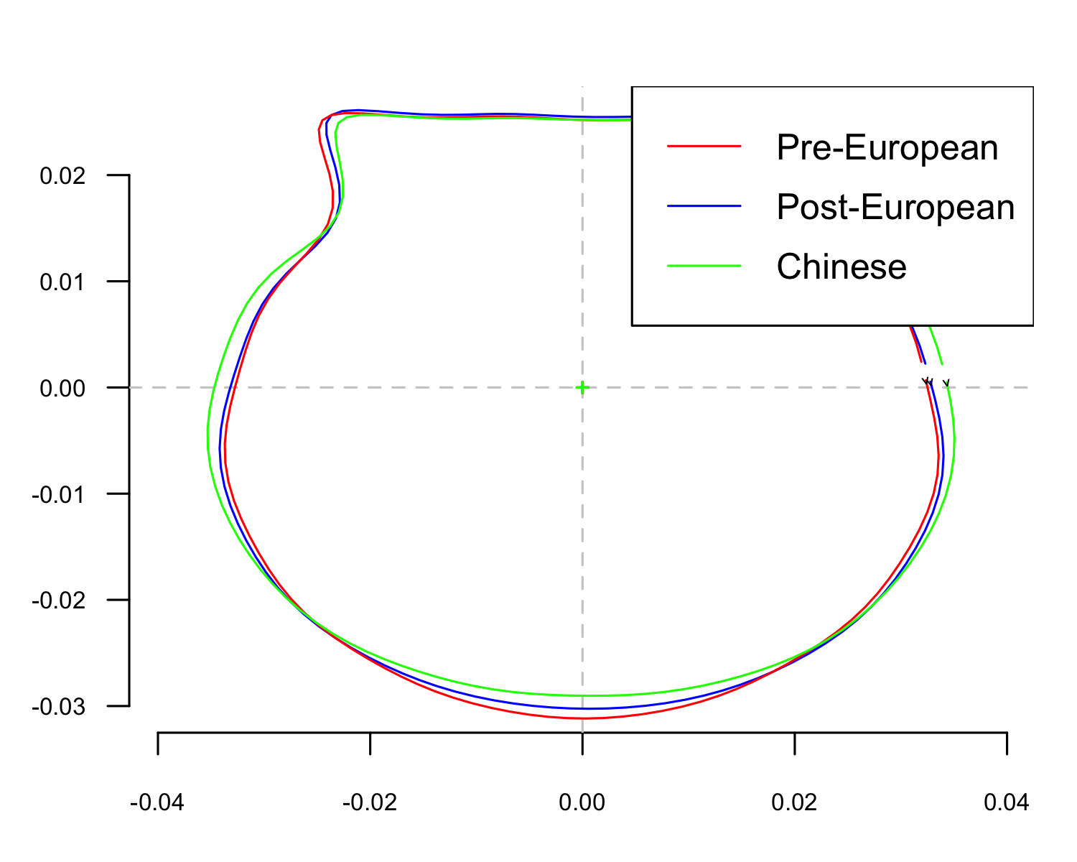

Figure 1: Mean pottery shapes of three phases

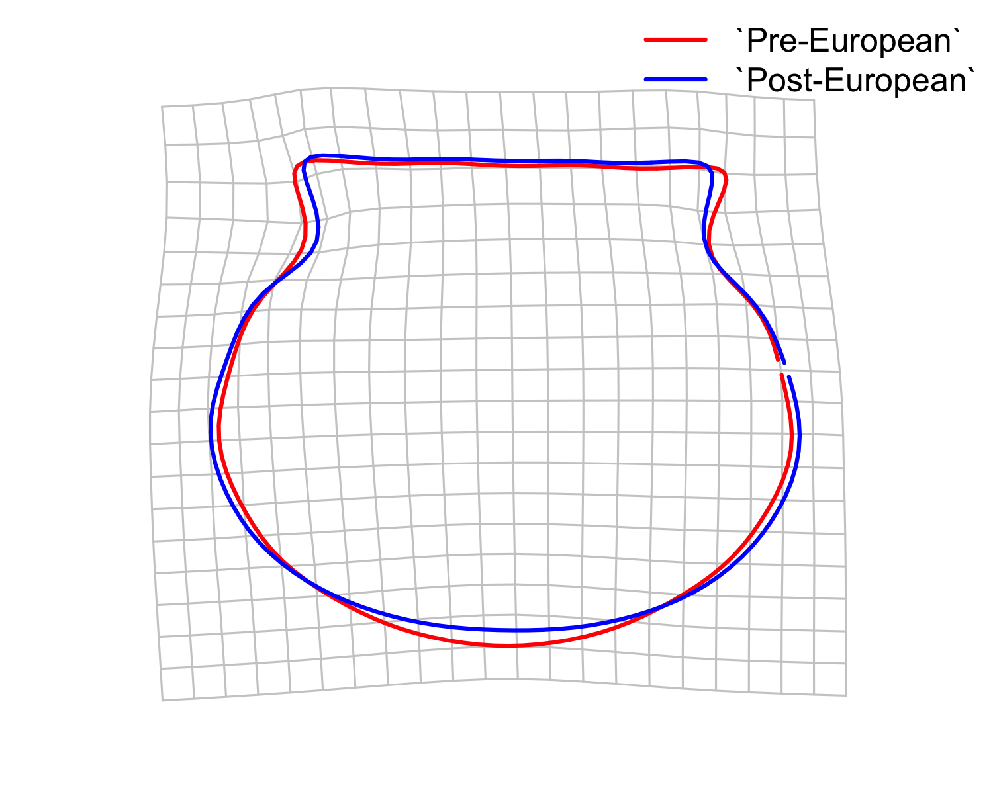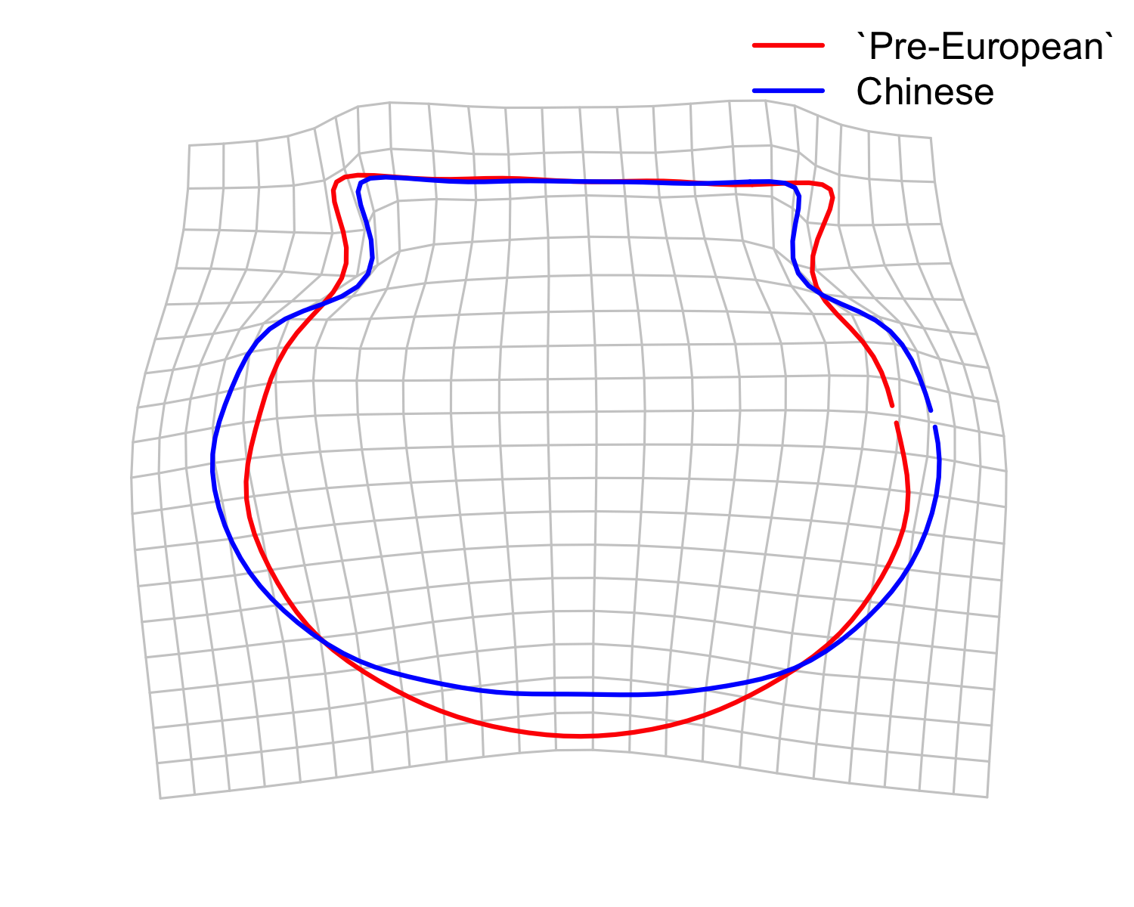

The elliptic Fourier coefficients are examined by principal components analysis to explore the shape variations across three phases. The first two principal components (PCs) explain 74.85% of the total variances, of which 48.32% is explained by the first principle component. With the third component, the first three principal components explain 86.08% of the total variances. Figure ?? shows the shape variation associated with the first three principal components. From the negative to the positive scores, the PC1 represents the height of the vessels from tall to short and the roundness of the body from round to oval-shaped. The PC2 relates to the neck and mouth constriction from narrow to wide. The PC3 explains a smaller portion of the variance (11.23%), which relates to the degree of the flare of the neck from curved to straight shape. The first two components account for most of the variance in relation to three phases were represented in Figure 4. The result reflects a large overlap of three groupings especially for shapes in the pre-European and post-European periods that might show some extent of the similarity. However, the spread of shape distribution indications a wider variation in shapes in the pre-European and post-European periods compared to those in the Chinese period along both PC1 and PC2 axes. In other words, there is a decreasing in shape variance in the Chinese period that shares the features of shorter height and narrower mouth.

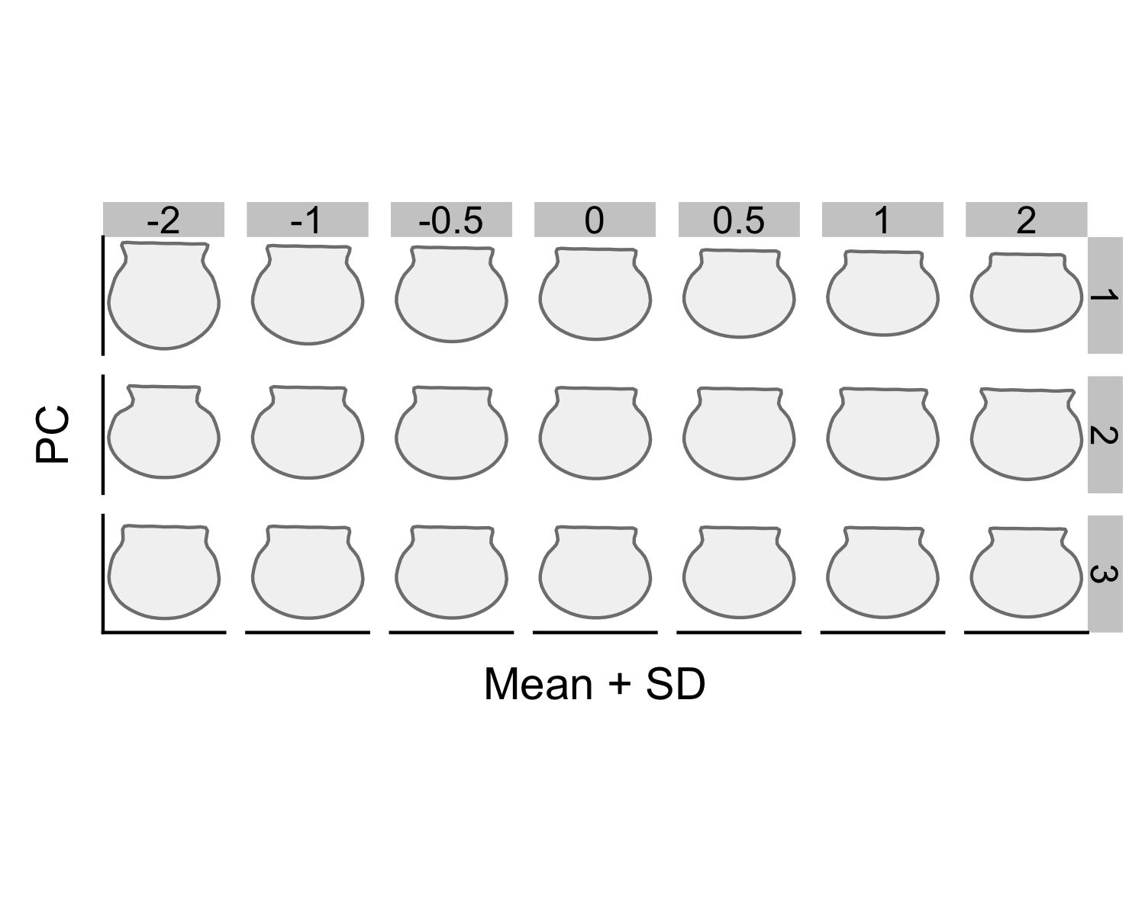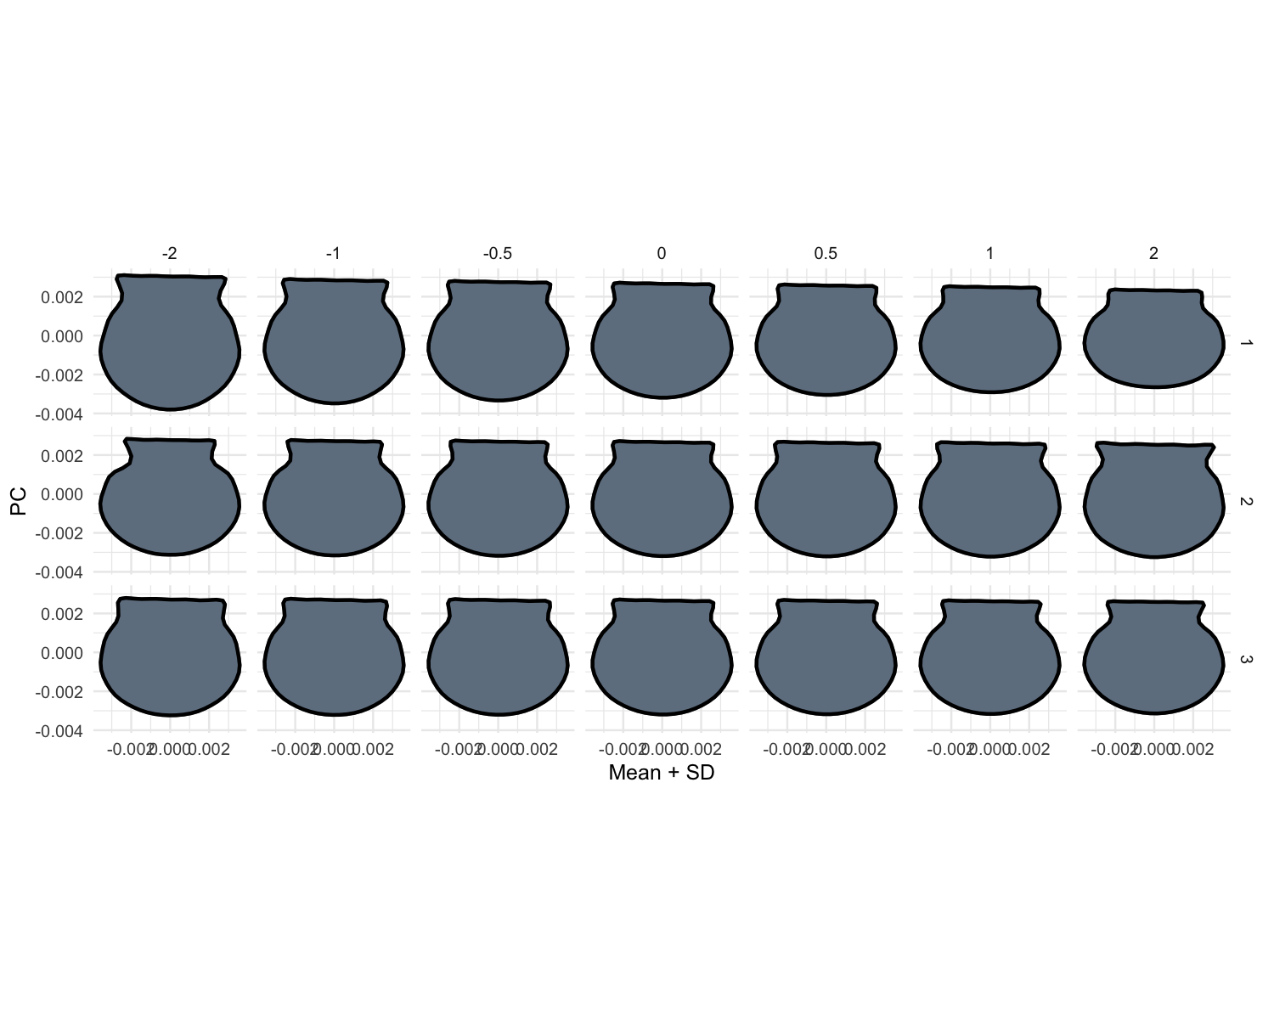

#> quartz_off_screen   
#> 2

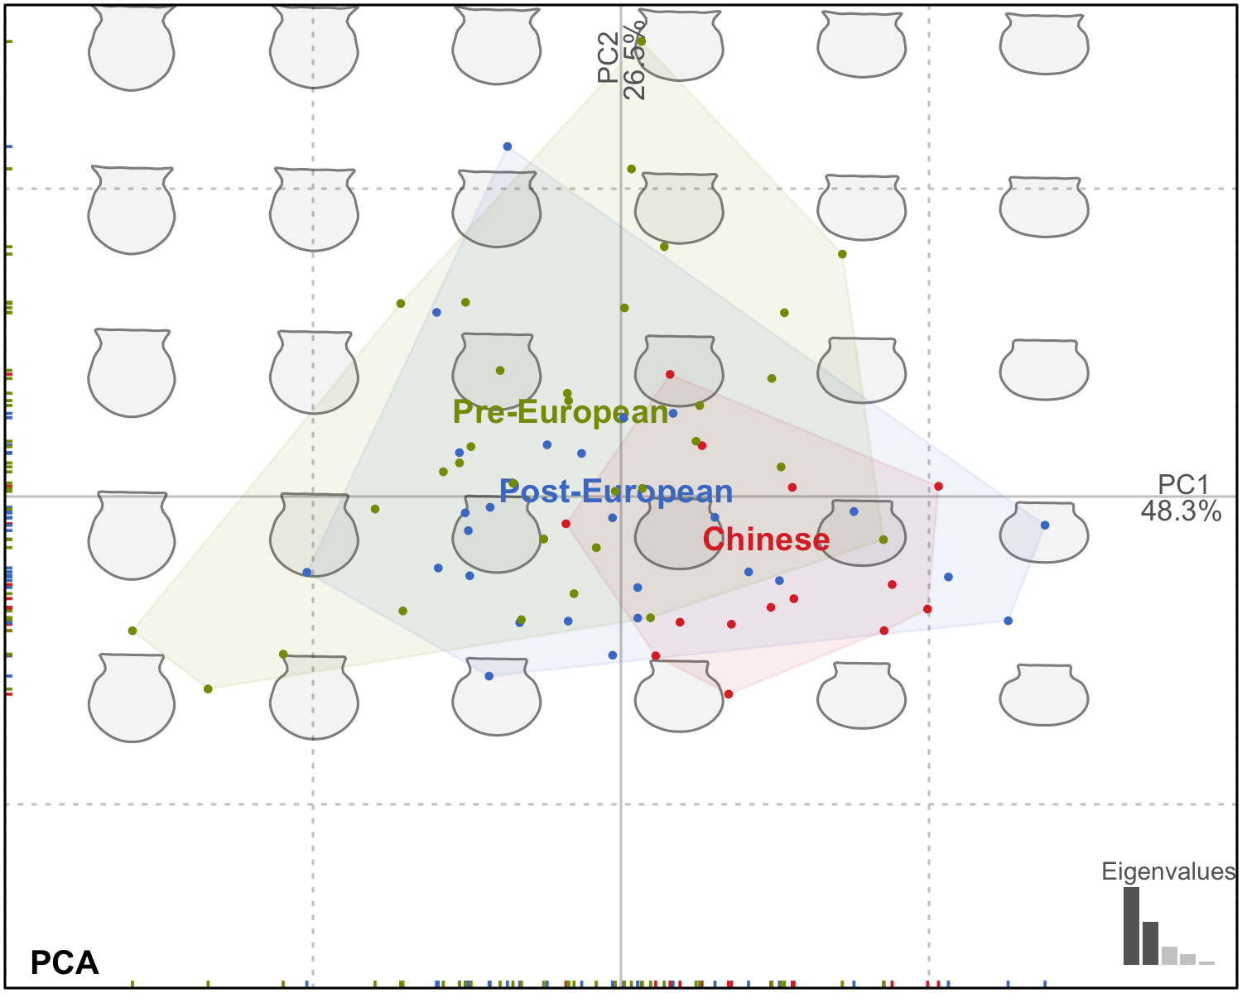

Figure 4: Pottery shape distribution by each occupation phase according to the first two PCs

#> $stars.tab  
#> Chinese Post-European Pre-European  
#> Chinese - ***   
#> Post-European *   
#>   
#> $summary (see also $manovas)  
#> Df Pillai approx F num Df den Df Pr(>F)  
#> Chinese - Post-European 1 0.3806 1.620 11 29 1.452e-01  
#> Chinese - Pre-European 1 0.6942 7.018 11 34 4.951e-06  
#> Post-European - Pre-European 1 0.3491 2.292 11 47 2.434e-02

Table 1: The statistics summary of MANOVA test for the PC scores

|  |  |  |  |  |  |  |
| --- | --- | --- | --- | --- | --- | --- |
|  | Df | Pillai | approx F | num Df | den Df | Pr(>F) |
| Chinese - Post-European | 1 | 0.3806357 | 1.620200 | 11 | 29 | 0.1451623 |
| Chinese - Pre-European | 1 | 0.6942310 | 7.017731 | 11 | 34 | 0.0000050 |
| Post-European - Pre-European | 1 | 0.3491049 | 2.291660 | 11 | 47 | 0.0243367 |

To test differences in the distribution of shape variables indicated by the PC scores, we use multivariate analysis of variance (MANOVA) to compare a pairwise combination between every sample means across three phases. The results in Table 1 show significant differences in shape between Pre-European and Post-European (p = ) and Pre-European and Chinese contact shapes (p = ), which corresponds to the previous observation of the different distribution in shapes in Chinese period according to PCA byplot. In addition, although there is a considerable overlap of shape variables between Pre-European and Post-European, their PC scores are significantly different from each other. There are not much differences between the shapes in the Post-European and Chinese contact periods.

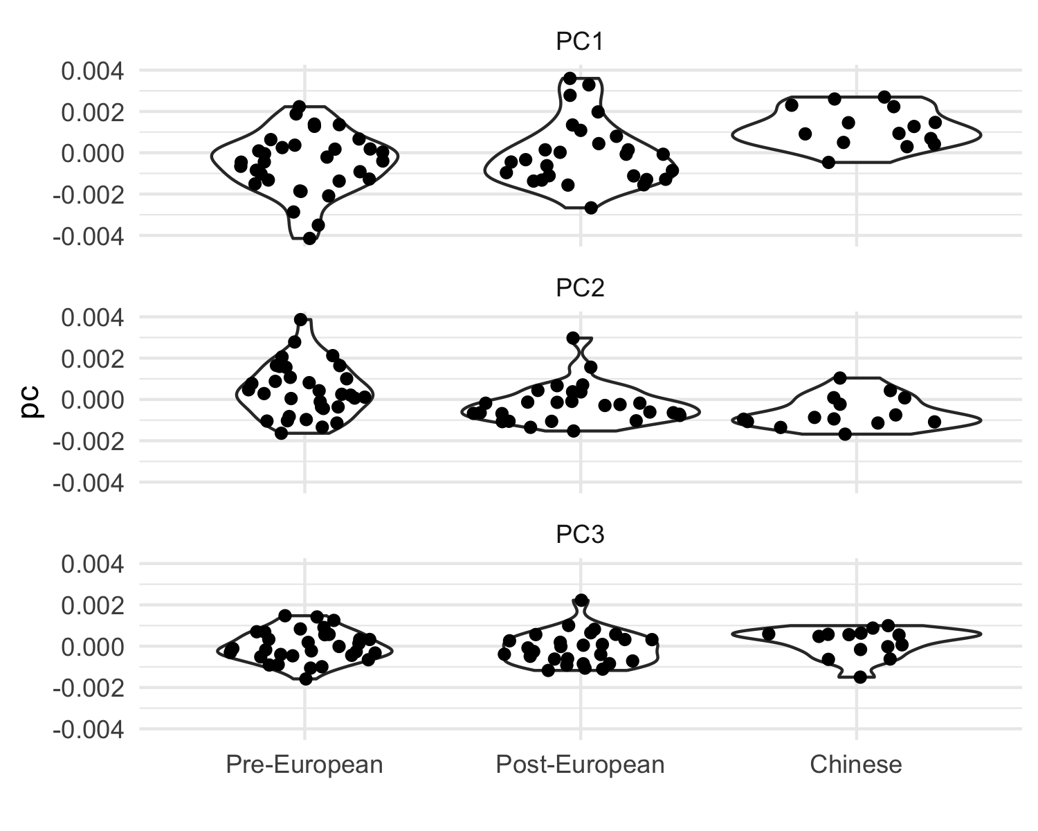

Figure 5: The distribution of PC scores by phases

#> # A tibble: 9 x 3  
#> # Groups: pcn [3]  
#> pcn phase variance  
#> <glue> <fct> <dbl>  
#> 1 PC1 Pre-European 0.00000216   
#> 2 PC1 Post-European 0.00000242   
#> 3 PC1 Chinese 0.000000902  
#> 4 PC2 Pre-European 0.00000162   
#> 5 PC2 Post-European 0.000000902  
#> 6 PC2 Chinese 0.000000587  
#> 7 PC3 Pre-European 0.000000553  
#> 8 PC3 Post-European 0.000000604  
#> 9 PC3 Chinese 0.000000487

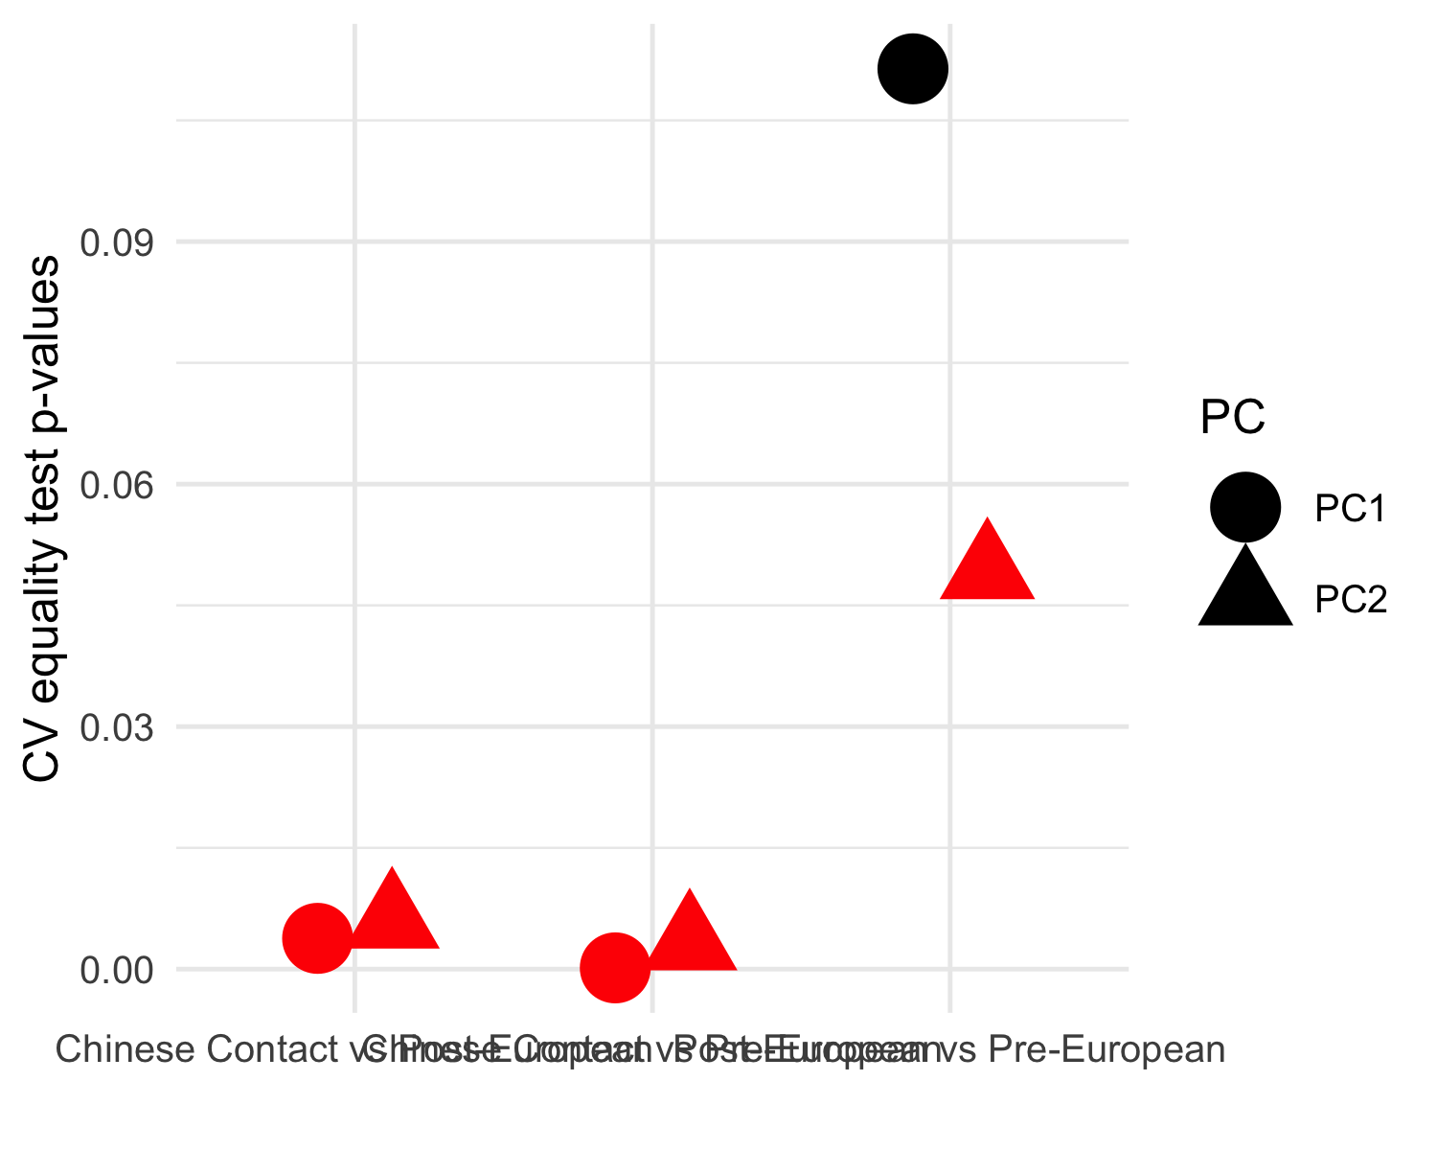

Figure 6: P-values of the CV equality test of PC1 and PC2 between phases, red color indicates p-value is less than 0.05

The variation of pottery shape for each phase is explored by the distributions of the first three PC scores to compare the extent of standardization across phases. Figure 5 suggests variations of PC scores for each vessel by phase. The first PC, the hight of the vessels, shows more variations in the pre-European period compared to the Chinese period. That indicates standardization appears strong in the Chinese period but weak in the pre-European period. The second PC also presents a similar pattern that stronger standardization of shape in the Chinese period compared to the other two phases. To see whether the differences in the distribution of PCs between any two phases is statistically significant, coefficients of variation statistic (CVs) among phase groups of PCs is examined with a modified signed-likelihood ratio test for the equality of CVs. P-values for the significant test of CVs of PC1 and PC2 show significant differences (P-value < 0.01) in the standardization of vessel shape across some periods, especially between Chinese contact with either pre-European or post-European Figure 6. Significant difference is also detected between pre-Eruopean and post-European (P-value < 0.05). Given the decline of the indigenous population in the Chinese period might be a cause of a more standardized shape (Chen, 2007), we examined the spatial distribution of pottery selected in this paper. The pottery distributed across the sampling area without any clusters could rule out the bias caused by the population dynamics.

# Discussion

1. Did foreign influence have impacts on indigenous pottery production that can be detected in the shape of the vessels? 2. How does pottery change in shape throughout 500 years from a single site that can represent the development of social organization in northeastern Taiwan?
2. Did pottery become more homogeneous and standardized in shape after foreign contacts with the European colonizer or the Chinese immigrants?

* cultural resistance
* trade (Alizadeh et al., 2018)
* identity, social boundary, Raux2015, Boness2017

Previous investigations at Kiwulan suggest an unequal distribution pattern of prestige goods, trade ornaments, during the presence of the European that hints the emergence of social inequality. Using an EFA-based outline approach, we examine the degree of the ceramic standardization as an indicator of the presence of ceramic specialization that is usually associate with social differentiation, such as the elite control (Costin, 2001; Junker, 1999). The results confirm that the differences in pottery shapes can be detected using EFA method. There are differences in pottery shapes detected in the indigenous society across different foreign contact phases, including the European in the 17th century and the Chinese in the 19th century. The significant difference especially presented between Chinese contact and either pre-European or post-European (P-value < 0.01). We also observe there is no obvious changes in the clay paste across different phases in relation to the increasing standardization of the pottery shape. More homogeneous and standardized in shape without changes in raw materials reflects the clay source might be the same but a preferred shape was emphasized during the Chinese contact period. This might indicate the appearance of specialized group. The pottery shape during the Chinese period tend to be short with oval-shaped body showing wider body diameter compared to previous two phases. It would need further analysis to understand if the changes in shape related to the function of pot.

The nature and context of the interaction with the foreign presences in indigenous society might give an insight into the different degree of standardized pottery among those contact phases.

# Conclusion

An increasing standardization of shape of pottery during the Chinese contact period compared to the other two periods is observed. This study provide an comparable basis for our understanding of the standardized pottery as an indicator of social changes in a cultural contact conditions. Northeastern Taiwan had been encountered two major foreign contacts in the 17th century with the Europeans and 19th century with the Chines immigrants. It shows that the standardization of pottery shape appears during the European presence and increased in the Chinese period. This may suggest that an emergence of specialized groups or a consensus of the adoption of similar shape of pottery in the society. These results are important to understand the influence of culture contact on local indigenous societies and answer the anthropological question that concerns the the mechanisms for social changes. In addition, our case study, which includes an openly available research compendium of R code suitable for use with any other assemblage, will help to expand the use of shape-based quantitative methods to questions about craft specialization and standardization in prehistoric technologies.

# Acknowledgements

We would like to thank the Yilan County Cultural Affairs Bureau in Taiwan for permitting access to the pottery used in this study. We thank Dr. Wen-Shan Chen in the Department of Geosciences, National Taiwan University for his invaluable guidance for petrographic analysis in his lab.

##### pagebreak

# References

Acabado, S., 2017. The archaeology of pericolonialism: Responses of the “unconquered” to spanish conquest and colonialism in ifugao, philippines. International Journal of Historical Archaeology 21, 1–26.

Acabado, S., Barretto-Tesoro, G., Amano, N., 2018. Status differentiation, agricultural intensification, and pottery production in precapitalist kiyyangan, ifugao, philippines. Archaeological Research in Asia 15, 55–69.

Adams, D.C., Rohlf, F.J., Slice, D.E., 2004. Geometric morphometrics: Ten years of progress following the “revolution”. Italian Journal of Zoology 71, 5–16.

Alizadeh, K., Samei, S., Mohammadkhani, K., Heidari, R., Tykot, R.H., 2018. Craft production at köhne shahar, a kura-araxes settlement in iranian azerbaijan. Journal of Anthropological Archaeology 51, 127–143.

Andrade, T., 2007. How Taiwan became chinese : Dutch, spanish, and han colonization in the seventeenth century. Columbia University Press, New York.

Arnold, D.E., 2000. Does the standardization of ceramic pastes really mean specialization? Journal of Archaeological Method and Theory 7, 333–375.

Arnold, J.E., Munns, A., 1994. Independent or attached specialization: The organization of shell bead production in california. Journal of Field Archaeology 21, 473–489.

Birch, T., Martinón-Torres, M., 2019. Shape as a measure of weapon standardisation: From metric to geometric morphometric analysis of the iron age ‘havor’lance from southern scandinavia. Journal of Archaeological Science 101, 34–51.

Blackman, M.J., Stein, G.J., Vandiver, P.B., 1993. The standardization hypothesis and ceramic mass production: Technological, compositional, and metric indices of craft specialization at tell leilan, Syria. American Antiquity 58, 60–80.

Bonhomme, V., Picq, S., Gaucherel, C., Claude, J., others, 2014. Momocs: Outline analysis using r. Journal of Statistical Software 56, 1–24.

Bookstein, F.L., 1997. Landmark methods for forms without landmarks: Morphometrics of group differences in outline shape. Medical image analysis 1, 225–243.

Bookstein, F.L., 1991. Morphometric tools for landmark data: Geometry and biology. Cambridge University Press.

Buchanan, B., Collard, M., O’Brien, M.J., 2019. Geometric morphometric analyses support incorporating the goshen point type into plainview. American Antiquity 1–11.

Cardillo, M., 2010. Some applications of geometric morphometrics to archaeology, in: Elewa, A.M.T. (Ed.), Morphometrics for Nonmorphometricians. Springer, pp. 325–341.

Chen, Y.-p., 2007. Qi wu lan yi zhi qiang jiu fa jue bao gao [report on the archaeological excavations at ki-wu-lan site]. Lanyang museum, Yilan, Taiwan.

Claude, J., 2008. Morphometrics with r. Springer Science & Business Media.

Costin, C.L., 2001. Craft production systems, in: Archaeology at the Millennium. Springer, pp. 273–327.

Costin, C.L., 1991. Craft specialization: Issues in defining, documenting, and explaining the organization of production. Archaeological method and theory 1–56.

Dietler, M., 2015. Archaeologies of colonialism: Consumption, entanglement, and violence in ancient mediterranean france. Univ of California Press.

Dietler, M., 2005. The archaeology of colonization and the colonization of archaeology: Theoretical challenges from an ancient mediterranean colonial encounter, in: Stein, G. (Ed.), The Archaeology of Colonial Encounters: Comparative Perspectives. NM: Sch. Am. Res. Press, Santa Fe, pp. 33–68.

Dietler, M., 1997. The iron age in mediterranean france: Colonial encounters, entanglements, and transformations. Journal of World Prehistory 11, 269–358.

Eerkens, J.W., Bettinger, R.L., 2001. Techniques for assessing standardization in artifact assemblages: Can we scale material variability? American Antiquity 66, 493–504.

Feinman, G.M., 2000. Corporate/network: New perspectives on models of political action and the puebloan southwest. Social Theory in Archaeology, University of Utah Press, Salt Lake City 31–51.

Fox, A.N., 2015. A study of late woodland projectile point typology in new york using elliptical fourier outline analysis. Journal of Archaeological Science: Reports 4, 501–509.

Given, M., 2004. The archaeology of the colonized. Routledge, London; New York.

Gunz, P., Mitteroecker, P., 2013. Semilandmarks: A method for quantifying curves and surfaces. Hystrix, the Italian Journal of Mammalogy 24, 103–109.

Haruda, A., Varfolomeev, V., Goriachev, A., Yermolayeva, A., Outram, A., 2019. A new zooarchaeological application for geometric morphometric methods: Distinguishing ovis aries morphotypes to address connectivity and mobility of prehistoric central asian pastoralists. Journal of Archaeological Science 107, 50–57.

Hirshman, A.J., Lovis, W.A., Pollard, H.P., 2010. Specialization of ceramic production: A sherd assemblage based analytic perspective. Journal of Anthropological Archaeology 29, 265–277.

Hoggard, C.S., McNabb, J., Cole, J.N., 2019. The application of elliptic fourier analysis in understanding biface shape and symmetry through the british acheulean. Journal of Paleolithic Archaeology 2, 115–133.

Ioviţă, R., 2010. Comparing stone tool resharpening trajectories with the aid of elliptical fourier analysis, in: New Perspectives on Old Stones. Springer, pp. 235–253.

Junker, L.L., 1999. Raiding, trading, and feasting: The political economy of philippine chiefdoms. University of Hawaii Press.

Junker, L.L., 1993. Craft goods specialization and prestige goods exchange in philippine chiefdoms of the fifteenth and sixteenth centuries. Asian Perspectives 1–35.

Kuhl, F.P., Giardina, C.R., 1982. Elliptic fourier features of a closed contour. Computer graphics and image processing 18, 236–258.

Lawing, A.M., Polly, P.D., 2010. Geometric morphometrics: Recent applications to the study of evolution and development. Journal of Zoology 280, 1–7.

Lycett, S.J., Cramon-Taubadel, N. von, 2013. A 3D morphometric analysis of surface geometry in levallois cores: Patterns of stability and variability across regions and their implications. Journal of Archaeological Science 40, 1508–1517.

Marwick, B., 2017. Computational reproducibility in archaeological research: Basic principles and a case study of their implementation. Journal of Archaeological Method and Theory 24, 424–450. <https://doi.org/10.1007/s10816-015-9272-9>

Marwick, B., Boettiger, C., Mullen, L., 2018. Packaging data analytical work reproducibly using r (and friends). The American Statistician 72, 80–88.

Marwick, B., Krishnamoorthy, K., n.d. Cvequality: Tests for the equality of coefficients of variation from multiple groups.

Meloro, C., Hudson, A., Rook, L., 2015. Feeding habits of extant and fossil canids as determined by their skull geometry. Journal of Zoology 295, 178–188.

Mullins, P.R., 2011. The archaeology of consumption. Annual Review of Anthropology 40, 133–144.

R Core Team, 2019. R: A language and environment for statistical computing. R Foundation for Statistical Computing, Vienna, Austria.

Rice, P.M., 1991. Specialization, standardization, and diversity: A retrospective, in: Bishop, R.L., Lange, F.W. (Eds.), The Ceramic Legacy of Anna O. Shepard. University Press of Colorado Boulder, pp. 257–279.

Roux, V., 2015. Standardization of ceramic assemblages: Transmission mechanisms and diffusion of morpho-functional traits across social boundaries. Journal of anthropological archaeology 40, 1–9.

Roux, V., 2003. Ceramic standardization and intensity of production: Quantifying degrees of specialization. American Antiquity 68, 768–782.

Roux, V., Karasik, A., 2018. Standardized vessels and number of potters: Looking for individual production, in: Ina Miloglav, J.V. (Ed.), Artisans Rule: Product Standardization and Craft Specialization in Prehistoric Society. Cambridge Scholars Publishing, pp. 20–39.

Scaramelli, F., Scaramelli, K.T. de, 2005. The roles of material culture in the colonization of the orinoco, venezuela. Journal of Social Archaeology 5, 135–168.

Silliman, S., 2001. Agency, practical politics and the archaeology of culture contact. Journal of social archaeology 1, 190–209.

Silliman, S.W., 2005. Culture contact or colonialism? Challenges in the archaeology of native North America. American Antiquity 55–74.

Slice, D.E., 2007. Geometric morphometrics. Annu. Rev. Anthropol. 36, 261–281.

Stark, B.L., 1995a. Economic intensification and ceramic specialization in the philippines: A view from kalinga. Research in Economic Anthropology 16, 179–226.

Stark, B.L., 1995b. Problems in analysis of standardization and specialization in pottery, in: Mills, B.J., Crown, P.L. (Eds.), Ceramic Production in the American Southwest. The University of Arizona Press, Tucson, pp. 231–267.

Tite, M.S., 1999. Pottery production, distribution, and consumption—the contribution of the physical sciences. Journal of archaeological method and theory 6, 181–233.

Topi, J.R., VanPool, C.S., Waller, K.D., VanPool, T.L., 2018. The economy of specialized ceramic craft production in the casas grandes region. Latin American Antiquity 29, 122–142.

Torrence, R., Clarke, A., 2000. Negotiating difference: Practice makes theory for contemporary archaeology in Oceania, in: Torrence, R., Clarke, A. (Eds.), The Archaeology of Difference : Negotiating Cross-Cultural Engagements in Oceania. Routledge, London; New York, pp. 1–31.

Trabert, S., 2017. Considering the indirect effects of colonialism: Example from a great plains middle ground. Journal of Anthropological Archaeology 48, 17–27.

Wilczek, J., Monna, F., Barral, P., Burlet, L., Chateau, C., Navarro, N., 2014. Morphometrics of second iron age ceramics–strengths, weaknesses, and comparison with traditional typology. Journal of archaeological science 50, 39–50.

##### pagebreak

### Colophon

This report was generated on 2020-01-07 09:46:25 using the following computational environment and dependencies:

#> ─ Session info ───────────────────────────────────────────────────────────────  
#> setting value   
#> version R version 3.6.1 (2019-07-05)  
#> os macOS Sierra 10.12.6   
#> system x86_64, darwin15.6.0   
#> ui X11   
#> language (EN)   
#> collate en_US.UTF-8   
#> ctype en_US.UTF-8   
#> tz America/Los_Angeles   
#> date 2020-01-07   
#>   
#> ─ Packages ───────────────────────────────────────────────────────────────────  
#> package * version date lib source   
#> assertthat 0.2.1 2019-03-21 [1] CRAN (R 3.6.0)   
#> backports 1.1.5 2019-10-02 [1] CRAN (R 3.6.0)   
#> bookdown 0.16 2019-11-22 [1] CRAN (R 3.6.0)   
#> broom 0.5.2 2019-04-07 [1] CRAN (R 3.6.0)   
#> callr 3.3.2 2019-09-22 [1] CRAN (R 3.6.0)   
#> cellranger 1.1.0 2016-07-27 [1] CRAN (R 3.6.0)   
#> cli 2.0.0 2019-12-09 [1] CRAN (R 3.6.1)   
#> colorspace 1.4-1 2019-03-18 [1] CRAN (R 3.6.0)   
#> cowplot * 0.9.4 2019-01-08 [1] CRAN (R 3.6.0)   
#> crayon 1.3.4 2017-09-16 [1] CRAN (R 3.6.0)   
#> cvequality * 0.2.0 2019-01-07 [1] CRAN (R 3.6.0)   
#> desc 1.2.0 2018-05-01 [1] CRAN (R 3.6.0)   
#> devtools 2.2.1 2019-09-24 [1] CRAN (R 3.6.0)   
#> digest 0.6.23 2019-11-23 [1] CRAN (R 3.6.0)   
#> dplyr * 0.8.3 2019-07-04 [1] CRAN (R 3.6.0)   
#> ellipsis 0.3.0 2019-09-20 [1] CRAN (R 3.6.0)   
#> evaluate 0.14 2019-05-28 [1] CRAN (R 3.6.0)   
#> fansi 0.4.0 2018-10-05 [1] CRAN (R 3.6.0)   
#> farver 2.0.1 2019-11-13 [1] CRAN (R 3.6.0)   
#> forcats * 0.4.0 2019-02-17 [1] CRAN (R 3.6.0)   
#> fs 1.3.1 2019-05-06 [1] CRAN (R 3.6.0)   
#> generics 0.0.2 2018-11-29 [1] CRAN (R 3.6.0)   
#> ggforce 0.2.2 2019-04-23 [1] CRAN (R 3.6.0)   
#> ggplot2 * 3.2.1 2019-08-10 [1] CRAN (R 3.6.0)   
#> glue 1.3.1 2019-03-12 [1] CRAN (R 3.6.0)   
#> gtable 0.3.0 2019-03-25 [1] CRAN (R 3.6.0)   
#> haven 2.1.0 2019-02-19 [1] CRAN (R 3.6.0)   
#> here * 0.1 2017-05-28 [1] CRAN (R 3.6.0)   
#> highr 0.8 2019-03-20 [1] CRAN (R 3.6.0)   
#> hms 0.4.2 2018-03-10 [1] CRAN (R 3.6.0)   
#> htmltools 0.3.6 2017-04-28 [1] CRAN (R 3.6.0)   
#> httr 1.4.1 2019-08-05 [1] CRAN (R 3.6.0)   
#> jsonlite 1.6 2018-12-07 [1] CRAN (R 3.6.0)   
#> knitr 1.26 2019-11-12 [1] CRAN (R 3.6.1)   
#> labeling 0.3 2014-08-23 [1] CRAN (R 3.6.0)   
#> lattice 0.20-38 2018-11-04 [1] CRAN (R 3.6.1)   
#> lazyeval 0.2.2 2019-03-15 [1] CRAN (R 3.6.0)   
#> lifecycle 0.1.0 2019-08-01 [1] CRAN (R 3.6.0)   
#> lubridate 1.7.4 2018-04-11 [1] CRAN (R 3.6.0)   
#> magrittr 1.5 2014-11-22 [1] CRAN (R 3.6.0)   
#> MASS 7.3-51.4 2019-03-31 [1] CRAN (R 3.6.1)   
#> memoise 1.1.0 2017-04-21 [1] CRAN (R 3.6.0)   
#> modelr 0.1.4 2019-02-18 [1] CRAN (R 3.6.0)   
#> Momocs * 1.3.0 2019-12-20 [1] Github (MomX/Momocs@028e70e)  
#> munsell 0.5.0 2018-06-12 [1] CRAN (R 3.6.0)   
#> nlme 3.1-140 2019-05-12 [1] CRAN (R 3.6.1)   
#> pillar 1.4.3 2019-12-20 [1] CRAN (R 3.6.0)   
#> pkgbuild 1.0.6 2019-10-09 [1] CRAN (R 3.6.0)   
#> pkgconfig 2.0.3 2019-09-22 [1] CRAN (R 3.6.0)   
#> pkgload 1.0.2 2018-10-29 [1] CRAN (R 3.6.0)   
#> plyr 1.8.4 2016-06-08 [1] CRAN (R 3.6.0)   
#> polyclip 1.10-0 2019-03-14 [1] CRAN (R 3.6.0)   
#> prettyunits 1.0.2 2015-07-13 [1] CRAN (R 3.6.0)   
#> processx 3.4.1 2019-07-18 [1] CRAN (R 3.6.0)   
#> ps 1.3.0 2018-12-21 [1] CRAN (R 3.6.0)   
#> purrr * 0.3.3 2019-10-18 [1] CRAN (R 3.6.0)   
#> R6 2.4.1 2019-11-12 [1] CRAN (R 3.6.0)   
#> Rcpp 1.0.3 2019-11-08 [1] CRAN (R 3.6.0)   
#> readr * 1.3.1 2018-12-21 [1] CRAN (R 3.6.0)   
#> readxl 1.3.1 2019-03-13 [1] CRAN (R 3.6.0)   
#> remotes 2.1.0 2019-06-24 [1] CRAN (R 3.6.0)   
#> reshape2 1.4.3 2017-12-11 [1] CRAN (R 3.6.0)   
#> rlang 0.4.2 2019-11-23 [1] CRAN (R 3.6.0)   
#> rmarkdown 1.15 2019-08-21 [1] CRAN (R 3.6.0)   
#> rprojroot 1.3-2 2018-01-03 [1] CRAN (R 3.6.0)   
#> rstudioapi 0.10 2019-03-19 [1] CRAN (R 3.6.0)   
#> rvest 0.3.4 2019-05-15 [1] CRAN (R 3.6.0)   
#> scales 1.1.0 2019-11-18 [1] CRAN (R 3.6.0)   
#> sessioninfo 1.1.1 2018-11-05 [1] CRAN (R 3.6.0)   
#> stringi 1.4.3 2019-03-12 [1] CRAN (R 3.6.0)   
#> stringr * 1.4.0 2019-02-10 [1] CRAN (R 3.6.0)   
#> testthat 2.3.1 2019-12-01 [1] CRAN (R 3.6.1)   
#> tibble * 2.1.3 2019-06-06 [1] CRAN (R 3.6.0)   
#> tidyr * 1.0.0 2019-09-11 [1] CRAN (R 3.6.0)   
#> tidyselect 0.2.5 2018-10-11 [1] CRAN (R 3.6.0)   
#> tidyverse * 1.2.1 2017-11-14 [1] CRAN (R 3.6.0)   
#> tweenr 1.0.1 2018-12-14 [1] CRAN (R 3.6.0)   
#> usethis 1.5.1 2019-07-04 [1] CRAN (R 3.6.0)   
#> utf8 1.1.4 2018-05-24 [1] CRAN (R 3.6.0)   
#> vctrs 0.2.1 2019-12-17 [1] CRAN (R 3.6.0)   
#> withr 2.1.2 2018-03-15 [1] CRAN (R 3.6.0)   
#> xfun 0.11 2019-11-12 [1] CRAN (R 3.6.1)   
#> xml2 1.2.2 2019-08-09 [1] CRAN (R 3.6.0)   
#> yaml 2.2.0 2018-07-25 [1] CRAN (R 3.6.0)   
#> zeallot 0.1.0 2018-01-28 [1] CRAN (R 3.6.0)   
#>   
#> [1] /Library/Frameworks/R.framework/Versions/3.6/Resources/library

The current Git commit details are:

#> Local: master /Users/EmilyWang/Desktop/School document/LW-Paper/kwl-pottery-2019  
#> Remote: master @ origin (https://github.com/LiYingWang/kwl.pottery.git)  
#> Head: [be7b0ac] 2020-01-07: work on discussion

Word count: 4469