Neuropixels Data Processing Basic Protocol
Version: 2026 Mar | Contact: li.yuan.noki@gmail.com
Scope | This document outlines the basic preprocessing workflow for Neuropixels recordings, using the odor go/no-go analysis pipeline as the example framework. Specific details may change as neuropixels and software evolves, but the general workflow remains useful.

1. Software Requirements
- MATLAB R2023b
- Anaconda

2. Code Package and Path Management
Repository: https://github.com/LiYuan-001/Odor-goNogo-neuropixels-analysis-pipeline
Download the github package and save it in your designated path, such as: D:\Npx_code
Please follow the README file included in the package.
Important: Do not search for functions directly in my folder on the lab network drive, and do not add my code folder on the network drive to your MATLAB working path. Please download and use your own local copy to avoid accidental changes or path conflicts.

3. Workflow Labels and Overview
- (a) Recommended to complete on the same day as recording, so recording issues can be identified and corrected before the next session.
- (b) Usually too time-consuming to complete on the recording day.

Overall workflow
Step | Process | Timing
1 | CatGT | a
2 | Generate session-specific channel map | a
3 | Kilosort spike sorting | a
4 | Phy manual curation | b
5 | Synchronize Neuropixels and I/O timestamps | a
6 | Extract curated clusters and assign synced spike times | b
7 | Session split into different blocks (task-specific) | a
8 | Go/no-go behavior analysis (task-specific) | a
9 | Video position extraction using DeepLabCut (task-specific) | a
10 | Position synchronization with Neuropixels data (task-specific) | a
11 | Customized downstream analysis | b

4. Preprocessing Overview
Steps 1–3 can also be integrated through the Python package SpikeInterface, which provides an efficient and reproducible workflow in Anaconda. Or there are many AI based skills etc. However, this document describes each step separately. Regardless of the interface used, it is important to understand what each step does and to adjust the workflow when necessary.

Recommendation: Steps 1–4 are best run on a local SSD for speed.

Step 1. CatGT
Recommended timing: (a)
Purpose: CatGT corrects sub-millisecond timing mismatches between channels, performs common-mode noise subtraction on AP data, and applies filtering to AP and LF signals. I made GUI based operation but here I will explain the most basic way, run it with commands.
- Documentation: See: https://billkarsh.github.io/SpikeGLX/
- Example CatGT folder: C:\Users\nrpix\OneDrive\Documents\CatGT-win
- How to start: Edit runit.bat in a text editor before running it. Do not double-click it directly before checking the arguments.
- Required edits: At minimum, update -LOCALARGS, -run, and -dest for the current session.

- Probe selection: -prb=0,1 for two probes; -prb=0 for probe 0 only; -prb=1 for probe 1 only.
- Optional parameter: -chnexcl={0;369,370;1;0,1} excludes selected channels from denoising/filtering.
- Expected output: A folder named catgt_<RunName>_g0 containing .ap.bin, .ap.meta, .lf.bin, and .lf.meta files for each probe.
- Error handling: If output files are missing, check C:\Users\nrpix\OneDrive\Documents\CatGT-win\CatGT.log. Most problems are caused by path errors, naming mismatches, or missing files.
- Folder naming for downstream analysis: The downstream code expects probe-specific folders, for example catgt_<RunName>_g0_imec0 and catgt_<RunName>_g0_imec1.
Example values

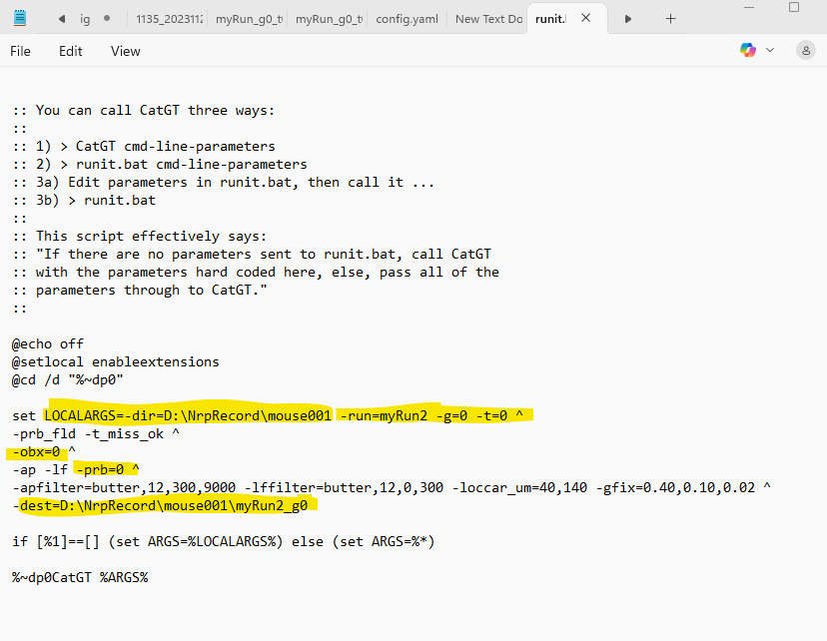

Step 2. Generate a Session-Specific Channel Map
Recommended timing: (a)
Purpose: The available channels can differ across sessions, so the channel map must be generated separately for each recording.
- Preparation: Make sure the downloaded analysis code folder is on the MATLAB path, then change the current folder to the CatGT output folder for the session.
- Optional bad-channel exclusion: You can exclude channels that should not be considered by Kilosort.
- Expected output: Choose the .ap.meta file. MATLAB will save a .mat channel map file and a chanMap.png figure for visual inspection.
MATLAB commands and steps:
- open ‘Matlab’
- in the command window, key in: addpath(genpath(‘D:\Npx_code’))
- change the current matlab path to the desired data folder (generated by catGT)
here use example recording folder. In the command window, key in:
cd(‘D:\NpxRecord\mouse001_processed\myRun_g0\catgt_myRun_g0_imec0’)
- in the command window, key in:
SGLXMetaToCoords2_badChan
If you have any bad channels you do not want kilosort to consider, such as channel 0 and channel 100, key in:
SGLXMetaToCoords2_badChan([0,100]).
The index follows the channel index in the SpikeGLX
It detects the .meta files in the folder and allows you to choose one for channel map generation.
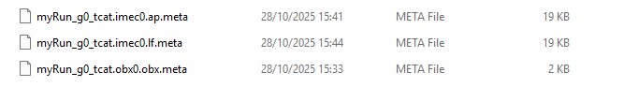
- choose the .ap.meta file and a .mat file will be auto save as ‘runname.imecX.ap_kilosortChanMap.mat’.
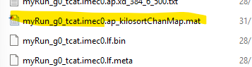
- A channel map figure will be generated and auto saved in the folder with the name as ‘chanMap.png’. We can use it for visual check.
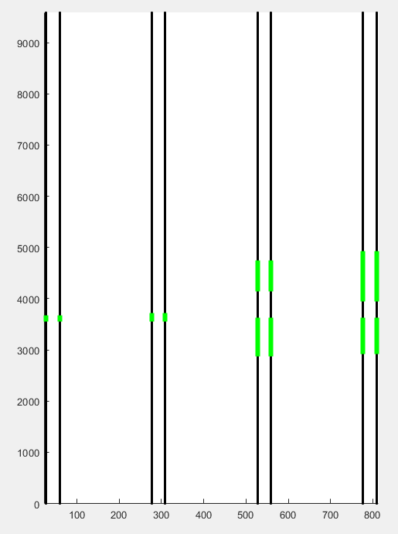

Step 3. Kilosort
Recommended timing: (a)
Purpose: Kilosort automatically detects and clusters spikes using GPU-based template matching and drift correction.
- Documentation: See: https://github.com/MouseLand/Kilosort
- Environment name: In my setup, the Kilosort 4 environment is named ks4.
- Important note: Always use the channel map generated in Step 2 for the current session.
- Expected output: A folder named kilosort4 will be created inside the selected data folder.
Anaconda commands
- Open anaconda prompt
- Type: activate ks4
- Type: cd path of the data folder
- Type: python -m kilosort
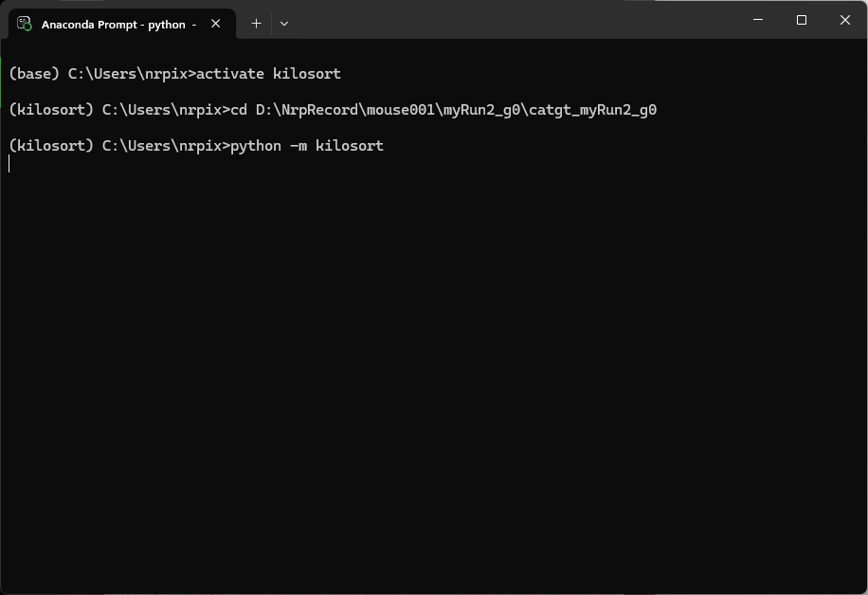
Then follow the GUI to use kilosort 4.0. One thing to notice is to make sure to use the channel map we generated for each data folder in the Step 2.
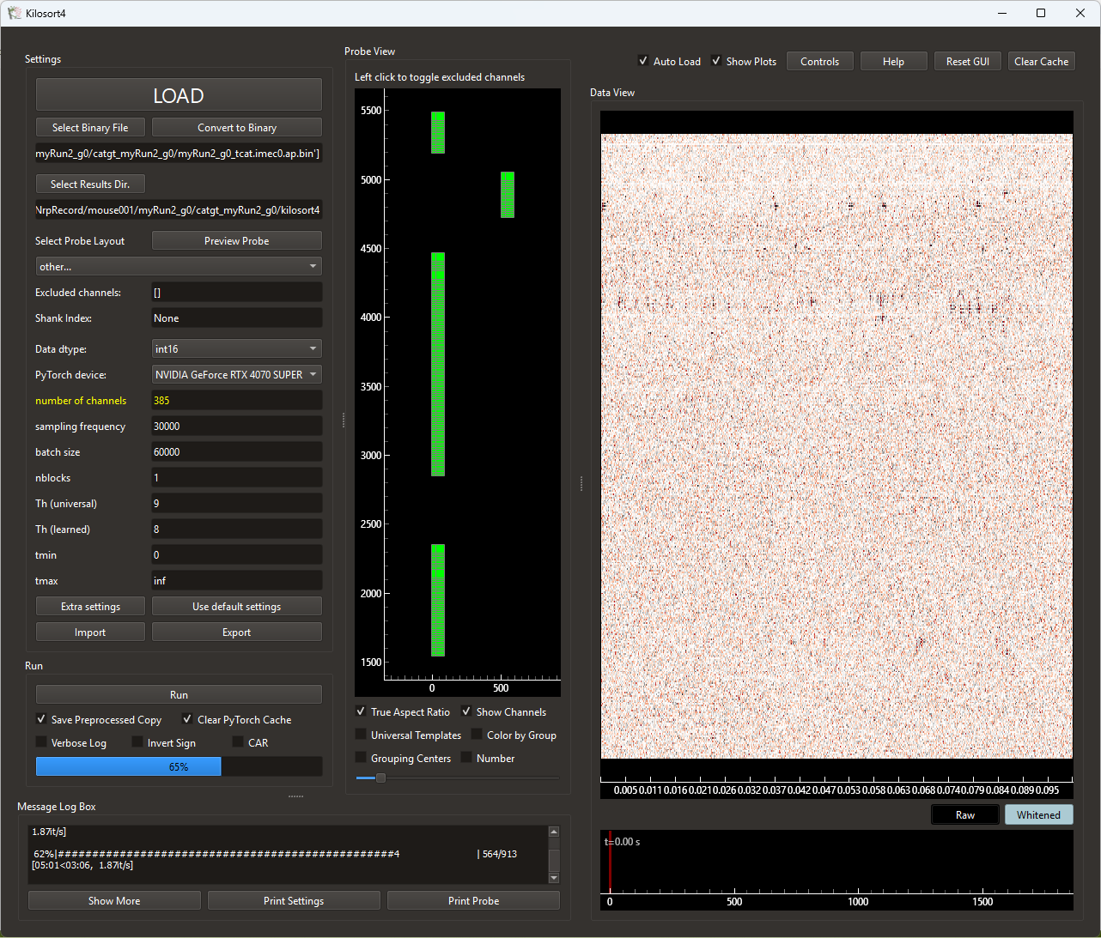
Steps of using kilosort GUI
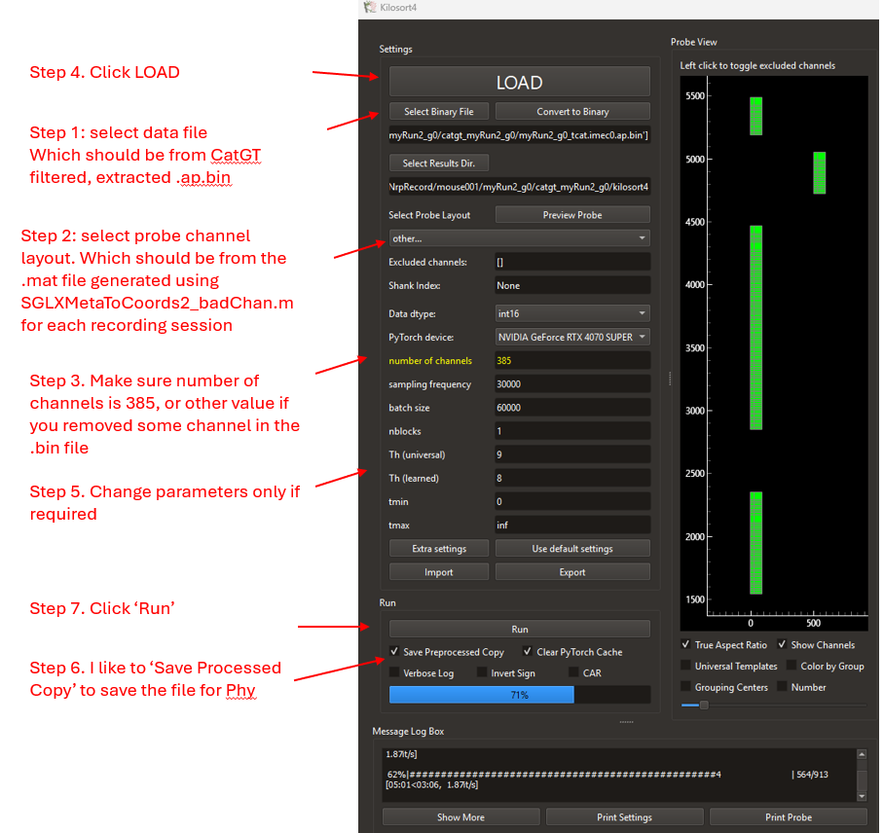

All the files will be written in a newly generated folder called ‘kilosort4’ in the data folder we selected where data is from.
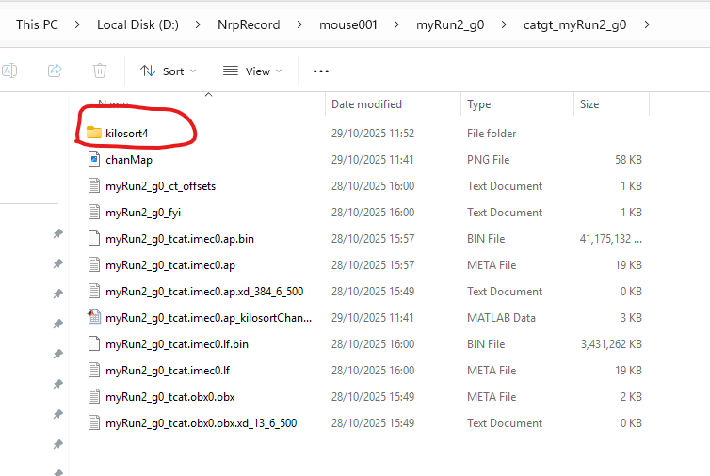

Step 4. Phy
Recommended timing: (b)
Purpose: Phy is used for manual curation of Kilosort output, allowing visualization, quality control, and refinement of clusters.
- Documentation: See: https://github.com/cortex-lab/phy
- Environment name: In my setup, the environment is named phy2.
- Note: Lab-specific curation criteria will be added later.
Anaconda commands
activate phy2
cd <path_to_kilosort4_folder>
phy template-gui params.py

Step 5. Synchronize Neuropixels and I/O Timestamps
Recommended timing: (a)
Purpose: Multiple data streams should not be aligned simply by their own index or nominal sampling rate. Even small clock differences can cause substantial misalignment over long recordings. This step synchronizes streams using rising TTL edges.
- Background: Relevant SpikeGLX documentation: https://billkarsh.github.io/SpikeGLX/help/syncEdges/Sync_edges/
Required metadata: From this step, all analysis using matlab require the recording session information, which example is in the ‘NpxCode’ folder, with the name as ‘npx_analysis.xlsx’. Please make sure you follow the format when you add more recording sessions. There are more columns in the excel file which are self explainable recording settings.
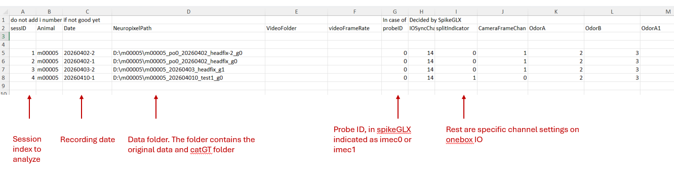
- Expected output: A folder such as ProcessedData/AnimalID-date and a syncTime.mat file used in downstream analysis.
MATLAB commands
- Open matlab
- (optional if you already added path) In the command window, key in:
addpath(genpath(‘D:\Npx_code’))
- (Optional if you already did) Open the Preprocess_Allclocks_Sync.m in the Editor window, change the result destination folder to your desired folder.
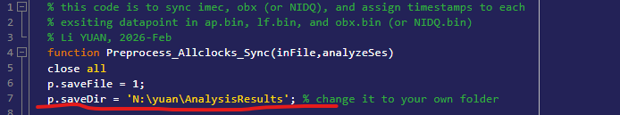
- In the command window, key in:
Preprocess_Allclocks_Sync ('npx_analysis.xlsx',[1,2])
This analyses sessInd 1 and 2 from the excel file. You can feely decide decide which recording sessions you would like to do.
- Outcome: in this step, as new folder called ‘ProcessedData/AnimalID-date’ will be generated in the folder specified in step c
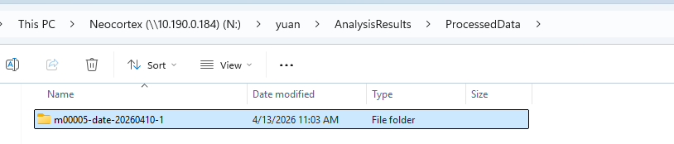
And a .mat file called ‘syncTime.mat’ will be save in the folder, and will be used for all following analysis.

When step 5 is done, it is good to upload the data onto the network drive. As most read and write consuming analysis is done.

Step 6. Extract Curated Clusters and Assign Synchronized Spike Times
Recommended timing: (b)
Purpose: This step extracts waveform and cluster information for good units and assigns synchronized timestamps to their spikes. The code can process as many probes as are specified in the session spreadsheet.
- Expected outputs: A figure folder such as xx_SpikeShape and a pixelCluster_imecX.mat file containing good clusters, synchronized spike times, waveform information, and related outputs.
MATLAB commands
- Open matlab
- (optional if you already added path) In the command window, key in:
addpath(genpath(‘D:\Npx_code’))
- (Optional if you already did) Open the Preprocess_Npx_extractClusters.m in the Editor window, change the result destination folder to your desired folder.
- In the command window, key in:
Preprocess_Npx_extractClusters ('npx_analysis.xlsx',[1,2])
This analyses sessInd 1 and 2 from the excel file. You can feely decide decide which recording sessions you would like to do.
- Outcome 1: in this step, a new folder called ‘xx_SpikeShape’ will be generated in the Figure folder specified at step c.
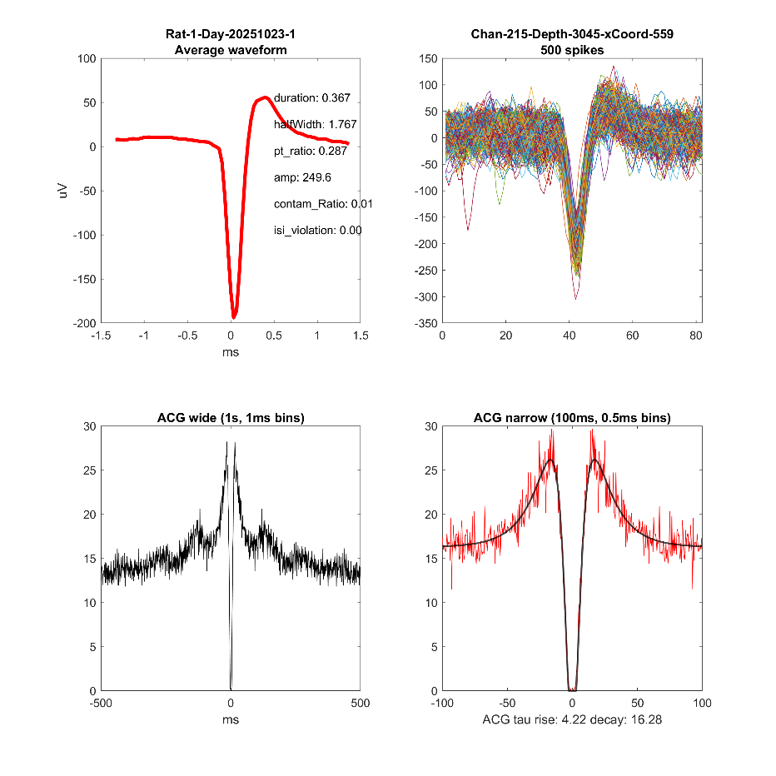
- Outcome 2: The .mat file, ‘npx_Cluster_imecX.mat’, for all good and multi clusters, including synchronized timestamps, waveform calculations etc are saved in the ‘Processed’ folder generated in Step 5.

5. Task-Specific Steps Still to Be Added
- Session split into different blocks
- Go/no-go behavior analysis
- Video position extraction using DeepLabCut
- Position synchronization with Neuropixels data
These steps will be documented once the remaining task-specific pipeline code is finalized.

6. Final Notes
- Use a local SSD whenever possible for preprocessing speed.
- Keep a local copy of the analysis code rather than pointing MATLAB to a shared network-drive code directory.
- Check output folders after each step before moving on.
- This protocol will continue to evolve as the pipeline develops.

