Formula One Analysis
– STAT 6341 Sports Analytics Final Report
Author: Léon Yuan
Date: 2023-12-13
Instructor: Dr. South

Introduction
Methodology
Bayesian Linear Mixed Model
Machine Learning Algorithms
R Shiny Dashboard
Results
Bayesian Linear Mixed Model
Constructors
Drivers
Year
Circuit
Qualify Position
Age
Prediction
Machine Learning Algorithms
Compare Bayesian and Frequentist linear models
Discussions and Conclusions
Limitations
Future Work
Conclusions
Selling
References
Appendix

Introduction
Formula 1 is the most cutting-edge auto technology and fastest race sport globally. It is an international team sport, involving more than 20 countries and 5 continents. This project aims to compare drivers and car manufacturers across seasons in the past and predict drivers’ performance in the future. The potential consumers are drivers who participate in Formula One and race fans who want a deep and thorough understanding of this sport. I found two published academic papers from Springer that discussed how different factors influence points. The first is A Data-Driven Analysis of Formula 1 Car Races Outcome (Patil et al., 1970). This paper applied Principal Component Analysis and Multivariable Linear Regression. The second is Formula One Race Analysis Using Machine Learning (Kumar et al., 2023). This paper applied logistic regression, decision tree classifier, random forest classifier, support vector machine, Gaussian NB, and k-neighbor classifier. I also found many highly commented notebooks about F1 data analysis on the Kaggle. For instance, a Formula One Pit Stop analysis is here. A Formula One Post-Race Summary is here. A ​​Formula One detailed Data Visualization is here. I found a well-organized database of Formula 1 on Kaggle, collected by the best sudoku solver in India, Rohan Rao, a Data Scientist at H2O.ai. The database contains 14 data tables in 20.63 Meg bite. The major tables I used for my analysis are circuit, constructors, drivers, qualifying, races, and results. The database structure is attached in the Appendix.

Methodology

Bayesian Linear Mixed Model
Bayesian models allow me to make inferences without specifying a null hypothesis. If Bayesian models perform well, the posterior inference generally is more accurate and provides an accurate measurement of uncertainty. For simplicity, I assumed normal distributions for all parameters and outcome variables. I also assumed linear relationships between race points and factors. I also included fixed effects and random effects for different factors. As a result, it is a Bayesian linear mixed model. I selected seasonal year, circuit track, driver age, qualify position, constructor (car manufacturer), and driver as my predictors and outcome points in this model. I think seasonal year, circuit track, driver age, and qualify position are all fixed effects because I am only interested in the impacts of each specific element on points. Furthermore, I think the constructor and driver are random effects in my model because there are variations for each driver and constructor. For example, sometimes a driver performs better than other times. A constructor’s performance is unstable under some uncertainty. Overall, such random effects are also used to account for differences between each driver and constructor. I also considered each driver nested within each corresponding constructor because in Formula 1, each constructor sponsors and supports two drivers in each race. I think these two drivers under the same constructor share similar performance from their cars, but they are still different in racing because of individual differences. Except for age and points, all other predictors are categorical. The following table shows all variable characteristics.

Table 3: Variable Characteristics
Predictor | Effects
Year | Fixed
Circuit | Fixed
Age | Fixed
Qualify | Fixed
Constructor | Random
Driver | Random Nested Within Constructor
Points | Outcome

I wrote out my Bayesian linear mixed model formula as follows, given the likelihood is based on a normal distribution:

All the prior distributions are for all parameters are as follows:

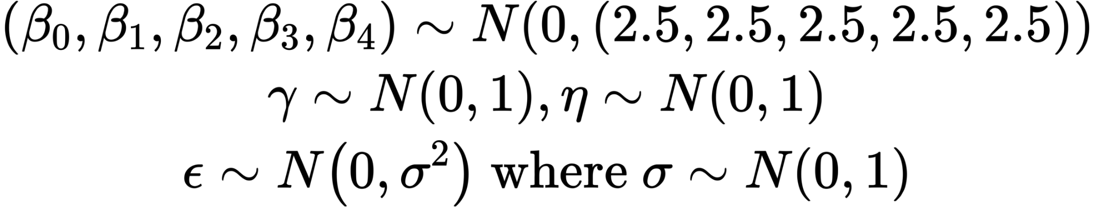
The original dataset does not have an age variable, but it has the dates of birth of all drivers and dates of their races. I manually calculated the ages of drivers as the differences between such two dates. The modeling data has 9,815 rows and 8 columns and includes races from season 1994 to 2023. It contains 168 drivers, 46 constructors, and 42 circuits. The following table is the snapshot of Bayesian data.

Table 4: Modeling Data
Year | Circuit Id | Driver Id | Constructor Id | Qualify | Age | Driver-Constructor | Points
1994 | 18 | 30 | 22 | 2 | 25.2 | 30.22 | 10
2010 | 3 | 4 | 6 | 3 | 28.6 | 4.6 | 25
2023 | 77 | 852 | 213 | 16 | 22.8 | 852.213 | 0

I used my desktop (Mac Studio 2023, Apple M2 Ultra, 64GB Memory) to run this Bayesian linear mixed model. I tried Mane Frame, but it failed to run. I used RStan language to build such a model. Furthermore, I set up 24 parallel cores, 8 chains, each of which has 3,000 iterations with 1,500 warmups. In total, I got 12,000 post-warmup samples. My desktop took 28 minutes to finish running. The complete R stan file is shared here for replication and review. I also included generated quantities for predicting historical points and future races. I used normal_rng() to draw posterior predictive samples for season 2023 at the Dutch Grand Prix on 2023-08-27, which does not exist in my data. For such a prediction in the future, I set up 4,000 iterations and four chains. There are 8,000 post-warm-up. There are 19 drivers in this race to predict. It took my desktop 20 minutes to finish.

I selected four representative parameters to show their trace plot for model diagnostics. These four parameters all show excellent mixed chains, and there is no divergent trend, as follows:

Figure 1: Trace Plot
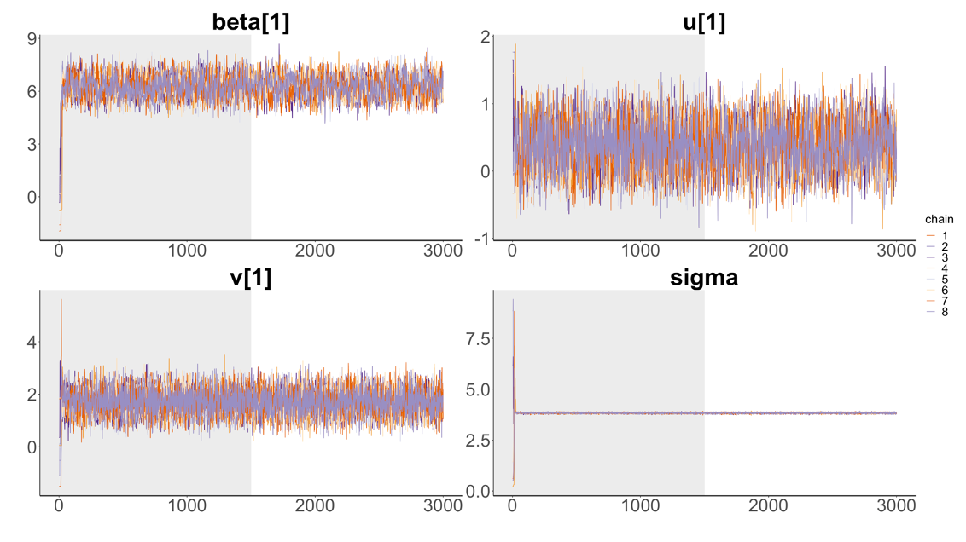
These four parameters are beta 1, the coefficient for the season year 1994; u 1, the random effect mean for constructor 1, British McLaren; the random effect mean for driver 1, Lewis Hamilton under McLaren; and the outcome normal distribution sigma.

The autocorrelations of posterior samples for these four parameters show very low autocorrelation after lag 10. The autocorrelation plot is as follows:

Figure 2: Autocorrelation Plot
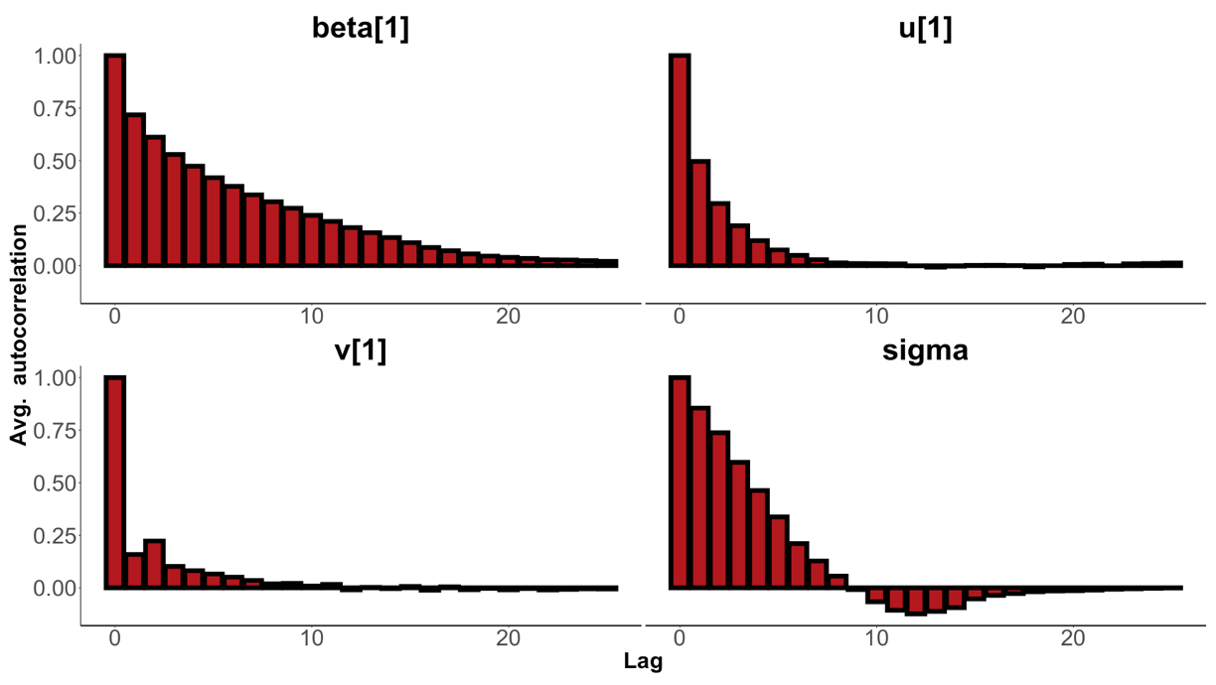

The effective sample size and Rhat of posterior samples for three parameters indicate enough equivalent simple random samples and well convergence. The table is shown as follows:

Table 5: ESS and Rhat
Parameter | Effective Sample Size | Rhat
β_1 | 1517.5 | 1.0
u_1 | 3005.0 | 1.0
v_1 | 5752.7 | 1.0

The predictive Bayesian model shows a similar good convergence as follows:

Figure 3: Trace Plot for Predictive Model
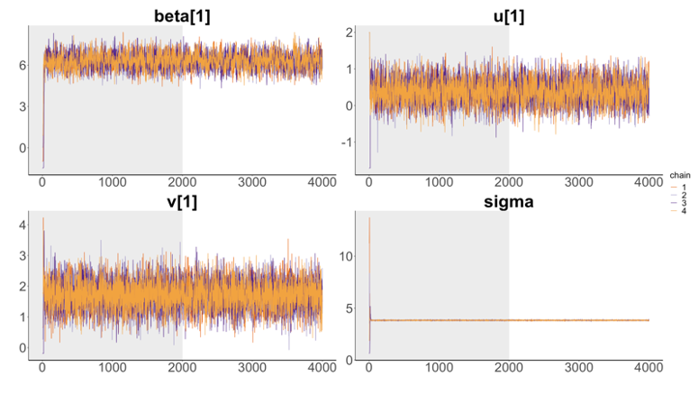

Machine Learning Algorithms

I applied three types of machine-learning algorithms to the same data that I used for Bayesian Modeling. Although they lack some interpretations compared to traditional statistical models, I want to see if they can make better predictions than statistics. The three algorithms are linear regression, random forest, and XGBoost. I used tidymodels to train and test them. For data pre-processing, I removed drivers who participated in less than 20 races in F1 because training models would throw errors when training processes couldn’t find those drivers in resampling. I removed the qualified position from 23rd to 28th because of the old system. I got 9,090 rows and seven columns. I split it into 80% as a training set and 20% as a test set. Year, circuit, driver, constructor, and qualify predictors are factored and dummied without one-hot encoding. Age is scaled and centered. I fine-tuned all possible parameters provided in the tidymodels with resampling into eight folds and repeated them 4 times, stratified by the constructor.

R Shiny Dashboard
I built an R shiny dashboard to visualize Formula One data dynamically and make new predictions with linear regression, random forest, and XGBoost on the same page for comparison. There is a home landing page to describe this project. The second tab shows a bar plot of all drivers' nationalities distribution. The third tab shows a bar plot of all constructors’ race involvement. The fourth tab shows a time series plot of all drivers’ race points from 1977 to 2023 grouped by drivers’ nationalities. The fifth tab shows a time series plot of all constructors’ race points from 1956 to 2023 grouped by constructors’ nationalities. The last tab shows the prediction panels produced by three models, and users can select their desired inputs by dropdown options for predictors. The linear regression panel also shows a 95% prediction interval.

Results

Bayesian Linear Mixed Model

Constructors
I compared the random effect coefficients for all constructors to see which constructor from this model was the best. I plotted the posterior means for all constructors and their uncertainty at 80% and 95% intervals. I found that it was clear German Mercedes and Austrian Red Bull posterior means are relatively more prominent than others, as shown as follows:

Because these two constructors are so close, I plotted the density curves for their posterior coefficient samples. I plotted a histogram of the difference between these two samples compared to zero, as shown in the vertical blue line. I calculated the highest density interval of such difference is [−0.39, 1.77]. I have 89.4% confidence that Mercedes performs better than Red Bull, although Red Bull has fewer variations than Mercedes.

Figure 4: Posterior for constructors
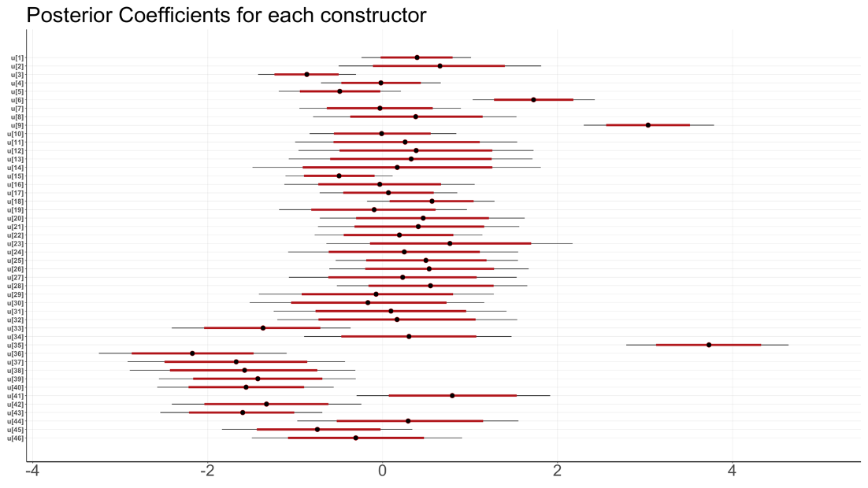
Figure 5: Density for two constructors
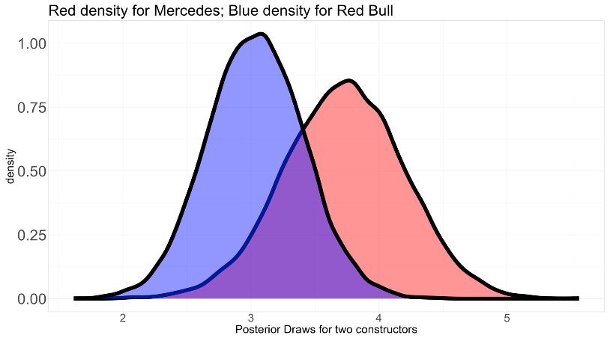
Figure 6: Histogram of difference
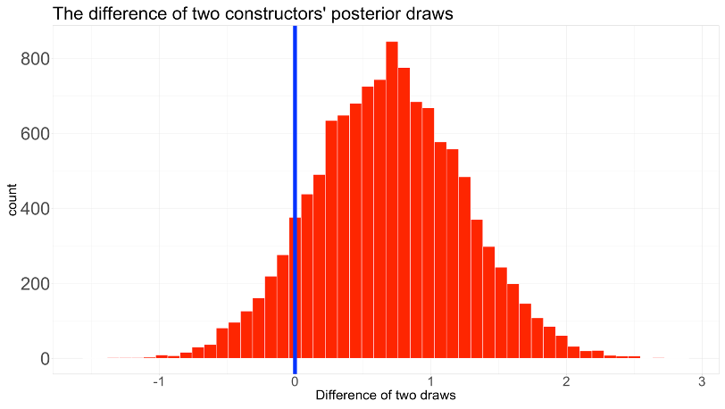

Drivers
I compared the random effect coefficients for all drivers nested within each constructor to see which driver from this model was the best. I plotted the posterior means for all drivers and their uncertainty at 80% and 95% intervals. I found that it was clear Fernando Alonso from Ferrari
and Lewis Hamilton from Mercedes's posterior means are relatively more prominent than others, as shown as follows:

Because these two drivers are so close, I plotted the density curves for their posterior coefficient samples. I plotted a histogram of the difference between these two samples compared to zero, as shown in the vertical blue line. I calculated the highest density interval of such a difference is [−0.89, 1.76]. I have 73% confidence that Lewis performed better than Fernando, given their variations and shapes are very close.

Figure 7: Posterior coefficients for all drivers
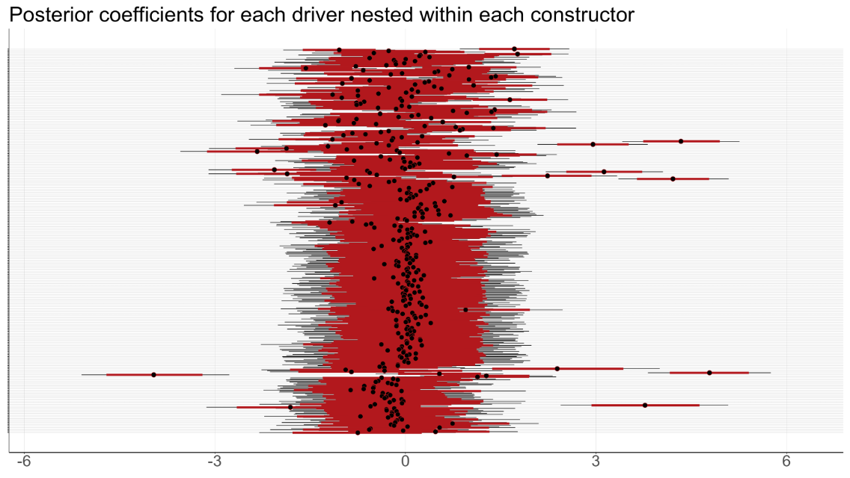
Figure 8: Density for two drivers
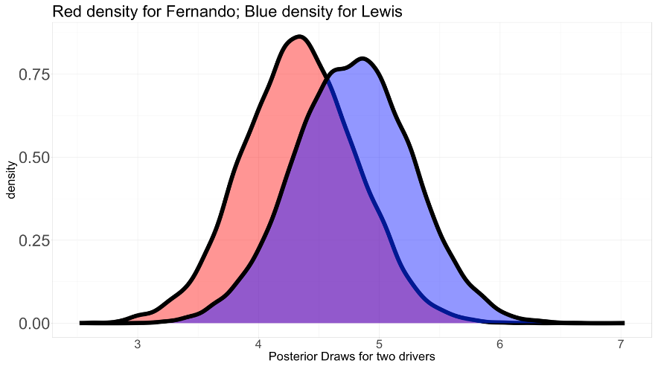
Figure 9: Histogram of Difference
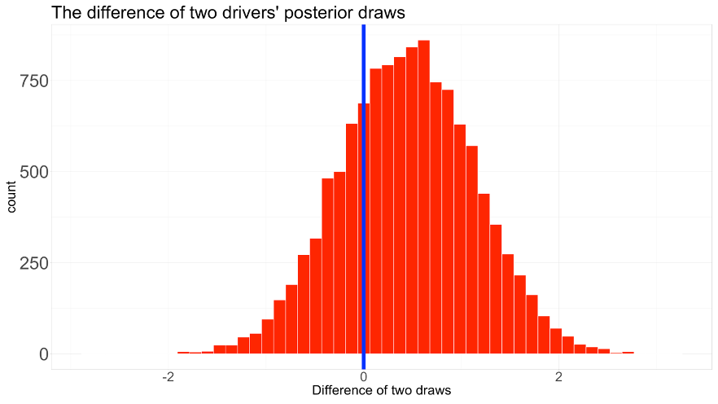

Year
I found a big gap for posterior coefficients of years before 2010 and after 2010 as follows. The mean of posterior coefficients for 2010 is 3.5 units larger than that in 2009. I investigated the reason for this gap: the Formula One point system was changed a lot in 2010. From 2003 to 2009, the first position is 10 points. However, starting from 2010, the first position is 25 points. The detailed change is as follows. Otherwise, there was no apparent difference year by year.

Figure 10: Gap between 2009 and 2010 Figure 11: Change of Point System
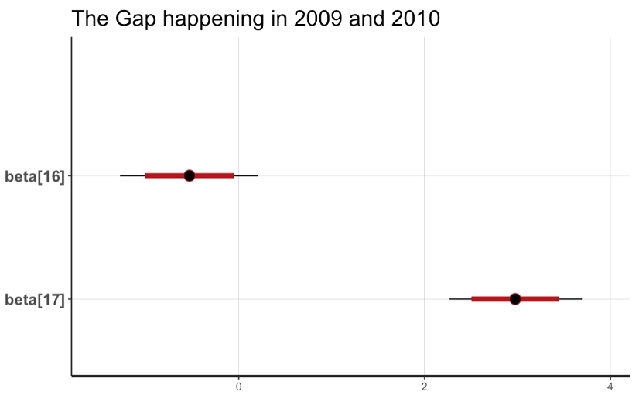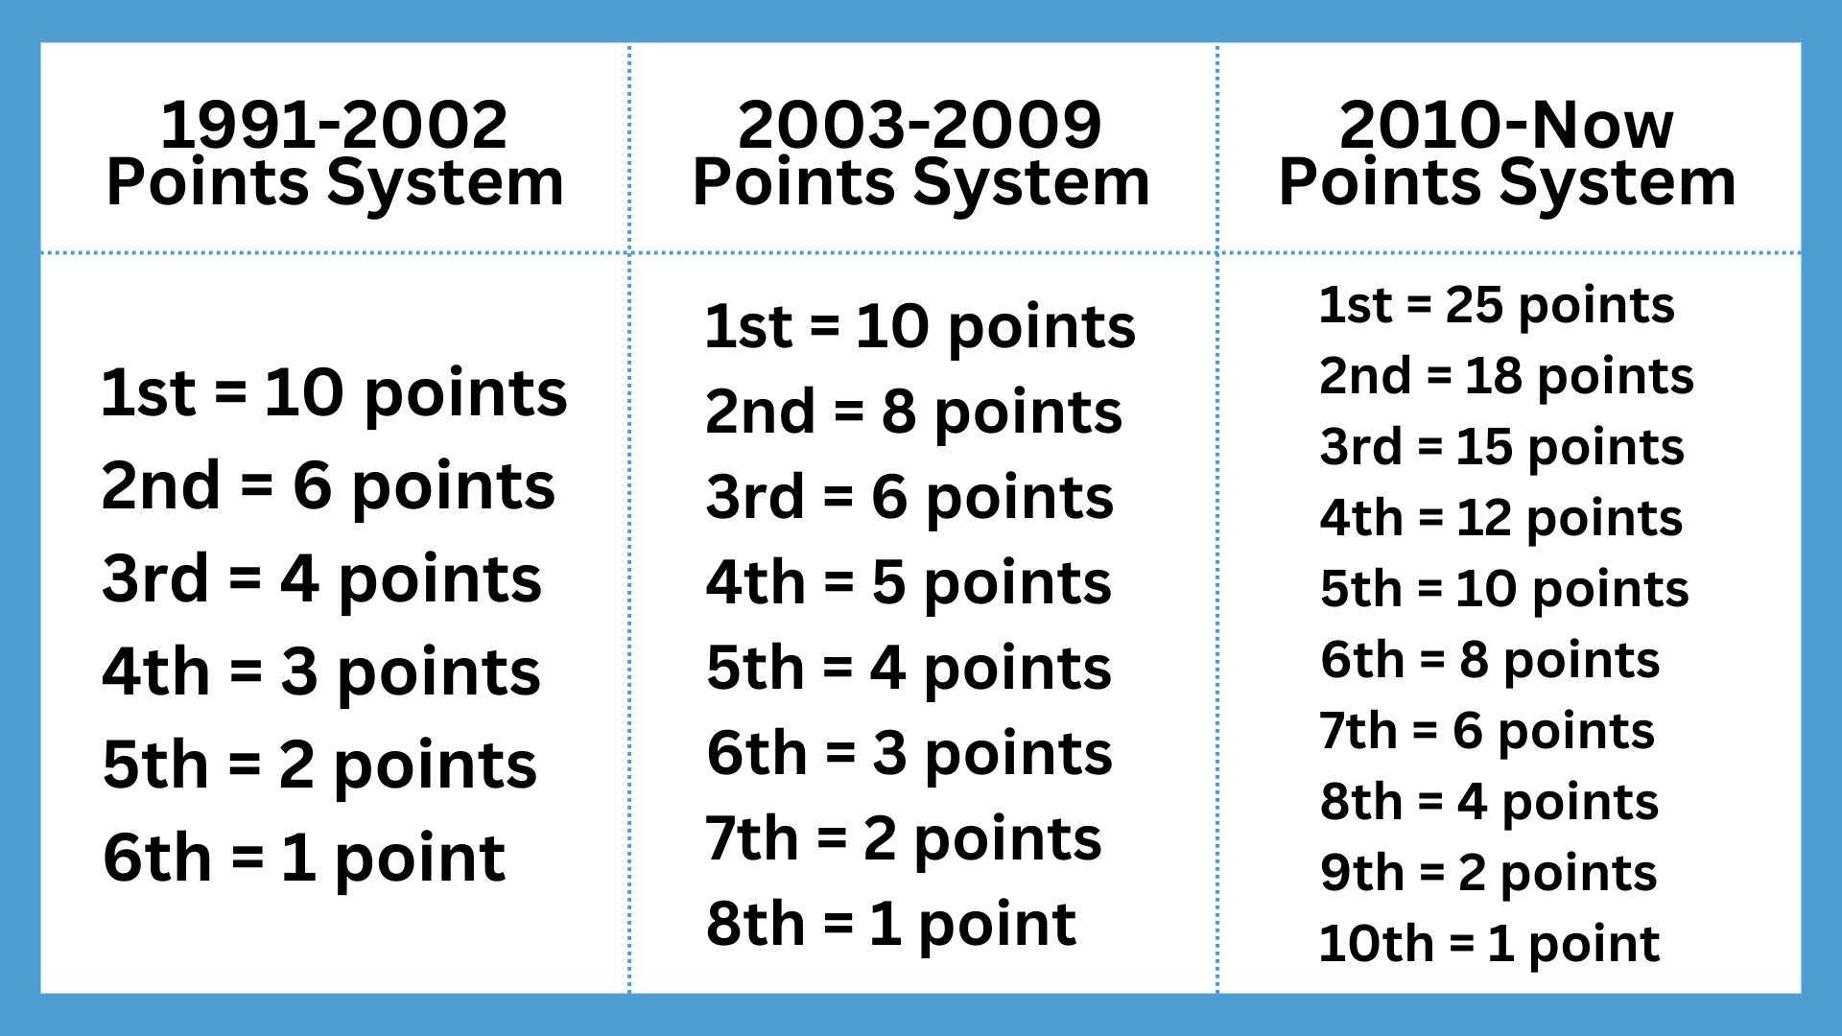

Circuit

I found that the Yas Marina Circuit in Abu Dhabi generally produces 0.3 units more points than all other circuits on average, as follows. Except for this circuit, all other circuits show a similar posterior mean. The Yas Marine is the world's most advanced luxurious Grand Prix, known for its smooth and flowing layout.

Figure 12: Posterior for Circuits
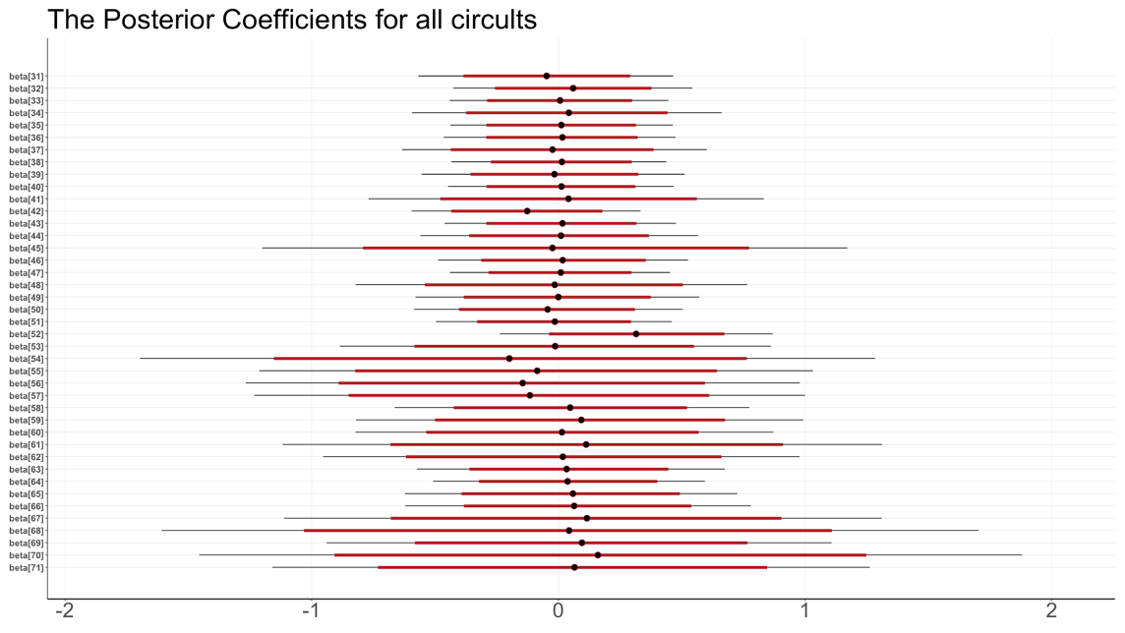

Qualify Position
I found it evident that front-qualified positions have more points than those in later positions, as follows. The first three starting positions gain more advantages in races than those in middle positions compared to later positions. The qualified positions from 23rd to 28th have few records in the data, so their posterior means and uncertainty levels need to be accurately valid.

Figure 13: Posterior for Qualified
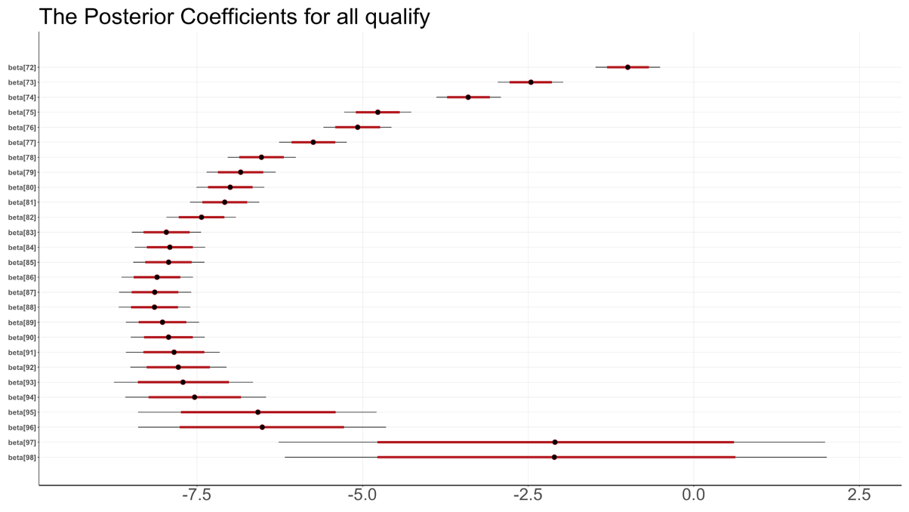

Age
The positive posterior coefficient of Age means older drivers may perform better because of more racing experience. However, Age does not influence race points a lot. If age increases by 1, given that other predictors are fixed, the histogram of the posterior point changes is shown below. As I observe, the most common change of points is less than 1 point.

Figure 14: Histogram of posterior point changes
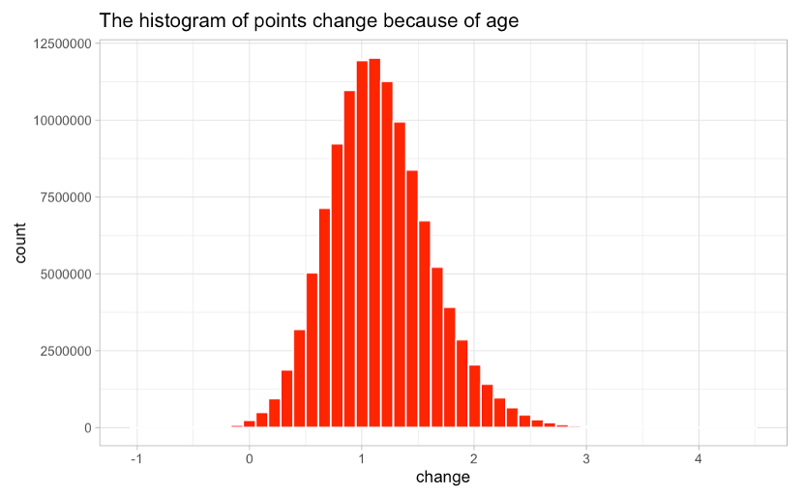

Prediction
I used normal_rng() to draw posterior predictive samples for season 2023 at the Dutch Grand Prix on 2023-08-27, which does not exist in my data. In this race, there were 19 drivers needed to predict. Each driver's Bayesian prediction point and uncertainty intervals are shown below. I found that for the top three drivers, Max Verstappen, Fernando Alonso, and Pierre Gasly, the Bayesian predictions are underestimated because actual blue points are even larger than their upper predicted intervals. The predicted points are overestimated for lower-ranked drivers George Russel and Charles Leclerc. Bayesian predictions are close to actual blue points for most middle-ranked drivers.

Figure 15: Posterior Predictive Points ranked by true Points
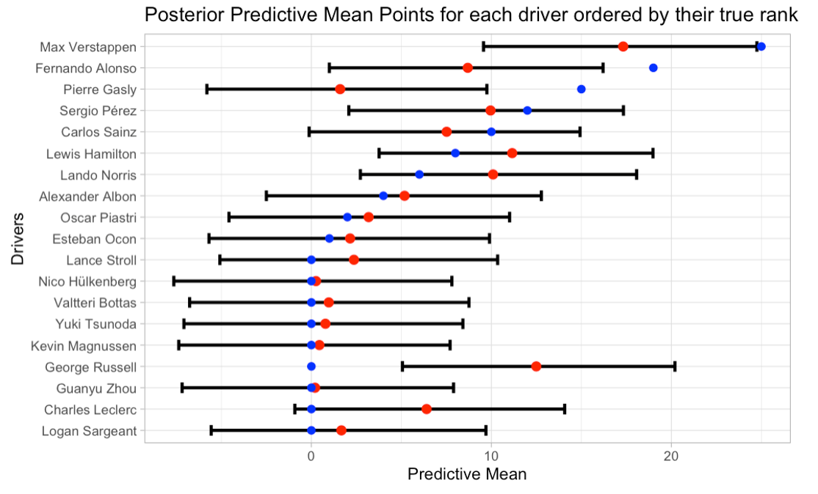

Machine Learning Algorithms
I used the tidymodels framework to create a size of 10 hyper tuning parameter spaces with grid_latin_hypercube and tune_race_anova to speed up the grid search. After training and testing, I found that linear regression performs the best of all. Random Forest and XGBoost perform very closely. The comparison of RMSE is given below. The best fine-tuned Random Forest and XGBoost model specifications are shown below.

Table 6: RMSE Comparison
Model | Train RMSE | Test RMSE | Standard Error
Linear Regression | 3.93 | 4.22
Random Forest | 4.43 | 4.50 | 0.02
XGBoost | 4.42 | 4.57 | 0.02

Table 7: Best Model Specification
Model | mtry | min n | Tree Depth | Learn Rate
Random Forest | 5 | 22
XGBoost | 3 | 16 | 1114 | 0.03

The variable importance plot of XGBoost shows constructor Mercedes is the most influential. The ALE plot shows Mercedes helps drivers gain more points in a straight line.

Figure 16: Variable Importance Figure 17: ALE Plot
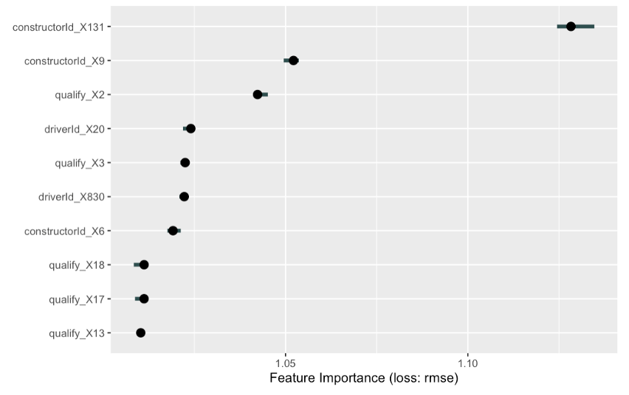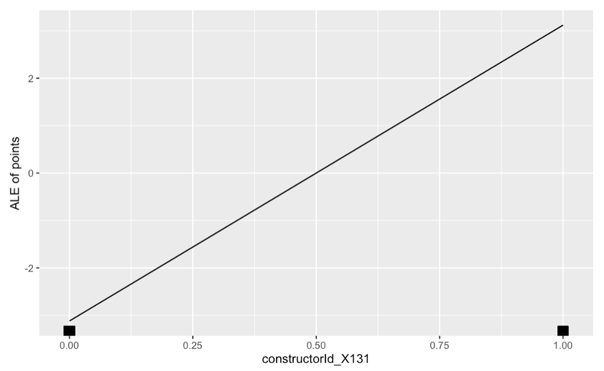

Compare Bayesian and Frequentist linear models
I compared the Bayesian linear mixed model with the frequentist model in the season 2023 in the Dutch Grand Prix on Aug. 27. The Bayesian model’s predictions performed slightly better than the frequentists’ because its RMSE is slightly lower.

Model | RMSE
Bayesian | 5.58
Frequentist | 5.98

Discussions and Conclusions

Limitations
I only used a few predictors in my models. However, they can’t represent the whole race situation. So, there are still many unexplained variations in my model residuals. There are too many driver and constructor levels. Such too many levels would decrease the model prediction performance. My model includes the races before 2010 and after 2010 as a whole. However, there was a significant point system change in 2010. This policy change may introduce some noise, decreasing the model's performance. I used a normal distribution as all parameters prior. Some parameters may not follow a simple normal. I used the normal distribution to assume the outcome variable. However, the points are discrete, from 25 points for 1st position, 18 points for 2nd position, and so on.

Future Work
Creating more features and including more predictors such as pit stop time, fastest lap time, number of accidents, and number of overtaking. These new predictors represent races in more dimensions. There was a significant point system change in 2010. Building two separate models for races before 2010 and after 2010 may be accurate, reflecting the performance in two periods. Creating an indicator variable for before 2010 and after 2010 is another way to show this change in the model. Using a zero-inflated Poisson distribution for the outcome variable is more realistic because all drivers only get 25 points, 18 points, and so on. Split the seasonal years into two parts. Use the first part of the data to get the prior distribution for all parameters. Use the second part of the data to build the posterior distribution and make inferences.

Conclusions
I find there are 165 British drivers and 158 American drivers. These two countries produce the most F1 drivers. Most of the other drivers are from European countries. Ferrari and McLaren are the two most involved car manufacturers in F1. Mercedes and Red Bull are the two most powerful car manufacturers. I have 90% confidence that Mercedes performs better than Red Bull, although Red Bull’s performance is more stable. Fernando Alonso from Ferrari and Lewis Hamilton from Mercedes are the two most excellent racers. I have 73% confidence that Lewis performed better than Fernando, given their performance stability is very close. The Yas Marine Circuit makes drivers get more points than other circuits in general because it is well-known for its smoothness and flowing layout. Qualified positions have a significant influence on race points. The first three positions gain much more advantages than the middle and later positions. The first three positions definitely have clear roads to race, while later positions are likely to be blocked by front cars and cause more accidents to stop racing. Although elderly drivers usually have more experience in races and gain a bit of an advantage, Age does not affect drivers’ performance much. My predictions from all models show that in the future, Max Verstappen will dominate the whole season.

Selling
The sellable product is my R shiny dashboard. Drivers can observe that point changes for other drivers and constructors from 1977 to 2023. They can choose which constructors are more suitable for them. Race fans can make point predictions for future races. My overall conclusions are also very valuable to fans and people unfamiliar with Formula One for a brief introduction.

References
Patil, A., Jain, N., Agrahari, R., Hossari, M., Orlandi, F., & Dev, S. (1970, January 1). A data-driven analysis of formula 1 car races outcome. SpringerLink. https://link.springer.com/chapter/10.1007/978-3-031-26438-2_11
Kumar M., Preethi N. (2023). Formula One Race Analysis Using Machine Learning. (n.d.). Springer Professional. https://www.springerprofessional.de/en/formula-one-race-analysis-using-machine-learning/24060770

Appendix

Table 1: Database
Data Set | Rows | Columns
circuit | 77 | 9
constructors | 211 | 5
constructor_results | 12290 | 5
constructor_standings | 13051 | 7
drivers | 857 | 9
drivers_standings | 34124 | 7
lap_times | 551742 | 6

Table 2: Database
Data Set | Rows | Columns
pit_stop | 10089 | 7
qualifying | 9815 | 9
races | 1101 | 18
results | 26080 | 18
seasons | 74 | 2
sprint_results | 180 | 16
status | 139 | 2

