An Efficient Byzantine Fault Tolerance Blockchain Consensus Protocol for Wireless Blockchain Systems

Abstract- Blockchain can solve security and trust challenges in wireless networks. Most previous studies of blockchain consensus protocols in wireless network rely on efficient and stable transmissions and correct leaders. Nevertheless, nodes in wireless blockchain have limited physical resources, unreliable channels, and varying bandwidths influenced jamming attacks or environments. In this paper, we propose a novel Byzantine fault-tolerant consensus protocol SWIB (Stability-aware Wireless Blockchain) for blockchain in wireless networks. SWIB randomly selects a block proposer to prevent adversary corruption, and uses a threshold BLS signature scheme as voting mechanism to improve the performance of blockchain system. Because only one block will be confirmed in per round, SWIB protocol can avoid the occurrence of blockchain forks. Moreover, it can tolerate up to $\left\lfloor \frac{N-1}{2}\right\rfloor$ malicious nodes among $N$ consensus nodes. Extensive simulation results show that SWIB is resistant to jamming attack and Sybil attack.

Introduction
With the rapid development of wireless communication and blockchain technologies, much work has been carried out to apply blockchains in wireless applications, such as mobile edge computing [1], intelligent 5G technology [2], the Internet of Vehicles [3], etc. Applications for wireless networks face with significant challenge of security and trust. Resources constrained mobile devices are vulnerable to various attacks. Meanwhile, the open communication of wireless networks is heavily impacted by environment. Both channel bandwidth and jamming attacks make the communication in wireless networks become unstable and unreliable. Blockchain has received great attention from both academia and industry. With salient properties of decentralization and persistence as well as traceability, blockchain provides a new way to solve security and trust problems. This means that blockchain technology can provide reliable and secure resource sharing services in wireless networks. In this case, secure, trust, and efficient services of data interaction, secure access control, data traceability, identity authentication in wireless field can be supported by integration of blockchain and wireless networks.
Currently, much study on wireless blockchain systems is directly enable popular blockchain protocols deployed in the global Internet to wireless network environment. Consensus algorithms adopted by these blockchain protocols usually require massive resources consumption (e.g., Proof-of-Work [4]) and complicated design (e.g., Proof-of-Stake [5]), or rely on reliable communications (e.g., Practical Byzantine Fault Tolerant [6]). However, the limitation of wireless network makes these classical blockchain consensus protocol difficult to be deployed in wireless networks. This motivates research on design of blockchain protocol for wireless networks.
Considering the low-power wireless devices and instability of wireless transmission, Xu et al. [9] proposed an efficient and fair Proof-of-Communication consensus protocol for wireless blockchain systems. Zou et al. [10] proposed a fast consensus protocol for permissioned wireless blockchain systems, which can achieve k-times consensus in unreliable and multi-access wireless environment. Besides, to overcome the interference of wireless broadcast communication, Xu et al. proposed a single-hop wireless blockchain consensus protocol under an adversarial SINR model based on a Proof-of-Channel consensus algorithm [11]. In [12], Xu et al. designed a fast fault-tolerant protocol for multi-hop wireless blockchain network wChain. To accelerate data aggregation, this protocol constructs communication spanner by maximized independent set. However, these consensus protocol cannot tolerate Byzantine failure, which is the common phenomena in wireless networks.
In this paper, we propose a stability-aware wireless blockchain consensus protocol SWIB. This protocol is analogous to the Proof-of-Stake consensus protocol in the way that nodes can achieve consensus without consuming massive resources for mining. SWIB operates in a round-by-round fashion. Our protocol adopts a randomized election algorithm to ensure a block proposer can be elected in a random and non-interactive way, meaning that consensus nodes can determine a block proposer without communicating with each other. In addition, SWIB utilizes a secure threshold BLS (Boneh-Lynn-Shacham) signature scheme as voting mechanism to achieve consensus on a valid block. This mechanism ensures that the message complexity of SWIB is $O(N)$ and the Byzantine fault tolerance of the protocol is $⌊\frac{N-1}{2}⌋$. Besides, SWIB adopts a broadcast mechanism to resist jamming attack. Our contributions in this paper are summarized as follows:
- We propose a new blockchain consensus protocol SWIB, which combines random election algorithm with threshold BLS signature scheme. It can ensure the generation of blocks in wireless blockchain systems and reaching consensus in unreliable and unstable wireless networks.
- We propose a random block proposer election algorithm, which is suitable for wireless networks. Consequently, a node can be elected as block proposer in a randomized way, which can reduce the corruption risk of adversary.
- To improve the robustness of SWIB, we use threshold BLS signature scheme as voting mechanism to improve the efficiency and stability of consensus process. The message complexity of completing a consensus process is $O(N)$. SWIB can tolerate up to$⌊\frac{N-1}{2}⌋$ Byzantine failure. Even the block proposer fails after broadcasting a block, block finalization can still be completed. Moreover, our protocol design satisfies strong consistency that can efficiently prevent blockchain forks.
- SWIB guarantees persistence and liveness to blockchain system when adversary controls less than 50% of voting power. Finally, extensive simulation results validate the correctness of our theoretical analytical results.
The rest of this paper is organized as follows. Section 2 introduces related work on state-of-the-art blockchain protocols, wireless consensus algorithms. In Section 3, we introduce various models and assumptions in this study. In Section 4, we present the details of the stability-aware wireless blockchain consensus protocol. Security and performance analyses are conducted in Section 5. Extensive simulation results are presented in Section 6 for performance evaluation, and conclusion is given in Section 7.

Related Work
In this section, we give a brief review of existing work for consensus protocols in blockchain. We will first introduce state-of-the-art blockchain consensus protocols and then consensus protocols for wireless networks.

2.1 Blockchain Consensus Protocols
In this subsection, we briefly introduce popular blockchain consensus protocols, and divide into two categories: resource-proof-based and communication-based. For a comprehensive overview in this aspect, please refer to [13].
Resource-proof-based consensus protocols require consensus nodes to compete for the block proposal right in each round using their physical resources (e.g., computational power, memory, etc.) or virtual resources (e.g., shares, reputation, wealth, etc.). The most classic proof-of-physical-resources consensus protocol is Proof-of-Work (PoW) [4], which is adopted in Bitcoin and Ethereum. In PoW consensus algorithm, nodes win the block proposal opportunity by solving a computational puzzle. However, this protocol cannot provide instant consensus finality of blockchain protocol [14]. Actually, even though adversary controls computing power is less than 50% of total power, multi-blocks confirmation can only guarantee probabilistic consistency of PoW-based consensus protocol. Due to the large time-varying of generate a block, the block-confirmation latency of PoW-based blockchain protocol is in general large, and transaction throughput is limited. In order to improve the performance of blockchain system, some other physical-resource-proof-based consensus protocols have been proposed. For example, consensus nodes running Proof-of-Space consensus protocol [15] compete for block proposal right through occupied memory or disk space, and achieve consensus within about 4 minutes. Proof-of-Burn consensus protocol [16] belongs to the category of physical-resources-proof-based consensus protocols. Consensus nodes obtain block proposal chance by burning another “coin” such as Bitcoin. These protocols always require to consume massive physical resources.
Physical-resource-proof-based consensus protocols consume huge physical resources of consensus nodes to pursue the block proposal chance, which leads to massive waste of physical resources. As an alternative, virtual-resource-proof-based consensus protocols can avoid such large resource overhead. Proof-of-Stake (PoS) [5] is a typical consensus protocol in this aspect. In PoS, consensus nodes are elected as block proposer according to their held stakes. The more stakes a node holds, the higher the probability it is elected. In order to solve the “Nothing at stake” problem of PoS and improve the performance of blockchain system, some consensus protocols have been proposed. Such as Proof-of-Authority consensus protocol [17], in which consensus nodes passing a preliminary authentication aware the right to generate new blocks. Proof-of-Reputation [18] is also a virtual-resource-proof-based consensus protocol, in which consensus nodes with enough reputation can obtain the right to generate a new block. Virtual-resource-proof-based consensus protocols do not consume physical resources, and are friendly to environment. Therefore, more and more blockchain systems pursue to use proof-of-virtual-resource consensus protocols.
In communication-based blockchain consensus protocols, all consensus nodes reach consensus on block proposal by exchanging messages and performing local computation. The most classical communication-based consensus protocol is practical Byzantine fault tolerant consensus protocol (PBFT) [6]. In NEO [19], partial nodes of delegated Byzantine fault tolerant consensus protocol are delegated to participant consensus process to reach agreement by voting on generated block. Reducing the number of consensus nodes can decrease the number of communication messages, and further increase the performance of system. Zyzzyva [20] utilizes a modified BFT consensus protocol SBFT. The consensus protocol employs a threshold signature scheme to reduce communication overhead of consensus process. Since consensus latency decreases, the performance of system will be improved. These protocol usually can achieve strong consistency and high throughput, but rely on reliable communications. Most of these protocols can tolerate Byzantine failure and provide strong consistency.
Hybrid consensus protocols can alleviate the “impossible triangle” of blockchain systems. The first version of Casper [21] is a hybrid consensus of PoW and PoS, aiming to replace the PoW consensus algorithm with PoS consensus algorithm in Ethereum. This consensus protocol improves the security of blockchain system by reducing the risk of chain fork. Fruitchain [22] uses a hybrid consensus protocol of PoW and DPoS consensus algorithms. This protocol can achieve high performance and low fork probability. In order to prevent chain fork and achieve high performance, some hybrid consensus protocols combining resource-proof-based and BFT consensus algorithms have been proposed. ByzCoin [23] improves transaction throughput by adopting a hybrid consensus protocol of PoW and BFT consensus algorithms. This protocol can achieve strong consistency of blockchain system. These consensus protocols are not suitable for wireless networks with limited resources devices due to high computation overhead. To decrease the waste of resources, Tendermint [24] uses a hybrid consensus protocol combining PoS and BFT consensus algorithms. This protocol adopts leader rotation mechanism to avoid adversary corruption, and achieve high security and performance of system by BFT consensus algorithm. Besides, Algorand consensus protocol [25] is a hybrid consensus protocol of PoS and Byzantine agreement algorithms. This protocol uses VRF-based leader and committee election algorithm to prevent adversary knowing the information of leader and committee in advance. Byzantine agreement protocol can make sure high performance and strong consistency of system. However, these consensus protocols adopting BFT consensus algorithms rely on reliable communication model. Thus, these protocols cannot be directly utilized in wireless scenarios with unreliable and unstable communication channels. Our protocol is a type of hybrid consensus protocol combining PoS and communication-based consensus algorithms. This protocol uses PoS consensus algorithm to ensure the fairness of consensus process, and utilize a special communication-based consensus algorithm to improve the performance and security of system.

2.2 Consensus Protocols for Wireless Networks
Since our study is closely related to consensus protocols and wireless networks, we briefly introduce the studies on consensus protocols for wireless networks in this subsection.
Xu et al. [9] proposed an efficient and fair Proof-of-Communication consensus protocol in wireless blockchain systems. Zou et al. [10] proposed a fast consensus protocol that can achieve k-times consensus in unreliable and multi-access wireless environment. To overcome the interference of wireless broadcast communication, Xu et al. proposed BLOWN that based on a Proof-of-Channel consensus algorithm under adversarial SINR model [11]. In addition, Xu et al. designed a fast fault-tolerant wireless blockchain protocol wChain [12], which can quickly aggregate data and reach consensus in multi-hop wireless communication networks. Newport and Robinson [26] proposed fault-tolerant distributed consensus algorithms to solve consensus problem of wireless systems through abstract MAC layer model. These consensus protocols can only tolerate crash failures. Our protocol can tolerate Byzantine failures.
Moniz et al. [27] proposed an asynchronous Byzantine consensus protocol for resource-constrained wireless ad hoc networks. Even some messages are lost dynamically, the protocol can still achieve consensus efficiently. The message complexity of this protocol can up to $O\left(N^{2}\right)$ in normal case, and up to $O\left(N^{3}\right)$in the worst case. According to the intrinsic property of wireless broadcast communication, Jiang et al. [8] proposed a Sybil-proof-based Byzantine fault-tolerant consensus protocol, which can realize real-time consensus in wireless networks. The message complexity of the protocol is $O\left(N^{2}\right)$. These protocols can tolerate up to $⌊\frac{N}{3}⌋$ failures, while our protocol can tolerate up to $⌊\frac{N-1}{2}⌋$ failures. The message complexity of our protocol is $O(N)$.

Models and Related Technology
We describe the preliminaries of SWIB, including network model, blockchain setting, communication model, and attack models. When designing a blockchain consensus protocol, we first require to determine a network model that is fundamental infrastructure running the protocol. Then, we should consider the data architecture of distributed ledger used in our protocol. To improve the performance of blockchain protocol, we use a threshold BLS signature scheme as voting mechanism to reduce consensus latency. Since computing time is negligible small, we can analyze the performance of consensus protocol by giving a communication mode. In order to discuss the attacks-resistance of consensus protocol, attack models should be predefined.

3.1 Network Model
Blockchain consensus protocols are designed according to network models. Consensus nodes achieve consensus through networks transmitting messages. We only consider a wireless broadcast network consisting of nodes, which are located within communication range of each other, and communicating with each other by transmitting messages. All nodes have same functions. Each node equipped with transceiver works in a half-duplex manner. This means that nodes can transmit or receive messages, but not both simultaneously. In practice, such a network can be formed by a group of unmanned aerial vehicles or intelligent vehicles.
Nodes adopting digital signature technology can achieve node identity confirmation and the verification and integrity of communication messages. In digital signature, each node has its key pair, which used to message encryption and decryption, and generate signature. We assume that each node can get its private-public key pair and a main public key by independently running a secure distributed key generation protocol. Each node can obtain the public keys and identities of other nodes by exchanging messages. Thus, each node knows the identities and public keys of all other nodes.

3.2 Blockchain
Blockchain is a public electronic ledger, which similar to a relational database. This ledger is openly and simultaneously shared among various nodes in system. Blockchain uses a consensus protocol to ensure the dependability and integrity of blockchain system. Therefore, blockchain can only be updated when consensus is reached on a new block between nodes in the system. Each node maintains a local blockchain, which is composed of blocks chronologically linked to create a chain. Each block contains a block header and a block body. The block header records blockchain version, block proposer, block height, previous hash, block hash, block full signature, and transactions hash root, etc. The block body stores transaction recodes, which consist of payer's information, payee's information and other necessary contents. Figure 1 shows the data structure of a blockchain.

Fig. 1 Blockchain

3.3 Threshold BLS Signature Scheme Technology
Threshold Boneh-Lynn-Shacham (BLS) signature scheme [28] is the combination of threshold signature scheme and BLS signature scheme [29]. BLS signature scheme is closely related to bilinear maps and Gap Diffie-Hellman (GDH) groups, where the Computational Diffie-Hellman problem is hard but the Decision Diffie-Hellman problem is easy. Threshold signature scheme allows multiple participants securely reconstruct a secret (i.e., a main private key) and perform computation (i.e., signature generation or decryption) even an adversary has corrupted some participants. Threshold BLS signature scheme includes key generation algorithm, signature generation algorithm and verification algorithm. The key generation algorithm adopts a discrete log-based distributed key generation method [30] to distribute private-public key pair and a main public key to participants. In threshold BLS signature scheme, participants jointly sign a message through the signature generation algorithm. The full signature of the message can be obtained when a sufficient number of participants sign the message. All participants can use the main public key to verify the full signature by the verification algorithm. The signature share generation and verification of threshold BLS signature scheme concurs with the BLS signature scheme, and the aggregation of full signature is congruent with threshold signature scheme.
To improve the efficiency and stability of consensus process, consensus protocols adopt a threshold BLS signature scheme as voting mechanism. All consensus nodes use a share of a main private key as their private keys. In a consensus round, each node generates a partial signature of a proposal as a vote of the node for the proposal. A full signature of the proposal can be recovered by nodes who aggregate a sufficient number of partial signatures. Thus, achieving consensus among nodes do not require all-to-all communications. Since several partial signatures can be aggregated into a full signature, nodes can verify multiple votes and consensus result in an operation. Therefore, the efficiency of consensus process will be improved. Besides, the termination of a consensus process not relies on a special node of system. Any node who recovers the full signature can terminate the consensus process. The stability of consensus process is increase.

3.4 Communication Model
In SWIB, we mainly focus on the impact of wireless communication in the performance of blockchain system. As a metric that used to evaluate the performance of blockchain system, consensus latency consists of computing time and communication time. However, the computation load of nodes in SWIB is small, which means computing time is negligibly small.
During consensus process, nodes broadcast messages over wireless channel to achieve consensus. We consider a communication model with p-persistent carrier-sense multiple access (CSMA). Nodes continuously sense channel and transmit message with a constant probability when detecting channel idle. We assume that wireless channels follow the standard path-loss model and the Rayleigh fading model [31]. In detail, the path-loss of the wireless channel between nodes $u$ and $v$ is modeled as
$$\begin{aligned}PL_{dB}\left(d_{u,v}\right)= PL_{dB}\left(d_{0}\right)+10\log_{10}{{\left(\frac{d_{u,v}}{d_{0}}\right)}^{α}}\#\left( AUTONUM \backslash * Arabic \right)\end{aligned}$$
where $PL_{dB}\left(d_{0}\right)$ is the path-loss at reference distance $d_{0}$, and $d_{u,v}$ is the distance between nodes $u and v$, and $α∈(2, 6]$ is path-loss exponent. Let $H_{u,v}$ be the channel gain from $u$ to $v$, following the complex normal distribution with zero mean and variance $P_{t}$ (i.e., $H_{u,v}∼CN(0, P_{t})$). When a signal is transmitted from $u$ to $v$ with transmission power $P_{t}$, the Signal-to-Noise (SNR) ratio at receiving node $v$ is formulated as
$$\begin{aligned}SNR_{uv}\left(H_{u,v}\right)={10}^{-\frac{ PL_{dB}\left(d_{0}\right)}{10}}⋅ \frac{P_{t}⋅{\left|H_{u,v}\right|}^{2}}{P_{n}}⋅{\left(\frac{d_{u,v}}{d_{0}}\right)}^{-α}\#\left( AUTONUM \backslash * Arabic \right)\end{aligned}$$
where$P_{t}$ is transmit power, and $P_{n}$ is the additive white Gaussian noise.
Since time in our protocol implementation is divided into synchronized slots, in which nodes can complete a packet transmission. The fixed time interval of a slot is calculated as follows:
$$\begin{aligned}τ_{o}= \frac{m}{B⋅\log\left(1+β\right)}\#\left(3\right)\end{aligned}$$
where $m$ is the maximum size of packet sent by nodes during consensus process in bits, and $β$ is the target SNR ratio of transmission, and $B$ is the bandwidth utilized for transmission. Since a message will be divided into multiple packets in transmission process, the time interval of transmit a message should be $τ=l⋅τ_{o}$, where $l$ is the number of packets of the message.
During consensus process, messages losses can lead to consensus failure. Message losses are mainly caused by channel collision and channel fading. Therefore, a successful transmission should satisfy two conditions: 1) if and only if there only one node transmitting in a time slot; and 2) SNR ratio is equal to or bigger than the target one.
In our communication model, each node competes for accessing the channel to broadcast messages over wireless channels. In channel contention process, the transmission between nodes will fail if more than one node transmits in a same slot. Channel contention success probability of a node can be expressed as
$$\begin{aligned}p_{comp}\left(N\right)=\frac{Np{\left(1-p\right)}^{N-1}}{1-{\left(1-p\right)}^{N}}\#\left(4\right)\end{aligned}$$
where $N$ is the number of consensus nodes, and $p$ is channel compete probability of each node.
Since nodes compete for accessing the channel, each node is allocated a contention time duration for channel contention process. We have the following proposition.
Proposition 1. For a given target contention success probability $0≤ς<1$, the required time slots of channel contention process are
$$\begin{aligned}x_{comp}=\left\lceil \frac{\log\left(1-ς\right)}{\log\left(1- p_{comp}\right)}\right\rceil \#\left(5\right)\end{aligned}$$
where $p_{comp}=\frac{Np{\left(1-p\right)}^{N-1}}{1-{\left(1-p\right)}^{N}}$ is contention success probability.
Proof: Let $X$ be the number of required time slots for a node compete successfully. We suppose that $x_{comp}$ is the minimum value such that
$$\begin{aligned}\operatorname{Pr}\left[X≤x_{comp}\right]=1-{\left(1-p_{comp}\right)}^{x_{comp}}≥ς\end{aligned}$$
where $p_{comp}$ is channel contention success probability, and $0≤ς<1$ is a target contention success probability. Then, the required time slots are calculated as
$$\begin{aligned}x_{comp}=\left\lceil \frac{\log\left(1-ς\right)}{\log\left(1-p_{comp}\right)}\right\rceil .\end{aligned}■$$
During transmission process, the SNR ratio between nodes varies with a time-variant communication environment. When SNR ratio is less than a given target threshold, the communication between nodes is interrupted. Since ${\left|H_{u,v}\right|}^{2}$ is exponentially distributed, the SNR outage probability between nodes $u$ and $v$ is expressed as follows
$$\begin{aligned}ϵ_{u,v}\left(H_{u,v}\right)=\operatorname{Pr}\left[SINR\left(u,v\right)<β\right]\#(6)\#\# \\ = Pr\left[{|H}_{u,v}{\left.​\right|}^{2}<{10}^{-\frac{ PL_{dB}\left(d_{0}\right)}{10}}⋅\frac{βP_{n}}{P_{t}}⋅{\left(\frac{d_{u,v}}{d_{0}}\right)}^{α}\right]\#(7) \\ =1-e^{-{10}^{\frac{ PL_{dB}\left(d_{0}\right)}{10}}⋅\frac{βP_{n}}{P_{t}}⋅{\left(\frac{d_{u,v}}{d_{0}}\right)}^{α}}.\#\left(8\right)\end{aligned}$$
In order to guarantee communication under unreliable networks, retransmission mechanism is necessary. When communication failure occurs, retransmissions are carried out until the lost messages are successfully delivered. In our considered model, each transmitting node is allocated a broadcast time duration for a packet broadcast. We can obtain the following proposition.
Proposition 2. For a given probability $0≤ξ<1$, the required number of time slots to broadcast a packet from a node to its target nodes is
$$\begin{aligned}x_{trans}=\left\lceil \frac{\log\left(1-ξ^{\frac{1}{n}}\right)}{\log{ϵ_{max}}}\right\rceil ,\#\left(9\right)\end{aligned}$$
where $n$ is the number of the target nodes, and $ϵ_{max}= 1-e^{-{10}^{\frac{ PL_{dB}\left(d_{0}\right)}{10}}⋅\frac{βP_{n}}{P_{t}}⋅{\left(\frac{d_{max}}{d_{0}}\right)}^{α}}$is the SNR outage probability between the node and its maximum distance target node.
Proof: Let $X$ be the number of time slots that require to transmit a packet from node $v$ to node $u$ via broadcast. Since transmission failure might occurs with a certain probability due to channel fading, the packet will be sent repeatedly until successful transmit. Therefore, the probability density function of $X$ is represented as
$$\begin{aligned}f\left(X\right)= \left\{\begin{aligned}{ϵ_{v,u}}^{X-1}\left(1-ϵ_{v,u}\right), X≥1, \\ 0, otherwise\end{aligned}\right.\#(10)\#\end{aligned}$$
where $ϵ_{u,v}$ is the SNR outage probability between the two nodes. Then, the broadcast outage probability is bounded as
$$\begin{aligned}\operatorname{Pr}\left[\max_{u}{X_{u}}≤x\right]=\prod_{u∈V∖\left\{v\right\}}{\operatorname{Pr}\left[X_{u}≤x\right]}=\prod_{u∈V∖\left\{v\right\}}{\left(1-ϵ_{v,u}^{x}\right)≥{\left(1- ϵ_{max}^{x}\right)}^{n}},\#(11)\end{aligned}$$
where $ϵ_{max}$ is the SNR outage probability between the source node and its maximum distance target node. Since the target broadcast success probability $ξ$ is given, we can compute the required time slots as
$$\begin{aligned}x_{trans}=\left\lceil \frac{\log\left(1-ξ^{\frac{1}{n}}\right)}{\log{ϵ_{max}}}\right\rceil .■\end{aligned}$$

3.5 Attack Models
Attacks launching by adversary can halt consensus process. The attack-resistance is very important for security of blockchain system. We assume that an arbitrary adversary can control no more than $50\%$ of the total voting power and corrupt nodes. In SWIB, we only consider two kinds of attacks of adversary: Sybil attack and jamming attack.
- Adversary can launch Sybil attack, in which adversary can generate a large number of identities for corrupted nodes. These nodes can deviate from consensus protocol. Adversary may obtain inappropriate power in consensus process. Adversary can overwhelm other nodes through majority voting power, then control the generation of blocks and prevent other new nodes from entering system.
- Adversary can launch jamming attack to halt the security of blockchain system. Jamming attack is a denial-of-service attack that adversary prevents other nodes from using the channel to communicate by occupying the channel they are communicating on. Blockchain system adopting communication-based consensus protocols will loss liveness when consensus process is interrupted by adversary launching jamming attack. Adversary can prevent other nodes from broadcasting their votes. A consensus process cannot be complete if the number of votes is less than the secure threshold of blockchain system. In addition, adversary can prevent other new nodes from entering system by jamming the requests of these new nodes.
We design SWIB that can resistant both Sybil attack and jamming attack. Even attacked by adversary, blockchain system can still work securely.

The Stable-aware Wireless Blockchain Consensus Protocol
In this section, we propose a stable-aware wireless blockchain consensus protocol, abbreviated as SWIB. We first present an overview of the protocol, and then give the details of SWIB. To ensure the security of the protocol, we propose incentive and publishment mechanisms and a synchronization mechanism.

4.1 Overview
In this subsection, we present an overview of SWIB, which adopts a four-stages framework to achieve consensus in blockchain system round-by-round (As shown in Fig. 2). The four stages of SWIB include block proposer election stage, block generation stage, block verification stage, and block finalization stage. SWIB adopts a random block proposer election algorithm and a threshold BLS signature scheme to prevent inherent forks and reduce system overhead. The random block proposer election algorithm used in block proposer stage can reduce adversary corruption risk and prevent inherent forks. The threshold BLS signature scheme used in both block verification and finalization stages can reduce the system overhead of consensus process.

Fig. 2 An overview of SWIB in a round $r$. At the beginning of the round, all consensus nodes are assumed to maintain a same replica of the blockchain. (1) Block proposer election algorithm is executed to randomly determine the block proposer for the current round; (2) the elected block proposer will generate a new block, and broadcast to other nodes; (3) verify legality of the new block, and run signature generation algorithm to vote for valid block; (4) run signature aggregation algorithm and signature recovery algorithm to finalize the block when generating the full signature.
In SWIB, each round consists of the four stages, whose detailed description will be given in the following. In the block proposer election stage, a block proposer will be randomly elected from all consensus nodes via random block proposer election algorithm. This algorithm is based on the roulette wheel selection and uses both remaining active time and the number of generated blocks as the elected weight of nodes. In block generation stage, the elected block proposer will generate a new block, which contains a set of transactions and relevant information of previous blocks and block proposer. The block will be broadcast to all other consensus nodes in the blockchain system. SWIB uses a secure threshold BLS signature scheme as voting mechanism, which is related to both block verification stage and finalization stage. Upon receiving the block, nodes start block verification stage. In this stage, nodes will generate a partial signature of the block as a vote of the block if the block proposer and the content of the block is verified. Then, each node will aggregate a sufficient number of partial signature shares into a full signature, which can be verified by a main public key. The valid full signature will be broadcast to other nodes. In block finalization stage, upon receipt or generation of a full signature, nodes will add the full signature to the corresponding block, append the block into their local blockchain, and update their node list. After that, nodes will start a new round. The process of executing a complete consensus round is presented in Algorithm 1.
To join a blockchain system, nodes require to obtain identities and system relevant information. New nodes get identities and active time by depositing certain amount of money. These money will be stored in a virtual account, and can only be taken out by the depositor through executing an unpledged operation. Then, nodes obtain their private-public key pair and a main public key via a distributed key generation algorithm. Nodes gain the information of other nodes and blockchain by exchanging messages. Nodes start participating consensus process when they have the latest blockchain, the random seed of the current round, and a consensus node list that ordered by the hash value of their public keys.

4.2 The SWIB Protocol
SWIB protocol is a four-stages framework blockchain consensus protocol, which achieves consensus on blocks among consensus nodes. In the following, we shall present the details of these stages.

4.2.1 Block Proposer Election Stage
In block proposer election stage (Algorithm 1, lines 3-6), we present a block proposer election algorithm based on a roulette wheel selection to randomly elect a unique block proposer. It first generates a random value in election process. Then, a roulette wheel will be constructed according to the stability of nodes. The elected probability of nodes in the wheel is proportional to their stability. Finally, a block proposer of current round is determined according to the random value and the wheel constructing by elected probability of nodes.
A distributed randomness generation function allows consensus nodes to independently produce an unpredictable and verifiable random value. In each round, the calculation of the random value is performed as
$$\begin{aligned}Rdm^{r}=\frac{H\left(r,B_{H}^{r-1},sig_{full}^{r-1}\right)}{2^{len\left(H\left(r,B_{H}^{r-1}, sig_{full}^{r-1}\right)\right)}}\#\left(12\right)\end{aligned}$$
where $r$ is the current round number, and $B_{H}^{r-1}$ is the hash of the latest confirmed block, and $sig_{full}^{r-1}$ is the full signature. For simplicity, the $B_{H}^{-1}, sig_{full}^{-1}$ inputs of the function in the very first round are set to be null.
Node stability is determined by their active time and the number of generated valid blocks in several latest rounds. The active time is defined as the time interval that nodes can participate in consensus processes. The active time of each node is obtained by depositing money to a blockchain system. Node active time will decrease with the passage of time. We count the number of valid blocks generated by each node within several latest rounds, in which produce same number of valid blocks. We can compute the stability as follows:
$$\begin{aligned}S_{v}=k_{at}×\frac{T_{v}}{∑T_{v}}+k_{nb}×\frac{N_{v}}{K}\#\left(13\right)\end{aligned}$$
where $T_{v}$ is node active time, $∑T_{v}$ is the cumulative active time of all nodes, $N_{v}$ is the number of valid blocks generated by a node, and $K$ is the fixed number of cumulative valid blocks, $k_{at}$ and $k_{nb}$ ($k_{at}+k_{nb}=1, k_{at}≥0, k_{nb}≥0$) are the weights of active time and the number of valid blocks, respectively. Note that $ρ_{v}= \frac{T_{v}}{∑T_{v}}$ is active time ratio and $r_{v}=\frac{N_{v}}{K}$ is consensus ratio.
According to the distributed randomness generation function and the node stability, we present a block proposer election algorithm is based on the roulette wheel selection. A roulette wheel is constructed from the node elected probability, which is defined as the ratio of the stability of a node and total stability of all nodes. The wheel is represented in the form of a pie chart, where the area occupied by each node on the roulette wheel is proportional to its elected probability. According to the elected probabilities of nodes, we can calculate the cumulative elected probabilities of nodes. In the algorithm, a random value in the interval $[0, 1)$ is generated via a distributed randomness generation function. When the cumulative elected probability is greater than the random number, the corresponding node is elected as current block proposer. Since a node with better stability value will occupy a bigger area in the pie chart, the node will have high probability being elected.
Block proposer election algorithm ensures low computation power consumption and security of block proposer election. In our protocol, no puzzle solving competition is required to be block proposer. Instead, block proposer can be chosen based on node stability. Only generating a random value and constructing roulette wheel require to consume the computational power of nodes. Thus, the algorithm ensure that nodes will consume very small computational power in election process. Since node stability is time-variant, nodes with large deposits cannot always have advantage on election process. Our algorithm can prevent nodes with high deposit control block proposer election stage. Since block proposer election algorithm introduces randomness, adversary cannot predict block proposer in advance.

4.2.2 Block Generation Stage
In block generation stage (Algorithm 1, lines 8-18), a block will be generated by the legal block proposer. First, the block proposer will request transactions from other nodes if it has not enough transactions to generate a block. Then, once receiving the request, nodes will compete for broadcasting transactions to the block proposer. In general, the elected block proposer will generate a new block, which contains transaction records and other necessary information. Then, the block proposer will broadcast the new block to all other nodes. When receiving the block successfully, nodes will immediately start block verification stage.
A block contains a header and a body. The header consists of the round number, the hash value of previous block, the current block hash, the identity of the block proposer, the full signature and the root of transactions, and so on. Block body usually stores transaction recodes. Block will package all necessary information in but full signature, which, can only be appended to this block in block finalization stage.

4.2.3 Block Verification Stage
In block verification stage (Algorithm 1, lines 20-29), consensus nodes vote for the validation of a new block. Nodes receiving a new block first verify the legality of current block proposer and the content of the block. Then, if the result of verification is valid, nodes will generate partial signatures to vote for it and broadcast their signature to other nodes; otherwise, nodes will do nothing. Finally, nodes will aggregate enough partial signatures into a full signature, which indicates a sufficient number of nodes agree on the block.
When receiving a block, consensus nodes need to check the following conditions:
- Block proposer: The output of block proposer election algorithm is same with the identity of block proposer.
- Previous hash: The previous hash value in the current block is equal to the hash of last block on its blockchain.
- Transactions: All transactions included in the current block should not conflict with previous confirmed transactions.
If all the above conditions are satisfied, nodes will generate partial signatures to vote for the block. When the block collects enough (threshold) votes, it is considered to be verified.
Full signature recovering by a sufficient number of partial signatures is used as a proof of block validation in block verification stage. SWIB utilizes a voting mechanism that based on a threshold BLS signature scheme. In this voting mechanism, nodes will generate a partial signature through the signature generation algorithm of the scheme as a vote of a block. When gathering a sufficient number of partial signature shares of the block, nodes can recover a full signature through the signature recovery algorithm of the scheme. The full signature can be verified through the signature verification algorithm of the scheme. The successful reconstruction of the full signature indicates that a sufficient number of nodes approve the block. In this case, the block is considered to be verified. Therefore, it is feasible to use the full signature as the proof of block validation.

4.2.4 Block Finalization Stage
In block finalization stage (Algorithm 1, lines 31-35), a block will be finalized. If there are a sufficient number of nodes agree on a block, nodes will append the block in their local blockchain and update their node list.
Full signature proves the finalization of a block. When receiving or recovering a valid full signature, nodes will add it to the corresponding block. Then, each node will append this block into their local blockchain. Finally, nodes will update their node list, such as updating list members, active time, and so on. After that, nodes start a new consensus round.
A broadcast message function (Algorithm 1, lines 36-58) is presented to reduce channel contention. In our protocol, nodes maintain an estimate of adversary time window. Each node will send a message with channel compete probability. Nodes count the number of idle slots within their estimate of adversary time window. If there is no idle slot, the probability will be multiplicatively decreased and the estimated time window will be reduced. Otherwise, the channel compete probability will be multiplicatively increased and the estimated time window will be decrease by 1. The broadcast message mechanism ensures that node can adjust their channel compete probabilities and an estimate of adversary time window to reduce channel contention.

Protocol Analysis
In this section, we analyze the security and performance of SWIB. The security is analyzed in terms of consensus security, random generation security, and attack resistance. The performance is analyzed in terms of consensus success probability and consensus latency.

5.1 Security
In this section, we analyze the security and performance of SWIB. The security is analyzed in terms of persistence and liveness. The performance is analyzed in terms of consensus success probability and consensus latency.
We assume that each honest node can only vote for a block once in a consensus round, and only one block will be committed in a consensus round. We have the following theorem.
Theorem 1. In blockchain system consisting of $N$ nodes, SWIB can tolerate up to $\left\lceil \frac{N-1}{2}\right\rceil$ Byzantine nodes.
Proof. Let $H$ be the set of honest nodes, and $A$ be the set of malicious nodes. In a consensus round, a block signed by at least $\left\lceil \frac{N+1}{2}\right\rceil$ nodes will be finalized. Since all honest nodes will vote for the same block once, either only one of the blocks or an empty block obtains at least $\left\lceil \frac{N+1}{2}\right\rceil$ partial signature to recover full signature. When the number of malicious nodes is greater than $\left\lceil \frac{N-1}{2}\right\rceil$, two blocks may be finalized by recovering two distinct valid full signatures in the same consensus round. However, this contrary with the uniqueness of SWIB. In addition, adversary controls more than $\left\lceil \frac{N-1}{2}\right\rceil$ malicious nodes can control the recovery of full signature or forge a valid full signature through their private keys. Thus, SWIB can only tolerate up to $\left\lceil \frac{N-1}{2}\right\rceil$ Byzantine nodes.■
In SWIB, there is only one block proposer will be determined in each round.
Lemma 1. When block proposer election stage ends, one and only one block proposer will be randomly determined.
Proof. The random value generated through the distributed randomness generation function is unpredictable, verifiable and consistent. Although the hash value $B_{H}^{r-1}$ and the round number $r$ are pre-known parameters, the full signature $sig_{full}^{r-1}$ can only be revealed at the end of round$r-1$. The full signature makes it impossible for nodes to predict the value in advance. Even a node first recovers a full signature before others, the full signature cannot be tampered due to the security of threshold BLS signature scheme. The full signature can be verified through the signature verification algorithm of threshold BLS signature scheme. Since all nodes have same inputs, the random value of nodes should be consistent and verifiable.
In each round, a block proposer is determined by the random value and node stability. Since nodes have same view on nodes list, all nodes will construct the same roulette wheel according to their stability. The node, whose cumulative elected probability is greater than the random number, will be elected as block proposer. Therefore, at the end of block proposer stage, there is only one node randomly elected as the block proposer. ■
Lemma 2. When block generation stage ends, all nodes receive a block from an honest block proposer with a probability $ξ$, which is a target transmission success probability of a block.
Proof. The target transmission success probability that a block proposer broadcasts a new block to all other nodes is $ξ$. Thus, the block proposer success in broadcasting a block with probability $ξ$. ■
Lemma 3. When block verification stage ends, at least one honest node knows that a sufficient number of nodes agree on the block with probability $1-{\left[\sum_{f=\left\lceil \frac{N+1}{2}\right\rceil -F}^{N-F-1}{\left({N-F-1 \atop f}\right){\left(1-ς⋅ξ^{T_{sig}}\right)}^{f}⋅{\left(ς⋅ξ^{T_{sig}}\right)}^{N-F-1-f}}\right]}^{N-F}$, where $F$ is the number of malicious nodes and $f$ is the number of nodes that fail to transmitting message to the honest node.
Proof. First of all, we know that the probability of a block received by all the other nodes is $ξ$. The following analysis is based on the assumption that a block has been generated by an honest block proposer and received by all the other nodes.
In block verification stage, all nodes but block proposer will generate partial signatures if they verify the new block. Nodes will aggregate a sufficient number of partial signatures into a full signature. The transmission success probability of transmitting a signature is $ξ$, and the target channel contention success probability is $ς$. Thus, a node success in broadcasting a partial signature with probability $ς⋅ξ$.
Aggregation failure occurs when a node fails to recover a full signature in a consensus round. Let $F$ be the number of malicious nodes, and $V_{F}$ be the set of these nodes. The number of partial signatures recovering a full signature should be greater than or equal to $\left\lceil \frac{N+1}{2}\right\rceil .$ Then, the probability of aggregated failure is given as
$$\begin{aligned}p_{Aggr}= \sum_{f=\left\lceil \frac{N+1}{2}\right\rceil -F}^{N-F-1}{\left({N-F-1 \atop f}\right){\left(1-ς⋅ξ\right)}^{f}⋅{\left(ς⋅ξ\right)}^{N-F-1-f}}\#(14)\end{aligned}$$
If all honest nodes failed to recover the full signature, a consensus process will be interrupted. The probability that recovering a full signature is calculated as
$$\begin{aligned}p_{full}=1-\prod_{v∈V∖V_{F}}{p_{ Aggr}} \end{aligned}$$
$$\begin{aligned} =1-\prod_{v∈V∖V_{F}}{\sum_{f=\left\lceil \frac{N+1}{2}\right\rceil -F}^{N-F-1}{\left({N-F-1 \atop f}\right){\left(1-ς⋅ξ\right)}^{f}⋅{\left(ς⋅ξ\right)}^{N-F-1-f}}}\end{aligned}$$
$$\begin{aligned} =1-{\left[\sum_{f=\left\lceil \frac{N+1}{2}\right\rceil }^{N-1}{\left({N-1 \atop f}\right){\left(1-ς⋅ξ\right)}^{f}⋅{\left(ς⋅ξ\right)}^{N-f-1}}\right]}^{N-F}.■\end{aligned}$$
Lemma 4. When block finalization ends, all nodes achieve a consensus with probability $ς⋅ξ$.
Proof. From the Lemma 3, we know that at least one honest node knows that a sufficient number of nodes agreeing on the generated block. The probability transmitting a full signature to all other nodes is $ς⋅ξ$. When receiving a valid full signature, nodes will update the block in their local blockchains. If not receive the full signature, then nodes will commit an empty block. If receive a full signature of the empty block, nodes will update the block in their local blockchains. Otherwise, all nodes will not change their local blockchain.■
We conduct a security analysis to show that SWIB protocol provides persistence and liveness to blockchain system. If the number of honest nodes fulfills the requirement of threshold BLS signature scheme, our protocol can guarantee persistence:
Theorem 2. (Persistence) If an honest node $v$proclaims block $B$ is the $i^{th}$ block in blockchain, then other nodes should report the same result.
Proof. In order to prove the persistence property, we need to show that for any two blockchains $BC_{u}$ and $BC_{v}$of honest nodes $u$ and $v$ should have same block at the same position. To prove by contradiction, we assume that $B_{u}$ $≠B_{v}$, where $B_{v}$ and $B_{u}$ are blocks at the same position $i$ of $BC_{u}$ and $BC_{v}$as maintained by nodes $u$ and $v$, respectively. There are two cases when the assumption holds:
Case 1. $B_{u}$ and $B_{v}$ are respectively appended to the position $i$ of blockchains $BC_{u}$ and $BC_{v}$ at the same round. Block finalization depends on a unique full signature, which is recovered by at least $\left\lceil \frac{N+1}{2}\right\rceil$ valid partial signature shares. If blocks $B_{u}$ and $B_{v}$ are generated by a block proposer and finalized in the same round, then two full signatures are recovered in a round. This indicates that honest nodes sign two distinct blocks in a round, which is not permissioned in SWIB. Thus, contradicting with the uniqueness of SWIB.
Case 2. $B_{u}$ and $B_{v}$ are appended to the blockchains $BC_{u}$ and $BC_{v}$ respectively in two different rounds. We assume that $B_{u}$ is appended to the position $i$ of blockchains $BC_{u}$ at round $r_{m}$, and $B_{v}$ is appended to the position $i$ of blockchains $BC_{v}$ at round $r_{n} (r_{m}<r_{n})$. A block is finalized if the number of nodes voting for the block is at least $\left\lceil \frac{N+1}{2}\right\rceil$. At the end of round $r_{n}$, at least $\left\lceil \frac{N+1}{2}\right\rceil$ nodes agree on that the $i$th block of blockchain is $B_{u}$ while at least $\left\lceil \frac{N+1}{2}\right\rceil$ nodes agree on that the $i$th block of blockchain is $B_{v}$. We have contradiction such that $N>\left\lceil \frac{N+1}{2}\right\rceil +\left\lceil \frac{N+1}{2}\right\rceil ≥N+1$. Hence $B_{v}=B_{u}$, which contradicts the assumption $B_{v}≠B_{u}.$
In summary, all honest nodes are queried for a special position block should respond with the same result. If an honest node says block $B$ is valid, then other honest nodes also agree on its validity.$∎$
SWIB guarantees liveness when the number of honest nodes satisfy the requirement of the protocol.
Theorem 3. (Liveness) When the number of malicious nodes is up to $\left\lfloor \frac{N-1}{2}\right\rfloor$, SWIB can complete a consensus round. And all nodes will obtain the following round random seed with a constant probability.
Proof. We require to prove that our protocol can guarantee liveness under the influence of malicious nodes. There are two cases for malicious nodes:
Case 1. Block proposer is malicious. If the malicious block proposer does not generate any block, honest nodes will commit an empty block. If the malicious block proposer generates an invalid block, the block will fail to pass the block validation stage. Honest nodes will refuse to vote for the invalid block and commit an empty block finally. In this case, each honest node generates partial signature for an empty block eventually. Since there are at least $\left\lceil \frac{N+1}{2}\right\rceil$ honest nodes, a full signature of the empty block will be reconstructed by enough partial signature shares. Thus, the next round random seed is generated successfully.
Case 2. At most $\left\lfloor \frac{N-1}{2}\right\rfloor$ malicious nodes refuse to vote for a block. When an honest node generates a valid block, at least $\left\lfloor \frac{N+1}{2}\right\rfloor$ honest nodes will generate partial signature to vote for the block. Once collecting a sufficient number of partial signature shares, nodes can recover a full signature. Thus, nodes start a new consensus round by generating or receiving the full signature, which is the random seed of the next consensus round.
In summary, if the number of malicious nodes is at most $\left\lfloor \frac{N-1}{2}\right\rfloor$, nodes can commit a block and generate the following round randomness with a constant probability. $∎$
In addition, SWIB can resist Sybil attack and jamming attack. We will discuss in the following.
(1) Sybil Attack
Adversary launches Sybil attack by generating pseudonyms. SWIB adopts stability as weight to prevent adversary benefiting from block proposer election. The elected probability of a node is proportional to its stability. We have the following proposition.
Proposition 3. In block proposer election stage, the elected probability of adversary will not increase due to increasing the number of pseudonyms.
Proof. We assume that the stability of an adversary is $S_{A}=k_{at}\frac{T_{A}}{\sum_{v}{T_{v}}}+k_{nb}\frac{N_{A}}{K}$, and the total stability of the system is $\sum_{v}{S_{v}}$. If adversary generates $m$ pseudonyms, whose stability are $s_{A}^{k}= k_{at}\frac{T_{A}^{k}}{\sum_{v}{T_{v}}}+k_{nb}\frac{N_{A}^{k}}{K}(k=1, ⋯, m)$. The elected probability of the $m$ pseudonyms is
$$\begin{aligned}\sum_{k=1}^{m}{\frac{s_{A}^{k}}{\sum_{v}{S_{v}}}}= \frac{\sum_{k=1}^{m}{k_{at}\frac{T_{A}^{k}}{\sum_{v}{T_{v}}}+k_{nb}\frac{N_{A}^{k}}{K}}}{\sum_{v}{S_{v}}}= \frac{k_{at}\sum_{k=1}^{m}{\frac{T_{A}^{k}}{\sum_{v}{T_{v}}}+k_{nb}\sum_{k=1}^{m}{\frac{N_{A}^{k}}{K}}}}{\sum_{v}{S_{v}}}= \frac{S_{A}}{\sum_{v}{S_{v}}}.\end{aligned}$$
This indicates that generating multiple pseudonyms will not increase the elected probability of adversary. As a result, our protocol can resistant Sybil attack in block proposer election.■
SWIB utilizing a secure threshold BLS signature scheme to prevent adversary halt block verification stage.
Proposition 4. If the number of malicious nodes is at most $\left\lfloor \frac{N-1}{2}\right\rfloor$, the block verification stage of SWIB is secure under Sybil attack.
Proof. According to Theorem 1, if the number of malicious nodes is bounded by $\left\lfloor \frac{N-1}{2}\right\rfloor$, they cannot control the recovery of full signature or forge a valid full signature through their private keys. Either honest node or malicious node being block proposer, remaining honest nodes will finalize a valid/an empty block by recovering a valid full signature. Therefore, the block verification stage is secure if the number of malicious nodes is bounded by $\left\lfloor \frac{N-1}{2}\right\rfloor$.
(2) Jamming Attack
When adversary launches jamming attack to prevent other nodes from broadcasting their messages, the liveness of blockchain system may be not satisfied. Reducing channel contention and increasing waiting time of timeout are solutions to resist jamming attack. In SWIB, utilizing an estimate of adversary time window to adjust the channel compete probability of will reduce channel contention. We have the following proposition.
Proposition 5. If adversary is $(1-δ, T)$-bounded, the channel contention will be reduced under jamming attack.
Proof. When adversary launches jamming attack, the estimate adversary time window of each node $T_{v}$ will increase. The probability that no node transmits in a slot is ${\left(1-p\right)}^{N}$. Then, the probability of at least one idle slot within $T_{v}$ of a node is computed as
$$\begin{aligned}{p_{idle}=1-\left(1-{\left(1-p\right)}^{N}\right)}^{T_{v}}.\#\left(15\right)\end{aligned}$$
Since adversary jams $(1- δ) T$ slots in any interval of $T$consecutive slots, the number of slots that honest nodes can transmit messages in $T_{v}$ will decrease. If there is no idle slot in the pass $T_{v}$ slots, the value of $T_{v}$ will increase and the channel compete probability of nodes $p$ will decrease. As result, the value of $p_{idle}$ will increase, which indicates that channel contention is reduced.

5.2 Performance
The performance of SWIB is analyzed according to the consensus success probability under wireless networks with unstable and unreliable channel in this subsection.
Theorem 4. If there are $F$ malicious nodes, SWIB achieve consensus with $O(N\log{N})$ slots. The consensus success probability is $1-{\left[\sum_{f=\left\lceil \frac{N+1}{2}\right\rceil -F}^{N-F-1}{\left({N-F-1 \atop f}\right){\left(1-ς⋅ξ^{T_{sig}}\right)}^{f}⋅{\left(ς⋅ξ^{T_{sig}}\right)}^{N-F-1-f}}\right]}^{N-F}$, where $T_{sig}$ is the number of packages of a signature.
Proof. In channel access process, according to channel contention success probability $p_{comp}$ (4), we derivate that the probability $p_{comp}=\frac{{\left(1-p\right)}^{N-1}}{1-{\left(1-p\right)}^{N}}<\frac{1/e}{1-1/e}=\frac{1}{e-1}.$ Thus, for a given target channel contention success probability $ς$, the required time slots of channel contention process is $\left\lceil \frac{\log\left(1-ς\right)}{\log\left(1- \frac{1}{e-1}\right)}\right\rceil$, which is constant.
In transmission process, since $ξ^{\frac{1}{N}}>\frac{N}{N-\log{ξ}}$, we obtain the maximum required time slots of transmitting a package to $N$ nodes $x_{comp}<\left\lceil \frac{\log\left(\frac{-\log{ξ}}{N-\log{ξ}}\right)}{\log{ϵ_{max}}}\right\rceil ≈O(\log{N})$ (9).
According to Lemma 1 and Lemma 2, we know that block proposer takes $O(\log{N})$ slots for transmitting a block to other nodes. In addition, our protocol can recover a full signature within $O(N\log{N})$ slots. After that, node broadcasts the full signature to all other nodes within $O(\log{N)}$ slots. Therefore, the time complexity of our protocol is $O(N\log{N})$. Since consensus process success in recovering a full signature, the consensus success probability is computed as follows
$$p_{Con}=ξ^{2}⋅\left(1-{\left[\sum_{f=\left\lceil \frac{N+1}{2}\right\rceil -F}^{N-F-1}{\left({N-F-1 \atop f}\right){\left(1-ς⋅ξ\right)}^{f}⋅{\left(ς⋅ξ\right)}^{N-F-1-f}}\right]}^{N-F}\right),$$
where $F$ is the number of malicious nodes.■
Consensus latency is defined as the time interval from a block proposal to its finalization. We assume that the computing time is negligible as compared with the time for channel contention and message transmission in wireless network. Consensus latency consists of channel contention latency and message transmission latency. We have the following proposition.
Proposition 6. Given a target channel contention success probability $ς$ and a target transmission success probability $ξ$, SWIB requires at least $L_{C}=τ_{o}⋅ \left[\left(N+1+N_{Tx}\right)⋅\left(T+\frac{T_{comp}}{δ}\right)+{(N_{Tx}*T_{Tx}+T}_{B}+N⋅T_{sig})⋅\left(T+\frac{T_{trans}}{δ}\right)\right]$seconds to against any $\left(1-δ, T\right)$-bounded adversary.
Proof. According to the required time slot of channel contention $x_{comp}$(5) and the required time slots of a packet transmission $x_{trans}$ (9), a node can transmit a packet successfully after at least $(T+\frac{x_{comp}}{δ})+(T+\frac{x_{trans}}{δ})$ time slots under jamming attack launched by $\left(δ, T\right)$-bounded adversary. Thus, the required time slots of block generation stage are
$$T_{BG}^{J}=N_{Tx}\left(T+\frac{x_{comp}}{δ}+T_{Tx}\left(T+\frac{x_{trans}}{δ}\right)\right)+\left(T+\frac{x_{comp}}{δ}+T_{B}\left(T+\frac{x_{trans}}{δ}\right)\right),$$
Where $N_{Tx}$ is the number of transmitted transactions, $T_{Tx}$ is the number of packages of a transaction, and $T_{B}$ is the number of packages of a block. The required time slots of block verification stage are
$$T_{BV}^{J}= N⋅\left[\left(T+\frac{x_{comp}}{δ}\right)+T_{sig}⋅\left(T+\frac{x_{trans}}{δ}\right)\right],$$
Where $T_{sig}$ is the number of packages of a signature. The required time slots of block finalization are
$$T_{BF}^{J}=\left(T+\frac{x_{comp}}{δ}\right)+T_{sig}⋅\left(T+\frac{x_{trans}}{δ}\right).$$
Since the time interval of a slot is $τ_{o}$(3), the consensus latency of SWIB should be calculated as
$$\begin{aligned}L_{C}= τ_{o}⋅\left[\left(N+1+N_{Tx}\right)⋅\left(T+\frac{T_{comp}}{δ}\right)+{(N_{Tx}*T_{Tx}+T}_{B}+N⋅T_{sig})⋅\left(T+\frac{T_{trans}}{δ}\right)\right].\#\end{aligned}■$$

Simulation Results
In this section, we numerically evaluate the performance of SWIB. Specifically, the number of slots used for achieving consensus in the wireless blockchain network when network size and other parameters vary is what we focus on.
In simulation, all nodes are deployed into a square area with size $100×100 m^{2}$ . The minimum distance between nodes is $1$ meter. Taking into account of communication between wireless nodes, we fix transmit power for all nodes as $P_{t}=100$mW, the noise power as $P_{n}={10}^{-10}$mW, the path-loss exponent $α$ as 3, and the bandwidth $B$ as $20$MHz. From Friis equation, we assume $PL_{dB}\left(d_{0}\right)=20\log_{10}{\frac{λ}{4πd_{0}}}$, $d_{0}=1$ meter and $λ=0.125$ meter, the ISM (industrial scientific and medical) ratio bounds at 2.4GHz. We set the target channel compete probability to be $ς=0.999$, the target transmission success probability to be $ξ=0.999$.
All experiments are performed under Windows 10 operating system, and running on a machine with an Intel i7-10700F Core, 2.90GHz CPU, 8.00 GB RAM. All the reported results are the average of 10 tests.

6.1 Performance
In this subsection, we evaluate the impact of network size on the protocol performance in terms of consensus success probability and consensus latency.
测试节点数量与共识成功率的影响（绘制理论曲线和实际曲线作为对比（考虑存在故障节点数量占比为0.49））
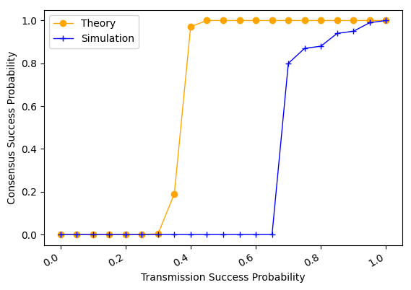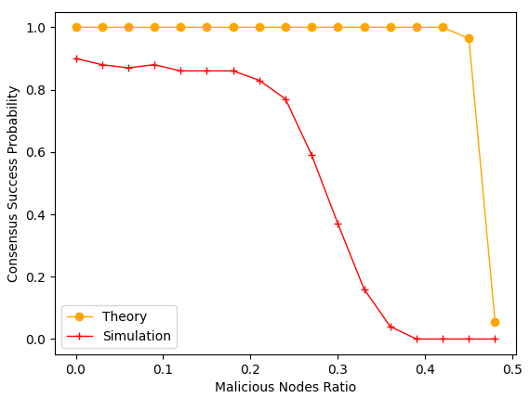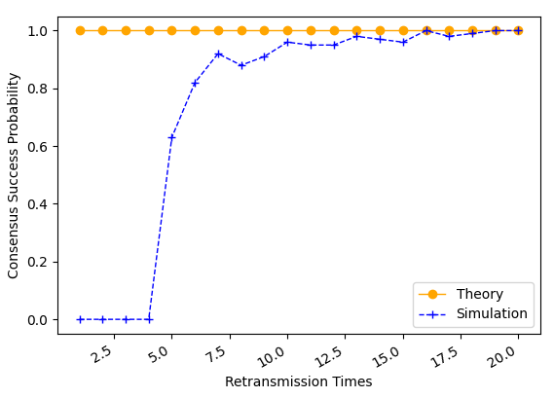
(a) Transmission success probability (b) Malicious nodes ratio (c) Retransmission Times
Fig. 3. Consensus success probability.
As shown in Fig. 3, we investigate how message transmission success probability, malicious node ratio, and retransmission times influence consensus success probability. As shown in Fig. 3 (a), consensus success probability increases with message transmission success probability when the probability is greater than 0.65. As shown in Fig. 3 (b), consensus success probability decreases with the increase of malicious nodes ratio. As shown in Fig. 3 (c), consensus success probability is zero when the message retransmission times is smaller than 5. Then, consensus success probability will increase with the increase of retransmission times and up to 1 finally. Thus, we can adjust message transmission success probability and retransmission times to guarantee high consensus success probability in blockchain system with malicious nodes.
As shown in Fig. 4, we study how network size and malicious nodes ratio influence consensus latency. We set the message transmission success probability as 0.2, and the retransmission times as 5. As shown in Fig. 4 (a), consensus latency increases with the increase of network size. As shown in Fig. 4 (b), the consensus latency decreases with the increase of
compare consensus success probability by different protocols with varying transmission success probability. Since transmission success probability is small, consensus success probabilities of the SWIB and PBFT are zero. Then, the two protocols can achieve consensus among nodes if the transmission success probability is high enough. As shown in Fig. 4(a), the consensus success probability of SWIB is bigger than that of PBFT when transmission success probability is greater than 0.5. As shown in Fig. 4(b), when there are 30% faulty nodes in network, SWIB has higher consensus success probability than PBFT when transmission success probability is greater than 0.75. In addition, since faulty block proposer will lead to consensus interruption in PBFT, the consensus success probability is small even transmission success probability is equal to 1. Thus, our protocol is more stable than PBFT under networks with unstable and unreliable communication channel.
测试节点数量对于共识时延的影响（考虑不存在故障节点时，随着节点数量的增加，共识时延的变化情况）
测试女巫故障节点数量对于共识时延的影响（考虑固定节点的数量时，随着故障节点数量的增加，共识时延的变化情况）
测试干扰攻击对于共识时延的影响
As shown in Fig. 3 (a), average consensus latency versus network size increases with network size while still acceptable even for 500-node networks and 1-MB blocks. Due to the broadcast nature of wireless channel, block transmission time does not vary with network size as we focus on studying one-hop wireless networks. However, block finalization requires enough partial signature shares, whose collection time grows proportionally with network size. This indicates that consensus nodes are required to collect more partial signature shares, and the recovery of full signature requires larger threshold. Meanwhile, the increase of network size will lead to more severe channel accessing competition, which eventually results in the increase of average consensus latency. In SWIB, node will dynamically adjust its channel compete probability to reduce channel contention. This mechanism can avoid a sharp increase of consensus latency with the increase of network size. As shown in Fig. 6 (b), average throughput can reach approximate 2000 TPS for 600-node networks and 1-MB blocks. Thus, we can adjust node channel compete probability and block size to guarantee high transaction throughput with reasonable consensus latency for different network settings.
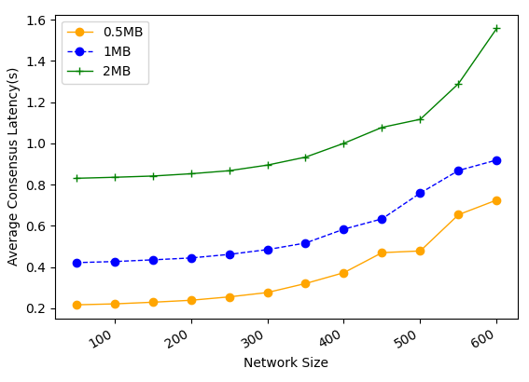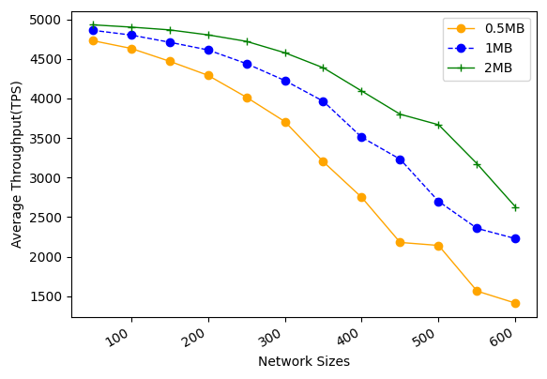
(a) Average latency (b) Average throughput
Fig. 6. Performance of SWIB for achieving consensus under different parameters $α$ and $Pt$.
We compare performance by SWIB and PBFT under varying network size and adversary power. In this experiment, each test lasts for 10 rounds, network size ranges from 50 to 600, and block size is fixed to 1 MB.
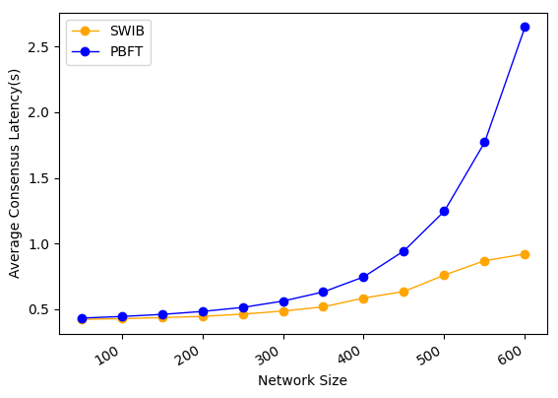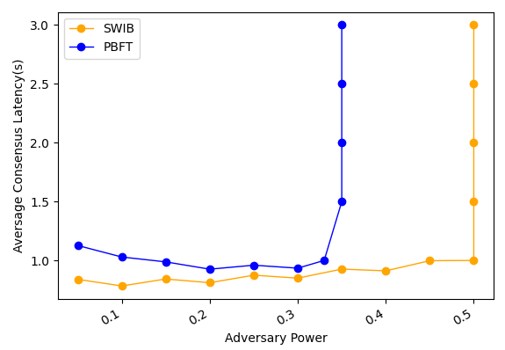
- Average latency vs. network size (b) Average throughput vs. network size
Fig. 7. Comparison of performance by different protocols.
As shown in Fig. 7(a), SWIB has much lower consensus latency than PBFT under same settings. For example, our protocol can achieve consensus within 1 second in 600-node wireless networks while that for PBFT will be 2.7 second. This is because SWIB can securely reach block consensus in one-time communication while PBFT requires two-times communications to reach consensus on a block.
As shown in Fig. 7(b), In PBFT, view change happens when a malicious leader proposes an invalid block or does not propose any block. All honest nodes require two-times communications to determine a new leader. In SWIB, honest nodes will discard invalid block and finalize an empty block instead, then starting the next consensus round. In the experiment here, all malicious nodes are assumed not to send any messages in a consensus round. Under this assumption, our protocol can work correctly when adversary power is smaller than 50% while PBFT will fail to reach consensus when adversary power is more than 33%. This indicates that our protocol has better fault tolerance performance than PBFT.

6.4 Attack Resistance
In this subsection, we evaluate the Sybil-attack-resistance and jamming-attack-resistance of SWIB.
We study how Sybil percentage of Sybil nodes impacts the consensus performance in terms of consensus latency and throughput. We increase the percentage of Sybil nodes from 5% to 49%, and repeat the experiments in three different sized networks while fixing block size to 1 MB.
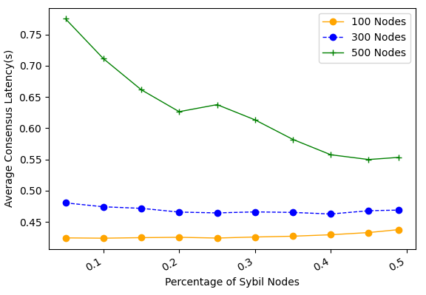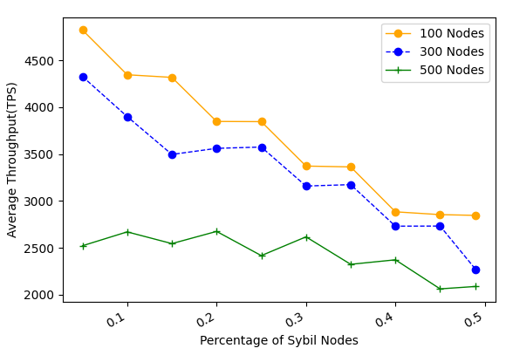
- Average consensus latency Vs. fraction of Sybil nodes (b) Average throughput Vs. fraction of Sybil nodes
Fig. 8. The performance of SWIB when confronting Sybil attack
As shown in Fig. 8 (a), consensus latency decreases with the percentage of Sybil nodes increasing. In SWIB, when a Sybil node is selected to serve as block proposer, an empty block will be eventually generated. Compare with the valid block case, propagation of an empty block requires small number of time slots. Thus, consensus latency will not significantly increase due to malicious block proposer in a round. Meanwhile, channel contention between nodes become light when the fraction of Sybil nodes increasing. This is because that Sybil nodes would not send messages during consensus process, or just send some error message with lower probability. As result, the consensus latency declines when the percentage of Sybil nodes increases. As shown in Fig. 8(b), average throughput will decrease with the increase of percentage of Sybil nodes. With the increase of Sybil nodes percentage, the probability of generating empty blocks increases. The average number of confirmed transactions will decrease. Even with a large number of Sybil nodes, SWIB can achieve more than 2000 TPS in blockchain network with 500 nodes and block size of 1 MB. Thus, our protocol can achieve acceptable performance when adversary issuing Sybil attack.
We evaluate the performance of SWIB in the presence of $(1-δ, T)$-bounded jammers. Considering two different jamming strategies in attacks: random jamming attack and consecutive jamming attack. The former one is that jammers randomly jam $\left(1-δ\right)T$ slots among $T$ slots. The later one is that jammers jam $\left(1-δ\right)T$ consecutive slots in each period of $T$ slots. Each test lasts for 10 rounds. The value $δ$ ranges from 0.1 to 1, and experiment is test under 500-node network and 1-MB block size. The smaller $δ$ is, the more time slots jammed. The adversary time window is chosen as 100 time slots.
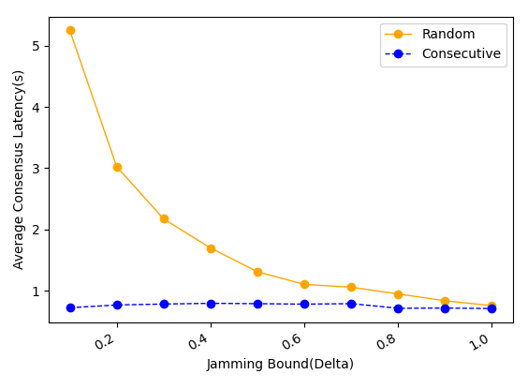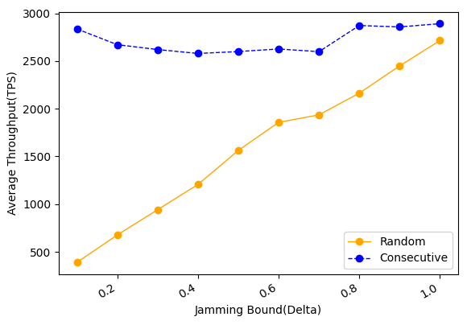
(a) Average consensus latency (b) Average throughput
Fig. 9. The performance of SWIB when confronting jamming attack.
As shown in Fig. 9 (a), consensus latency decreases with the increase of $δ$ under random jamming attack, and it not changes significantly under consecutive jamming attack. As shown in Fig. 9(b), the throughput of SWIB does not fluctuate significantly under consecutive jamming attack, and it approximately linear increase with the jamming bound increasing under random jamming attack. When adversary issues consecutive jamming attack, the channel compete probability of nodes is reduced quickly due to the estimate of adversary time window ${\hat{T}}_{v}$ increase fast. Since channel contention reduce, nodes can achieve consensus within small time slots. However, when jammers issue random jam attack, channel contention will not reduce significantly due to the estimate of adversary time window ${\hat{T}}_{v}$ not increase rapidly. This indicates that random jamming attack is more powerful than consecutive jamming attack in SWIB.

Conclusion and Future Research
In this paper, we proposed a stable wireless blockchain consensus protocol SWIB, which can ensure stable and secure consensus process by adopting verifiable random function and threshold signature scheme in one-hop wireless networks. We use a new verifiable block proposer algorithm to prevent the formation of forks and choose a more reliable block proposer to generate a valid block. Besides, by combining the nature of wireless communication protocol with threshold BLS signature scheme, consensus nodes can verify and vote for block proposal in secure and efficient way. In addition, according to the characteristic of threshold BLS signature scheme, all honest consensus nodes can recover full signature to complete block finalization in distributed manner. Moreover, our protocol can still work efficiently in wireless blockchain system under Sybil attacks and jamming attacks. Analysis and results show the efficiency and security properties of the SWIB protocol.
In the future, we will investigate the multi-hop version of SWIB protocol in wireless ad hoc networks. We should study the energy consumption in consensus process, and design energy efficiency consensus protocol in wireless network. What's more, it is necessary to investigate the impacts of mobility in ad hoc wireless network. Also, we will explore whether our protocol can mitigate other attacks such as long-term attacks, nothing-at-stake attacks, eclipse attacks, etc.

References:
[1] J. Xu, S. Wang, A. Zhou, and F. Yang, "Edgence: A blockchain-enabled edge-computing platform for intelligent IoT-based DApps," China Communications, vol. 17, no. 4, pp. 78-87, April 2020.
[2] T. Maksymyuk, J. Gazda, L. Han, and M. Jo, "Blockchain-Based intelligent network management for 5G and beyond," in Proceeding of 2019 3rd International Conference on Advanced Information and Communications Technologies (AICT), pp. 36-39, 2019.
[3] R. Jabbar, N. Fetais, M. Kharbeche, and et al, "Blockchain for the Internet of Vehicles: How to Use Blockchain to Secure Vehicle-to-Everything (V2X) Communication and Payment?" IEEE Sensors Journal, vol. 21, no. 14, pp. 15807-15823, July15, 2021.
[4] S. Nakamoto, "Bitcoin: A Peer-to-Peer Electronic Cash System." https://bitcoin.org/bitcoin.pdf, 2008.
[5] A. Kiayias, A. Russell, B. David, and R. Oliynykov, "Ouroboros: A provably secure proof-of-stake blockchain protocol," in Proceeding of 2017 Annual International Cryptology Conference, pp. 357–388, Springer, 2017.
[6] M. Castro, B. Liskov, "Practical Byzantine fault tolerance[C]." in Proceedings of the 3rd Symposium on Operating Systems Design and Implementation (OSDI), pp. 173-186, 1999.
[7] Z. Jiao, B. Zhang, L. Zhang, and et al, "A blockchain-based computing architecture for mobile ad hoc cloud," IEEE Network, vol. 34, no. 4, pp. 140-149, Jul./Aug. 2020.
[8] Z. Jiang, Z. Cao, B. Krishnamachari, and et al, "SENATE: A permissionless byzantine consensus protocol in wireless networks for real-time Internet-of-Things applications," IEEE Internet of Things Journal, vol. 7, no. 7, pp. 6576-6588, July 2020.
[9] Q. Xu, Y. Zou, D. Yu, and et al, "Consensus in wireless blockchain system," in WASA, 2020.
[10] Y. Zou, M. Xu, J. Yu, and et al, "A fast consensus for permissioned wireless blockchains," IEEE Internet of Things Journal, 2021.
[11] M. Xu, F. Zhao, Y. Zou, and et al, "BLOWN: a blockchain protocol for single-hop wireless networks under adversarial SINR," IEEE Transactions on Mobile Computing, 2021.
[12] M. Xu, C. Liu, Y. Zou, and et al, "wChain: a fast fault-tolerant blockchain protocol for multi-hop wireless networks," IEEE Transactions on Wireless Communications, vol. 20, no. 10, pp. 6915-6926, Oct. 2021.
[13] Y. Xiao, N. Zhang, W. Lou, and et al, "A survey of distributed consensus protocols for blockchain networks," IEEE Communications Surveys and Tutorials, vol. 22, no. 2, pp. 1432–1465, 2020.
[14] M. Vukolic, "The quest for scalable blockchain fabric: Proof-of-work vs. BFT replication," in Proceeding of International Workshop Open Problems Network Security, pp. 112–125, 2015.
[15] S. Dziembowski, S. Faust, V. Kolmogorov, and et al, “Proofs of space,” in Proceeding of Annual Cryptology Conference, pp. 585–605, Springer, 2015.
[16] K. Karantias, A. Kiayias, and D. Zindros. "Proof-of-Burn," in Proceeding of Financial Cryptography and Data Security, pp. 523-540, 2020.
[17] S. Joshi, "Feasibility of proof of authority as a consensus protocol model", arXiv: 2109.02480 [cs.DC], 2021.
[18] F. Gai, B. Wang, W. Deng, and W. Peng, "Proof of reputation: a reputation-based consensus protocol for peer-to-peer network," in Proceeding of Database Systems for Advanced Applications, pp. 666-681, 2018.
[19] Q. Wang, R. Li, S. Chen, and Y. Xiang. "Formal Security Analysis on DBFT Protocol of NEO." arXiv:2105.07459 [cs.CR], 2021.
[20] R. Kotla, L. Alvisi, M. Dahlin, and et al, "Zyzzyva: Speculative byzantine fault tolerance," ACM Transactions on Computer Systems, vol. 27, no. 4, pp. 1–39, 2010.
[21] V. Buterin and V. Griffith, "Casper the friendly finality gadget, " arXiv:1710.09437, 2017. [Online]. Available: https://arxiv.org/abs/1710.09437
[22] R. Pass and E. Shi. "Fruitchains: A fair blockchain, " in Proceedings of the ACM Symposium on Principles of Distributed Computing, pp. 315–324, 2017.
[23] E. Kokoris- Kogias, P. Jovanovic, N. Gailly, and et al, "Enhancing Bitcoin security and performance with strong consistency via collective signing," in Proceedings of the 25th USENIX Conference of Security Symposium, pp. 279–296, Aug. 2016.
[24] E. Buchman. "Tendermint: Byzantine fault tolerance in the age of blockchains," Ph.D. Thesis, The University of Guelph, Guelph, Ontario, Canada, June 2016.
[25] Y. Gilad, R. Hemo, S. Micali, and et al. "Algorand: Scaling Byzantine agreements for cryptocurrencies[C]," in Proceedings of the 26th Symposium on Operating Systems Principles, pp. 51–68, Shanghai, China, October 28–31, 2017.
[26] C. Newport and P. Robinson, "Fault-tolerant consensus with an abstract mac layer," in proceeding of the International Symposium on Distributed Computing (DISC), vol. 121, ISSN. 1868-8969, 2018.
[27] H. Moniz, N. F. Neves and M. Correia, "Byzantine fault-tolerant consensus in wireless ad hoc networks," IEEE Transactions on Mobile Computing, vol. 12, no. 12, pp. 2441-2454, Dec. 2013.
[28] A. Boldyreva, "Threshold signatures, multi signatures and blind signatures based on the gap-Diffie-Hellman-group signature scheme," in Proceeding of the 6th International Workshop on Theory and Practice in Public Key Cryptography, vol. 2567, pp. 31–46, 2003.
[29] D. Boneh, B. Lynn, and H. Shacham, "Short signatures from the Weil pairing[C]," in Proceeding of International Conference on the Theory and Application of Cryptology and Information Security, pp. 514-532, Springer, Berlin, Heidelberg, 2001.
[30] R. Gennaro, S. Jarecki, H. Krawczyk, and et al, "Secure distributed key generation for discrete-log based cryptosystems," in Proceeding of the 17th International Conference on the Theory and Applications of Cryptographic Techniques, vol. 1592, pp. 295–310, May. 1999.
[31] A. Goldsmith. "Wireless Communications, " Cambridge University Press, 1 ed., Aug. 2005.

