Models and Related Technology
We describe the preliminaries of SWIB, including network model, blockchain setting, communication model, and attack models. When designing a blockchain consensus protocol, we first require to determine a network model that is the fundamental infrastructure running the protocol. Then, we should consider the data architecture of distributed ledger used in our protocol. To improve the performance of blockchain protocol, we use a threshold BLS signature scheme as voting mechanism to reduce consensus latency. Since computing time is negligible small, we can analyze the performance of consensus protocol by giving a communication mode. In order to discuss the attacks-resistance of consensus protocol, attack models should be predefined.

3.1 Network Model
Blockchain consensus protocols are designed according to network models. Consensus nodes achieve consensus through networks transmitting messages. We only consider a wireless broadcast network consisting of nodes, which are located within communication range of each other, and communicating with each other by transmitting messages. All nodes have same functions. Each node equipped with transceiver works in a half-duplex manner. This means that nodes can transmit or receive messages, but not both simultaneously. In practice, such a network can be formed by a group of unmanned aerial vehicles or intelligent vehicles.
Nodes adopting digital signature technology can achieve node identity confirmation and the verification and integrity of communication messages. In digital signature, each node has its key pair, which used to message encryption and decryption, and generate signature. We assume that each node can get its private-public key pair and a main public key by independently running a secure distributed key generation protocol. Each node can obtain the public keys and identities of other nodes by exchanging messages. Thus, each node knows the identities and public keys of all other nodes.

3.2 Blockchain
Blockchain is a public electronic ledger, which similar to a relational database. This ledger is openly and simultaneously shared among various nodes in system. Blockchain uses a consensus protocol to ensure the dependability and integrity of blockchain system. Therefore, blockchain can only be updated when consensus is reached on a new block between nodes in the system. Each node maintains a local blockchain, which is composed of blocks chronologically linked to create a chain. Each block contains a block header and a block body. The block header records blockchain version, block proposer, block height, previous hash, block hash, block full signature, and transactions hash root, etc. The block body stores transaction recodes, which consist of payer's information, payee's information and other necessary contents. Figure 1 shows the data structure of a blockchain.

Fig. 1 Blockchain

3.3 Threshold BLS Signature Scheme Technology
Threshold Boneh-Lynn-Shacham (BLS) signature scheme [29] is the combination of threshold signature scheme and BLS signature scheme [30]. BLS signature scheme is closely related to bilinear maps and Gap Diffie-Hellman (GDH) groups, where the Computational Diffie-Hellman problem is hard but the Decision Diffie-Hellman problem is easy. Threshold signature scheme allows multiple participants securely reconstruct a secret (i.e., a main private key) and perform computation (i.e., signature generation or decryption) even an adversary has corrupted some participants. Threshold BLS signature scheme includes key generation algorithm, signature generation algorithm and verification algorithm. The key generation algorithm adopts a discrete log-based distributed key generation method [31] to distribute private-public key pair and a main public key to participants. In threshold BLS signature scheme, participants jointly sign a message through the signature generation algorithm. The full signature of the message can be obtained when a sufficient number of participants sign the message. All participants can use the main public key to verify the full signature by the verification algorithm. The signature share generation and verification of threshold BLS signature scheme concurs with the BLS, and the aggregation of full signature is congruent with threshold signature scheme.
To improve the efficiency and stability of consensus process, consensus protocols adopt the threshold BLS signature scheme as voting mechanism. All consensus nodes use a share of a main private key as their private keys. In a consensus round, each node generates a partial signature of a proposal as the vote of the node for the proposal. A full signature of the proposal can be recovered by nodes who aggregate a sufficient number of partial signatures. Thus, achieving consensus among nodes do not require all-to-all communications. Since several partial signatures can be aggregated into a full signature, nodes can verify multiple votes and consensus result in an operation. Therefore, the efficiency of consensus process will be improved. Besides, the termination of a consensus process not relies on a special node of system. Any node who recovers the full signature can terminate the consensus process. The stability of consensus process is increase.

3.4 Communication Model
In SWIB, we mainly focus on the impact of wireless communication in the performance of blockchain system. As a metric that used to evaluate the performance of blockchain system, consensus latency consists of computing time and communication time. However, the computation load of nodes in SWIB is small, which means the computing time is negligibly small. During consensus process, nodes broadcast messages over wireless channel to achieve consensus. We consider a communication model with p-persistent carrier-sense multiple access (CSMA). Nodes continuously sense channel and transmit message with a constant probability when detecting channel idle. We assume that wireless channels follow the Rayleigh fading model [32]. The channel gain between nodes follows the complex normal distribution. According to the Rayleigh fading model, the received signal-to-noise (SNR) ratio over the channel between nodes can be computed.
During consensus process, messages losses can lead to consensus failure. Message losses are mainly caused by channel collision and channel fading. Therefore, a successful transmission should satisfy two conditions: 1) if and only if there only one node transmitting in a time slot; and 2) the SNR ratio is equal to or bigger than the target one. In channel contention process, nodes compete for the channel with a constant transmit probability. Only if one node transmits in a mini time interval can the node transmit message successfully. Even a node competes successfully, it may fail to transmit a message due to channel fading. The SNR ratio over channel between nodes varies with the time-variant communication environment. When SNR ratio is less than a given target threshold, the communication between nodes is interrupted. In order guarantee communication under unreliable networks, retransmission mechanism is necessary. When communication interruption occurs, retransmissions are carried out until the lost messages are successfully delivered.

3.5 Attack Models
Attacks launching by adversary can halt consensus process. The attack-resistance is very important for security of blockchain system. We assume that an arbitrary adversary can control no more than $50\%$ of the total voting power and corrupt nodes. In SWIB, we only consider two kinds of attacks of adversary: Sybil attack and jamming attack.
- Adversary can launch Sybil attack, in which adversary can generate a large number of identities for corrupted nodes. These nodes can deviate from consensus protocol. Adversary may obtain inappropriate power in consensus process. Adversary can overwhelm other nodes through majority voting power, then control the generation of blocks and prevent other new nodes from entering system.
- Adversary can launch jamming attack to interfere with the message transmission. Jamming attack is a denial-of-service attack that adversary prevents other nodes from using the channel to communicate by occupying the channel they are communicating on. Consensus process can be interrupted when adversary launches jamming attack. Adversary can prevent other nodes from broadcasting their votes. A consensus process cannot be complete if the number of votes is less than the secure threshold of blockchain system. In Blockchain system adopting communication-based consensus protocols will loss liveness when consensus process is interrupted. Adversary can prevent other new nodes from entering system by jamming the requests of these new nodes. Therefore, the security of the system will be halted.
We design SWIB that can resistant both Sybil attack and jamming attack. Even attacked by adversary, blockchain system can still work securely.

The Stable-aware Wireless Blockchain Consensus Protocol
In this section, we propose a stable-aware wireless blockchain consensus protocol, abbreviated as SWIB. We first present an overview of the protocol, and then give the details of SWIB. To ensure the security of the protocol, we propose incentive and publishment mechanisms and a synchronization mechanism.

4.1 Overview
In this subsection, we present the overview of SWIB, which adopts a four-stages framework to achieve consensus in blockchain system round-by-round (As shown in Fig. 2). The four stages of SWIB include block proposer election stage, block generation stage, block verification stage, and block finalization stage. SWIB adopts a random block proposer election algorithm and a threshold BLS signature scheme to prevent inherent forks and reduce system overhead. The random block proposer election algorithm used in block proposer stage can reduce adversary corruption risk and prevent inherent forks. The threshold BLS signature scheme used in both block verification and finalization stages can reduce the system overhead of consensus process.

Fig. 2 An overview of SWIB in a round $r$. At the beginning of the round, all consensus nodes are assumed to maintain a same replica of the blockchain. (1) Block proposer election algorithm is executed to randomly determine the block proposer for the current round; (2) the elected block proposer will generate a new block, and broadcast to other nodes; (3) verify legality of the new block, and run signature generation algorithm to vote for valid block; (4) run signature aggregation algorithm and signature recovery algorithm to finalize the block when generating the full signature.
In SWIB, each round consists of the four stages, whose detailed description will be given in the following. In the block proposer election stage, a block proposer will be randomly elected from all consensus nodes via random block proposer election algorithm. This algorithm is based on the roulette wheel selection algorithm and uses both remaining active time and the number of generated blocks as the elected weight of nodes. In the block generation stage, the elected block proposer will generate a new block, which contains a set of transactions and relevant information of previous blocks and block proposer. The block will be broadcast to all other consensus nodes in the blockchain system. SWIB uses a secure threshold BLS signature scheme as voting mechanism, which is related to both block verification stage and finalization stage. Upon receiving the block, nodes start block verification stage. In this stage, nodes will generate a partial signature of the block as the vote of the block if the legality of block proposer and the content of the block is verified. Then, each node will aggregate a sufficient number of partial signature shares into a full signature, which can be verified by a main public key. In block finalization stage, the block will be finalized when it is approved by enough nodes. A valid full signature indicates that a sufficient number of nodes signed the block. Upon receipt or generation of a full signature, nodes will add the full signature to the corresponding block, append the block into their local blockchain, and update their node list. After that, nodes will start a new round. The process of executing a complete consensus round is presented in Algorithm 1. To ensure jamming-resistant communication over wireless channels, the broadcastSignature subroutine presented in Algorithm 2 is employed to broadcast signatures.
To join a blockchain system, nodes require to obtain identities and system relevant information. New nodes get identities and active time by depositing certain amount of money. These money will be stored in a virtual account, and can only be taken out by the depositor through executing an unpledged operation. Then, nodes obtain their private-public key pair and a main public key via a distributed key generation algorithm. Nodes gain the information of other nodes and blockchain by exchanging messages. Nodes start participating consensus process when they have the latest blockchain, the random seed of the current round, and a consensus node list that ordered by the hash value of their public keys.

4.2 The SWIB Protocol
SWIB protocol is a four-stages framework blockchain consensus protocol, which achieves consensus on blocks among consensus nodes. In the following, we shall present the details of these stages.

4.2.1 Block Proposer Election Stage
In block proposer election stage, we present a random block proposer election algorithm based on a roulette wheel selection to randomly elect a unique block proposer. The random block proposer election algorithm (Algorithm 1 lines 5-8) first generates a random value in election process. Then, a roulette wheel will be constructed according to the stability of nodes. The elected probability of nodes in the wheel is proportional to their stability. Finally, a block proposer of current round is determined according to the random value and the wheel constructing by elected probability of nodes.
A distributed randomness generation function allows consensus nodes to independently produce an unpredictable and verifiable random value. In each round, the calculation of the random value is performed as
$$Rdm^{r}=\frac{H\left(r,B_{H}^{r-1},sig_{full}^{r-1}\right)}{2^{len\left(H\left(r,B_{H}^{r-1}, sig_{full}^{r-1}\right)\right)}},$$
where $r$ is the current round number, and $B_{H}^{r-1}$ is the hash of the latest confirmed block, and $sig_{full}^{r-1}$ is the full signature that revealed at the end of the previous round. For simplicity, the $B_{H}^{-1}, sig_{full}^{-1}$ inputs of the function in the round that generates the genesis block is set to be null.
The random value generated through the distributed randomness generation function is unpredictable, verifiable and consistent. Although the hash value $B_{H}^{r-1}$ and the round number $r$ are pre-known parameters, the full signature $sig_{full}^{r-1}$ can only be revealed at the end of round$r-1$. The full signature makes it impossible for nodes to predict the value in advance. Even a node first recovers a full signature before others, the full signature cannot be tampered due to the security of threshold BLS signature scheme. The full signature can be verified through the signature verification algorithm of threshold BLS signature scheme. Since all nodes have same inputs, the random value of nodes should be consistent and verifiable.
The stability of nodes is determined by their active time and the number of generated valid blocks in several latest rounds. The active time is defined as the time interval that nodes can participate in the consensus process. The active time of each node is obtained by depositing money to a blockchain system. All nodes’ active time will decrease with the passage of time. We count the number of valid blocks generated by each node within several latest rounds, in which produce same number of valid blocks. We can compute the stability of a node as follows:
$$S_{v}=a×\frac{T_{v}}{∑T_{v}}+b×\frac{N_{v}}{K}$$
where $T_{v}$ is the active time of the node, $∑T_{v}$ is the cumulative active time of all nodes, $N_{v}$ is the number of valid blocks generated by the node, and $K$ is the fixed number of valid blocks. We define $ρ_{v}= \frac{T_{v}}{∑T_{v}}$ as active time ratio and $r_{v}=\frac{N_{v}}{K}$ as the consensus ratio, where $a$ and $b$ ($a+b=1, a≥0, b≥0$) are the weights of active time ratio and consensus ratio, respectively.
Utilizing stability of nodes as weight in block proposer election can decrease computation power consumption and increase the security protocol in block proposer election. Compare to PoW-based leader election algorithm, our block proposer election algorithm will consume very small computational power in election process. Only generating a random value and computing stability and its corresponding elected probability require to consume the computing power of nodes. Compare to pure PoS-based leader election algorithm, our algorithm can prevent nodes with high weight always be block proposer. With time passing, the active time of nodes will be decrease, and the stability of nodes will be changed. Nodes depositing much more money cannot always have advantage on election process. Thus, the security of block proposer election process is improved by taking stability as election weight.
According to the distributed randomness generation function and the stability of nodes, we present a block proposer election algorithm is based on the roulette wheel selection. A roulette wheel is constructed from the node elected probability, which is defined as the ratio of the stability of a node and total stability of all nodes. The wheel is represented in the form of a pie chart, where the area occupied by each node on the roulette wheel is proportional to its elected probability. According to the elected probabilities of nodes, we can calculate the cumulative elected probabilities of nodes. In the algorithm, a random value in the interval $[0, 1)$ is generated via a distributed randomness generation function. When the cumulative elected probability is greater than the random number, the corresponding node is elected as current block proposer. Since a node with better stability value will occupy a bigger area in the pie chart, the node will have high probability being elected.

4.2.2 Block Generation Stage
A block will be generated by the legal block proposer in block generation stage (see Algorithm 1 lines 10-17). In general, the elected block proposer will generate a new block, which contains transaction records and other necessary information. Then, the block proposer will broadcast the new block to other nodes. When receiving the block successfully, nodes will immediately start block verification stage.
A block contains a header and a body. The header consists of the round number, the hash value of previous block, the current block hash, the identity of the block proposer, the full signature and the root of transactions, and so on. Block body usually stores transaction recodes. Block will package all necessary information in but full signature, which, can only be appended to this block in block finalization stage.

4.2.3 Block Verification Stage
In block verification stage, consensus nodes achieve consensus on that the new block is valid. All nodes receiving a new block from current block proposer will verify the block. If the block proposer is legal and the block contend is valid, nodes will generate partial signatures to vote for it and broadcast their signature to other nodes. Nodes will aggregate enough partial signatures into a full signature, which can be verified by nodes via a main public key. The pseudo code of block verification is presented in Algorithm 1 lines 19-36.
When receiving a block, consensus nodes will verify the legality of block proposer and the content of the block. A node needs to check the following conditions:
- Block proposer: The output of block proposer election algorithm is the same with the identity of block proposer.
- Previous hash: The previous hash value in the current block is equal to the hash of last block on its blockchain.
- Transactions: All transactions included in the current block should not conflict with previous confirmed transactions.
A block is valid if it obtains enough vote from consensus nodes. If all the above conditions are satisfied, then each node vote for the block as a vote, and broadcast their votes to other nodes. When a node collects enough (threshold) votes for the block, it is considered to be verified.
The full signature is used as a proof of block validation in block verification stage. SWIB utilizes a voting mechanism that based on a threshold BLS signature scheme. In this voting mechanism, nodes will generate a partial signature through the signature generation algorithm of the scheme as a vote of a block. When gathering a sufficient number of partial signature shares of the block, nodes can recover a full signature through the signature recovery algorithm of the scheme. The full signature can be verified through the signature verification algorithm of the scheme. The successful reconstruction of the full signature indicates that a sufficient number of nodes approve the block. In this case, the block is considered to be valid. Therefore, it is feasible to use the full signature as the proof of block validation.
A broadcast signature mechanism is presented to help nodes resistant jamming attack by reducing channel contention. In our protocol, nodes have a channel compete probability and an estimate of adversary time window. Each node will send a message with the probability. Nodes count the number of idle slots within their estimate of adversary time window. If there is no idle slot, the probability will be multiplicatively decreased and the estimated time window will be increase. Otherwise, the channel compete probability will be multiplicatively increased and the estimated time window will be decrease by 1. The broadcast signature mechanism can ensure that node can adjust their channel compete probability and an estimate of adversary time window to reduce channel contention. The pseudo code is presented in Algorithm 2.

4.2.4 Block Finalization Stage
In block finalization stage, a block will be finalized. If there are a sufficient number of nodes agree on a block, nodes will update the block in their local blockchain and update their node list. The pseudo code of block finalization is presented in Algorithm 1 lines 38-45.
Full signature proves the finalization of a block. When receiving or recovering a valid full signature, nodes will add it to the corresponding block. Then, each node will append this block into their local blockchain. Finally, nodes will update their node list, such as updating list members, active time, and so on. After that, nodes start a new consensus round.

4. 3 Synchronization Mechanism
Synchronization mechanism is important to guarantee the security of consensus process. If consensus nodes have distinct view on blockchain, the previous hash of the processing block may be different with the hash of the latest block on their blockchain. Since the result of block verification is false, nodes will not vote for the block. As result, consensus may be not achieved among these nodes. The synchronization mechanism can ensure that nodes have the latest blockchain all the time. Therefore, consensus process will not be interrupted in block verification due to inconsistent blockchain. The pseudo code of the synchronization mechanism is presented in Algorithm 3.
Our synchronization mechanism improves the security of synchronization process by allowing nodes request blocks from multiple high-quality nodes. In SWIB, nodes with higher stability are more likely to maintain the latest blockchain, and have lower risk of sending faulty blockchain information. The synchronization mechanism allows new nodes to request a part of blockchain information from multiple high-quality nodes. This will reduce the risk that a node transmits error blockchain information to mislead new nodes. Once a node transmits error block information, the receiving node can immediately detect it through blockchain information received from other nodes. The new node can request the of blockchain information from other trustworthy nodes to ensure the receipt of correct blockchain information.
The synchronization mechanism can reduce the burden of a single node in synchronization process. It is a huge burden for a node to transmit a large number of blocks. The node consumes large transmitting power and transmitting time to complete this transmission. Actually, all consensus nodes have obligation to response for the request of blockchain information. In our mechanism, nodes are allowed to request a part of blockchain information from multiple nodes. For the requested nodes, the transmit power consumption This mechanism decreases the burden of a single requested node.

Protocol Analysis
In this section, we will analyze the performance and security of SWIB. The performance is analyzed in terms of consensus success probability and consensus latency. The security is analyzed in terms of consensus security, random generation security, and attack resistance.

5.2 Security Analysis
In this subsection, we analyze the security of SWIB in terms of consensus security, the random generation, and attacks resistance.
The security of SWIB relies on a secure threshold BLS signature scheme. Uniqueness is an important property of the scheme to ensure the security of SWIB. In a secure $(t,N)$-threshold BLS signature scheme, any set of more than $t$ can generate a unique full signature for a message. SWIB requires that only one block can be finalized in each consensus round. If the threshold value of the scheme less than $\left\lceil \frac{N+1}{2}\right\rceil$, two distinct blocks can be finalized in a consensus round. Thus, any two sets with order $t$ should have at least one common element. Robustness is also an important property to ensure the security of SWIB. In a secure $(t,N)$-threshold BLS signature scheme, no adversary corrupting less than $t$ nodes can know any information about the main private key or can forge a valid signature. When adversary corrupts less than $t$ nodes, nodes can also recover a unique full signature to finalize a block, i.e., $N-t≥t$. Therefore, to ensure the security of SWIB, the threshold value of the scheme should be no less than $\left\lceil \frac{N+1}{2}\right\rceil$.

Consensus Security
We conduct a security analysis to show that SWIB protocol provides persistence and liveness to blockchain system.
If there are a quorum of $t≥\left\lceil \frac{N+1}{2}\right\rceil$ nodes fulfilling the requirement of threshold BLS signature scheme, our protocol can guarantee persistence:
Theorem 1. (Persistence) If an honest node $v$ proclaims block $B$ is the $i^{th}$ block in the blockchain, then other honest nodes should report the same result.
Proof. In order to prove the persistence property, we need to show that for any two blockchains $BC_{u}$ and $BC_{v}$of honest nodes $u$ and $v$ should have same block at the same position. To prove by contradiction, we assume that $B_{u}$ and $B_{v}$ are two different blocks at a same position $i$ of $BC_{u}$ and $BC_{v}$as maintained by nodes $u$ and $v$, respectively. There are two cases when the assumption holds:
Case 1. $B_{u}$ and $B_{v}$ are respectively appended to the position $i$ of blockchains $BC_{u}$ and $BC_{v}$ in the same round. The block finalization depends on a unique full signature, which is recovered by at least $\left\lceil \frac{N+1}{2}\right\rceil$ valid partial signature shares. If two different blocks $B_{u}$ and $B_{v}$ are finalized in the same round, it indicates that the threshold BLS signature scheme recovers two different full signatures in a consensus round. This conflicts with the uniqueness property of threshold BLS signature scheme, which contradicts our assumption.
Case 2. $B_{u}$ and $B_{v}$ are appended to the blockchains $BC_{u}$ and $BC_{v}$ respectively in two different rounds. Assuming that $B_{u}$ and $B_{v}$ are respectively appended to the position $i$ of blockchains $BC_{u}$ and $BC_{v}$ at rounds $r_{m}$ and $r_{n} (m<n)$. According to our protocol, block $B_{u}$ is finalized in the $r_{m}$ round if the number of nodes voting for the block is at least $\left\lceil \frac{N+1}{2}\right\rceil$. Since two different blocks cannot be finalized in the same round, at least $\left\lceil \frac{N+1}{2}\right\rceil$ nodes agree that $B_{u}$ is the $i$th block of their blockchains in round $r_{m}$. Using contradiction, we assume that $B_{v}≠B_{u}.$ Since $r_{m} < r_{n}$, node $v$ crashes before round $r_{n}$ and recovers in round $r_{n}$ so that block $B_{v}$ is appended into $BC_{v}$ when node $v$ updates its blockchain. In this case, at least $\left\lceil \frac{N+1}{2}\right\rceil$ nodes have a same view on $i$th block is $B_{v}$ at the end of round $r_{n}$. Since there are at least $\left\lceil \frac{N+1}{2}\right\rceil$ nodes agreeing on the $i$th block in round $r_{m}$ is $B_{u}$ and the network size is $N$, we have contradiction such that $N>\left\lceil \frac{N+1}{2}\right\rceil +\left\lceil \frac{N+1}{2}\right\rceil ≥N+1$. Hence $B_{v}=B_{u}$, which contradicts the assumption $B_{v}≠B_{u}.$
In summary, all honest nodes are queried for a special position block should respond with the same result. If an honest node says block $B$ is valid, then other honest nodes also agree on its validity.$∎$
SWIB utilizes a synchronization mechanism to ensure the consistency of nodes. This protocol can guarantee liveness under eventual synchrony. We need at least $t≥\left\lceil \frac{N+1}{2}\right\rceil$ honest nodes to ensure the finalization of consensus process.
Theorem 2. (Liveness) We suppose that there are at most $\left\lfloor \frac{N-1}{2}\right\rfloor$ faulty nodes in blockchain system, SWIB can finalize a block that proposed by a correct node, and obtain the following round random seed.
Proof. The best case is that no failures occur in blockchain system. Our protocol SWIB can finalize a valid block by recovering the full signature, which can produce the round randomness for the following round.
We are required to prove that our protocol can guarantee liveness under the influence of adversary. The behaviors of malicious nodes controlled by adversary include: 1) intentionally not generating a valid block and 2) refusing to vote for the valid block. There are two cases for node failures:
Case 1. Block proposer is malicious. If the malicious block proposer does not generate any block, all honest nodes will commit on an empty block. If the malicious block proposer generates an invalid block, the block will fail to pass the block validation stage. Thus, all honest nodes will refuse to vote for the invalid block and commit an empty block finally. In this case, each honest node will generate partial signature for the empty block. Once the full signature of the block is reconstructed from enough partial signature shares, the next round randomness is generated successfully. Nodes will start new consensus round if they generate or receive the full signature.
Case 2. At most $\left\lfloor \frac{N-1}{2}\right\rfloor$ malicious nodes refuse to vote for a block. When a non-faulty node generates a valid block, at least $\left\lceil \frac{N+1}{2}\right\rceil$ honest nodes will generate partial signature to vote for the block. They will broadcast their signature shares to other nodes. Once collecting a sufficient number of partial signature shares, nodes can recover the full signature and broadcast it to other nodes. These honest nodes can finalize the block and start new consensus round by generate the full signature, which is the proof of block finalization and the randomness of the next consensus round.
In summary, if the number of faulty nodes is at most $\left\lfloor \frac{N-1}{2}\right\rfloor$, honest nodes can commit on a block and generate the following round randomness. $∎$

5.2.2 Random Generation
Our distributed randomness generation function is based on a robust threshold BLS signature scheme. Existence of minority of malicious nodes cannot hinder the generation of a valid full signature if more than $t≥\left\lceil \frac{N+1}{2}\right\rceil$ consensus nodes are honest. The full signature brings the randomness of block proposer election process. With the robust randomness, adversary cannot corrupt the process. Therefore, block proposer election adopting randomness can guarantee the block proposer is elected unpredictably. However, it does not ensure that the elected block proposer works honestly.
Adversary cannot still control the block proposer election stage even it has high elected probability. Let $X$ be a random value denoting the number consecutive block proposer election that controlled by adversary. Suppose an adversary has less than 50% probability to be elected as block proposer per round, the upper bound of the probability that the adversary controls $k$ consecutive block proposer election is $P\left\{X≥k\right\}< \frac{1}{2^{k}}$. Let ${10}^{-γ}$ be the upper bound of the probability. We can compute the upper bound of consecutive rounds electing adversary as block proposer. For example, setting $γ=7$, the adversary can at most control$24$ consecutive rounds to become block proposer. This indicates that the probability of adversary controlling more than $24$ consecutive rounds is less than ${10}^{-7}$, which is negligible. Therefore, our block proposer election algorithm can ensure that adversary will not always be block proposer.

5.2.3 Attack Resistance
In this subsection, we analyze Sybil attacks resistance and Jamming attacks resistance of SWIB.
SWIB utilizing stability as weight can prevent adversary from launching Sybil attack to benefit from block proposer election stage. Adversary launches Sybil attacks by generating pseudonyms. However, the elected probability will not increase due to increase the number of pseudonyms. The elected probability of a node is proportional to its stability. We assume that the stability of an adversary is $S_{A}=a\frac{T_{A}}{\sum_{v}{T_{v}}}+b\frac{N_{A}}{K}$, and the total stability of the system is $\sum_{v}{S_{v}}$. If the adversary generates $m$ pseudonyms, whose stability are $s_{A}^{k}= a\frac{T_{A}^{k}}{\sum_{v}{T_{v}}}+b\frac{N_{A}^{k}}{K}(k=1, ⋯, m)$. The sum of elected probability of the $m$ pseudonyms is
$\sum_{k=1}^{m}{\frac{s_{A}^{k}}{\sum_{v}{S_{v}}}= \frac{\sum_{k=1}^{m}{S_{A}^{k}}}{\sum_{v}{S_{v}}}}= \frac{\sum_{k=1}^{m}{a\frac{T_{A}^{k}}{\sum_{v}{T_{v}}}+b\frac{N_{A}^{k}}{K}}}{\sum_{v}{S_{v}}}= \frac{a\sum_{k=1}^{m}{\frac{T_{A}^{k}}{\sum_{v}{T_{v}}}+b\sum_{k=1}^{m}{\frac{N_{A}^{k}}{K}}}}{\sum_{v}{S_{v}}}= \frac{a\frac{N_{A}^{k}}{K}+b\frac{N_{A}}{K}}{\sum_{v}{S_{v}}}= \frac{S_{A}}{\sum_{v}{S_{v}}}$,
which indicates that generating multiple pseudonyms will not increase the elected probability. As a result, our protocol can resistant Sybil attack in block proposer election.
SWIB can ensure the security of block verification stage under Sybil attack if the number of nodes controlled by adversary satisfies the requirement of a threshold BLS signature scheme. Nodes controlling by adversary will not send messages or send some error messages during consensus process. Once a malicious node becomes block proposer, honest nodes will finalize an empty block eventually. Since the number of malicious nodes is bounded by $\left\lfloor \frac{N-1}{2}\right\rfloor$, the remaining honest nodes can complete block finalization by recovering a full signature.
SWIB uses a communication mechanism to resistant jamming attack, which can affect consensus process by jamming the message transmission of honest nodes. If no node recovers a full signature, the security of blockchain system cannot be guaranteed. Each node adjusts channel contention probability and an estimate of adversary time window through sensing the wireless channel. Channel contention will be reduced when the channel compete probabilities of nodes decrease. In this case, a full a signature can be recovered with higher probability under jamming attack. Besides, nodes will adjust the timeout duration to guarantee the termination of consensus process under jamming attack according to the estimate of adversary time window. Therefore, SWIB can ensure the security of blockchain system under jamming attacks.

5.1 Performance
We analyze consensus success probability and consensus latency, which is important metrics to measure the performance of a blockchain consensus protocol.
Since all messages of running SWIB are transmitted over wireless networks, we analyze the performance of our protocol by a wireless communication model. Wireless channels in our consider communication model follow the standard path-loss model and the Rayleigh fading model. In detail, the path-loss of the wireless channel between nodes $u$ and $v$ is modeled as
$$PL_{dB}\left(d_{u,v}\right)= PL_{dB}\left(d_{0}\right)+10\log_{10}{{\left(\frac{d_{u,v}}{d_{0}}\right)}^{α},}$$
where $PL_{dB}\left(d_{0}\right)$ is the path-loss at reference distance $d_{0}$, and $d_{u,v}$ is the distance between nodes $u and v$, and $α∈(2, 6]$ is path-loss exponent. Let $H_{u,v}$ be the channel gain from $u$ to $v$, following the complex normal distribution with zero mean and variance $P_{t}$ (i.e., $H_{u,v}∼CN(0, P_{t})$). When a signal is transmitted from $u$ to $v$ with transmission power $P_{t}$, the Signal-to-Noise (SNR) ratio at receiving node $v$ is formulated as
$$SNR_{uv}(H_{u,v})={10}^{-\frac{ PL_{dB}\left(d_{0}\right)}{10}}⋅ \frac{P_{t}⋅{\left|H_{u,v}\right|}^{2}}{P_{n}}⋅{\left(\frac{d_{u,v}}{d_{0}}\right)}^{-α}$$
where$P_{t}$ is transmit power, and $P_{n}$ is the additive white Gaussian noise.
Since the time in our protocol implementation is divided into synchronized slots, in which can complete a packet transmission. The fixed time interval of a slot is calculated as follows:
$$τ_{o}= \frac{m}{B⋅\log{(1+β)}}$$
where $m$ is the maximum size of packet sent by nodes during the consensus process in bits, and $β$ is the target SNR ratio of transmission, and $B$ is the bandwidth utilized for transmission. Since a message will be divided into multiple packets in transmission process, the time interval of transmit a message should be $τ=l⋅τ_{o}$, where $l$ is the number of packets of the message.
In our communication model, each node competes for accessing the channel to broadcast messages over wireless channels. In channel contention process, the transmission between nodes will fail if more than one node transmits in a same slot. Channel contention success probability can be expressed as
$$p_{comp}(N)=\frac{Np{\left(1-p\right)}^{N-1}}{1-{\left(1-p\right)}^{N}}$$
where $N$ is the number of consensus nodes, and $p$ is a constant transmit probability of each node.
During transmission process, the SNR ratio between nodes varies with the time-variant communication environment. When SNR ratio is less than a given target threshold, the communication between nodes is interrupted. Since ${\left|H_{u,v}\right|}^{2}$ is exponentially distributed, the SNR outrage probability between nodes $u$ and $v$ is expressed as follows
$$ϵ_{u,v}(H_{u,v})=\operatorname{Pr}\left[SINR\left(u,v\right)<β\right]= Pr\left[{|H}_{u,v}{\left.​\right|}^{2}<{10}^{-\frac{ PL_{dB}\left(d_{0}\right)}{10}}⋅\frac{βP_{n}}{P_{t}}⋅{\left(\frac{d_{u,v}}{d_{0}}\right)}^{α}\right]=1-e^{-{10}^{\frac{ PL_{dB}\left(d_{0}\right)}{10}}⋅\frac{βP_{n}}{P_{t}}⋅{\left(\frac{d_{u,v}}{d_{0}}\right)}^{α}}.$$
Since nodes compete for accessing the channel, each node is allocated a contention time duration for channel compete process. For a given target contention success probability, the minimum time slots of contention process can be computed. We have the following proposition.
Proposition 1. We assume that the total number of nodes in system is $N$. Each node competes for the channel with a constant probability $p$. For a given target contention success probability $0≤ς<1$, the required time slot of contention process is
$$x_{comp}=\left\lceil \frac{\log\left(1-ς\right)}{\log\left(1- p_{comp}\right)}\right\rceil$$
where $p_{comp}=\frac{Np{\left(1-p\right)}^{N-1}}{1-{\left(1-p\right)}^{N}}$ is contention success probability.
Proof: In a blockchain system, the total number of nodes is $N$, and the channel access probability of each node is $p$. Then, the channel contention success probability should be $p_{comp}=\frac{Np{\left(1-p\right)}^{N-1}}{1-{\left(1-p\right)}^{N}}.$ Let $X$ be a random variable denoting the number of time slots required for a node compete successfully. We suppose that $x_{comp}$ is the minimum value such that
$$\operatorname{Pr}\left[X≤x_{comp}\right]=1-{\left(1-p_{comp}\right)}^{x}≥ς$$
for a target contention success probability $0≤ς<1$. Then, the required number of time slots is calculated as
$$x_{comp}=\left\lceil \frac{\log\left(1-ς\right)}{\log\left(1-p_{comp}\right)}\right\rceil .$$
In our consider models, each transmitting node is allocated a broadcast time duration for a message broadcast. Each node has its target communication nodes. For a given target broadcast success probability, the minimum time slots of a node required for packet transmission to all target communication nodes can be computed. We can obtain the proposition.
Proposition 2. For a given probability $0≤ξ<1$, the required number of time slot to broadcast a packet from a node to its target nodes is
$$x_{trans}=\left\lceil \frac{\log\left(1-ξ^{\frac{1}{n}}\right)}{\log{ϵ_{max}}}\right\rceil$$
where $n$ is the number of the target nodes, and $ϵ_{max}= 1-e^{-{10}^{\frac{ PL_{dB}\left(d_{0}\right)}{10}}⋅\frac{βP_{n}}{P_{t}}⋅{\left(\frac{d_{max}}{d_{0}}\right)}^{α}}$is the SNR outage probability between the node and its maximum distance target node.
Proof: Let $X$ be a random variable denoting the number of time slots require to transmit a message from node $v$ to node $u$ via broadcast. Since transmission failure might occurs with a certain probability due to channel fading, the message will be sent repeatedly until successful transmit. Therefore, the probability density function of the random variable $X$ is represented as
$$f\left(X\right)= \left\{\begin{aligned}{ϵ_{v,u}}^{X-1}\left(1-ϵ_{v,u}\right), X≥1, \\ 0, otherwise\end{aligned}\right.$$
where $ϵ_{u,v}$ is the SNR outage probability between the two nodes. Then, the broadcast outage probability bounded as
$$\operatorname{Pr}\left[\max_{u}{X_{u}}≤x\right]=\prod_{u∈V∖\{v\}}{\operatorname{Pr}{[X_{u}≤x]}}=\prod_{u∈V∖\{v\}}{\left(1-ϵ_{v,u}^{x}\right)≥{\left(1- ϵ_{max}^{x}\right)}^{n}}$$
where $ϵ_{max}$ is the SNR outage probability between the node and its maximum distance target node. Since the target broadcast success probability $ξ$ is given, we can compute the required time slots as
$$x_{trans}=\left\lceil \frac{\log\left(1-ξ^{\frac{1}{n}}\right)}{\log{ϵ_{max}}}\right\rceil .$$

5.1.1 Consensus Success Probability
The performance of SWIB is analyzed according to the consensus success probability under wireless networks with unstable and unreliable channel in this subsection.
Consensus will fail if no node recovers the full signature in the consensus round. In our considered models, we have the following consensus success probability of SWIB.
Proposition 3. For a given round, the consensus success probability of our protocol is lower bounded as
$$p_{Cons}=1-{\left[\sum_{f=\left\lceil \frac{N-1}{2}\right\rceil }^{N-1}{\left({N-1 \atop f}\right){\left(1-p_{trans}\right)}^{f}⋅p_{trans}^{N-1-f} }\right]}^{N}$$
where the $N$ is the number of nodes, $p_{trans}= \frac{Np{\left(1-p\right)}^{N-1}}{1-{\left(1-p\right)}^{N}}(1-ϵ_{max})$ is the transmission success probability, and $ϵ_{max}= 1-e^{-{10}^{\frac{ PL_{dB}\left(d_{0}\right)}{10}}⋅\frac{βP_{n}}{P_{t}}⋅{\left(\frac{d_{max}}{d_{0}}\right)}^{α}}$ is the maximum SNR outage probabilities.
Proof. A node can transmit a message successful when it competes for accessing channel successfully and transmits the message over wireless channel successfully. Let $p_{comp}$ be the transmission contention successful probability, and $ϵ$ be the SNR outage probability between nodes. Then, the transmission success probability of a node is computed as
$$p_{trans}=p_{comp}⋅(1-ϵ)$$
Aggregation failure occurs when a node fails to recover a full signature by aggregating more than $\left\lceil \frac{N-1}{2}\right\rceil$ partial signature from other nodes in consensus process. Let $V$ be the set of consensus nodes in a round. For any node $v∈V$, the aggregated failure probability of the node due to transmission failure is given as
$$p_{Aggr}= \sum_{f=\left\lceil \frac{N+1}{2}\right\rceil }^{N-1}{\left({N-1 \atop f}\right){\left(1-p_{trans}\right)}^{f}⋅p_{trans}^{N-1-f} }$$
If all consensus nodes failed to recover the full signature, the consensus process in a round will be interrupted. The consensus success probability is calculated as
$$p_{Cons}=1-\prod_{v∈V}{p_{ Aggr}}$$
$$=1-\prod_{v∈V}{\sum_{f=\left\lceil \frac{N-1}{2}\right\rceil }^{N-1}{\left({N-1 \atop f}\right){\left(1-p_{trans}\right)}^{f}⋅p_{trans}^{N-1-f}}}$$
$$=1-{\left[\sum_{f=\left\lceil \frac{N+1}{2}\right\rceil }^{N-1}{\left({N-1 \atop f}\right){\left(1-p_{trans}\right)}^{f}⋅p_{trans}^{N-1-f} }\right]}^{N}.$$

5.1.2 Consensus Latency
In SWIB, consensus latency is defined as the time interval from a block proposal to its finalization. We assume that the computing time is negligible as compared with the time for channel contention and message transmission in wireless network.
Consensus latency consists of channel contention latency and message transmission latency. Each node requires $x_{comp}$ time slots in contention process. The contention latency of should be calculated as follows
$$L_{comp}=τ_{o}⋅x_{comp}$$
where $τ_{o}$is the time interval of a slot. Transmission latency is the time that transmitting all messages in a consensus round. The transmission latency of the SWIB is expressed as
$$L_{trans}=τ_{o}⋅T_{B}+ τ_{o}⋅\sum_{i=1}^{N-1}{T_{sig}+τ_{o}⋅T_{sig}}$$
where $T_{B}=\frac{M_{B}}{m}$ is the required time slots of transmitting a block, and $T_{sig}=\frac{M_{sig}}{m}$ is required time slots of transmitting a signature. The consensus latency can be computed as follows:
$$L_{cons}= τ_{0}⋅[\left(x_{comp}+T_{B}\right)+N(x_{comp}+T_{sig})]$$
Utilizing an estimate of adversary time window can compute the consensus latency under jamming attack to ensure the block finalization under jamming attack. We assume that the capability of adversary is $(1-δ, T)$- bounded, i.e., in any interval of $T$consecutive slots, adversary can jam no more than $(1- δ) T$ slots, where $T∈N$ and 0< $δ$ ≤ 1. Blockchain system requires to adjust timeout duration when adversary launches jamming attack. Thus, we can obtain
Proposition 4. Let $T_{C}$ be the number of time slots for each completed consensus round. SWIB requires at least $L_{jamm}= τ_{o}⋅\left[\left(N+1\right)⋅\left(T+\frac{T_{comp}}{δ}\right)+T_{B}⋅\left(T+\frac{T_{trans}}{δ}\right)+N⋅T_{sig}⋅\left(T+\frac{T_{trans}}{δ}\right)\right]$seconds to against any $\left(1-δ, T\right)$-bounded adversary.
Proof. Let $T_{comp}$ be the required time slot of channel contention, and $T_{trans}$ be the required time slots of a packet transmission. Assuming that in any interval of $T$consecutive slots, adversary can jam no more than $(1- δ) T$ slots, where $T∈N$ and 0< $δ$ ≤ 1. Thus, a node can transmit a packet successfully after at least $(T+\frac{T_{comp}}{δ})+(T+\frac{T_{trans}}{δ})$ time slots. A completed consensus process for each round requires $T_{C}={{(T}_{comp}+T}_{B})+N⋅(T_{comp}+T_{sig})$ time slots. Therefore, the requires time slots of running our protocol runs under jamming attack is calculated as
$$F= \left[\left(N+1\right)⋅\left(T+\frac{T_{comp}}{δ}\right)+T_{B}⋅\left(T+\frac{T_{trans}}{δ}\right)+N⋅T_{sig}⋅\left(T+\frac{T_{trans}}{δ}\right)\right]$$
where the capability of adversary is $(1-δ, T)$- bounded. Since the time interval of a slot is $τ_{o}$, the consensus latency under jamming attack should be calculated as
$$L_{jamm}= τ_{o}⋅\left[\left(N+1\right)⋅\left(T+\frac{T_{comp}}{δ}\right)+T_{B}⋅\left(T+\frac{T_{trans}}{δ}\right)+N⋅T_{sig}⋅\left(T+\frac{T_{trans}}{δ}\right)\right].$$
To reduce the heavy contention under jamming attack, each node maintains an estimate of adversary time window ${\hat{T}}_{v}$ to dynamically adjust their channel compete probability. In this case, SWIB can against $(1-δ, T)$-bounded adversary launching jamming attacks.

Simulation Results
In this section, we numerically evaluate the performance of SWIB. The impacts of various parameters are investigated, including block size, network size. We evaluate the performance of our protocol in terms of consensus latency and transaction throughput. All the experiments were performed under Windows 10 operating system, and running on a machine with an Intel i7-10700F Core, 2.90GHz CPU, 8.00 GB RAM. All the reported results were the average of 10 tests.
Taking into account of communication between wireless devices, we fix transmit power for all nodes as $P_{t}=100$mW, and the noise power as $P_{n}={10}^{-10}$mW. From Friis equation, we assume $PL_{dB}\left(d_{0}\right)=20\log_{10}{\frac{λ}{4πd_{0}}}$ and for the simulation we fix $d_{0}=1$ meter and $λ=0.125$ meter, from the ISM (industrial scientific and medical) ratio bounds at 2.4GHz. We set the target channel compete probability to be $ς=0.9999$, the target transmission success probability to be $ξ=0.9999$, the path loss exponent $α$ to be 3, and bandwidth $B$to be $20$MHz. In addition, all nodes are deployed into a square area with size $100×100 m^{2}$ , and the minimum distance between nodes is $1$ meter.

6.1 Impact of Weights in Node Stability
We evaluate the impact of node active time and the number of generated valid blocks in several latest consensus rounds on node stability. We study the probability of electing quality nodes as block proposer base on node stability.
We consider a blockchain system with network size $N=100$, and set that $\frac{N}{4}$ nodes with lower active time and also lower number of latest generated blocks; $\frac{N}{4}$ nodes with lower active time and higher number of latest generated blocks; $\frac{N}{4}$ nodes with higher active time and lower number of latest generated blocks; $\frac{N}{4}$ nodes with higher active time and higher number of latest generated blocks. Fig. 6(a) shows how the nodes are distributed. To investigate the impact of active time ratio weight, we measure the percentage of electing high-quality nodes as block proposer in 100 consensus times.
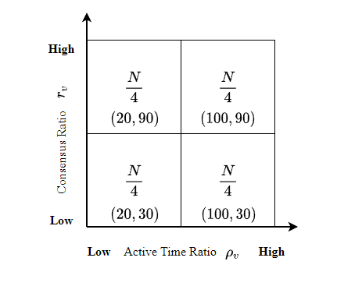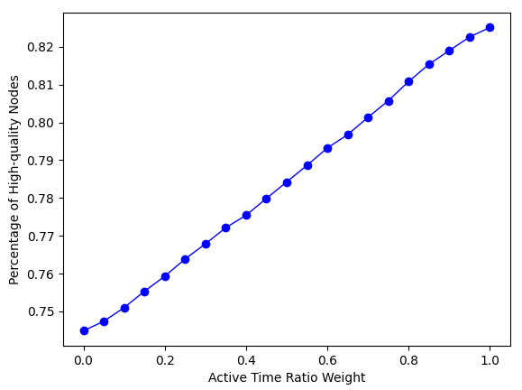
(a) (b)
Fig. 6. Percentage of high-quality under different coefficients.
Fig. 6(b) shows that the percentage of high-quality nodes being elected as block proposers almost linearly increases with the active time ratio weight a increasing. Both active time ratio and consensus ratio affect the probability for high-quality nodes to be selected as block proposers. The maximum value of the percentage is less than 0.85 while the minimum value is larger than 0.7. When the active time ratio weight equals 0.7, the percentage high-quality nodes can approximately reach 0.8. [Fig. 6(b)里，哪有此事？] In this case, active time ratio has larger impact than consensus ratio in the stability calculation. Consensus nodes that have high remaining active time would like to be honest than those with low remaining active time due to the incentive and punishment mechanism in SWIB. To ensure a relative high probability for high-quality nodes to be elected as block proposers, we set the active time ratio weight a as 0.7 and consensus ratio weight b as 0.3 in the subsequent performance experiments.

6.2 Consensus Interruption Comparison
In this subsection, we evaluate how the consensus interruption probability is affected by the communication interruption probability. In this test, we compared the consensus interruption probability by SWIB with PBFT and assume all nodes are honest.
【别人可能更关心部分节点不诚实情况下的协议性能，或者说“也关心”】
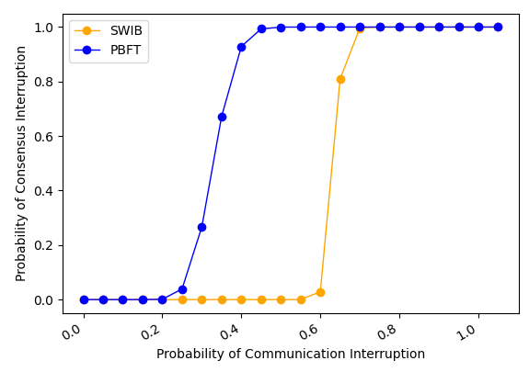 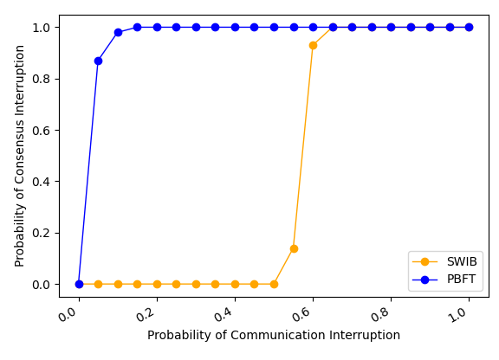 (a) Fault-free theoretical case (b) Fault-free practical case
Fig. 7. Consensus interruption probability comparison. [这两个黄词，到底怎么个解释、什么差别，什么都不说，难道等着读者猜测个说法，安到你头上？]
Fig. 7 compares the consensus interruption probability by different protocols with varying communication interruption probability. Fig. 7(a) shows the theoretical consensus interruption probability by the two protocols remains steady first, then increases to 1, which means no consensus can be reached in this case. The consensus in PBFT is interrupted with high probability when communication interruption probability is larger than 0.4. However, consensus process by SWIB can still work smoothly when the communication interruption probability is smaller than 0.5. This is because our protocol SWIB decouples leader selection (i.e., block proposer) from communication driven consensus process, our protocol is more stable than PBFT when nodes start to fail in receiving some messages. 【原因应该是收到partial signature shares而没有收到对应的block的时候，可以要求重传…而导致的, correct?】 The experiment results in Fig. 7(b) further validate the correctness of the theoretical results in Fig. 7(a).

6.3 Performance Comparison
In this subsection, we evaluate the impact of block size and network size on the protocol performance in terms of consensus latency and transaction throughput.
1) Impact of block size
In this experiment, we evaluate the impact of block size on the performance of SWIB. Each test lasts for 10 rounds. The block size varies from 0.5 MB to 5 MB, and the network size varies from 100 to 300 nodes.
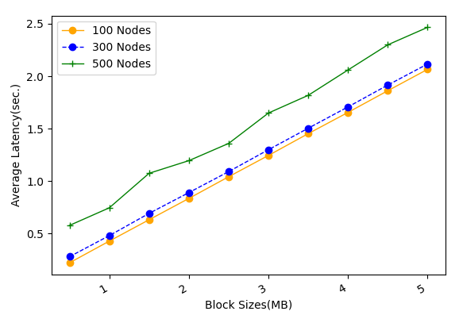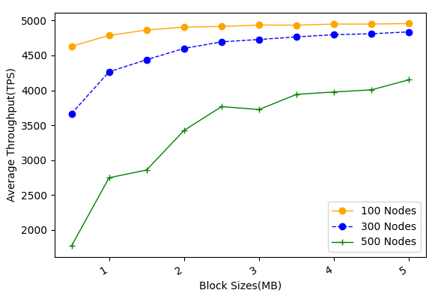
- Average latency (b) Average throughput
Fig. 8. The performance of SWIB versus block size. [横轴“Block Sizes => Block size”; 左图纵轴“Sec. => s”； Figs. 9-10同样处理]
[就图8里的试验，是怎么进行的？是从头到尾, 完整地把SWIB在你的仿真设置下按你说的设置跑的，然后画出相应的性能曲线？]
Fig. 8(a) shows that the consensus latency almost linearly increases with the block size increasing. When block size is smaller than 1 MB, the average consensus latency for all cases under study is shown to be below $1$ second. In Fig. 8(b), it is seen that the average throughput first increases rapidly, and finally tends to be flat, with the block size increasing. This indicates that only increasing block size cannot improve the average transaction throughput infinitely. When the block size equals 1 MB, SWIB can achieve large average transaction throughput with small average consensus delay. 【感觉不提每个节点以什么速率产生交易、以及交易是如何在网络中扩散的，缺乏这些，上面的结果，很难在读者心中产生共鸣】
2) Impact of network size
In this experiment, we evaluate the impact of network size on system performance. In here, each test lasts for 10 rounds.
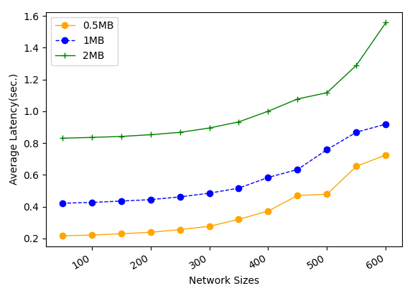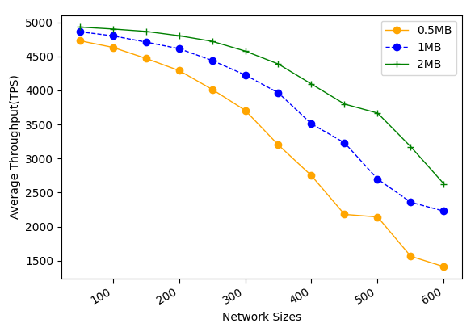
(a) Average latency (b) Average throughput
Fig. 9. The performance of SWIB versus network size. [左图纵轴改为Average Consensus Latency]
Fig. 9 shows the average consensus latency and throughput performance by SWIB when the block size varies from 0.5 MB to 2 MB and the network size varies from 50 to 600 nodes. Fig. 9 (a) shows the average consensus latency versus network size. In Fig. 9 (a), it is seen that the consensus latency increases with network size while still acceptable even for 600-node networks and 1-MB blocks. Due to the broadcast nature of wireless channel, block transmission time does not vary with network size as we focus on studying one-hop wireless networks. However, block finalization requires enough partial signature shares, whose collection time grows proportionally with network size. This indicates that consensus nodes are required to verify more partial signature shares, and the recovery of full signature requires larger threshold. Meanwhile, the increase of network size will lead to more severe channel accessing competition, which eventually results in the increase of consensus latency. Each SWIB node is assumed to dynamically adjust its transmission probability by sensing the channel state in the estimated adversary time window. [这里，冒出adversary字样，似乎不太合适] This design choice can avoid sharp increase of consensus latency with the increase of network size. Since the block size is fixed, as consensus latency increases, the average transaction throughput drops. Fig. 9 (b) shows that average transaction throughput can reach approximate 2000 TPS for 600-node networks and 1-MB blocks. Thus, we can adjust the node transmission probability and block size to guarantee high transaction throughput with reasonable consensus latency for different network settings.
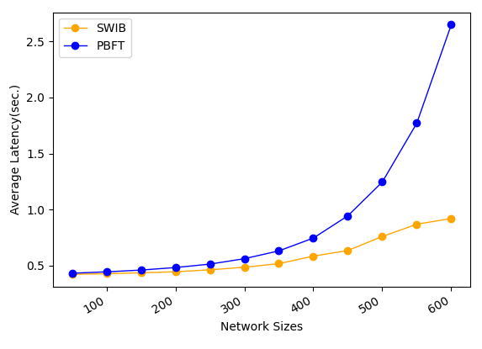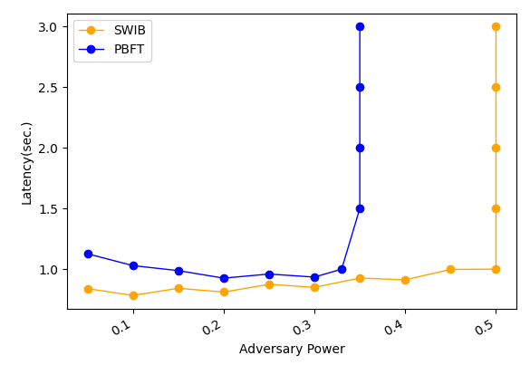
- Average latency vs. network size (b) Average throughput vs. network size
Fig. 10. Comparison of performance by different protocols.
Fig. 10 compares the performance by SWIB and PBFT under fault-free scenario with varying network size and adversary power. In this experiment, each test lasts for 10 rounds, network size ranges from 50 to 600, and block size is fixed to 1 MB.
Fig. 10(a) shows that the average consensus latency by different protocols with different network size. In Fig. 10(a), it is clearly seen that SWIB has much lower consensus latency than PBFT. For example, our protocol SWIB can achieve consensus within 1 second in 600-node wireless networks while that for PBFT will be 2.7 second. This is because SWIB can securely reach block consensus in one round of voting while PBFT requires two-rounds communications to reach consensus on a block.
Fig. 10(b) compares the consensus latency by different protocols with varying adversary power in 500-node networks. In PBFT, view change happens when a malicious leader proposes an invalid block or does not propose any block. In this case, all honest nodes require two round communications to determine a new leader. In SWIB, honest nodes will discard invalid block and sign an empty block instead, then entering the next consensus round. In the experiment here, all malicious nodes are assumed not to send any messages in a consensus round. Under this assumption, in Fig. 10(b), it is seen that our protocol can work correctly when adversary power is smaller than 50% while PBFT will fail to reach consensus when adversary power is more than 33%. This indicates that our protocol has better fault tolerance performance than PBFT.
[层次逻辑清楚，是表述科技论文内容的基本要求，我希望你能从上面这一小节的修改，和你以前写的对比，真正地学习到如何到达这一目标！否则，如果哪天我不愿意再为乱写的内容修改的时候，事情就会搁置下去…]

6.4 Attack Resistance
In this subsection, we evaluate how Sybil percentage of Sybil nodes impacts the consensus performance in terms of transaction consensus latency and system throughput. We increase the percentage of Sybil nodes from 5% to 49%, and repeat the experiments in four different sized networks while fixing block size to 1 MB.
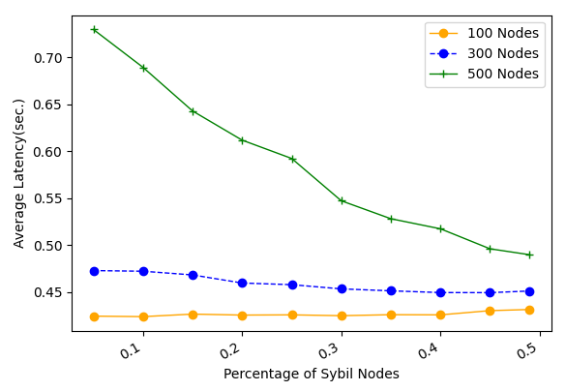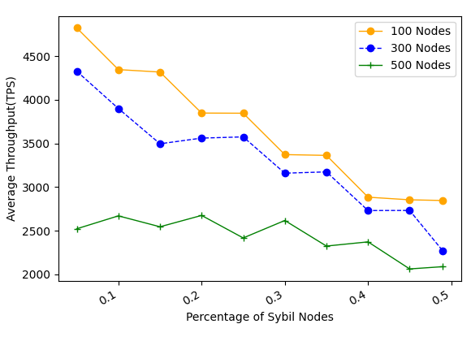
- Average latency Vs. fraction of Sybil nodes (b) Average throughput Vs. fraction of Sybil nodes
Fig. 11. The performance of SWIB when confronting Sybil attacks
Fig. 11 shows the performance of SWIB with varying percentage of Sybil nodes in the network. In Fig. 11 (a), it is seen that the consensus latency by SWIB decreases with the percentage of Sybil nodes increasing. In SWIB, when a Sybil node is selected to serve as block proposer, empty block will be eventually generated. Compare with the valid block case, propagation of an empty block requires small number of time slots. Thus, the consensus latency will not significantly increase due to malicious block proposer in a round. Meanwhile, channel contentions between consensus nodes become light when the fraction of Sybil nodes increasing. This is because that Sybil nodes would not send messages during consensus process, or just send some error message with lower transmission probability. As result, the consensus latency declines when the percentage of Sybil nodes increases. With the increase of Sybil nodes percentage, the probability of generating empty blocks increases. In this case, the average number of confirmed transactions will decrease. In Fig. 11 (b), it can be seen that the average transaction throughput will decrease with the increase of percentage of Sybil nodes. Also, it is seen that SWIB can achieve more than 2000 TPS in blockchain network with 500 nodes and block size of 1 MB. As a result, our protocol can resist to Sybil attacks, and achieve acceptable performance when adversary issuing Sybil attacks. [中间的解释，没太看明白里面的逻辑]
Next, we evaluate the performance of SWIB in the presence of $(1-δ, T)$-bounded jammers. Here, we consider different jamming strategies in the attacks: one is random jamming such that the jammer randomly jams $\left(1-δ\right)T$ slots among $T$ slots, another is perpetual jamming such that the jammer jams $\left(1-δ\right)T$ consecutive slots in each period of $T$ slots. Each test lasts for 10 rounds. The value $δ$ ranges from 0.1 to 1. The smaller $δ$ is, the more time slots jammed. The adversary time window is chosen as 100 time slots.
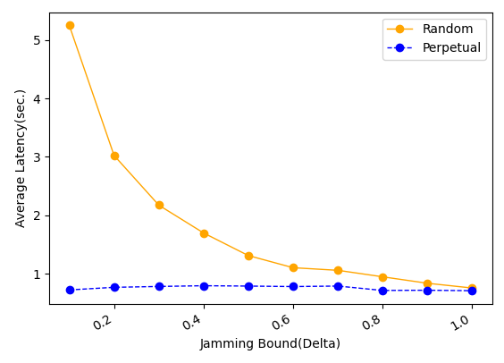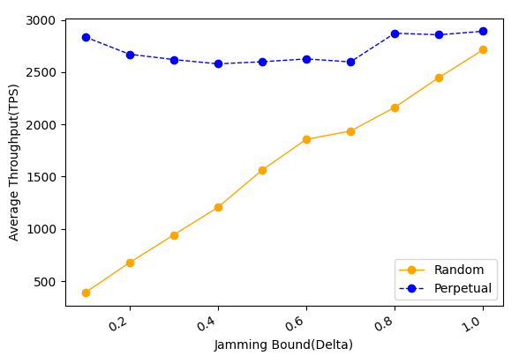
(1) Average consensus latency (b) Average throughput
Fig. 12. The performance of SWIB when confronting Jamming attacks.
Fig. 12 (a) shows that the consensus latency decreases with the increase of $δ$ under random jamming attacks while keeping steady under perpetual jamming attacks. This indicates that, for SWIB, random jamming attack is more powerful than perpetual jamming attack. When adversary issues perpetual jamming attacks, the transmission probability of nodes is reduced quickly by the maintained estimate of adversary time window ${\hat{T}}_{v}$. In this case, channel contentions in the network will be reduced, and nodes can transmit a message successfully within small time slots. However, when jammers issue random jam attack, transmission probability of nodes will not reduce significantly due to the estimate of adversary time window ${\hat{T}}_{v}$ not increase rapidly. The required time of partial signature shares aggregation will decline when increasing the value of $δ$. Thus, the consensus latency decreases with the increase of $δ$. Fig. 12 (b) shows that the throughput of SWIB does not fluctuate significantly under perpetual jamming attacks. As block size is fixed and consensus latency is reduced, the average throughput under random jamming attacks increases with the improvement of value $δ$. The throughput can exceed 1000 TPS in 500-node networks under $\left(0.7, 100\right)$-bounded adversary who launches random jamming attacks. Therefore, our protocol can securely operate in blockchain system when adversary issuing jamming attack, and achieve acceptable transaction throughput within reasonable consensus latency.

Conclusion and Future Research
In this paper, we proposed a stable wireless blockchain consensus protocol SWIB, which can ensure stable and secure consensus process by adopting verifiable random function and threshold signature scheme in one-hop wireless networks. We use a new verifiable block proposer algorithm to prevent the formation of forks and choose a more reliable block proposer to generate a valid block. Besides, by combining the nature of wireless communication protocol with threshold BLS signature scheme, consensus nodes can verify and vote for block proposal in secure and efficient way. In addition, according to the characteristic of threshold BLS signature scheme, all honest consensus nodes can recover full signature to complete block finalization in distributed manner. Moreover, our protocol can still work efficiently in wireless blockchain system under Sybil attacks and jamming attacks. Analysis and results show the efficiency and security properties of the SWIB protocol.
In the future, we will investigate the multi-hop version of SWIB protocol in wireless ad hoc networks. We should study the energy consumption in consensus process, and design energy efficiency consensus protocol in wireless network. What's more, it is necessary to investigate the impacts of mobility in ad hoc wireless network. Also, we will explore whether our protocol can mitigate other attacks such as long-term attacks, nothing-at-stake attacks, eclipse attacks, etc.

