Models and Related Technology
We describe the preliminaries of SWIB, including network model, blockchain setting, communication model, and attack models. When designing a blockchain consensus protocol, we first require to determine a network model that is fundamental infrastructure running the protocol. Then, we should consider the data architecture of distributed ledger used in our protocol. To improve the performance of blockchain protocol, we use a threshold BLS signature scheme as voting mechanism to reduce consensus latency. Since computing time is negligible small, we can analyze the performance of consensus protocol by giving a communication mode. In order to discuss the attacks-resistance of consensus protocol, attack models should be predefined.

3.1 Network Model
Blockchain consensus protocols are designed according to network models. Consensus nodes achieve consensus through networks transmitting messages. We only consider a wireless broadcast network consisting of nodes, which are located within communication range of each other, and communicating with each other by transmitting messages. All nodes have same functions. Each node equipped with transceiver works in a half-duplex manner. This means that nodes can transmit or receive messages, but not both simultaneously. In practice, such a network can be formed by a group of unmanned aerial vehicles or intelligent vehicles.
Nodes adopting digital signature technology can achieve node identity confirmation and the verification and integrity of communication messages. In digital signature, each node has its key pair, which used to message encryption and decryption, and generate signature. We assume that each node can get its private-public key pair and a main public key by independently running a secure distributed key generation protocol. Each node can obtain the public keys and identities of other nodes by exchanging messages. Thus, each node knows the identities and public keys of all other nodes.

3.2 Blockchain
Blockchain is a public electronic ledger, which similar to a relational database. This ledger is openly and simultaneously shared among various nodes in system. Blockchain uses a consensus protocol to ensure the dependability and integrity of blockchain system. Therefore, blockchain can only be updated when consensus is reached on a new block between nodes in the system. Each node maintains a local blockchain, which is composed of blocks chronologically linked to create a chain. Each block contains a block header and a block body. The block header records blockchain version, block proposer, block height, previous hash, block hash, block full signature, and transactions hash root, etc. The block body stores transaction recodes, which consist of payer's information, payee's information and other necessary contents. Figure 1 shows the data structure of a blockchain.

Fig. 1 Blockchain

3.3 Threshold BLS Signature Scheme Technology
Threshold Boneh-Lynn-Shacham (BLS) signature scheme [29] is the combination of threshold signature scheme and BLS signature scheme [30]. BLS signature scheme is closely related to bilinear maps and Gap Diffie-Hellman (GDH) groups, where the Computational Diffie-Hellman problem is hard but the Decision Diffie-Hellman problem is easy. Threshold signature scheme allows multiple participants securely reconstruct a secret (i.e., a main private key) and perform computation (i.e., signature generation or decryption) even an adversary has corrupted some participants. Threshold BLS signature scheme includes key generation algorithm, signature generation algorithm and verification algorithm. The key generation algorithm adopts a discrete log-based distributed key generation method [31] to distribute private-public key pair and a main public key to participants. In threshold BLS signature scheme, participants jointly sign a message through the signature generation algorithm. The full signature of the message can be obtained when a sufficient number of participants sign the message. All participants can use the main public key to verify the full signature by the verification algorithm. The signature share generation and verification of threshold BLS signature scheme concurs with the BLS signature scheme, and the aggregation of full signature is congruent with threshold signature scheme.
To improve the efficiency and stability of consensus process, consensus protocols adopt a threshold BLS signature scheme as voting mechanism. All consensus nodes use a share of a main private key as their private keys. In a consensus round, each node generates a partial signature of a proposal as a vote of the node for the proposal. A full signature of the proposal can be recovered by nodes who aggregate a sufficient number of partial signatures. Thus, achieving consensus among nodes do not require all-to-all communications. Since several partial signatures can be aggregated into a full signature, nodes can verify multiple votes and consensus result in an operation. Therefore, the efficiency of consensus process will be improved. Besides, the termination of a consensus process not relies on a special node of system. Any node who recovers the full signature can terminate the consensus process. The stability of consensus process is increase.

3.4 Communication Model
In SWIB, we mainly focus on the impact of wireless communication in the performance of blockchain system. As a metric that used to evaluate the performance of blockchain system, consensus latency consists of computing time and communication time. However, the computation load of nodes in SWIB is small, which means computing time is negligibly small.
During consensus process, nodes broadcast messages over wireless channel to achieve consensus. We consider a communication model with p-persistent carrier-sense multiple access (CSMA). Nodes continuously sense channel and transmit message with a constant probability when detecting channel idle. We assume that wireless channels follow the standard path-loss model and the Rayleigh fading model [32]. In detail, the path-loss of the wireless channel between nodes $u$ and $v$ is modeled as
$$\begin{aligned}PL_{dB}\left(d_{u,v}\right)= PL_{dB}\left(d_{0}\right)+10\log_{10}{{\left(\frac{d_{u,v}}{d_{0}}\right)}^{α}}\#\left( AUTONUM \backslash * Arabic \right)\end{aligned}$$

where $PL_{dB}\left(d_{0}\right)$ is the path-loss at reference distance $d_{0}$, and $d_{u,v}$ is the distance between nodes $u and v$, and $α∈(2, 6]$ is path-loss exponent. Let $H_{u,v}$ be the channel gain from $u$ to $v$, following the complex normal distribution with zero mean and variance $P_{t}$ (i.e., $H_{u,v}∼CN(0, P_{t})$). When a signal is transmitted from $u$ to $v$ with transmission power $P_{t}$, the Signal-to-Noise (SNR) ratio at receiving node $v$ is formulated as
$$\begin{aligned}SNR_{uv}\left(H_{u,v}\right)={10}^{-\frac{ PL_{dB}\left(d_{0}\right)}{10}}⋅ \frac{P_{t}⋅{\left|H_{u,v}\right|}^{2}}{P_{n}}⋅{\left(\frac{d_{u,v}}{d_{0}}\right)}^{-α}\#\left( AUTONUM \backslash * Arabic \right)\end{aligned}$$

where$P_{t}$ is transmit power, and $P_{n}$ is the additive white Gaussian noise.
Since time in our protocol implementation is divided into synchronized slots, in which nodes can complete a packet transmission. The fixed time interval of a slot is calculated as follows:
$$\begin{aligned}τ_{o}= \frac{m}{B⋅\log\left(1+β\right)}\#\left(3\right)\end{aligned}$$
where $m$ is the maximum size of packet sent by nodes during consensus process in bits, and $β$ is the target SNR ratio of transmission, and $B$ is the bandwidth utilized for transmission. Since a message will be divided into multiple packets in transmission process, the time interval of transmit a message should be $τ=l⋅τ_{o}$, where $l$ is the number of packets of the message.
During consensus process, messages losses can lead to consensus failure. Message losses are mainly caused by channel collision and channel fading. Therefore, a successful transmission should satisfy two conditions: 1) if and only if there only one node transmitting in a time slot; and 2) SNR ratio is equal to or bigger than the target one.
In our communication model, each node competes for accessing the channel to broadcast messages over wireless channels. In channel contention process, the transmission between nodes will fail if more than one node transmits in a same slot. Channel contention success probability can be expressed as
$$\begin{aligned}p_{comp}\left(N\right)=\frac{Np{\left(1-p\right)}^{N-1}}{1-{\left(1-p\right)}^{N}}\#\left(4\right)\end{aligned}$$
where $N$ is the number of consensus nodes, and $p$ is a constant transmit probability of each node. During transmission process, the SNR ratio between nodes varies with a time-variant communication environment. When SNR ratio is less than a given target threshold, the communication between nodes is interrupted. Since ${\left|H_{u,v}\right|}^{2}$ is exponentially distributed, the SNR outage probability between nodes $u$ and $v$ is expressed as follows
$$\begin{aligned}ϵ_{u,v}\left(H_{u,v}\right)=\operatorname{Pr}\left[SINR\left(u,v\right)<β\right]\#(5)\#\# \\ = Pr\left[{|H}_{u,v}{\left.​\right|}^{2}<{10}^{-\frac{ PL_{dB}\left(d_{0}\right)}{10}}⋅\frac{βP_{n}}{P_{t}}⋅{\left(\frac{d_{u,v}}{d_{0}}\right)}^{α}\right]\#(6) \\ =1-e^{-{10}^{\frac{ PL_{dB}\left(d_{0}\right)}{10}}⋅\frac{βP_{n}}{P_{t}}⋅{\left(\frac{d_{u,v}}{d_{0}}\right)}^{α}}.\#\left(7\right)\end{aligned}$$
In order guarantee communication under unreliable networks, retransmission mechanism is necessary. When communication failure occurs, retransmissions are carried out until the lost messages are successfully delivered.

3.5 Attack Models
Attacks launching by adversary can halt consensus process. The attack-resistance is very important for security of blockchain system. We assume that an arbitrary adversary can control no more than $50\%$ of the total voting power and corrupt nodes. In SWIB, we only consider two kinds of attacks of adversary: Sybil attack and jamming attack.
- Adversary can launch Sybil attack, in which adversary can generate a large number of identities for corrupted nodes. These nodes can deviate from consensus protocol. Adversary may obtain inappropriate power in consensus process. Adversary can overwhelm other nodes through majority voting power, then control the generation of blocks and prevent other new nodes from entering system.
- Adversary can launch jamming attack to halt the security of blockchain system. Jamming attack is a denial-of-service attack that adversary prevents other nodes from using the channel to communicate by occupying the channel they are communicating on. Blockchain system adopting communication-based consensus protocols will loss liveness when consensus process is interrupted by adversary launching jamming attack. Adversary can prevent other nodes from broadcasting their votes. A consensus process cannot be complete if the number of votes is less than the secure threshold of blockchain system. In addition, adversary can prevent other new nodes from entering system by jamming the requests of these new nodes.
We design SWIB that can resistant both Sybil attack and jamming attack. Even attacked by adversary, blockchain system can still work securely.

The Stable-aware Wireless Blockchain Consensus Protocol
In this section, we propose a stable-aware wireless blockchain consensus protocol, abbreviated as SWIB. We first present an overview of the protocol, and then give the details of SWIB. To ensure the security of the protocol, we propose incentive and publishment mechanisms and a synchronization mechanism.

4.1 Overview
In this subsection, we present an overview of SWIB, which adopts a four-stages framework to achieve consensus in blockchain system round-by-round (As shown in Fig. 2). The four stages of SWIB include block proposer election stage, block generation stage, block verification stage, and block finalization stage. SWIB adopts a random block proposer election algorithm and a threshold BLS signature scheme to prevent inherent forks and reduce system overhead. The random block proposer election algorithm used in block proposer stage can reduce adversary corruption risk and prevent inherent forks. The threshold BLS signature scheme used in both block verification and finalization stages can reduce the system overhead of consensus process.

Fig. 2 An overview of SWIB in a round $r$. At the beginning of the round, all consensus nodes are assumed to maintain a same replica of the blockchain. (1) Block proposer election algorithm is executed to randomly determine the block proposer for the current round; (2) the elected block proposer will generate a new block, and broadcast to other nodes; (3) verify legality of the new block, and run signature generation algorithm to vote for valid block; (4) run signature aggregation algorithm and signature recovery algorithm to finalize the block when generating the full signature.
In SWIB, each round consists of the four stages, whose detailed description will be given in the following. In the block proposer election stage, a block proposer will be randomly elected from all consensus nodes via random block proposer election algorithm. This algorithm is based on the roulette wheel selection and uses both remaining active time and the number of generated blocks as the elected weight of nodes. In block generation stage, the elected block proposer will generate a new block, which contains a set of transactions and relevant information of previous blocks and block proposer. The block will be broadcast to all other consensus nodes in the blockchain system. SWIB uses a secure threshold BLS signature scheme as voting mechanism, which is related to both block verification stage and finalization stage. Upon receiving the block, nodes start block verification stage. In this stage, nodes will generate a partial signature of the block as a vote of the block if the block proposer and the content of the block is verified. Then, each node will aggregate a sufficient number of partial signature shares into a full signature, which can be verified by a main public key. The valid full signature will be broadcast to other nodes. In block finalization stage, upon receipt or generation of a full signature, nodes will add the full signature to the corresponding block, append the block into their local blockchain, and update their node list. After that, nodes will start a new round. The process of executing a complete consensus round is presented in Algorithm 1. To ensure jamming-resistant communication over wireless channels, the BroadcastMessage subroutine presented in Algorithm 2 is employed to broadcast signatures.
To join a blockchain system, nodes require to obtain identities and system relevant information. New nodes get identities and active time by depositing certain amount of money. These money will be stored in a virtual account, and can only be taken out by the depositor through executing an unpledged operation. Then, nodes obtain their private-public key pair and a main public key via a distributed key generation algorithm. Nodes gain the information of other nodes and blockchain by exchanging messages. Nodes start participating consensus process when they have the latest blockchain, the random seed of the current round, and a consensus node list that ordered by the hash value of their public keys.

4.2 The SWIB Protocol
SWIB protocol is a four-stages framework blockchain consensus protocol, which achieves consensus on blocks among consensus nodes. In the following, we shall present the details of these stages.

4.2.1 Block Proposer Election Stage
In block proposer election stage, we present a random block proposer election algorithm based on a roulette wheel selection to randomly elect a unique block proposer. The random block proposer election algorithm (Algorithm 1 lines 5-8) first generates a random value in election process. Then, a roulette wheel will be constructed according to the stability of nodes. The elected probability of nodes in the wheel is proportional to their stability. Finally, a block proposer of current round is determined according to the random value and the wheel constructing by elected probability of nodes.
A distributed randomness generation function allows consensus nodes to independently produce an unpredictable and verifiable random value. In each round, the calculation of the random value is performed as
$$\begin{aligned}Rdm^{r}=\frac{H\left(r,B_{H}^{r-1},sig_{full}^{r-1}\right)}{2^{len\left(H\left(r,B_{H}^{r-1}, sig_{full}^{r-1}\right)\right)}}\#\left(8\right)\end{aligned}$$
where $r$ is the current round number, and $B_{H}^{r-1}$ is the hash of the latest confirmed block, and $sig_{full}^{r-1}$ is the full signature. For simplicity, the $B_{H}^{-1}, sig_{full}^{-1}$ inputs of the function in the very first round are set to be null.
Node stability is determined by their active time and the number of generated valid blocks in several latest rounds. The active time is defined as the time interval that nodes can participate in consensus processes. The active time of each node is obtained by depositing money to a blockchain system. Node active time will decrease with the passage of time. We count the number of valid blocks generated by each node within several latest rounds, in which produce same number of valid blocks. We can compute the stability as follows:
$$\begin{aligned}S_{v}=k_{at}×\frac{T_{v}}{∑T_{v}}+k_{nb}×\frac{N_{v}}{K}\#\left(9\right)\end{aligned}$$
where $T_{v}$ is node active time, $∑T_{v}$ is the cumulative active time of all nodes, $N_{v}$ is the number of valid blocks generated by a node, and $K$ is the fixed number of cumulative valid blocks, $k_{at}$ and $k_{nb}$ ($k_{at}+k_{nb}=1, k_{at}≥0, k_{nb}≥0$) are the weights of active time and the number of valid blocks, respectively. Note that $ρ_{v}= \frac{T_{v}}{∑T_{v}}$ is active time ratio and $r_{v}=\frac{N_{v}}{K}$ is consensus ratio.
According to the distributed randomness generation function and the node stability, we present a block proposer election algorithm is based on the roulette wheel selection. A roulette wheel is constructed from the node elected probability, which is defined as the ratio of the stability of a node and total stability of all nodes. The wheel is represented in the form of a pie chart, where the area occupied by each node on the roulette wheel is proportional to its elected probability. According to the elected probabilities of nodes, we can calculate the cumulative elected probabilities of nodes. In the algorithm, a random value in the interval $[0, 1)$ is generated via a distributed randomness generation function. When the cumulative elected probability is greater than the random number, the corresponding node is elected as current block proposer. Since a node with better stability value will occupy a bigger area in the pie chart, the node will have high probability being elected.

4.2.2 Block Generation Stage
A block will be generated by the legal block proposer in block generation stage (see Algorithm 1 lines 10-23). Block proposer will request transactions from other nodes if it has not enough transactions to generate a block. Once receiving the request, nodes will compete for broadcasting transactions to the block proposer. In general, the elected block proposer will generate a new block, which contains transaction records and other necessary information. Then, the block proposer will broadcast the new block to other nodes. When receiving the block successfully, nodes will immediately start block verification stage.
A block contains a header and a body. The header consists of the round number, the hash value of previous block, the current block hash, the identity of the block proposer, the full signature and the root of transactions, and so on. Block body usually stores transaction recodes. Block will package all necessary information in but full signature, which, can only be appended to this block in block finalization stage.

4.2.3 Block Verification Stage
In block verification stage, consensus nodes achieve consensus on that a new block is valid. All nodes receiving a new block from current block proposer will verify the block. If the block proposer is legal and the block contend is valid, nodes will generate partial signatures to vote for it and broadcast their signature to other nodes. Nodes will aggregate enough partial signatures into a full signature, which can be verified by nodes via a main public key. The pseudo code of block verification is presented in Algorithm 1 lines 25-42.
When receiving a block, consensus nodes will verify the block proposer and the content of the block. A node needs to check the following conditions:
- Block proposer: The output of block proposer election algorithm is same with the identity of block proposer.
- Previous hash: The previous hash value in the current block is equal to the hash of last block on its blockchain.
- Transactions: All transactions included in the current block should not conflict with previous confirmed transactions.
A block is valid if it obtains enough vote from consensus nodes. If all the above conditions are satisfied, then each node vote for the block as a vote, and broadcast their votes to other nodes. When a node collects enough (threshold) votes for the block, it is considered to be verified.
Full signature is used as a proof of block validation in block verification stage. SWIB utilizes a voting mechanism that based on a threshold BLS signature scheme. In this voting mechanism, nodes will generate a partial signature through the signature generation algorithm of the scheme as a vote of a block. When gathering a sufficient number of partial signature shares of the block, nodes can recover a full signature through the signature recovery algorithm of the scheme. The full signature can be verified through the signature verification algorithm of the scheme. The successful reconstruction of the full signature indicates that a sufficient number of nodes approve the block. In this case, the block is considered to be valid. Therefore, it is feasible to use the full signature as the proof of block validation.

4.2.4 Block Finalization Stage
In block finalization stage, a block will be finalized. If there are a sufficient number of nodes agree on a block, nodes will append the block in their local blockchain and update their node list. The pseudo code of block finalization is presented in Algorithm 1 lines 44-51.
Full signature proves the finalization of a block. When receiving or recovering a valid full signature, nodes will add it to the corresponding block. Then, each node will append this block into their local blockchain. Finally, nodes will update their node list, such as updating list members, active time, and so on. After that, nodes start a new consensus round.
A broadcast message mechanism is presented to help nodes resistant jamming attack by reducing channel contention. In our protocol, nodes have a channel compete probability and an estimate of adversary time window. Each node will send a message with the probability. Nodes count the number of idle slots within their estimate of adversary time window. If there is no idle slot, the probability will be multiplicatively decreased and the estimated time window will be reduced. Otherwise, the channel compete probability will be multiplicatively increased and the estimated time window will be decrease by 1. The broadcast message mechanism ensures that node can adjust their channel compete probability and an estimate of adversary time window to reduce channel contention. The pseudo code is presented in Algorithm 2.

4. 3 Synchronization Mechanism
Synchronization mechanism is important to guarantee the security of consensus process. If consensus nodes have distinct view on blockchain, the previous hash of a processing block may be different with the hash of the latest block on their blockchain. Since the result of block verification is false, nodes will not vote for the block. As result, consensus may be not achieved among these nodes. The synchronization mechanism can ensure that nodes have the latest blockchain all the time. Therefore, consensus process will not be interrupted in block verification due to inconsistent blockchain. The pseudo code of the synchronization mechanism is presented in Algorithm 3.
Our synchronization mechanism improves the security of synchronization process by allowing nodes request blocks from multiple high-quality nodes. In SWIB, nodes with higher stability are more likely to maintain the latest blockchain, and have lower risk of sending faulty blockchain information. The synchronization mechanism allows new nodes to request a part of blockchain information from multiple high-quality nodes. This will reduce the risk that a node transmits error blockchain information to mislead new nodes. Once a node transmits error block information, the receiving node can immediately detect it through blockchain information received from other nodes. The new node can request the of blockchain information from other trustworthy nodes to ensure the receipt of correct blockchain information.
The synchronization mechanism can reduce the burden of a single node in synchronization process. It is a huge burden for a node to transmit a large number of blocks. The node consumes large transmitting power and transmitting time to complete this transmission. Actually, all consensus nodes have obligation to response for the request of blockchain information. In our mechanism, nodes are allowed to request a part of blockchain information from multiple nodes. For the requested nodes, the transmit power consumption should be small. This mechanism decreases the burden of a single requested node.

Protocol Analysis
In this section, we analyze the security and performance of SWIB. The security is analyzed in terms of consensus security, random generation security, and attack resistance. The performance is analyzed in terms of consensus success probability and consensus latency.
Since SWIB allows only a single block to be finalized in each consensus round, we obtain the following theorem:
Theorem 1. If a consensus round can only finalize a block in SWIB, the threshold value of a secure $(t,N)$-threshold BLS signature scheme should greater than or equal to $\left\lceil \frac{N+1}{2}\right\rceil$.
Proof. We assume that that the threshold value $t$ is less than $\left\lceil \frac{N+1}{2}\right\rceil$. Let $H$ be the set of honest nodes, and $A$ be the set of malicious nodes. In a consensus round, all honest nodes will generate partial signature for a valid block $B_{valid}$, while all malicious nodes will generate partial signature for a conflict block $B_{conflict}$. In the scheme, any set of more than $t$ can generate a unique full signature for a message. If $\left|H\right|≥t$ and $\left|A\right|≥t$, the two blocks will be finalized by recovering two distinct valid full signatures in the consensus round. However, this contrary with the uniqueness of SWIB. Thus, the threshold value $t$ should greater than or equal to $\left\lceil \frac{N+1}{2}\right\rceil$.
If threshold value $t≥\left\lceil \frac{N+1}{2}\right\rceil$, SWIB has robustness. We obtain the following corollary.
Corollary 1. To ensure the security of SWIB, adversary controls at most $\left\lceil \frac{N-1}{2}\right\rceil$ nodes.
Proof. In a secure $(t,N)$-threshold BLS signature scheme, no adversary corrupting less than $t$ nodes can know any information about the main private key or can forge a valid signature. In SWIB, the threshold value $t$ is greater than or equal to $\left\lceil \frac{N+1}{2}\right\rceil .$ When adversary corrupts less than $t$ nodes, nodes can also recover a unique full signature to finalize a block. Thus, if adversary controls at most $\left\lceil \frac{N-1}{2}\right\rceil$ nodes, it cannot control the recovery of full signature or forge a valid full signature through the private keys of its controlled nodes. This means that SWIB is secure when adversary controls at most $\left\lceil \frac{N-1}{2}\right\rceil$ nodes.
Since nodes compete for accessing the channel, each node is allocated a contention time duration for channel compete process. For a given target contention success probability, the minimum time slots of contention process can be computed. We have the following proposition.
Proposition 1. We assume that the total number of nodes in system is $N$. Each node competes for accessing channel with a constant probability $p$. For a given target contention success probability $0≤ς<1$, the required time slot of contention process is
$$\begin{aligned}x_{comp}=\left\lceil \frac{\log\left(1-ς\right)}{\log\left(1- p_{comp}\right)}\right\rceil \#\left(11\right)\end{aligned}$$
where $p_{comp}=\frac{Np{\left(1-p\right)}^{N-1}}{1-{\left(1-p\right)}^{N}}$ is contention success probability.
Proof: Let $X$ be the number of required time slots for a node compete successfully. We suppose that $x_{comp}$ is the minimum value such that
$$\begin{aligned}\operatorname{Pr}\left[X≤x_{comp}\right]=1-{\left(1-p_{comp}\right)}^{x_{comp}}≥ς\#\left(12\right)\end{aligned}$$
where $p_{comp}$ is channel success contention probability, and $0≤ς<1$is a target contention success probability. Then, the required number of time slots is calculated as
$$\begin{aligned}x_{comp}=\left\lceil \frac{\log\left(1-ς\right)}{\log\left(1-p_{comp}\right)}\right\rceil .\#\left(13\right)\end{aligned}$$
In our consider models, each transmitting node is allocated a broadcast time duration for a message broadcast. Each node has its target communication nodes. For a given target broadcast success probability, the minimum time slots of a node required for packet transmission to all target communication nodes can be computed. We can obtain the proposition.
Proposition 2. For a given probability $0≤ξ<1$, the required number of time slot to broadcast a packet from a node to its target nodes is
$$\begin{aligned}x_{trans}=\left\lceil \frac{\log\left(1-ξ^{\frac{1}{n}}\right)}{\log{ϵ_{max}}}\right\rceil ,\#\left(14\right)\end{aligned}$$
where $n$ is the number of the target nodes, and $ϵ_{max}= 1-e^{-{10}^{\frac{ PL_{dB}\left(d_{0}\right)}{10}}⋅\frac{βP_{n}}{P_{t}}⋅{\left(\frac{d_{max}}{d_{0}}\right)}^{α}}$is the SNR outage probability between the node and its maximum distance target node.
Proof: Let $X$ be a random variable denoting the number of time slots require to transmit a message from node $v$ to node $u$ via broadcast. Since transmission failure might occurs with a certain probability due to channel fading, the message will be sent repeatedly until successful transmit. Therefore, the probability density function of the random variable $X$ is represented as
$$\begin{aligned}f\left(X\right)= \left\{\begin{aligned}{ϵ_{v,u}}^{X-1}\left(1-ϵ_{v,u}\right), X≥1, \\ 0, otherwise\end{aligned}\right.\#\left(15\right)\end{aligned}$$
where $ϵ_{u,v}$ is the SNR outage probability between the two nodes. Then, the broadcast outage probability bounded as
$$\begin{aligned}\operatorname{Pr}\left[\max_{u}{X_{u}}≤x\right]=\prod_{u∈V∖\left\{v\right\}}{\operatorname{Pr}\left[X_{u}≤x\right]}=\prod_{u∈V∖\left\{v\right\}}{\left(1-ϵ_{v,u}^{x}\right)≥{\left(1- ϵ_{max}^{x}\right)}^{n}},\#\left(16\right)\end{aligned}$$
where $ϵ_{max}$ is the SNR outage probability between the source node and its maximum distance target node. Since the target broadcast success probability $ξ$ is given, we can compute the required time slots as
$$\begin{aligned}x_{trans}=\left\lceil \frac{\log\left(1-ξ^{\frac{1}{n}}\right)}{\log{ϵ_{max}}}\right\rceil .\#\left(17\right)\end{aligned}$$

5.1 Block Proposer Stage
We first analyze block proposer election in terms of computational power consumption and security.
Lemma 1. When block proposer election stage ends, one and only one block proposer will be randomly determined.
Proof. The random value generated through the distributed randomness generation function is unpredictable, verifiable and consistent. Although the hash value $B_{H}^{r-1}$ and the round number $r$ are pre-known parameters, the full signature $sig_{full}^{r-1}$ can only be revealed at the end of round$r-1$. The full signature makes it impossible for nodes to predict the value in advance. Even a node first recovers a full signature before others, the full signature cannot be tampered due to the security of threshold BLS signature scheme. The full signature can be verified through the signature verification algorithm of threshold BLS signature scheme. Since all nodes have same inputs, the random value of nodes should be consistent and verifiable.
In each round, a block proposer is determined by the random value and node stability. Since nodes have same view on nodes list, all nodes will construct the same roulette wheel according to their stability. The number of nodes, whose cumulative elected probability is greater than the random number, should be one. Therefore, at the end of block proposer stage, there is only one node randomly elected as the block proposer.■
Block proposer election algorithm ensures low computation power consumption and security of block proposer election. In our protocol, no puzzle solving competition is required to be block proposer. Instead, it can be chosen based on node stability. Only generating a random value and constructing roulette wheel require to consume the computational power of nodes. Thus, the algorithm ensure that nodes will consume very small computational power in election process. Utilizing stability of nodes as weight of electing block proposer can ensure the security of block proposer election. Since node stability varies with a time-variant and does not only depend on deposits, nodes with large deposits cannot have advantage on election process. Our algorithm can prevent nodes with high deposit control block proposer election stage. Since block proposer election algorithm introduces randomness, adversary cannot predict block proposer in advance. Thus, the election of block proposer is secure.

5.2 Block Generation Stage
We analyze the performance of block generation in this subsection. Block and transactions will be transmitted in this stage. Let $T_{B}=\frac{M_{B}}{m}$ and$T_{Tx}=\frac{M_{Tx}}{m}$ be the required time slots of transmitting a block, where $m$ is the size of a packet in bits, $M_{B}$ is the size of a block in bits, and $M_{Tx}$ is the size of a transaction in bits. We can obtain the following lemma.
Lemma 2. Given a target contention success probability $ς$ and a target transmission success probability $ξ$, all consensus nodes can receive the generated block after $\left(2+\left\lceil \frac{M_{B}}{M_{Tx}}\right\rceil \right){⋅x}_{comp}+\left(1+T_{B}\right)⋅x_{trans}+T_{Tx}⋅\left\lceil \frac{\log\left(1-ξ\right)}{\log{ϵ_{max}}}\right\rceil$ slots with a constant probability $ς⋅ξ$ in block generation stage.
Proof. According to the required time slot of channel contention process (11) and the required number of time slot of transmission process (14), the required time slots of transmitting request other nodes is calculated as
$$x_{req}=x_{comp}+x_{trans}.$$
The required time slots of transmit transactions to block proposer is calculated as
$$x_{Txs}=\left\lceil \frac{M_{B}}{M_{Tx}}\right\rceil ⋅\left(x_{comp}+T_{Tx}⋅\left\lceil \frac{\log\left(1-ξ\right)}{\log{ϵ_{max}}}\right\rceil \right)$$
The required time slots of transmitting blocks to other
$$x_{B}= x_{comp}+T_{B}⋅x_{trans}$$
Thus, the required time slots of block generation stage is calculated as
$$x_{BG}=\left(2+\left\lceil \frac{M_{B}}{M_{Tx}}\right\rceil \right){⋅x}_{comp}+\left(1+T_{B}\right)⋅x_{trans}+T_{Tx}⋅\left\lceil \frac{\log\left(1-ξ\right)}{\log{ϵ_{max}}}\right\rceil .$$

5.3 Block Verification
In this subsection, we analyze the performance and security of block verification. Let $T_{sig}=\frac{M_{sig}}{m}$ be the required time slots of transmitting a signature, where $m$ is the size of a packet in bits, $M_{sig}$ is the size of a signature in bits
Lemma 3. When block verification stage ends, at least one node will know that a sufficient number of nodes agree on the generated block after $(N-1)⋅\left(x_{comp}+T_{sig}⋅x_{trans}\right)$slots with a constant probability $1-{\left[\sum_{f=\left\lceil \frac{N+1}{2}\right\rceil }^{N-1}{\left({N-1 \atop f}\right){\left(1-ς⋅ξ\right)}^{f}⋅{\left(ς⋅ξ\right)}^{N-f-1}}\right]}^{N}$.
Proof. First of all, we know that the probability of a block received by all the other nodes is $ς⋅ξ$.
The following analysis is based on the assumption that a block has been generated by the elected block proposer and received by all the other nodes.
All nodes but block proposer will generate partial signatures if they verified the block. Aggregation failure occurs when a node fails to recover a full signature by aggregating more than partial signatures from other nodes in consensus process. Let $V$ be the set of consensus nodes in a consensus round. For any node $v∈V$, the aggregated failure probability of the node due to transmission failure is given as
$$\begin{aligned}p_{Aggr}= \sum_{f=\left\lceil \frac{N+1}{2}\right\rceil }^{N-1}{\left({N-1 \atop f}\right){\left(1-ς⋅ξ\right)}^{f}⋅{\left(ς⋅ξ\right)}^{N-f-1}}\#\left(20\right)\end{aligned}$$
If all consensus nodes failed to recover the full signature, a consensus process will be interrupted. The probability that recovery a full signature is calculated as
$$\begin{aligned}p_{full}=1-\prod_{v∈V}{p_{ Aggr}} \#\left(21\right)\end{aligned}$$
$$\begin{aligned}=1-\prod_{v∈V}{\sum_{f=\left\lceil \frac{N+1}{2}\right\rceil }^{N-1}{\left({N-1 \atop f}\right){\left(1-ς⋅ξ\right)}^{f}⋅{\left(ς⋅ξ\right)}^{N-f-1}}}\#\left(22\right)\end{aligned}$$
$$\begin{aligned}=1-{\left[\sum_{f=\left\lceil \frac{N+1}{2}\right\rceil }^{N-1}{\left({N-1 \atop f}\right){\left(1-ς⋅ξ\right)}^{f}⋅{\left(ς⋅ξ\right)}^{N-f-1}}\right]}^{N}.\#\left(23\right)\end{aligned}$$
The upper bound of the required time slots in block verification is calculated as
$$x_{BV}=\left(N-1\right)⋅\left(x_{comp}+T_{sig}⋅x_{trans}\right)$$

5.4 Block Finalization
In this subsection, we analyze the performance and security of block finalization.
Lemma 4. When block verification stage ends, all nodes achieve a consensus after $x_{comp}+T_{sig}⋅x_{trans}$ slots with a constant probability $ς⋅ξ$.
Proof. From the Lemma 3, we know that at least one node knows a sufficient number of nodes agreeing on the generated block with a constant probability. When a node recovers a full signature, it will broadcast the signature to all other nodes. The probability that a node broadcast the full signature to other nodes is $ς⋅ξ$. The required number of time slots of broadcasting full signature is $x_{comp}+T_{sig}⋅x_{trans}$. After receiving the full signature, all nodes will update the block in their local blockchains. If all nodes fail to recover a full signature, all nodes will propose an empty block and star block verification stage again.
Combining the above Lemmas, we have the following theorem for performance and security of our protocol.
Theorem 2. SWIB achieve consensus
Proof. Combining
We conduct a security analysis to show that SWIB protocol provides persistence and liveness to blockchain system.
If there are $t≥\left\lceil \frac{N+1}{2}\right\rceil$ nodes fulfilling the requirement of threshold BLS signature scheme, our protocol can guarantee persistence:
Theorem 1. (Persistence) If an honest node $v$ proclaims block $B$ is the $i^{th}$ block in the blockchain, then other honest nodes should report the same result.
Proof. In order to prove the persistence property, we need to show that for any two blockchains $BC_{u}$ and $BC_{v}$of honest nodes $u$ and $v$ should have same block at the same position. To prove by contradiction, we assume that $B_{u}$ and $B_{v}$ are two different blocks at a same position $i$ of $BC_{u}$ and $BC_{v}$as maintained by nodes $u$ and $v$, respectively. There are two cases when the assumption holds:
Case 1. $B_{u}$ and $B_{v}$ are respectively appended to the position $i$ of blockchains $BC_{u}$ and $BC_{v}$ in the same round. Block finalization depends on a unique full signature, which is recovered by at least $\left\lceil \frac{N+1}{2}\right\rceil$ valid partial signature shares. If two different blocks $B_{u}$ and $B_{v}$ are finalized in the same round, it indicates that a threshold BLS signature scheme recovers two different full signatures in a consensus round. This conflicts with the uniqueness property of threshold BLS signature scheme, which contradicts our assumption.
Case 2. $B_{u}$ and $B_{v}$ are appended to the blockchains $BC_{u}$ and $BC_{v}$ respectively in two different rounds. Assuming that $B_{u}$ and $B_{v}$ are respectively appended to the position $i$ of blockchains $BC_{u}$ and $BC_{v}$ at rounds $r_{m}$ and $r_{n} (m<n)$. According to our protocol, block $B_{u}$ is finalized in the $r_{m}$ round if the number of nodes voting for the block is at least $\left\lceil \frac{N+1}{2}\right\rceil$. Since two different blocks cannot be finalized in the same round, at least $\left\lceil \frac{N+1}{2}\right\rceil$ nodes agree that $B_{u}$ is the $i$th block of their blockchains in round $r_{m}$. Using contradiction, we assume that $B_{v}≠B_{u}.$ Since $r_{m} < r_{n}$, node $v$ crashes before round $r_{n}$ and recovers in round $r_{n}$ so that block $B_{v}$ is appended into $BC_{v}$ when node $v$ updates its blockchain. In this case, at least $\left\lceil \frac{N+1}{2}\right\rceil$ nodes have a same view on $i$th block is $B_{v}$ at the end of round $r_{n}$. Since there are at least $\left\lceil \frac{N+1}{2}\right\rceil$ nodes agreeing on the $i$th block in round $r_{m}$ is $B_{u}$ and the network size is $N$, we have contradiction such that $N>\left\lceil \frac{N+1}{2}\right\rceil +\left\lceil \frac{N+1}{2}\right\rceil ≥N+1$. Hence $B_{v}=B_{u}$, which contradicts the assumption $B_{v}≠B_{u}.$
In summary, all honest nodes are queried for a special position block should respond with the same result. If an honest node says block $B$ is valid, then other honest nodes also agree on its validity.$∎$
SWIB utilizes a synchronization mechanism to ensure the consistency of nodes. This protocol can guarantee liveness under eventual synchrony. We need at least $t≥\left\lceil \frac{N+1}{2}\right\rceil$ honest nodes to ensure the finalization of consensus process.
Theorem 2. (Liveness) We suppose that there are at most $\left\lfloor \frac{N-1}{2}\right\rfloor$ faulty nodes in blockchain system, SWIB can finalize a block that proposed by a correct node, and obtain the following round random seed.
Proof. We are required to prove that our protocol can guarantee liveness under the influence of adversary. The behaviors of malicious nodes controlled by adversary include: 1) intentionally not generating a valid block and 2) refusing to vote for valid blocks. There are two cases for node failures:
Case 1. Block proposer is malicious. If the malicious block proposer does not generate any block, all honest nodes will commit on an empty block. If the malicious block proposer generates an invalid block, the block will fail to pass the block validation stage. Thus, all honest nodes will refuse to vote for the invalid block and commit an empty block finally. In this case, each honest node will generate partial signature for the empty block. Once the full signature of the block is reconstructed from enough partial signature shares, the next round randomness is generated successfully. Nodes will start new consensus round if they generate or receive a valid full signature.
Case 2. At most $\left\lfloor \frac{N-1}{2}\right\rfloor$ malicious nodes refuse to vote for a block. When a non-faulty node generates a valid block, at least $\left\lceil \frac{N+1}{2}\right\rceil$ honest nodes will generate partial signature to vote for the block. They will broadcast their signature shares to other nodes. Once collecting a sufficient number of partial signature shares, nodes can recover a full signature and broadcast it to other nodes. These honest nodes can finalize the block and start new consensus round by generating or receiving the full signature, which is the proof of block finalization and the randomness of the next consensus round.
In summary, if the number of faulty nodes is at most $\left\lfloor \frac{N-1}{2}\right\rfloor$, honest nodes can commit on a block and generate the following round randomness. $∎$

5.5 Attack Resistance
In this subsection, we analyze Sybil attacks resistance and Jamming attacks resistance of SWIB.
SWIB utilizing stability as weight can prevent adversary from launching Sybil attack to benefit from block proposer election stage. Adversary launches Sybil attacks by generating pseudonyms. However, the elected probability will not increase due to increase the number of pseudonyms. The elected probability of a node is proportional to its stability. We assume that the stability of an adversary is $S_{A}=a\frac{T_{A}}{\sum_{v}{T_{v}}}+b\frac{N_{A}}{K}$, and the total stability of the system is $\sum_{v}{S_{v}}$. If adversary generates $m$ pseudonyms, whose stability are $s_{A}^{k}= a\frac{T_{A}^{k}}{\sum_{v}{T_{v}}}+b\frac{N_{A}^{k}}{K}(k=1, ⋯, m)$. The sum of elected probability of the $m$ pseudonyms is
$$\begin{aligned}\sum_{k=1}^{m}{\frac{s_{A}^{k}}{\sum_{v}{S_{v}}}}= \frac{\sum_{k=1}^{m}{a\frac{T_{A}^{k}}{\sum_{v}{T_{v}}}+b\frac{N_{A}^{k}}{K}}}{\sum_{v}{S_{v}}}= \frac{a\sum_{k=1}^{m}{\frac{T_{A}^{k}}{\sum_{v}{T_{v}}}+b\sum_{k=1}^{m}{\frac{N_{A}^{k}}{K}}}}{\sum_{v}{S_{v}}}= \frac{S_{A}}{\sum_{v}{S_{v}}}\#\left(10\right)\end{aligned}$$
which indicates that generating multiple pseudonyms will not increase the elected probability. As a result, our protocol can resistant Sybil attack in block proposer election.
SWIB can ensure the security of block verification stage under Sybil attack if the number of nodes controlled by adversary satisfies the requirement of a threshold BLS signature scheme. Nodes controlling by adversary will not send messages or send some error messages during consensus process. Once a malicious node becomes block proposer, honest nodes will finalize an empty block eventually. Since the number of malicious nodes is bounded by $\left\lfloor \frac{N-1}{2}\right\rfloor$, the remaining honest nodes can complete block finalization by recovering a full signature.
SWIB uses a communication mechanism to resistant jamming attack, which can affect consensus process by jamming the message transmission of honest nodes. If no node recovers a full signature, the security of blockchain system cannot be guaranteed. Each node adjusts channel contention probability and an estimate of adversary time window through sensing the wireless channel. Channel contention will be reduced when the channel compete probabilities of nodes decrease. In this case, a full a signature can be recovered with higher probability under jamming attack. Besides, nodes will adjust the timeout duration to guarantee the termination of consensus process under jamming attack according to the estimate of adversary time window. Therefore, SWIB can ensure the security of blockchain system under jamming attacks.

5.2 Performance
We analyze consensus success probability and consensus latency, which are important metrics to measure the performance of a blockchain consensus protocol.

5.2.1 Consensus Success Probability
The performance of SWIB is analyzed according to the consensus success probability under wireless networks with unstable and unreliable channel in this subsection.
Consensus will fail if no node recovers a full signature in a consensus round. In our considered models, we have the following consensus success probability of SWIB.
Proposition 3. For a given round, the consensus success probability of our protocol is lower bounded as
$$\begin{aligned}p_{Cons}=1-{\left[\sum_{f=\left\lceil \frac{N-1}{2}\right\rceil }^{N-1}{\left({N-1 \atop f}\right){\left(1-p_{trans}\right)}^{f}⋅p_{trans}^{N-1-f} }\right]}^{N}\#\left(18\right)\end{aligned}$$
where the $N$ is the number of nodes, $p_{trans}= \frac{Np{\left(1-p\right)}^{N-1}}{1-{\left(1-p\right)}^{N}}(1-ϵ_{max})$ is the transmission success probability, and $ϵ_{max}= 1-e^{-{10}^{\frac{ PL_{dB}\left(d_{0}\right)}{10}}⋅\frac{βP_{n}}{P_{t}}⋅{\left(\frac{d_{max}}{d_{0}}\right)}^{α}}$ is the maximum SNR outage probabilities.
Proof. A node can transmit a message successful when it competes for accessing channel successfully and transmits the message over wireless channel successfully. Let $p_{comp}$ be the transmission contention successful probability, and $ϵ$ be the SNR outage probability between nodes. Let $p_{f}$ be the probability that a node is faulty. Then, the transmission success probability of a node is computed as
$$\begin{aligned}p_{trans}={p_{f}⋅p}_{comp}⋅\left(1-ϵ\right)\#\left(19\right)\end{aligned}$$
Aggregation failure occurs when a node fails to recover a full signature by aggregating more than $\left\lceil \frac{N-1}{2}\right\rceil$ partial signature from other nodes in consensus process. Let $V$ be the set of consensus nodes in a round. For any node $v∈V$, the aggregated failure probability of the node due to transmission failure is given as
$$\begin{aligned}p_{Aggr}= \sum_{f=\left\lceil \frac{N+1}{2}\right\rceil }^{N-1}{\left({N-1 \atop f}\right){\left(1-p_{trans}\right)}^{f}⋅p_{trans}^{N-1-f}}\#\left(20\right)\end{aligned}$$
If all consensus nodes failed to recover the full signature, a consensus process will be interrupted. The consensus success probability is calculated as
$$\begin{aligned}p_{Cons}=1-\prod_{v∈V}{p_{ Aggr}} \#\left(21\right)\end{aligned}$$
$$\begin{aligned}=1-\prod_{v∈V}{\sum_{f=\left\lceil \frac{N-1}{2}\right\rceil }^{N-1}{\left({N-1 \atop f}\right){\left(1-p_{trans}\right)}^{f}⋅p_{trans}^{N-1-f}}}\#\left(22\right)\end{aligned}$$
$$\begin{aligned}=1-{\left[\sum_{f=\left\lceil \frac{N+1}{2}\right\rceil }^{N-1}{\left({N-1 \atop f}\right){\left(1-p_{trans}\right)}^{f}⋅p_{trans}^{N-1-f} }\right]}^{N}.\#\left(23\right)\end{aligned}$$

5.2.2 Consensus Latency
In SWIB, consensus latency is defined as the time interval from a block proposal to its finalization. We assume that the computing time is negligible as compared with the time for channel contention and message transmission in wireless network.
Consensus latency consists of channel contention latency and message transmission latency. Each node requires $x_{comp}$ time slots in contention process. The contention latency of should be calculated as follows
$$\begin{aligned}L_{comp}=τ_{o}⋅x_{comp}\#\left(24\right)\end{aligned}$$
where $τ_{o}$is the time interval of a slot. Transmission latency is the time that transmitting all messages in a consensus round. The transmission latency of the SWIB is expressed as
$$\begin{aligned}L_{trans}=τ_{o}⋅T_{B}+ τ_{o}⋅\sum_{i=1}^{N-1}{T_{sig}+τ_{o}⋅T_{sig}}\#\left(25\right)\end{aligned}$$
where $T_{B}=\frac{M_{B}}{m}$ is the required time slots of transmitting a block, and $T_{sig}=\frac{M_{sig}}{m}$ is required time slots of transmitting a signature. The consensus latency can be computed as follows:
$$\begin{aligned}L_{cons}= τ_{0}⋅\left[\left(x_{comp}+T_{B}\right)+N\left(x_{comp}+T_{sig}\right)\right]\#\left(26\right)\end{aligned}$$
Utilizing an estimate of adversary time window can compute the consensus latency under jamming attack to ensure block finalization under jamming attack. We assume that the capability of adversary is $(1-δ, T)$- bounded, i.e., in any interval of $T$consecutive slots, adversary can jam no more than $(1- δ) T$ slots, where $T∈N$ and 0< $δ$ ≤ 1. Blockchain system requires to adjust timeout duration when adversary launches jamming attack. Thus, we can obtain
Proposition 4. Let $T_{C}$ be the number of time slots for each completed consensus round. SWIB requires at least $L_{jamm}= τ_{o}⋅\left[\left(N+1\right)⋅\left(T+\frac{T_{comp}}{δ}\right)+T_{B}⋅\left(T+\frac{T_{trans}}{δ}\right)+N⋅T_{sig}⋅\left(T+\frac{T_{trans}}{δ}\right)\right]$seconds to against any $\left(1-δ, T\right)$-bounded adversary.
Proof. Let $T_{comp}$ be the required time slot of channel contention, and $T_{trans}$ be the required time slots of a packet transmission. Assuming that in any interval of $T$consecutive slots, adversary can jam no more than $(1- δ) T$ slots, where $T∈N$ and 0< $δ$ ≤ 1. Thus, a node can transmit a packet successfully after at least $(T+\frac{T_{comp}}{δ})+(T+\frac{T_{trans}}{δ})$ time slots. A completed consensus process for each round requires $T_{C}={{(T}_{comp}+T}_{B})+N⋅(T_{comp}+T_{sig})$ time slots. Therefore, the required time slots of running our protocol runs under jamming attack is calculated as
$$\begin{aligned}F= \left[\left(N+1\right)⋅\left(T+\frac{T_{comp}}{δ}\right)+T_{B}⋅\left(T+\frac{T_{trans}}{δ}\right)+N⋅T_{sig}⋅\left(T+\frac{T_{trans}}{δ}\right)\right]\#\left(27\right)\end{aligned}$$
where the capability of adversary is $(1-δ, T)$- bounded. Since the time interval of a slot is $τ_{o}$, the consensus latency under jamming attack should be calculated as
$$\begin{aligned}L_{jamm}= τ_{o}⋅\left[\left(N+1\right)⋅\left(T+\frac{T_{comp}}{δ}\right)+T_{B}⋅\left(T+\frac{T_{trans}}{δ}\right)+N⋅T_{sig}⋅\left(T+\frac{T_{trans}}{δ}\right)\right].\#\left(28\right)\end{aligned}$$
To reduce the heavy contention under jamming attack, each node maintains an estimate of adversary time window ${\hat{T}}_{v}$ to dynamically adjust their channel compete probability and system timeout duration. In this case, SWIB can against $(1-δ, T)$-bounded adversary launching jamming attacks.

Simulation Results
In this section, we numerically evaluate the impacts of weighs in node stability, the consensus success probability of SWIB, and the performance of SWIB. We evaluate the performance of our protocol in terms of consensus latency and transaction throughput.
(仿真中理论指标与实际指标要做对比)
In simulation, all nodes are deployed into a square area with size $100×100 m^{2}$ . The minimum distance between nodes is $1$ meter. Taking into account of communication between wireless nodes, we fix transmit power for all nodes as $P_{t}=100$mW, the noise power as $P_{n}={10}^{-10}$mW, the path-loss exponent $α$ as 3, and the bandwidth $B$ as $20$MHz. From Friis equation, we assume $PL_{dB}\left(d_{0}\right)=20\log_{10}{\frac{λ}{4πd_{0}}}$, $d_{0}=1$ meter and $λ=0.125$ meter, the ISM (industrial scientific and medical) ratio bounds at 2.4GHz. We set the target channel compete probability to be $ς=0.9999$, the target transmission success probability to be $ξ=0.9999$.
All experiments are performed under Windows 10 operating system, and running on a machine with an Intel i7-10700F Core, 2.90GHz CPU, 8.00 GB RAM. All the reported results are the average of 10 tests.

6.1 Impact of Weights in Node Stability
We evaluate the impact of node active time and the number of generated valid blocks in several latest consensus rounds on node stability. We study the probability of electing quality nodes as block proposer base on node stability. As shown in Fig. 3(a), there are 100 consensus nodes of with four different settings uniformly distributed in a network. To investigate the impact of active time and the number of generated valid blocks, we measure the percentage of electing high-quality nodes as block proposer in 100 consensus times.
As shown in Fig. 3(b), with the increase of active time ratio weight a, the percentage of high-quality nodes is approximate a parabolic curve. Both active time ratio and consensus ratio affect the probability. When the active time ratio weight $a$ equals 0.5, the maximum percentage is more than 0.422. The elected probability of nodes is proportional to node stability, which is determined by active time and the number of generated valid blocks. Node with high active time have lower probability that leaving system during consensus process. In addition, nodes who have generated a large number of valid blocks in recent consensus rounds would not like to temper blockchain. Thus, in order to elect honest nodes as block proposers with high er probability, we set both active time ratio weight a and consensus ratio weight b as 0.5 in the subsequent performance experiments.
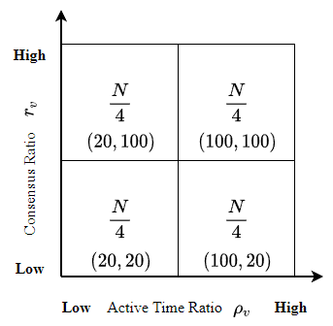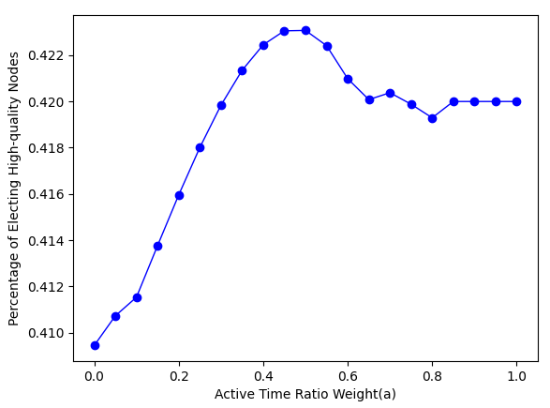
(a) Experiments settings (b) Elected probability Vs. active time ratio weight
Fig. 3. Percentage of high-quality under different weight.

6.2 Consensus Success Probability
In this subsection, we evaluate consensus success probability, which is affected by transmission success probability. In this test, we compared the consensus success probability by SWIB with PBFT.
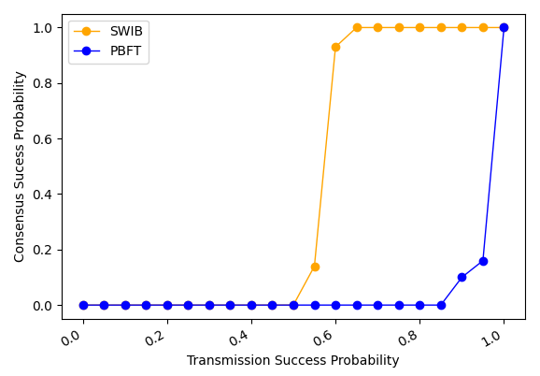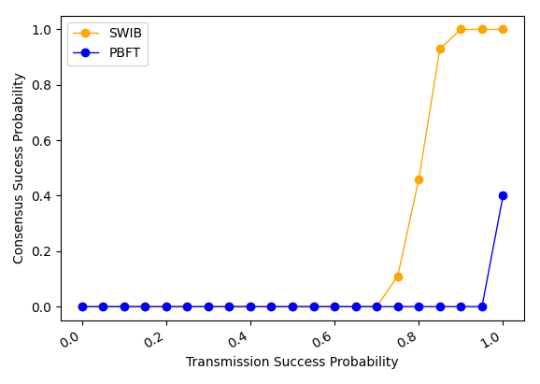
(a) Network with no faulty nodes (b) Networks with 30% faulty nodes
Fig. 4. Consensus success probability comparison.
As shown in Fig. 4, we compare consensus success probability by different protocols with varying transmission success probability. Since transmission success probability is small, consensus success probabilities of the SWIB and PBFT are zero. Then, the two protocols can achieve consensus among nodes if the transmission success probability is high enough. As shown in Fig. 4(a), the consensus success probability of SWIB is bigger than that of PBFT when transmission success probability is greater than 0.5. As shown in Fig. 4(b), when there are 30% faulty nodes in network, SWIB has higher consensus success probability than PBFT when transmission success probability is greater than 0.75. In addition, since faulty block proposer will lead to consensus interruption in PBFT, the consensus success probability is small even transmission success probability is equal to 1. Thus, our protocol is more stable than PBFT under networks with unstable and unreliable communication channel.

6.3 Performance
In this subsection, we evaluate the impact of block size and network size on the protocol performance in terms of consensus latency and transaction throughput.
1) Impact of block size
In this experiment, we evaluate the impact of block size on the performance of SWIB. The block size varies from 0.5 MB to 5 MB, and the network size varies from 100 to 300 nodes. Each test lasts for 10 rounds.
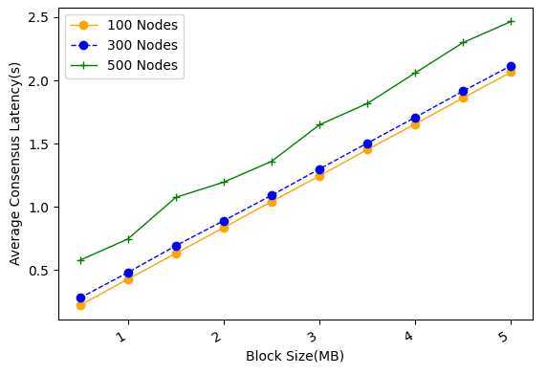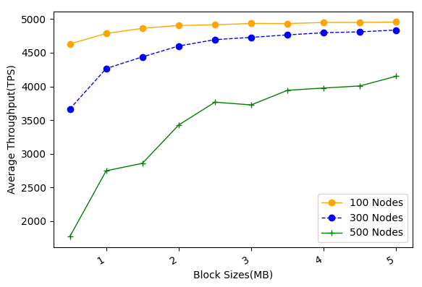
- Average consensus latency (b) Average throughput
Fig. 5. The performance of SWIB versus block size.
As shown in Fig. 5(a), average consensus latency almost linearly increases with block size increasing. When block size is smaller than 1 MB, the average consensus latency for all cases under study is below $1$ second. As shown in Fig. 5(b), with the block size increasing, average throughput first increases rapidly and finally tends to be flat. This indicates that only increasing block size cannot improve throughput infinitely. When block size equals to 1 MB, SWIB can achieve large average throughput with small average consensus delay.
2) Impact of network size
In this experiment, we evaluate the impact of network size on system performance. The network size varies from 100 to 600, and the block size varies from 0.5 MB to 2 MB. Each test lasts for 10 rounds.
As shown in Fig. 6 (a), average consensus latency versus network size increases with network size while still acceptable even for 600-node networks and 1-MB blocks. Due to the broadcast nature of wireless channel, block transmission time does not vary with network size as we focus on studying one-hop wireless networks. However, block finalization requires enough partial signature shares, whose collection time grows proportionally with network size. This indicates that consensus nodes are required to collect more partial signature shares, and the recovery of full signature requires larger threshold. Meanwhile, the increase of network size will lead to more severe channel accessing competition, which eventually results in the increase of average consensus latency. In SWIB, node will dynamically adjust its channel compete probability to reduce channel contention. This mechanism can avoid a sharp increase of consensus latency with the increase of network size. As shown in Fig. 6 (b), average throughput can reach approximate 2000 TPS for 600-node networks and 1-MB blocks. Thus, we can adjust node channel compete probability and block size to guarantee high transaction throughput with reasonable consensus latency for different network settings.
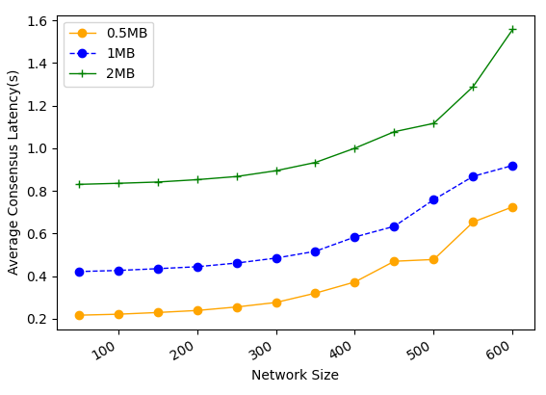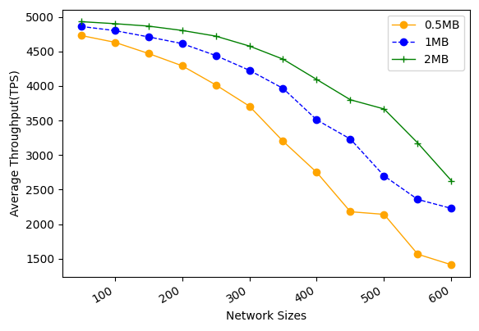
(a) Average latency (b) Average throughput
Fig. 6. The performance of SWIB versus network size.
We compare performance by SWIB and PBFT under varying network size and adversary power. In this experiment, each test lasts for 10 rounds, network size ranges from 50 to 600, and block size is fixed to 1 MB.
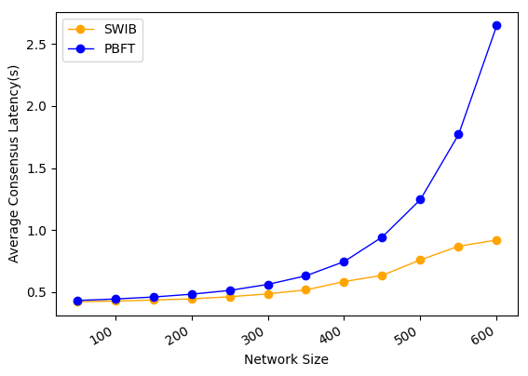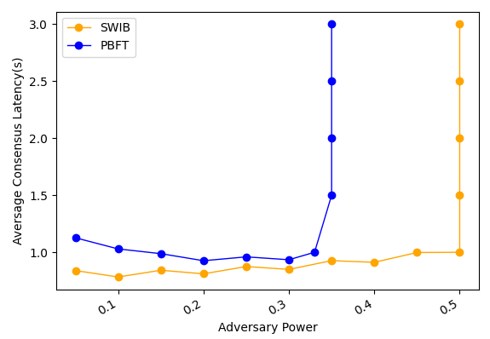
- Average latency vs. network size (b) Average throughput vs. network size
Fig. 7. Comparison of performance by different protocols.
As shown in Fig. 7(a), SWIB has much lower consensus latency than PBFT under same settings. For example, our protocol can achieve consensus within 1 second in 600-node wireless networks while that for PBFT will be 2.7 second. This is because SWIB can securely reach block consensus in one-time communication while PBFT requires two-times communications to reach consensus on a block.
As shown in Fig. 7(b), In PBFT, view change happens when a malicious leader proposes an invalid block or does not propose any block. All honest nodes require two-times communications to determine a new leader. In SWIB, honest nodes will discard invalid block and finalize an empty block instead, then starting the next consensus round. In the experiment here, all malicious nodes are assumed not to send any messages in a consensus round. Under this assumption, our protocol can work correctly when adversary power is smaller than 50% while PBFT will fail to reach consensus when adversary power is more than 33%. This indicates that our protocol has better fault tolerance performance than PBFT.

6.4 Attack Resistance
In this subsection, we evaluate the Sybil-attack-resistance and jamming-attack-resistance of SWIB.
We study how Sybil percentage of Sybil nodes impacts the consensus performance in terms of consensus latency and throughput. We increase the percentage of Sybil nodes from 5% to 49%, and repeat the experiments in three different sized networks while fixing block size to 1 MB.
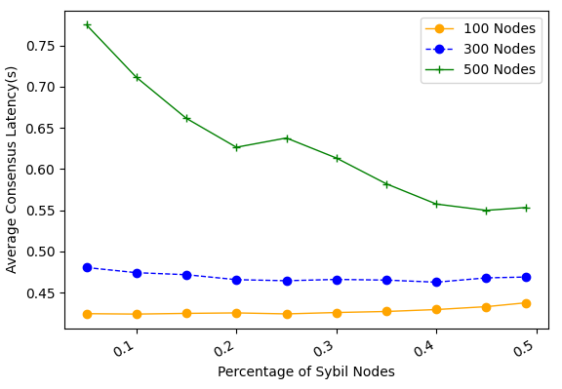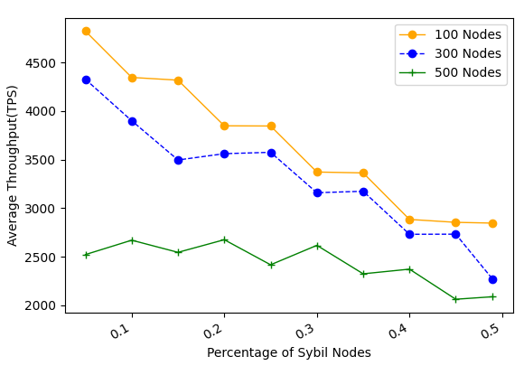
- Average consensus latency Vs. fraction of Sybil nodes (b) Average throughput Vs. fraction of Sybil nodes
Fig. 8. The performance of SWIB when confronting Sybil attack
As shown in Fig. 8 (a), consensus latency decreases with the percentage of Sybil nodes increasing. In SWIB, when a Sybil node is selected to serve as block proposer, an empty block will be eventually generated. Compare with the valid block case, propagation of an empty block requires small number of time slots. Thus, consensus latency will not significantly increase due to malicious block proposer in a round. Meanwhile, channel contention between nodes become light when the fraction of Sybil nodes increasing. This is because that Sybil nodes would not send messages during consensus process, or just send some error message with lower probability. As result, the consensus latency declines when the percentage of Sybil nodes increases. As shown in Fig. 8(b), average throughput will decrease with the increase of percentage of Sybil nodes. With the increase of Sybil nodes percentage, the probability of generating empty blocks increases. The average number of confirmed transactions will decrease. Even with a large number of Sybil nodes, SWIB can achieve more than 2000 TPS in blockchain network with 500 nodes and block size of 1 MB. Thus, our protocol can achieve acceptable performance when adversary issuing Sybil attack.
We evaluate the performance of SWIB in the presence of $(1-δ, T)$-bounded jammers. Considering two different jamming strategies in attacks: random jamming attack and consecutive jamming attack. The former one is that jammers randomly jam $\left(1-δ\right)T$ slots among $T$ slots. The later one is that jammers jam $\left(1-δ\right)T$ consecutive slots in each period of $T$ slots. Each test lasts for 10 rounds. The value $δ$ ranges from 0.1 to 1, and experiment is test under 500-node network and 1-MB block size. The smaller $δ$ is, the more time slots jammed. The adversary time window is chosen as 100 time slots.
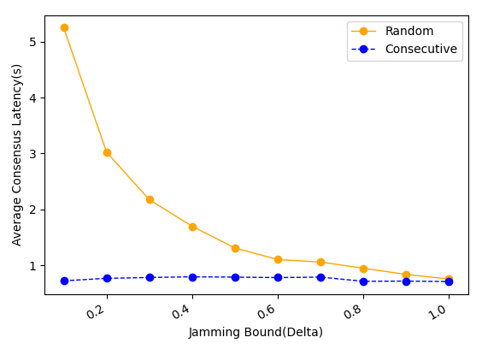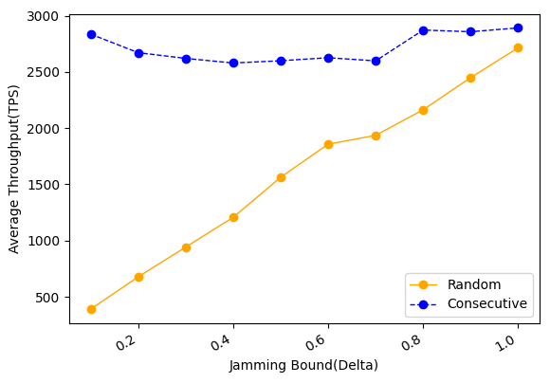
(a) Average consensus latency (b) Average throughput
Fig. 9. The performance of SWIB when confronting jamming attack.
As shown in Fig. 9 (a), consensus latency decreases with the increase of $δ$ under random jamming attack, and it not changes significantly under consecutive jamming attack. As shown in Fig. 9(b), the throughput of SWIB does not fluctuate significantly under consecutive jamming attack, and it approximately linear increase with the jamming bound increasing under random jamming attack. When adversary issues consecutive jamming attack, the channel compete probability of nodes is reduced quickly due to the estimate of adversary time window ${\hat{T}}_{v}$ increase fast. Since channel contention reduce, nodes can achieve consensus within small time slots. However, when jammers issue random jam attack, channel contention will not reduce significantly due to the estimate of adversary time window ${\hat{T}}_{v}$ not increase rapidly. This indicates that random jamming attack is more powerful than consecutive jamming attack in SWIB.

Conclusion and Future Research
In this paper, we proposed a stable wireless blockchain consensus protocol SWIB, which can ensure stable and secure consensus process by adopting verifiable random function and threshold signature scheme in one-hop wireless networks. We use a new verifiable block proposer algorithm to prevent the formation of forks and choose a more reliable block proposer to generate a valid block. Besides, by combining the nature of wireless communication protocol with threshold BLS signature scheme, consensus nodes can verify and vote for block proposal in secure and efficient way. In addition, according to the characteristic of threshold BLS signature scheme, all honest consensus nodes can recover full signature to complete block finalization in distributed manner. Moreover, our protocol can still work efficiently in wireless blockchain system under Sybil attacks and jamming attacks. Analysis and results show the efficiency and security properties of the SWIB protocol.
In the future, we will investigate the multi-hop version of SWIB protocol in wireless ad hoc networks. We should study the energy consumption in consensus process, and design energy efficiency consensus protocol in wireless network. What's more, it is necessary to investigate the impacts of mobility in ad hoc wireless network. Also, we will explore whether our protocol can mitigate other attacks such as long-term attacks, nothing-at-stake attacks, eclipse attacks, etc.

