**Proceedings of the ASME 2020**

**Fluids Engineering Division Summer Meeting**

**FEDSM2020**

**July 12-16, 2020, Rosen Shingle Creek Orlando, FL, USA**

**FEDSM2010-####**

Stovesim: An open source optimization software package for wood-fired biomass cookstoves

**Liam Cassidy1, Nordica MacCarty, Ph.D.1**

**1**Oregon State University, Corvallis, Oregon, United States

Abstract

The use of solid biomass as a fuel source for primary cooking is common to more than half of the world’s population. Household air pollution (HAP) as a product of utilizing biomass as a fuel while cooking indoors was estimated to have caused 2.8 million deaths alongside 85.6 million disability-adjusted life years in 2015—disproportionately affecting women and children in low-to-middle income countries. Moreover, combustion of biofuel is estimated to contribute to 20% of worldwide carbonaceous aerosols which have significant negative health impacts related to air quality and a strong influence on our global radiative balance. Despite efforts to improve biomass cookstove technology, modern technology remains an inefficient cooking and heating source due to improvement methods being based primarily on experimental observation and derived “rules of thumb”. More recently, the use of computational fluid dynamics (CFD) has been encouraged as a means of design advancement by bringing to light the complex and interconnect thermophysical processes within the modern cookstove. Moreover, integrating CFD into the design stage of cookstove development can reduce the dependence on costly and time-consuming experiments. The objective of this work is to present *StoveSim*, an open-source fluid dynamics simulation and optimization software package that utilizes OpenFOAMTM solvers. The work will include assumptions and methodology applied in the CFD, usage instructions, and results of a preliminary case study. Moving forward, the software will be installable with an open-source license for use and further development within the biomass cookstove community.

Keywords: Biomass, Cookstove, Computational Fluid Dynamics, Software Development

Nomenclature

Place nomenclature section, if needed, here. Nomenclature should be given in a column, like this:

α alpha

β beta

1. INTRODUCTION

Biomass is used as a fuel source for primary cooking by more than half of the world population. Burning biomass indoors causes household air pollution (HAP) which is estimated to have contributed to 2.8 million deaths and 85.6 million disability-adjusted life years in 2015; these estimates were found to disproportionately affect women and children in low resource countries [1]. In addition to detrimental health effects, combustion of biomass fuel contributes to 20% of carbonaceous aerosols which has a strong influence on Earth’s radiative balance [2]. Over the past thirty years, significant research efforts have been made to design affordable biomass cookstoves to disseminate to the developing nations most reliant on biomass combustion. A handful of design features have been attributed to improved cooking performance such as addition of a chimney and XX (what else?) (cite this). Despite the research efforts made, biomass cookstoves remain detrimental with respect to user health and climate change contribution.

Much of the early progress in cookstove design was derived by experimental observation and “rules of thumb”. More recently, experimental work has been coupled with computational methods to, first, better understand physical phenomena that yield a cleaner cookstove, and second, take a step towards predictability and optimization of cookstoves. Computational fluid dynamics (CFD) has been identified as a robust method to augment current understanding of cookstove performance as it relates to specific geometric and operational parameters.

Introducing forced-draft oxidizer-control has been identified as a promising design feature to improve efficiency of biomass cookstoves, thereby limiting the detrimental impacts of current technology (**add some citations here—Uws, that one berkely**). More specifically, adding small electronic fans in cross-flow

1. **MATERIALS AND METHODS**

All materials and methods that have been used in the work must be stated clearly. Subtitles should be used when necessary.

**2.1 CFD Geometry and Mesh**

The geometry is a two-dimensional representation of a cylindrical biomass cookstove with secondary forced draft and a pot skirt. The geometry of the stove is completely based on user-defined parameters. A schematic of the stove and a description of required input arguments are shown below.

Wc

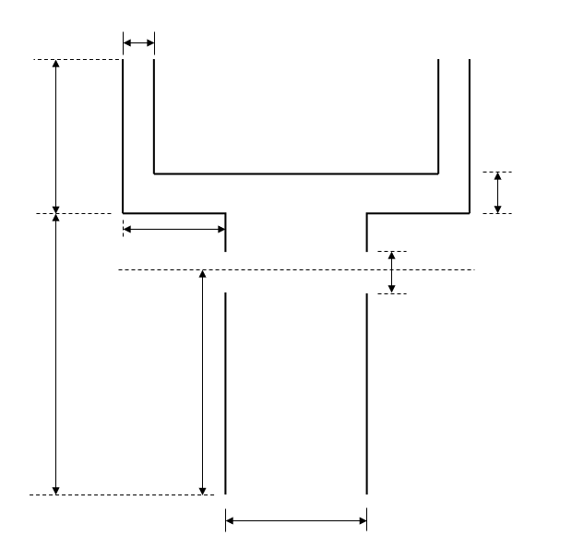

Ld

Hd

Dfd

Lc

Hcc

Hfd

Dc

Figure XX. Schematic of Geometry

Table XX. Required Geometric Arguments

|  |  |  |
| --- | --- | --- |
| Property | Variable | Default Unit |
| Combustion chamber diameter | Dc | m |
| Secondary inlet diameter | Dfd | m |
| Secondary inlet height | Hfd | m |
| Combustion chamber height | Hcc | m |
| Deck length | Ld | m |
| Deck height | Hd | m |
| Channel length | Lc | m |
| Channel width | Wc | m |

A mesh is generated using the *blockMesh* utility, which reads points, edges, faces, blocks, and boundary definitions defined in the *blockMeshDict* file within a respective case directory. Per OpenFOAMTM convention, the mesh size is defined by the number of cells in each coordinate direction within each unique block of the geometry. The number of cells in each coordinate direction in each unique block are assigned equal; this, in turn, makes the mesh non-uniform.

In order to verify the mesh size used in the analyses, a grid convergence study was performed as outlined by Celik et al. [**X**]. Net mass flow rate through the domain, *mnet*, was used as the global variable in the analysis, and each unique step size *hi*, was conservatively computed using the expected maximum dimension of such a cookstove design—the combustion chamber height For the purposes of the grid convergence study, *hi*was computed using **Eqn. (X),** where *N_cells* is the number of cells assigned to each coordinate direction and each block within the domain.

(X)

**Table X shows the results of the grid convergence study. As shown, at a minimum mesh size of XX, the solution becomes grid independent (<5% difference in successive net mass flow rates).**

--running these cases now

**2.2 Numerical Schemes**

**2.3.1 Boundary Conditions**

The mass flow rate of the fuel is computed using a simplified Bernoulli-based approach, presented previously by Agenbroad (CITE), where the user-defined firepower is used to compute the mass flow rate of the fuel:

(1)

The composition of the volatiles entering the domain from the primary inlet are taken from Udesen (who cites another author!), and is assumed to be constant. The mass fractions of respective species are scaled as described in equation (2) using the mass flow rate from equation (1) to determine the mass flow rate of each species to match OpenFOAMTM convention. Table XX shows the assumed mass fractions and the resulting mass flow rates per each species.

(2)

Table XX. Primary Fuel Composition and Flow Rate

|  |  |  |
| --- | --- | --- |
| Species | Mass Fraction (kg-specie/kg-mixture) | Mass Flow Rate (kg/s)* |
| CO | 0.383 | 9.575 E-5 |
| CO2 | 0.237 | 5.925 E-5 |
| H2 | 0.006 | 1.5 E-6 |
| H2O | 0.312 | 7.8 E-5 |
| CH4 | 0.062 | 1.55 E -5 |

*Based on a 5 kW firepower (2.5 E-4 kg/s)

During cookstove operation, ambient air is entrained into the combustion chamber due to buoyancy-induced flow. In order to approximate the mass flow rate of ambient air, the approach presented by Agenbroad [**reference Agen’s part 1 article**] is applied, where the mass flow rate of air is computed assuming the cookstove is an isobaric system with no mechanical work, ideal gas behavior, and negligible changes to kinetic and potential energy. Mass flow rate of air is computed using Eqn. (X),

(X)

Where is the user-defined cookstove firepower, is the assumed peak temperature within the cookstove 1300 K (experimentally observed), is the ambient air temperature 300 K, and is the constant specific heat evaluated at the average of ambient and peak temperatures (800 K), **1099 J/kg-K**.

The secondary air injection velocity magnitude and trajectory are based on user-defined flow rate, secondary air injection diameter as well as the flow rate and angle ranges and increments. The velocity magnitude for a given flow rate is computed using equation (3). Velocities are with respect to index *i*, which corresponds to a single flow rate, *Qi.*

(3)

The array for angles to be simulated is computed geometrically based on angle range and number of angles analyzed of the right side secondary inlet defined by the user. Figure X below shows a schematic representing the angle definition; and represent the maximum and minimum angles covered by the simulation array are 240o and 120o, respectively. In the example below, the number of angles analyzed is 5. The inlet angles of the left hand secondary port is symmetric.

+y

90o

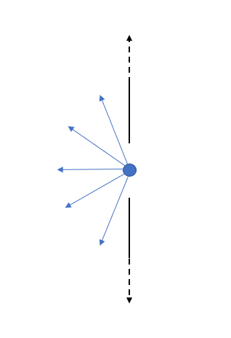

+x

240o

120o

270o

The horizontal and vertical components of velocity are computed based on the indexed angle, .

(4)

(5)

The composition of the secondary inlets is 79% nitrogen and 21% oxygen, by volume; the internal domain is initially set to an equivalent composition.

`

The cookstove outlets are assumed to be pressure outlets. The walls of the cookstove are prescribed with a no-slip condition.

**2.3.1 Boundary Conditions—Energy and Species**

It is assumed that the primary draft of air, due to buoyancy induced flow in practice, and prominent wood volatile species react instantaneously relative to the downstream reactions within the cookstove combustion chamber. Following this assumption, an equilibrium mixture temperature of the wood fuel composition (previously shown in **Table XX**) at 300 K, and ambient air 79% nitrogen and 21% oxygen) at 300 K is computed using CanteraTM equilibrium solvers. The primary inlet temperature is assigned a constant value equal to the resulting temperature from the chemical equilibrium calculation. For the case of a 5 kW firepower configuration, the resulting equilibrium temperature is **XXX K.**

The secondary air is assumed to be a constant 300 K, as is the full interior of the domain. The entire cookpot surface is assigned a constant surface temperature associated with the minimum heat flux required to bring water to boil. The Zuber correlation shown in **Eqn. (X)** is used to compute the minimum heat flux, *qs’’* associated with the condition **[reference bergman text, pg 663**]. The surface temperature is then computed based on the excess temperature, recovered from the Nukiyama boiling curve, and saturation temperature **Eqn. (X)**.

(X)

Where thermophysical properties are evaluated at saturation temperature, 373.15 K, and constant *C* is empirically found to be 0.09 by Berenson [X—page 663 of bergman]. *qs’’* is equal to 22,280 W/m2 given the properties listed in Table X.

Table XX. Thermophysical Properties for Zuber Theory

|  |  |  |
| --- | --- | --- |
| Variable | Value | Unit |
| Ρv | 0.5955 | kg/m3 |
| hfg | 2654 | kJ/kg |
| g | 9.81 | m/s2 |
| Ρl | 957.9 | kg/m3 |
| σ | 58.9 x 10-3 | N/m |

The constant surface temperature of the pot is then computed using **Eqn. (X)**

(X)

Where the excess temperature , 285 K, is evaluated using the Nukiyama boiling curve at the computed surface heat flux and is the saturation temperature of water at atmospheric pressure, 373.15 K. The resulting pot surface temperature is equal to 385.15 K.

The outer pot surfaces are assigned a constant flux condition (out of domain) corresponding to natural convection condition, where ambient surrounding air temperature is 300 K, and the convection coefficient is conservatively assumed to be 10 W/m2-K. **@LC consider incorpoerating black body radiation moving forward!**

A tabulated summary of the prescribed boundary conditions for momentum, species, and energy equations can be seen below in Table XX.

Table XX. Auxiliary Conditions Table Summary

|  |  |  |  |
| --- | --- | --- | --- |
| **Surface/Body** | **Momentum Condition** | **Energy Condition** | **Species Condition** |
| Cookpot surface | No slip | Constant temperature Ts = XXX K | Zero gradient |
| Outlet | Pressure outlet | Initially at 300 K, 1 atm | Hmm |
| Primary inlet | Mass flow inlet as a function of firepower (variable) | Equilibrium temperature of mixture (variable) | Equilibrium composition (variable) |
| Secondary inlet | Constant velocity and trajectory based on user input | Air at a constant 300 K and 1 atm | Constant 79% nitrogen and 21% oxygen |
| Stove outer walls | No slip | Constant heat transfer coefficient of 10 W/m2-K with surroundings at 300 K | Zero gradient 79% nitrogen and 21% oxygen |
| Internal mesh | Initialized at zero flow | Initialized at 300 K | Initialized at 79% nitrogen and 21% oxygen |

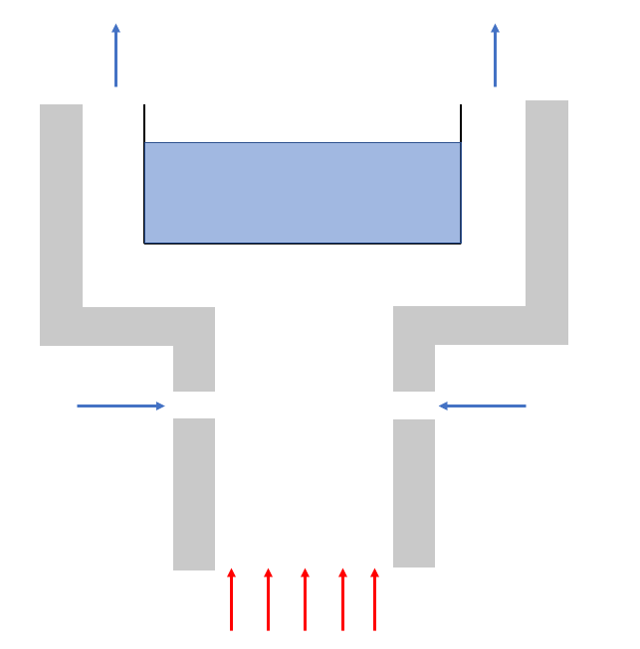

Figure XX. Auxilary Conditions Figure Summary

**2.2 Software Usage**

Subtitles should be bold but not all-capped.

**2.2.1 User Definitions**

To precondition the simulations, users are required to declare a series of input parameters in a local *input.yml* file; Table X below presents the full list of required user-definitions, units, and allowable limits. Note, the parameter names are declared with underscores in the *input.yaml* file, and will prevent the package from running properly if edited by the user.

|  |  |  |
| --- | --- | --- |
| **Parameter** | **Unit** | **Allowable Range** |
|  |  |  |
|  |  |  |
|  |  |  |
|  |  |  |
|  |  |  |
|  |  |  |
|  |  |  |
|  |  |  |
|  |  |  |
|  |  |  |
|  |  |  |
|  |  |  |
|  |  |  |
|  |  |  |
|  |  |  |

The variables used to define the design space, respect to the secondary forced draft are the

1. **RESULTS AND DISCUSSION**

Place results and discussion here. *Authors should make sure that all tables, graphics, and equations fit within the columns and do not run into the margins.* All figures, graphs, tables, etc. should be numbered. Ensure that all text is in black and that there is no highlighted text.

**FIGURE 1:** PERCENTAGE OF PAPERS THAT SHOULD BE FORMATTED CORRECTLY  
  
Equations should be numbered (1), (2), (3), and so on, with the number flush right in the column and a space before and after the equation, like this:

(1)

1. **CONCLUSION**

Place 3-4 line conclusion here.

**ACKNOWLEDGEMENTS**

Place any acknowledgements here.  
  
**REFERENCES**

[1] Thakur article, First Name. *The Name of the Book*, 2019

[2] Roden et al., 2006; Yttri et al., 2009

[X] Celik article from CFD course – GCI and uncertainties.