For this question, because there is only one company, I do not let be an entity. The relation which company receives the orders become ‘teams receive and conduct the order’. I also let leader become an attribute of moving team and let driver contain in the relation ‘drive’ between employee and vehicle. So that two entities-leader, driver are taken out of the diagram,

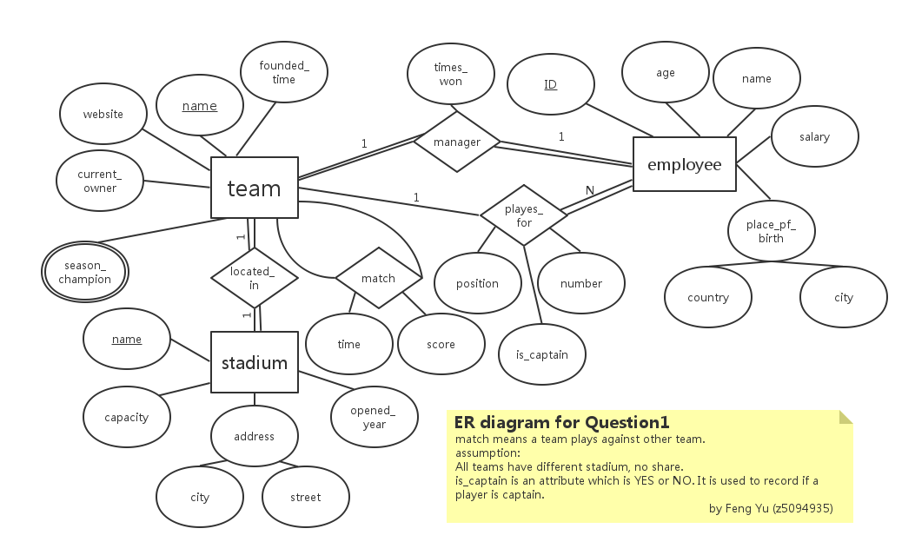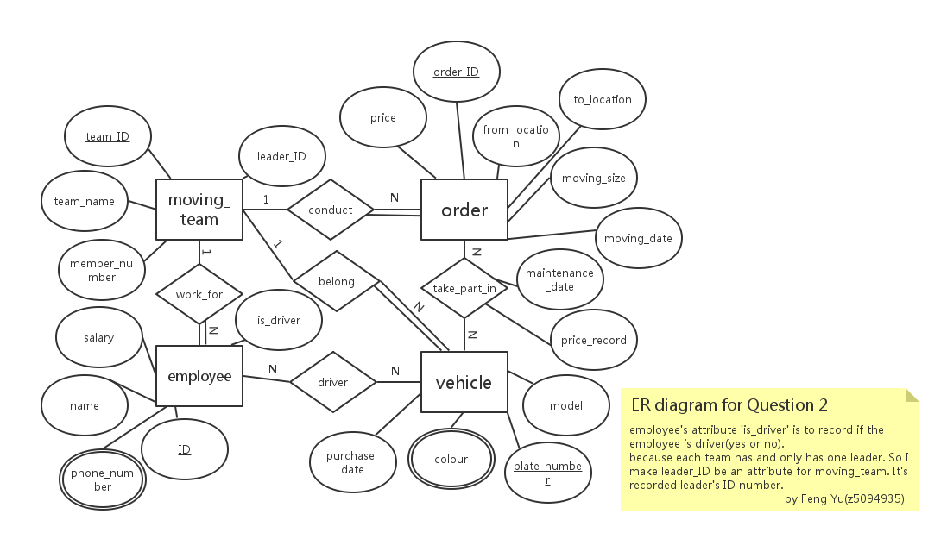

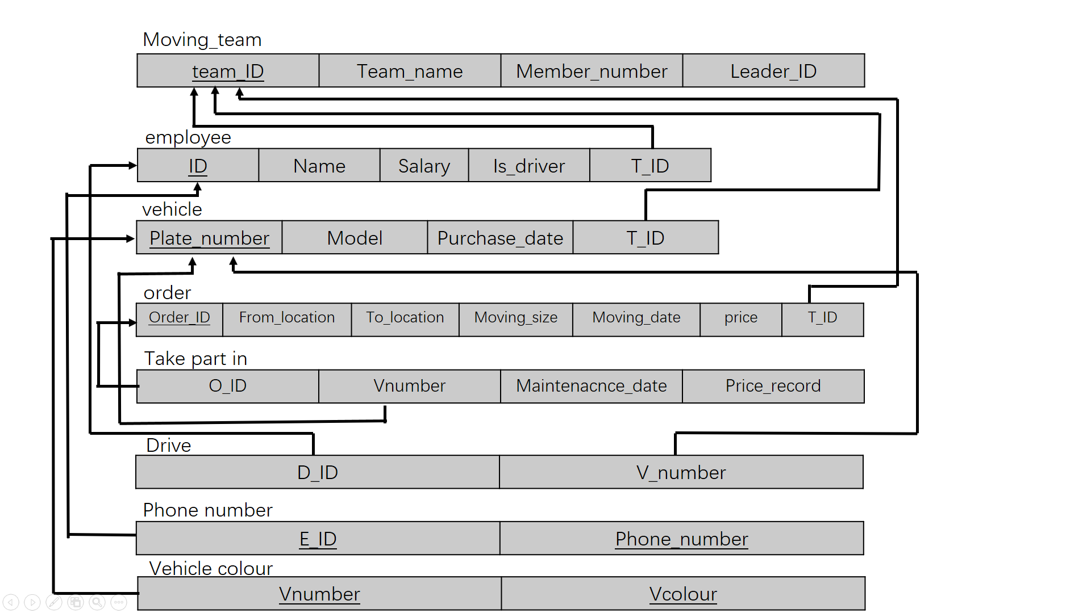**Relation model**

# Qusetion 3

1. To get the maximum number, I assume that all of the attributes are unique (all are candidate key). For N element the different combination is N!.

So the number of possible super-key is $\left|P\left(n\right)\right|=2^{n}$ and **Ø** should be deleted. So the final answer is $2^{n}-1$**.**

(2) when all the attributes become candidate keys, the number of candidate key get maximum.So the answer is **N**