# Readme

Gaming review website –

* Homepage (Intro page that has a scrolling banner going through images of games that we have reviewed. Upcoming review/game area that shows recent reviews/games that will be released soon. Top 10 Favourite games?
* Reviews – Images showing the game, when hovered expands area slightly and shows a short caption of the review. Maybe the first sentence/a star rating? Dropdown menu under review to allow to specify reviews for PC/XBOX/PS4. (Expansion into Movie/TV reviews?)
* Contact Us – Simple form to allow users to send in questions/ideas about new games to review.
* About us – Basic about us page talking about what we do

## Navigation Plan

Navigation Bar at the top of the website which displays across all pages. This would have buttons to navigate to the Homepage, and a dropdown to link the different review pages, as well as to the Contact us and About us pages.

## Wireframe Designs

Homepage

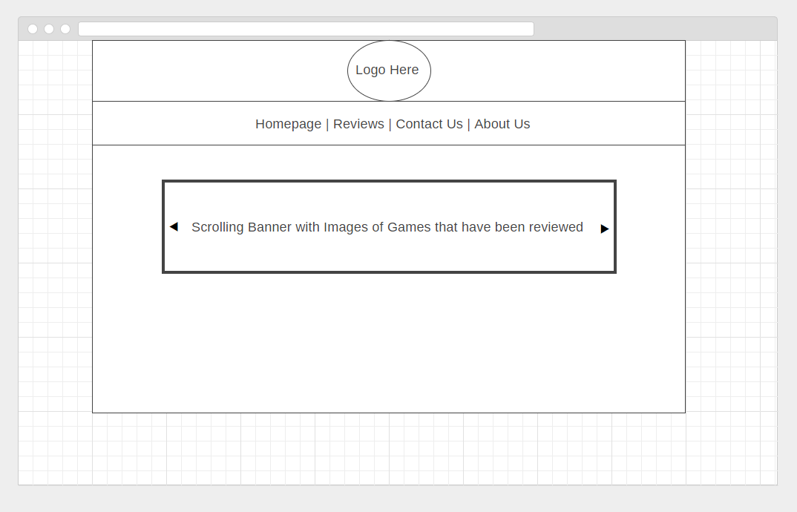

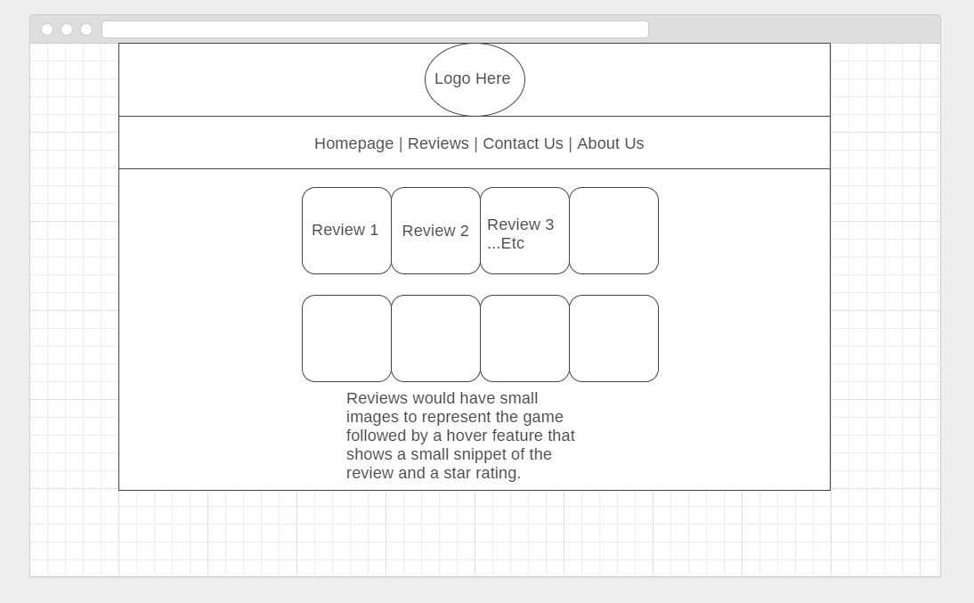Reviews

Contact Us

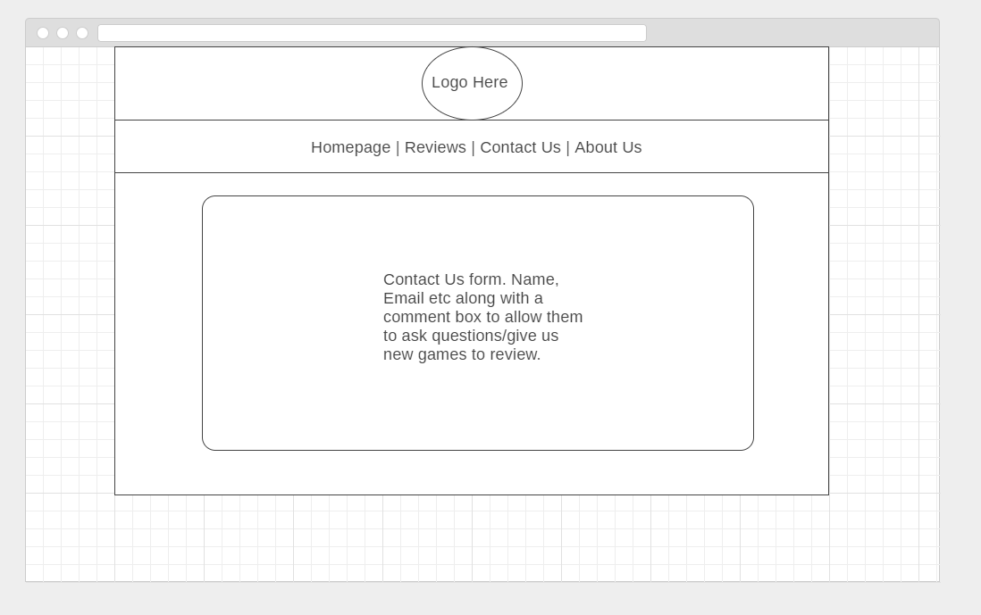

About Us

