Liam Saxon

[Email address]

AT2.1-java

Table of Contents

1 Class Diagram 2

2 Test case 2

3 Screenshots 2

# Versioning

Projects uploaded to GitHub to ensure version control. Projects can be separated into various releases and various branches to ensure versioning.

# Debugging

Using break points and test cases I can view what data is stored in each variable. Screen shot below to show

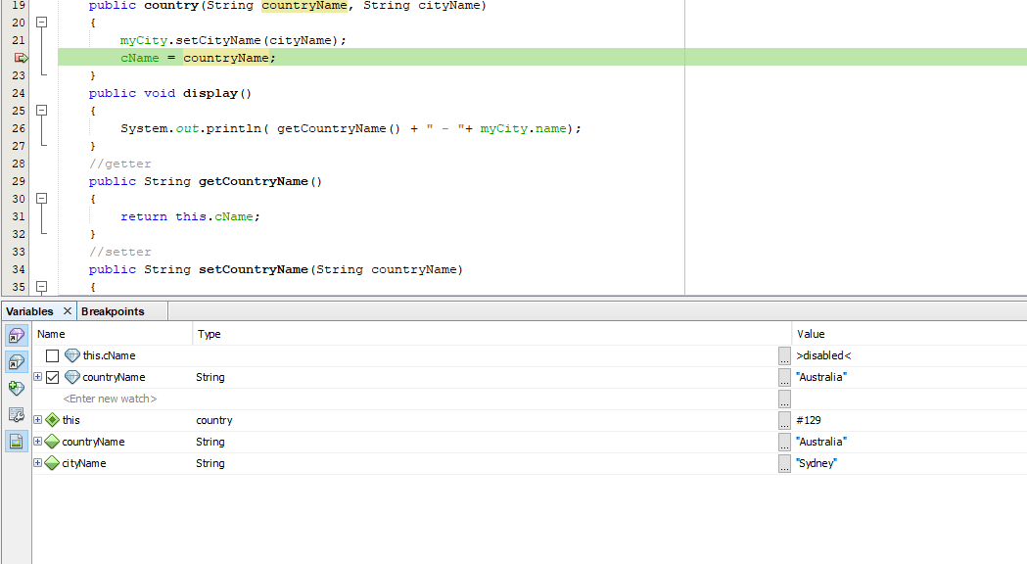

# Class Diagram

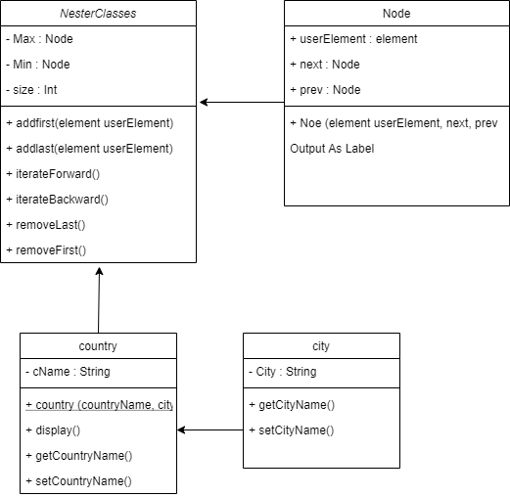

# Test case

|  |  |  |  |
| --- | --- | --- | --- |
| Test case | description | expected outcome | evidence |
| Case 1 | Run the program | Program runs through the methods successfully | See Ref 1 screenshot |
| Case 2 | Not including a city or country in the object creation | Unsuccessful run. Won’t allow for running without both strings provided | See Ref 2 screenshot |

# Screenshots

**Ref 1**

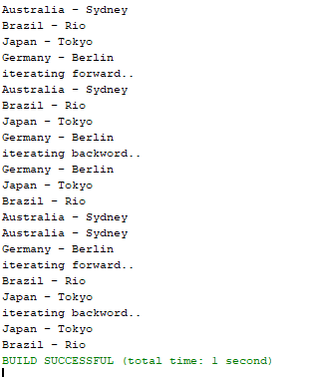

**Ref 2**

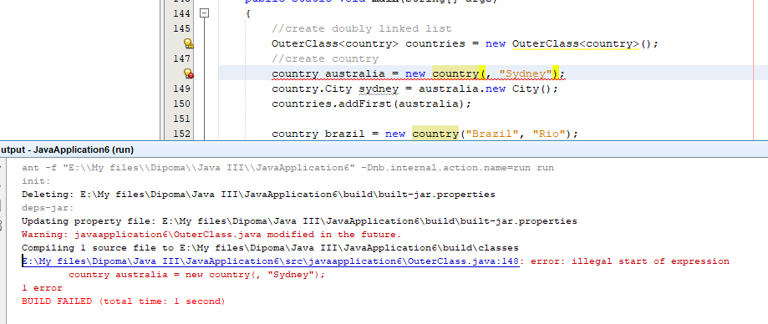

# Unit Testing

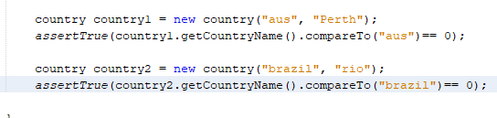

# GitHub

<https://github.com/Liam-Saxon/JavaIII>