Liam Saxon

[Email address]

AT2.3-java

Table of Contents

Versioning 2

Debugging 2

Class Diagram 2

Test case 2

Unit Testing 4

GitHub 4

# Versioning

Projects uploaded to GitHub to ensure version control. Projects can be separated into various releases and various branches to ensure versioning.

# Debugging

Using break points and test cases I can view what data is stored in each variable. Screen shot below to show

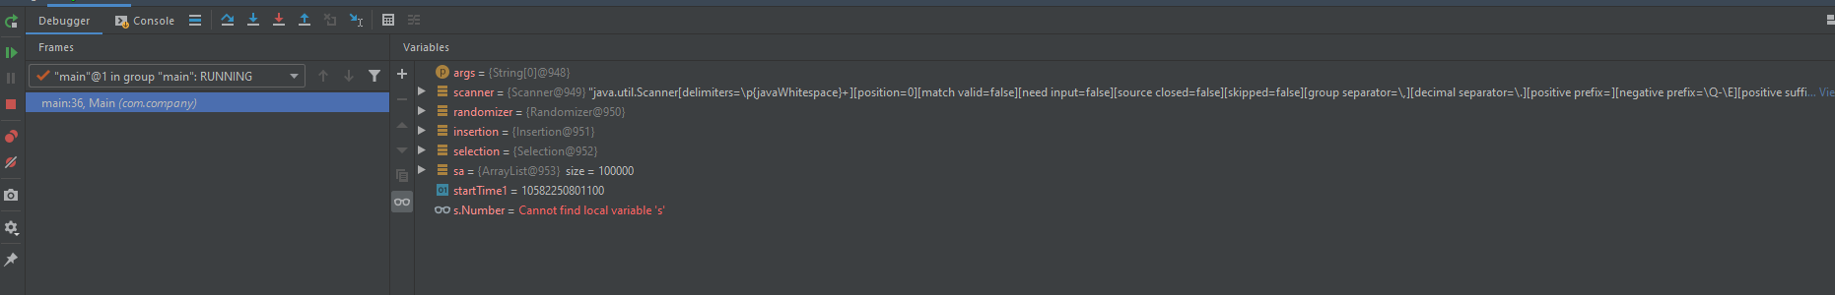

# Class Diagram

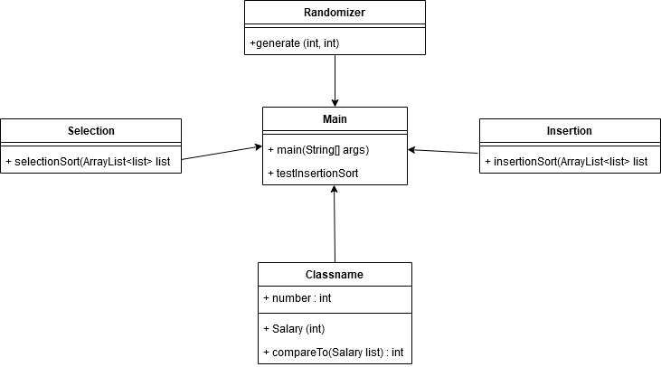

# Test case

|  |  |  |  |
| --- | --- | --- | --- |
| Test case | description | expected outcome | evidence |
| Case 1 | Collection sort | Program sorts the arraylist with the collection sort | See Ref 1 screenshot |
| Case 2 | Insertion Sort | Program sorts the arraylist with the Insertion sort | See Ref 2 screenshot |
| CASE 3 | Selection Sort | Program sorts the arraylist with Selection sort | See Ref 3 Screenshots |

Screenshots

**Ref 1**

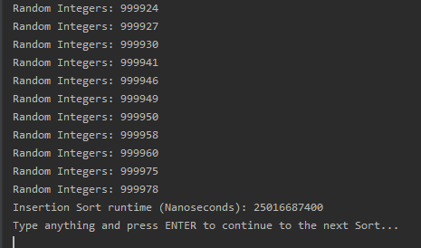

**Ref 2**

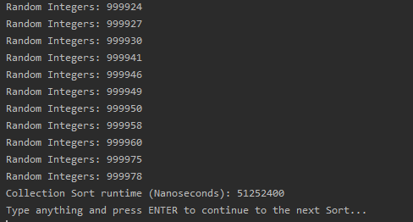

**Ref 3**

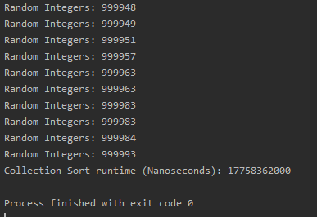

# Unit Testing

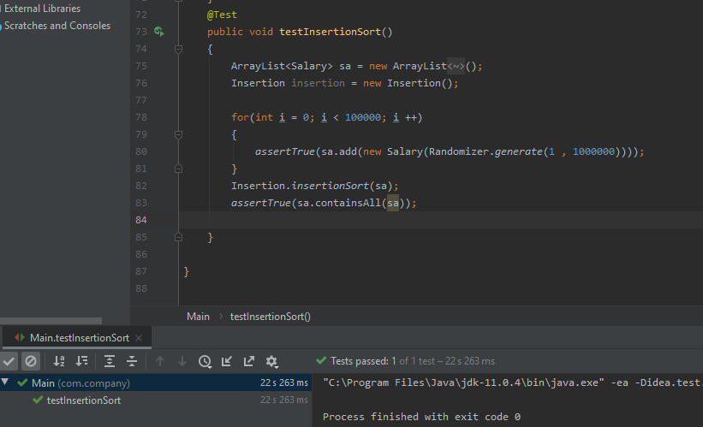

# GitHub

<https://github.com/Liam-Saxon/Java-III>