Liam Saxon

[Email address]

AT2.4-java

Table of Contents

Versioning 2

Debugging 2

Class Diagram 2

Test case 2

Unit Testing 4

GitHub 4

# Versioning

Projects uploaded to GitHub to ensure version control. Projects can be separated into various releases and various branches to ensure versioning.

# Debugging

Using break points and test cases I can view what data is stored in each variable. Screen shot below to show

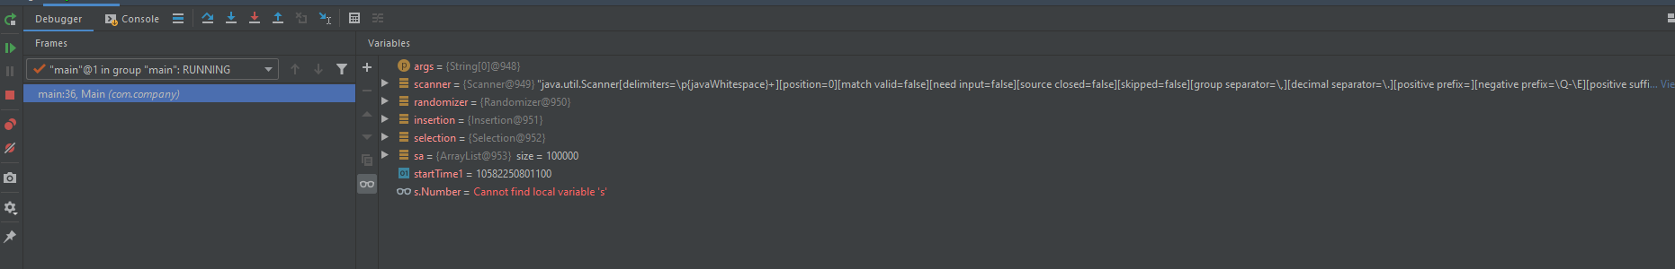

# Class Diagram

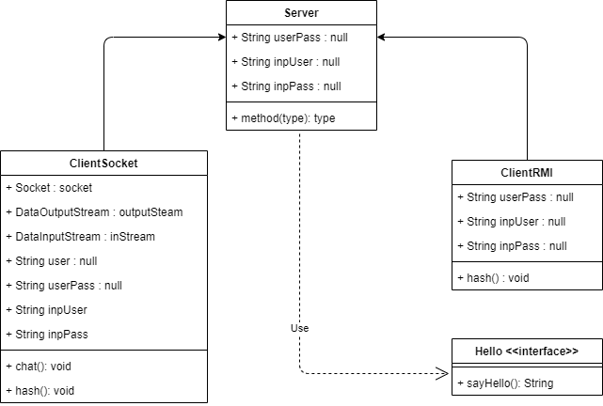

# Test case

|  |  |  |  |
| --- | --- | --- | --- |
| Test case | description | expected outcome | evidence |
| Case 1 | Run Server class with Socket selection | Server starts and tells user that its listening on port ‘1234’ | See ref 1 and the following screenshots. |
| case 2 | Run Server class with RMI selection (having run start rmiregistry beforehand) | Server starts and tells the users its ready | See ref 2 and the following screenshots. |
| Case 3 | Launch ClientRMI or Client Socket | Asked to create username and password | See ref 3 and the following screenshots. |
| Case 4 | Entering the username and password that were created or admin and admin will login the client to the server | When the correct credentials are input the user is connected to the server if its online | See ref 4 and the following screenshots. |

# Screenshots

## Ref 1

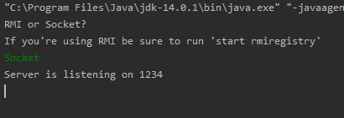

## Ref 2

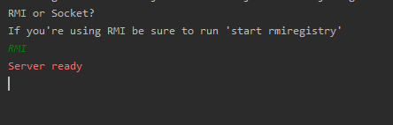

## Ref 3

**RMI**

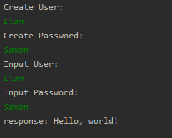

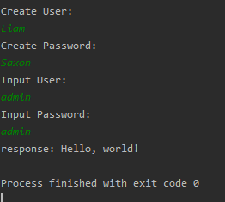

**Socket Server**

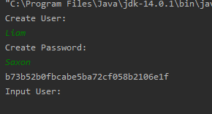

User creation with hash for testing purposes / proof (removed in the submitted version)

## Ref 4

**Socket client**

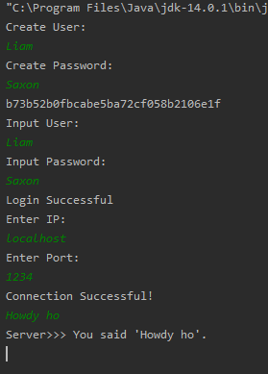

**Socket Server**

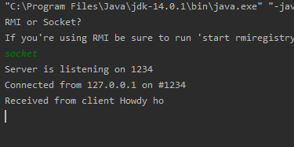

**RMI Client**

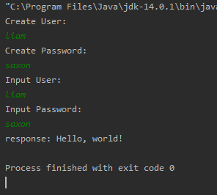

**RMI Server**

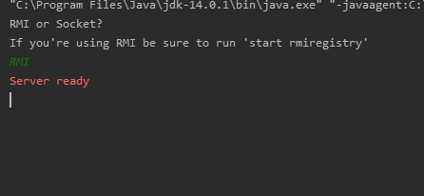

# Unit Testing

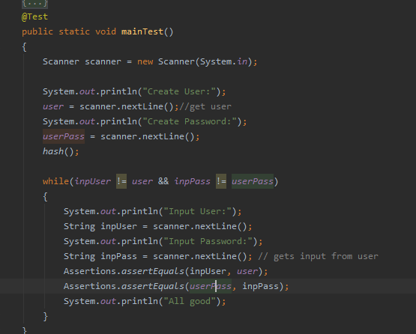

# GitHub

<https://github.com/Liam-Saxon/Java-III>