Liam Saxon

[Email address]

AT2.7-java

Table of Contents

Versioning 2

Debugging 2

Class Diagram 2

Test case 2

Unit Testing 4

GitHub 4

# Versioning

Projects uploaded to GitHub to ensure version control. Projects can be separated into various releases and various branches to ensure versioning.

# Debugging

Using break points and test cases I can view what data is stored in each variable. Screen shot below to show

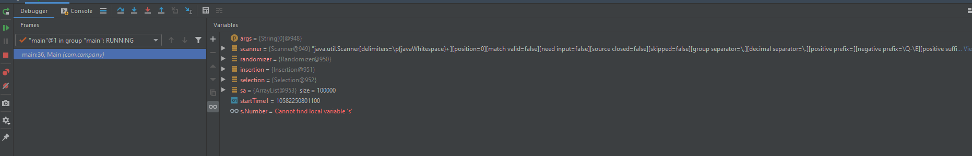

# Class Diagram

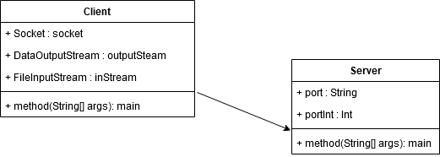

# Test case

|  |  |  |  |
| --- | --- | --- | --- |
| Test case | description | expected outcome | evidence |
| Case 1 | Server boots, asking for port | Server boots after port is entered and awaits a client connection | See ref 1 and the following screenshots. |
| case 2 | Client boots, asks for port and IP then proceeds to send the file from client to server | After the IP and port are successfully entered the file’s URL is checked and if valid sends a copy of the file over the server class creating a copy in its desired URL location | See ref 2 and the following screenshots. |

Screenshots

**Ref 1**

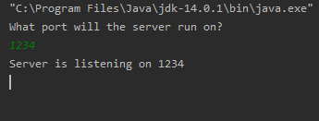

**Ref 2**

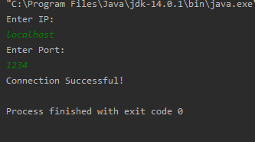

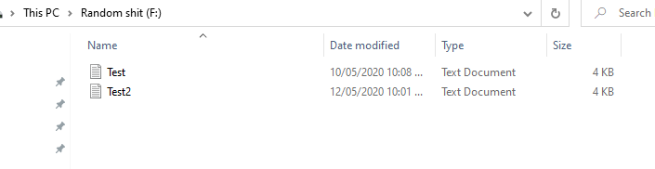

# Unit Testing

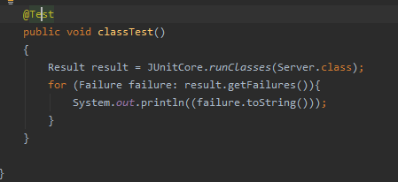

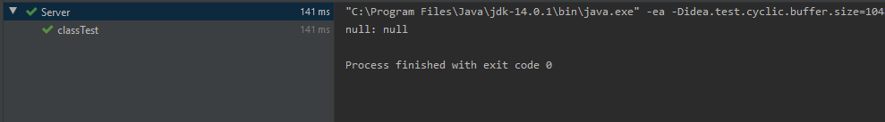

# GitHub

<https://github.com/Liam-Saxon/Java-III>