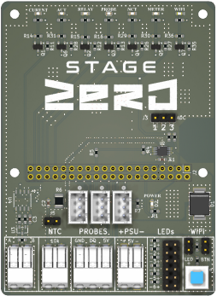
3x Temp Probes
ADC Header Not Used
NTC header Not Used
LEDs connected via DUPONT 2 Pin Wire, mounted in DB
Halo Metal Switch, Panel Mounted on DB
2x RS485 Coms wires from IV Meter
2x wires from Thermostat
Additional Wire connection for Probe

